|  |  |
| --- | --- |
| **Radiocommunication Study Groups** |  |
|  |  |
|  |  |
| Source: Document 5A/TEMP/189 | **Annex 14 to**  **Document 5A/469-E** |
| **6 June 2017** |
| **English only** |
| Annex 14 to Working Party 5A Chairman’s Report | |
| Working document toward preliminary draft new Report ITU-R M.[amateur_50_MHz] | |
| Spectrum needs for the amateur service in the frequency band 50-54 MHz in Region 1 and sharing with mobile, fixed, radiolocation, and broadcasting services | |

Table of Contents

1 Introduction 4

2 Current usage of the 50-54 MHz frequency band in Region 1 4

2.1 The amateur service 4

2.2 The Radiolocation service 6

2.3 The Broadcasting service 6

2.4 The Fixed and Mobile services 6

[2.5 Inter-regional sharing between services 6

3 Spectrum needs for the amateur service in Region 1 6

3.1 General Considerations 6

3.2 Propagation Issues 7

3.3 Future usage 8

3.4 Usage Categorisation 8

3.5 Approach to determining spectrum needs 9

3.6 Spectrum Needs Summary 11

4 Characteristics of amateur stations for sharing studies 11

4.1 Global characteristics 11

4.2 Specific Region 1 characteristics 11

4.3 Propagation Factors 13

5 Sharing with the mobile service 13

5.1 System parameters of the mobile service 14

5.2 Other mobile systems specs (add as necessary) 15

5.3 Minimum coupling loss calculations 15

6 Sharing with the fixed Service 16

7 Sharing with the radiolocation Service 16

8 Sharing with the broadcasting service 16

8.1 Background 16

8.2 The 2016 Situation 17

8.3 Digital Terrestrial Television Broadcasting in Band 1 – 47–68 MHz 18

8.4 Analogue Television Broadcasting in Band 1 – 47–68 MHz 19

8.5 Inter-Regional Sharing Situation 19

[8.6 Sharing between the broadcasting service in Region 1 and the amateur service  
in Region 3 19](#_Toc483919397)

[8.7 Sharing between the broadcasting service in Region 1 and the amateur service  
in Region 2 20](#_Toc483919398)

8.8 Sharing study details 20

8.9 Summary and conclusions 20

Annex 1 Sharing with Mobile Service 20

A1.2 Introduction 21

A1.3 Background 21

A1.4 The study scenarios and basic system parameters 21

A1.5 Operational Considerations 22

A1.6 Estimating the service range of the tactical links 23

A1.7 Range of the amateur service links assumed in this study 23

A1.8 Results of the simulations 24

A1.9 Conclusion 28

Annex 2 Application-based approach to calculation of spectrum needs 29

A2.1 General 29

A2.2 Input parameters 29

A2.3 Calculation Process 30

A2.4 An example of input parameters values and obtained results 31

A2.5 Input parameters 31

A2.6 Spectrum needs 32

Annex 3 Amateur Stations & Density 33

Annex 4 Digital spectrum arrangement for the band 52–54 MHz 34

A4.1 Digital amateur applications (channel spacing up to 500 kHz) 34

[Annex 5 MCL interference analysis between amateur and mobile service  
in the band 50-54 MHz 36](#_Toc483919420)

[A5.1 Technical and operational Parameters of amateur service in the band  
50-54 MHz 36](#_Toc483919421)

A5.2 Amateur radio emission mask 36

A5.3 Characteristics of Considered Mobile applications 38

A5.4 Propagation model 38

A5.5 Calculation method 39

A5.6 Protection criterion and ambient noise figure 39

A5.7 Determination of minimum path attenuation 41

A5.8 Evaluation of the interference ranges 41

A5.8 Summary and conclusions 42

Annex 6 Wind Profile Radar System 43

A6.1 Background 43

A6.2 WPR location and parameters 44

A6.3 In-band separation distances 45

A6.4 Summary and Conclusions 46

Annex 7 Sharing with the broadcasting service 47

A7.1 Introduction 47

A7.2 Method 47

A7.3 Variables for the unwanted amateur station signal 49

A7.4 Variables for the wanted TV signal 50

A7.5 The calculation 50

A7.6 Sharing scenario 51

A7.7 Alternative Approach 51

A7.8 Summary and Conclusions 52

A8.1 Introduction and summary 53

A8.2 Study details 53

A8.3 The major metropolitan area study 53

A8.4 The rural centre study 54

*Editor’s note: Use update table of content commands to update above table as each entry is linked to the section titles*

# 1 Introduction

Resolution **658** (Geneva, 2015) invites ITU-R to conduct the following studies to support the deliberations of WRC-19 on agenda item 1.1:

*1 to study spectrum needs in Region 1 for the amateur service in the frequency band 50‑54 MHz;*

*2 taking into account the results of the above studies, to study sharing between the amateur service and the mobile, fixed, radiolocation and broadcasting services, in order to ensure protection of these services.*

This Report responds to the invitations of Resolution **658**.

# 2 Current usage of the 50-54 MHz frequency band in Region 1

## 2.1 The amateur service

The 50-54 MHz frequency band is allocated to the Amateur Service in Regions 2 and 3. While the Region 1 African countries listed in RR **No. 5.169** have an allocation to the amateur service in the 50-54 MHz frequency band on a primary basis, a number of other Region 1 countries have authorised the use of all or parts of the 50-52 MHz frequency band by the amateur service on a mainly secondary (but sometimes national primary) basis in accordance with RR **No. 4.4**.

CEPT’s European Table of Frequency Allocations allocates the 50-52 MHz frequency band to the amateur service on a secondary basis. As of October 2016, twenty-four of the forty-eight member administrations of CEPT have notified an allocation to the amateur service in the CEPT European Communications Office’s online Frequency Information System (EFIS). In addition a further twelve CEPT administrations have indicated that amateur usage is an application in this band. This demonstrates that 75% of CEPT’s membership authorise amateur usage within the 50-52 MHz frequency band. The permitted maximum power of such stations is mostly 100 W, in some countries there are territorial limitations with regard to power and frequencies.

Table 2.1 provides a list of Region 1 Administrations and the conditions for using the 50-54 MHz frequency band, as published in the website of Region 1 of the International Amateur Radio Union (IARU).

Table 2.1

Conditions for amateur service usage of the 50-52 MHz band in Region 1, as at May 2017

| Country | Band | Status1 | RR2 | Country | Band | Status1 | RR2 | Country | Band | Status1 | RR2 | Country | Band | Status1 | RR2 |
| --- | --- | --- | --- | --- | --- | --- | --- | --- | --- | --- | --- | --- | --- | --- | --- |
| AFS | 50-54 | P | 5.169 | DNK | 50-52 | S |  | LBR |  | No Info |  | S | 50-52 | S | |
| ALB | 50-52 | S |  | E | 50-52 | S |  | LBY |  | No Info |  | SDN |  | No Info |  |
| ALG | NO |  |  | EGY | NO |  |  | LIE | 50-52 | S |  | SEN | 50-51 | P | 5.169 |
| AND | 50-52 | S |  | ERI |  | No Info |  | LSO | 50-54 | P | 5.169 | SEY |  | No Info |  |
| AGL |  | No Info |  | EST | 50-52 | S |  | LTU | 50-52 | S |  | SMR | 50-52 | S | |
| ARM | NO |  |  | ETH |  | No Info |  | LUX | 50-52 | S |  | SOM | 50-54 |  |  |
| ARS | NO |  |  | F | 50-52 | S |  | LVA | 50-52 | S |  | SRB | 50-51.9 | S | |
| AUT | 50-52 | S |  | FIN | 50-52 | S |  | MAU | NO |  |  | SRL |  | No Info |  |
| AZE | NO |  |  | G | 50-51 | P |  | MCO | 50-52 | S |  | SSD |  | No Info |  |
| BEL | 50-52 | S |  | 51-52 | S |  | MDA | NO |  |  | STP |  | No Info |  |
| BEN |  | No Info |  | GAB |  | No Info |  | MDG |  | No Info |  | SUI | 50-52 | S | |
| BFA |  | No Info |  | GEO | NO |  |  | MKD | 50-52 | S |  | SVK | 50-52 | S | |
| BHR | 50-50.5 | P |  | GHA |  | No Info |  | MLI |  | No Info |  | SVN | 50-52 | S | |
| 50.5-52 | S |  | GMB |  | No Info |  | MLT | 50-52 | S |  | SWZ | 50-54 | P | 5.169 |
| BIH | 50-52 | S |  | GNE |  | No Info |  | MNE | 50-52 | S |  | SYR |  | No Info |  |
| BLR | NO |  |  | GNB |  | No Info |  | MNG |  | No Info |  | TZA |  | No Info |  |
| BOT | 50-54 | P | 5.169 | GRC | 50-52 | S |  | MOZ |  | No Info |  | TCD |  | No Info |  |
|  |  |  |  | GUI |  | No info |  |  |  |  |  |  |  |  |  |
| BUL | 50.05-50.2 | S |  | HNG | 50-52 | S |  | MRC |  | No Info |  | TGO |  | No Info |  |
| BDI |  | No Info |  | HOL | 50-52 | S |  | MTN |  | No Info |  | TJK | NO |  |  |
| CAF |  | No Info |  | HRV | 50-51.9 | S |  | MWI | 50-54 | P | 5.169 | TKM | NO |  |  |
| CME |  | No Info |  | I | 50-52 | S |  | NGR |  | No Info |  | TUN | NO |  |  |
| COD | 50-54 | P | 5.169 | IRL | 50-52 | S |  | NIG | NO |  |  | TUR | NO |  | |
| COG |  | No Info |  | IRQ |  | No Info |  | NMB | 50-54 | P | 5.169 | UAE |  | No Info |  |
| COM |  | No Info |  | ISL | 50-52 | S |  | NOR | 50-52 | S |  | UGA |  | No Info |  |
| CPV |  | No Info |  | ISR | 50-52 | S |  | OMA | 50-52 | S |  | UKR |  | No Info |  |
| CTI |  | No Info |  | JOR | 50-51.5 | S |  | POL | 50-52 | S |  | UZB | NO |  |  |
| CVA | 50-52 | S |  | KAZ | NO |  |  | POR | 50-52 | S |  | YEM |  | No Info |  |
| CYP | 50-51 | S |  | KEN | NO |  |  | QAT |  | No Info |  | ZMB | 50-54 | P | 5.169 |
| CZE | 50-52 | S |  | KGZ | NO |  |  | ROU | 50-52 | S |  | ZWE | 50-54 | P | 5.169 |
| D | 50.08-51 | S |  | KWT |  | No Info |  | RUS | NO |  |  |  |  |  |  |
| DJI |  | No Info |  | LBN | NO |  |  | RRW | 50-54 | P | 5.169 |  |  |  |  |
| **5.169** Alternative allocation: in **Botswana**, **Lesotho**, **Malawi**, **Namibia**, **the Dem. Rep. of the Congo,** **Rwanda, South Africa**, **Swaziland**, **Zambia and Zimbabwe**, the band 50-54 MHz is allocated to the amateur service on a primary basis. In Senegal, the band 50-51 MHz is allocated to the amateur service on a primary basis. (WRC-12) | | | | | | | | | | | | | | | |

1 Status: P = primary, S = Secondary, No info = no information available.2 RR is the applicable Radio Regulation Article **5** footnote.

The frequency range 50.0-50.5 MHz is utilised for weak signal communications, which would derive great benefit from harmonisation with Regions 2 and 3. The essential need here is for 500 kHz of narrowband applications including propagation beacons.

The frequency range 50.5-52 MHz is currently utilised for voice communications using frequency or phase modulation, Data, Gateways and FM Repeaters. Concerning two frequency repeaters, sufficient separation must be available between input and output frequencies in order to be able to easily engineer the cavity diplexers required for such installations. Digital Voice and data is already being used for 50 MHz networks in the amateur service incorporating text and simple voice messaging. Such systems have shown to be of considerable value in emergency communications. See RR **No. 25.3**.

The amateur service, with more than three million operators worldwide, continues to grow. Radio amateurs utilise allocations to the amateur service to engage in scientific and technical investigation and experimentation, provide communication in the wake of natural disasters, provide non‑commercial public service communications, conduct other activities to advance technical education, develop radio operating technique and enhance international goodwill.

## 2.2 The Radiolocation service

RR **No. 5.162A** provides for an additional allocation to the radiolocation service on a secondary basis in a number of countries in Region 1, limited to the operation of wind profiler radars in accordance with **Resolution 217 (WRC-97)**. Very few wind profiler radars operate in the  
50-54 MHz frequency band.

## 2.3 The Broadcasting service

The 47-68 MHz frequency band is allocated to the broadcasting service on a primary basis in Region 1. In recent years broadcasting has significantly declined in the 47-68 MHz frequency band and analogue television is expected to be phased out by 2020 as conversion to digital television broadcasting in a different part of the spectrum proceeds. However in Eastern Europe the band is still used for analogue television.

## 2.4 The Fixed and Mobile services

Footnotes RR **No. 5.164** and RR **No. 5.165** allocate part, or all, of the frequency band 47-68 MHz to the land mobile service on a primary basis in a number of countries in Region 1.

It has to be noted that RR **No. 5.167** and RR **No 5.167A** provide allocations to the fixed service on a primary basis to a number of countries in Region 3. No further study on the fixed service is provided in this report as WRC-19 agenda item 1.1 only applies to Region 1.

## [2.5 Inter-regional sharing between services

Due to the different service allocations as given in various footnotes in the Radio Regulations there is inter-regional sharing between services at the borders between Region 1 and Regions 2 and 3.]

# 3 Spectrum needs for the amateur service in Region 1

## 3.1 General Considerations

Article **1.56** of the Radio Regulations defines the amateur service as

*amateur service:*  a radiocommunication service for the purpose of self-training, intercommunication and technical investigations carried out by amateurs, that is,   
by duly authorized persons interested in radio technique solely with a personal aim   
and without pecuniary interest.

The 50 MHz band exemplifies all key aspects of the amateur service - communication, technical investigation and self-training. Underpinning this are harmonised allocations to the amateur service on a global basis for which the International Amateur Radio Union develops utilisation plans. The   
50 MHz band is also the first band in the frequency spectrum above 30 MHz where the full wide range of amateur modes and infrastructure (such as repeaters and gateways) can be used. These range from conventional and emerging terrestrial techniques, all the way to specialist EME (moon-bounce) stations. This part of the spectrum is also where propagation characteristics are highly attractive for amateur investigations. In contrast, its relatively high noise levels and unwieldy antenna sizes continue to detract from major commercial use, especially for mobile communications.

Regulatory and technical decisions over many years have had a significant impact on the use of broadcasting in both the 50-54 MHz range and indeed over all of the frequency band 47–68 MHz (also known as Broadcasting Band-I). In this band, as analogue television broadcasting declined and finally ceased in most countries, many CEPT administrations found it possible to allocate all or parts of the band 50-52 MHz to the amateur service under the conditions of RR **No.** **4.4** on a national primary and/or secondary basis. This has complemented existing primary 50-54 MHz amateur service allocations in Africa under RR **No. 5.169** and the 50-54 MHz primary allocation to the amateur service in Regions 2 and 3.

IARU Region-1 in consultation with IARU Regions 2 and 3 has consequently developed a plan to facilitate intercommunication and technical investigations in the 50 MHz range. The most common applications to date have been the use of relatively narrow bandwidth (less than 25 kHz) analogue and digital modes in the 50-52 MHz range, within which the long distance weak-signal and propagation beacon applications are globally coordinated within 50.0-50.5 MHz. For Region 1 countries with 52-54 MHz allocations, that range is designated for wideband modes, an area where significant innovation, growth and benefits are forecast, should it become more accessible.

IARU band plans are generally flexible and are regularly reviewed in order to reflect technical developments and user requirements. For example in 2011 the range 50.0-  
50.5 MHz was the subject of detailed re-planning and beacon upgrades in Region-1 to accommodate demand and technology advances. Such reviews can be expected to continue as technology (and amateur ingenuity) evolves.

The opportunity provided by WRC-19 AI 1.1 to achieve global harmonisation would provide the means to introduce new and innovative communications systems. The following paragraphs provide the reasons for the granting of an allocation to the amateur service in Region 1 in the range 50-54 MHz, in response to AI 1.1 of WRC-19.

The amateur service sees a need to bridge the very wide gap between the existing allocations to the amateur service at 28 MHz and 144 MHz in Region 1 thus avoiding the use of RR **No. 4.4** by those administrations in Region 1, not party to RR **No.** **5.169**, which have provided, at a national level, an allocation to the amateur service within the 50-54 MHz frequency range.

## 3.2 Propagation Issues

The frequency range 30-80 MHz marks the transition area between ionospheric and non-ionospheric propagation modes, which makes it particularly interesting for experimentation and study within the amateur service. A number of propagation modes are used by amateurs in the range 50-54 MHz:

– Free-space (line of sight)

– Sporadic-E ‘clouds’

– E and F2 multi-hop and chordal-hop

– Trans-equatorial spread-F

– E-layer Field Aligned Irregularities (FAI)

– Aurora backscatter

– Meteor scatter

– Earth-Moon-Earth (using the moon's surface as a passive reflector)

– Tropospheric super-refraction and ducting

– Tropospheric scatter

– Scatter from aircraft and objects in near Earth orbits (e.g. International Space Station).

An allocation within this frequency range in Article **5** of the Radio Regulations has not been generally available to the amateur service in Region 1 for over half a century. Alignment with Regions 2 and 3 would therefore facilitate the general understanding and prediction of propagation events as data accumulates and more Region 1 administrations grant their amateur licensees access to spectrum in the 50-54 MHz frequency band. Therefore, longer-term propagation studies would continue and thrive.

## 3.3 Future usage

*{editors note: need reference to annex 2* (*Application-based approach) }*

Additional spectrum above 52 MHz is required in order to give amateur radio room to develop new innovative applications, systems and modes in keeping with 21st century developments and to assist young people in developing new communications skills. Based on current experimentation, in general these will be digital, combining voice, video and data like services encompassing a wide range of appropriate bandwidths. These applications, systems and modes may be used in conjunction with HAMNET, a mainly IP based broadband point-to-point network in the amateur service utilising spectrum mainly in allocations to the amateur service at 2.3 GHz and 5.7 GHz.

In addition, access to the entire 50-54 MHz frequency band in Region 1 would mitigate problems experienced by the amateur service in several ways. The widespread rise in the overall noise floor in MF and HF spectrum increasingly renders lower frequencies allocated to the amateur service subject to disturbance and harmful interference, particularly in urban environments. Furthermore, additional VHF spectrum would help to compensate for possible loss of spectrum identified for IMT in the 2.3 GHz band and the 3.4 GHz bands at recent WRCs. This would apply especially for wideband modes such as data and multimedia which are increasingly being displaced from these bands.

Amateur innovation in the 52-54 MHz frequency band could also pioneer the way for commercial applications in other parts of the low VHF band where many administrations are investigating how such spectrum might be used in an efficient and effective manner. HoT (HAMNET of Things), Machine to Machine and Station to Remote Station are anticipated applications.

Unlike Region 2 and in some cases Region 3, the amateur service in Region 1 does not have allocations elsewhere in the VHF range at 146-148 MHz and 220-225 MHz; harmonising with Regions 2 and 3 in the 50-54 MHz frequency band would therefore seem appropriate, especially if global networks with roaming capabilities are eventually realised.

Current trials show that Reduced Bandwidth digital amateur Television (RB-DATV) could also be implemented above 52 MHz. With leading-edge amateur innovation, currently the lowest data rate achievable for RB-DATV (MPEG-4/DVB-S QPSK) is 333 kb/s requiring a necessary bandwidth of 500 kHz. See for example the Radio Society of Great Britain *RadCom* journal of November 2014 and the British Amateur Television Club *CQ-TV* journal of May 2015 for further details of this experimental work.

When the hardware to support such applications matures, it is expected that there will be greater demands for VHF amateur spectrum to provide some form of one-to-one amateur video communications as well as other data services.

## 3.4 Usage Categorisation

Based on a sound background of existing usage and anticipated growth in digital systems, we can address the spectrum needs based on the following usage categories within the range 50-54 MHz:

Table 3.1

Usage Categories in 50-54 MHz

|  |  |
| --- | --- |
| Usage Categorisation | Frequency, MHz |
| Narrowband weak-signal communications, including a subsection for 24/7 propagation beacons | 50.0–50.5 |
| Relatively Narrowband (<=25 kHz) voice, data, repeaters, gateways | 50.5–52.0 |
| Wider bandwidth predominantly digital applications (See Annex-3) | 52.0–54.0 |

50-52 MHz is aligned with and would be utilised to satisfy current and continuing analogue/digital usage and developments on a global basis, whereas 52–54 MHz is needed to satisfy the wider bandwidths and data rates of advanced digital scenarios. The latter includes both IP links/mesh utilisations as well as innovative compressed multimedia (currently based on DVB-S2/MPEG technologies adapted for terrestrial use).

The full 50-54 MHz frequency band is well supported by amateur developers, including those employing the latest SDR techniques partly as a consequence of the entire frequency band   
50–54 MHz being allocated in RR Article **5** in ITU Regions 2 and 3 and part of Region 1. Thus growth in digital modes can be expected to continue in the existing 50-52 MHz range, assisted by 52-54 MHz developments – and vice versa.

## 3.5 Approach to determining spectrum needs

*{editor’s note: more explanation of method is required}*

An application-based approach is a good choice for the amateur service to assess spectrum needs for the frequency band 50–54 MHz and would focus on the specific applications expected in this frequency band. An example of this approach can be found in Recommendation ITU-R M.1651 “A method for assessing the required spectrum for broadband nomadic wireless access systems including radio local area networks using the 5 GHz band” which provides the methodology for assessing spectrum requirements for RLANs. This Recommendation was developed and utilized in the WRC-07 study cycle, then again as part of RLAN spectrum requirements under WRC-15 agenda item 1.1 and more recently is one of the methods being used for WRC-19 agenda item 1.13. For the amateur service at 50 MHz the input parameters of the applications could reflect different situations for various countries with less complexity than an approach based on traffic forecasts.

In order to calculate the total amount of spectrum needs **R** (Hz) in this approach, the following basic equation is used:

**R**= (*Connection density*, *Application data rate*, *Usage patterns*)   
/ (*Service area*, *Spectral efficiency*)

In practice the determination of the above has to be undertaken with appropriate parameters for each of the differing service categorisations in Table 3, as described in Annex 1 to this document.

Table 3. shows an example of an estimate of spectrum needs for the different frequency ranges between 50 MHz and 54 MHz using the application-based approach. Further details of this approach can be found at Annex 2.

Table 3.2

Estimated spectrum needs based on the application based approach

|  |  |  |  |  |
| --- | --- | --- | --- | --- |
| Frequency ranges | 50.0–50.5 MHz | 50.5–52.0 MHz | 52.0–54.0 MHz | Total |
| Spectrum needs | R1 | R2 | R3 | Rtotal |

The spectrum need can be calculated for different countries but the overall requirement should be based on at least average use (see table 3.3), knowing that in the high population density areas additional spectrum would be required (see table 3.4) when emergencies, public service, special events, contests and favourable anomalous propagation conditions occur.

*{editors note: explain special events, contests and propagation conditions}*

Table 3.3

Spectrum Requirement - Average Case



Table 3.4

Spectrum Requirement – Higher Population Density Area Case



As mentioned in section 3.1 IARU band plans are generally flexible and are regularly reviewed in order to reflect technical developments and user requirements. Thus if it is the case that the balance is driven by newer digital applications, some adjustments would be made in the middle to upper parts of the available frequency range.

*{editors note: check for use of services vs. usage}*

## 3.6 Spectrum Needs Summary

An Application-based approach has been developed and has found to be suitable for estimating the spectrum needs for current and envisaged amateur applications in the 50- 54 MHz frequency band. A nominal set of frequency sub-ranges have been used to align with the existing and expected categories of applications.

Results show that the average amateur density in the CEPT area requires just over 4 MHz, with some countries having a high population of radio amateurs potentially needing well in excess of that (or necessitating greater re-use or narrower channels with consequential problems).

For sparser areas, the lower densities offer the possibility of greater range, non-line-of sight communications for both standard amateur traffic and for more innovative applications which are expected to have a wider societal benefit.

# 4 Characteristics of amateur stations for sharing studies

## 4.1 Global characteristics

There is an existing allocation to the amateur service between 50-54 MHz in ITU Regions 2 and 3; therefore the most recent version of Recommendation ITU-R M.1732, “Characteristics of systems operating in the amateur and amateur-satellite services for use in sharing studies”, contains the range of current characteristics that might be used by the amateur service across the world.

## 4.2 Specific Region 1 characteristics

Considering contemporary and future likely use of the 50 – 54 MHz frequency band by the amateur service in Region 1 a subset of the range of likely characteristics is suggested for use in the sharing analyses that are contained in this report.

Typical transmission modes that may be used in this band are Morse telegraphy, analogue and digital voice, narrow band data modes and reduced bandwidth digital television. Based on the various Usage Categories given in section 3.4 of this report and considering the range of parameters given in Recommendation ITU-R M.1732 the usage in the sub-bands are highly likely to be:

– 50.0-50.5 MHz: Individual stations employing directional antennas, with intermittent usage, but emitting relatively high effective radiated power as this segment may be utilized for relatively long distance communications. This existing usage has been ongoing for many years.

– 50.5-52 MHz: Stations use low to medium power levels, operate mobile and may use repeaters. Likely transmissions modes are FM/Digital voice and low to moderate rate data links. This existing usage has been ongoing for many years.

– 52-54 MHz: Stations using wider bandwidth transmission modes would have effectively low power spectral density e.g. lower power and wider bandwidth. These modes are under active development and will be implemented in the future.

Table 4.1 provides suggested and typical parameters of amateur stations that are currently used, and likely to be used in the future. These parameters are based on the following considerations:

– The suggested modes specified in the 52-54 MHz frequency range are subject to future development; however the maximum bandwidth and power given in the table are likely to be maximum values irrespective of future transmission modes.

– The height of amateur station antennas are generally limited by local housing planning considerations and economic factors, moreover, amateur stations may be used ‘in the field’ for special events, contests etc. so a probability distribution is appropriate to cover these situations.

– The percentage of time a station transmits cannot be precisely known, however even a very active amateur operator is unlikely to transmit for more than approximately one hour per day (on average), so a 5 % duty cycle is assumed.

*{editors note: check figures and check terminology vs. usage section}*

Table 4.1

Suggested parameters of the amateur service for use in the  
 sharing studies of this report.

|  |  |  |  |
| --- | --- | --- | --- |
| Parameter | Value | | |
| Frequency Range | 50.0-54.0 MHz | | |
| Emission Mode | SSB (J3E) | FM (F3E) | Wideband Digital  OFDM, QPSK, QAM |
| Power and duty cycle | 20 dBW @ 2.5%  10 dBW @ 5% | 13 dBW @ 5% | 17 dBW @ 5% |
| Emission masks:  Out of band domain  Spurious domain | ITU-R SM.1541-6 Annex 9  ITU-R SM.329-12 | | |
| Necessary Emission Bandwidth | 3 kHz | 16 kHz | 300 kHz |
| Amateur receiver sensitivity dBm @ 50 Ohms in necessary bandwidth | T.B.D | T.B.D | T.B.D |
| Forward Antenna Gain | 9.4 dBi (Directional) | 2.5 dBi  (Omni-Directional) | 2.5 dBi  (Omni-Directional)  4 dBi  (Directional) |
| Polarisation | Horizontal | Vertical | Vertical |
| Antenna type | Yagi see Fig [ ] | Monopole | Monopole or low gain directional antenna |
| Antenna heights for use in simulations and probability of use | 10 m @ 95%  20 m @ 2.5%  100 m @ 1.8%  1000 m @ 0.7% | 10 m @ 95%  20 m @ 5% | 10 m @ 95%  20 m @ 5% |
| Area average of amateur stations | 0.07 amateurs/km2 | 0.07 amateurs/km2 | 0.07 amateurs/km2 |
| Activity factor | 2.1% | 10% | 10% |
| Density of stations transmitting in the simulation bandwidth | 0.0015 transmitter/km2 | 0.007 transmitter/km2 | 0.007 transmitter/km2 |
| Simulation bandwidth | 0.5 MHz | 1.5 MHz | 2 MHz |

*{editors note: need to better define activity factor: what does it include? transmission time, receiving vs. transmitting times etc.}*

**4.3 Antenna type and polarisation**

The suggested antenna types are representative of typical contemporary amateur practice. The polarisation of the antennas used by the amateur station is not generally considered in the studies contained in this report. Usual practice of the amateur service is to use horizontally polarised antennas in the 50 – 50.5 MHz frequency range and vertically polarised antennas above 50.5 MHz for FM and other relatively short range transmission modes. However individual amateur operators are free to use whatever polarisation is appropriate for the best link performance, consequently the only mention is to note that cross-polarisation may potentially reduce the probability of interference by some amount in some cases.

## 4.4 Propagation Factors

This report only considers radio propagation characteristics that are found in the various propagation models: Extended-Hata, ITU-R Rec. P.1546, Rec. P.2001, Rec. P.526, etc. Anomalous propagations modes such as sporadic E, trans-equatorial, meteor scatter etc. are not considered as they are usually very transient and geographically localised. Because of these factors, such propagation events and their potential interference effects are impossible to predict and any interference that does occur is likely to very transient and restricted to a small geographical area. Suggested propagation models to be used for studies are given in table 4.2.

Table 4.2

Propagation Models – ITU Radiocommunication Services sharing with Amateur Service

|  |  |  |  |
| --- | --- | --- | --- |
|  | Land Mobile | Broadcasting | Radiolocation |
| SEAMCAT - EHATA | X |  | X |
| SEAMCAT- 1546 |  | X |  |
| E-HATA | X |  | X |
| ITU-R P.1546 |  | X |  |
| ITU-R P.2001 | X |  | X |
| ITU-R P.526 | X |  |  |

# 5 Sharing with the mobile service

According to RR Article **5**.164 and the European Table of Frequency Allocations (ECA TABLE), the frequency band 47-68 MHz is allocated to the land mobile service on a primary basis.

Following ITU texts are relevant to the sharing analysis:

– Recommendation ITU-R [M.1825](http://www.itu.int/rec/R-REC-M.1825/en) – *Guidance on technical parameters and methodologies for sharing studies related to systems in the land mobile service.*

– Recommendation ITU-R [M.1634](http://www.itu.int/rec/R-REC-M.1634/en) – *Interference protection of terrestrial mobile service systems using Monte Carlo simulation with application to frequency sharing.*

– Report ITU-R [SM.2028-1](http://www.itu.int/rec/R-REC-SM.2028/en) – *Monte Carlo simulation methodology for the use in sharing and compatibility studies between different radio services or systems.*

– Recommendation ITU-R [SM.1055](http://www.itu.int/rec/R-REC-SM.1055/en) – *The use of Spread Spectrum Techniques.*

## 5.1 System parameters of the mobile service

One incumbent land mobile system is the Governmental Mobile Radio system.

The Governmental Mobile Radio systems enclose several kinds of devices. They are integrated into:

– Land Vehicles,

– Portable Handsets.

– Base stations

Many of these stations can be operated in Fixed Frequency mode only. Fixed Frequency is thus a nominal mode to be considered in the compatibility studies.

Table 5.1

System parameters

|  |  |
| --- | --- |
| System Type | Governmental Mobile |
| Frequency Tuning range with 25 kHz steps | 30-88 MHz |
| Receiver Bandwidth | 16 kHz |
| Protection Criteria | I/N= -6 dB |
| Receiver sensitivity | -112 dBm @ 10 dB SINAD |

Table 5.2

|  |  |
| --- | --- |
| Vehicular parametersTransmitter/Receiver Type | Vehicle |
| Antenna height (meters) | 2 m |
| Antenna polarization | Linear Vertical  Note: may be slightly tilted |
| Antenna gain (dBi) | -3 dBi |
| Antenna radiation pattern | Omnidirectional |
| Tx Power | 0.4 W to 50 W |
| Out of band emission | ITU-R TBD |
| Adjacent channel protection | 60 dB |

Table 5.3

Handset parameters

|  |  |  |
| --- | --- | --- |
| **Transmitter/Receiver Type** | | **Handset** |
| Antenna height (meters) | | 1.5 m |
| Antenna polarization | | Linear Vertical  Note: may be slightly tilted |
| Antenna gain (dBi) | | -10 dBi |
| Antenna radiation pattern | | Omnidirectional |
| Tx Power | | 0.2 to 5 W |
| Out of band emission | ITU-R TBD | | |
| Adjacent channel protection | 60 dB | | |

Table 5.4

Base Station

|  |  |  |
| --- | --- | --- |
| **Transmitter/Receiver Type** | | **Base station** |
| Antenna height (meters) | | 8 m |
| Antenna polarization | | Linear Vertical |
| Antenna gain (dBi) | | 2.15 dBi |
| Antenna radiation pattern | | Omnidirectional |
| Tx Power | | 5 to 50 W |
| Out of band emission | ITU-R TBD | | |
| Adjacent channel protection | 60 dB | | |

### 5.2 Other mobile systems specs (add as necessary)

### 5.3 Minimum coupling loss calculations

Different scenarios are considered in order to investigate an impact of various parameters such as antenna heights, topological conditions and emission masks of the amateur radio transmitter on the mobile radio receivers. Different mask options for the amateur service have been taken into account:

– M1: as provided in Recommendation ITU-R SM.1541-6

– M2: M1 with reduced levels of the unwanted emission into adjacent channels

– ME: M2 for mobile SSB equipment (for spurious domain only)

Minimum required path attenuation to protect mobile service from amateur radio operation is shown in the table 5.5 below. The details of the study are provided in **Annex 4.**

Table 5.5

Minimum path loss necessary to protect the mobile radio receiver

| Interference scenario | Necessary path loss AS1 for mask option M1 [dB] | Necessary path loss AS2 for mask option M2 [dB] | Necessary path loss AS2 for mask option ME [dB] |
| --- | --- | --- | --- |
| Same channel | 55 dBm + 123 dB  = 178 dB | 55 dBm + 123 dB  = 178 dB | 55 dBm + 123 dB  = 178 dB |
| 1st adjacent channel  f0 + 1.35 kHz < fadj < f0 + 3.24 kHz | 47.8 dBm + 123 dB  = 170.8 dB | 32.8 dBm + 123 dB  = 155.8 dB | 32.8 dBm + 123 dB  = 155.8 dB |
| 2nd adjacent channel  f0 + 3.24 kHz < fadj < f0 + 6.075 kHz | 8.5 dBm + 123 dB  = 131.5 dB | 8.5 dBm + 123 dB  = 131.5 dB | 8.5 dBm + 123 dB  = 131.5 dB |
| Spurious | -16 dBm + 123 dB  = 107 dB | -16 dBm + 123 dB  = 107 dB | dBm + 123 dB  = 127 dB |

Term f0 defines the frequency offset between the centre frequencies of interfering transmitter (amateur service) and victim receiver (mobile service).

**5.4 Monte Carlo simulations**

*{Editors note: Add info on simulations in annex and reference to annex}*

**5.5 Summary and conclusions**

*{Editors note: Add summary and conclusions of all mobile sharing studies}*

# 6 Sharing with the fixed Service

In the European Common Allocation table there is no allocation to the fixed service in the 50‑54 MHz frequency band.

# 7 Sharing with the radiolocation Service

## 7.1 Background

## 7.2 Study details

## 7.3 Study Results

# 8 Sharing with the broadcasting service

## 8.1 Background

The following ITU texts are relevant to the sharing analysis:

– Report ITU-R BT. 2387-0 (07/2015) contains information on responses from administrations on use of various frequency bands, including 50-54 MHz for broadcasting.

– Recommendation ITU-R [BT.1368](http://www.itu.int/rec/R-REC-BT.1368/en) – *Planning criteria, including protection ratios, for digital terrestrial television services in the VHF/UHF bands.*

– Recommendation ITU-R [BT.2033](http://www.itu.int/rec/R-REC-BT.2033/en) – *Planning criteria, including protection ratios, for second generation of digital terrestrial television broadcasting systems in the VHF/UHF bands.*

– Recommendation ITU-R [SM.851](http://www.itu.int/rec/R-REC-SM.851/en) – *Sharing between the broadcasting service and the fixed and/or mobile services in the VHF and UHF bands.*

– Final Acts of the European Broadcasting Conference (Stockholm, 1961 as revised in Geneva, 2006) (“ST61”) in the European Broadcasting Area.

– Final Acts of the African Broadcasting Conference (Geneva, 1989 as revised in Geneva, 2006) (“GE89”) in the African Broadcasting Area and neighbouring countries.

In addition to the Article **5** allocation to the broadcasting service in Region 1 mentioned in *noting d)*, the band continues to be subject to both the Final Acts of the European Broadcasting Conference (Stockholm, 1961 as revised in Geneva, 2006) (“ST61”) in the European Broadcasting Area and the Final Acts of the African Broadcasting Conference (Geneva, 1989 as revised in Geneva, 2006) (“GE89”) in the African Broadcasting Area and neighbouring countries.

The ITU-R eQry database also shows that there are a total of 353 broadcasting assignments recorded in the ST61 and GE89 plans still using the frequency range 50-54 MHz in 41 administrations. The MIFR contains 555 broadcasting transmitters in that band in Region 1. This information is shown in Table 8.1 below:

TABLE 8.1

|  |  |  |  |  |
| --- | --- | --- | --- | --- |
| Date | IFIC no. | ST61 | GE89 Region 1 | MIFR Region 1 |
| 24/10/2016 | 2831 | 292 | 56 | 555 |
| TV entries falling into or overlapping with frequency range 50 MHz-54 MHz. The information submitted to the BR for recording in the MIFR may not necessarily include all broadcasting stations in operation thus it may not reflect the actual use of the frequency band. | | | | |

## 8.1.1 The 2016 Situation

In the European Regional Telecommunications Organisation (RTO), CEPT administrations have been urged to remove their unused assignments to the broadcasting service in the band 50-54 MHz in view of agenda item 1.1 of WRC-19. This action will be in line with an earlier decision to protect assignments according to the Stockholm Agreement 1961 Plan.

The CEPT over a number of decades has developed a European Common Allocation (ECA) table, which is reviewed annually. Footnote ECA3 states 'CEPT administrations are urged to take all practical steps to clear the band 47-68 MHz of assignments to the broadcasting service. The broadcasting assignments according to Stockholm Agreement 1961 shall be protected.' At a recent CEPT meeting administrations agreed that it could be useful if the totality of Broadcasting Band 1 could be addressed in accordance with ECA3 and unused assignments listed in the MIFR suppressed. ECA3 will therefore be reviewed at future meetings when the ECA is addressed.

The closure of analogue television in the 47–68 MHz frequency band relates directly to the introduction of digital television. In 2009, the European Commission promoted a coordinated approach to the freeing up and future use of the radio spectrum because it wanted to ensure that EU citizens could enjoy the benefits of digital television. For that to happen, Member States (and other CEPT countries) closed analogue transmissions and moved to digital broadcasting. The switch-off of analogue terrestrial TV transmission was completed by 2009 in Germany, Finland, Luxembourg, Sweden and the Netherlands. The 2012 EU target for switch-off was met by almost all Member States of the European Union.

The MIFR does not reflect this result. The current situation is that in Western Europe the 47‑68 MHz frequency band is no longer used for terrestrial television broadcasting to the general public.

## 8.1.2 Digital Terrestrial Television Broadcasting in Band 1 – 47-68 MHz

The Chester July 1997 Multilateral Coordination Agreement (MCA) attended by 34 CEPT administrations representing Member countries of the ITU was convened under the terms of Article **6** of the ITU Radio Regulations and dealt with the technical criteria as well as coordination principles and procedures for the introduction of Digital Terrestrial Television Broadcasting (DTTB). Article 4 of the Multilateral Co-ordination Agreement states that coordination procedures only deal with the frequency bands in which DTTB is envisaged, i.e. 174 to 230 MHz and 470 to 862 MHz. In the other bands the procedures of the 1961 Stockholm Agreement (ST61) would apply, without additional procedures.

Furthermore, the joint CEPT ERC/EBU Report on Planning and Introduction of Terrestrial Digital Television (DVB-T) in Europe, Izmir, December 1997 states in Section D2-2 “Due to long distance propagation effects and the high man-made-noise level, Band I is not considered suitable for DVB‑T”.

During consultations carried out by ITU Secretary General in 2000/2001 an overwhelming majority of the countries of the European Broadcasting Area indicated their support for the proposed revision of ST61. In addition, Member States from the planning area of the Regional Agreement for VHF/UHF television broadcasting (GE89) in the African Broadcasting Area (ABA) and neighbouring countries also expressed the wish to convene a Regional Radiocommunication Conference (RRC) for the same purposes.

The ITU Council, at its sessions in 2001 and 2002, adopted Resolutions 1185 and 1180, by which it agreed to the convening of a RRC on the planning of terrestrial broadcasting in the VHF/UHF bands, for the combined planning area covering the European Broadcasting Area (EBA), the African Broadcasting Area, and the countries outside the African Broadcasting Area which are parties to the Regional Broadcasting Agreement, Geneva, 1989.

The Plenipotentiary Conference, Marrakesh, 2002, also considered this issue and decided to extend the planning area to the territories of the following countries that are not or only partially covered by the planning areas of both the ST61 and GE89 Agreements: Armenia, Azerbaijan, Georgia, Kazakhstan, Kyrgyzstan, Russian Federation (the part of the territory to the west from longitude 170° E), Tajikistan, Turkmenistan and Uzbekistan (see Resolution 117 (Marrakesh, 2002)).

In summary, the planning area comprised those parts of Region 1 that are situated west of the meridian 170° East and north of the parallel 40° South, as well as the whole territory of the Islamic Republic of Iran.

The expectation that the band 47–68 MHz will not be utilised for DTTB in Region 1 continues in the ITU-R documentation, especially Report ITU-R BT.2387-0 (07/2015) which contains information from administrations on the current and future use of various frequency bands, including 50-54 MHz for broadcasting. None of the responding administrations identified VHF1 spectrum for their current or future DTTB services. However it is likely that several countries in Region 2 may adopt or have adopted the ATSC DTTB standard in spectrum allocated to the Broadcasting Service above 54 MHz.

## 8.1.3 Analogue Television Broadcasting in Band 1 – 47-68 MHz

Report ITU-R BT.2387-0 (07/2015) clearly indicates that low VHF spectrum is not generally considered by administrations to be suitable for DTTB. As national Analogue Switch Off (ASO) programmes are completed, the number of analogue television stations diminishes in those countries where DTTB has been fully implemented. However there are a large number of analogue stations assigned frequencies in the VHF band below 100 MHz which are still in operation, for example 2 091 in Brazil above 54 MHz and 3 683 in the Russian Federation, some of which will be in the 47‑54 MHz frequency band. It therefore appears that analogue television in VHF1 spectrum remains a cost effective means of reaching viewers in remote areas of large countries.

Another important consideration is that many of the remaining analogue broadcasting stations in Region 1 were planned using the criteria and Plan assignments detailed in ST61 and GE89. On the assumption that those countries which have completed their ASO have decommissioned their analogue transmitters that the interference environment for those stations which remain operational has as a result significantly improved and the combined interference potential of several hundred amateur stations spread across the countries of central and western Europe is likely to be significantly less than the situation when the band was utilised solely for television broadcasting.

Nevertheless, it may in some situations be necessary to develop mechanisms to limit the possibility of harmful interference being caused by the amateur service to broadcasting reception in the 50‑54 MHz frequency band in Region 1, until such time that the broadcasting stations cease operations.

## 8.1.4 Inter-Regional Sharing Situation

The 50–54 MHz frequency band is currently allocated to the amateur service in Region 2 and Region 3 on a primary basis. However in Region 3 the countries specified in numbers **5.167**, **5.167A**, **5.168** and **5.170** of the Radio Regulations have alternative allocations to other radiocommunication services. ITU Region 1 has a border with Regions 2 and 3. Inter-regional sharing between the primary amateur service in Regions 2 and 3 and the primary analogue television broadcasting service in Region 1 seems to have been successful with minimal or no harmful interference occurring to the service areas of analogue television stations.

## 8.1.5 Sharing between the broadcasting service in Region 1 and the amateur service in Region 3

[The border between the Russian Federation and Japan is of particular interest since in Region 1 the band is used extensively for analogue television broadcasting by the Russian Federation. Japan in Region 3 has authorised the use of band 50–54 MHz by amateur service licensees. The distance between Japan and the Russian Federation at its closest point is 43 km and at its farthest point about 1 000 km, with a considerable amount of territory within 600 to 800 km across the Sea of Japan. In September 2016 there were 435 565 Japanese amateur licensees, about 0.34% of the Japanese population. With a land area of 378 000 km2, on average one should find more than one amateur station per square kilometre. The maximum permitted power at the antenna of an amateur station in Japan is 30 dBW.]

Another similar case is between Mongolia and the Russian Federation in Region 1 and China in Region 3. These three countries share long territorial borders. Currently there are 5 783 amateur licences in the provinces adjacent to that part of the border in China, together with significant numbers of TV broadcasting stations. No complaints on interference issues between stations of the amateur service and the broadcasting service in that part of China have been received by the administration of China.

*Editor’s note: Need more information about sharing, when, how and where.*

### 8.1.6 Sharing between the broadcasting service in Region 1 and the amateur service in Region 2

[A similar situation exists between the Russian Federation in Region 1 and the United States in Region 2 where the amateur service has operated for many years on a primary basis in the 50‑54 MHz frequency band. Here the closest distance is 83 km across the Bering Strait. The main difference between Japan and the United States would be a smaller density of amateur service stations per square kilometre in the State of Alaska. As of November 2016 the US regulator has recorded about 3 800 amateur licences in the State of Alaska]

*Editor’s note: Sections 8.6 & 8.7 need additional information for relevance, esp. if there are broadcasting stations in existence or planned near Japan or Alaska.*

## 8.2 Sharing study details

*{Editors note: add introduction to studies and refer to study details supplied in annex}*

## 8.3 Study results

*Editor’s note: Summary text will change as studies progress*

[An examination has been made of the switchover from analogue to digital terrestrial television broadcasting and concludes that it is highly unlikely that the band 50–54 MHz will be utilised for digital television broadcasting in the future in Region 1. Nevertheless there remain a large number of operational analogue television transmitters in a small number of countries.

Sharing between analogue television and the amateur service is not new in this frequency band and examples have been provided of how sharing currently exists on an inter-regional basis.]

# 9 Main conclusion of the study

*{Editors note: to be added when we are done…}*

Annex 1

Sharing with Mobile Service

This report contains the results of Monte-Carlo simulations performed using the SEAMCAT software tool to assess the possibility of co-channel sharing in the frequency band around 52 MHz between a proposed governmental tactical communications system and the amateur service.

The results indicate that under the most likely circumstances the probability of co-channel interference is low and contained within a very limited area. A protection distance of 40 km, to separate the tactical and amateur stations, could be applied if required though under most circumstances the interference would be transitory due to the very different operational characteristics of the tactical system and amateur service.

## A1.2 Introduction

There is a need to undertake appropriate sharing studies between various services and the amateur service for WRC-19 agenda item 1.1 which is considering the possibility of a new amateur service allocation in the 50‑54 MHz frequency band. This contribution presents a sharing study between a proposed government tactical communications system and the amateur service for a number of scenarios in the 50‑54 MHz frequency band.

## A1.3 Background

Recommendation [ITU-R M.1634](http://www.itu.int/rec/R-REC-M.1634/en) notes under *considering…*

“*c)* that deterministic interference calculations may not give a complete picture of the severity of the interference, for example, in terms of percentage of time;

*d)* that deterministic calculations are simple but may result in important decisions being made which overlook potentially useful sharing opportunities;

*e)* that probabilistic interference calculations can provide significantly improved insights that enable more informed decisions regarding use of radio spectrum;”

Recommendation ITU-R M.1634 further states that the software tool known as SEAMCAT is an appropriate method for undertaking the recommended probabilistic sharing studies. SEAMCAT was developed by the group of European Conference of Postal and Telecommunications Administrations (CEPT), European Telecommunications Standardization Institute (ETSI) members and international scientific bodies. SEAMCAT is publicly available along with relevant reference and user documentation at: [http://www.cept.org](http://www.cept.org/eco/eco-tools-and-services/seamcat-spectrum-engineering-advanced-monte-carlo-analysis-tool/product-download).

This document presents the results of SEAMCAT simulations covering a number of scenarios that are thought to represent a worst case situation when considering contemporary technology of the amateur service and a proposed government tactical communication system that may be used in the 50‑54 MHz frequency band.

## A1.4 The study scenarios and basic system parameters

This SEAMCAT simulation study covers six situations in a rural environment with both the ‘victim’ (tactical system) and the ‘interfering’ (amateur station) links operating on the same frequency of 52 MHz:

– Base station transmitting to vehicle receiver.

– Base station transmitting to handset receiver.

– Vehicle transmitting to base station receiver.

– Vehicle transmitting to handset receiver.

– Handset transmitting to base station receiver.

– Handset transmitting to vehicle receiver.

Each simulation was run for 20 000 individual random positions with the amateur transmitter free to operate anywhere within a 40 km radius of a tactical transmitter. All the relevant SEAMCAT parameters are given in Table A1.8.

The transmission mode of the amateur station is single sideband suppressed carrier (SSB) using a 100 W Peak-Envelope-Power (PEP) transmitter operating with a duty cycle of 5 % which represents 1.2 hours of transmission per day. The amateur transmit and receive antennas have a gain of 9.4 dBi and are located 10 m above ground. The emission mask of the amateur signal is shown in Figure A1.5.

The ‘victim’ (tactical) system specifications used for the SEAMCAT studies are shown in Table A1.1 through A1.5:

Using the parameters specified for the Protection Criteria of *I/N* = -6 dB and 10 dB SINAD the equivalent SEAMCAT Noise Floor and Interference Criteria were calculated and a given in Table A1.5

Table A1.5

SEAMCAT noise floor and interference criteria used for this study

|  |  |
| --- | --- |
| Noise floor | -126.9 dBm  = -169 + 10 log10(16000) |
| *C/I* | 16.97 dB |
| *C/(N+I)* | 10 dB |
| *(N+I)/N* | 0.97 dB |
| *I/N* | -6 dB |

## A1.5 Operational Considerations

Tactical systems are likely to be deployed rapidly in response to various situations, operate for a relatively short period of time (hours to days) and then be stood down or moved to another area. The vehicular and handset assets are likely to be highly mobile and move continuously or intermittently throughout the service area, not remaining in any given position for an extended period of time. The handset devices carried by the user have a limited range and the user is highly likely to remain in close proximity to the host vehicle at all times otherwise communication may be lost.

*{Editors note: consider or mention cases when not operational and use is restricted to relatively fixed areas}*

Stations of the amateur service are relatively sparse, static and located in homes or temporary field sites. In general they are highly visible and their location or proximity is known because of national licensing requirements and all transmissions are clearly identified by the call-sign of the transmitting station. Amateur stations operate intermittently and much more time is spent listening than transmitting. A typical amateur operator is only likely to be operational for an hour or two each day, or a few hours a week.

A final factor to consider is that most amateur antennas likely to be used around 52 MHz are horizontally polarized versus the vertical polarization of the tactical system. This cross‑polarization is not taken into account in this study but its presence in the actual usage of the band under consideration would reduce the interfering signal strength in the range 6 to 18[1] dB which would further decrease the probability of interference.

## A1.6 Estimating the service range of the tactical links

The first step undertaken in this study was to estimate the likely service range of the tactical system from the parameters provided. In particular, the specified receiver sensitivity of -112 dBm for a 10 dB SINAD sets the lower limit for the required signal strength and defines the maximum likely operational range.

SEAMCAT simulations were run for the six scenarios over a variety of coverage radii and the predicted mean desired signal strength (dRSS) and standard deviations were recorded and compared to the minimum required signal strength. The radius of the service area was taken to be that given by the mean desired signal strength minus two standard deviations. This implies that approximately 97% of all possible paths in the service area will be above the minimum signal strength of -112 dBm. dRSS is the predicted mean desired signal strength i.e. of the tactical service, in a service area with the radius shown. If the value *dRSS – 2.StdDev* falls below approximately -112 dBm the link does not meet its required performance criteria. The results of these calculations are shown in Table A1.6

Table A1.6

Predicted ranges of tactical devices in various configurations based on the minimum acceptable signal strength of 112 dBm for a 10 dB SINAD.

|  |  |  |  |  |
| --- | --- | --- | --- | --- |
| Link | Radius (km) | dRSS (dBm) | StdDev (dBm) | dRSS – 2.StdDev (dBM) |
| Base to vehicle | 40 | -88.56 | 12.21 | -112.98 |
| Base to handset | 15 | -87.42 | 11.87 | -111.16 |
| Vehicle to base | 40 | -88.57 | 12.1 | -112.77 |
| Vehicle to handset | 3 | -86.93 | 12.73 | -112.39 |
| Handset to base | 7.5 | -87.02 | 11.96 | -110.94 |
| Handset to vehicle | 1 | -91.19 | 10.64 | -112.47 |

The service ranges show significant variation due to the differences in transmitter power, antenna gain and antenna elevation and these ranges will dictate the use and positioning of the individual tactical system assets. This SEAMCAT study uses the above predicted transmission ranges as the basis for assessing the compatibility of the tactical and amateur service communication links.

## A1.7 Range of the amateur service links assumed in this study

The second part of this study assumes there is one active amateur transmitter (‘interfering’ transmitter) in a radius of 40 km around a tactical system transmitter and both systems are operating on the same frequency. As the amateur service doesn’t have a defined service area, transmissions from the amateur stations are to other amateur station receivers which may be either inside or outside of the tactical service area. In this case it is assumed that the amateur receiver can be within a radius of 40 km of any position that the amateur transmitter may occupy. This implies that in some cases the tactical system assets may be very close to an amateur station, or relatively far away in other cases and this is to be expected as the tactical system is not a fixed installation and may be deployed in any position relative to an amateur station. Figure A1.1 shows this study scenario.

In this study the test areas for each service completely overlap and in normal practice an amateur station would not transmit on an occupied frequency, so the situations presented in this simulation would not usually occur in practice as the amateur station would be aware that a tactical station was already using the frequency.

Figure A1.1

The SEAMCAT simulation for the Base-to-Handset scenario which has a 15 km service range, with the relative positions of the tactical and amateur stations free to move within the entire 40 km radius amateur transmitter area. The figure shows just 401 positions of the 20 000 random positions actually used to calculate the interference statistics

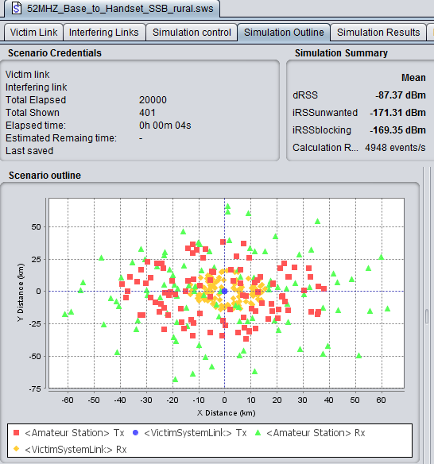

## A1.8 Results of the simulations

This study assumes that the amateur transmitter is within a 40 km radius of a tactical system transmitter, operating on the same frequency and with the tactical receiver operating anywhere within its defined service area. Table A1.7 shows the predicted average probability of interference for the scenarios and it can be seen that the probability of interference is generally small and the tactical links generally function without interference for more than 95% of the time for the given  
10 dB *C/I* protection criteria. Those scenarios that do have a higher probability of interference (vehicle-to-base and handset-to-base) are all mobile situations that are highly likely to be transient as the relative distance between the tactical assets and amateur station changes. The table also shows that the *I/N* criteria is not a good indicator of compatibility for this type of application as the position of the victim and interfering systems are likely to be constantly moving and that while the *I/N* criteria may be exceeded the ultimate Signal to Noise Ratio is acceptable.

Table A1.7

Predicted co-channel average interference probability for each study scenario assuming the tactical assets are operating within their operating ranges and with the amateur station transmitting anywhere within a 40 km radius of a tactical transmitter

|  |  |  |  |  |
| --- | --- | --- | --- | --- |
| Link | Radius (km) | *C/I*% (17 dB) | *C/(N+I)*% (10 dB) | *I/N*% (-6 dB) |
| Base-to-vehicle | 40 | 2.73 | 1.78 | 14.16 |
| Base-to-handset | 15 | 1.11 | 0.66 | 6.43 |
| Vehicle-to-base | 40 | 8.73 | 5.47 | 38.11 |
| Vehicle-to-handset | 3 | 1.19 | 0.66 | 6.45 |
| Handset-to-base | 7.5 | 10.1 | 6.25 | 44.65 |
| Handset-to-vehicle | 1 | 3.82 | 2.44 | 17.53 |

Table A1.8

The main parameters used for the SEAMCAT studies given in this document. Any other parameters not specified were left as the program default values. SEAMCAT version 4.1.0 revision 2337 was used for this study

| Parameter | Value | Comments |
| --- | --- | --- |
| Amateur transmitter power | SSB:50 dBm (100 W) PEP | Typical of amateur equipment used around 52 MHz. The emission mask is shown in Figure 4. |
| Duty cycle of amateur transmitter | SSB: 2.5% at 40 dBm and 2.5% at 50 dBm | 5% operation is 1.2 hours per day; most amateurs would transmit less than this on average. Considering SSB; for smoothly read text, the mean power of the speech signal is 10 dB lower than the power of a reference sinusoidal signal (see Recommendation [ITU-R SM.326](http://www.itu.int/rec/R-REC-SM.326/en), Note 2 to Table 1). |
| Amateur links antennas, RX & TX | 4 element Yagi, 9.4 dBi gain | Typical amateur antennas. See Figure 2 for radiation pattern. |
| Amateur antenna height, RX & TX | 10 m (above ground) | A probable maximum amateur height due to planning requirements. |
| Number of active amateur transmitters in service area | 1 |  |
| Base station transmitter power | 47 dBm (50 W) |  |
| Vehicle transmitter power | 47 dBm (50 W) |  |
| Handset transmitter power | 37 dBm (5 W) |  |
| Tactical base station antenna | Omni-directional vertical, 2.15 dBi gain, 8 m high | See Figure 3 for radiation pattern. |
| Vehicle antenna | Omni-directional vertical, -3 dBi gain, 2 m high | See Figure 3 for radiation pattern. |
| Handset station antenna | Omni-directional vertical, -10 dBi gain, 1.5 m high | See Figure 3 for radiation pattern. |
| Tactical service receiver sensitivity | -112 dBm ( 0.56 uV into 50 ohms) |  |
| Mobile link bandwidth and modes | 16 kHz |  |
| Mobile service interference criteria | *C/I* = 16.97 dB  *C/(N+I)* = 10 dB  *(N+I)/N* = 0.97 dB  *I/N* = -6 dB | 10 dB SINAD and -6 dB *I/N* specified |
| Mobile service noise floor | -126.9 dBm | Based on the fundamental calculation of [noise power per Hertz (kTB)](https://en.wikipedia.org/wiki/Johnson%E2%80%93Nyquist_noise), corrected for bandwidth (16 kHz) and receiver noise Figure (4 dB):  -129 dBm = -174 dBm/Hz + 10log(BW) + NF |
| Coverage radius | 40 km for amateur  1 to 40 km for tactical system |  |
| General environment | Rural , over land |  |
| Propagation model | Extended-Hata | Suitable for elevated transmitters in a cluttered, non-line-of-site environment between 30 MHz and 3 GHz up to a maximum range of 100 km |

Figure A1.2

Radiation pattern of the 4 element Yagi used in this study. Side lobes have not been included as the random assignment of directions in the simulation covered all possibilities of direction by the main lobe.

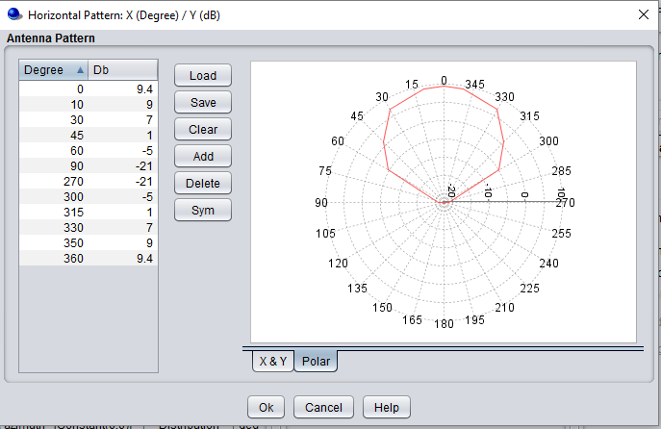

Figure A1.3

Radiation pattern of the 2.15 dBi antenna used in this study. The other omni-directional antennas have the same pattern but use different gains in place of 2.15 dBi as shown here.

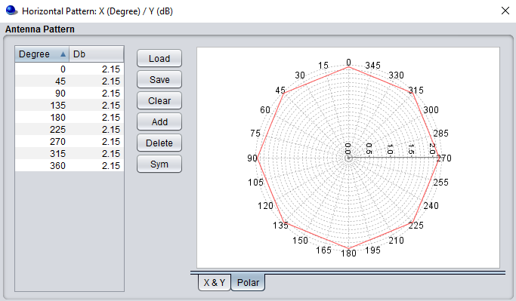

Figure A1.4

Emission mask for the SSB transmissions made by the amateur station transmitter used in this study.

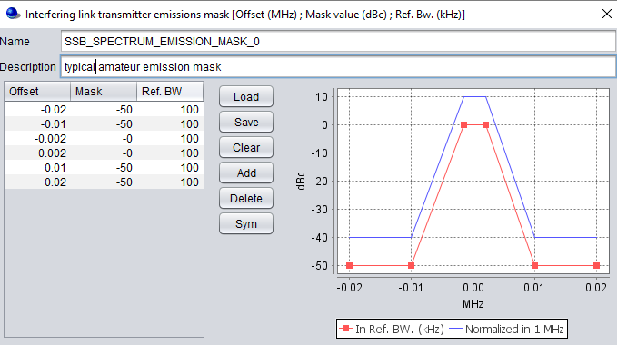

## A1.9 Conclusion

Using Monte-Carlo simulators such as SEAMCAT allow various scenarios to be examined relatively quickly. The simulations discussed above are thought to represent typical worst case situations that might be encountered if a tactical service and amateur service coexist in the 50‑54 MHz band. Notwithstanding that the co-channel interference probability is low in some cases and moderate in others it would appear that any interference which is likely to occur would be transient, probably be in the same jurisdiction as the tactical system and could be handled by national provisions in place for the use of the radio spectrum, which might include bilateral or multilateral agreements in place with neighbouring countries.

Annex 2

Application-based approach to calculation of spectrum needs

## A2.1 General

This approach can:

– Take account of the expected capabilities and usage scenarios, and is

– Able to be readily implemented using common software tools such as a spreadsheet.

The results from this calculation procedure need to be considered carefully given that the output might be sensitive to the input parameter values on the usage of advanced applications which can be drawn from a large range of possible values. This input parameter, on the other hand, could reflect the different situation in particular regions or countries.

## A2.2 Input parameters

Input parameters to the assessment process can be grouped as:

**User related:**

– Connection density

– Application data rate

– Application usage pattern assumptions

The number of amateur stations per square kilometre has been calculated for CEPT countries in Annex 3, Table A3.1. This data may be further refined to develop user densities in particular countries or urban / rural areas should it be required.

**Radio related:**

– Service area (Inter-Site Distance - ISD) {*editors note: ISD needs more explanation*}

– Spectral efficiency

**Step by step approach**

The following steps 1 to 3 and the final calculation are the essence of the ‘Application based determination’.

**Step 1**

Service Categorisation (SC)

In principle a matrix of service categorisations can be identified across different connection density types. For simplicity the average density of radio amateurs has been used. In practise individual amateurs are most likely to be grouped in relation to urban areas, whilst some automatic systems such as repeaters, gateways, data-links or propagation beacons may be more remotely located on high ground/buildings etc.

Specific considerations have to be paid to those system with high duty cycles such as 24/7 beacon and linked-repeaters, compared to an individual amateurs who may have much more variable/lower usage – but which may peak during activity events such as, emergencies, contests or propagation openings.

Application density definition

Each application density parameter can be characterised by assessing the number of users or devices in a given area and the communication activity factor.

Connection density (/km2) can be calculated by evaluating the active number of users or devices in a given area in the application density considered. Simply:

Connection density = (Number of users or devices in a given area) × (Activity factor)

Activity factor can reflect the proportion of users/devices that are simultaneously actively communicating. It will be dependent upon when any services or applications are consumed and could vary with time. It may be important to take this into account.

Service type data rates

Application data rates need to be assigned to each service type.

**Step 2**

Usage Pattern

An application usage pattern is defined as a common user(s) behaviour denoting the percentage of active user/device using a given service type in a given application density. The values for the input can be defined differently by regions or countries in percentage (%).

Activity factor and usage pattern could be influenced according to different frequency ranges to reflect the different operational environments anticipated.

**Step 3**

Deployment considerations

Assuming a regular pattern of service areas, inter-site distances (ISD) and spectral efficiency figures can be derived and relevant performance objectives assigned to each application density.

## A2.3 Calculation Process

The total amount of spectrum needs ***R*** (Hz) can be calculated in the following way:

***Rts*** = (*C* × *A* × *U*) / *I* / *S*

***Rt***= ∑***Rts***

***R*** = max(***Rt***)

where:

*C* = Connection density (users/km2);

*A* = Application data rate (bits/s);

*U* = Usage patterns (%);

*I* = Number of service areas/km2 based on the ISD (km);

*S* = Spectral efficiency (bits/s/Hz);

***Rts*** = A set of spectrum needs in given teledensities[2] and service types (Hz);

***Rt*** = A set of spectrum needs in given teledensities (Hz).

***R*** is therefore the spectrum need for the amateur service in 50-54 MHz as the maximum from the set of needs based on the set of teledensities ***Rt***. It is not confined to any one service area, application and teledensity.

## A2.4 An example of input parameters values and obtained results

An example of this application-based approach adjusted for WRC-19 agenda item 1.1 and Resolution **658 (WRC-15)** can be described as follows.

## A2.5 Input parameters

Connection density

For most service categories we can base this on the individual amateurs. Based on the statistical data in Annex-3 where an overall average density of amateurs was calculated:

Table A2.1

Connection Densities, C

|  |  |
| --- | --- |
| Case | Connection Density / km2 |
| Low | 0.02 |
| Average | 0.0694 |
| Maximum | >0.2 |

The one exception to this can be made for the extensive amateur propagation beacon network which is typically at >100 km separation distances (giving a lower density of ~0.001), but which has a high usage pattern due to its 24/7 operation (see below).

Application data rate

Considerations for data rates range from around less than 1 kb/s for Morse or weak-signal structured data modes, to around 25 kb/s for FM/digital voice and 100-512 kb/s for wideband data/media

Table A2.2

Application data rate types, A

|  |  |
| --- | --- |
| Service type | Application data rate, bits/s |
| Low BW/data rate application | 1 000 |
| Medium BW/data rate application | 25 000 |
| High data rate application | 512 000 |

Note: for estimating purposes, analogue mode bandwidths are considered to be directly equivalent to bits/s.

Application usage pattern

Usage pattern could be influenced according to different frequency ranges to reflect the different operational environments anticipated.

Table A2.3

Application Types and their Usage patterns

|  |  |
| --- | --- |
| Application type | Usage Pattern, % |
| Individual amateurs (analogue traffic) | 2 |
| Conventional Voice/data repeaters, nodes and gateways and new digital developments | 10 |
| Beacons and linked/automatic systems | 25-100 |
| High data rate applications | 5-25 |

Service Area and Spectral efficiency

Inter-site distances for *Service Area* relate to either coverage areas or typical contact distances depending of the application

*Spectral Efficiency*, whilst nominally in bits/Hz, in practice this has to be tailored for the length of the overall contact, including any error correction and acknowledgements required to successfully pass a message.

For example propagation beacons have longer transmission sequences (which may include a significant amount of error-correction coding) so have been assumed to be no more than 0.25 bits/Hz equivalent.

## A2.6 Spectrum needs

Table A1-3 shows an example of the estimated spectrum needs for the main service categories as they are likely to be used within the overall study range of 50-54 MHz.

Table A2.4

Spectrum Requirements example based on average amateur density {*editors note: check calcs*}



Annex 3

Amateur Stations & Density

Using the 2016 data in document CEPT CPG-PTD(17)20, the number of amateur stations per square kilometre has been calculated for most CEPT countries in the table below. This data may be further refined to develop user densities in urban and rural areas.

Table A3.1

CEPT Amateur statistics for 2016

|  |  |  |  |
| --- | --- | --- | --- |
| **Country** | **Licencees** | **Territorial Area (km2)** | **Licensees per km2** |
| Albania | 117 | 28,750 | 0.004 |
| Andorra | 82 | 468 | 0.175 |
| Austria | 6467 | 83,879 | 0.077 |
| Belarus | 1400 | 207,600 | 0.007 |
| Belgium | 5261 | 30,530 | 0.172 |
| Bosnia and Herzegovina | 3500 | 51,200 | 0.068 |
| Bulgaria | 6960 | 111,000 | 0.063 |
| Croatia | 1657 | 56,590 | 0.029 |
| Cyprus | 236 | 9,251 | 0.026 |
| Czech Republic | 5396 | 78,870 | 0.068 |
| Denmark | 8680 | 42,930 | 0.202 |
| Estonia | 600 | 45,340 | 0.013 |
| Finland | 7229 | 338,100 | 0.021 |
| France | 13752 | 643,800 | 0.021 |
| Germany | 74698 | 357,022 | 0.209 |
| Greece | 6900 | 132,000 | 0.052 |
| Hungary | 3120 | 93,030 | 0.034 |
| Ireland | 1801 | 70,270 | 0.026 |
| Italy | 25000 | 301,300 | 0.083 |
| Latvia | 340 | 64,590 | 0.005 |
| Lithuania | 730 | 65,300 | 0.011 |
| Luxembourg | 559 | 2,586 | 0.216 |
| Malta | 439 | 316 | 1.389 |
| Monaco | 51 | 2.02 | 25.248 |
| Netherlands | 12637 | 41,540 | 0.304 |
| Norway | 6745 | 323,800 | 0.021 |
| Poland | 13098 | 312,700 | 0.042 |
| Portugal | 5677 | 92,210 | 0.062 |
| Romania | 4048 | 238,400 | 0.017 |
| San Marino | 100 | 61 | 1.634 |
| Slovakia | 1500 | 49,040 | 0.031 |
| Slovenia | 4400 | 20,270 | 0.217 |
| Spain | 30756 | 505,400 | 0.061 |
| Sweden | 13000 | 450,300 | 0.029 |
| Switzerland | 4818 | 41,290 | 0.117 |
| United Kingdom | 84694 | 243,600 | 0.348 |
| **Totals** | **356,448** | **5,133,335** |  |
| **Average licensees per km2  for listed countries** | | **0.0694** |  |

Annex 4

Digital spectrum arrangement for the band 52–54 MHz

*{Editors note: this might be better somewhere else}*

In Region-1 this sub range is currently band planned by IARU as appropriate for ‘all-modes’ in those countries where it is already allocated ( RR **5.169**). Consistent with this current position is the Service Categorisation for amateur applications used in this document. Predominantly this band segment is assumed to be suitable for all for wideband modes which can include wideband digital communications, reduced bandwidth digital television, machine to machine applications, as well as adaptations of HAMNET[3] terminal devices. These applications currently exist in microwave bands and a few Region 1 countries with experimental amateur VHF developments. Their further development and adaptation to the frequency band 50-54 MHz requires the certainty of a sufficiently wide frequency allocation in Region 1. Digital communications is a highly innovative area, so it is likely that additional applications may subsequently emerge.

The availability of the entire frequency band 50-54 MHz would additionally encourage development of new technologies to support disaster relief in accordance with the IARU-ITU and Red Cross/Red Crescent MoUs[4] on disaster relief operations, consistent with Article **25.9A** of the Radio Regulations.Examples would be mobile video used for searching for survivors in earthquakes and easier establishment of medium capacity digital links over difficult propagation paths.

50 MHz digital amateur systems will thus either evolve from existing developments in other VHF/UHF bands, or will incorporate the use of new technologies and applications that will benefit from the physical characteristics of the frequency band in question. Hence the work on spectrum needs under Resolution **658 (WRC-15)** will have to take account of current and future amateur service applications in this spectrum.

## A4.1 Digital amateur applications (channel spacing up to 500 kHz)

In Region-1 IARU is currently considering an update to its band plan guidance for the 52-54 MHz range for existing amateur users, based on this proposal:-.

*In those Region-1 countries where 52-54 MHz (or parts thereof) is allocated, its use should be planned on the basis of up to 4 x 500 kHz blocks which may be sub-divided or merged to suit digital applications. Amateurs using digital transmission methods should also ensure that their transmissions do not spread beyond band edges.*

The four blocks that are the basis of scheme are illustrated in Table A4.1.

Table A4.1

Guidance for 52-54 MHz amateur applications



If an allocation is agreed during WRC-19 then further IARU band planning may be initiated to accommodate specific applications. For example full size blocks may be needed for DATV or regional/trunk data-links, whereas other blocks may be subdivided for local 100 kb/s simplex user access[5].

The scheme is also adaptable for countries where parts of the 52-54 MHz range may have existing assignments to other services.

Annex 5

MCL interference analysis between amateur and mobile service   
in the band 50-54 MHz

## A5.1 Technical and operational Parameters of amateur service in the band 50-54 MHz

The current spectrum and modes of operation used by radio amateurs is considered according to Recommendation ITU-R M.1732-2.

The characteristics of amateur radio equipment are prescribed in Recommendations ITU-R SM.1541-6 and M.1732-2. The strongest interference emissions from amateur radio transmitters are to be expected in SSB operation, because of intermodulation distortion in the power amplifier. Accordingly, the analysis shown in this contribution are based on operational case 2K70J3E.

Details of the relevant technical and operational parameters for the amateur service are given in ITU-R M.1732

## A5.2 Amateur radio emission mask

According to Recommendation ITU-R SM.1541-6 ANNEX [3], spectrum mask option 1, represented graphically in **Error! Reference source not found*.** is a somewhat conservative definition. Often, amateur radio transmitters exhibit smaller adjacent channel emissions than represented in this recommendation. In order to take this fact into account, an additional spectrum mask (Option 2) is defined for the compatibility studies to be carried out. This is plotted graphically in **Error! Reference source not found*.**   
[*Editor’s note: References to be added]

Figure Axx5.2

OoB emissions of amateur stations in operation above 30 MHz in the  
normal or narrowband applications of recommendation ITU-R SM.1539



For “spurious emissions”, the values specified in the Recommendation ITU-R SM.329-12, as shown in Table Axx5.1, are used.

The appropriate measurement bandwidths are specified in the respective standards as 100 kHz.

Table A5.1

Limit values for spurious emissions according to Recommendation ITU-R SM.329-12

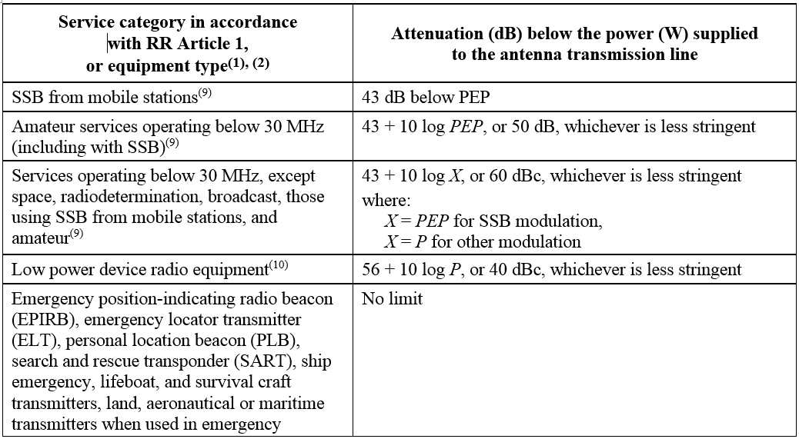

It must be assumed that in SSB operation the "spurious emissions" decrease as the frequency spacing in relation to the carrier frequency increases. This is the nature of intermodulation interference. Accordingly, one could assume that interference with very large frequency spacing in relation to the carrier frequency is well below the limit value.

Figure A5.2

Emission masks (e.i.r.p.) for 2.7 kHz bandwidth (5 kHz channel spacing, 5 dBi antenna gain   
and 100 W transmitter power for amateur radio transmitters)

## A5.3 Characteristics of Considered Mobile applications

The mobile radio equipment used for this study is mobile either mounted on vehicles or used for handset voice communication. From the technical viewpoint, these two applications differ fundamentally in terms of their transmitter powers, antenna heights and antenna gain. The parameters used for the compatibility studies are detailed in paragraph 6.1

## A5.4 Propagation model

Radio wave propagation is calculated for different propagation scenarios representing flat as well as hilly terrain and mountainous environment. Propagation effects are calculated according to the model of Recommendation ITU-R P.2001-2. The results represent mean values which are subject to statistical fluctuations[6]. The calculated losses show values which are lower for a probability of 50% of all possible cases. For lower probabilities, the path loss is several dBs lower than calculated for 50% of all cases. The calculated values therefore indicate a somewhat optimistic interference scenario. Regarding the influence of clutter, it can be concluded that on the TX side with an antenna height of 10 m and in a suburban environment, the loss due to clutter does not increase. For an antenna height of 1.5 m at the receiver, clutter may increase loss by approximately 5 dB. Because the clutter is not taken into consideration for the calculations, the calculation is somewhat conservative. Furthermore sporadic E propagation effects which occur spontaneously and lead to very low radio propagation losses for long propagation paths, are neglected.

## A5.5 Calculation method

In order to evaluate the interference ranges of amateur radio transmitters for different propagation scenarios, the following calculation method is executed in four consecutive steps:

1 The required protection level is evaluated with a protection criterion of I/N = - 6 dB based on ambient noise figure according Recommendation ITU-R P.372-13

2 The radiated power for co- and adjacent channels is calculated

3 The minimum required path attenuation is calculated to meet the required protection level

4 The interference range is evaluated by means of the calculated minimum path attenuation and evaluated path attenuation for different propagation scenarios, respectively path profiles.

## A5.6 Protection criterion and ambient noise figure

For mobile radios, a protection criterion of I/N = - 6 dB is specified. According to Recommendation ITU-R P372-13, natural background noise (dominated by galactic noise) corresponds to a noise figure of F = 15 dB at a frequency of 50 MHz. The maximum acceptable interference power for the mobile Service is calculated as follows:

, where is the thermal noise power at a temperature of 20°C and BW is the receiver bandwidth

Accordingly, the maximum acceptable interference power for mobile service application is calculated as follows:

The maximum acceptable interference power for amateur service application is calculated as follows:

The values for the ambient noise figure F defined in Recommendation ITU-R P372-13 relate to measurements with a vertical dipole or monopole antenna. In the given case, the victim antennas (mobile service) also show isotropic directivity in the azimuth, though with a gain which differs from the Recommendation's notional ideal antennas. However, because the ambient interference is substantially higher than the level of the receiver's internal noise, the gain of the victim antenna needs not be considered.

It should also be noted that the assumed noise figure of 15 dB for antennas with increased directivity in the horizontal direction has been set somewhat too high. If corresponding antennas (with increased directivity in the elevation) are used at the victim receiver, the computed interference ranges represent a minimum, as in this case galactic noise actually reduces receiver sensitivity by less than the determined 15 dB.

## 2.2 Radiated power for co- and adjacent channels

The calculated transmit interference power of amateur radio transmitters is determined on the basis of emission masks option 1 mask option 2 and mask for mobile SSB transmission mode. Consideration is given to the fact that the bandwidth of the receiver affected by the interference (16 kHz) is greater than that of the interference signal (2.7 kHz). The calculated interference powers at the transmitter output of the interference source, corrected for bandwidth, are shown in two tables below

Table a5.2

Bandwidth-corrected adjacent channel and out-of-band emission of an amateur radio transmitter with an assumed antenna gain of 5 dBi

| Interference emissions | Power PE e.i.r.p for mask option 1 [dBm] | Power PE e.i.r.p for mask option 2 [dBm] | Power PE e.i.r.p for mask option 2 (“mobile SSB equipment”) [dBm] |
| --- | --- | --- | --- |
| Same channel | 50 dBm + 5 dBi  = 55 dBm | 50 dBm + 5 dBi  = 55 dBm | 50 dBm + 5 dBi  = 55 dBm |
| 1st adjacent channel  f0 + 1.35 kHz < fadj < f0 + 3.24 kHz Δf = 3.24 kHz – 1.35 kHz = 1.89 kHz BWRX=16 kHz | 55 dBm – 10 dB + 10 log(1.89)  = 47.8 dBm | 55 dBm – 25 dB + 10 log(1.89)  = 32.8 dBm | 55 dBm – 10 dB + 10 log(1.89)  = 32.8 dBm |
| 2nd adjacent channel  f0 + 3.24 kHz < fadj < f0 + 6.075 kHz Δf = 6.075 kHz – 3.24 kHz = 2.835 kHz BWRX=16 kHz | 55 dBm – 51 dB +10 log(2.835)  = 8.5 dBm | 55 dBm – 51 dB +10 log(2.835)  = 8.5 dBm | 55 dBm – 51 dB +10 log(2.835)  = 8.5 dBm |
| Spurious  Measurement = 100 kHz BWRX=16 kHz | 55 dBm – 43 dB - 10 log(100) +10 log(16/100)  = -16 dBm | 55 dBm – 43 dB - 10 log(100) +10 log(16/100)  = -16 dBm | 55 dBm – 43 dB +10 log(16/100)  = 4 dBm |

Table a5.3

Bandwidth-corrected adjacent channel and out-of-band emission of a mobile radio transmitter with an assumed antenna gain of -3 dBi and a transmitter power of 50 W

| Interference emissions | Power PE e.i.r.p [dBm] |
| --- | --- |
| Same channel | 47 dBm – 3 dBi = 44 dBm |
| Adjacent channel (Adjacent channel suppression -60 dBc)  f0 + 12.5 kHz < fadj < f0 + 37.5 kHz Δf = 37.5 kHz – 12.5 kHz = 25 kHz BWRX=2.7 kHz | 44 dBm – 60 dB – 9.7 dB = -25.7 dBm |
| Spurious 1  f0 + 25 kHz < fadj < f0 + 50 kHz Δf = 50 kHz – 25 kHz = 25 kHz BWRX=2.7 kHz | 44 dBm – 75 dB – 5.7 dB = -36.7 dBm |
| Spurious 2  f0 + 50 kHz < fadj < f0 + 100 kHz Δf = 100 kHz – 50 kHz = 50 kHz BWRX=2.7 kHz | 44 dBm – 80 dB – 5.7 dB = -41.7 dBm |
| Spurious > f0 +/- 100 kHz  Measurement = 100 kHz BWRX=16 kHz | 44 dBm – 90 dB+10 log(2.7/100) = -61.7 dBm |

## A5.7 Determination of minimum path attenuation

The minimum path losses which are necessary to reduce the reception level of the interference signal below the protection value is calculated as:

The values calculated for all considered path profiles are provided in the table below

Table a5.4

Minimum path loss necessary to protect the mobile radio receiver

| Interference scenario | Necessary path loss AS1 for mask option 1 [dB] | Necessary path loss AS2 for mask option 2 [dB] | Necessary path loss AS2 for mask option 2 (“mobile SSB equipment”) [dB] |
| --- | --- | --- | --- |
| Same channel | 55 dBm + 123 dB  = 178 dB | 55 dBm + 123 dB  = 178 dB | 55 dBm + 123 dB  = 178 dB |
| 1st adjacent channel  f0 + 1.35 kHz < fadj < f0 + 3.24 kHz | 47.8 dBm + 123 dB  = 170.8 dB | 32.8 dBm + 123dB  = 155.8 dB | 32.8 dBm + 123 dB  = 155.8 dB |
| 2nd adjacent channel  f0 + 3.24 kHz < fadj < f0 + 6.075 kHz | 8.5 dBm + 123 dB  = 131.5 dB | 8.5 dBm + 123 dB  = 131.5 dB | 8.5 dBm + 123 dB  = 131.5 dB |
| Spurious | -16 dBm + 123 dB  = 107 dB | -16 dBm + 123 dB  = 107 dB | dBm + 123 dB  = 127 dB |

## A5.8 Evaluation of the interference ranges

The evaluated interference ranges are shown in Table 4.5, taking into consideration the different mask options as mentioned in section ‎0. Values for mask option 1 are marked (M1), for mask option 2 are marked (M2) and for mask option 2 considering mobile SSB equipment are marked with (ME). In Table 4.5 the term f0 defines the frequency offset between the centre frequencies of interfering transmitter (amateur service) and victim receiver (mobile service).

Table A5.5

Interference ranges for different interference scenarios and emission mask options

|  | Interference ranges [km]  (Values for both mask options and for “mobile SSB equipment”). | | | |
| --- | --- | --- | --- | --- |
|  | 0 < f0 < 9.35 [kHz] | 9.35 < f0 < 11.24 [kHz] | 11.24 < f0 <14.75 [kHz] | f0 > 14.75 [kHz] |
| Scenario 1:  TBD | TBD (M1) TBD (M2) TBD (ME) | TBD (M1) TBD (M2) TBD (ME) | TBD (M1) TBD (M2) TBD (ME) | TBD (M1) TBD (M2) TBD (ME) |
| Scenario 2:  TBD | TBD (M1) TBD (M2) TBD (ME) | TBD (M1) TBD (M2) TBD (ME) | TBD (M1) TBD (M2) TBD (ME) | TBD (M1) TBD (M2) TBD (ME) |
| Scenario n:  TBD | TBD (M1) TBD (M2) TBD (ME) | TBD (M1) TBD (M2) TBD (ME) | TBD (M1) TBD (M2) TBD (ME) | TBD (M1) TBD (M2) TBD (ME) |

*{Editors note: add summary and conclusion section}*

## A5.8 Summary and conclusions

Add stuff here….

Annex 6

Wind Profile Radar System

## A6.1 Background

In the frequency band 46-68 MHz, RR No. **5.162A** provides an additional allocation to the radiolocation service on a secondary basis in a number of countries and limited to the use of wind profiler radars.

5.162A *Additional allocation:* in Germany, Austria, Belgium, Bosnia and Herzegovina, China, Vatican, Denmark, Spain, Estonia, the Russian Federation, Finland, France, Ireland, Iceland, Italy, Latvia, The Former Yugoslav Republic of Macedonia, Liechtenstein, Lithuania, Luxembourg, Monaco, Montenegro, Norway, the Netherlands, Poland, Portugal, the Czech Rep., the United Kingdom, Serbia, Slovenia, Sweden and Switzerland the band 46-68 MHz is also allocated to the radiolocation service on a secondary basis. This use is limited to the operation of wind profiler radars in accordance with Resolution **217 (WRC‑97)**.    (WRC‑12)

The relevant Wind profiler radars parameters for sharing studies with amateur service are described in Table A6.1 below (to be confirmed):

TABLE A6.1

| System parameter | Range of values |
| --- | --- |
| Pulse peak power (kW) | 5‑60 |
| Average transmitted power (kW) | 0.5‑5 |
| Main beam antenna gain (dBi) | 30‑34 |
| Antenna beamwidth (degrees) | 4‑6 |
| Main pointing elevation angle (degrees) | 90 (zenith) |
| Tilt angle from main pointing (degrees) | 11‑16 |
| Antenna side-lobe suppression between 0 and 5° compared to horizon (dB) | 33 (minimum) – 40 (Median) |
| Additional shielding at horizon (dB) | TBD |
| Pulse width (µs) | 1‑10 |
| Necessary bandwidth (MHz) | 0.2‑2.2 |
| Occupied bandwidth (MHz) | 0.5‑5 |
| Protection criteria (I/N)(dB) | –6 |
| Noise figure (dB) | 3 (TBC) |
| Maximum interference level in necessary bandwidth (dBW) | –154 (TBC) |

*{editors note: add antenna height details}*

The reference ITU-R documents related to wind profilers are:

– Resolution **217 (WRC-97)** – *Implementation of wind profiler radars*.

– Recommendation ITU-R M.1226 – *Technical and operational characteristics of Wind Profiler Radars in the bands in the vicinity of 50 MHz.*

– Report ITU-R M.2013 – *Wind profiler radars.*

## A6.2 WPR location and parameters

Figure A6.2

Identified VHF WPR systems in Europe (Red=in 50-54 MHz, Green=out of band)

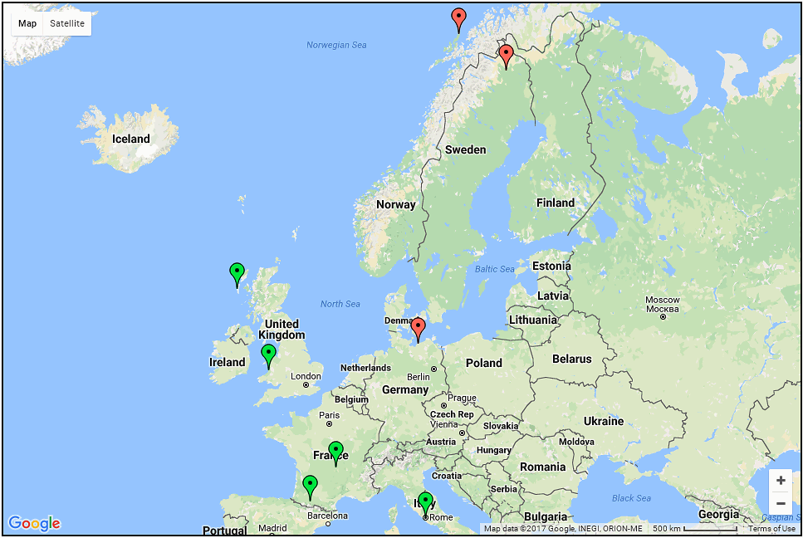

Table A6.2

WPR locations parameters

|  |  |  |  |  |  |  |  |  |  |
| --- | --- | --- | --- | --- | --- | --- | --- | --- | --- |
| Sitename | WMO Site No | Lattitude, N | Longitude, E | Freq, MHz | Power Mean, kW | Power Pk, kW | Antenna Gain | Beam Width | Avg mins |
| Kühlungsborn (OSWIN) (Germany) |  | 54.1183 | 11.7690 | 53.50 | 4.5 | 90.0 | 30.0 | 6.0 |  |
| South Uist (UK) | 03019, 03020, 03021, 03022 | 57.3536 | -7.3752 | 64.00 | 4 .0 | 40.0 | 29.0 | 4.5 | 15/30 |
| Abersywyth (NERC-MST) (UK) | 3501 | 52.4245 | -4.0055 | 46.50 | 2.5 | 100 (typ.) 160.0 (max.) | 35 .0 | 3.0 | 30 |
| Clermont-Ferrand (France) | 7453 | 45.7125 | 3.0903 | 45.00 | 0.8 | 5.0 | 30.0 | 5.5 |  |
| Lannemezan (France) | 7626 | 43.1290 | 0.3660 | 45.00 | 0.8 | 5.0 | 30.0 | 5.5 | 15 |
| Kiruna (Esrange) (Sweden) | 2043 | 67.8865 | 21.1065 | 52.00 | 72.0 |  | 29.0 | 6.7 | 30 |
| Andenes MAARSY-MST (Norway) | 1012 | 69.2980 | 16.0420 | 53.50 | 40.0 | 800.0 | 33.5 | 3.6 |  |
| SOUSY Svalbard Radar (Norway) |  | 78.1530 | 16.0300 | 53.50 | 0.2 | 2.0 | 30.0 | 5 |  |
| Rome (Ciampino) (Italy) | 16239 | 41.8080 | 12.5850 | 65.50 | ? | ? | ? |  |  |

Table A6.3

WPR parameters used for study

|  |  |
| --- | --- |
| **System parameter** | **Range of values** |
| Pulse peak power (kW) | 2 – 800 |
| Average transmitted power (kW) | 0.2 – 72 |
| Main beam antenna gain (dBi) | 29 – 35 |
| Antenna beamwidth (degrees) | 3 – 7 |
| Main pointing elevation angle (degrees) | 90 (zenith) |
| Tilt angle from main pointing (degrees) | 11 – 16 |
| Antenna side-lobe suppression between 0 and 5° compared to horizon (dB) | 33 (minimum) – 40 (Median) |
| Additional shielding at horizon (dB) | TBD |
| Pulse width (µs) | 1 - 10 |
| Necessary bandwidth (MHz) | 0.2 - 2.2 |
| Occupied bandwidth (MHz) | 0.5 – 5 |
| Protection criteria (I/N)(dB) | -6 |
| Noise figure (dB) | 3 |
| Maximum interference level in necessary bandwidth (dBW) | -154 (for 0.2 MHz bandwidth) |

*{editors note: add antenna height details}*

## A6.3 In-band separation distances

At a preliminary stage, it is proposed to assess separation distance between amateur service stations and WPR taking into account the following elements:

* Amateur service stations typical EIRP ranging 2 to 26 dBW (see [M.1732](http://www.itu.int/rec/R-REC-M.1732/en) for both analogue and digital systems).
* Amateur service stations typical bandwidth ranging 2.7 to 16 kHz (see M.1732 for both analogue and digital systems).
* WPR victim scenario.
* Hata (rural) propagation model (at 52 MHz) (median case):



Table A6.4

Separation distances calculations



## A6.4 Summary and Conclusions

The above calculations show that typical separation distance between Amateur service systems and Wind profiler would range from 29 to 202 km. In order to refine these sharing analysis, additional detailed characteristics of Amateur service systems would be required, in particular on antenna patterns and pointing scenarios.

However, taking into the low number of WPR (and probably the expected low number of amateur systems), sharing could probably be considered on a case-by-case basis, between the Amateur and meteorological communities.

The relevant procedure would need additional consideration but WMO is of the view that it will only be possible and efficient if both services are at equal status within the 50-54 MHz band.

Annex 7

Sharing with the broadcasting service

## A7.1 Introduction

WRC-19 agenda item 1.1 is to consider an allocation of the frequency band 50-54 MHz to the amateur service in Region 1, in accordance with Resolution **658 (WRC-15)**. The Resolution requests to take into account the results of sharing studies with incumbent services. This document from IARU deals with the compatibility between the amateur service and the broadcasting service prior to the switch-off of the analogue broadcasting service in this frequency band.

IARU-R1 has studied various mechanisms which have been used by administrations in the past in Regions 1 and 3 to regulate the amateur service in the 50‑54 MHz frequency band where amateur stations have existed in relatively close geographical proximity to the service areas of analogue television broadcasting stations. In addition WP 6A of ITU-R has provided WP 5A with details of the current ITU-R Recommendations which detail the criteria necessary to assess sharing conditions and these have been used in formulating the sharing model detailed in section 2 below. To address part of the sharing scenario requested by WRC-19 agenda item 1.1, section 2 of this document shows a sharing model that can be used or adapted to show how sharing between the amateur service and the remaining analogue television broadcasting applications in Region 1 in the band 50‑54 MHz is feasible.

In addition, section 3 provides details of perhaps the most challenging sharing scenario from the European Broadcasting Area (EBA); sharing between the amateur service and analogue television in the broadcasting service in the Russian Federation prior to analogue switch-off sometime after 2018. The sharing method calculates the difference in field strength between the wanted TV field and the field resulting from an amateur transmitter.

Recommendation ITU-R SM.851-1 entitled *Sharing between the broadcasting service and the fixed and/or mobile services in the VHF and UHF bands* has been used in many forums to address sharing between the amateur service and the broadcasting service. In general this appears acceptable in the case of avoiding harmful interference to analogue broadcasting; however care must be exercised when addressing the polarization of amateur stations’ antennas which may be vertically or horizontally polarized depending on the location and application being utilized.

The minimum median value of the field strength to be protected is specified as 46 dB µV/m in Table 1 of Recommendation ITU-R SM.851-1 (50% of time, 90% of locations). The required protection ratio is also given by Recommendation ITU-R SM.851-1, which is determined from Tables 3, 5 and Figure 2 of the Recommendation and depends on the frequency separation between wanted and interfering emissions.

The amateur signal strength is calculated using ITU-R recommendations and assumes the use of a four element Yagi antenna with the characteristics shown in the figure A7.1 below. The signal strength is further adjusted based on factors to adjust for differences in signal polarisation, receiver antenna gain factors and losses due to obstructions between the amateur station and TV receiver.

## A7.2 Method

The minimum field strength for which protection against interference is provided in planning should never be lower than 46 dBµV/m from Table 1 of Recommendation ITU-R SM.851-1.

Remaining analogue television transmitters in Region 1 generally utilise the SECAM System D/K standard with a channel centre frequency of 52.50 MHz, vision carrier frequency 49.75 MHz and sound carrier 56.25 MHz. Carrier offsets may be used.

The method involves calculating the difference between the wanted TV signal's field and the field resulting from an amateur transmitter operating on a frequency within the TV channel some distance away from the edge of the TV service area. If the amateur signal is less than the minimum signal strength based on the minimum required TV signal field strength adjusted for the protection ratio, then no harmful interference will occur.

Due to propagation phenomena it is estimated that European amateur stations such as those described in the paragraph below, which establishes the field strength from a specific type of amateur station less than 500 kHz from the 49.75 MHz video carrier of a television station will be transmitting for only 8.5% of daylight hours on 90 days within a year. In other parts of Region 1 especially in geographical areas nearer to the equator activity times may be greater.

Other amateur applications including digital emissions with channel bandwidths of up to 500 kHz will employ a lower station e.r.p. generally not exceeding 20 dBW and will be separated from the 49.75 MHz vision carrier by between 1 and 4 MHz, thus requiring a lower protection ratio to protect the service area of the television broadcasting transmitter. Conversely the amateur emissions’ duty cycle is likely to be greater than the higher power amateur transmitters closer to the vision carrier.

Figure A7.1

Polar Diagram of assumed amateur transmitting antenna

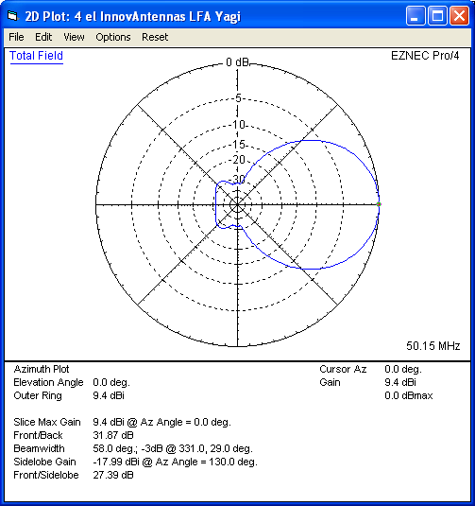

## A7.3 Variables for the unwanted amateur station signal

*E* is the field strength (dB µV/m) of a typical amateur station which is located at a distance of *d* km from the service area of an analogue television transmitter. It assumes the amateur station antenna is pointing in the direction of the TV station and uses a state-of-the-art four element Yagi antenna design as shown in the figure above. The maximum gain is approximately 9 dBi which equates to 7 dBd The value of *E* is determined using Recommendation ITU-R P.1546 curves for land paths for the case of 10% time and 50% locations, and *h*2 = 10 m and e.r.p. of 30 dBW. *Pr* is the radio frequency protection ratio. This value is determined from ITU Recommendation ITU-R SM.851-1. For the situation given above with a carrier separation of around 400 kHz a *Pr* of 50 dB is required.

*At* is the amateur transmitting antenna factor. From the antenna diagram above, the side-lobe gain is –18 dBi which equates to –20 dBd. It is extremely likely that amateur operators will point their antennas away from the broadcasting transmitters which are geographically close to them because:

– TV video signal levels in their receivers will be excessive and would interfere with the reception of weak signals and most importantly,

– Administrations which have a large number of analogue television transmitters remaining in their territory have generally not authorized amateur emissions from their territory in the 50‑54 MHz frequency band. Since amateur operators outside such jurisdictions do not have the possibility of making amateur communications with such geographical areas it is unlikely that they will beam their emissions towards such territories.

*Ol* is the Obstruction loss. Amateur radio stations are generally situated in domestic locations. They are not normally located on prime VHF sites and are often in heavily obstructed areas. Obtaining any degree of foreground Fresnel zone clearance is in many cases impossible. For the purposes of this study a 10 dB obstruction loss for amateur stations has been assumed at these frequencies.

*Cp* - is a receiving antenna polarisation factor. Recommendation ITU-R P.1406 indicates that polarization changes due to scattering from various obstacles may be significant and that such scattering increases as the frequency is lowered reaching a maximum or about 18 dB at 35 MHz. As the standard deviation of the scattering is significant, a value of 10 dB is assumed for the cross polarization loss at 50 MHz for the purposes of this study.

*Ad* is a television antenna receiving discrimination factor determined from Recommendation   
ITU-R BT.419 entitled Directivity and polarization discrimination of antennas in the reception of television broadcasting. Television receiving antennas nearest to amateur stations are likely to be pointed away from amateur stations whereas there will be additional geographical separation between television receiving antennas pointing towards the broadcasting transmitter and amateur stations in the model. 7 dB is permitted for this situation.

*Afs* – the aggregate field strength of the amateur stations at a given distance from the edge of the TV station service area is calculated from:

*Afs* = *E* + *At* + *Ol* + *Cp* + *Ad*

## A7.4 Variables for the wanted TV signal

*Tfs* is the minimum TV Field strength of 46 dBµV/m

*Pr* is the required protection ratio, specified by the relevant ITU-R Recommendations depending on the type of TV service and the frequency separation between the wanted and unwanted signal.

*TVifs* is the maximum field strength of the interfering signal calculated from the minimum wanted TV signal field strength adjusted by the specified protection ratio:

*TVifs* = *Tfs* – *Pr*

## A7.5 The calculation

The difference in field strength is calculated between the wanted TV field with its protection factor (*TVifs*) and the field resulting from an amateur transmitter (*Afs*).

If the amateur station(s) field strength (*Afs*) is equal to or less than the TV interference field strength (*TVifs*), then there should be no interference. If the *Afs* is greater than *TVifs*, interference is possible.

E.g. for no interference:

*TVifs* ≥ *Afs*

which is calculated from

*Tfs* – *Pr* ≥ *E* + *At* + *Ol*+ *Cp* + *Ad*

where all the variables are in dB.

## A7.6 Sharing scenario

This section addresses the results of calculations concerning sharing between the amateur service in neighbouring Region 1 countries adjacent to the Russian Federation and legacy analogue television transmitters utilising SECAM System D/K with a channel centre frequency of 52.50 MHz, vision carrier frequency 49.75 MHz and sound carrier 56.25 MHz. Carrier offsets may be used.

Table A7.1

|  |  |  |  |  |
| --- | --- | --- | --- | --- |
| System D 625 lines | | | | |
| Channel | Video-carrier (MHz) | Centre (MHz) | Colour-subcarrier (MHz) | Audio-carrier (MHz) |
| 2 | 49.75 | 52.50 | 54.18 | 56.25 |
| 3 | 59.25 | 62.00 | 63.68 | 65.75 |

It should be noted that the video carrier is outside the band being considered for an allocation to the amateur service in Region 1, the separation between the amateur transmitter and the vision carrier being greater than 400 kHz.

*Pr* = 50 dB. This value was determined from Tables 3, 5 and Figure 2 of Recommendation   
ITU-R SM.851-1 based on video carrier protection.

For a 50 km distance and 1 transmitting amateur station, the calculated figures for this sharing scenario are given below:

Table A7.2

|  |  |
| --- | --- |
| Component | Values |
| *E*: Amateur signal level dB(µV/m) from stations 50 km from TV service area boundary | 27 |
| *At*: TX side-lobe gain (dBd) | -20 |
| *Ol*: obstruction loss (dB) | -10 |
| *Cp*: Antenna polarisation factor (dB) | -10 |
| *Ad*: TV RX antenna discrimination factor (dB) | -7 |
| Amateur field strength at edge of TV service area dB(µV/m)  *Afs* = *E*  + *At* + *Ol* + *Cp* + *Ad* | -20 |
|  |  |
| *Tfs*: Wanted TV signal strength at service area boundary dB(µV/m) | 46 |
| *Pr*: Interference protection ratio (dB) | 50 |
| Permissible interference field strength at TV service area boundary: *TVifs* = *Et* – *Pr* | -4 |
| *TVifs* > or = *Afs*? | Yes |
| Interference from amateur stations? | No |

## A7.7 Alternative Approach

Although the sharing study described in previous paragraphs suggests that sharing would be feasible between SECAM analogue television broadcasting and the amateur service in the frequency band 50‑54 MHz a SEAMCAT study has been conducted to determine the probability of harmful interference occurring for several sharing situations for different configurations of the broadcasting and amateur services. Using Monte-Carlo simulators such as the CEPT/ETSI SEAMCAT software package allow various scenarios to be examined relatively quickly. The simulations conducted are thought to represent typical worst-case situations that might be encountered if the broadcasting service (analogue television) coexists with the amateur service in the 50‑54 MHz frequency band. Report ITU-R SM.2028-1 entitled *Monte Carlo simulation methodology for the use in sharing and compatibility studies between different radio services or systems* is particularly relevant in this regard.

Further details of the SEAMCAT analyses are contained in the attached annex to this document.

## A7.8 Summary and Conclusions

This document shows that sharing is possible using the method described without any harmful interference occurring from an amateur transmitter with a power level (e.r.p. of 30 dBW) at a distance of 50 km from a television transmitters’ service area in the frequency band 50‑54 MHz.

This study details a method of ascertaining whether a rather basic sharing scenario will likely protect remaining analogue television broadcasting applications in Region 1 in the band 50‑54 MHz, until this band is no longer used for broadcasting.

The method calculates the difference in field strength between the wanted TV field with its protection factor (*TVifs*) and the field resulting from an amateur transmitter (*Afs*).

If the amateur station(s) field strength (*Afs*) is equal to or less than the TV interference field strength (*TVifs*), then there should be no interference. If the *Afs* is greater than *TVifs*, interference is possible.

In addition to the method described in sections 1 to 3 above a Monte-Carlo SEAMCAT simulation was conducted as discussed in section 4 and the Annex to this document. The predicted probability of interference between the amateur service and the TV broadcasting service is relatively low if typical operating conditions of both the TV service and amateur service are taken into account. In both rural and suburban environments the calculated mean signal strength (dRSS) of the TV signal is greater than the minimum receiver sensitivity of ‑48 dBm implying that the TV receivers display relatively interference free images when the amateur stations are not transmitting.

Notwithstanding that the interference probability is low; any harmful interference which does occur could likely be handled through bilateral or multilateral agreements in place with neighbouring countries.

It is believed that the foregoing has described scenarios to demonstrate that successful sharing is possible between the amateur service and broadcasting service in Region 1, in European countries which border those countries which have NOT so far implemented a full changeover to terrestrial digital television broadcasting in bands above 174 MHz.

Annex 8

A Monte-Carlo simulation study of compatibility between the analogue TV broadcast service and the amateur service

## A8.1 Introduction and summary

This report presents the results of Monte-Carlo simulations using the SEAMCAT software tool to predict the probability of interference to residential analogue TV reception in suburban and rural environments by stations of the amateur service.

The probability of interference is found to be low in the cases considered by this study.

## A8.2 Study details

This study considers two typical scenarios:

– A major metropolitan area with a high powered TV broadcast transmitter.

– A small rural township serviced by a relatively lower power transmitter.

Two propagation models were used in the simulations, with the most appropriate model selected for each service:

– For the TV broadcasting service ‘ITU-R P.1546-4 Land’ with the analogue broadcasting option selected and signal strength calculations are for between 10% and 50% of the time. ITU-R P.1546 calculations are only valid for field strengths exceeded for percentage times in the range from 1% to 50%.

– For the amateur service the ‘Extended-Hata’ model was used.

For the TV receiver, the required protection ratio of wanted to unwanted signal strengths (*C/I*) is 54 dB. The sensitivity of the TV receiver is –48 dBm (~1 mV into 50 Ohms) and the bandwidth of the TV signal is assumed to be 5 MHz.

The TV receiving antenna used in the study is a low gain design which is ‘built in’ to SEAMCAT and it would be suitable for short to medium range reception of TV signals; however it is likely, and experience suggests, that receivers on the outskirts of the TV coverage area will use antennas with higher gains and more directional characteristics which will reduce the potential for interference from any directions other than the main lobe that will be pointing towards the TV broadcast transmitter antenna.

The study assumes two amateur stations operating anywhere within a 50 km radius of the TV broadcast transmitter. The two amateur stations have a 100 W transmitter and use four-element Yagi antennas at 10 m elevation and are operating on a 5% duty cycle. The amateur transmitters may be communicating to receivers either inside or outside of the TV service area. All the parameters used by SEAMCAT are given in Table A8.3.

## A8.3 The major metropolitan area study

This study is modelled on the TV transmitter in Moscow found in the ITU BR database record 061000305, an extract of which is shown in Figure A8.3.

The TV broadcast transmitter is assumed to have an effective radiated power of 316 kW (85 dBm) into an omni-directional antenna with a numerical gain of 1 at an effective height of 385 metres and the radius of the TV service area is assumed to be 50 km. The predictions for the probability of interference made by SEAMCAT for the metropolitan area are shown in Table A8.1 and the simulation outline is shown in Figure A8.1.

Table A8.1

Probability of interference for the major city calculated by SEAMCAT using the parameters given in Table A8.3. The *C/I* column is the calculated percentage of interference for the *C/I* protection criteria of 54 dB; Mean dRSS is the calculated mean signal strength of the desired TV signal and its standard deviation also shown.

|  |  |  |  |
| --- | --- | --- | --- |
| *C/I* % (54 dB) | Mean dRSS (dBm) | dRSS StdDev (dBm) | Environment |
| 0.14 | -29.69 | 11.34 | Suburban |
| 0.81 | -29.09 | 11.27 | Rural |

Figure A8.1

Simulation outline of the major metropolitan area (Moscow) study. This figure shows 601 positions of the 100 000 random positions that SEAMCAT simulates to predict the probability of interference.

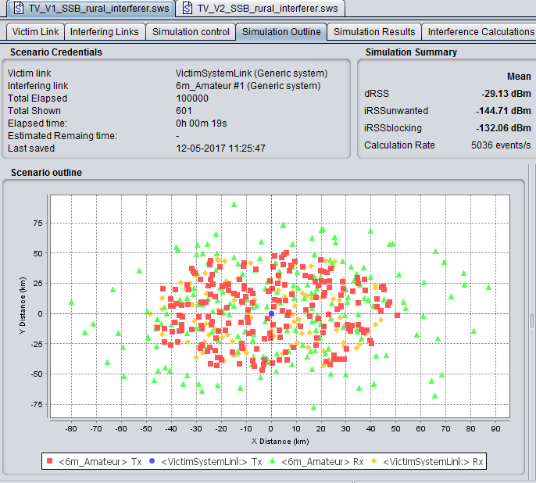

## A8.4 The rural centre study

This study is modelled on the TV transmitter in Zapadnaya Dvina Tver found in the ITU BR database record 096002674, an extract of which is shown in Figure A8.4. The other parameters used in the simulation e.g. receiver antenna, sensitivity, amateur characteristics etc. are the same as previously described in section A8.2 above.

The TV broadcast transmitter is assumed to have an effective radiated power of 165 W (52.2 dBm) into an omni-directional antenna with a numerical gain of 1 at an effective height of 92 metres and the radius of the TV service area is assumed to be 5 km.

Given the low transmitter power of 165 Watts (22.2 dBW) and relatively low antenna height (92 m), it is assumed that the broadcast station serves a small rural community or some other type of isolated compact settlement. The image from Google Earth (Figure A8.9) shows the town at the center of a largely forested area with a diameter of approximately 5 km.

Table A8.2 shows the calculated probability of interference to residential TV reception by amateur operators and Figure A8.2 shows the simulation outline.

Table A8.2

Probability of interference for the rural township calculated by SEAMCAT using the parameters given in Table A8.3. The *C/I* column is the calculated probability of interference; Mean dRSS is the calculated mean signal strength of the desired TV signal and its standard deviation also shown.

|  |  |  |  |
| --- | --- | --- | --- |
| *C/I* % (54 dB) | Mean dRSS  (dBm) | dRSS StdDev (dBm) | Environment |
| 1.57 | -41.06 | 9.99 | Rural |

Figure A8.2

Simulation outline of the rural township (Zapadnaya Dvina Tver) study. This figure shows 601 positions of the 100 000 random positions that SEAMCAT simulates to predict the probability of interference

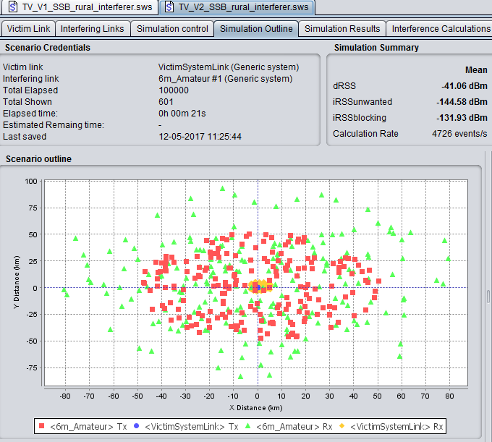

Figure A8.3

Extract from ITU database giving details of the Moscow television transmitter used   
in the simulation in section A8.3 of this Report

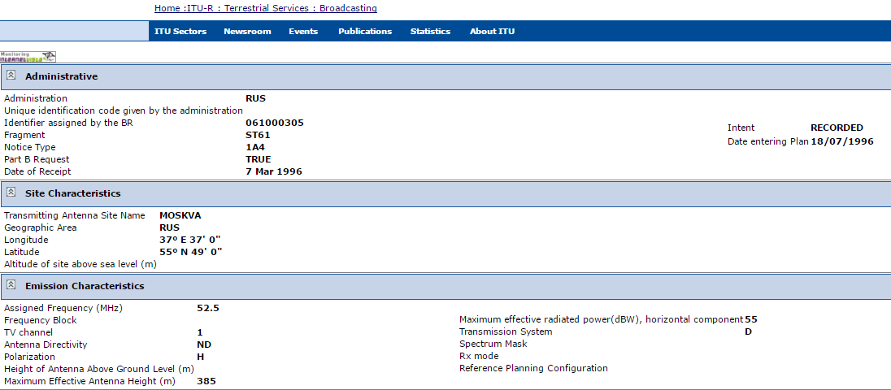

Figure A8.4

Extract from ITU database giving details of the Zapadnaya Dvina Tver television transmitter used in the simulation in section A8.4 of this Report

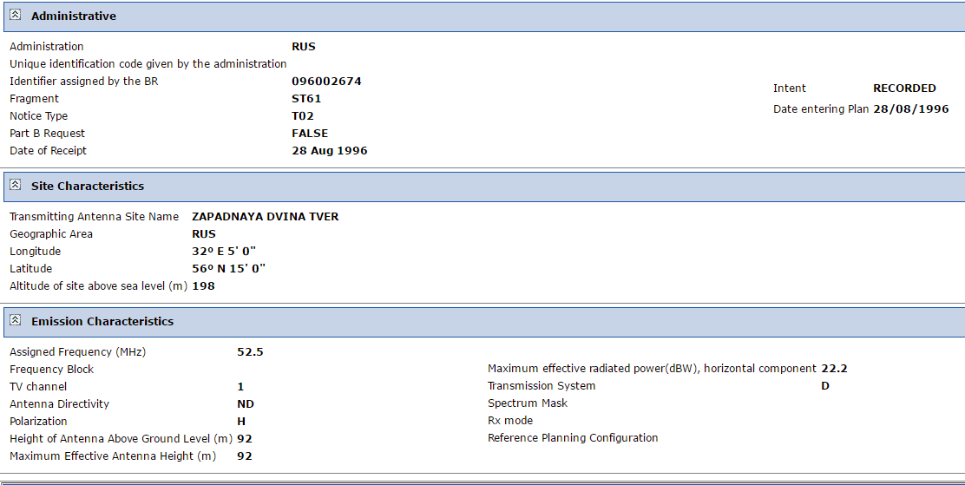

Table A8.3

The main parameters used for the SEAMCAT studies given in this document. Any other parameters not specified were left as the program default values. SEAMCAT version 4.1.0 revision 2337 was used for this study.

| Parameter | Value | Comments |
| --- | --- | --- |
| Frequency | 52.5 MHz | Same frequency is used for both the TV transmitter and amateur station |
| Amateur transmitter power | SSB: 50 dBm (100 W) PEP | Typical of amateur equipment used around 52 MHz. See Figure A7 for emission mask. |
| Duty cycle of amateur transmitter | SSB: 2.5% at 40 dBm and 2.5% at 50 dBm | 5% operation is 1.2 hours per day; most amateurs would transmit less than this on average. Considering SSB; for smoothly read text, the mean power of the speech signal is 10 dB lower than the power of a reference sinusoidal signal (see Recommendation [ITU-R SM.326](http://www.itu.int/rec/R-REC-SM.326/en), Note 2 to Table 1). |
| Amateur links antennas,  RX & TX | SSB:4 element Yagi, 9.4 dBi gain | Typical amateur antennas. See figure A5 for radiation pattern. |
| Amateur antenna height,  RX & TX | 10 m (above ground) | A probable maximum amateur height due to planning requirements. |
| Number of active amateur transmitters in service area | 2 |  |
| Television broadcast transmitter power | 85 dBm ( 316 kW)  52.2 dBm (165) | The difference between ERP and e.i.r.p. is small and is ignored here. Since ERP is given antenna gain is assumed to be 0 dBi |
| Television broadcast transmitter antenna | Omni-directional vertical, 0 dBi gain |
| Television transmitter height | 385 m & 92 m |  |
| TV receiver antenna height | 5 m (above ground) |  |
| TV receiver sensitivity | -48 dBm ( 1 mV into 50 ohms) |  |
| TV receiver antenna gain | 0 dBi | See figure A6 for radiation pattern. Pattern based on ITU-R BT.419 which is a built-in SEAMCAT option. |
| TV signal bandwidth | 5 MHz |  |
| Interference criteria | *C/I* = 53.97 dB, *C/(N+1)* = 47 dB  *(N+I)/N* = 0.97 dB, *I/N* = -6 dB |  |
| Noise floor | -103 dBm | Based on the fundamental calculation of [noise power per Hertz (kTB)](https://en.wikipedia.org/wiki/Johnson%E2%80%93Nyquist_noise), corrected for bandwidth (5 MHz) and receiver noise figure (4 dB):  -103 dBm = -174 dBm/Hz + 10 log(BW) + NF |
| Coverage radius | 50 km TV transmitter to receiver  5 km TV transmitter to receiver | Major city  Rural town |
| General environment | Rural and suburban |  |
| Propagation model | For amateur service: Extended-Hata  TV service: ITU-R P.1546-4 Land | Suitable for elevated transmitters in a cluttered, non-line-of-site environment between 30 MHz and 3 GHz up to a maximum range of 100 km  Broadcasting & other terrestrial services, typically considered in cases with high mounted transmitter antennas e.g. above  50 – 60 m |

Figure A8.5

Radiation pattern of the 4 element Yagi used in this study. Side lobes have not been included as the random assignment of directions in the simulation covered all possibilities of direction by the main lobe

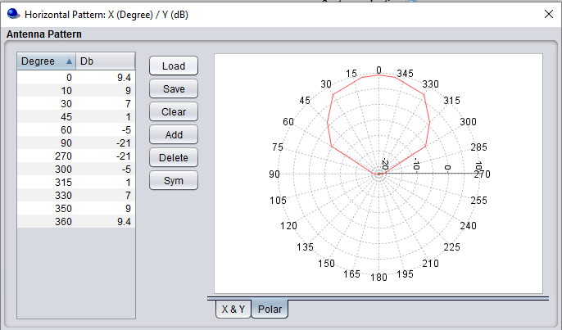

Figure A8.6

Radiation pattern of the TV receiver antenna

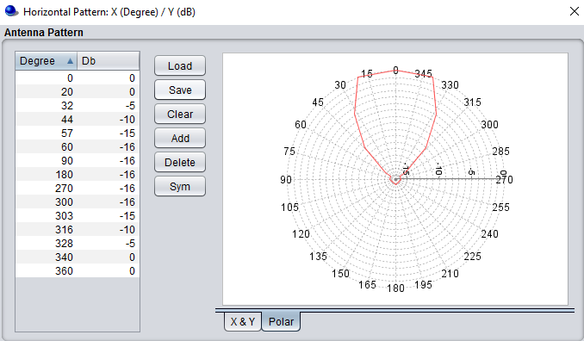

Figure A8.7

Emission mask of SSB transmission from the amateur station used in this study

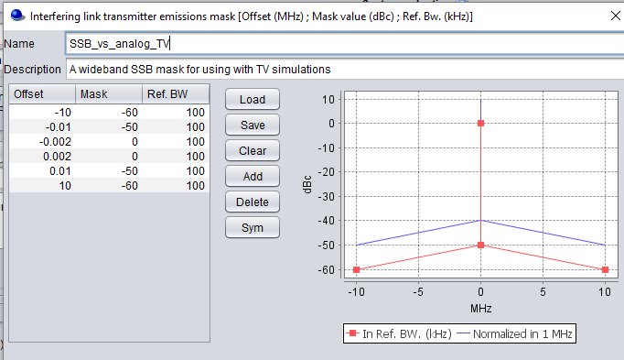

Figure A8.8

A Google Earth image of Zapadnaya Dvina showing the extent of the settlement and rural nature of the surrounding environment. The township appears to have a diameter of roughly 5 km as shown by the lines drawn on the image. This is in accord with the assumed TV coverage area of 5 km radius

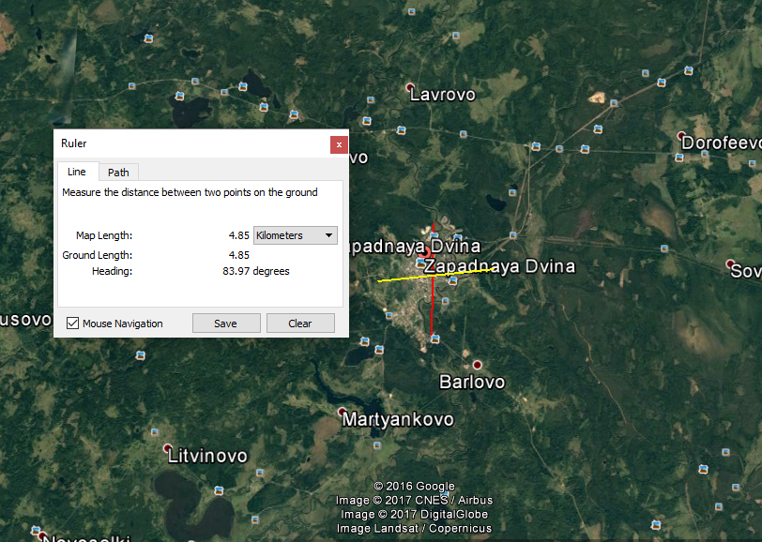

Suggested numbering scheme for annexes of 50 MHz sharing study

V1 30 May 2017

Identify general topic then reports by sub-topic

A1: Spectrum needs and existing/proposed usage of the 50 – 54 MHz frequency band

A1.1: Spectrum needs (IARU)

A1.2: Licensees information (IARU)

A1.3: Band plans (IARU)

A1.4: Spectrum needs (Russia)

A2: Sharing with the broadcast service

A2.1 Static study (IARU)

A2.2 SEAMCAT study (IARU)

A2.3: Static (Russia)

A2.4: SEAMCAT study (Russia)

A3: Sharing with the mobile service

A3.1 MCL study (Swiss)

A3.2 SEAMCAT study on governmental mobile system (IARU)

A3.3: Germany

A3.4 PMR (IARU)

A4: Sharing with the radiolocation service

A4.1: WMO

A4.2:

A5: Sharing with fixed service and anything else

A5.1:

1. The adjustment factor resulting from the antenna polarization discrimination for horizontally polarised broadcasting emissions with respect to vertically polarised mobile emissions is -18 dB, from section 4.1 of Recommendation ITU-R SM.851-1.
2. Teledensity; terminal density: Number of end-user terminals per square kilometre.
3. See <https://www.tapr.org/pdf/DCC2014-TheEuropeanHAMNET-DG8NGN.pdf>
4. Copies of the MoUs are at: <http://www.iaru.org/uploads/1/3/0/7/13073366/ituandiarumou.pdf>   
   and <http://www.iaru.org/uploads/1/3/0/7/13073366/ifrcandiarumou.pdf>
5. A particular benefit of VHF for this is that amateurs can achieve non-line of site data communications, which is not possible in UHF/Microwave bands with conventional Wi-Fi etc.
6. With spherical diffraction, attenuation effects occur which depend on the gradient of the local dielectric characteristics of the environment. These are considered in the model as statistical parameters.