INTERNATIONAL TELECOMMUNICATION UNION |  | Focus Group on ICT&CC
TELECOMMUNICATION  STANDARDIZATION SECTOR  STUDY PERIOD 2005-2008 |  | FG ICT&CC-C-9Rev.1
English only
Original: English
 |  | Geneva, 1-3 September 2008
CONTRIBUTION
Source: | AIM Consortium
Title: | The AIM project-a harmonized technology for profiling and managing the energy consumption of home appliances

Scope
The ITU-T has recently launched a focus group on climate change to identify from the standardization viewpoint, within the competences of ITU-T, the impact of ICTs on Climate Change, in particular:
- the reduction of ICT’s own emissions over their entire lifecycle (direct impact),
- the mitigation that follows through the adoption of ICTs in other relevant sectors (indirect impact),
- and facilitating the monitoring of relevant climate parameters.
This document aims at disseminating to that ITU-T focus group, information about an intelligent network architecture for energy saving applications to be taken into consideration in its planned work on fields a) and b).
In both cases mitigation of humans’ intervention on climate change is perceived as rationalistic consumption of energy, safeguarded by ICT-enabled technologies. In this context, the document describes a strategy that focuses on minimizing the energy that is consumed by home appliances and highlights a number of concepts that have been envisaged and adopted in order to render this strategy applicable in real households.
These concepts are within the competences of the ITU-T and relate mainly to the methodology that the focus group is going to develop in order to describe and estimate the energy consumption of ICTs.
The document is organized in two sections. Section 1 provides information on the project in the context of which the aforementioned strategy is developed. Section 2 analyses its architecture and introduces a number of concepts that may be taken into consideration by the FG in its work on modeling ICTs energy consumption.

Section 1: Information about the AIM project
The main objective of the AIM project (www.ict-aim.eu) is to foster a harmonized technology for profiling and managing the energy consumption of home appliances being either in active or stand-by state. In doing so, the project introduces energy consumption monitoring and management mechanisms in the home network and a proper service creation environment to serve virtualization of energy consumption, with the final aim of offering users a number of standalone and operator services.
The project applies its technology on three appliance types, namely, white goods (refrigerators, kitchens and washing machines), communication devices (cordless phones and wireless communication devices for domestic use) and audiovisual equipment (TV Sets and Set-top-boxes), targeting delivery of energy saving applications grouped in three use-cases:
1) Use-case for residential users to be used for managing the energy consumption of their households intelligently, e.g. automated stand-by devices detection and switch off in the absence of people at home or during the night, setting of maximum levels of energy consumption, etc.
2) Use-case for utility companies to plan better energy generation.
3) Use-case for network operators, for subscribers wishing to monitor and manage the energy consumption of their households remotely.
The AIM technology will be evaluated in the context of experiments that will be hosted, initially in a virtual home environment and later on in real households.
The project was launched in June 2008 and has two years of duration.

Section 2: Envisaged concepts and solutions
To implement its technology the project has envisaged the architecture depicted in Figure 1, consisting mainly of three components:
- the household appliances equipped with network interfaces,
- the residential gateway in the role of service broker towards the user, and
- the Energy Monitoring Device (EMD), which performs communication homogenization on the interface between itself and the residential gateway by hiding the specificities of the various network interfaces of the household appliances.
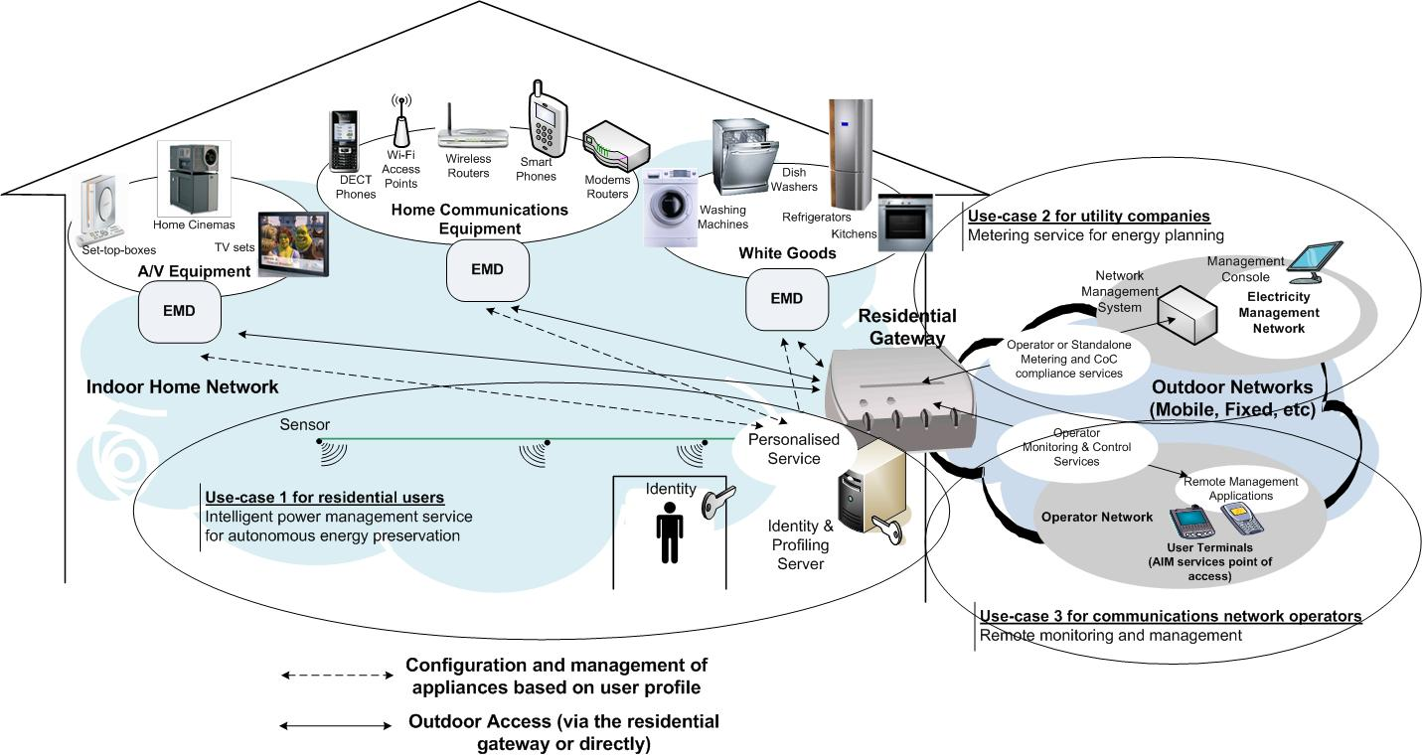
Figure 1: The AIM architecture
Under the given network architecture, realization of energy saving applications becomes possible through adoption of the following concepts:
Service accommodation: Energy monitoring services are accommodated on the residential gateway, which also performs:
- household appliances recognition and internal functions control.
- ‘energy resources’ virtualization and instantiation in the context of user-created services. The term ‘energy resources’ is used to identify all appliances that consume energy, their internal functions (e.g. the washing programs of washing machines, the communication modes of a wireless hot spot, etc) as well as energy control methods, e.g. set up of energy consumption thresholds, masking of appliance functions, etc.
- service creation and personalized execution.
Appliance profiling: Appliances’ internal functions are analyzed and grouped in power modes with regard to their contribution to logical operations such as washing programs for washing machines, viewing modes for TV sets, communication modes for gateways, digital phones and wireless hot spots, etc (Figure 2). Each power mode is assigned a certain energy consumption level, thus making possible creation of profiles per appliance type. By accommodating these profiles on the residential gateway, the network may estimate in real time the energy consumed within the household, simply by determining the state of each appliance. Appliance profiles are also useful for determining the operational state of each appliance. For example if it is switched on or in stand-by mode.
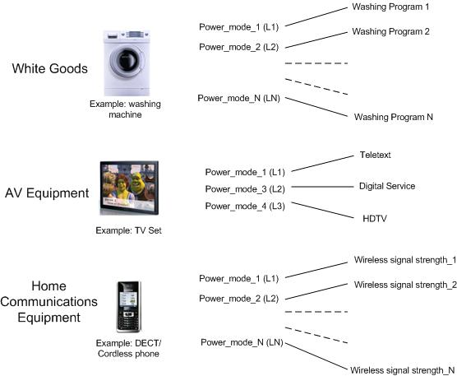
Figure 2: Examples of appliance profiles
Logical interfaces: Apart of the three main components noted earlier, the AIM architecture encompasses a number of logical interfaces whose role is to provide physical communication and integrate the functionality of the AIM components within the context of user applications.
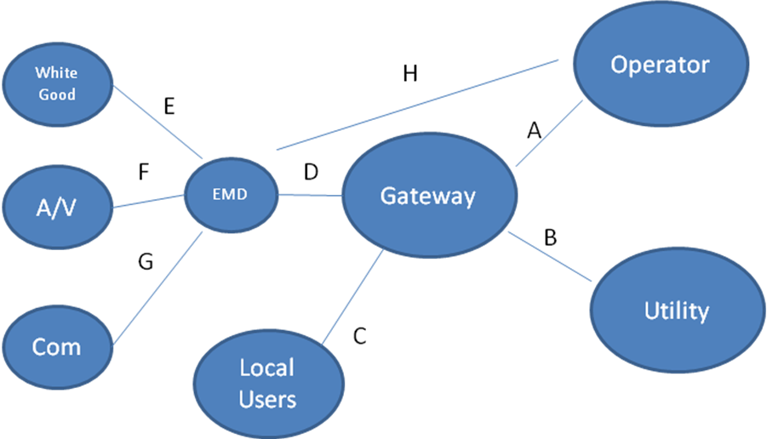
Figure 3: Logical representation of AIM components and the interfaces interconnecting them
Interface A: Binds the applications of the network operator with the services of gateway.
Interface B: Binds the applications of the utility with the services of gateway.
Interface C: Binds the applications of the local user with the services of gateway. This interface may be implemented using standard service execution interfaces, such as JAVA APIs.
Interface D: This interface implements a protocol that is common for all appliances and allows the gateway to:
- request appliance status information from the EMD(s),
- control the appliances, e.g. switch off an appliance, mask a particular appliance function, etc,
- perform special initialization functions, e.g. retrieve the number and type of connected appliances, determine their internal functions, power modes, etc.
Interfaces E,F,G: May be of proprietary or standard type. These interfaces implement protocols that allow EMD(s) to access appliances’ internal functions. Depending on the appliance model, access may be confined to simple ‘status read’ cycles or may also comprise ‘write’ cycles, using a particular set of control primitives.
Interface H: Is similar in function with the interface A, but the services of the gateway are replaced by corresponding services in the operator network, whereas the user application communicates directly with the appliances, via the EMD.

Conclusions
Although today every household appliance can be controlled over the network, versatility of utilized interfaces and diversity of supported functions render difficult implementation of uniform network management logic.
During the definition phase of the AIM architecture, it was found that developing networked technologies for energy management and monitoring of household appliances is largely relying on the establishment of generic communication interfaces between the controlled devices and the management logic of the network.
We propose that the FG studies the requirements for these interfaces with reference to any existing standardisation work in this area.
We also propose that the FG identifies and endorses energy profiles defined up to date for some household appliance types so that the industry is able to categorize their products by the energy they consume. On way of doing so is by endorsing the use of the CoC (Code of Conduct) concept, defined by the EC for white goods, in all household appliance types as a standard mode of ‘green’ operation.
Attached: Presentation

