INTERNATIONAL TELECOMMUNICATION UNION
 | WRC-2000 | WORLD  RADIOCOMMUNICATION  CONFERENCE | Addendum 15 to  Document 34-E
 | WRC-2000 | WORLD  RADIOCOMMUNICATION  CONFERENCE | 6 May 2000
 | WRC-2000 | WORLD  RADIOCOMMUNICATION  CONFERENCE | Original: English
ISTANBUL, 8 MAY – 2 JUNE 2000
 |  |  | PLENARY MEETING
Note by the Secretary-General
REVIEW AND POSSIBLE REVISION OF THE 1997 BROADCASTING-SATELLITE SERVICE PLANS FOR REGIONS 1 AND 3
STUDY TO ASSESS THE IMPACT OF USING AN ORBITAL POSITION
WITHIN THE ORBITAL ARC 25° W to 10° E for Tunisia
Please find attached to this document additional information to that contained in Document WRC2000/34.

Yoshio UTSUMI
Secretary-General

Attachment: Study to assess the impact of using an orbital position within the orbital arc 25° W to 10° E for Tunisia
aTTACHMENT
Director, Radiocommunication Bureau
STUDY TO ASSESS THE IMPACT OF USING AN ORBITAL POSITION
WITHIN THE ORBITAL ARC 25° W TO 10° E FOR TUNISIA

1 Introduction
The Radiocommunication Bureau received a telefax dated 31 March 2000 from the Administration of Tunisia requesting a preference for an orbital position within the orbital arc from 25° W to 10° E instead of the orbital position 30° W, which was used in the “basic” feasibility studies.
As the request was received after the last IRG meeting, the Bureau informed this Administration that its request would be studied at the end of the “basic” downlink and feeder-link feasibility studies, together with other national preferences yet to be studied, if time and resources permit.
This document provides the results of this additional study conducted by the Bureau for consideration by WRC-2000.

2 Methodology
At the end of the “basic” downlink and feeder-link feasibility studies, the national beams of Tunisia are removed from the orbital position 30° W in both the “basic” downlink and feeder-link files.
A search for a new orbital position within the orbital arc from 25° W to 10° E is conducted for the downlink. For that purpose, a Step 4 run is performed (see the Step 4 methodology described in Attachment 1 to Document CMR2000/34 and its Corrigendum 1).
Once the required number of downlink channels have been found at an orbital position within the requested orbital arc, a feeder-link study is performed to find the required number of feeder-link channels at the same orbital position (see the feeder-link methodology described in Attachment 1 to Document CMR2000/34 and its Corrigendum 1).

3 Downlink results
The Step 4 run firstly considered the orbital position 25° W. It was not possible to find a block of ten channels at that position. All nominal orbital positions within the arc >25° W to 10° E were then considered. Again, it was not possible to find a block of ten channels at those nominal orbital positions. A further search at non-nominal orbital positions was also unsuccessful.
The Step 4 run was repeated with the improved fast roll-off space station transmit antenna as described in Recommendation ITU-R BO.1445 applied to the TUN15000 beam. This run found that it was possible to accommodate the national downlink beam of Tunisia (TUN15000) at the non-nominal orbital position 21° W without any EPM excess.
A further Step 4 run was performed with the improved fast roll-off antenna applied and the e.i.r.p. of the TUN15000 adjusted. The result of this exercise was that it was not possible to accommodate the TUN15000 beam at a nominal orbital position within the arc 25° W to 10° E; it was only possible to accommodate the beam at the non-nominal orbital position 21° W without any EPM excess.
The ellipse parameters and a plot of the resulting downlink beam shape at 21° W are provided below.
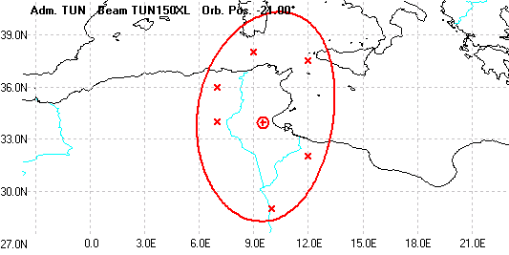

Antenna  gain | Boresight latitude | Boresight longitude | Major axis half-power beamwidth | Minor axis half-power beamwidth | Major axis orientation
43.23 dB | 33.95° N | 9.51° E | 1.70° | 0.78° | 115.63°

4 Feeder-link results
The orbital position of the Tunisia national feeder-link beam (TUN15000) was changed from 30° W to the orbital position found in the downlink study: 21° W. The ellipse parameters were recalculated using the ITU/EBU ellipse software. The feeder-link ellipse parameters and a plot of the resulting beam shape at 21° W are provided below.

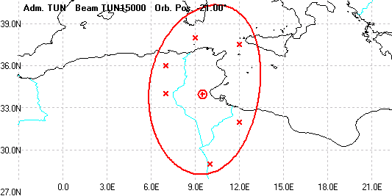

Antenna  gain | Boresight latitude | Boresight longitude | Major axis half-power beamwidth | Minor axis half-power beamwidth | Major axis orientation
43.23 dB | 33.95° N | 9.51° E | 1.70° | 0.78° | 115.63°

An MSPACE run was then performed to assess the new feeder-link interference situation resulting from the use of the channels 21, 23, 25, 27, 29, 31, 33, 35, 37, 39 CL, which were those found at 21° W in the downlink study, after a transposition of these ten channels to the feeder-link frequency band at 17 GHz.
The results showed that it was possible to accommodate into the feeder-link file the national feeder-link beam of Tunisia at the orbital position 21° W without any EPM excess.

5 Summary
The results of this BSS-to-BSS study show that it is possible to accommodate the national downlink and feeder-link beams of Tunisia at 21° W without any EPM excess in both the downlink and feeder-link respectively.

________

