INTERNATIONAL TELECOMMUNICATION UNION
TELECOMMUNICATION  STANDARDIZATION SECTOR  STUDY PERIOD 2001-2004 |  |  | ccTLD Doc 8
 |  |  | Original: English
Workshop on Member States' experiences with ccTLD
Geneva, 3-4 March 2003
DOCUMENT FOR ccTLD WORKSHOP
Source: | Ethan Katsh
Title: | UDRP decisions: some recommendations for improving access

“The value of data increases when people can find it”
- Google advertisement
The Uniform Dispute Resolution Policy (UDRP) established a process as well as a policy, a set of procedures for resolving domain name disputes as well as a set of standards to be employed in making decisions. The principal standard is “bad faith” but in order to determine whether a domain name holder’s behavior violates this standard, a fairly detailed process was put in place for selecting panelists, obtaining and exchanging information, reaching a decision within a specified time period, and, depending upon the decision of the panelist, changing, canceling or preserving the registration.
The UDRP process, like all legal processes, consists of a string of coordinated communication and information processing activities. Parties, panelists and providers must acquire, retrieve, understand, communicate and evaluate information in order to reach the end point of the process. If any of these informational activities are burdensome, the process may not operate efficiently, and, if more burdensome for one party than the other, the process may be unfair. For example, obstacles placed in the way of searching for information can affect whether certain arguments are made and how they are framed, whether costs are higher than they need to be, whether professional expertise is needed, and even whether a respondent decides to participate in the process.
For the past two years, with support from the Markle Foundation, I have been concerned with how difficult it is for those who need information about UDRP decisions to actually obtain it, and what would be required for more a more efficient information retrieval system to be put in place so that parties, lawyers, panelists, and others could obtain the information that they need in a systematic way? For reasons explained in Part I of this report, I believe that the informational system underlying the UDRP process has significant problems. Indeed, I would argue that, for an institution, such as ICANN, whose work concerns the efficient functioning of the Internet, the informational system in place is embarrassing in its inefficiencies. As I discuss in Part II, however, these inefficiencies are remediable with a minimal amount of oversight and coordination from ICANN or the providers. Indeed, I also describe a solution that has been developed, that will be usable in early December, 2002, and that could be put in place permanently if ICANN and the UDRP providers were interested in doing so.

I. Are some repairs needed
Section 4J. of the UDRP states that “All decisions under this Policy will be published in full over the Internet.” By the time as few as ten or twenty decisions appeared in early 2000, users of the UDRP recognized that there was a problem. While providers could post decisions at little cost and any user with a Web browser could read a decision, every additional case posted made it harder to find out which case one might want to read. One could read decisions which one could find but the growing universe of decisions made finding information in decisions increasingly difficult.
Posting decisions online made access possible, but, as the number of decisions grew, finding decisions dealing with a particular issue or set of facts became increasingly difficult. It has been an open question whether decisions of panelists should be considered as precedent but, regardless of the weight that should be given prior decisions, all panelists have been interested in consulting decisions involving the different parts of the policy. Even if prior decisions are not controlling, panelists will try to look to prior decisions for guidance, to see the reasoning of other panelists, and to see if there have been similar factual situations.
The only reason the system did not break completely is that some individuals and groups provided assistance. At a very early date, for example, Scott Donahey, a member of the UDRP Review Task Force, reviewed the decisions every few weeks and prepared a report summarizing what had occurred. This was enormously helpful but it was a volunteer effort and not something that could be expected to continue forever. Other efforts, mostly voluntary and non-commercial, followed. The following list of efforts to allow one to become aware of relevant decisions is not meant to be exhaustive but illustrates that a need existed and continues to exist for access not simply to decisions, but to information in decisions.
1. Wendy Seltzer, then of the Berkman Center at Harvard Law School, designed the search engine that is currently at the ICANN site.
2. Our Center for Information Technology and Dispute Resolution at the University of Massachusetts made available another search engine.
3. LEXIS and WESTLAW currently provide some access to UDRP decisions for those with LEXIS and WESTLAW access.
4. UDRPlaw.net is an enormously useful site that was begun during the Summer of 2001. Other ICANN related Web sites such as Brett Fausett’s ICANN Blog often have information about UDRP decisions.
5. WIPO has a searchable database of WIPO UDRP decisions at http://arbiter.wipo.int/domains/search/index.html
6. Informal systems and listservs communicated information about decisions. The International Trademark Association listserv, and perhaps other listservs, allow one to ask questions to a knowledgeable audience about cases and issues.
7. The main providers alert their own panelists to recent noteworthy decisions and some provide panelists with research assistance.
8. Very useful databases covering some portion of UDRP decisions have been produced and made available, e.g. Milton Mueller’s downloadable database and report on the first 3800 decisions and Michael Geist’s database with other information.
Each of these resources is a significant contribution and the result of considerable effort. The individuals who have contributed to the informational infrastructure underlying the UDRP deserve a great deal of credit since, if they had not come forward, the functioning of the UDRP process might, over time, very well have come to a halt. Yet, it is also fair to say that what has happened is that several bandaids have been placed on a problem. The bandaids allow the process to continue to operate but the bandaids are not permanent and if some fall off, the UDRP process would deteriorate.
To those panelists and lawyers who are aware of and have access to all of the resources listed earlier, it may seem that I am making the system appear more fragile than it is. For those users, however, who do not have access to LEXIS or Westlaw, do not participate in the INTA listserv, and do not receive special updates from providers, as the number of decisions grows, the difficulty in making sense of the system also grows. Even for those who find and use one of the current search engines, a key problem with the search results is that false positives will grow as the number of decisions grows. At best, one will find growing inefficiencies, at worst, one will find growing unfairness as what had been intended to be a relatively easy to use system becomes increasingly complex.
I had the privilege of being a panelist in a UDRP dispute involving the domain name tolandpools.com In this case, the domain name holder registered the domain name in order to criticize a company, Toland Pools, that had built a swimming pool for him. In determining whether the domain name had been registered in bad faith, I thought it would be useful to look at the reasoning of other panelists in cases decided under 4.c(iii) and see how they had treated consumer protest sites. I had been aware of several of the various “sucks” cases and did indeed think them relevant. But the domain name at issue in my case was identical to the trademark, not a variant that was unlikely to be confused with the company. Thus, the issue was somewhat different from what faced panelists in the "sucks" cases.
I would have liked to do a search for cases that relied upon Section 4.c(iii). Yet, it was not really possible to do that. It was easy enough to do a search for the phrase “legitimate noncommercial or fair use of the domain name,” but that generated an exceptionally long list, since there were many cases which printed portions of the UDRP even if the case had nothing to do with that section. I benefitted from being acquainted with a panelist who had decided a case that I thought was similar to mine and this led me to a few other decisions. I remain confident that I reached the correct result and I understand that I was not required to look at any other cases. Yet, this was a straightforward question concerning an important UDRP clause and I certainly would have preferred to have read everything that was available and appropriate.
II. Making some repairs
It is not my purpose to criticize ICANN for not putting a better system in place initially. ICANN actually did what governments typically did in the print era, namely publish whole decisions with little value added provided. In the United States, private law publishers took advantage of this to market information retrieval systems to lawyers. The Web, however, makes possible new methods of publishing and accessing information, thus changing the cost of adding value to public domain information. The publishing requirement in Section 4J is part of what might be considered version 1.0 of the UDRP process. If improvements can be put in place for relatively little cost, it would be appropriate for the Task Force to recommend that version 1.0 be upgraded.
With support from the Markle Foundation, I have worked with the Cornell Law School Legal Information Institute to design a publishing model and Web site that would allow access to data that is currently not available at all or only available at considerable expense or effort. The Legal Information Institute, ten years ago, was the first legal research site on the Web and is still considered by many to be the most professional and authoritative source of legal information on the Web. By mid or late December 2002, we expect to have available at http://udrp.lii.info an up to date database containing all decisions from all providers. The system should be available for testing with a smaller subset of decisions by the second week of December, 2002.
What is needed for a more modern publishing approach is for there to be a database of information about UDRP decisions, with data entered each time a decision is made and with this data accessible in as efficient and flexible manner as possible. Data entry should not be and need not be a significant burden on providers, who already oversee various informational requirements that must be fulfilled. Information about cases could be accessed using a form such as that in Figure 1 below.

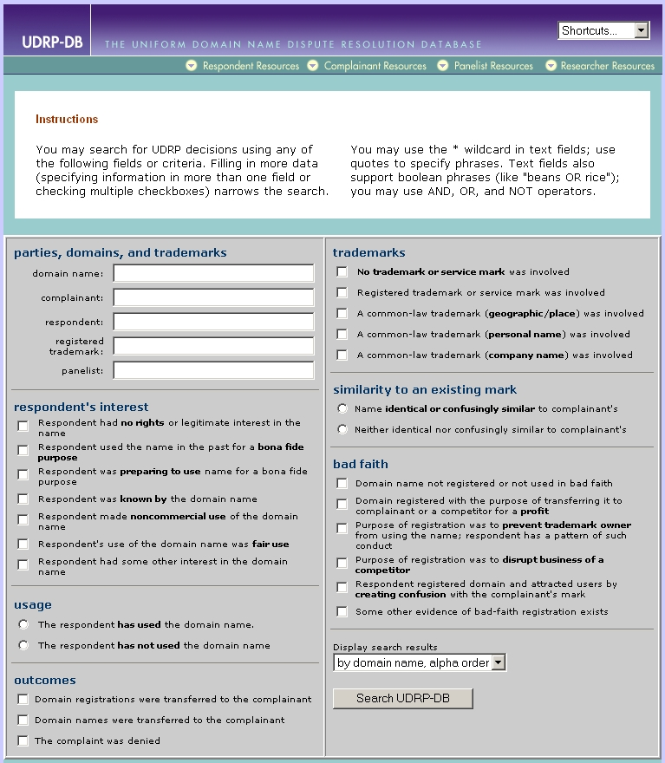

Figure 1
We are prepared to make our forms, database and process available freely to ICANN and the providers. I would also like to acknowledge some assistance from the National Arbitration Forum in providing us with some data. What is, I believe, necessary for version 2.0 of the UDRP information infrastructure to emerge is for the providers to agree on an approach that will benefit users. The providers are competitors and, unfortunately, there are no incentives for them, on their own, to provide data to a common database. On the other hand, the user community does not benefit from having access to incomplete information.
When eResolution went out of business, I wrote to Louis Touton urging him to make certain that the eResolution decisions would not disappear along with their Web site. I volunteered to host the decisions on our own server, if need be, and this is where they currently are. I am pleased to be able to provide this service but what I am suggesting is that the integrity of the UDRP process needs to be part of someone's ongoing responsibility. I would assume that this would be someone at ICANN but perhaps someone has an alternative suggestion about this. UDRP decisions are important to the parties involved in the dispute but, over time, they are accumulating, decision by decision, as a kind of cyberlaw jurisprudence. I am not suggesting that ICANN needs to exercise a heavy hand and expend great energies and expense in overseeing the integrity of UDRP information and access to it. However, the current model, what I refer to as version 1.0, in which there is absolutely no oversight and no concern should also not be acceptable.

______________

