INTERNATIONAL TELECOMMUNICATION UNION
Radiocommunication Bureau
(Direct Fax N°. +41 22 730 57 85)

Circular Letter  4/LCCE/64  7/LCCE/29  8/LCCE/93  9/LCCE/58 | 5 March 2001
To Administrations of Member States of the ITU and
Radiocommunication Sector Members participating in the work of
Joint Task Group 4-7-8-9 of Radiocommunication Study Groups 4, 7, 8 and 9
Subject: Second meeting of Joint Task Group 4-7-8-9 on 5 GHz band allocations (Resolution 736 (WRC-2000))

Introduction
The second meeting of Joint Task Group 4-7-8-9 was foreseen in the programme of the Radiocommunication Study Groups by the meeting of Study Group Chairmen and Vice-Chairmen in June 2000.

Date and place of the meeting
Following the kind invitation from the Administration of the United States, the meeting will take place in the Cleveland Marriott Airport Hotel, Cleveland, Ohio, from 4 to 8 June 2001.
Services directly connected with meeting activities, such as delegate registration, document distribution, etc., will be located at the meeting place. Registration will commence at 08:30 hours on the opening day. The opening session will commence at 10:00 hours.
Information concerning the venue of the meeting and accommodation is provided in Annex 2.

Programme of the meeting
The meeting agenda is shown in Annex 1.

Working language
Joint Task Group 4-7-8-9 conducts its work in English.
Contributions
Contributions in response to the work of Joint Task Group 4-7-8-9 assigned to this meeting are invited. Contributions will be processed and dispatched in accordance with Resolution ITU-R 1-3 and posted on TIES/ITUDOC. In view of the meeting taking place outside Geneva, the deadline for submitting contributions will be Wednesday, 30 May 2001. Documents received after this deadline and which cannot be processed by the Secretariat in time for the opening of the meeting will be forwarded to the next meeting of the Joint Task Group.
Copies of each contribution should be sent to the Study Group Department, Radiocommunication Bureau, for processing, to the Chairman of the Joint Task Group and to the Chairmen and Vice-Chairmen of Radiocommunication Study Groups 4, 7, 8 and 9. The pertinent addresses can be found in Annex 3 to this Circular. Participants are encouraged to submit contributions by electronic mail as outlined in Administrative Circular CA/17 (Revision 2) of 16 April 1999 (http://www.itu.int/itudoc/itu-r/ac/ca/ca-17-r2.html) to:
renata.zecha@itu.int
Participation
In order to make the necessary arrangements, it is requested that the intended participation of your representative(s) be advised no later than one month before the opening of the meeting by means of the annexed form (Annex 4) (to be photocopied as required).
Robert W. Jones
Director, Radiocommunication Bureau

Annexes: 4
Distribution:
- Administrations of Member States and Radiocommunication Sector Members participating in the work of Joint Task Group 4-7-8-9 of Radiocommunication Study Groups 4, 7, 8 and 9
- Chairman and Vice-Chairmen of Radiocommunication Study Groups 4, 7, 8, and 9
- Secretary General of the ITU, Director of the Telecommunication Standardization Bureau, Director of the Telecommunication Development Bureau
ANNEX 1

Draft agenda for the second meeting of Joint Task Group 4-7-8-9

(Cleveland, Ohio, 4 - 8 June 2001)

1 Opening remarks
2 Approval of the agenda
3 Establishment of the drafting groups
4 Introduction and attribution of contributions
5 Development of temporary documents
6 Programme of work in the forthcoming months
7 Date and venue of the next meeting
8 Any other business

J. ZUZEK
Chairman, Joint Task Group 4-7-8-9
ANNEX 2
INFORMATION FOR PARTICIPANTS
(English only)

Meeting: JRG 4-7-8-9
Date: 4-8 June 2001
Place: Cleveland Marriott Airport
4277 West 150th Street
Cleveland, OH 44135
Tel: +1-800-228-9290 – Please use this number for reservations.
+1 216-252-5333 (if unable to call 800 number)
Fax ; +1 216-252-9404
E-mail: 110530.1624@compuserve.com

NASA Point of Contact: John E. Zuzek
Tel: +1 201-433-3469
Fax: +1 201-977-7444
E-mail: jzuzek@grc.nasa.gov

Hotel Information: Room Rate - $86.00 single or double (U.S. Domestic per diem rate). Rates are guaranteed 3 days before and 3 days after the conference, and you must register prior to 11 May, otherwise, the rooms are released and are available only on a space available basis without a guaranteed rate. As usual, reservations must be guaranteed by credit card or a deposit. To ensure the rate, inform the hotel that you are registering for the ITU conference.

Check in time 1500 hrs. – check out time 1200 hrs.
The Hotel offers non-smoking rooms; individual climate control, free cable with in-room pay movies; two-line telephone, W/voice mail; hairdryer, iron and ironing board; gourmet coffees and teas; large indoor pool and state-of-the-art health club.

Airport: Hopkins International Airport (CLE)

Transportation: Free shuttle to and from airport (approx. 4 miles distant) (Call Hotel for transportation)
Rental Cars: All companies are represented. Free shuttle from airport to central rental facility. Easy access from Shuttle lot to I-71 North (toward Cleveland) – off ramp at 150th Street (1st exit after getting on I-71 at Brook Park Road after leaving shuttle lot) leads directly into Marriott parking lot. Free parking.
Hotel also provides free transportation (24hrs.) from hotel to Rapid Transit station (rail) to downtown Cleveland. $1.50 each way. Approx. 15 minutes to downtown. Tower Center (Public Square). Rental not essential, but may be desirable for after hours.
Registration: An area directly in front of the plenary room (Ballroom) that will serve for this function.
Facilities: There will be one plenary room, one break-out room, a room for the Secretariat, and one room for delegates. Secretariat and Delegates rooms will be equipped with computers, printers and copiers as stipulated. The Plenary room (Ballroom) is on ground floor; other three rooms are nearby on 2nd floor)
Restaurants: The Hotel has Jack’s Place, a combined lounge and restaurant featuring steaks and seafood. Nearby restaurants tend to be fast-food or similar. However, if a rental car is used, several restaurants are within a 20-30 minute drive. In Addition, if rapid transit is used, excellent downtown eating establishments are available.
Other hotels in the area are:
Baymont @ 4222 W. 150th Street – Tel. 216-251-8500
Best Western @ 16501 Snow Road, Brook Park –Tel. 216- 267-9364
Hilton Garden Inn @ 4900 Emerald Court – 216-898-1898
Holiday Inn @ 4181 150th Street – 216-252-7700
Courtyard (Marriott) 24901 Country Club Blvd., North
Olmsted, OH 440-716-9977
Note: None of the above hotels come close to having the quality of the conference hotel
Reception: There will be a welcoming reception at the hotel on Tuesday, evening from 1800 hrs to 2000 hrs.

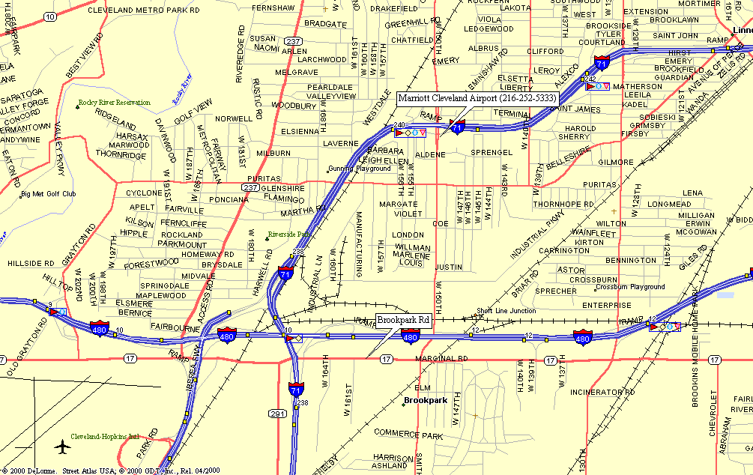
Map 1 - Overview of Route From Cleveland Hopkins International Airport to Marriott Hotel (Meeting Location)
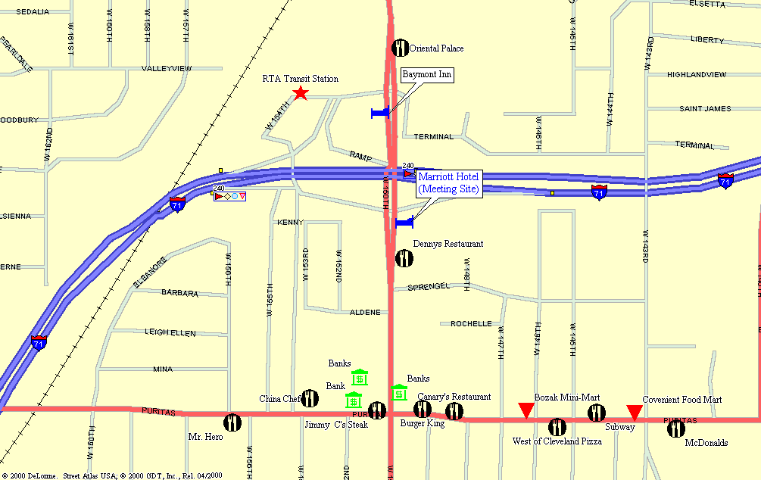
Map 2 - General Area of JTG 4-7-8-9 Meeting Site

ANnEX 3
List of Chairmen and Vice Chairmen

Study Group 4

Chairman and Vice Chairmen

Mr. Y. ITO
Chairman, Study Group 4
KDD Corporation
3-2, Nishishinjuku 2-Chome
Shinjuku-ku
TOKYO 163-8003
Japan
Tel: +81 3 33477630
Fax: +81 3 33475603
Internet: ya-ito@kdd.co.jp

Mr. J.M.P. FORTES
Vice-Chairman, Study Group 4
CETUC-PUC/Rio
Pontificia Universidade Catolica
Rua Marques de Sao Vicente, 225
Prédio Kennedy 7° andar
RIO DE JANEIRO, RJ 22453-900
Brazil
Tel: +55 21 2743664
Tel: +55 21 5299384
Fax: +55 21 2743664
Internet: jmfortes@mamao.cetuc.puc-rio.br

Mrs. V. RAWAT
Vice-Chairman, Study Group 4
Industry Canada
300 Slater Street
OTTAWA, Ontario K1A 0C8
Canada
Tel: +1 613 9904685
Fax: +1 613 9903158
Internet: rawat.veena@ic.gc.ca

Mr. A.G. REED
Vice-Chairman, Study Group 4
Reed Satellite Studies Limited
9 Links Close
ASHSTEAD, Surrey KT21 2HH
United Kingdom
Tel: +44 1372 272791
Fax: +44 1372 279054
Internet: lq59@dial.pipex.com

Mr. J. SESEÑA NAVARRO
Vice-Chairman, Study Group 4
Teledesic Communications Spain, S.L.
Via dos Castillas 33
Edificio 7
28224 POZUELO – MADRID
Spain
Tel: +34 630 047191 (mobile)
Fax: +34 91 7990520
Internet: jsesena@iies.es

Study Group 7
Chairman and Vice Chairmen

Mr. R.M. TAYLOR
Chairman, Study Group 7
TT&C
P.O. Box 629
ROSHARON, TX 77583
United States of America
Tel: +1 979 2859263
Fax: +1 979 2859545
Internet: robert@teleregs.com

Mr. G. DE JONG
Vice-Chairman, Study Group 7
NMi Van Swinden Laboratorium
Schoemakerstraat 97
2628 VK DELFT
Netherlands (Kingdom of the)
Tel: +31 15 2691500
Fax: +31 15 2612971
Internet: gdejong@NMi.nl

Mr. V. MEENS
Vice-Chairman, Study Group 7
CNES – DSO/RC/BF
BPI 2511
18, avenue Edouard Belin
31401 TOULOUSE Cedex 4
France
Tel: +33 5 61273808
Fax: +33 5 61281574
Internet: vincent.meens@cnes.fr

Mr. R. JACOBSEN
Vice-Chairman, Study Group 7
Commonwealth Scientific and Industrial Research Organization (CSIRO)
Canberra Deep Space Communication Complex
P.O. Box 4350
KINGSTON, ACT 2604
Australia
Tel: +61 2 62017909
Fax: +61 2 62017808
Internet: richard.jacobsen@ties.itu.int

Mr. M. VASILIEV
Vice-Chairman, Study Group 7
Russian Institute of Space Device Engineering
53 Aviamotornaya Street
111250 MOSCOW
Russian Federation
Tel: +7 095 2734719
Fax: +7 095 2734719
Internet: gkrch-russia@mtu-net.ru

Study Group 8

Chairman and Vice Chairmen

Mr. C. VAN DIEPENBEEK
Chairman, Study Group 8
Radiocommunications Agency
DGTP/RDR
P.O. Box 450
9700 AL GRONINGEN
Netherlands (Kingdom of the)
Tel: +31 505 877130
Fax: +31 505 877400
Internet: chris-van.diepenbeek@rdr.nl

Mr. T. MIZUIKE
Vice-Chairman, Study Group 8
KDD Corporation
2-1-15 Ohara
Kamifukuoka
SAITAMA 356-8502
Japan
Tel: +81 492 787810
Fax: +81 492 787318
Internet: mizuike@lab.kdd.co.jp

Mr. V. STRELETS
Vice-Chairman, Study Group 8
General State Supervisory Department for Communications in the Russian Federation
6, 2nd Spasonalivkovsky per.
117909 MOSCOW
Russian Federation
Tel: +7 095 2389498
Fax: +7 095 2003230
Internet: strelets@podlipki.ru

Mr. R.L. SWANSON
Vice-Chairperson, Study Group 8
Chairperson, Working Party 8B
Federal Communications Commission (FCC)
445 12th Street S.W.
WASHINGTON, D.C. 20554
United States of America
Tel: +1 202 4180732
Fax: +1 202 4187270
Internet: rswanson@fcc.gov

Study Group 9

Chairman and Vice Chairmen

Mr. V.M. MINKIN
Chairman, Study Group 9
Radio Research and Development Institute (NIIR)
16 Kazakova Street
103064 MOSCOW
Russian Federation
Tel: +7 095 2619307
Fax: +7 095 2619307
Fax: +7 095 2610090
Internet: minkin@niir.pvt.msu.su

Mr. A. HASHIMOTO
Vice-Chairman, Study Group 9
NTT DoCoMo, Inc.
Wireless Link Development Department
Sanno-Park Tower, 39F
2-11-1 Nagata-cho
TOKYO 100-6150
Japan
Tel: +81 3 51561760
Fax: +81 3 51560285
Internet: hashimoto@nttdocomo.co.jp

Mr. H. MAZAR
Vice-Chairman, Study Group 9
Tadiran Electronic Systems Ltd.
29 Hamerkava St.
P.O. Box 150
HOLON 58101
Israel (State of)
Tel: +972 3 5577551
Fax: +972 3 5564536
Internet: mazar@ties.itu.int

Ms. K. MEDLEY
Vice-Chairman, Study Group 9
NTIA – Department of Commerce
1401 Constitution Avenue N.W
Room 4606
WASHINGTON, D.C. 20230
United States of America
Tel: +1 202 4821896
Fax: +1 202 5018189
Internet: kmedley@ntia.doc.gov

Chairman, Joint Task Group 4-7-8-9

Mr. J. ZUZEK
NASA
Glenn Research Center
21000 Brookpark Road
Mail Stop 54-2
CLEVELAND, OH 44135
United States of America
Tel: +1 216 4333469
Fax: +1 216 9777444
Email: jzuzek@grc.nasa.gov

ANNEX 4
Registration Form
ITU-R Meeting
Cleveland, Ohio, 4 – 8 June 2001
Radiocommunication Bureau
I wish to participate in |  | Joint Task Group 4-7-8-9
 |  | ✓

Mr. Mrs. Ms. Miss:
(family name) (first name)

Accompanied by:
(family name) (first name)

1. REPRESENTATION
Name of Member State:
❒ Head of Delegation  Deputy  Delegate
(to be completed by representatives of Member States only)
Name of Sector Member: ..
❒ Recognized Operating Agencies
❒ Scientific or Industrial Organizations
❒ Regional and other International Organizations
❒ Regional Telecommunication Organizations
❒ Intergovernmental Organizations Operating Satellite Systems
❒ Other Entities Dealing with Telecommunication Matters
❒ United Nations and its Specialized Agencies

2. OFFICIAL ADDRESS
Name of the Company:
Street address:
City/State/Code/Country:
Business tel.: Fax:
E-mail: In case of emergency:
3. DOCUMENTS ☑ English
Date: Signature:
For BR Secretariat use only
Approved (if applicable) | Personal Section |  | Meeting Section |  | Pigeonhole
To be returned duly completed to the Radiocommunication Bureau |  | Place des Nations  CH-1211 Geneva 20  Switzerland |  | Telephone: +41 22 730 5802  Telefax: +41 22 730 6600  Telex: 421000 UIT

