INTERNATIONAL TELECOMMUNICATION UNION
Radiocommunication Bureau
(Direct Fax No. +41 22 730 57 85)
Circular Letter 26 April 2000
7/LCCE/24
To Administrations of Members States of the ITU and
Radiocommunication Sector Members participating in the work
of Working Parties, 7B, 7C and 7D of Radiocommunication Study Group 7

Subject: Meetings of Working Parties 7B, 7C, 7D and 7E
Working Party 7B Space radio systems
Working Party 7C Earth exploration satellite systems and meteorological elements
Working Party 7D Radio astronomy
Working Party 7E Inter-service sharing and compatibility

Introduction
The meetings of Working Parties 7B, 7C, 7D and 7E have been decided by the Chairmen and Vice-Chairmen meeting in November 1999.

Date and place of the meetings
The Administration of Canada of America on behalf of Canadian public and private sectors has kindly offered to host the meetings of Working Parties 7B, 7C, 7D and 7E from 27 July to 4 August 2000 (see Annex 1). The meeting dates are as follows:
Working Party 7E 27-28 July 2000 Radisson President Hotel
Working Parties 7B, 7C and 7C 31 July-4 August 2000 MacDonald Dettwiler
The meetings will take place in Richmond, B.C., Canada (see Annex 3). Services directly connected with meeting activities, such as delegate registration, document distribution, etc. will be located in the respective buildings. Registration will commence at 08:30 hours on the opening days. A joint meeting of Working Parties 7B, 7C and 7D will take place at 09:30 hours on 31 July 2000.
Programme of the meetings
A preliminary draft agenda for these meetings is contained in Annex 2.
The establishment of Working Party 7E will be announced in Administrative Circular CACE/177.
Working language
The Working Parties will conduct their work in English.
Contributions
Contributions in response to the work of Working Parties 7B, 7C, 7D and 7E are invited. These will be processed according to the provisions laid down in Resolution ITU-R 1-2, and posted on TIES/ITUDOC. In view of the meeting taking place outside Geneva, the deadline for submitting contributions will be Friday, 21 July 2000, 18:00 Geneva time.
One copy of each contribution should be sent to the Secretariat, Radiocommunication Bureau for processing. Contributions should also be sent to the Chairmen of the relevant Working Party and to the Chairman and Vice-Chairmen of Study Group 7. The pertinent addresses can be found in Annex 4 to this circular. Participants are encouraged to submit contributions by electronic mail as outlined in Revision 2 to Administrative Circular CA/17 of 16 April 1999 to:
renata.zecha@itu.int
Contributions received up to six weeks in advance of the meeting are dispatched, as far as possible, before the meeting in their original language. Later contributions, received up to seven days in advance of the meeting, are made available at the opening of the meeting. Documents received after 21 July will be forwarded to the next meeting of the respective Working Party. Resolution ITU-R 1-2 provides that contributions which are not available to participants at the opening of the meeting shall not be considered.

Participation
In order to make the necessary arrangements, it is requested that the intended participation of your representative(s) be advised not later than one month before the opening of the meeting, by means of the annexed form (Annex 5) (to be photocopied as required).

Robert W. Jones
Director, Radiocommunication Bureau

Annexes: 5

Distribution:

- Administrations of Member States of the ITU and Radiocommunication Sector Members participating in the work of Working Parties 7B, 7C, and 7D of Radiocommunication Study Group 7
- Chairman and Vice-Chairmen of Radiocommunication Study Group 7
- Secretary-General of the ITU, Director of the Telecommunication Standardization Bureau, Director of the Telecommunication
Development Bureau
ANNEX 1

Canadian invitation letter

Not available in electronic form

ANNEX 2

Preliminary Draft Agenda for the meetings of
Working Parties 7B, 7C , 7D and 7E
(Richmond, B.C. 27 July to 4 August 2000)

1 Introduction by the Chairman
2 Approval of the agenda
3 Status of Questions assigned to the Working Party and related work
4 Chairman's progress report
5 Report on the RA-2000
6 Work programme for the meeting
7 Introduction of input documents
8 Establishment of drafting groups and attribution of documents
9 Preparation of output documents
10 Discussion of the future work plan
11 Venue of the next meetings
12 Any other business

S. TAYLOR E. MARELLI
Chairperson, Working Party 7B Chairperson, Working Party 7C

J.B. WHITEOAK J. E. MILLER
Chairperson, Working Party 7D Chairperson, Working Party 7E

ANNEX 3

PRACTICAL INFORMATION FOR PARTICIPANTS

The meeting of Working Party 7E (27 to 28 July 2000) will take place in the:

Radisson President Hotel Room (single/double): Can$ 139.--
8181 Cambie Road Executive Suite: Can$ 169.--
Richmond BC, V6X 3X9
Canada

Tel: +1 604 276 8181
Fax: +1 604 276 8136

A block booking has been made at the Radisson President Hotel. The deadline for booking is 12 June 2000.

The meetings of Working Parties 7B, 7C and 7D will be held at:

MacDonald Dettwiler
13800 Commerce Parkway
Richmond, B.C., V6V 2J3
Canada

Tel: +1 604 278 3411
Fax: +1 604 276 2856

A shuttle bus will be operating between the Radisson President Hotel and MacDonald Dettwiler in the morning and in the evening from 31 July to 4 August. Richmond is located South of downtown Vancouver (about one hour by public transport).

A map of the area is attached for your information.

Activities will be organized on the weekend. Activities for spouses are being planned. Details will be posted on http://www.itu.int/itudoc/itu-r/sg7/lcce/index.html as soon as available.
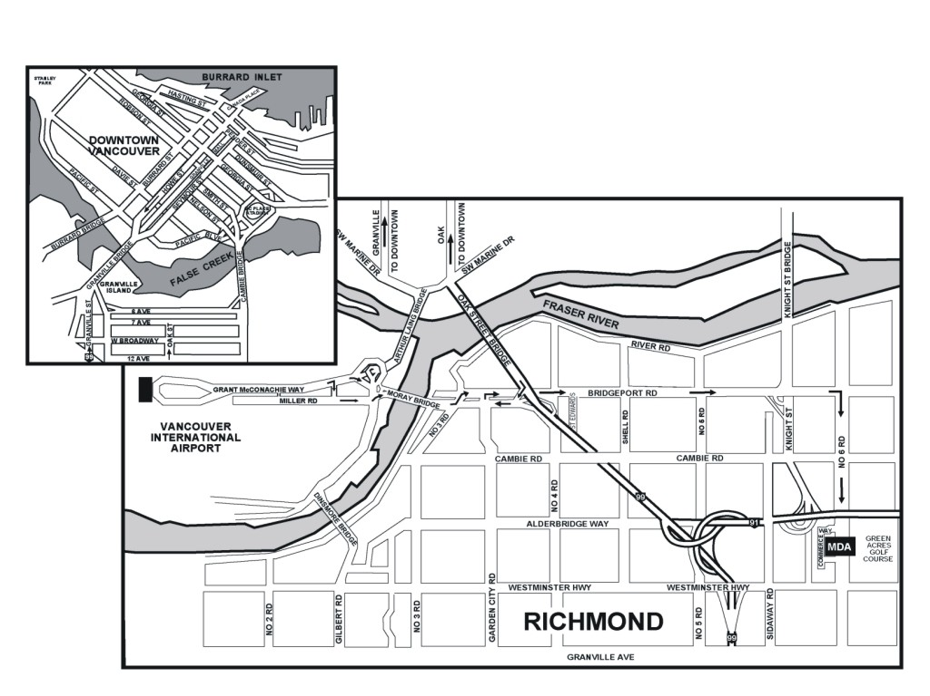

ANNEX 4
List of Chairpersons and Vice-Chairpersons*
Chairperson, Study Group 7
Mr. R. M. TAYLOR TEL: +1 409 285 9263
TT&C FAX: +1 409 285 0256
103 Oyster Creek Drive E-mail: robert@teleregs.com
Suite I.
LAKE JACKSON, TX 77566
United States of America
Vice-Chairpersons, Study Group 7
Mr. G. DE JONG TEL: +31 15 269 1500
NMi Van Swinden Laboratorium FAX: +31 15 261 2971
Schoemakerstraat 97 E-mail: gdejong@NMi.nl
2628 VK DELFT
Netherlands (Kingdom of the)
Mr. V. MEENS TEL: +33 5 612 73 808
CNES - DSO/RC/BF FAX: +33 5 612 81 574
BPI 2511 E-mail: vincent.meens@cnes.fr
18, avenue Edouard Belin
31401 TOULOUSE Cedex 04
France
Mr. J.B. WHITEOAK TEL: +61 2 9372 4110
Deputy Director FAX: +61 2 9372 4444
Australia Telescope National Facility E-mail: jwhiteoa@atnf.csiro.au
CSIRO
Corner Vimicra & Pembroke Rd.
MARSFIELD, NSW 2122
Australia
Chairperson, Working Party 7B
Mrs. S. TAYLOR TEL: +1 281 483 0122
NASA Johnson Space Center FAX: +1 281 483 5200
Mail Code GT Email: shayla.e.taylor1@jsc.nasa.gov
HOUSTON, TX 77058
United States of America
Chairperson, Working Party 7C
Mr. E. MARELLI TEL: +31 71 565 4305
European Space Agency (ESA) FAX: +31 71 565 4696
ESTEC E-mail: emarelli@estec.esa.nl
Keplerlaan 1
Postbus 299
2200 AG NOORDWIJK
Netherlands (Kingdom of the)
Chairperson, Working Party 7D
Mr. J. B. WHITEOAK
(see address above)

Chairperson, Working Party 7E
Mr. John E. MILLER Tel.: +1 301 809 2272
Stanford Telecommunications, Inc. Fax: +1 301 262 2642
7501 Forbes Blvd., Suite 105 E-mail: john.miller@itu.int or
Seabrook, MD 20706 jemiller@cpcug.org
United States of America

ANNEX 5
Registration Form
ITU-R Meetings
Richmond, B.C., Canada
27 July - 4 August 2000
Radiocommunication
Bureau
I wish to participate in | WP 7E  27-28  July | WP 7B  31 July-  4 August | WP 7C  31 July-  4 August | WP 7D  31 July-  4 August
Mr. Mrs. Ms. Miss:
(family name) (first name)
Accompanied by:
(family name) (first name)
1. REPRESENTATION
Name of Member State:
❒ Head of Delegation  Deputy  Delegate
(to be completed by representatives of Member States only)
Name of Sector Member: ..
❒ Recognized Operating Agencies
❒ Scientific or Industrial Organizations
❒ Regional and other International Organizations
❒ Regional Telecommunication Organizations
❒ Intergovernmental Organizations Operating Satellite Systems
❒ Other Entities Dealing with Telecommunication Matters
❒ United Nations and its Specialized Agencies
2. OFFICIAL ADDRESS
Name of the Company:
Street address:
City/State/Code/Country:
Business tel.: Fax:
E-mail: In case of emergency:
3. DOCUMENTS ☑ English
Date: Signature:
For BR Secretariat use only
Approved (if applicable) | Personal Section |  | Meeting Section |  | Pigeonhole
To be returned duly completed to the Radiocommunication Bureau |  | Place des Nations  CH-1211 Genève 20  Switzerland |  | Telephone: +41 22 730 5802  Telefax: +41 22 730 6600  Telex: 421000 UIT

* The chairmanship might change at the Radiocommunication Assembly 2000. The names and addresses can be found on http://www.itu.int/cgi-bin/htsh/compass/cvc_sg_list.sh after 15 June 2000.

