INTERNATIONAL TELECOMMUNICATION UNION
Radiocommunication Bureau
(Direct Fax N°. +41 22 730 57 85)

Circular Letter  3/LCCE/18 | 18 July 2001
To Administrations of Member States of the ITU and
Radiocommunication Sector Members participating in the
work of Radiocommunication Study Group 3
Subject: Meeting of Working Party 3K: Point-to-area propagation

Introduction
A meeting of Working Party 3K was foreseen in the programme of the Radiocommunication Study Groups by the meeting of Study Group Chairmen and Vice-Chairmen in June 2000 (see Administrative Circular CA/82).
Date and place of the meeting
Working Party 3K will meet from 7 to 13 November 2001.
The meeting will be hosted by the United Kingdom, Radiocommunications Agency, and will take place at the following address:
King’s Manor
Exhibition Square
York, Y01 7EP
United Kingdom
Services directly connected with meeting activities, such as delegate registration, document distribution, etc., will be located near the meeting room. Registration will open at 08:30 hours on 7 November, and the meeting will commence at 09:30 hours.
Programme of the meeting
The draft meeting agenda together with a list of the assigned Questions and relevant documentation is given in Annex 1.
Working language
Working Party 3K will conduct its work in English.
Contributions
Contributions in response to the work of Working Party 3K are invited. Contributions will be processed and dispatched in accordance with Resolution ITU-R 1-3, and posted on TIES/ITUDOC.
One copy of each contribution should be sent to the Secretariat, Radiocommunication Bureau, for processing, to the Chairman of the relevant Working Party and to the Chairman and Vice-Chairmen of Radiocommunication Study Group 3. The pertinent addresses can be found in Annex 2 to this Circular. Participants are encouraged to submit contributions by electronic mail as outlined in Revision 2 to Administrative Circular CA/17 of 16 April 1999 to:
lisa.lundby@itu.int
Documents received up to 6 weeks in advance of the meeting are dispatched, as far as possible, before the meeting in their original language. Later contributions, received up to 7 days in advance of the meeting, are made available at the opening of the meeting in the original working language and, if possible, in English. The Secretariat cannot guarantee that documents received after 7 days before the opening date of the meeting can be made available for the opening and submissions received later than 12:00 hours (Geneva time) on 5 November cannot be accepted. Resolution ITU-R 1-3 provides that contributions which are not available to participants at the opening of the meeting shall not be considered.
Hotel accommodation and arrival information
Annex 3 contains details regarding the venue and hotel accommodation, and delegates are advised to make reservations at the earliest opportunity. Also included in Annex 3, is information concerning arrival in York, together with a map indicating the meeting location.

Participation
The intended participation of your representative(s) should be advised not later than one month before the opening of the meeting, by means of the annexed form (Annex 4) (to be photocopied as required).
Robert. W. Jones
Director, Radiocommunication Bureau
Annexes: 4
Distribution:
- Administrations of Member States and Radiocommunication Sector Members participating in the work of Working Party 3K of Radiocommunication Study Group 3
- Chairman and Vice-Chairmen of Radiocommunication Study Group 3
- Secretary General of the ITU, Director of the Telecommunication Standardization Bureau, Director of the Telecommunication Development Bureau
ANNEX 1
Draft Agenda for the meeting of Working Party 3K
7 – 13 November 2001
York, United Kingdom
(Opening at 9:30 hours on 7 November 2001)

1 Opening remarks
2 Approval of agenda
3 Questions assigned to the Working Party
4 Examination of WP 3K Chairman's Report, Document 3K/1
5 Issues concerning future WRCs
6 Work programme
6.1 Propagation aspects concerning terrestrial path specific prediction methods in the frequency range 30 MHz - 3 GHz (3K-1)
6.2 Propagation aspects concerning terrestrial path general prediction methods in the frequency range 30 MHz - 3 GHz (3K-2)
6.3 Propagation aspects concerning short-path personal communications and wireless LANS in the frequency range 300 MHz - 100 GHz (3K-3)
6.4 Propagation aspects concerning terrestrial wireless access systems (3K-4)
6.5 Building entry loss
6.6 Handbooks
7 Liaison with other groups (including responses to liaison statements)
8 Future work programme
9 Any other business

R. GROSSKOPF
Chairman, Working Party 3K

Documentation relevant to the meeting of Working Party 3K

– Question ITU-R 203-2/3

– Question ITU-R 211-1/3

– Chairman's Report, Doc. 3K/1

– Contributions to agenda items, received in accordance with Resolution ITU-R 1-3

annex 2
List of Chairmen and Vice-Chairmen

Study Group 3

Dr. D.G. COLE
Chairman, Study Group 3
IPS Radio & Space Services
PO Box 1386
HAYMARKET NSW 1240
Australia
Tel: +61 2 92138001
Fax: +61 2 92138060
E-mail: david@ips.gov.au

Mr. B. ARBESSER-RASTBURG
Vice-Chairman, Study Group 3
European Space Agency (ESA)
ESTEC, TOS-EEP
Keplerlaan 1
2200 AG NOORDWIJK
Netherlands (Kingdom of the)
Tel: +31 71 5654541
Fax: +31 71 5654999
E-mail: bertram@xe.estec.esa.nl/
B.Arbesser-Rastburg@ties.itu.int

Mr. D.V. ROGERS
Vice-Chairman, Study Group 3
Communications Research Centre
3701 Carling Avenue
OTTAWA, Ontario K2H 8S2
Canada
Tel: +1 613 9985174
Fax: +1 613 9984077
E-mail: dave.rogers@crc.ca
Working Party 3K

Mr. R. GROSSKOPF
Chairman, Working Party 3K
Institut für Rundfunktechnik GmbH
Florianmühlstrasse 60
80939 MÜNCHEN
Germany (Federal Republic of)
Tel: +49 89 32399409
Fax: +49 89 32399351
E-mail: grosskopf@irt.de

annex 3
(English only)
Hotel accommodation and arrival information
The City of York
Steeped in history, York is one of the classic cities of the United Kingdom. In AD 71 a Roman fortress was founded and in 306 Constantine I was proclaimed Roman Emperor in York. Captured by the Vikings in 866 York became involved in a series of battles, the last of which took place in 1069 when it was subdued by William the Conqueror.
York received its first Royal Charter in 1158 which heralded its coming of age as a Merchant community. Its growth was challenged periodically by several serious fires and by four bouts of the plague, the last in 1832 just after the opening of the world's first railway (Stockton and Darlington railway 1825).
York's very fabric lends it an atmosphere which is almost tangible and provides an excellent environment for study.
The Venue - King's Manor
Situated in the city centre in Exhibition Square, King's Manor was originally the residence of the Abbot of St. Mary's Abbey, and parts of the building date back to the late 13th century.
It subsequently became the headquarters of the Council of the North, and in the late 17th century parts of the building were used as a school. In the 1960's the building became a part of the University of York, and today houses the world renowned Department of Archaeology, Centre for Medieval Studies and Centre for 18th Century Studies. Further details about King's Manor can be found at
www.york.ac.uk/admin/presspr/kmanor/
and a virtual tour is available at
www.york.ac.uk/depts/arch/kmtour/
The meeting will take place in the Huntingdon Room and associated spaces.
Travel
Two routes are recommended for overseas visitors arriving by air.
Arriving at Manchester International Airport: Take the train from the airport to York. This is an hourly service with a journey time of two hours. Cost is around £22.
Arriving at London Heathrow: Transfer to London King's Cross Railway Station by Tube or Heathrow express. Trains to York run at half hour intervals with a journey time of about two hours.
The attached street-map shows the location of the meeting place and covers an area of about 1.5km x 1.0km. Further maps can be found at www.streetmap.co.uk or at www.multimap.co.uk .
Hotels
There are many hotels and guest houses in York. The following hotels are within a few minutes walking distance (closest first) and are all 3-4 star quality. Participants are requested to make reservations directly with the hotel of their choice. To obtain the prices indicated, you must mention that your reservation is for a guest attending a conference at the University of York. For information on other hotels in York, please contact the York Visitor and Conference Bureau on +44 1904 554453.

Dean Court Hotel
Duncombe Place
York YO1 7EF
Tel +44 1904 625082
Fax +44 1904 620305
Price (Single) £69

The Grange Hotel
1 Clifton
York YO30 6AA
Tel +44 1904 644744
Fax +44 1904 612453
E-Mail info@grangehotel.co.uk
Price (single) £85

The Royal York Hotel
Station Road
York YO24 1AA
Tel +44 1904 653681
Fax +44 1904 623503
Price (single) £77

The Queens Hotel
Queens Staith Road
York YO1 6DH
Tel +44 1904 611321
Fax +44 1904 611388
Price (single) from £50

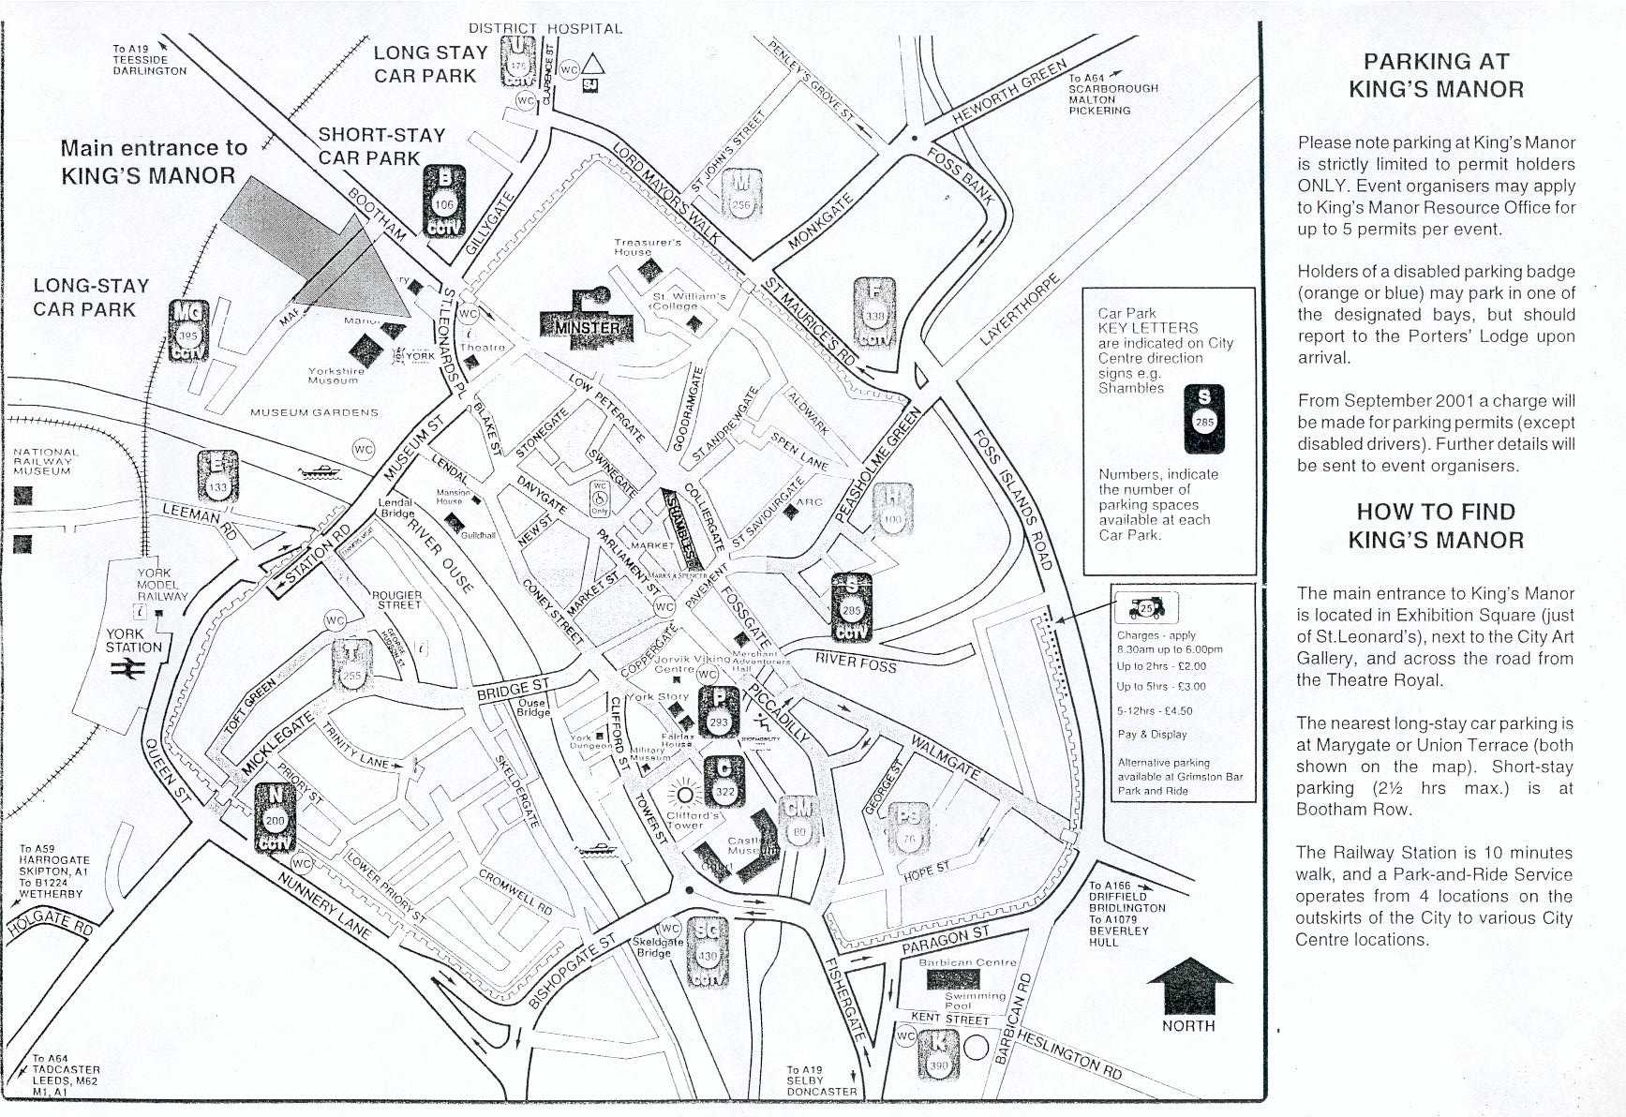
annex 4
Radiocommunication Bureau
Working Party 3K
York – United Kingdom, 7-13 November 2001

I wish to participate in
WP 3K
✓
Mr. Mrs. Ms. Miss:
(Family name) (First name)
Accompanied by:
(Family name) (First name)
1. Representation
Name of Member State:
❒ Head of Delegation  Deputy  Delegate
(To be completed by representatives of Member States only)
Name of Sector Member:
❒ Recognized Operating Agencies
❒ Scientific or Industrial Organizations
❒ Other Entities dealing with Telecommunication matters
❒ Regional and other International Organizations
❒ Regional Telecommunication Organizations
❒ Intergovernmental Organizations operating Satellite Systems
- United Nations and its Specialized Agencies
- Associate Members
2. Official Address
Name of the Company:
Street Address:
City/State/Code/Country:
Business tel.: Fax:
E-mail: In case of emergency:
3. Documents
☑ English only
Date: Signature:
For BR Secretariat use only
Approved (if applicable) |  | Personal Section | Meeting Section |  | Pigeonhole
Place des Nations | Telephone +41 22 730 58 02 |  |  | Telex 421 000 uit ch |  | E-mail: itumail@itu.int
CH-1211 Geneva 20 | Telefax Gr3: +41 22 730 66 00 |  |  | Telegram ITU GENEVE |  | www.itu.int
Switzerland
____________

