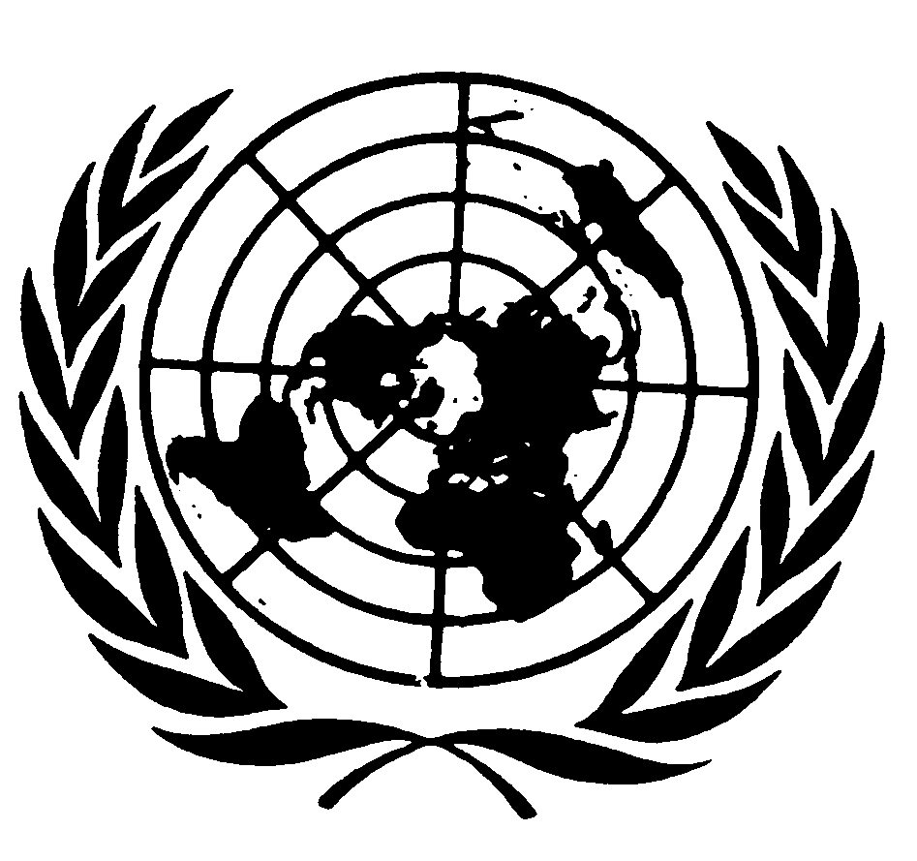
U N I T E D N A T I O N S N A T I O N S U N I E S

THE SECRETARY- GENERAL
--
MESSAGE ON WORLD RADIO DAY
13 February 2015

On World Radio Day, we celebrate a medium that captures the imagination and brings people together.

This year United Nations Radio, along with the United Nations, celebrates its 70th anniversary. Every year, United Nations Radio broadcasts over 1,200 documentaries, news items and editorials over the airwaves.

This year’s observance of World Radio Day highlights the importance of radio to the world’s 1.8 billion young women and men.

Radio matters for youth across the world.

As the international community shapes new sustainable development goals and a new global agreement on climate change, we need to hear the voices young women and men, loudly, strongly and urgently.

