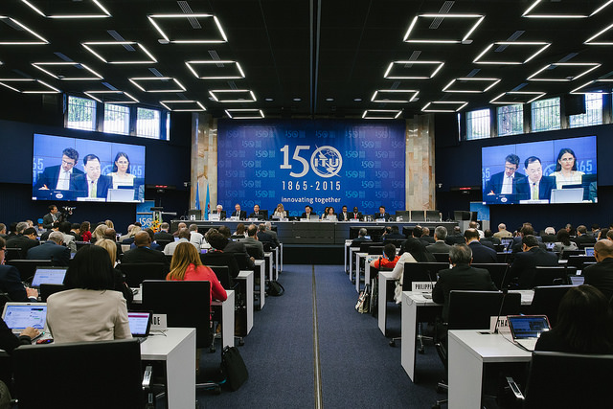



**2016 ITU YOUNG ICT POLICY LEADERS PROGRAMME**

**ABOUT**

The ITU Young ICT Policy Leaders (YIPL) programme is reserved for the exclusive participation of delegates under the age of 35 taking part if the 2016 Session of ITU Council (C-16). The programme, integrated into the main agenda of Council, provides a platform for delegates to network and meet global experts from the ICT sector, to nurture knowledge and to benefit from the exchange of experiences at an international level.

**OBJECTIVES OF THE 2016 EDITION**

The overall objective of the YIPL programme is to engage and empower the next generation of ICT policy makers, through knowledge and skills exchange, peer-to-peer mentoring and direct exposure to experienced leaders with a proven record of consensus building and consolidation. In particular, the 2016 edition of the YIPL will aim at:

* Learn from the real life experiences of peers – successes and challenges – and be inspired to further pursue personal development goals.
* Identify opportunities to advice and suggest working method and environment that would accommodate the requests and needs of the next generation of ITU delegates.

**PLANNED ACTIVITIES**

|  |
| --- |
| ***Panel discussion: How did you get there, sharing experiences*** |
| This session will involve two experienced delegates who will share their experience in international public policy, including their experience in ITU, as well as their successes and the challenges they faced within their professional career. Session panelists should have experience in leadership roles in various settings, in addition to or outside of the ITU Council, including within their administration. The intervention from the panelists will be will be followed by interactive discussion with YIPL participants.  Proposed moderator: Doreen Bogdan, Chief of ITU Strategic Planning and Membership Department  Proposed panelists  ***26 May 2016, 13:15-14:15, Room G1*** |
| ***Interactive dialogue: Ten years from now, shaping the future ITU*** |
| This session will discuss and share views and suggestions from the future policy leaders on how to improve ITU meetings, processes and services in the future. This interactive discussion will focus on how the next generation of ITU Delegates would like to see ITU, including its governing bodies and other main conferences.  Proposed moderator: Ahmed El-Sherbini, Chief, Conference and Publication Department  Proposed panelists  ***1 June 2016, 13:15-14:15, Room G1*** |
| ***Networking apéro: Meet the Young ICT Policy Leaders*** |
| This special event for Young ICT Policy Leaders at Council 16 will encourage networking between Young ICT Policy Leaders, special guests from the Council 16 conference, as well as the Geneva diplomatic community.  ***30 May 2016, 12:30-13:00, ICT Discovery*** |

**FURTHER INFORMATION**

* URL: [www.itu.int/council](http://www.itu.int/council)
* Contact information: [youth@itu.int](mailto:youth@itu.int)