World Telecommunication Standardization Assembly (WTSA-16)
Hammamet, 25 October - 3 November 2016
PLENARY MEETING |  | Addendum 16 to  Document 48-E
 |  | 9 October 2016
 |  | Original: English
United States of America
Proposed modification of wtsa-12 resolution 1
Abstract: | The United States fully supports CITEL IAP 10, in WTSA-16 Doc. 46(Add.10) as a priority, regarding modifications to Resolution 1. In addition, however, the U.S. proposes to suppress Section 2.3.2 as redundant, and to modify Section 2.3.3 to make the rules of procedure governing participation in meetings of regional study groups consistent with the general principles of openness, transparency and broad participation necessary to create worldwide standards reflected in the Constitution and Convention. The U.S. also proposes further clarity in Section 5 regarding the Duties of the TSB Direction, as well as section 7.2.3 regarding the approval of Questions if consensus is not achieved.

Introduction:

The Constitution charges the T-Sector with the responsibility to formulate Recommendations “with a view to standardizing telecommunications on a worldwide basis….” (CS104). The ITU Convention (CV) specifies that study groups are to fullfill this function within the T-Sector (CV193), and that study groups are to prepare “for the world telecommunications standardization assembly a report indicating the progress of work…” (CV 194).

Accordingly, in light of the Constitution and Convention, Sections 2.3.2 and 2.3.3 of Resolution 1 are not consistent with the general principles embodied in these provisions of openness, transparency and broad participation necessary to create worldwide standards. It should therefore be clear that participation in Regional Study Group is open to all Member States and Sector Members, regardless of what Region they represent.

Lastly, Section 5 regarding the Duties of the Director is modified in order to provide further clarity in the overall management of the Sector, consistent with the Strategic Plan of the Union in Resolution 71 (Rev. Busan, 2014), as well as section 7.2.3 regarding the approval of Questions if consensus is not achieved.

Proposal: While fully supporting CITEL IAP-10 (WTSA-16 Doc. 46(Add.10)) as a priority, the U.S. proposes to suppress Section 2.3.2 and to modify Section 2.3.3 and Section 5 of Resolution 1.

MOD USA/48A16/1
RESOLUTION 1 (REV. HAMMAMET, 2016)
Rules of procedure of the ITU Telecommunication
Standardization Sector
(Hammamet, 2016)1
The World Telecommunication Standardization Assembly (Dubai, 2012),
considering
a) that the functions, duties and organization of the ITU Telecommunication Standardization Sector (ITU-T) are stated in Article 17 of the ITU Constitution and Articles 13, 14, 14A, 15 and 20 of the ITU Convention;
b) that, in accordance with the above articles of the Constitution and Convention, ITU-T shall study technical, operating and tariff questions and adopt Recommendations with a view to standardizing telecommunications on a worldwide basis;
c) that the ITU-T Recommendations resulting from these studies must be in harmony with the International Telecommunication Regulations in force, complement the basic principles therein and assist all those concerned in the provision and operation of telecommunication services to meet the objectives set down in the relevant articles of those Regulations;
d) that, accordingly, the rapid developments in telecommunication technology and services require timely and reliable ITU-T Recommendations to assist all Member States in the balanced development of their telecommunications;
e) that general working arrangements of ITU-T are stated in the Convention;
f) that the General Rules of conferences, assemblies and meetings of the Union adopted by the Plenipotentiary Conference, and Resolution 165 (Guadalajara, 2010) of the Plenipotentiary Conference, on deadlines for the submission of proposals and procedures for the registration of participants for conferences and assemblies of the Union, apply to the World Telecommunication Standardization Assembly (WTSA);
g) that, in accordance with No. 184A of the Convention, WTSA is authorized to adopt the working methods and procedures for the management of the activities of ITU-T in accordance with No. 145A of the Constitution;
h) that careful review of the more detailed working arrangements has been made in order to adapt them to meet the increasing demand for developing Recommendations with the most effective use of the limited resources available to Member States, Sector Members and ITU headquarters,
recognizing
that Resolution 72 (Rev. Busan 2014), in recognizing a), requires transparency in the operation of all Union activities,
resolves
that the provisions referred to in considering e), f), g) and h) above shall be further elaborated by the provisions of this resolution and in the resolutions to which they refer, bearing in mind that, in the case of inconsistency, the Constitution, the Convention, the International Telecommunication Regulations and the General Rules of conferences, assemblies and meetings of the Union (in that order) shall prevail over this resolution.
…….
SECTION 2
Study groups and their relevant groups

2.1 Classification of study groups and their relevant groups
2.1.1 WTSA establishes study groups in order for each of them:
a) to pursue the goals laid down in a set of Questions related to a particular area of study in a task-oriented fashion;
b) to review and, as necessary, to recommend amendment or deletion of existing Recommendations and definitions within its general area of responsibility (as defined by WTSA), in collaboration with their relevant groups as appropriate.
2.1.2 To facilitate their work, study groups may set up working parties, joint working parties and rapporteur groups to deal with the tasks assigned to them.
2.1.3 A joint working party shall submit draft Recommendations to its lead study group.
2.1.4 A regional group may be established within a study group to deal with Questions and studies of particular interest to a group of Member States and Sector Members in an ITU region.
2.1.5 A study group may be set up by WTSA in order to carry out joint studies with the ITU Radiocommunication Sector (ITU-R) and prepare draft Recommendations on questions of common interest. ITU-T shall be responsible for the management of this study group and approval of its Recommendations. WTSA shall appoint the chairman and vice-chairman of the study group2, in consultation with the Radiocommunication Assembly as appropriate, and receive the formal report of the work of the study group. A report for information may also be prepared for the Radiocommunication Assembly.
2.1.6 A study group may be designated by WTSA or TSAG as the lead study group for ITU-T studies forming a defined programme of work involving a number of study groups. This lead study group is responsible for the study of the appropriate core Questions. In addition, in consultation with the relevant study groups and in collaboration, where appropriate, with other standards bodies, the lead study group has the responsibility to define and maintain the overall framework and to coordinate, assign (recognizing the mandates of the study groups) and prioritize the studies to be carried out by the study groups, and to ensure the preparation of consistent, complete and timely Recommendations. The lead study group shall inform TSAG on the progress of the work as defined in the scope of the lead study group activity. Issues which cannot be resolved by the study group should be raised for TSAG to offer advice and proposals for the direction of the work.

2.2 Meetings outside Geneva
2.2.1 Study groups or working parties may meet outside Geneva if invited to do so by Member States, ITU-T Sector Members or entities authorized in this respect by a Member State of the Union, and if the holding of a meeting outside Geneva is desirable (e.g. in association with symposiums or seminars). Such invitations shall be considered only if they are submitted to a WTSA or to an ITU-T study group meeting and they shall be finally planned and organized after consultation with the Director of TSB and if they are within the credits allocated to ITU-T by the Council.
2.2.2 For meetings held outside Geneva, the provisions of Resolution 5 (Kyoto, 1994) of the Plenipotentiary Conference as well as of ITU Council Decision 304 shall apply. Invitations to hold meetings of the study groups or their working parties away from Geneva shall be accompanied by a statement indicating the host's agreement to defray the additional expenditure involved and that it will provide at least adequate premises and the necessary furniture and equipment free of charge, except that in the case of developing countries equipment need not necessarily be provided free of charge if the government of the host so requests.
2.2.3 Should an invitation be cancelled for any reason, it shall be proposed to Member States or to other duly authorized entities that the meeting be convened in Geneva, in principle on the date originally planned.

2.3 Participation in meetings
2.3.1 Member States and other duly authorized entities shall be represented in the study groups and their relevant groups, such as working parties and rapporteur groups, in whose work they wish to take part, by participants registered by name and chosen by them as qualified to investigate satisfactory solutions to the Questions under study. Exceptionally, however, registration by Member States and other duly authorized entities3 with a study group or its relevant group may be made without specifying the name of the participants concerned. Chairmen of meetings may invite individual experts as appropriate.

2.3.2 Consistent with the general principles of openness, transparency and broad participation necessary to create worldwide standards reflected in the Constitution and Convention, all meetings of study groups, regional groups of study groups, focus groups or any other group or meeting shall be open to all delegates and representatives from Member States, Sector Members and Associates of the study group.

2.4 Reports of study groups to WTSA
2.4.1 All study groups shall meet sufficiently in advance of WTSA for the report of each study group to WTSA to reach administrations of Member States and Sector Members at least one month before WTSA.
2.4.2 The report of each study group to WTSA is the responsibility of the study group chairman, and shall include:
– a short but comprehensive summary of the results achieved in the study period;
– reference to all Recommendations (new or revised) that have been approved by the Member States during the study period;
– reference to all Recommendations deleted during the study period;
– reference to the final text of all draft Recommendations (new or revised) that are forwarded for consideration by WTSA;
– the list of new or revised Questions proposed for study;
– review of joint coordination activities for which it is the lead study group.

…….
SECTION 5
Duties of the Director
5.1 The duties of the Director of TSB are outlined in Article 15 and relevant provisions of Article 20 of the Convention. These duties are further elaborated in this resolution.
5.2 The Director shall take the necessary preparatory measures for meetings of WTSA, TSAG, study groups and other groups, and coordinate their work so that the meetings produce the best results in the shortest possible time. The Director shall fix, by agreement with TSAG and study group chairmen, the dates and programmes of TSAG, study group and working party meetings and shall group these meetings in time according to the nature of the work and the availability of TSB and other ITU resources.
5.3 The Director shall ensure that the secretariat support assigned to the Study Groups and Regional Groups works to support membership to accomplish the objectives defined in the Strategic Plan (Resolution 71, Rev. Busan, 2014), in particular the adoption of non-discriminatory and technologically neutral international standards (ITU-T recommendations), and applies the highest standards of efficiency, transparency and objectivity, consistent with the United Nations Standards of Conduct for International Civil Servants;
5.4 The Director shall suggest editorial updates to WTSA resolutions and provide a recommendation as to whether the modifications are significant enough to warrant the production of a revised version.
5.5 The Director shall manage the allocation of the ITU-T financial and TSB human resources required for meetings administered by TSB in a manner that is consistent with the approved Strategic and Financial Plans of the Sector and the Council approved budget.
5.6 The Director shall promote the active participation of the membership, in particular developing countries, in the membership driven, bottom-up work of the ITU-T and shall publish, in the chairman’s report of each meeting of a Study Group or Regional Group, a complete account of resources used and fellowships requested and provided along with any extra budgetary resources expended.
5.7 For meetings administered by the TSB, the Director will disseminate associated documents to ITU-T Member States and Sector Members (meeting reports, contributions, etc.) for ITU-T publication, which will include authorized operational support functions for the international telecommunication network and services (Operational Bulletin, code assignments, etc.).
5.8 The Director shall provide the required liaison between ITU-T and other Sectors and the General Secretariat of ITU and with other standards development organizations (SDOs).
5.9 In the Director's estimate of the financial needs of ITU-T until the next WTSA as part of the biennial budgetary preparatory process, the Director shall provide to WTSA (for information) a summary of the accounts for the years which have elapsed since the preceding WTSA, and the estimated expenses of ITU-T to cover its financial requirements until the next WTSA for the subsequent biennial budgets and financial plan, as appropriate, taking into account the pertinent results of WTSA, including priorities.
5.10 The Director shall prepare the financial estimates in accordance with relevant provisions of the Financial Regulations and Financial Rules, taking into account the relevant decisions of WTSA, including priorities for the work of the Sector.
5.11 The Director shall submit for preliminary examination by the Budget Control Committee, and thereafter for approval by WTSA, the accounts for expenses incurred for the current WTSA.
5.12 The Director shall submit to WTSA a report on the proposals that have been received from TSAG (see 4.9) concerning the organization, terms of reference and work programme of study groups and all other groups active in the Sector for the next study period. The Director may give views on these proposals.
5.13 In addition, the Director may, within the limits specified in the Convention, submit to WTSA any report or proposal which would help to improve the work of ITU-T, so that WTSA may decide what action to take. In particular, the Director shall submit to WTSA such proposals concerning the organization and terms of reference of the study groups for the next study period, which reflect the expressed priorities of the membership.
5.14 The Director may request assistance from the study group and TSAG chairmen regarding proposals for potential candidates for study group and TSAG chairmen and vice-chairmen, for consideration by the heads of delegation.
5.15 After the close of WTSA, the Director shall supply administrations of Member States and Sector Members taking part in the activities of ITU-T with a list of the study groups and other groups set up by WTSA, indicating the general areas of responsibility and the Questions that have been referred to the various groups for study, and requesting them to advise the Director of the study groups or other groups in which they wish to take part.
Furthermore, the Director shall supply the international organizations with a list of the study groups and other groups set up by WTSA, asking them to advise the Director of the study groups or other groups in which they wish to participate in an advisory capacity.
5.16 Administrations of Member States, Sector Members and other participating organizations are invited to supply these particulars after each WTSA as soon as possible and not later than two months after they have received the Director's circular, and to update them regularly.
5.17 In the interval between WTSAs, when circumstances so demand, the Director is authorized to take exceptional measures to ensure the efficiency of the work of ITU-T within the limits of the credits available.
5.18 In the interval between WTSAs, the Director may request assistance from the chairmen of study groups and the chairman of TSAG regarding the allocation of available financial and human resources to be able to assure the most efficient work of ITU-T.
5.19 In consultation with the chairmen of study groups and the chairman of TSAG, the Director shall ensure an appropriate flow of executive summary information on the work of the study groups. This information should be designed to assist in following and appreciating the overall significance of the work progressing in ITU-T.
5.20 The Director shall foster cooperation and coordination with the other standardization organizations for the benefit of all members and report to TSAG on these efforts.

……
SECTION 7
Development and approval of Questions

7.1 Development of Questions
7.1.0 Development of a draft Question for approval and inclusion in the work programme of ITU-T may be processed, preferably:
a) through a study group and TSAG;
b) through a study group and further consideration in the relevant committee of WTSA, when the study group meeting is its last prior to a WTSA;
c) through a study group where urgent treatment is justified;
or,
through WTSA (see 7.1.10).
7.1.1 Member States, and other duly authorized entities, shall submit proposed Questions as contributions to the study group meeting which will consider the Question(s).
7.1.2 Each proposed Question should be formulated in terms of specific task objective(s) and shall be accompanied by appropriate information as listed in Appendix I to this resolution. This information should clearly justify the reasons for proposing the Question and indicate the degree of urgency, while taking into account the relationship of the work of other study groups and standardization bodies.
7.1.3 TSB shall distribute the proposed Questions to the Member States and Sector Members of the study group(s) concerned so as to be received at least one month before the study group meeting which will consider the Question(s).
7.1.4 New or revised Questions may also be proposed by a study group itself during a meeting.
7.1.5 Each study group shall consider the proposed Questions to determine:
i) the clear purpose of each proposed Question;
ii) the priority and urgency of new Recommendation(s) desired, or changes to existing Recommendations resulting from the study of the Questions;
iii) that there be as little overlap of work as possible between the proposed Questions both within the study group concerned and with Questions of other study groups and the work of other standardization bodies.
7.1.6 Agreement by a study group to submit proposed Questions for approval is achieved by reaching consensus among the Member States and Sector Members present at the study group meeting when the proposed Question is discussed that the criteria in 7.1.5 have been satisfied.
7.1.7 TSAG shall be made aware by liaison statement from the study groups of all proposed Questions, in order to allow it to consider the possible implications for the work of all ITU-T study groups or other groups. In collaboration with the author(s) of proposed Question(s), TSAG shall review and, if appropriate, may recommend changes to these Question(s), taking into account the criteria in 7.1.5 above.
7.1.8 The opportunity for review of the Questions by TSAG prior to approval may be dispensed with only where urgent approval of the proposed Question is justified in the opinion of the Director of TSB, after consulting the chairman of TSAG and the chairman of any other study groups where overlap or liaison problems could arise.
7.1.9 A study group may agree to commence work on a draft Question before its approval.
7.1.10 If, despite the above provisions, a Member State or Sector Member proposes a Question directly to a WTSA, the latter either approves the Question or invites the Member State or Sector Member to submit the proposed Question to the next meeting of the relevant study group(s) to allow time for its thorough examination.
7.1.11 The Director shall take account of the relevant provisions of WTSA Resolution 44 (Rev. Dubai, 2012) in responding to any request submitted by developing countries5 through the Telecommunication Development Bureau (BDT), particularly with regard to matters connected with training, information, examination of questions which are not covered by the ITU-D study groups, and technical assistance required for the examination of certain questions by the ITU-D study groups. In order to allow for the specific characteristics of countries with economies in transition, developing countries, and especially the least developed countries, TSB shall take account of the relevant provisions of WTSA Resolution 44 (Rev. Dubai, 2012) in responding to any request submitted by such countries through BDT, particularly with regard to matters related to training, information, examination of questions which are not covered by the ITU-D study groups, and technical assistance required for the examination of certain questions by the ITU-D study groups.

7.2 Approval of Questions between WTSAs (see Figure 7.1a)
7.2.1 Between WTSAs, and after development of proposed Questions (see 7.1 above), the approval procedure for new or revised Questions is set out in 7.2.2 and 7.2.3 below.

figure 7.1a
Approval of questions between WTSAs
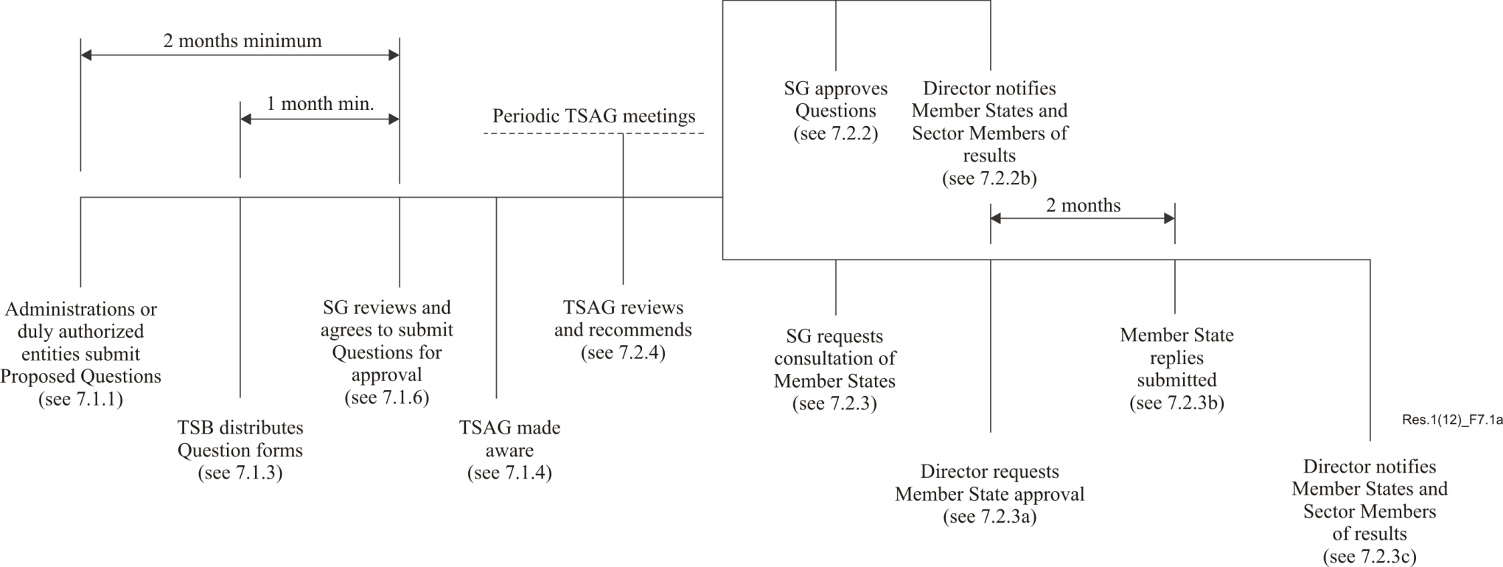

7.2.2 New or revised Questions may be approved by a study group if consensus at the study group meeting is achieved. In addition, some Member States and Sector Members (normally at least four) have to commit themselves to support the work, e.g. by contributions, provision of rapporteurs or editors and/or hosting of meetings. The names of the supporting entities should be recorded in the meeting report, together with the type of support to which they are committing.
a) The proposed Question, once approved, shall have the same status as Questions approved at a WTSA.
b) The Director shall notify the results by circular.
7.2.3 Alternatively, if the support as described in 7.2.2 has been offered, but consensus of the study group to approve a new or revised Question is not achieved, the study group may continue to consider the matter, terminate the matter, or request approval by consultation of the Member States.
a) The Director shall request Member States to notify the Director within two months whether they approve or do not approve the proposed new or revised Question.
b) A proposed Question is approved and has the same status as Questions approved at a WTSA, if:
– a simple majority of all the Member States responding are in agreement; and
– at least ten replies are received.
c) The Director shall notify the results of the consultation by circular. (See also 8.2.)
7.2.4 Between WTSAs, TSAG shall review the work programme of ITU-T and recommend revisions as necessary.
7.2.5 In particular, TSAG shall review any new or revised Question to determine whether it is in line with the mandate of the study group. TSAG may then endorse the text of any proposed new or revised Question or may recommend that it be modified. TSAG will note the text of any new or revised Question already approved.

7.3 Approval of Questions by WTSA (see Figure 7.1b)
7.3.1 At least two months prior to WTSA, TSAG shall meet to consider, review and, where appropriate, recommend changes to Questions for WTSA's consideration, while ensuring that the Questions respond to the overall needs and priorities of the ITU-T work programme and are duly harmonized to:
i) avoid duplication of effort;
ii) provide a coherent basis for interaction between study groups;
iii) facilitate monitoring overall progress in the drafting of Recommendations;
iv) facilitate cooperative efforts with other standardization organizations.
7.3.2 At least one month before WTSA, the Director shall inform the Member States and Sector Members of the list of proposed Questions, as agreed by TSAG.
7.3.3 The proposed Questions may be approved by WTSA in accordance with the General Rules.

Figure 7.1b
Approval of Questions at WTSA
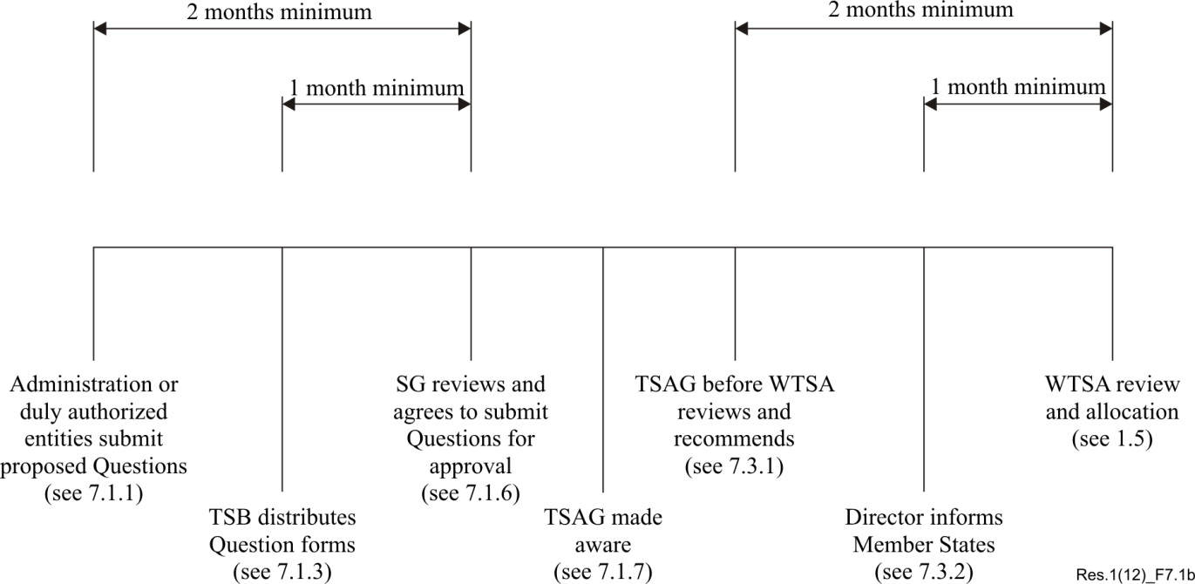

7.4 Deletion of Questions
Study groups may decide in each individual case which of the following alternatives is the most appropriate for the deletion of a Question.

7.4.1 Deletion of a Question between WTSAs
7.4.1.1 At a study group meeting, it may be agreed by consensus among those present to delete a Question, e.g. either because work has been terminated or because no contributions have been received at that meeting and at the previous two study group meetings. Notification about this agreement, including an explanatory summary about the reasons for the deletion, shall be provided by a circular. If a simple majority of the Member States responding has no objection to the deletion within two months, the deletion will come into force. Otherwise the issue will be referred back to the study group.
7.4.1.2 Those Member States which indicate disapproval are requested to provide their reasons and to indicate the possible changes that would facilitate further study of the Question.
7.4.1.3 Notification of the result will be given in a circular, and TSAG shall be informed by the Director. In addition, the Director shall publish a list of deleted Questions whenever appropriate, but at least once by the middle of a study period.

7.4.2 Deletion of a Question by WTSA
Upon the decision of the study group, the chairman shall include in his or her report to WTSA the request to delete a Question. WTSA will decide as appropriate.

1 Previously published (Geneva, 1956 and 1958; New Delhi, 1960; Geneva, 1964; Mar del Plata, 1968; Geneva, 1972, 1976 and 1980, Malaga-Torremolinos, 1984; Melbourne, 1988; Helsinki, 1993; Geneva, 1996; Montreal, 2000; Florianópolis, 2004; Johannesburg, 2008; Dubai, 2012).
2 In special cases, WTSA may appoint the chairman and request the Radiocommunication Assembly to appoint a vice-chairman.
3 See Article 19 of the Convention.
5 These include the least developed countries, small island developing states, landlocked developing countries and countries with economies in transition.

