User guide for Rapporteur Group meeting (RGM) document sharing

Very Important Notes:
- Single meeting document template – There is only one meeting document template provided and it may be used to build either a DOC, Contribution or a TD for a Rapporteur Group meeting of any ITU-T study group.
- File naming – Avoid special characters, such as: # % & * : < > ? / { | } ~ \ + ` ^
- Set track changes off – Before uploading your document, please make sure to set the track changes option in WinWord to off (REVIEW ribbon, Tracking Block, Track Changes button; see snapshot on the right). | 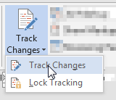

Steps:
- Access the main ITU-T Rapporteur Group Meeting (RGM) site - Log in with your TIES account* to:
https://extranet.itu.int/meetings/ITU-T/
* NOTE: Guest account access is also possible in special cases. Please consult with TSB.

- View a specific meeting - Select the meeting of interest from the list. See the example below, Q4/17 interim Rapporteur Group e-meeting (18+19 Jan 2016):
- Download the meeting document template - Click on Template download on the top menu to get to the RGM Template page. Download mtgdoc_template.docx. The meeting document template may be used to build either a Contribution, TD, or other working document for a rapporteur-group meeting.
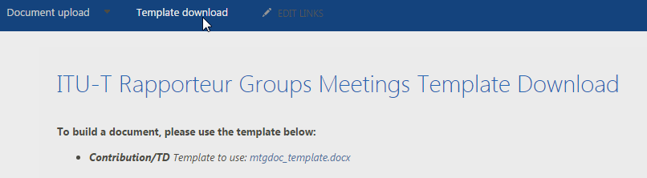

- Build a document - To build your document using the meeting document template, simply fill in the appropriate details:
- Title – Subject of the document.
- Purpose – Intended use of the document (N/A, Admin, Discussion, Information, Proposal, Other).
- Contact – Submitter’s name, role, email, telephone number, etc..
- Keywords – List of key terms, phrases, abbreviations, etc.
- Abstract – Summary of the purpose or content of the document.
- Text of the document – Content of the file, including text, tables, figures, etc.
The following items marked with (AUTO) will be automatically filled in by the system (Source and Questions will be prompted during upload):
- ShortDocNo – Automatic document number provided by the system.
- SGText – Related study group.
- Questions – Related study group Questions.
- Venue, date – Place and meeting date(s) of the rapporteur group meeting.
- RGM doc type – Type of rapporteur group meeting document (DOC, Contribution or TD).
- Source – Identifier of the submitter(s) of the document. For DOC and TDs the source is the submitter’s role (ex. Chairman, Rapporteur, Editor, etc.) and for Contributions it is the submitter’s country/organization.
Below is a view of an unfilled meeting document template:
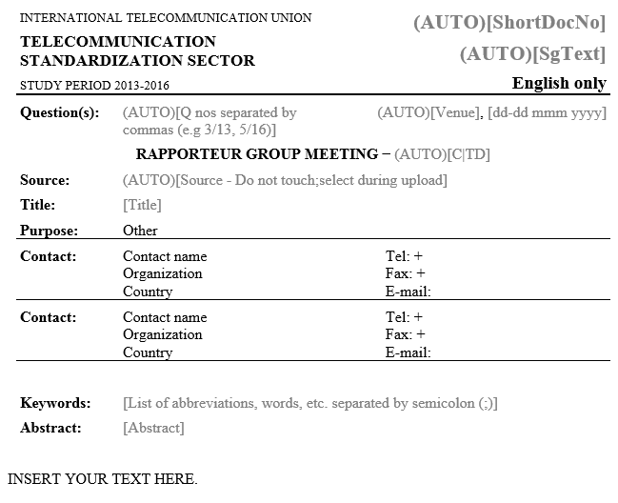

The following is an example of a properly filled in meeting document template (before upload):
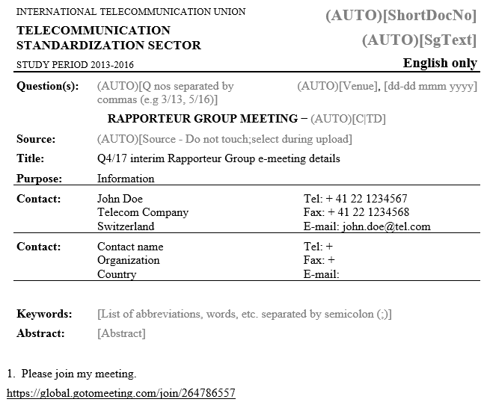
The following is an example of a properly filled in meeting document template (after upload):
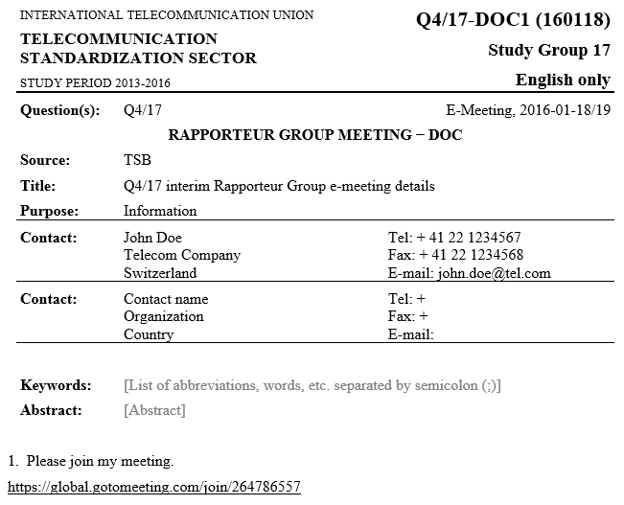
- Upload an RGM document - Choose a Document upload option from the top drop-down menu. The following document types may be uploaded: DOC, Revision and Attachment.
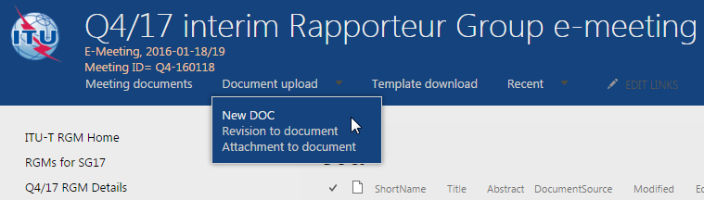
- Upload a DOC – To upload a new document, select New DOC from the Document upload drop-down menu. Click on Choose File button (in Mozilla browsers, e.g., Chrome and Firefox) or Browse button (in Internet Explorer), then select the document from your computer.
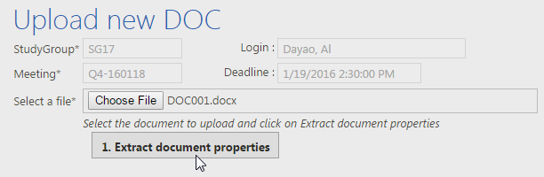
- After selecting the file, click on the Extract document properties button to display the details of the document.
- Fill in additional document details – To select the target Questions, click the terms icon and select the appropriate Question(s) from the list. After you have selected all the applicable Questions, click the OK button.
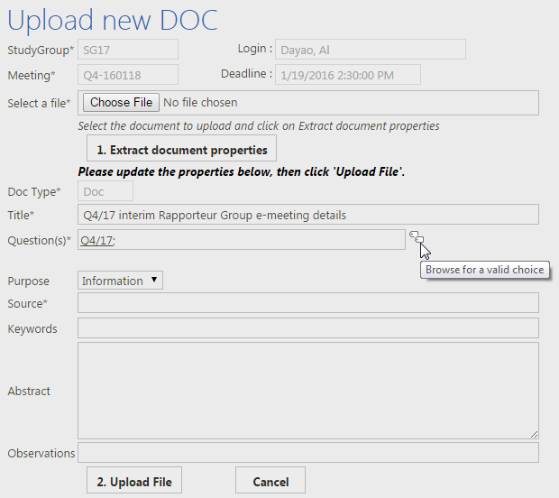
- To fill in the Source of the DOC, type in Role (e.g., Chairman, Rapporteur Qx/y, Editor R.xyz, etc.).
If you wish, you may also update other document details: Title, Purpose, Keywords, Abstract and Observations.
- Upload the document – Once you have confirmed that all document details are correct, click the Upload file button.
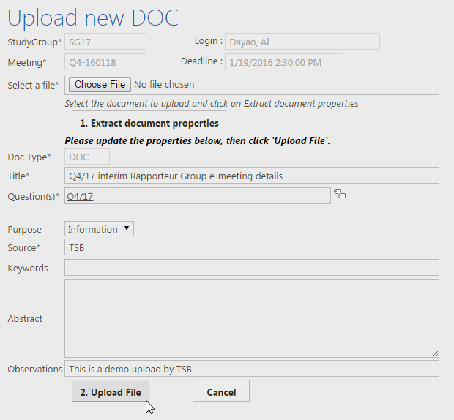
After your document is uploaded, a message will be displayed on the bottom of the page confirming the number of your document and a link to a page where it will be displayed and available for download. If you don’t immediately see the document, please refresh or reload the page.
- Upload a Revision to a document - To upload a revision to an existing document, select Revision to document from the Document upload drop-down menu.
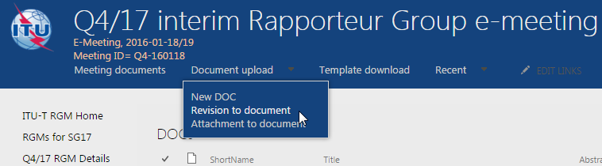
Select the original document to which the revision is to be associated. After the original document is selected, the details of the document are displayed.
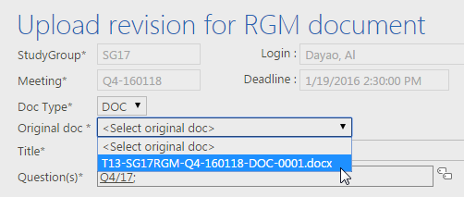
To select the file to be uploaded as revision to the selected original document, click on the Choose File button (or Browse button in Internet Explorer) to choose the file from your computer.
NOTE: Update the document details (Title, Purpose, Source, Abstract, etc.) if necessary and click the Upload Revision File button to upload the document.
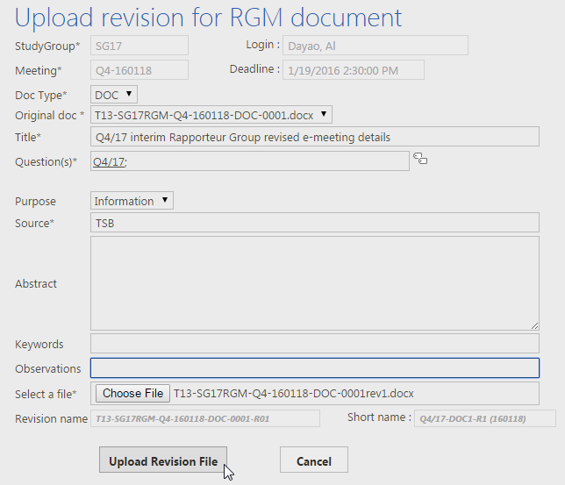
- Upload an Attachment to a document - To upload an attachment to an existing document, select Attachment to document from the Document upload drop-down menu.
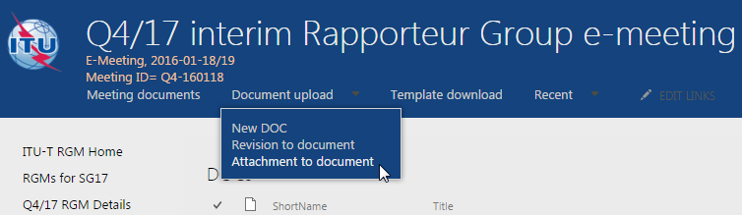
Select the original document to which the attachment is to be associated. After the original document is selected, the details of the document are displayed.
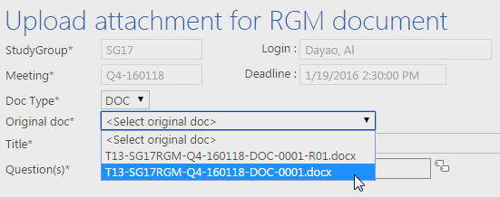
To select the file to be uploaded as attachment to the selected original document, click the Choose File button (or Browse button in Internet Explorer) to choose the file from your computer.
NOTE: Update the document details if necessary and click the Upload Attachment File button to upload the document.
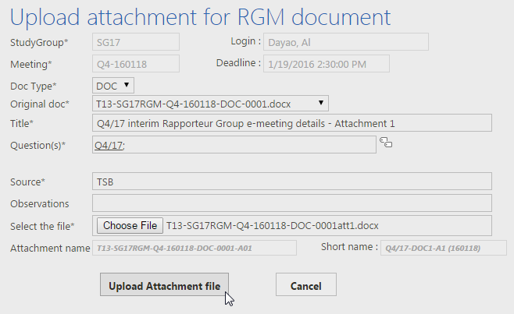
- Withdraw a document: This is an administrative task; contact TSB for assistance.

