(Version 2.0)

Practical information for the meeting of ITU-T Study Group 16  
(Sapporo, 30 June – 11 July 2014)

# 1 Introduction

The Ministry of Internal Affairs and Communications of Japan (MIC) is pleased to welcome the participants to the ITU-T Study Group 16 meeting, which will be held in Sapporo, 30 June – 11 July 2014, which is located in Hokkaido Island, north of Japan. This document provides practical information for the meeting and guidance to delegates for their stay in Sapporo.

# 2 Meeting venue

The ITU-T SG16 meeting venue is:

Sapporo Convention Center  
1-1-1 Higashi-Sapporo 6-jo, Shiroishi-ku, Sapporo 003-0006, Japan   
Tel: +81 11 817 1010  
Fax: +81 11 820 4300  
[http://www.sora-scc.jp/eng/index.html](http://www.sony.net/)

The location map of Sapporo Convention Center is found in **Figure 1.**

Figure 1

The location map of Sapporo Convention Center and recommended hotels

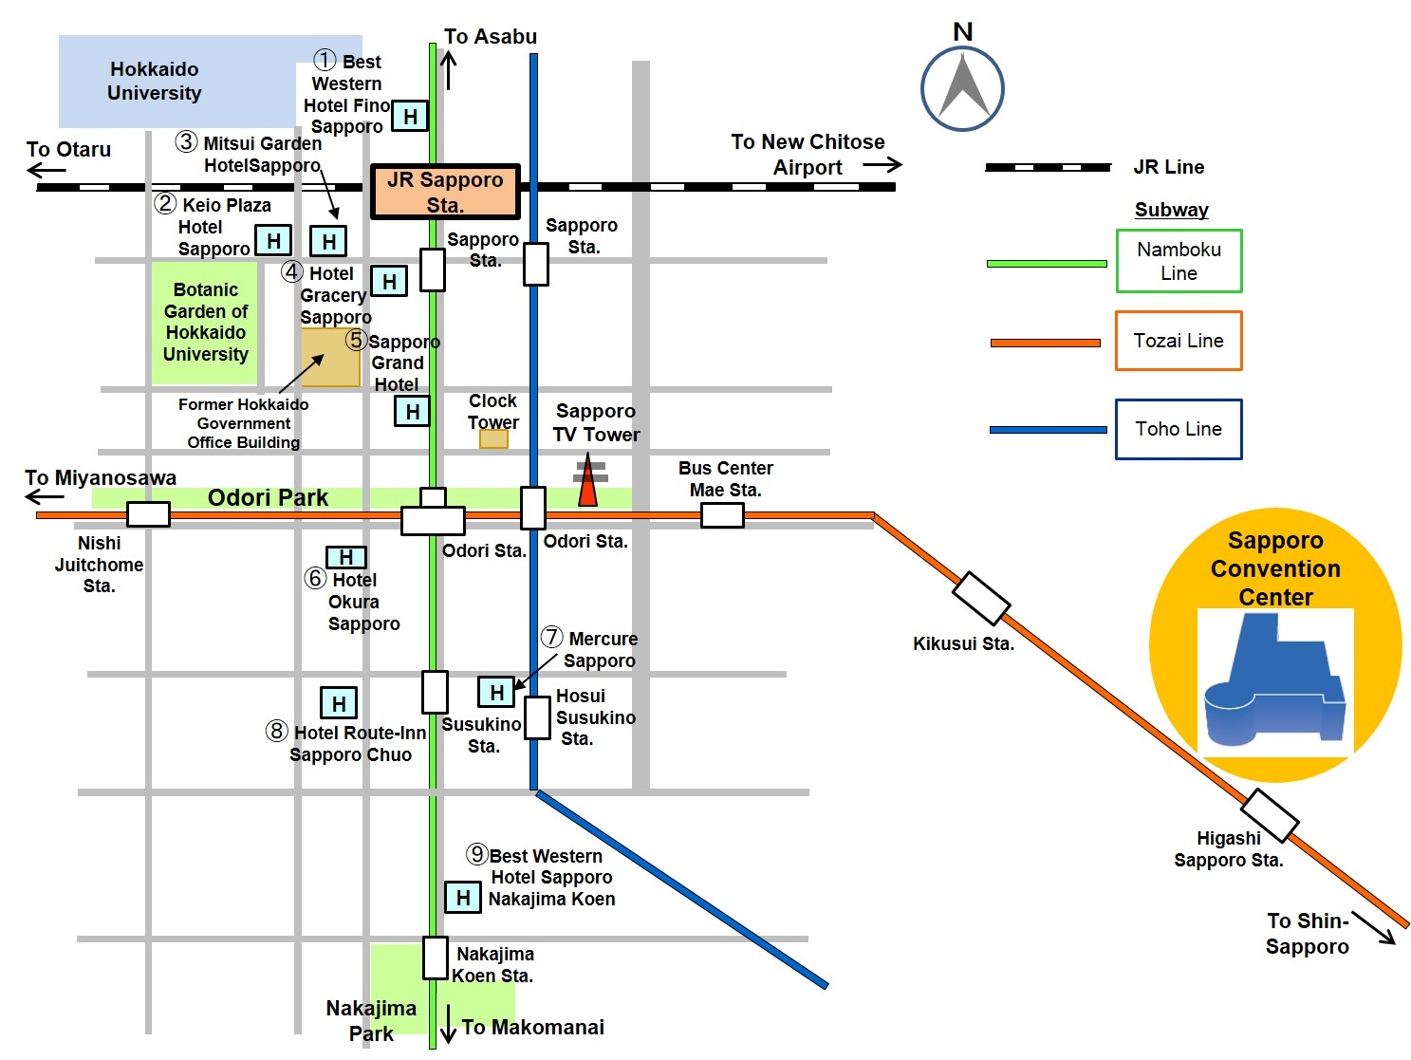

# 3 Registration

The plenary meeting will open at **1030 hours** on Monday, 30 June 2014 at the Meeting Room 204 on the second floor. Registration will commence at **0830 hours** in front of the Main Hall C/3 on the first floor. Registration service will resume at the Meeting Room 205 (Secretariat’s room) after the second day of meeting.

# 4 Access to the meeting venue

## 4.1 Flights to the New Chitose Airport

The New Chitose Airport is conveniently situated close to the city of Sapporo. It is connected with domestic flights to Japan’s main international airports at Narita (New Tokyo International Airport), Haneda (Tokyo International Airport), Nagoya (Chubu Centrair International Airport) and Kansai (Kansai International Airport). The New Chitose Airport has also regular direct international flights to various cities overseas (see **Figure 2**).

Please see [http://www.new-chitose-airport.jp/en](http://www.ttc.or.jp/e/) for more detailed information about New Chitose Airport.

FIGURE 2

Domestic and international service routes to New Chitose Airport

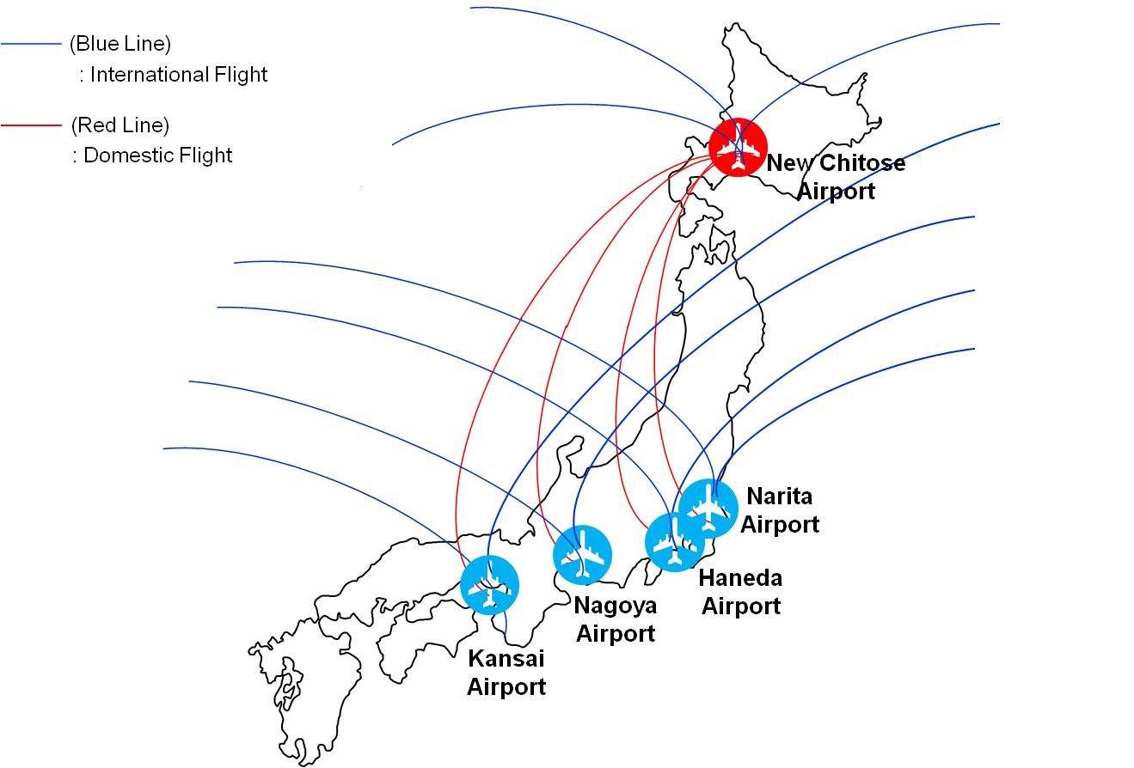

## 4.2 Transportation from New Chitose Airport to the Sapporo city area

JR Rapid Airport Express

The most convenient transportation is by JR (Japan Railway) Rapid Airport Express. JR New Chitose Airport Station is directly connected with New Chitose Airport. The Rapid Airport Express bound for JR Sapporo Station leaves every 15 mins and takes 36 mins The train fare is JPY 1,080. After arrival at JR Sapporo Station, newcomers who are not booking hotels within a walking distance from JR Sapporo Station had better go by taxi to their own hotel. It takes about 10 mins from JR Sapporo Station to the hotels shown in Figure 1. The taxi fare is about JPY 1,000.

Please see the website at [http://www.new-chitose-airport.jp/en/access/jr/](http://www.route-inn.co.jp/english/pref/hokkaido.html) for more detailed information about the JR Rapid Airport Express.

Airport Limousine Bus

An airport limousine bus service is available from the New Chitose Airport to Sapporo Downtown. There are two ticket counters, “Chuo bus” and “Hokuto Kotsu”. The “Chuo bus” counter is located in Japan Air Lines (JAL) arrival lobby and the “Hokuto Kotsu” counter is located in All Nippon Airways (ANA) arrival lobby. The airport limousine bound for Sapporo Downtown leaves every 15 mins. It takes about 70 mins from the New Chitose Airport to the JR Sapporo Station. The bus fare is JPY 1,030. There are several bus stops before and after the JR Sapporo Station and some of them may be close to hotels where you are staying. Since the bus route is complicated, it is recommended that newcomers get off the bus at the JR Sapporo Station and go by taxi to their own hotel.

Please see the following website [http://www.new-chitose-airport.jp/en/access/bus/](https://www.ituaj.jp/) for more detailed information about the airport limousine bus service.

## 4.3 Access to the Sapporo Convention Center

The Sapporo Convention Center is located approximately 8 min. walk from Higashi-Sapporo Subway Station of Subway Tozai Line. Participants who stay around JR Sapporo Station take Subway Namboku Line for Makomanai at Sapporo Subway Station. Get off at Odori Subway Station, which is the next one from Sapporo Sabway Station, and change to Tozai Subway Line for Shin-Sapporo. Higashi-Sapporo Subway Station is the 3rd one from Odori Subway Station. It takes about 15 mins from Sapporo Subway Station to Higashi-Sapporo Station.

The vicinity map around the Sapporo Convention Center is shown in **Figure 3**.

Several alternatives to get from the New Chitose Airport to the meeting venue are shown in **Figure 4** and **Table 1**.

Figure 3

The vicinity map around Sapporo Convention Center

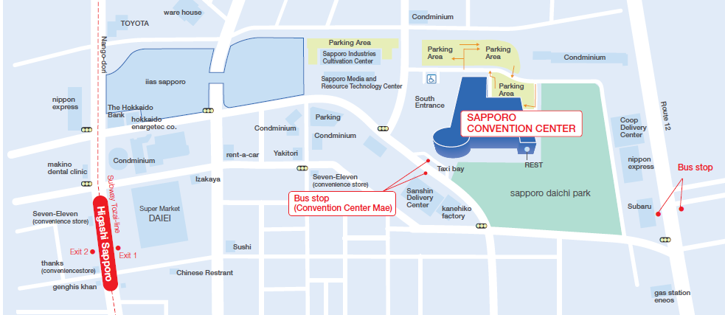

**To Odori**

**To Shin-Sapporo**

**Shopping Mall**

8 min. walk from Higashi-Sapporo Station

FIGURE 4

Transportation from New Chitose Airport to the Meeting Venue

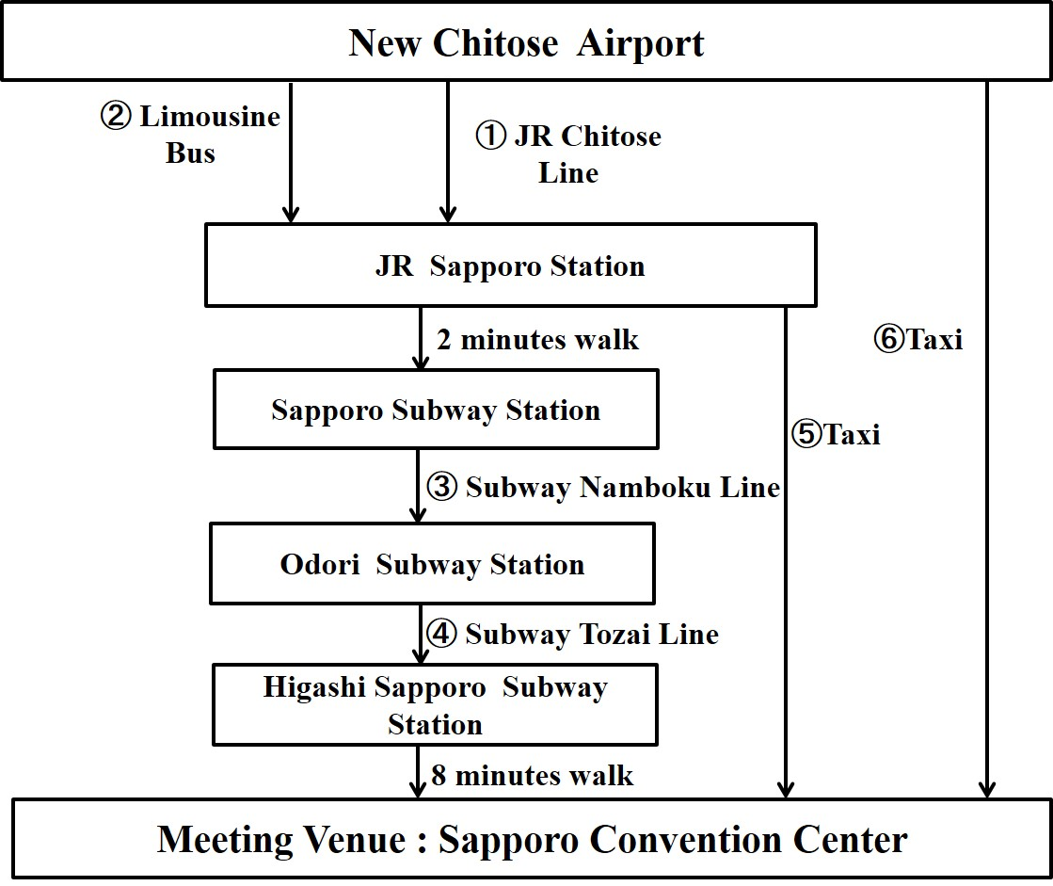

Table 1

Table of transportation for use from New Chitose Airport to the Meeting Venue

|  |  |  |  |  |
| --- | --- | --- | --- | --- |
| No.\*1 | Transportation | Approx. time required (minutes) | Fares\*2 (JPY) | Remarks |
| 1 | JR Chitose Line | 36 | 1,080 | Every 15mins |
| 2 | Limousine bus | 70 | 1,030 | Every 15mins |
| 3 | Subway Namboku Line | 15 | 240 | Every 7 mins |
| 4 | Subway Tozai Line | Every 7 mins |
| 5 | Taxi | 10 | Approx. 1,700 |  |
| 6 | Taxi | 50 | Approx. 14,000 | Including expressway fare |

\*1 The numbers in row correspond to the numbers in Figure 4.

\*2 Fares include 8% consumption tax.

# 5 Hotel accommodation

A total of 200 guest rooms have been booked with preferential rates for participants of the ITU-T SG16 meeting in Sapporo at the hotels listed in **Attachment 1**. Please note that no accommodations are available at the meeting venue (Sapporo Convention Center). The location map of those hotels is shown in **Figure 1**.

Hotel reservation will be carried out by an online system. Participants wishing to reserve a guest room of those hotels are requested to access to the following website managed by Japan Tourist Bureau (JTB) Global Marketing & Travel: [https://mice.jtbgmt.com/itu\_t\_sg16/](http://www.ntt.co.jp/index_e.html).

It is recommended that you print out a confirmation issued by the online system and show it at the check-in counter of the hotel. **All reservation requests must be made no later than 30 May 2014**. Availability and room rates are not guaranteed after the date.

# 6 Visa and immigration information

Participants who require a visa to enter Japan should apply for a visa at a Japanese consulate or diplomatic mission in their respective country well in advance of their departure.

Participants are also advised to contact their local travel agents or carriers. The embassy may take at least two weeks for visa processing.

For more information, please visit the website of the Ministry of Foreign Affairs of Japan at: [http://www.mofa.go.jp/j\_info/visit/visa/](http://www.sora-scc.jp/eng/index.html).

Participants who need visa support letters for entering Japan shall **fill out all items in Application Form in Attachment 2,** then email or fax the form to the following contact point together with **a copy of photograph page of the passport no later than 23 May 2014.**

Mr Hideki Suganami and Mr Junkichi Fujisawa  
The ITU Association of Japan  
Tel: +81 3 5357 7627  
Fax: +81 3 3356 8170  
E-mail: [t-sg16-visa@ituaj.jp](http://www.nec.com) (E-mail is the preferable communication means)

# 7 Network

Wireless and wired LAN services will be provided in the meeting room.

# 8 Welcome reception

A welcome reception will be held in the Sapporo Convention Center at 1730 hours on Tuesday, 1 July 2014.

# 9 Additional local events

**9.1 Showcasing**

The results of latest research and developments in ICT will be exhibited by manufacturers and institutes in Japan at the Meeting Room 108 on the first floor from 1 July to 4 July. Details on showcasing are informed in Attachment 3.

**9.2 Workshop**

Workshop cooperated with the Showcasing above will be held at the Small Hall on the second floor in the afternoon of 1 July. Details on Workshop are informed in Attachment 4.

# 10 General information

## 10.1 About Sapporo

Sapporo is the capital of Hokkaido Prefecture and fifth largest city in Japan, with a population of 1.9 million. The website [http://www.welcome.city.sapporo.jp/english/](http://www.keioplaza-sapporo.co.jp/english/) contains varied information about Sapporo.

A tourism application for smartphones is also available free of charge. Further information is provided at the following website: <http://www.hbc.co.jp/rocket/sapporoinfo/pc/index_en.html>.

## 10.2 Language

Japanese is the official language in Japan. However, English is spoken in major hotels, large restaurants, department stores and other major organizations and tourist locations.

## 10.3 Climate

July is the most comfortable season in Sapporo. The temperature during July ranges from 17 to 25 degrees centigrade. Average rainfall in July is about 80 mm.

## 10.4 Local time

Local time is GMT + 9 hours. Daylight saving time is *not* used.

## 10.5 Banks & currency

The Japanese currency unit is the Japanese Yen (JPY). There are four kinds of bills (10,000 yen, 5,000 yen, 2,000 yen and 1,000 yen) and six kinds of coins (500 yen, 100 yen, 50 yen, 10 yen, 5 yen and 1 yen) used. Only Japanese Yen (JPY) is accepted at stores and restaurants. Major foreign currencies may be exchanged to JPY at foreign exchange counters of banks at the international airports on presentation of your passport. Japanese banks are usually open Monday to Friday from 0900 to 1500 hours. The exchange rate as of 13 March 2014 is 102.78 Japanese Yen to 1 US Dollar. Major credit cards are normally accepted in most hotels, restaurants, department stores, but only cash is accepted in local smaller shops.

## 10.6 Tax

Consumption tax is increased from 5% to 8% after 1 April 2014 in Japan.

## 10.7 Tipping

Tipping is *not* customary in Japan.

## 10.8 Electricity

|  |  |
| --- | --- |
| The standard power supply in Japan is 100 Volts. The frequency is 50 Hz in eastern Japan, including Sapporo. The type of power outlet/‌connector used in Japan is A-type which is a two-parallel-pronged type (see illustration on the right). Most power outlets do *not* accept the three-pin plug used in North America or continental European plugs. Delegates are advised to bring with them an appropriate power outlet adapter. | type_a_large |

# 11 Insurance

The organizer does not accept responsibility for accidents that might occur. Participants are encouraged to purchase travel insurance that covers accidental loss of belongings, medical costs, and other possible risks.

# 12 Emergency phones

The nationwide emergency phone numbers are:

* Police: 110
* Ambulance/Fire: 119

# 13 Local contact point

If you have any questions about the meeting arrangements, please contact:

Mr Hideki Suganami and Mr Junkichi Fujisawa  
The ITU Association of Japan  
Tel: +81 3 5357 7627  
Fax: +81 3 3356 8170  
E-mail: [t-sg16-sapporo@ituaj.jp](http://www.welcome.city.sapporo.jp/english/) (E-mail is the preferable communication means)

ATTACHMENT 1

Hotel accommodation for the ITU-T SG16 meeting in Sapporo

| No\*0 | Hotel name | | Room type (occupancy)\*1 | Room rate\*2 (JPY) | |
| --- | --- | --- | --- | --- | --- |
| Room charge only | Including breakfast |
| 1 | Best Western Hotel Fino Sapporo |  | Single | 10,800 | 11,880 |
| URL | [http://sapporo.bwhotels.jp/](http://www.okura.com/domestic/hokkaido/okura_sapporo/) | | |
| 2 | Keio Plaza Hotel Sapporo |  | Single | 10,584 (11,124)\*3 (10,044)\*4 (11,664)\*5 | 11,664 (12,204)\*3 (11,124)\*4 (12,744)\*5 |
|  | Twin (single occupancy) | 16,848  (17,928)\*3  (15,768)\*4 (19,008)\*5 | 17,928 (19,008)\*3 (16,848)\*4 (20,088)\*5 |
|  | Twin (double occupancy) | 16,848  (17,928)\*3  (15,768)\*4  (19,008)\*5 | 19,008 (20,088)\*3 (17,928)\*4 (21,168)\*5 |
| URL | [http://www.keioplaza-sapporo.co.jp/english/](http://www.oki.com/) | | |
| 3 | Mitsui Garden Hotel Sapporo |  | Single | 10,500  (16,000)\*6 | 12,000  (17,500)\*6 |
|  | Twin (single occupancy) | 17,000  (28,000)\*6 | 18,500  (29,500)\*6 |
|  | Twin (double occupancy) | 17,000  (28,000)\*6 | 20,000  (31,000)\*6 |
| URL | <http://www.gardenhotels.co.jp/eng/sapporo/> | | |
| 4 | Hotel Gracery Sapporo |  | Single | 10,500 (9,700)\*3  (8,200)\*4 (12,500)\*5 | 11,500 (10,700)\*3  (9,200)\*4 (13,500)\*5 |
|  | Twin (single occupancy) | 14,200 (12,500)\*3 (11,000)\*4 (16,200)\*5 | 15,200 (13,500)\*3 (12,000)\*4 (17,200)\*5 |
|  | Twin (double occupancy) | 18,600 (17,000)\*3 (14,000)\*4 (22,600)\*5 | 20,600 (19,000)\*3 (16,000)\*4 (24,600)\*5 |
| URL | [http://sapporo.gracery.com/](mailto:t-sg16-visa@ituaj.jp) | | |
| 5 | Sapporo Grand Hotel |  | Single | 16,500 | 17,500 |
|  | Twin or Double (single occupancy) | 20,600 | 21,600 |
|  | Twin or Double (double occupancy) | 20,600 | 22,600 |
| URL | [http://www.grand1934.com/english/](http://www.mitsubishielectric.com/index.html) | | |
| 6 | Hotel Okura Sapporo |  | Double or Twin (single occupancy) | 15,120 | 16,200 |
|  | Twin (double occupancy) | 23,760 | 25,920 |
| URL | [http://www.okura.com/domestic/hokkaido/okura\_sapporo/](http://www.kddi.com/english) | | |
| 7 | Mercure Sapporo |  | Double (single occupancy) | 8,430 (12,225)\*6 | 9,430 (13,225)\*6 |
|  | Twin(double occupancy) | 9,500 (14,100)\*6 | 11,500 (16,100)\*6 |
| URL | [http://www.accorhotels.com/gb/hotel-7023-mercure-sapporo/index.shtml](http://www.new-chitose-airport.jp/en/access/bus/) | | |
| 8 | Hotel Route-Inn Sapporo Chuo |  | Single | - | 7,400 (6,850)\*7 (7,900)\*8 |
| URL | [http://www.route-inn.co.jp/english/pref/hokkaido.html](http://www.nhk.or.jp/english/) | | |
| 9 | Best Western Hotel Sapporo Nakajima Koen |  | Twin or Double (single occupancy) | 10,500 | 11,500 |
| URL | [http://sapporo-nakajimakoen.bwhotels.jp/](http://www.new-chitose-airport.jp/en) | | |

**Notes:**

|  |  |
| --- | --- |
| \*0 | Numbers in row correspond to numbers in Figure 1. |
| \*1 | “Single” or “Double” or “Twin” indicates the type of room; the text in parenthesis indicates single or double occupancy. |
| \*2 | Room rates include service charge and 8% consumption tax. |
| \*3 | 28 June |
| \*4 | 29 and 30 June |
| \*5 | 5 and 12 July |
| \*6 | 28 June, 5 and 12 July |
| \*7 | 29 June and 6 July |
| \*8 | 28 June, 4, 5, 11 and 12 July |

ATTACHMENT 2

Application form for Visa support letters

|  |
| --- |
| **ITU-T SG 16 meeting**  **Sapporo, Japan, 30 June - 11 July 2014** |
| **PRINT ALL ITEMS AND SAVE TO WORD OR PDF, THEN SEND BY E-MAIL** |
| **Name**   |  |  |  |  |  |  | | --- | --- | --- | --- | --- | --- | | (**🖵**Mr. **🖵**Ms.) |  |  |  |  |  |   Family Name Middle Name Given Name   |  |  | | --- | --- | | 漢字姓名(\*) |  |   **\*If you are a Chinese participant, please write your name in Chinese characters.**   |  |  | | --- | --- | | **Occupation** |  | | **Job title** |  | | **Company / Organization** |  | | **(\*\*):** |  |   **\*\*If you are a Chinese participant, please write your company/organization in Chinese characters as well.**   |  |  | | --- | --- | | **Country** (where you live) |  | | **Address (\*1)**: |  |   **(\*1) VISA supporting documents will be sent to the address above by courier service.**   |  |  |  |  |  |  | | --- | --- | --- | --- | --- | --- | | **Phone No:** |  | **Fax No:** |  | **E-mail:** |  |   **PASSPORT INFORMATION:**   |  |  |  |  |  |  | | --- | --- | --- | --- | --- | --- | | **Passport No:** |  | |  |  |  | | **Date of issue:** |  | (DD/MM/YYYY) | **Expiry date:** |  | (DD/MM/YYYY) | | **Place of birth:** |  | | **Date of birth:** |  | (DD/MM/YYYY) | | **Nationality:** |  | |  |  |  |   **THE DATE of ARRIVAL in / DEPATURE from JAPAN and FLIGHT INFORMATION** (\*2) **:**   |  |  |  |  |  |  |  |  |  |  |  | | --- | --- | --- | --- | --- | --- | --- | --- | --- | --- | --- | |  |  | Overseas airport |  | JPN airport |  | Date |  | Flight No. |  | Time | | Arrival in Japan | from |  | to |  |  |  |  |  |  |  | |  |  | JPN airport |  | Overseas airport |  | Date |  | Flight No |  | Time | | Departure from Japan | from |  | to |  |  |  |  |  |  |  |   **(\*2) For VISA support letters, a planned flight schedule is available as well.**  **HOTEL ACCOMMODATION**     |  |  |  |  |  |  | | --- | --- | --- | --- | --- | --- | | **Hotel name:** |  | |  |  |  | | **Address:** |  | | | **Phone No.:** |  | | **Check in date:** |  | (DD/MM/YYYY) | **Check out date:** |  | (DD/MM/YYYY) |   \* If making your own accommodation arrangement other than hotels, please indicate your contact address and phone  number:   |  |  |  |  |  | | --- | --- | --- | --- | --- | | **Name of contact person:** |  |  | | | | **Address** |  | | **Phone No.** |  |   **Date: Signature:**  **Deadline of submission: 23 May 2014 for all visa related documents** |
| **Please submit this form to:**  Hideki Suganami(Mr.)/Junkichi Fujisawa(Mr.) The ITU Association of Japan Tel: +81 3 5357 7627 Fax: +81 3 3356 8170 E-mail: [t-sg16-visa@ituaj.jp](http://www.mofa.go.jp/j_info/visit/visa/) (E-mail is the preferable communication means) |

ATTACHMENT 3

Showcasing

**Date & Time: July 1st (Tue) – 3rd (Thu) 10:00 - 17:00**

**July 4th (Fri ) 10:00 - 14:00**

**Location: Meeting Room 108 - 1F**

**Organizer: SG16 Sapporo Meeting Hosting Committee**

**Contents of Showcasing**

|  |  |
| --- | --- |
| Organization | Title of Exhibition |
| MIC  (Supported by NHK,NICT,SHARP) | 8K Video Demonstration using 85-inch Monitor |
| NICT | ①To Create a World Without Language Barriers (U-STAR)  ②"KoeTra" An application for the hearing impaired |
| NICT | Simple 3D Format (Global View and Depth) |
| MITSUBISHI ELECTRIC | IPTV terminal device based on ITU-T standards |
| MITSUBISHI ELECTRIC | High speed services over 10G-EPON access networks |
| NTT | Depth-based Free viewpoint TV |
| NTT | Reliable 4K H.265/HEVC Real-time Transmission by using MMT-FEC |
| FUJITSU | Application of Video Watermarking Technologies |
| NHK | 8K-UHDTV H.265/HEVC Real-time Encoder |
| OKI | ITU-T standards based IPTV solutions |
| 3Dragons | Full Color All-Round Parallax Display "Holo-Deck" |

ATTACHMENT 4

Workshop

**－Multimedia Technologies－**

**Date: TUESDAY 1 July 2014**

**Time: 13:15-16:25**

**Registration: 13:00**

**Location: Small Hall - 2F**

**Organizer: Workshop Program Committee**

**Support: Ministry of Internal Affairs and Communications**

**Cooperation: The Telecommunication Technology Committee**

**Member of Workshop Program Committee**

* *Kiyoshi Tanaka, Nippon Telegraph and Telephone Corporation*
* *Michiko Fukahori, National Institute of Information and Communications Technology*
* *Yushi Naito, Mitsubishi Electric Corporation*
* *Kazuhiko Tanaka, The ITU Association of Japan*
* *Yosuke Endo, Japan Broadcasting Corporation (NHK) / The Telecommunication Technology Committee IPTV Working Group Chair*

**Time Schedule:**

|  |  |
| --- | --- |
| * **Keynote Speech** | |
|  | |
| **13:15-13:30** | **Welcome** |
|  | * *Yushi Naito, SG16 Chairman, Mitsubishi Electric Corporation* |
|  | * *Toshihiro Matsui, Director, Standardization Division, Global ICT Strategy Bureau, Ministry of Internal Affairs and Communications* |
|  | * *Yoichi Maeda, CEO & S.V.P, The Telecommunication Technology Committee* |
|  |  |
| **13:30-13:45** | **Keynote Speech 1** |
|  | * *Toshiaki Fujita, Senior Vice President of Service Innovation Laboratory Group, Nippon Telegraph and Telephone Corporation* |
|  |  |
| **13:45-14:00** | **Keynote Speech 2** |
|  | * *Fumihiko Tomita, Vice President, National Institute of Information and Communications Technology* |
|  |  |
| **14:00-14:15** | **Keynote Speech 3** |
|  | * *Kenichi Tanaka, Fellow, Mitsubishi Electric Corporation* |

|  |  |
| --- | --- |
| * **Technical Session**: Organized by TTC MM-AG | |
|  |  |
| **Special Session** |  |
| **14:15-14:45** | **Invited Speech: Beyond the content distribution, and its technology** |
|  | * *Jay Kishigami, Professor, Muroran Institute of Technology / W3C Advisory Board* |

|  |  |
| --- | --- |
| **Session 1** | Organized by TTC IPTV-WG |
| **14:55-15:10** | **H.265/HEVC Encoder for UHDTV** |
|  | * *Mitsuo Ikeda, Senior Research Engineer, Supervisor, NTT Media Intelligence Laboratories, Nippon Telegraph and Telephone Corporation* |
|  |  |
| **15:10-15:25** | **8K-UHDTV H.265/HEVC Real-time Encoder** |
|  | * *Atsuro Ichigaya, Research Engineer, Advanced Television Systems Research Division, Science & Technology Research Laboratories, Japan Broadcasting Corporation (NHK)* |
|  |  |
| **15:25-15:40** | **ITU-T standards based IPTV solutions and the global testbed** |
|  | * *Hideki Yamamoto, Senior Manager, Broadband Media Department, Carrier Systems Division, Telecom Systems Business Division, Oki Electric Industry Co., Ltd.* |
|  |  |
| **15:40-15:55** | **ITU-T Standards for Multimedia Application Platforms** |
|  | * *Fernando Masami Matsubara, Manager, Planning & Administration Department, Mitsubishi Electric Corporation* |

|  |  |
| --- | --- |
| **Session 2** |  |
| **15:55-16:10** | **To Create a World Without Communication Barriers** |
|  | * *Chiori Hori, Director of Spoken Language Communication Laboratory, Universal Communication Research Institute, National Institute of Information and Communications Technology* |
|  |  |
| **16:10-16:25** | **An advanced traffic management solution for big-data circumstances** |
|  | * *Yoshito Sakurai, Director International Standardization, Strategy Planning & Development Office, Information & Telecommunication Systems Company, Hitachi, Ltd.* |

The Meeting of ITU-T Study Group 16

**30 June – 11 July 2014, Sapporo, Japan**

**Organized by :**

International Telecommunication Union (ITU)

**Hosted by :**

Ministry of Internal Affairs and Communications (MIC)

[](http://sapporo.bwhotels.jp/)



**Sponsored by :**

|  |
| --- |
| ・National Institute of Information and Communications Technology (NICT) |
| ・Mitsubishi Electric Corporation |
| ・Nippon Telegraph and Telephone Corporation (NTT) |
| ・FUJITSU LIMITED |
| ・Hitachi, Ltd. |
| ・Japan Broadcasting Corporation (NHK) |
| ・Oki Electric Industry Co., Ltd. |
| ・NEC Corporation |
| ・KDDI CORPORATION |
| ・Sony Corporation |
| ・Toshiba Corporation |
| ・SoftBank Mobile Corp. |
| ・Softfront |

[](http://www.new-chitose-airport.jp/en/access/jr/)



[](http://staging.itu.int/en)



[](https://mice.jtbgmt.com/itu_t_sg16/)



**In partnership with:**

|  |
| --- |
| ・The ITU Association of Japan (ITU-AJ) |
| ・The Telecommunication Technology Committee (TTC) |



\*　Above logotypes are linked to the individual websites.

\_\_\_\_\_\_\_\_\_\_\_\_\_\_

\_\_\_\_\_\_\_\_\_\_