Question(s): | 1 |  | Meeting, date: |  | 26 Sep. – 01Oct.l 2013
Study Group: | 13 | Working Party: | 1 | Intended type of document (R-C-TD): TD |  | 01
Source: | Rapporteur Q1/13
Title: | Information of ITU-T SG13 Q1 Interim Meeting
Contact: | Heechang Chung  NIA  Korea(Republic of) |  |  |  | Tel:+82-2-2131-0220  Fax:+82-2-2131-0209  Email:heechang@nia.or.kr
Please don’t change the structure of this table, just insert the necessary information.
Tentative Agenda for Q01/13 Interim meeting
(26th (Thu) – 1th (Tue) Oct2013, Seoul (TTA), Korea)

Question | 01/13
Source: | Rapporteur, Q01/13
Title: | Tentative Agenda for Q01/13 Interim meeting
Purpose: | information / discussion
- Introduction
- Approval of the agenda
- Goals of this meeting
- Discussions of Supplement documents of approval in next meeting and the revisions of the draft recommendations
- Discussions of new draft recommendations relevant to new work items and the living lists for further study
- The main objectives of the meeting are to progress below items
Y.nscreen-sc, Y.ufn-sc, Y.fsul, and new work item

4. Tentative schedule:

Day | Date | Morning | Afternoon
Thu | Sep 26 | Plenary Q01/13 adm-01, | Y.nscreen-sc
Fri | Sep 27 | Y.ufn-sc, Y.fsul, | Y.nscreen-sc
Mon | Sep 30 | New work item Living lists | Y.nscreen-sc
Tue | Oct. 01 | New work item Living lists | Closing Plenary meeting
NOTE 1: Meeting starts at 9h30.
NOTE 2: Evening sessions could be possibly considered if required for additional meeting.
NOTE 3: The meeting will be paperless, Internet connectivity will be provided in the meeting room.
NOTE 4: Contribution Document will be submitted to heechang@nia.or.kr and gyoonchung@daum.net. before 21th Sep. 2013

Venue Information
Venue: TTA (Telecommunications Technology Association)
Address: 267-2 Seohyeon-dong, Bundang-gu, Seongnam-city, Gyonggi-do, Korea
Phone: +82 31 724 0084
E-mail: ssoh@tta.or.kr
Home page: http://www.tta.or.kr/English/

Following TTA website is for location and transportation to TTA.
- http://www.tta.or.kr/English/new/about/access.jsp

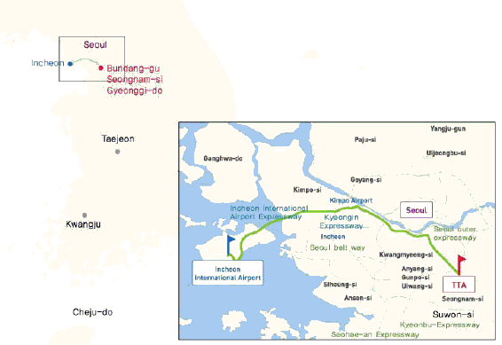
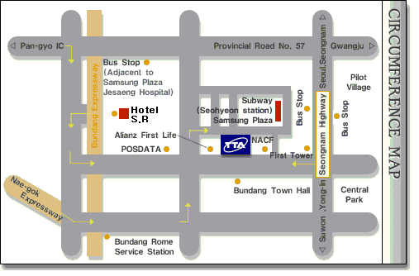

Transfers from Airport
TTA is located in the downtown area and the center of Seongnam-City, approximately one hour from Airport.

Please refer following websites for airport transportation information.
- Incheon Airport: http://www.airport.kr/airport/traffic/bus/busList.iia?flag=E

In order to ensure smooth access from Incheon International Airport to TTA, we are please to provide some practical information.

- Arrival at Incheon International Airport  When you’re arrived at the airport, please pick up some useful information, e. g., City Maps, Tourist Information booklet at Information Center located inside of the airport building, please see the right picture. | 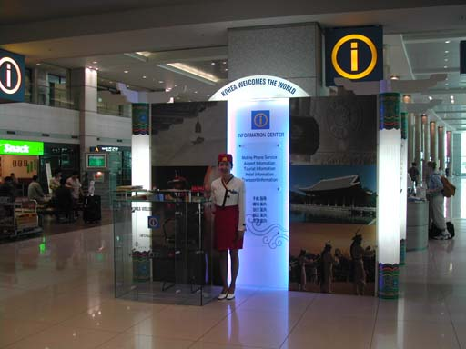
- At near to Exit Number #5, you can buy the Ticket for Airport Limousine Bus from the Airport to Bundang (or Seohyoen Station), the fare is 12,000Won. Please also see the right picture.  ※ Please Note; Using the TAXI from the Airport to TTA or to Downtown is not recommended due to high cost. (50,000Won/85,000Won for Delux Taxi) | 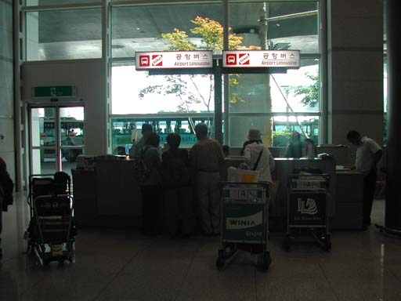
- If you are sure to get the Ticket, then you can move to Airport Limousine BUS STOP #7B with getting out the Airport building through the Exit Number #7. | 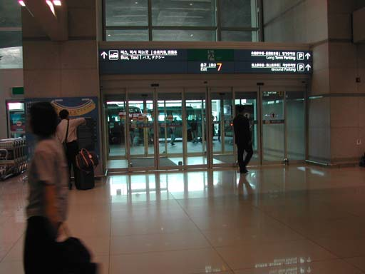
- As soon as you’re getting out from the Airport Building, you can find the Bus Stop #7B. The Interval of the Bus operation is about 20 minutes. Please wait there for moments when you’re middle of the Interval. | 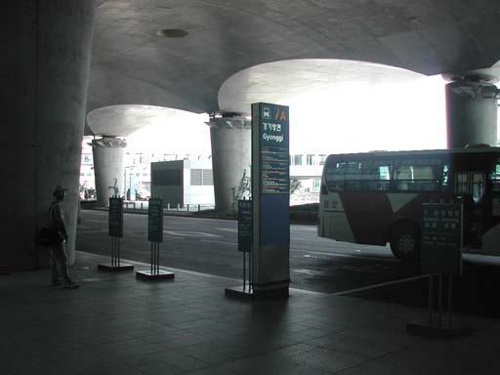
- When you’re in time, you’ll get right Airport Limousine Bus to Bundang (or Seohyoen Station). Please check the picture on your right. | 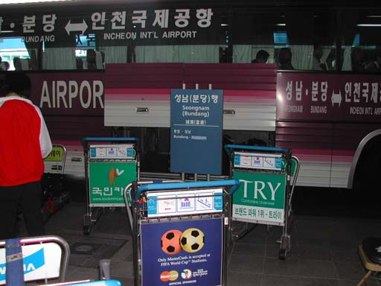
- Another picture of Airport Limousine Bus to Bundang (or Seohyoen Station). From the Airport to Bundang will takes about an hour. Please remember the name of Bus Stop, Seohyoen-Station, first stop after departure from the Airport. | 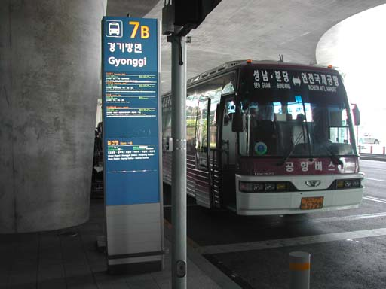

* If you are come to Gimpo airport, you also can take Airport Bus from Gimpo airport to Seongnam (Bundang), the fare is 6,000Won. Please remember the name of Bus Stop, Seohyoen-Station, first stop after departure from the Airport.

Hotels
Two hotels are recommended by the host organization, i.e. the Hotel S.R.
- Hotel rooms will be assigned on a first-come-first-serve basis, thus early reservation is recommended.
- Any changes or cancellations regarding room reservation should be informed by e-mail or faxed to the hotel.

Travel Information

Visa
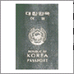
Any foreign visitors wishing to enter Korea must have a valid passport. Tourists may visit Korea for 15 days without a visa, but proof of confirmed round air reservation is required. However, some countries require visas to enter the Republic of Korea. For more information, please visit the Ministry of Foreign Affairs and Trade at www.mofat.go.kr. If you need invitation letter for VISA, to make smooth preparation of this meeting, please make sure the deadline requesting invitation letter for VISA.

Currency & Exchange

The Korean currency unit is the WON (indicated ￦). Bank notes are ￦10,000, ￦5,000, ￦1,000 bills and coin denominations are ￦500, ￦100, ￦50, ￦10. One US dollar is about ￦1,200 as of May, 2010. Money can be exchanged at Incheon International Airport, banks, and hotels. http://www.keb.co.kr/IBS/english/fx/rate/average/index.jsp


Weather
The Weather in July is usually hot. The average temperature is 16~29°C (60.8~84.2°F). For more detailed climate information, please contact the Korea Meteorological Administration:
http://www.kma.go.kr

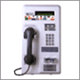
Telephone Calls
A local calls cost ￦70 for three minutes. To make an international call, first dial the international dialling code (001, 002 or 008), then the country code, area code, and the local telephone number. You may also rent a cellular phone at the Incheon International Airport.

Electricity
The standard supply is 220 volts with AC/60 cycles. Outlets for 220 volts are available at the hotels.

The two following outlets are compatible with those available in Korea.

a) It is popularly known as the europlug which is described in CEE 7/16
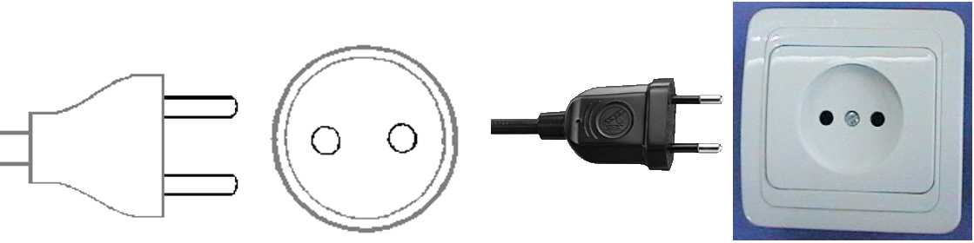
b) This plug is similar to the above except that it is round and has the addition of two grounding clips on the side of the plug
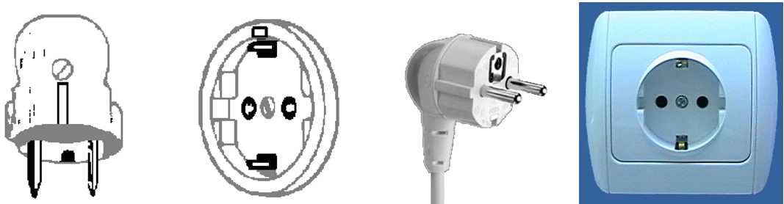

Emergencies
Police 112
Fire Department 119
Medical Emergencies 1339

Business Hours
Government offices are open from Monday to Friday between the hours of 09:00 and 18:00.
Most private businesses open at anywhere from 08:30 to 10:00 and close in the evening. Banks are a major exception. Their business hours are from 09:30 to 16:30 on weekdays. They are closed Saturdays and Sundays.
Foreign diplomatic missions in Seoul generally maintain strict business hours including lunch. They are usually open from 09:00 to 17:00 on weekdays and are closed on Saturdays and Sundays.
Major departments stores are usually open from 10:30 to 20:00, including Sundays, but smaller shops tend to be open earlier and close later every day of the week

Automated Teller Machines (ATM) for Foreign Travellers
Travellers who carry internationally recognized credit cards can get a cash advance in Korean won at Automated Teller Machines (ATMs) installed at airports, major hotels, department stores, subway stations and tourist attractions.

Tipping
Tipping is not a traditional Korea custom. A 10% service charge is added to your bill at all tourist hotels and 3-10% at some big restaurants.

Tax
Value-added tax (VAT) is levied on most goods and services at a standard rate of 10% and is included in the retail price. In tourist hotels, this 10% tax applies to meals and other services and is added into the bill.

Mail
Domestic postal rates are ￦190 for a letter of up to 25g, ￦1,490 for registered letter of no more than 25g, and ￦1,500 or ￦2,000 for a package of up to 2kg. A postcard costs ￦160.
■ Korea post: www.koreapost.go.kr

Newspaper, TV and Radio
There are three English-language dailies, the Korea Times and the Korea Herald, and the International Herald Tribune Joongang Daily. They are available at most news stands and in most hotel gift shops.
Korea has fine TV networks, all broadcasting in Korean (KBS1, KBS2, MBC, SBS, and EBS). Along with the national broadcasting networks, there are also many cable TV channels specializing in a wide field of programming including news, movies, entertainment, sports, etc. Of note is Arirang TV, a special English channel produced in Korea (cable channel #50). The channel features programming in politics, the economy, community, and culture, providing insight and understanding about things Korean through popular TV serial dramas with English subtitles. Some 90 hotels in Korea offer Arirang TV on cable or satellite.

Korea & Korean Tourism
Please visit the following Websites for more information on Korea and possible tours:
http://www.kois.go.kr
http://www.tour2korea.com

Local time
GMT + 9 hours. (same as Tokyo time)

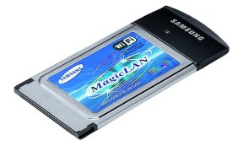
Computer Networking
Each meeting room will be equipped with wireless access (Wireless LAN, supporting IEEE802.11b, 2.4GHz band) to the Internet. Those who wish to use the wireless access must be equipped with the necessary hardware and correctly configured PC.

Attachment #1

SG13 Q01 Interim Meeting
(26 Sep– 01 Qct 2013, Seoul(TTA), Korea)

Request for Letter of Invitation for VISA issue to participate in ITU-T SG13 Q01 Interim Meeting
If needed, please return this form, no later than 14 Oct 2013 for the processing of formal invitation letter.

Family Name
Given Name
Date of Birth(yyyy/mm/dd)
Gender
Company(Individual Member)
Nationality
Passport Number
Mailing Address
(With postal code)
Expected entry date
Expected departure date
Tel.
Fax.
E-mail

SG13 Q01 Rapporteur chair Heechang chung
NIA bldg, 77 mugyo-dong, jung-gu, seoul, korea
Tel : +82-2-2131-0220, Fax +82-2-2131-0209
Email : heechang@nia.or.kr, gyoonchung@daum.net

Attachment #2
Hotel information

GALLERY HOTEL  Seohyeon-Dong, Bundang-Gu,  Seongnam-City, Gyeonggi-Do,  Korea  Tel: +82 31 702 8200  FAX: +82 31 707 6776  Email: gallery@galleryhotel.co.kr  Website: http://www.galleryhotel.co.kr/ | 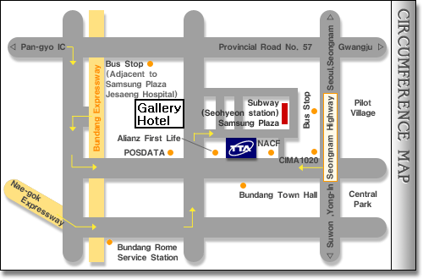

SR Hotel

Address : Seohyeon-dong, bundang-gu Seongnam-si Gyeonggi-do, korea
Tel : +82-31-702-6565/Fax +82-31-705-7891, Email : service@srhotel.co.kr, homepage : www.srhotel.co.kr

