**ITU-T SG12 Q5**

**Rapporteur’s meeting**

**June 25 to 26, 2014**

**Lund, Sweden**

**Hosted by:**

**SONY**

**1. Introduction**

Sony Corporation is pleased to welcome participants to the ITU-T Study Group 12 Question 5

rapporteur’s meeting in Lund, Sweden June 25th–26th, 2014.

**Local contact**

Peter Isberg, Sony Mobile Communications AB

Email: Peter.Isberg@sonymobile.com

Phone: +46 10801 3056 (office); +46706293056 (mobile)

**2. Meeting venue**

|  |  |
| --- | --- |
| Venue | Sony Mobile Communications, Lund, Sweden |
| Address | Mobilvägen 4, 221 88 Lund |
|  |
| Location | The meeting will take place in the “Glasgow” building at the Sony premises  Sony is located close to the Ideon Science Park, close to the motorway E22, 4 km to Lund´s central station and 400 m to buses with connections to Lund city, Malmö airport Sturup and trains.  Visitor’s parking is available; please report your license number in the Sony reception in the mornings. |

**3. Hotel accommodation recommendations**

Venue: Elite Hotel Ideon, Lund

GPS coordinate 55.71779, 13.21384

Address: Scheelevägen 27, 223 63 Lund

Contact: Phone: +46 46 287 1100 FAX: +46 46 287 1101   
E-Mail: [info.Lund@elite.se](mailto:info.Lund@elite.se)

Other info: In the hotel reception you can borrow a bike for free, also bus tickets to the local buses could be bought in the reception. Credit cards only accepted on the “Yellow” regional buses.   
  
You find the bus stop “Ideon” in walkable distance about 200 meters from the hotel entrance. The stop is served by local buses (line 20, 21), regional buses (lines 166, 169) and shuttle buses from Sturup (Malmö Airport).

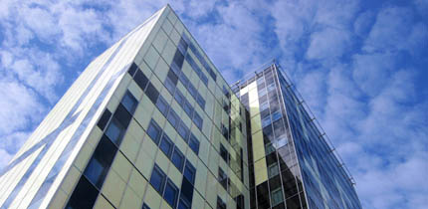

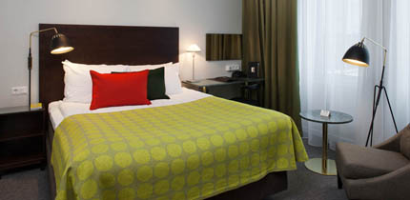

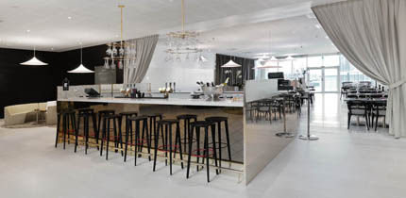

**Making your reservation:**

To make your reservation, please contact the hotel directly at: [reservation.lund@elite.se](mailto:reservation.lund@elite.se)

Phone: +46 46 287 1100

The Elite hotel is at walking distance to Sony (1,2 km,15 minutes)

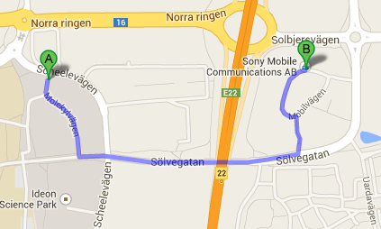

**Other hotels:**

**Grand Hôtel**, a traditional and nice hotel close downtown at walking distance (200 m) from the train station (and close to e.g. the medieval cathedral “Domkyrkan” for sight-seeing):

<http://grandilund.com/>

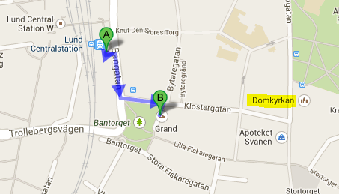

**Ideon Hotel**, a small hotel in the Ideon research park with walking distance to the meeting venue (1,1 km,15 minutes)

<http://www.hotelideon.com/>

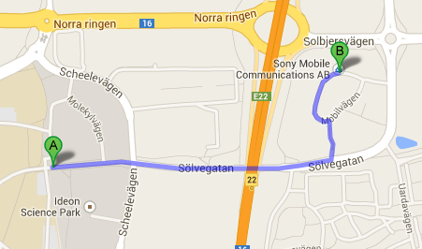

**4. How to get to the Hotel / Meeting Venue by taxi/car/train**

The train connection is very convenient; however other alternatives are also presented here.

* 1. You can get a taxi for approx. 100 Euro from Kastrup to Lund. Credit cards mostly accepted. The hotel is within 40 minutes by car from Kastrup airport.
  2. By car. Please be aware that you have to pay the Öresund bridge toll btw Denmark and Sweden. Credit cards accepted, approx. 40 Euro (one direction).
  3. Via Copenhagen-Kastrup Airport by train to Lund Central Station it takes approx 35 minutes. Trains leave typically every 20 min (twice as often during rush hours and more seldom during late nights, after 1 am).

After exiting the customs, walk straight ahead for some 50 m. Behind pillars you will find ticket vending machines marked with “Skånetrafiken”. You can buy a ticket with credit card (135 SEK or ~€15), select “Lund C” and “Over the bridge”.

http://www.ostercity.se/bilder/butiker/skanetrafiken_logo.gif

Please note that tickets can NOT be bought on the train.

Taxis usually accept credit cards. In Sweden please use the taxi companies TaxiKurir +464070000 and Taxi Skåne +4640330330 to secure quality in price.

* 1. Travel planners: [Copenhagen-Kastrup](http://www.cph.dk/en/), [Öresundstrain](http://www.oresundstag.se/en/Start/), [SJ](http://www.sj.se/start/startpage/index.form?l=en), [Sturups Airport](http://www.swedavia.com/malmo/), [Buses from/to airports](http://www.flygbussarna.se/en)

Travel by car/taxi from Copenhagen International Airport Kastrup to Lund (53 km)

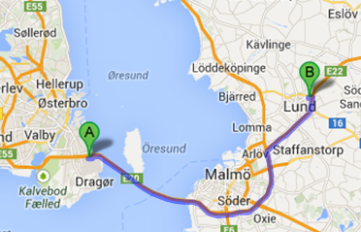

Travel by taxi from Lund central station to Sony (4 km)

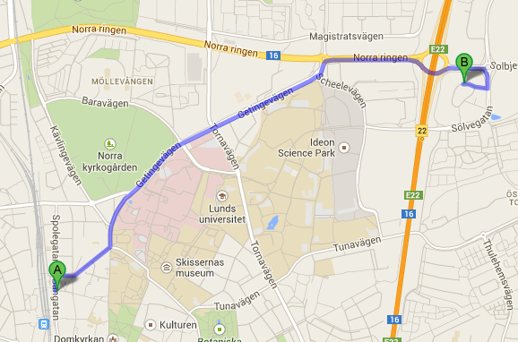

**5. Lund/Skåne information**

Walking distance in Lund Ideon area to other telecom companies like Sony, Ericsson, Nokia-Scalado, Huawei, Intel, Sigma Connectivity, Tech Mahindra.

Other Companies: Tetra Pak (HQ): 5,6 km, Alfa Laval (HQ): 4,2 km, Gambro: 700 m, Axis: 300 m, Skånes University hospital: 1,6 km, Lunds University: 2,3 km, Lunds Tekniska Högskola: 1,1 km

New material research institutes which will facilitate 20000 people year 2025

• MAX-Lab IV: approx. 2 km, Synchrotron light source, <https://www.maxlab.lu.se/>

• EES: approx. 3 km, Neutron acceleration, <http://europeanspallationsource.se/>

Communications

* Central station in Lund (from Elite & Ideon hotels): 3 km
* Sturup (Malmö Airport): 26 km
* Kastrup (Copenhagen Airport): 54 km

Visit

[**http://www.visitlund.se/en**](http://www.visitlund.se/en) (e.g. ”Domkyrkan”, a cathedral with oldest parts from the 12th century)

<http://www.visitlund.se/en/eat>

[**http://visitskane.com/en/**](http://visitskane.com/en/)

<http://visitskane.com/en/theme/historia>

[**http://www.arrivalguides.com/en/Travelguides/Europe/Sweden/LUND**](http://www.arrivalguides.com/en/Travelguides/Europe/Sweden/LUND)

<http://en.wikipedia.org/wiki/Scania>

<http://en.wikipedia.org/wiki/History_of_Scania>

Hven island:

<http://wikitravel.org/en/Ven>

**6. Further relevant information**

**Visa:**

Before you travel, it is very important to see if you require a VISA to enter Sweden and follow the outlined process. Please be sure to validate this at your earliest opportunity as the process can be quite lengthy.

If documentation is required with your Visa application from Sony Mobile Communications to validate your visit to Sweden, please email Marie Olsson at [marie.olsson@sonymobile.com](mailto:marie.olsson@sonymobile.com)

**Payment / Credit Cards / ATM:**

Swedish currency is SEK. Example exchange rates: 1SEK = 0.114165 EUR 1 EUR = 8.75926 SEK

Payment with credit cards is accepted in mostly all shops and restaurants.

**Weather in Lund:**

The month of June in Lund can range from a high of 22°C to low temperatures ranging down in the evenings to 11°C. There may be rain. To ensure you pack appropriately, it is suggested that you check the weather forecast before you travel.

**7. Contributions**

Please refer to the ITU-T SG12 Q5 rapporteur Lars-Birger Nielsen, [LarsBirger.Nielsen@bksv.com](mailto:LarsBirger.Nielsen@bksv.com) and the Q5 distribution list [t13sg12q5@lists.itu.int](mailto:t13sg12q5@lists.itu.int) regarding submission of contributions for the meeting.