Practical Information for the Study Group 12, Question 10
interim meeting in Stockholm, 17th -18th June

Address of the meeting

Ericsson
Torshamnsgatan 23
Kista, Stockholm
Sweden

Contact for administrative arrangements

Gunilla Berndtsson
Phone: +46 76 1011119
Email: gunilla.berndtsson@ericsson.com

Meeting schedule

The interim meeting for question 10 of Study Group 12 will start on Tuesday 17th June 9:00 and will end Friday 18th February no later than 17:30.

Venue
The meeting will be held at the Ericsson offices in Kista, north of Stockholm. The address of the meeting place is:
Ericsson
Torshamnsgatan 23
Kista, Stockholm
Sweden

Practical Information
A local Kista map can be found at http://www.hitta.se/SearchCombi.aspx?vad=&var=torshamnsgatan+23E%2c+kista
WLAN internet connection will be available at the meeting.

The visitor entrances are marked with red dots in the map below. Enter building 20 from the road Torshamnsgatan. You will be able to collect a visitor´s badge at the reception. The meeting will be in the conference room “Björn S” in building 21, which is connected to building 20.
Torshamnsgatan
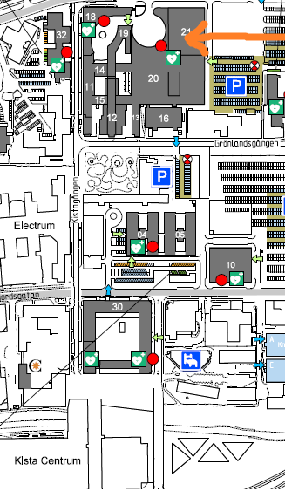

Transport
Prices below are quoted in Swedish kronor (SEK, or KR). Approximate exchange rates are 1 EUR≈9 SEK. Credit cards are accepted almost everywhere including shops, kiosks, taxis and airport coaches.
Note that there is no price regulation for taxis in Sweden, but all taxis are required by law to have a sign on the side windows showing their prices for a typical 15-minute 10 km trip for different times of the day. The large-letter price to the right is the highest price they would charge for such a trip. Please look carefully at this price, as some drivers/companies have extremely high prices to scam tourists who often assume that all taxis cost the same!
The highest price displayed on the sign should be in the region of 300 SEK for a normal taxi, and you should never need to take a taxi with higher typical price than 400 SEK. Observe the authentic photo below where you in this case would be charged more than 1000 euro for a 15-min trip! If you keep with the three biggest taxi companies (Taxi Stockholm, Taxi Kurir, dark blue cars, or Taxi 020, yellow cars) you should be safe.
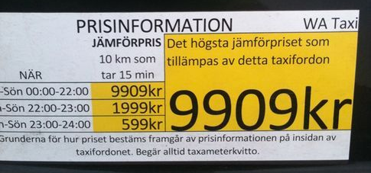

Travel from the airport to Stockholm
From Arlanda airport (ARN), which is situated 40 km north of Stockholm, you have some options:
- Taxi to Stockholm city should cost between 400 to 500 SEK. It’s slightly cheaper to Kista. Feel free to ask for a fixed price before entering the taxi, it is common with fixed-price drives on this route.
- Flight train non-stop to Stockholm City (Central Station) takes 20 minutes and costs 260 SEK. The train is called “Arlanda Express”. http://www.arlandaexpress.com
- Bus to Stockholm City takes 40 minutes and costs 105 SEK. The bus is called “Flygbuss” (“Airport Coach”) and stops several times before the final stop at Cityterminalen (bus terminal connected to the railway station, Central Station). http://www.flygbussarna.se/en
- Commuter train from “Arlanda C”. The train takes you to Stockholm city for 125 SEK. You can also take the commuter train from ”Arlanda C” to “Helenelund”, and then have a 10 minute walk to the meeting venue in Kista.
- Local train “Upptåget” directly from the airport to Upplands Väsby, then change to train towards Stockholm. Takes 40 minutes and costs 110 SEK. If you anyway will buy a travelcard, the extra cost for this trip is 60 SEK (extra airport terminal cost). Read more at the end of http://sl.se/en/Visitor/Tickets/Visitor-tickets/

Travel between Stockholm and Kista

- Taxi costs around 300 SEK and takes 15 minutes.
- Subway (tunnelbana) is easy and frequent. It takes 20 minutes from Stockholm to Kista. Subway stations are marked with a “T”. Take the blue line towards Akalla, get off at Kista. Then pass through the mall and walk along Kistagången to the meeting venue (10 minutes).
Link to map of Kista subway station: http://www.hitta.se/ViewDetailsPink.aspx?Vkiid=y4GLRb7%2faUllzLUPTikd8w%3d%3d&vad=Kista+tunnelbanestation&var=Kista
- Commuter train (“Pendeltåg”) is quick and takes 12 minutes from the Central Station to Helenelund. Train stations are marked with a “J”. Take the train towards Märsta or Upplands Väsby, get off at Helenelund. Then walk 10 minutes to the meeting venue. (Take aim at a high rise glass façade building, walk under the highway, walk past the high rise building and continue a few hundred meters. The meeting venue is then on your left.
Link to map of Helenelund train station: http://www.hitta.se/ViewDetailsPink.aspx?vad=Helenelund+pendelt%e5gsstation&var=helenelund&Vkiid=24AhqRan9YkYXjbI0wB7cA%3d%3d&Vkid=10464259&isAlternateNumberResult=False

Prices for local transport
The fee can be paid at the entrance to the metro. However, buying an access card and add content (money) to it makes it cheaper and more convenient. Alternatively, you can buy a one-day travel card for 115 SEK or a three-day for 230 SEK. http://sl.se/en/Visitor/Tickets/Visitor-tickets/

Accommodation
We have not made any block reservations, below are some possibilities. Some of the hotels have a special rate for Ericsson, which you might be able to get if you call the hotel and state that you are an Ericsson customer. The hotels are roughly ordered by rate with the most expensive first.

Stockholm
The trip to Kista takes roughly 20 minutes and walking to the meeting venue 10 additional minutes.
- Nordic Sea Hotel
Address: Vasaplan 4, Stockholm
Phone: 46 8 50 56 30 00
http://www.nordicseahotel.se/en/
Nice design hotel located very close to the central station, subway and Arlanda express train. The hotel is co-located with an ice bar, which some say is a cold and interesting experience. This is not the cheapest hotel, but still with reasonable rates.
Link to a local map:
http://www.hitta.se/SearchCombi.aspx?vad=&var=Vasaplan+4%2c+Stockholm
- Clarion Hotel Amaranten
Address: Kungsholmsgatan 31, Stockholm.
Phone: +46 8 692 5200, Fax: + 46 8 652 6248
https://www.nordicchoicehotels.se/clarion/clarion-hotel-amaranten/
There is an entrance to the subway station (Rådhuset) in the same building as the hotel with a direct connection to Kista (blue line towards Akalla). The Central Station is within 10 minutes walking distance.
Link to a local map:
http://www.hitta.se/SearchCombi.aspx?vad=&var=Kungsholmsgatan+31%2c+Stockholm
- Comfort Hotel Stockholm
Address: Kungsbron 1, Stockholm
Phone: +46 8 566 222 00
http://www.choicehotels.no/choice/en/stockholm-hotel-comfort-se030-en
Cheap but still ok hotel located quite close to the central station, subway and Arlanda Express. Note that the cheapest rooms do not have a window.
Link to a local map:
http://www.hitta.se/SearchCombi.aspx?vad=&var=Kungsbron+1%2c+Stockholm

Kista
The area is not too exciting, but you will be able to walk to the meeting venue:
- Scandic Victoria Tower
Address: Arne Beurlings torg 3A, Kista
Phone: +46 8 517 533 00, Fax: +46 8 517 533 11
http://www.scandichotels.com/en/Hotels/Countries/Sweden/Stockholm/Hotels/Victoria-Tower/
Brand new with 20 floors and a sky bar with a nice view of Stockholm. Might be the most expensive in Kista (but prices vary).
Link to a local map:
http://www.hitta.se/SearchCombi.aspx?vad=&var=Arne+Beurlings+torg+3A%2c+Kista
- Memory Hotel
Address: Borgarfjordsgatan 3, Kista.
Phone: +46 8 793 0700, Fax: + 46 8 793 0800
http://www.memoryhotel.se/?l=en
Nice hotel, not brand new.
Link to a local map:
http://www.hitta.se/SearchCombi.aspx?vad=&var=Borgarfjordsgatan+3%2c+Kista
- StayAt Hotel Apartments
Address: Danmarksgatan 34/38, Kista.
Phone: +46 8 505 727 00, Fax: +46 8 505 727 99
http://www.booking.com/hotel/se/accome-apartment-kista.html
A cheaper option in the shopping mall (Kista Centrum).
Link to a local map:
http://www.hitta.se/SearchCombi.aspx?vad=&var=Danmarksgatan+38%2c+Kista

Other practical information
Being in Scandinavia you cannot be sure what weather to expect, but average temperature should be around 20 degrees C in the middle of June.
The time zone in Sweden is Central European Time (CET), one hour ahead of GMT.
The power plugs used in Sweden are of type C or F as described on this page: http://www.worldstandards.eu/electricity/plugs-and-sockets/

Useful Stockholm Links
Stockholm information: http://www.stockholmtown.com/ and www.cityguide-europe.com/se/stockholm.
Local travel: http://sl.se/en/Visitor/Plan-your-journey/, and you can also download maps and plan your trip at the same site.

Welcome to a dinner cruise in the Stockholm archipelago on Tuesday evening

http://www.stromma.se/en/Stockholm/Dining-Cruises/Dinner-Cruise/Shrimp-Buffet/

The cost for this arrangement will be 295 SEK.

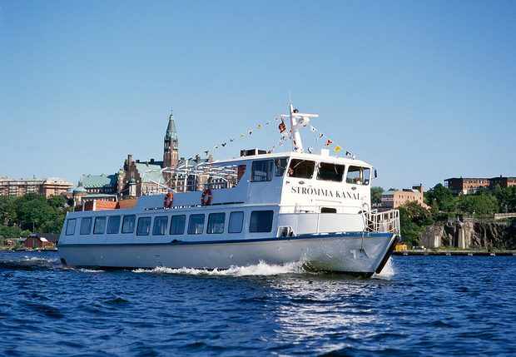

Welcome to Stockholm!

