Meeting Announcement
Sixth Meeting FG SmartCable and SG9 Rapporteurs’ meetings
Tokyo, Japan, 26 September-2 October 2013

1. FG SmartCable and SG9 Rapporteurs meetings in Tokyo, Japan
The sixth physical meeting of the FG SmartCable will take place on 26-27 September 2013, Tokyo, Japan, at the kind invitation of KDDI Corporation (see clause 2 below).
In addition, and according to the results of last ITU-T Study Group 9 meeting (14-18 January 2013), the following SG9 Rapporteurs meetings will be also organized at the same venue on 30 September-2 October 2013 at the kind invitation of KDDI Corporation. The Rapporteurs meetings are: Q1/9, 3/9, 4/9, 5/9, 6/9, 7/9, 8/9, 9/9, 10/9, joint 1/9 & 7/9, and joint 5/9, 8/9 & 9/9 (see clause 3 below).
The venue address is:
KDDI Corporation
Shibuya Hikarie (building name)
2-21-1 Shibuya, Shibuya-ku
Tokyo, 150-8510, Japan
To enable the host to make the necessary arrangements concerning the organization of both, the Focus Group meeting and the Rapporteurs meetings, please register via the on-line form, as soon as possible, but not later than 26 August 2013. Please note that pre-registration of participants to the meeting is carried out exclusively online at the following address:
http://www.itu.int/online/regsys/ITU-T/misc/edrs.registration.form?_eventid=3000559
To easily provide you with any updates concerning the meeting planning, please fill in the registration form with a valid e-mail address.
A complete meeting plan is provided in ANNEX 3 for the meeting participants’ convenience.
To enter Japan for the meetings indicated above, you may need a letter of invitation from the host (KDDI Corporation), which you will need to present to the Embassy/Consulate of Japan in your area in order to obtain your visa (see ANNEX 2 for the Invitation letter). The visa must be requested and obtained from the office (embassy or consulate) representing Japan in your country or, if there is no such office in your country, from the one that is closest to the country of departure. Please be aware that visa approval might take time so kindly make your visa request as soon as possible.

2. Focus Group on Smart Cable Television (FG SmartCable)
FG SmartCable was established by SG 9 “Television and sound transmission and integrated broadband cable networks” on 4 May 2012.
The outputs and all contributions of the previous FG SmartCable meetings can be accessed at the FG SmartCable document repository (IFA server): http://ifa.itu.int/t/fg/smartcable/docs.
Please note, for accessing the documents it is necessary to have a TIES or a GUEST account. Please find more information at: http://itu.int/en/ITU-T/focusgroups/smartcable .
The draft agenda for the meeting, as well as all contributions will be available at: http://ifa.itu.int/t/fg/smartcable/docs/201309/in/
According to the Recommendation ITU-T A7, the FG SmartCable is open to any individual from a country which is a member of ITU who is willing to contribute to the work. This includes individuals who are also members of international, regional and national organizations and the list of participants is to be maintained for reference purposes. Please note that there is no fee to register and participate in the FG SmartCable meetings.
The participant registration will begin at 0830 on 26 September 2013. The FG SmartCable meeting will open at 0930. Please find detailed information concerning the meeting venue along with the list of hotels, logistics, and practical information in ANNEX 1.
Participants shall submit input documents in electronic format to the FG SmartCable Secretariat via email attachment at tsbfgsmartcable@itu.int. A document template is made available from the FG SmartCable homepage. With a view to settling any questions that might arise concerning contributions, please indicate the source of the input documents as well as the name, telephone number and e-mail address of the contact person.
You can participate remotely to the FG SmartCable meeting. If you wish to do so, please indicate it when you register online by checking the appropriate check-box.
The deadline to submit input documents is 19 September 2013. Please note that this is a paperless meeting.
The discussions will be held in English only.
All other information, including results of previous FG SmartCable meetings, is available at the FG SmartCable web page at: http://www.itu.int/en/ITU-T/focusgroups/smartcable/

3. SG9 Rapporteurs groups meetings
The SG9 Rapporteurs meetings will open at 0930 hours on 30 September 2013. Participant registration will begin at 0830 hours. Detailed information concerning the meeting rooms will be available onsite and provided to you at the registration desk.
To contribute to the Rapporteurs meetings, please send your Contribution to the responsible Rapporteur, preferably by 18 September 2013, or directly submit the Contributions to the related FTP area as provided below:
Question | Rapporteur | Associate
1/9 | Shigeyuki Sakazawa  sh-sakazawa@kddi.com | Yangsu Kim  kimys@etri.re.kr
3/9 | Han-Seung Koo  koohs@etri.re.kr | Shigenobu Masaya  m-shigenobu@jlabs.or.jp
4/9 | Masaru Takechi  takechi.m-fa@nhk.or.jp | Aguinaldo Boquimpani  aguinaldo.boquimpani@yahoo.com
5/9 | Mayumi Matsumoto  matsumoto@jlabs.or.jp | Dong Wang  wang.dong@zte.com.cn
6/9 | Satoshi Miyaji  sa-miyaji@kddi.com
7/9 | Tae Kyoon Kim  tkkim@etri.re.kr | Ouyang Feng  ouyangfeng@abs.ac.cn
8/9 | Gale Lightfoot  lightfg@cisco.com | Lakshmi Raman  lakshmigraman@yahoo.com
9/9 | Shaibal Chakrabarty  shaibalc@cisco.com | Jiansheng Zhang  zhangjs@chinabtn.com
10/9 | Tomohiko Takahashi  tk-takahashi@kddi.com
Please use the provided set of templates to prepare your contribution. The templates are accessible from each ITU-T study group web page, under “Delegate resources” (http://itu.int/ITU-T/studygroups/templates). The name, fax and telephone numbers and e-mail address of the person to be contacted about the contribution should be indicated on the cover page of all documents.

3.1 Location of meeting documents:
Question 1: http://ifa.itu.int/t/2013/sg9/exchange/wp1/q1/2013-Sept-Tokyo
Question 3: http://ifa.itu.int/t/2013/sg9/exchange/wp1/q3/2013-Sept-Tokyo
Question 4: http://ifa.itu.int/t/2013/sg9/exchange/wp2/q4/2013-Sept-Tokyo
Question 5: http://ifa.itu.int/t/2013/sg9/exchange/wp2/q5/2013-Sept-Tokyo
Question 6: http://ifa.itu.int/t/2013/sg9/exchange/wp1/q6/2013-Sept-Tokyo
Question 7: http://ifa.itu.int/t/2013/sg9/exchange/wp2/q7/2013-Sept-Tokyo
Question 8: http://ifa.itu.int/t/2013/sg9/exchange/wp2/q8/2013-Sept-Tokyo
Question 9: http://ifa.itu.int/t/2013/sg9/exchange/wp2/q9/2013-Sept-Tokyo
Question 10: http://ifa.itu.int/t/2013/sg9/exchange/wp2/q10/2013-Sept-Tokyo
The meeting will be run paperless and the discussions will be held in English only.
The audio teleconference may be prepared upon request. If any participant is willing to use it, please notify to relevant Rapporteurs prior to the meeting.
Yours faithfully,
Satoshi Miyaji (WP1/9 Chairman)
Dong Wang (WP2/9 Chairman), and
Tom Russell (FG SmartCable Chairman)
Annexes: 3
- ANNEX 1 -PRACTICAL INFORMATION
- ANNEX 2 - INVITATION LETTER REQUEST FORM
- ANNEX 3 – DRAFT MEETING PLAN

ANNEX 1 –PRACTICAL INFORMATION

Meeting Venue
KDDI Corporation
Shibuya Hikarie (building name)
2-21-1 Shibuya, Shibuya-ku
Tokyo, 150-8510, Japan

Transportation and site information:
Participants from foreign countries will enter Japan through Narita Airport (NRT, New Tokyo International Airport) or Haneda Airport (HND, Tokyo International Airport).
Narita Airport (NRT): http://www.narita-airport.jp/en/index.html
Haneda Airport (HND): http://www.haneda-airport.jp/inter/en/
The recommended transportation options from either airport to the venue are described below.
- Airport Limousine Bus
From these airports, non-stop shuttle services to the Shibuya area (Cerulean Tower Tokyu Hotel and Shibuya Excel Hotel Tokyu) are available. No reservation is required.
http://www.limousinebus.co.jp/en/
From | To | Fare | Travel Time | Frequency
Narita Airport | Shibuya | JPY 3,000 | 75 min – 125 min | Every 70 minutes
Haneda Airport | Shibuya | JPY 1,000 | 30 min – 70 min | Every hour
- Narita Express
The JR Narita Express (N’EX) stopping at Shibuya Station is available at the Narita Airport. No reservation is required.
http://www.jreast.co.jp/e/nex/
From | To | Fare | Travel Time | Frequency
Narita Airport | Shibuya | JPY 3,110 (2nd class)  JPY 4,600 (1st class) | 80 min | Every hour or twice per hour
- Taxi
Taxi is available at the airports.
From | To | Fare | Travel Time
Narita Airport | Shibuya | Approx. JPY 30,000 | 70 min – 90 min
Haneda Airport | Shibuya | Approx. JPY 8,000 | 30 min – 50 min

Passports and Visas
Participants needing a visa should apply at a Japanese consulate or a diplomatic mission in their respective country well in advance of their departure. Participants are also advised to contact their local travel agents or carriers. The Embassy may take at least two weeks for visa processing.
For more information, please visit the website of the Ministry of Foreign Affairs of Japan at:
http://www.mofa.go.jp/j_info/visit/visa/
Participants needing an invitation letter and/or visa supporting documents for entering Japan shall fill out all items in the Application Form of Annex 2, then email the form to the following contact point together with a copy of the photograph page of their passport no later than 1st of August 2013.

Mr Tomohiko TAKAHASHI
Media and CATV Business Division,
KDDI Corporation
Mobile: +81 5943 9830
Email: tk-takahashi@kddi.com

Transportation Map
The following map shows the relationship between Centre of Tokyo and the airports. The Hotels near the venue (KDDI at Shibuya Hikarie) are also indicated on the second map.
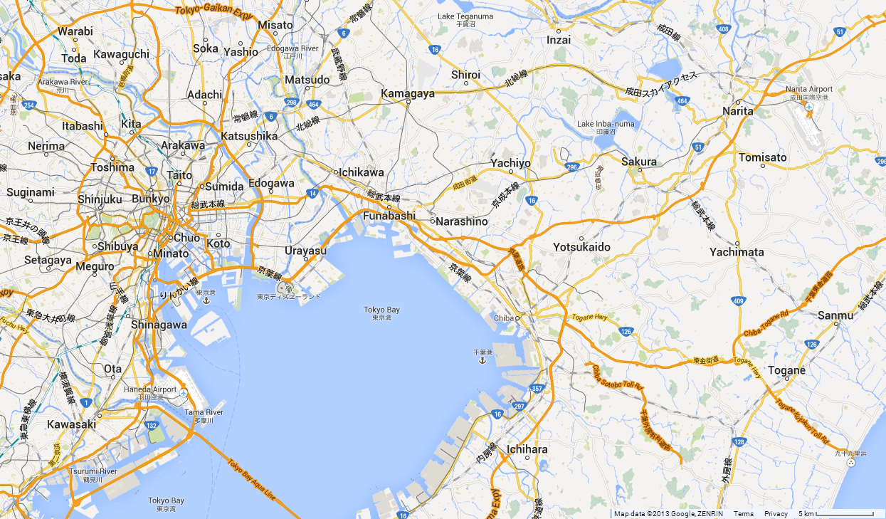
Tokyo and vicinity
Haneda Airport
Narita Airport
Centre of Tokyo
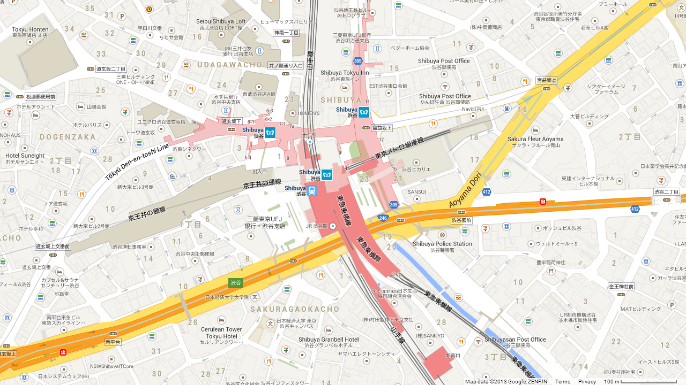
Detailed map of Shibuya
Shibuya Station
Hotel Mets Shibuya
Shibuya Tokyu Inn
Shibuya Excel Hotel Tokyu
Cerulean Tower Tokyu Hotel
KDDI
at Shibuya Hikarie
Note: “Tokyu” is a name of the railway company running some real estate business including hotels, please do not be confused with “Tokyo.”

Climate – during September and October
Monthly Average values of the temperature and precipitation in Tokyo are given in the table.
 | September | October
Average Max Temperature | 29.8°C/85.6°F | 23.0°C/73.4°F
Average Minimum Temperature | 23.3°C/73.9°F | 16.2°C/61.2°F
Average Precipitation | 45.5mm/1.79in | 30.0mm/1.18in
Statistics as of 2012. Source: Japan Meteorological Agency

Hotels
The following list represents the recommended hotels located within walking distance from the venue:
Shibuya Tokyu Inn
1-24-10, Shibuya, Shibuya-ku,
Tokyo 150-0002, Japan
+81 3 3498 0109
[5 minutes by walk]
http://www.tokyuhotelsjapan.com/en/TI/TI_SHIBU/index.html

Shibuya Excel Hotel Tokyu
1-12-2, Dogenzaka, Shibuya-ku,
Tokyo 150-0043, Japan
+81 3 5457 0109
[8 minutes by walk]
Direct bus from Narita Airport or Haneda Airport is available
http://www.tokyuhotelsjapan.com/en/TE/TE_SHIBU/index.html

Hotel Mets Shibuya
3-29-17 Shibuya, Shibuya-ku,
Tokyo 150-0002
+81 3 3409 0011
[8 minutes by walk]
http://www.jrhotelgroup.com/eng/code/codeeng126.htm

Cerulean Tower Tokyu Hotel (a Concorde Hotel)
26-1 Sakuragaoka-cho, Shibuya-ku,
Tokyo 150-8512, Japan
+81 3 3476 3000
[12 minutes by walk]
Direct bus from Narita Airport or Haneda Airport is available
http://www.tokyuhotelsjapan.com/en/TH/TH_CERUL/index.html

Internet access and wireless coverage

Internet access in the meeting rooms will be provided by KDDI. It is important to register early to the meeting so the host can set up internet access rights for every participant. More information will be available onsite.

Technical assistance

For any technical issue you might have on site, please contact:

Mr Tomohiko TAKAHASHI
Media and CATV Business Division,
KDDI Corporation
Mobile: +81 5943 9830
Email: tk-takahashi@kddi.com

Receptions and coffee breaks
Coffee breaks and lunches will be provided by the host.
A reception in the evening on Thursday 26 September 2013 near the venue is planned.
More information will be made available on site.

Electricity
The voltage in Japan is 100 Volts, which is different from North America (120V), Central Europe (220V) and most other regions of the world.
http://www.worldstandards.eu/electricity.htm
Japanese electrical plugs typically have two pins, as shown below, and some plugs have three pins including a grounding prong.
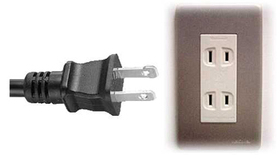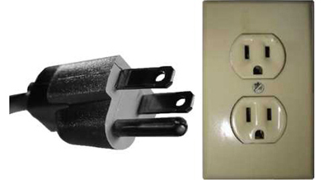
Type-A (in most cases) Type-B (in some cases)
Some North American equipment will work fine in Japan without adapter or converter, however, some sensitive equipment may not work properly.
The frequency of electric current is 50 Hertz in Eastern Japan (including Tokyo, Yokohama, Tohoku, Hokkaido) and 60 Hertz in Western Japan (including Nagoya, Osaka, Kyoto, Hiroshima, Shikoku, Kyushu), however this frequency difference affects only sensitive equipment.
It is suggested guests bring their own power converters and wall plug adapters to allow use of international appliances. Hotels typically provide irons, ironing boards and hair dryers in the hotel rooms, so there is no need to bring these items with you.

Useful information

Contact of the health service at the venue

Police: 110

Ambulance: 119

Fire: 119

Nearest hospital: Japan Red Cross Medical Center, 4-1-22 Hiroo Shibuya-ku Tokyo. For general questions, call 03-3400-1311. For more information, http://www.shibuyaguide.com/shibuya-hospitals-and-clinics/

Pharmacies
Most medicines are readily available at the pharmacy located on the B1 floor of the Shibuya Hikarie (the venue). If needed, please check on site with Mr Tomohiko Takahashi.
Currency exchange

The currency in Japan is Japanese Yen (JPY); please check the currency exchange rate in the local bank system or you can have as a reference the following link: http://www.xe.com/

Additional information

General information about Shibuya, Tokyo (Japan) at:

• Shibuya: http://www.japan-guide.com/e/e3007.html

http://www.shibuyaguide.com/

http://www.city.shibuya.tokyo.jp/eng/index.html

• Tokyo: http://www.japan-guide.com/e/e2164.html

http://www.metro.tokyo.jp/ENGLISH/index.htm

Contact person
Mr Tomohiko Takahashi
Mobile: +81 80 5943 9830
Email: tk-takahashi@kddi.com

ANNEX 2 INVITATION LETTER REQUEST FORM
ITU-T Focus Group Smart Cable Television and SG 9 joint Rapporteurs’ meetings
Tokyo, Japan, 26 September – 2 October, 2013
Application Form for Visa Supporting Documents

Name

(Mr. Ms. Dr.)
 | Family Name |  | Middle Name |  | Given Name
Your full name in Chinese characters(*): _
*If you are a Chinese participant, please write your name in Chinese characters.

Official Title _

Department: _

Organization _
(**): _
**If you are a Chinese participant, please write your organization in Chinese characters as well.

Country (where you live) _

Address (*1): _
(*1) VISA supporting documents will be sent to the address above by courier service.

Phone No. Fax No. E-mail _

PASSPORT INFORMATION:

Passport No. : Date of Issue: / / (DD/MM/YYYY)

Expiry Date : / / (DD/MM/YYYY)

Place of Birth: Date of Birth: / / (DD/MM/YYYY)

Nationality: _
FLIGHT INFORMATION(*2) :
Arrival in Tokyo (Haneda / Narita) from city Date / / Flight No. Time _
Departure from Tokyo(Haneda/Narita) to city Date / / Flight No. Time _
(*2) For VISA supporting documents, a planned flight s chedule is available as well.
HOTEL ACCOMMODATION
This information is NOT for hotel reservation order sheet, but NEEDED for staying schedule for visa supporting documents.

Hotel name : _
Check in date: / / (DD/MM/YYYY) Check out date: / / (DD/MM/YYYY)

If making your own accommodation arrangement other than recommended hotels in Tokyo, please indicate your contact address and phone number:

Hotel Address _
Hotel phone No. _

Date: Signature:
Deadline of Submission: 1st of August 2013 for all visa related documents
Please Return this form To:
Mr Tomohiko TAKAHASHI
Media and CATV Business Division,
KDDI Corporation
Mobile: +81 5943 9830
Email: tk-takahashi@kddi.com

ANNEX 3 – Draft meeting plan
Draft timetable of FG Smart Cable & SG9 Interim Rapporteurs meeting (Tokyo, Japan, 26 September – 2 October 2013)
 | Thu 26 September |  |  |  |  | Fri 27 September |  |  |  |  | Mon 30 September |  |  |  |  | Tue 1 October |  |  |  |  | Wed 2 October
 | AM |  | PM |  | E | AM |  | PM |  | E | AM |  | PM |  | E | AM |  | PM |  | E | AM |  | PM
FG SmartCable | X | X | X | X |  | X | X | X | X
Q1/9 |  |  |  |  |  |  |  |  |  |  | X |  |  |  |  |  |  |  |  |  | X
Q3/9 |  |  |  |  |  |  |  |  |  |  |  |  | X | X |  |  |  |  | X
Q4/9 |  |  |  |  |  |  |  |  |  |  | X | X | X | X |  | X | X | X | X |  | X | X | X | X
Q5/9 |  |  |  |  |  |  |  |  |  |  |  |  | X |  |  |  |  |  |  |  |  | X
Q6/9 |  |  |  |  |  |  |  |  |  |  |  |  |  |  |  | X |  |  |  |  |  |  | X | X
Q7/9 |  |  |  |  |  |  |  |  |  |  |  | X |  |  |  |  | X
Q8/9 |  |  |  |  |  |  |  |  |  |  |  | X |  |  |  |  |  | X
Q9/9 |  |  |  |  |  |  |  |  |  |  | X |  |  |  |  |  |  |  |  |  |  |  |  | X
Q10/9 |  |  |  |  |  |  |  |  |  |  |  |  |  | X |  |  |  | X |  |  | X | X
Joint Q1, 7/9 |  |  |  |  |  |  |  |  |  |  |  |  | X | X |  |  |  |  | X |  |  |  | X
Joint Q5, 8, 9/9 |  |  |  |  |  |  |  |  |  |  |  |  |  |  |  | X | X
SESSION TIMES (unless otherwise noted):
Session 1: 0930-1045; Session 2: 1115-1230; Session 3: 1430-1545; Session 4: 1615-1730; Evening Sessions: 1800-1915
X | Represents a meeting session.
E | Represents a evening session (starts at 1800)

