ITU-T Study Group 5 Meeting on Environment and Climate Change

ITU-T Study Group 5 Meeting on Environment and Climate Change will take place in Kochi, India from 08-19 December 2014.

The meeting will take place at:

Le Méridien Kochi
Maradu Kochi
Kerala, India
PIN/ZIP : 682304
Tel.: +91 484 270 5777
Fax: +91 484 270 5750

For hotel reservations, please contact:

Mr. Shinoj Paul

Tel.: +91 484 270 5777
Fax: +91 484 270 5750
Mob: +91 9895765772
Email: shinoj.paul@lemeridien.com

Reservation Timings - 0800 hours to 2000 hours IST

For further information, see Annex 1.
Annex 1

Information for the ITU-T Study Group 5: Environment and Climate Change

1 Introduction:

The Ministry of Communications & Information Technology, Government of India, invites participants to the ITU-T SG5 on Environment and Climate Change scheduled to be held during
08-19 December 2014 at Kochi, India. Kochi, also known as Cochin is a major port city on the west coast of India by the Arabian Sea and is part of the district of Ernakulam in the state of Kerala.
This Annex provides both information on the meeting and guidance to the delegates for their stay in Kochi.

2 Meeting venue:

Le Méridien Kochi
Maradu Kochi
Kerala, India
PIN/ZIP : 682304
Tel.: +91 484 270 5777
Fax: +91 484 270 5750

3 Hotel accommodation: Le Méridien Kochi is the venue of the ITU-T SG5 meeting. Details of the hotel bookings will be provided separately.

4 Transport and Access:

4.1 How to reach Kochi: Kochi is accessible by air, road & railways

4.1.1 By Air: The Kochi airport is designated by the international airport code as COK (Cochin International Airport). Cochin airport is connected by air with all metros i.e. Delhi, Mumbai, Kolkata, Chennai and Bangalore. It is located at the centre of the state which is approximately 1 hour drive to Le Meridien. Conveyance like buses, pre-paid taxis are available from the airport easily. The charges vary as per the distance.

4.1.2 By Train: Ernakulam Junction railway station is the largest railway station in the city of Kochi.

4.1.3 Public transport in Kochi: For transport within the city, buses and taxis are available throughout the day. The city has a very fast and efficient bus transport system, mainly dominated by private operators, known as Red-Buses.

How to reach the venue from airport: Contact the help desk at the Cochin airport for car rental services.

5 Conference Visa: Participants can refer to the FAQs on Conference Visas at the web site of the Ministry of Home Affairs at: http://mha1.nic.in/pdfs/ForeigD-FAQs-on-ConferenceVisa.pdf If you need an individual invitation letter, please apply for it well within the time indicated in the FAQs by e-mail to the following, using the format provided in Appendix A:

Mr. Desh Raj Bhadana
Manager-Admin
COAI
14, Bhai Veer Singh Marg,
New Delhi-110001, INDIA
Mobile: +91-9958871801
Tel: +91 11 23349275
Fax: +91 11 23349276
Email: dbhadana@coai.in

Further instructions for foreigners coming to India can be found at: http:/www.immigrationindia.nic.in/instr_foreigners2.htm

6 Currency & banking


The official currency is the Indian Rupee (INR or )

Exchange rates (as on 14th Oct 2014)

INR | EUR | USD | GBP | CNY | JPY | RUB
100 | 1.29 | 1.64 | 1.02 | 10.02 | 175.48 | 66.20

Banking hours

Banks in Kochi are operational from Monday to Saturday. On weekdays the banks are open from 09:30 hours to 16:00 hours. Saturdays are half-days for the banks.

Credit cards

Internationally recognized credit cards such as Visa, MasterCard, Amex are accepted in most of the hotels & restaurants.

7 Wi-Fi Access

Wi-Fi Internet facility would be available in the hotel.

8 Language

The National language is Hindi and local language is Malayalam. But, English is spoken in every hotel.

9 Local Time

Compared to GMT there is an offset of +5:30 hours.

10 Tax and Tipping

VAT 14.5 % is added to the bills. Accommodation is with luxury tax and service tax as per the Government of India rules.

Tips are not essential, but a gesture of appreciation. No fixed amount for tipping.

11 Climate

The weather in Kochi is humid due to its proximity to the sea. Day time temperature in Kochi during December ranges from 30-33 degrees Celsius and night time temperature ranges from 19-23 degrees Celsius. Light rain showers are expected in December.

12 Electricity

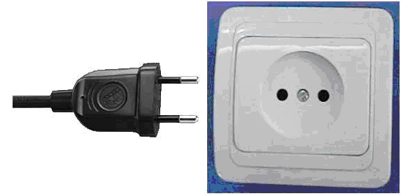
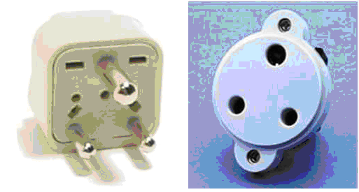

The common electrical current in Kochi is AC (230 Volt/50 Hz cycle). In the above picture the two kinds of sockets and plugs (Type C and D) used in India are shown. An adapter plug may be needed. Always check the power supply before using equipment.

Appendix A

Proforma for Invitation Letter

Family Name (Last Name)
Forename (First Name)
Fathers Name
Gender
Birth date (DD/MM/YYYY)
Passport Number
Country of Issue
Date of Issue
Date of Expiry
Company Name
Company/mailing address
Postal Code
Telephone Number

________________

