INTERNATIONAL TELECOMMUNICATION UNION |  | Joint Coordination Activity  On Accessibility and Human Factors
TELECOMMUNICATION  STANDARDIZATION SECTOR  STUDY PERIOD 2013-2016 |  | Doc 144
English only
Original: English
Source: | TSB
Title: | Agenda of the Third International Annual Conference and Exhibition on Communications and Information Technologies for People With Disabilities: Inclusion, Empowerment, and Participation (Cairo, Egypt, 13-14 April 2014)

Under the auspices of H.E. the Minister of Communications and Information Technology

The Third International Annual Conference and Exhibition on
Communications and Information Technologies for People With Disabilities:
Inclusion, Empowerment, and Participation

Tentative Agenda

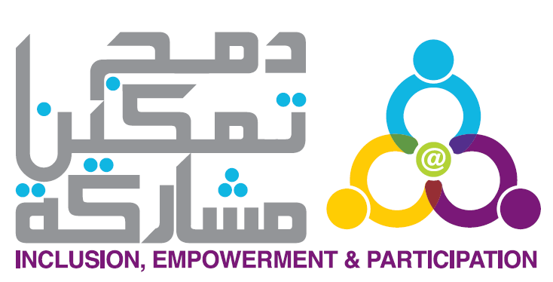

Smart Village Convention Center, Cairo, Egypt
13-14 April 2014,

Sponsors
Pre –Conference Training Day: 12April 2014

ICT and Inclusive employment. International Labour Organization(ILO)

Day I

9:30- 10:30 | Arrival & Registration
10:30-11:30 | Opening Session  - Dr. Abeer Shakweer – Minister’s Advisor for Social Services- Ministry of  Communication and Information Technology(MCIT).  - Eng. Hatem Dewaider – CEO Vodafone.  - Dr. Youssef ElKaryoti – Regional Director ILO Organization  - H.E. Ambassador James Moran, EU Ambassador to Egypt.  - H.E Dr. Mahmoud Abou ElNasr – Minister of Education.  - H.E. Eng. Atef Helmy, Minister of Communications and Information  Technology.
11:30-12:00 | ICDL4PWDs Certificates awarding  - Awarding the certificates for the PWDs employed through “The Training for Employment Grant”.
12:00-12:30 | Keynote Speakers  - Malcolm Johnson – Director of the Telecommunication Standardization Bureau-  International Telecommunication Union (ITU).  - Brahima Sanou- Director, Telecommunication Development Bureau-  International Telecommunication Union (ITU).  - Axel Leblois – President and Executive Director -The Global Initiative for  Inclusive ICTs (G3ict).
12:30-13:00 | - Awarding the ICDL certificates for the PWDs graduated from the “ICDL Grant”.
13:00-14:00 | - Opening of the Exhibition of Assistive Technologies  H.E. Eng. Atef Helmy, Minister of Communications and Information Technology
14:00-14:30 | Break
14:30-15:30 | Assistive Technologies for PWDs  - Prof. Suzan Shor, ITU, Accessibility toolkit accessibility for people with disabilities.  - Mr. Christopher, British Federation of the Deaf People (The British Experience).
15-30:16:00 | ICT4PWDs: Funding Opportunity  - Dr. Heba Gaber – Research and Innovation Officer, European Union, Delegation to Egypt.  - Mrs. Bothaina Esmat – Head of ICT4PWDs observatory- Ministry of Communications and Information Technology.
16:00-16:30 | Break
16:30-17:45 | Communications and information technology and opportunities to integrate PWDs into the labor market  - Ms. Amal Mwafy – ILO Organization  - Ms. Debra Rue – G3ict Organization  - Dr. Shereefa Masoud,, Daesn for People with Visual Disabilities .  - Telecom Egypt  - ICT Companies shared in integrate PWDs into the labor market
17:45-18:45 | Lunch

Day 2

9:30-10:30 | Arrival & Registration
10:30-11:30 | Integration of Educational techniques using modern technology  - Mrs. Heba Hagras, Assistive Technology for PWDs.  - Dr. Ahmed Adam, Minister’s Advisor for Special Needs.  - Dr. Abd ElHameed Kabash, Ain Shams University.  - Mr. Olaf Mittelstaedt - Project lead Daisy Consortium
11:30-12:00 | Break
12:00-15:00 | Inclusive ICT for Education Seminar: The Global Initiative for Inclusive ICTs (G3ict)- Part I
15:00-15:30 | Break
15:30-17:30 | Inclusive ICT for Education Seminar: The Global Initiative for Inclusive ICTs (G3ict)- Part II
17:30-18:30 | Lunch

