|  |  |  |  |  |
| --- | --- | --- | --- | --- |
|  | | **International Telecommunication Union** | | |
|  | |  | | |
| **ITU-T** | **FG-SSC** | |
| TELECOMMUNICATION STANDARDIZATION SECTOR OF ITU | | (05/2015) |
|  | ITU-T Focus Group on Smart Sustainable Cities | | | |
|  | **Setting the framework for an ICT architecture of a smart sustainable city** | | | |
|  | Focus Group Technical Specifications | | | |



FOREWORD

The International Telecommunication Union (ITU) is the United Nations specialized agency in the field of tele­com­mu­ni­ca­tions, information and communication technologies (ICTs). The ITU Telecommunication Standardization Sector (ITU-T) is a permanent organ of ITU. ITU-T is responsible for studying technical, operating and tariff questions and issuing Recommendations on them with a view to standardizing telecommunications on a worldwide basis.

The procedures for establishment of focus groups are defined in Recommendation ITU-T A.7. ITU-T Study Group 5 set up the ITU-T Focus Group on Smart Sustainable Cities (FG-SSC) at its meeting in February 2013. ITU-T Study Group 5 is the parent group of FG-SSC.

Deliverables of focus groups can take the form of technical reports, specifications, etc., and aim to provide material for consideration by the parent group in its standardization activities. Deliverables of focus groups are not ITU-T Recommendations.

|  |
| --- |
| **SERIES OF FG-SSC TECHNICAL REPORTS/SPECIFICATIONS**  Technical Report on "Smart sustainable cities: a guide for city leaders"  Technical Report on "Master plan for smart sustainable cities"  Technical Report on "An overview of smart sustainable cities and the role of information and communication technologies"  Technical Report on "Smart sustainable cities: an analysis of definitions"  Technical Report on "Smart water management in cities"  Technical Report on "Electromagnetic field (EMF) considerations in smart sustainable cities"  Technical Specifications on "Overview of key performance indicators in smart sustainable cities"  Technical Report on "Information and communication technologies for climate change adaptation in cities"  Technical Report on "Cybersecurity, data protection and cyber resilience in smart sustainable cities"  Technical Report on "Integrated management for smart sustainable cities"  Technical Report on "Key performance indicators definitions for smart sustainable cities"  Technical Specifications on "Key performance indicators related to the use of information and communication technology in smart sustainable cities"  Technical Specifications on "Key performance indicators related to the sustainability impacts of information and communication technology in smart sustainable cities"  Technical Report on "Standardization roadmap for smart sustainable cities"  Technical Report on "Setting the stage for stakeholders’ engagement in smart sustainable cities"  Technical Report on "Overview of smart sustainable cities infrastructure"  Technical Specifications on "Setting the framework for an ICT architecture of a smart sustainable city"  Technical Specifications on "Multi-service infrastructure for smart sustainable cities in new-development areas"  Technical Report on "Intelligent sustainable buildings for smart sustainable cities"  Technical Report on "Anonymization infrastructure and open data in smart sustainable cities"  Technical Report on "Standardization activities for smart sustainable cities" |

© ITU 2015

All rights reserved. No part of this publication may be reproduced, by any means whatsoever, without the prior written permission of ITU.

**Setting the framework for an ICT architecture of a smart sustainable city**

Acknowledgements

These Technical Specifications were researched and written by Leonidas Anthopoulos (Technological Education Institute of Thessaly), Paolo Gemma (Huawei), Ramy Ahmed (National Telecom Regulatory Authority, Egypt), Ziqin Sang (Fiberhome Technologies), Flavio Cucchietti (Telecom Italia), Zhen Luo (Fiberhome Technologies), Jia Guo (Fiberhome Technologies), Lei Gu (China Telecom) and Yuanyuan Liu (China Unicom), as a contribution to ITU-T Focus Group on Smart Sustainable Cities (FG-SSC).

Additional information and materials relating to this report can be found at: [www.itu.int/itu-t/climatechange](http://www.itu.int/itu-t/climatechange). If you would like to provide any additional information, please contact Cristina Bueti at [t](mailto:tsbsg5@itu.int)[sbsg5@itu.int](mailto:sbsg5@itu.int).

Setting the framework for an ICT architecture of a smart sustainable city

**Table of Contents**

1 Scope 1

2 References 1

3 Definitions 2

3.1 Terms defined elsewhere 2

3.2 Terms defined in this document 2

4 Abbreviations and acronyms 3

5 The architecture terminology 3

5.1 Architecture 3

5.2 ICT Architecture 4

5.3 ICT Architecture development methodology 5

5.4 Smart Sustainable City ICT Architecture 6

5.5 SSC ICT Architecture development methodology 7

5.6 SSC ICT Architecture interfaces 8

6 SSC ICT architecture 8

6.1 SSC ICT architecture framework 8

6.2 SSC ICT Meta-Architecture 16

6.3 SSC ICT architecture 19

7 Indicative SSC ICT architectural snapshots from different views 20

8 Guidelines for the SSC ICT architecture 28

9 Conclusions 35

Appendix A 37

Bibliography 40

Setting the framework for an ICT architecture of a smart sustainable city

Executive Summary

These Technical Specifications describe the ICT architecture development framework of Smart Sustainable Cities and concludes on corresponding architecture views and guides.

These Technical Specifications are expected to become an ITU-T Recommendation.

Keywords

Architecture, ICT Architecture, ICT Architecture Framework, Information Communication Technologies (ICT), Smart Sustainable Cities (SSC)

Introduction

According to the Terms of Reference (ToR) of the Focus Group on Smart Sustainable Cities (FG‑SSC), one of the objectives is to:

* Suggest future ITU-T study items and related actions within the scope of the ITU-T SG5 for example on:

• Concepts, coverage, vision and use cases of smart and sustainable cities.

• Characteristics and requirements of smart and sustainable cities.

• Efficient services and network infrastructure of smart and sustainable cities, as well as its architectural framework from the environmental impact point of view.

In this document an architectural framework of SSC is proposed.

1 Scope

These Technical Specifications describe the ICT architecture development framework of a smart sustainable city and concludes on corresponding architecture views and guides.

It is applicable to ICT architecture for Smart Sustainable Cities.

2 References

[ITU-T TR SSC Def] *Technical Report on smart sustainable cities: an analysis of definitions*.

[ITU-T TR SSC KPIs Def] *Key performance indicators definitions for smart sustainable cities*.

[ITU T TR SSC-0113] *Technical Report on "Setting the stage for stakeholders’ engagement in smart sustainable cities" Engaging stakeholders or smart sustainable cities"*.

[ITU-T TR SSC-0090] *Technical Report on "Cybersecurity, data protection and cyber resilience in smart sustainable cities"*

[ITU-T TR SSC-0097] *Technical Report on ”Overview of smart sustainable cities*

*infrastructure”*.

[ITU-T TR SSC-0347] *Technical Specifications for Multi-Service Infrastructure for smart sustainable cities in new-build areas*.

[ITU-T TR SSC overview] *Technical Report on An overview of smart sustainable cities and the role of information and communication technologies*.

[ITU-T TR SSC building] *FG-SSC deliverable, Technical Report on intelligent sustainable buildings for smart sustainable cities*.

[ITU-T TR SSC water] *FG-SSC deliverable, Technical Report on Smart water management in cities*.

[ITU-T TR SSC management] *FG-SSC deliverable, Technical Report on Integrated management for smart sustainable cities*.

3 Definitions

3.1 Terms defined elsewhere

These Technical Specifications use the following terms defined elsewhere:

**3.1.1 Smart sustainable cities** [ITU-T TR SSC Def]: A smart sustainable city is an innovative city that uses information and communication technologies (ICTs) and other means to improve quality of life, efficiency of urban operation and services, and competitiveness, while ensuring that it meets the needs of present and future generations with respect to economic, social and environmental aspects.

3.2 Terms defined in this document

These Technical Specifications defines the following term:

**3.2.1 Architecture***:* A definition of the structure, relationships, views, assumptions and rationale of a system.

**3.2.2 SSC ICT architecture**: The architecture of a smart sustainable city, which emphasizes on the role of the ICT (set of ICT components, which play individual roles within the system (i.e., authentication, data repositories, etc.) and all the components interact in order to establish the expected entire SSC role.

**3.2.3 Architecture framework**: The process that results in the definition of an architecture, consists of 3 steps: a) meta-architecture definition; b) architecture definition; and c) guides' definition.

4 Abbreviations and acronyms

These Technical Specification/Reports use the following abbreviations and acronyms:

BSI British Standards Institute

EDA Event Driven Architecture

FG-SSC Focus Group on Smart Sustainable Cities

GPS Global Positioning System

HART Highway Addressable Remote Transducer Protocol

ICT Information and Communication Technologies

IoT Internet of Things

ISO International Organization for Standardization

ITU International Telecommunication Union

OAM & P & security Operation, Administration, Maintenance and Provisioning, and Security

RFID Radio Frequency Identity

SCADA Supervisory Control and Data Acquisition

SOA Service Oriented Architecture

SOE State-Owned-Enterprise

SSC Smart Sustainable Cities

UML Unified Modeling Language

WPAN Wireless Personal Area Network

5 The architecture terminology

5.1 Architecture

The term architecture is over-used in the context of ICTs and has been applied to aspects ranging from the structure of information to the delivery of technology, and even the technical management of an ICT solution [14; 15]. The term architecture is so wide ranging that all of these uses may indeed be valid. It may be worthwhile to draw on a familiar use for the term – the structuring of physical forms such as buildings. Architecture is defined as: *formation or construction as or as if as the result of a conscious act; a unifying or coherent form or structure; the art or science of building* [14; 15].

The key components of this definition concern something with a defined structure. The architecture of a building, for instance, is based on solid and coherent reasoning. The architect, the undertaker of the architecture, is charged with considering a wide range of aspects in the development of the architecture including , the client's will, site's requirements, legal and financial constraints, technology limitations, the building's users, and a host of other considerations that do not immediately appear to be directly related to the formation of the building. In essence, the architect is the conduit, through which all of the factors flow in realizing the final structure of the building. This relation between alternative stakeholders' perspectives and influencing forces, impacts the architecture formulation via a shared vision ( as depicted in Figure 1).

Figure 1 – Forces that impact architecture formulation

The above characteristics can result in the definition of the architecture [14]:

*A pragmatic, coherent structuring of a collection of components that through these factors supports the vision of the full ''user'' in an elegant way.*

An alternative would be [15]:

*A definition of the structure, relationships, views, assumptions and rationale of a system.*

5.2 ICT Architecture

The above analysis for the definition concerns a system (collection of components) and each of the individual components can represent corresponding architectural practices. For instance, an information system consists of components, which play individual roles within the system (i.e., authentication, data repositories, etc.) and they all interact to establish the entire system's role. As such, the term architecture offers the following features:

* It is used to define a single "system".
* It describes the functional aspects of the system.
* It concentrates on describing the structure of the system.
* It describes both the intra-system and inter-system relationships.
* It defines guidelines, policies, and principles that govern the system's design, development, and evolution over time.

Each system's component has to be defined with the same or alternative architectural practices (hardware, software, data flow, business flow, management, etc.), which can represent alternative architectural perspectives, which at high level synthesize the enterprise ICT architecture [14]:

* The *information architecture* deals with the structure and use of information within the organization, and the alignment of information with the organization's strategic, tactical, and operational needs.
* The *business systems architecture* structures the informational needs into a delineation of necessary business systems to meet those needs.
* The *technical architecture* defines the technical environment and infrastructure in which all information systems exist.
* The *software or application architecture* defines the structure of individual systems based on defined technology.

All the above information underlines that an architecture *defines a framework within which a system can be accurately specified and built at a specific time frame. It functionally defines what the elements of the system do and how the data and information is exchanged between them. An architecture is functionally oriented and not technology specific, which allows the architecture to remain effective over time. It defines "what" must be done, not "how" it will be implemented.*

5.3 ICT Architecture development methodology

According to the above findings, the definition of an architecture has a lot to do with information collection and understanding of all the stakeholders' needs, together with the limitations that come from the external environment and of the laws that impact the operation of system. As such, the following process is suggested to lead the architecture development (Figure 2):

Figure 2 – ICT architecture development methodology

5.4 Smart Sustainable City ICT Architecture

This document emphasizes on the *technical architecture* from the architectural perspectives, which defines the platform on which the SSC organization (i.e., government, project coalition or business) builds and uses ICT in order to achieve in its defined mission [14]. To this end, the SSC architecture is the element, which:

* describes and defines the structure of the environment in which business systems are delivered;
* creates and maintains a set of core technology standards with which the SSC organization can measure technology projects;
* is an organizational capability – the people within (and outside) the ICT organization who provide strategic technical advice;
* is a means of resolving organizational technical issues;
* sets system (and hence software architecture), project, and corporate technology direction;
* establishes a reasoned approach for the integration of technology and business systems;
* establishes a framework for technology procurement decisions;
* both provides input to and is driven from the ICT planning process;
* allows the organization to control technology costs;
* develops a clear understanding of an organization's critical technical issues;
* provides a governance structure to support the ongoing health of the organization's technical environment;

As such, the SSC ICT architecture should be developed based on the complete architectures of its underlying systems in order to benefit from the potential integration and hence cost savings, of the underlying modules in the process of the combined city service provisioning management and control.

Accordingly, a smart sustainable city ICT Architecture document defines the types of components:

* Complex Systems (as a system of systems);
* Interconnections and Interfaces (between the Complex Systems); and
* Information Exchanges (between these Complex Systems).

5.5 SSC ICT Architecture development methodology

According to Figure 2, the methodology that this document follows concerns:

1. The definition of SSC ICT meta-architecture.

2. The definition of alternative SSC ICT architectures.

3. The definition of frameworks and patterns for the SSC ICT architecture.

The above process passes via the establishment of the following milestones (Figure 3):

1. *Identification of the needs:* This involves assessing the status quo of city services and processes. Examples from different regions should be described and analyzed in order to develop a rather generic or region-specific standardized architecture that can be found suitable for real implementation in different regions of the world.

2. *Stakeholders Identification and Needs Analysis:* This includes the roles and responsibilities of each stakeholder in developing, installing, procuring, operating, and maintaining the SSC elements is to be documented in addition to the functional and security related needs.

3. *Scope definition:* This includes the geographic boundaries and time frame that should be clearly stated at the onset of the process. The list of potential city service sectors, along with sector specific services should also be clearly identified and analyzed.

4. *Functional Requirements' definition:* This includes specifying a formal description of each subsystem belonging to a specific city service sector in order to identify the activities conducted by each subsystem.

5. *Subsystem and corresponding Interfaces' definition*: This describes how the different subsystems are connected and identifies any interfacing requirement.

6. *Dataflow* Analysis: Dataflow analysis between the different subsystems is conducted in this stage.

7. *Information Security and Privacy Requirements' definition:* Information security requirement is to be conducted based on the needs, functional, interface, and dataflow specifications of each subsystem.

8. *Systems Analysis and Final Design:* This involves analysis of the potential merge, deletion or addition of a system module to integrate different systems is to be conducted in this stage.

Figure 3 – SSC ICT architecture development methodology

5.6 SSC ICT Architecture interfaces

The interface is the median, which stands between the subsystems of one system [14]. There's no particular owner of an interface, neither intersystem contracts exist to describe the interfaces. Most interfaces execute typical batch jobs, while almost all require physical interventions to move generated files between subsystems. In the proposed SSC ICT architecture interfaces play the role to deliver information between discrete SSC ICT subsystems.

6 SSC ICT architecture

6.1 SSC ICT architecture framework

### 6.1.1 Identification of needs

The concept of Smart Sustainable Cities (SSC) has risen from the emerging urbanism phenomenon across the globe, according which the proportion of the international population that will live in cities will exceed 66% in 2050. The previously given SSC definition provides this document with the following characteristics for a smart sustainable city:

1. It concerns an urban space with innovative –not necessarily based on ICT- features. However, this document focuses on SSC architecture, where the ICT have a crucial role amongst the other innovative solutions and city facilities.

2. These innovation solutions address the following urban dimensions:

a. *People*: in terms of discovering and meeting today and future generations' requirements;

b. *Living*: by enhancing quality of life and social coherency, as well as efficiency regarding energy, food, water, etc.;

c. *Environment*: which includes protection, waste and emissions control against climate change;

d. *Governance*: in terms of ensuring urban utility and service availability;

e. *Economy*: in terms of sustainable growth and city competitiveness (attracting habitants, visitors and businesses).

Other approaches [1, 2] discuss about urban *mobility* in terms of transportation, which can be concerned part of the above *Living* dimension; *resilience* in terms of resistance against natural disasters, pandemics, terrorist attacks, accidents, etc. [3], which can be addressed by the above *environment* and *governance* SSC dimensions (Figure 4); *innovation* in terms of urban innovation [4], which is mainly disruptive, although the smart sustainable city becomes steadily a social innovation [5].

On the other hand, ITU Focus Group on SSC (FG-SSC) has delivered its document regarding Key Performance Indicators' (KPIs) definitions, which aligns to the United Nations Habitat dimensions (Table 6.1.1).

Table 6.1.1 – ITU SSC key performance indicators (KPIs)

|  |
| --- |
| SSC dimension |
| ICT |
| Environmental sustainability |
| Productivity |
| Quality of life |
| Equity and social inclusion |
| Physical infrastructure |

The above characteristics illustrate the complex SSC nexus (shown Figure 1), where the five dimensions match the SSC KPIs (Table 6.1.2), Matching was performed with the comparison of SSC KPIs with each of these dimensions and an important finding showing that complete matching is performed between *ICT*, *Quality-of-Life* and *Physical infrastructure* SSC KPIs with SSC dimensions, while the *Living* and *Government* SSC dimension matches to all SSC KPIs.

Table 6.1.2 – Matching between SSC dimensions and SSC-KPIs

|  |  |  |  |  |  |
| --- | --- | --- | --- | --- | --- |
| SSC dimension  SSC KPIs | People | Living | Government | Environment | Economy |
| ICT | **X** | **X** | **X** | **X** | **X** |
| Environmental sustainability |  | **X** |  | **X** |  |
| Productivity |  | **X** | **X** |  | **X** |
| Quality of life | **X** | **X** | **X** | **X** | **X** |
| Equity and social inclusion | **X** | **X** | **X** | **X** |  |
| Physical infrastructure | **X** | **X** | **X** | **X** | **X** |

Environment

Economy

Government

Living

People

**Smart Sustainable City**

Figure 4 – Smart Sustainable City dimensions fitting to the SSC and SSC-KPIs definition

### 6.1.2 Scope Identification

A smart sustainable city ICT architecture has to comply with the particular requirements of all forms of cities, as well as with all alternative smart infrastructure types that have or are being followed by SSC.

According to the above findings, ICT plays crucial role for smart sustainable city development. More specifically, it has been depicted that ICT contributes to all the SSC dimensions (people, living, government, mobility, economy and environment), which is translated that the alternative ICT solutions, as they're expressed with SSC focus group's documents (i.e., IoT, telecommunication network, cloud computing, cybersecurity, etc.), play major role in SSC development.

SSC can be classified according to the smart infrastructure type and corresponding development stage [6] to the following categories:

a) *Hard infrastructure* based: This category refers to city innovations, which target the efficiency and technological advancement of the city's hard infrastructure systems (i.e., transport, water, waste, energy).

b) *Soft infrastructure* based: City innovations, which address the efficiency and technological advancement of the city's soft infrastructure and the people of the city (i.e., social and human capital; knowledge, inclusion, participation, social equity, etc.).

With regard to the city development stage they're classified as the following:

a) *New cities* (Greenfield or 'cities from scratch' or 'planned cities'): They concern smart sustainable city projects where the entire city is being developed from ground zero, even urban planning addresses the above smart city dimensions and innovative solutions are embedded in the city. Various cases of this type are under development around the world ([*FG SSC-0347, Technical Specifications for Multi-Service Infrastructure for Smart Sustainable Cities in New-Build Areas*]).

b) *Existing cities*: They concern SSC projects where the innovative solutions are installed in existing infrastructure. Representatives of this category concern all the cities, which develop various types of innovative solutions.

c) *Smart plants*: they concern from-scratch projects, which are developed inside existing cities (i.e., new neighborhoods, new blocks or harbors, etc.) ([*FG SSC-0347, Technical Specifications for Multi-Service Infrastructure for Smart Sustainable Cities in New-Build Areas*].

Finally, SSC ICT architecture has to comply with the all potential evolution that has been followed, such as from wireless and broadband cities, to recent ubiquitous and green cities [16], which demands flexibility from the architecture.

### 6.1.3 Stakeholders Identification

According to [ITU TR SSC-0113], a stakeholder is defined as any entity, an institution or an individual, that has an interest in SSC or that can significantly influence or be influenced by its deployment. As such, a set of stakeholders have been identified and concern:

a. **Municipalities, City Council and city administration:** They are responsible for city management, and therefore they are the main promoters of SSC initiatives on each specific city.

b. **National and regional governments:** They have remit on policies that can affect SSC implementation.

c. **City services companies:** They would be implementing SSC solutions to increase city services efficiency.

d. **Utility providers:** They are responsible for the deployment of some of the features of SSC such as smart grid or smart water management.

e. **ICT Companies** (Telecom Operators, Start-ups, Software Companies): These are the providers of the global and integrated solutions, the city platforms, as well as the ICT infrastructure to support SSC deployment.

f. **NGOs:** They are involved in all initiatives that can influence society and therefore are a stakeholder in SSC, especially on the axis of social sustainability.

g. **International, Regional and Multilateral Organizations:** They include UN agencies and multilateral organizations. They can be promoters of initiatives towards human development, environmental sustainability and improvement of quality of life worldwide. They can offer funding opportunities, and are promoters of SSC initiatives.

h. **Industry associations:** Since industries are interested in the deployment of SSC, industry associations also work towards the success of this new model.

i. **Academia, research organizations and specialized bodies:** They study SSC and associated trends, including its impacts and contributions to sustainable development.

j. **Citizens and citizen organizations:** As users of cities, citizens are affected both directly and indirectly by SSC deployment.

k. **Urban Planners:** Their expertise is important to better understand how to include ICTs into medium and long term city planning, as well as to consider urban complexities.

l. **Standardization bodies:** These are critical to ensure a common terminology and minimum characteristics of a SSC, as well as to define measurement methods to assess the performance and sustainability of city services based on ICT technologies.

It is obvious that the SSC ICT architecture has to comply with the alternative interests and perspectives that the above stakeholders' group have on a smart sustainable city.

### 6.1.4 Architectural Principles

Architectural principles [14] concern guides that summarize the overall intent of both the IT strategic direction and the ensuing technical architecture resulting from this process. Resulting principles provide necessary vision for all ICT initiatives to follow within the SSC.

The previously identified context regarding needs, scope and stakeholders illustrate that there's a broad environment where the SSC ICT architecture has to be applied, which addresses:

*– Different geographic areas* (with various political, economic, technological, social and cultural characteristics);

*– Different technological artefacts* that potentially have been applied in the urban space (i.e., existing ICT solutions that have been developed by alternative stakeholders; public or private broadband networks, etc.);

*– Size and type of the city* (small versus global cities and capitals; new versus existing cities accordingly), which differentiate the size of SSC ICT impact and availability requirements, as well as the capability to install various hard infrastructure (simple for new cities and blocks, compared to historical cities);

*– Different timeframes* within which the SSC ICT architecture is requested to operate (small communities change more slowly and their needs accordingly, compared to global cities).

The architectural principles that enable the SSC ICT architecture to align to the above characteristics concern:

*– Layered structure*: Layered architecture has been proved to be applied in the mostly well managed SSC cases and can be applicable to most cases. Some layers have already introduced by the (*ITU FG-SSC 0097 specifications document on SSC infrastructure*) such as, the data and communication layer. However, exceptions have to be considered in cases where the SSC is not centrally and simultaneously developed, such as many European cases.

*– Interoperability:* Interoperability needs to be ensured among heterogeneous and distributed systems in SSC for provision and consumption of a variety of information and services.

*– Scalability:* The SSC ICT architecture has to be able to scale-up and down according to the size of city, the demand for services or business changes within the SSC.

*– Flexibility*: Cutting-edge (i.e., cloud computing, IoT, etc.) and emerging technologies have be able to be adopted, while physical or virtual resources have to be rapidly and elastically adjusted to provide various types of SSC services.

*– Fault tolerant:* Many quality attributes concern themselves with the availability of the architecture and its hosted componentry. Although fault tolerance is a rather strong phrase, it states the apex to which services and the architecture should aspire.

*– Availability, manageability and resilience:* Service availability must be ensured according the SSC user demand; disaster recovery must be provided in various levels; manageability relates to operational concerns, in a sense that managing the architecture directly supports SSC ICT operations. Manageability -at a systems/subsystems level- has to be secured in order to allow normal operations of equipment, networks and applications, especially considering more and more operation process would be managed automatically.

*– Standards-based:* This principle has an identifiable tension with that of technology and vendor independence. Essentially, an organization endorses this principle to ensure contestability, replace ability, and longevity.

*– Technology and/or vendor independence:* SSC and mainly those that run under the State supervision and/or funding, require that architectures, solutions, or services be vendor-independent, to facilitate contestability, replacement, or simpler interoperability or integration. Of course, vendor independence may also compromise one's ability to negotiate preferential rates or treatment, and it is not unusual for (larger) organizations to nominate a preferred list of suppliers for certain services, allowing a degree of negotiation to occur to support cost containment.

### 6.1.5 Functional Requirements

Beyond the above architectural requirements, the ITU SSC focus groups has provided with specifications a lot of SSC functions, that the proposed SSC ICT architecture must offer:

*– Cybersecurity, data protection and cyber resilience (FG-SSC 0090):* Smart sustainable cities (SSC) are highly dependent on information and communication technologies (ICTs), including Internet of Things (IoT), radio frequency identification (RFID), and machine-to-machine (M2M). The advanced underlying infrastructure not only resolves the need for hyper-connectivity for smart sustainable city components and services, but also introduces higher levels of complexity and higher volumes of data. Cybersecurity, information protection and system resilience constitute political and governance issues at the forefront of new developments in this field.

*– Privacy:* Privacy protection should be ensured during data transmission, aggregation, storage, and mining and processing.

*– Integrated Management (FG-SSC 0210):* Integrated management for SSC (IMSSC) seeks to alleviate challenges in the SSC management through the incorporation of sensor web, model web, service interfaces, ICT products, Internet of things (IoT) as well as the cloud computing technologies in areas of city operations and management. Integration of such technologies is adapted to continuously resolve the problems in smart sustainable city management by encoding, fusing and sharing the information resources of the cities in a unified way. Such an integration has to be achieved by the proposed SSC ICT architecture, while the architecture itself has to establish integration between its sub-systems and/or components.

*– Hard infrastructure and environmental management:* The proposed SSC ICT architecture must meet SSC defined specifications, regarding SSC smart infrastructure and environmental management (smart water management, smart building, energy efficiency, etc.).

*– Service delivery:* The proposed SSC ICT architecture must deliver a specified –but scalable- service portfolio to its end-users. SSC ICT end users are all the city inhabitants (service demand side), as well as representatives from the SSC stakeholders (service supply side).

*– Information flow:* The information flow runs between SSC ICT end-users (demand and supply side and sensors) and SSC ICT subsystems, via the interfaces of each subsystem.

### 6.1.6 SSC ICT Architectural views

An individual system structure is a complex collection of components, building blocks, objects, hardware, networks, services, and non-functional requirements [14]. Representing these aspects in a unified architecture can be difficult. This is complicated by the fact that an eclectic array of skills is required to specify, develop, and assure such an architecture. This problem is multiplied for the SSC ICT architecture development, which represents an enterprise technical architecture. All components of the ICT environment are required to be modelled within the architecture to ensure that the end product (in this case, the SSC) is complete, logical, reasoned, and meets the predefined business requirements.

The complexity of such a representation limits its ability to be understood (a significant aspect of the architectural approach being the ability to support effective communication of the architecture) by those who created it and possibly not even then [14]. It affects the architecture's ability to be assessed and assured by subject matter experts in the organization, while it complicates the ability to deliver and maintain the architecture.

Architectural views reduce the effects of these issues and enable increased understanding, assessment, assurance, implementation and maintenance: *a view is a means of describing how an organization's specific needs are embodied in the architecture*. Views can be taken at any point through the architecture and there is no right way to divide the architecture. The most typical approaches include:

*• Functional views:*  This view focuses on the functional aspects of the SSC, meaning what the SSC is intended to do.

*• Implementation views:* This view focuses on how the system is implemented and it is analysed in:

▪ *Management view*: It concerns the SSC service provider point of view and determines the offered services, the supporting personnel, the manageability of system's subsystems and the decision of a centrally or distributed management method;

▪ *Security view*: This view focuses on SSC requirements for cybersecurity;

▪ *Builder's view*: This concerns the view of particular subsystems' developers;

▪ *The data management view*: This view deals with the storage, retrieval, processing, archiving, and security of data; and

▪ *The user view:* This view considers the usability aspects of the SSC ICT environment.

*• Physical views*: These views concentrate on the location, type, and power of the equipment and software:

▪ *Computing view*: This view presents a number of different ways in which software and hardware components can be assembled into working systems.

▪ *The communications view:* This view examines various ways of structuring communications facilities to simplify the SSC ICT planning and design. It examines the networking elements of the architecture in the light of geographic constraints, bandwidth requirements, and so on.

*• Business Process Domain View:* This view is a set of functional views aligned with the business process structure of the SSC. Business process domain views are used during architecture development as a means of verifying and demonstrating that the architecture being developed is addressing the SSC business requirements.

*• Software Engineering View:* It helps the architect to analyse the current methods used by the organization to develop software and aids in positioning architectural styles for future development.

6.2 SSC ICT Meta-Architecture

All the aforementioned specifications and requirements analyze the SSC in the following components, which must be integrated via the proposed SSC ICT architecture:

* **Soft infrastructure:** people, knowledge, communities
* **Hard infrastructure:** buildings, networks (transportation, telecommunications), utilities (water, energy, waste)
* **ICT-based innovative solutions:** both hardware and software solutions, which address the above hard and soft infrastructure
* **Other innovative solutions (beyond the ICT):** technological innovation that addresses smart city dimensions (i.e., open spaces, recycling system, smart materials, organizational innovations in government, etc.)
* **Natural environment:** concerns the physical landscape and the corresponding characteristics, where the city is installed (i.e., ground, forests, rivers, lakes, mountains, flora, etc.) and grounds the limitations for the hard ICT infrastructure installation.

An indicative n-tier architecture where physical, utility and ICT environments co-exist and interact, while people and businesses are also part of the SSC eco-system and interact with the smart city via SSC services is illustrated on (Figure A.1). In [7] various smart sustainable cities around the world were explored and an important outcome concerns that the architecture that is preferred by well-managed managed cases is the multi-tier (Table 1), which is applied in new, existing and smart planting cases, while it addresses both soft and hard infrastructure, while it considers natural environment and the evolving Internet-of-Things (IoT) in terms of sensor installation. Another architectural approach concerns the Service Oriented Architecture (SOA) (Figure A.2), which is proposed for existing cities, where innovation mainly focuses on soft infrastructure, as well as where IoT is utilized (Figure A.3). Finally, event-driven architecture (EDA) is proposed (Figure A.4), but it has not been applied yet. Table 1 shows that architecture is independent to the ICT solutions that is applied in the city, as well as independent to the smart city organization (Public organization, State-Owned-Enterprise (SOE), Project coalition or Private Company).

All the given information collected from literature and case studies suggest that the meta-architecture of the SSC must be multi-tier in order to be clear and sustainable, in terms of standardization and communication of these standards. According to the examined cases, this n-tier architecture must utilize hard and soft infrastructure and must contain the minimum following layers (Figure 5) from top to bottom:

**Layer 1) Natural Environment:** It concerns all the environmental features where the city is located (landscape, rivers, lakes, sea, forests, etc.).

**Layer 2) Hard Infrastructure (Non ICT-based):** It contains all the urban features, which have been installed by human activities and are necessary for city operation (buildings, roads, bridges, energy-water-waste utilities, etc).

**Layer 3) Hard Infrastructure (ICT-based):** It concerns all smart hardware, with which SSC services are offered (i.e., datacenters, supercomputers and servers, networks, IoT, sensors, etc.)

**Layer 4) Services:** The SSC services, which are offered via the hard and soft infrastructure (i.e., smart safety, intelligent transportation, smart government, smart water management, etc.). These services have been analyzed and classified by various scholars [12] and are being focused by ITU FG-SSC too:

– Transportation services: parking management, logistics, trip optimization, intelligent transportation, accessibility and traffic management, etc.

– E-government services: administrative procedures, documents and open data, service applications (i.e., tax payments), e-deliberation and crowd sourcing, etc.

– E-Business services: typical intra-organization and inter-organization services, which are supported by the ICT (i.e., Enterprise Resource Planning (ERP) and Customer Relationship Management (CRM) functions, online procurement systems, e-banking systems, etc.).

– Safety and Emergency services: accident management (i.e., traffic accidents), crime prevention, public space monitoring, climate effects' changes, alerting and emergencies (i.e., in cases of kidnapping and natural disasters, etc.), etc.

– Smart health services: information sharing (i.e., environmental pollution data to people with diseases), tele-medicine, tele-care, health record management, etc.

– Tourism services: city guides, location based services, marketplaces, content sharing, etc.

– Education services: distance learning, digital content, digital libraries, ICT-based learning, ICT-literacy, etc.

– Smart Building: building performance optimization, remote monitoring and control, etc.

– Waste management services: monitoring, city waste management, emission control, recycling with the use of ICT, etc.

– Smart Energy services: artificial lighting, smart grids, energy efficiency's management, etc.

– Smart water services: quality measurement, water management, remote billing, etc.

**Layer 5) Soft Infrastructure:** individuals and groups of people living in the city, as well as applications, databases, software and data, with which the SSC services are realized.

­ 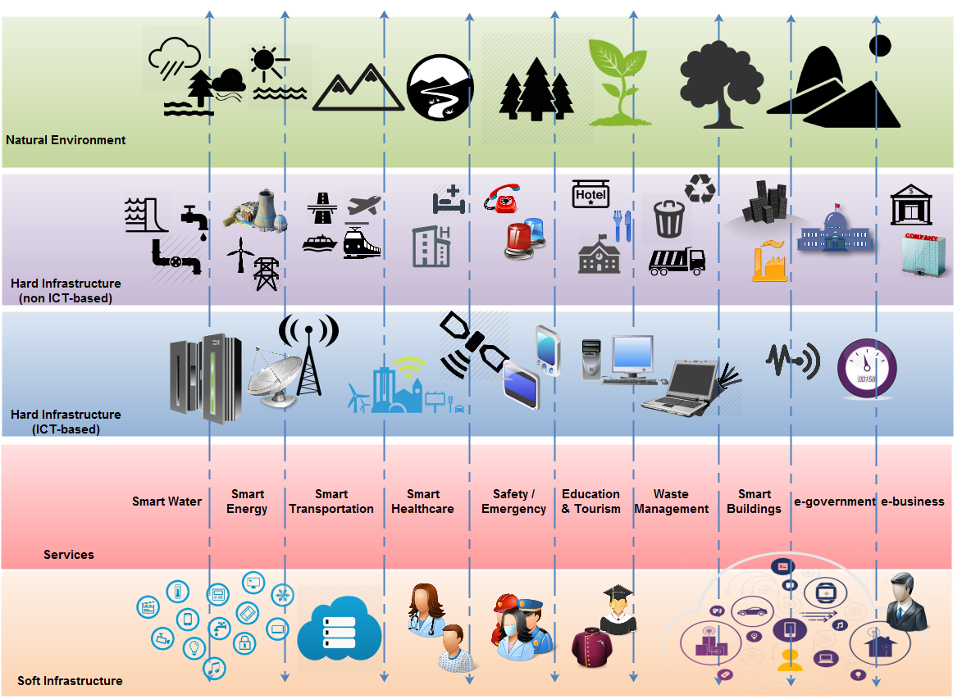

Figure 5 – Multi-tier SSC ICT meta-architecture

6.3 SSC ICT architecture

### 6.3.1 SSC ICT system's analysis and subsystems' definition

By its definition, the SSC ICT architecture aims to provide the following services to its end-users (inhabitants and stakeholders' representatives):

* Transportation services.
* E-government services.
* E-business services.
* Safety and Emergency services.
* Smart health services.
* Tourism services.
* Education services.
* Smart Building.
* Waste management services.
* Smart Energy services.
* Smart water services.

From the management view (service provider), all the above services structure the SSC service portfolio and a separate subsystem can be defined to offer each of them (Figure 6). Each subsystem requires both infrastructure and software to operate, its uses and produces data, while it transacts with end-users (demand and supply side) and with other subsystems via communication channels within the SSC.

Figure 6 – SSC ICT system's subsystems

Various transactions occur within the SSC ICT architecture and between SSC ICT end-users and the SSC ICT architecture subsystems. Indicatively, these transactions concern:

1. Information and service requests (demand side end-users);

2. Information and service delivery (supply side end-users and sub-systems);

3. Information and service requests (demand side subsystems);

4. Information and service delivery (supply side subsystems);

5. Information storage (demand side subsystems);

6. Information retrieval (supply side subsystems).

Individual interfaces stand around each subsystem and interconnects it with the others, while separate user interfaces offer service options to its end-users (demand and supply side) in order for a transaction to be performed.

7 Indicative SSC ICT architectural snapshots from different views

### 7.1.1 A software engineering view of the SSC ICT architecture

According to [14] a multi-tier architecture can satisfy the SSC ICT architecture. More specifically, a 5-level approach introduces sufficient flexibility (Figure 7) due to following reasons:

* In a two-tier architecture, the user interface and business logic are tightly coupled while the data is kept independent. This allows the data to be independently maintained. The tight coupling of the user interface and business logic assure that they will work well together – for this problem in this domain. However, the tight coupling of the user interface and business logic dramatically increases maintainability risks while reducing flexibility and opportunities for reuse.
* A three-tier approach adds a tier that separates (an amount of) the business logic from the user interface. This in principle allows the business logic to be used with different user interfaces as well as with different data stores. With respect to the use of different user interfaces, users might want the same user interface but using different commercial off-the-shelf (COTS) presentation servers, for example, thin client, Java Virtual Machine (JVM) or Common Desktop Environment (CDE).
* Similarly, if the business logic is to be used with different data stores, then each data store must use the same data model (''data standardization''), or a mediation tier must be added above the data store (''data encapsulation'').
* An additional level of flexibility can be achieved using a 5-tier scheme for software, extending the three-tier paradigm.

Figure 7 – A multi-tier SSC ICT architecture from a software engineering point of view

### 7.1.2 A communications view of the SSC ICT architecture

The communications view examines various ways of structuring communications facilities to simplify the SSC ICT planning and design. It examines the networking elements of the architecture in the light of geographic constraints, bandwidth requirements, and so on. Various alternatives can be followed to establish communications between SSC ICT architecture subsystems:

1. Cable networks (fiber-optic, coal-based networks within the city, etc.) installed in SSC;

2. Wireless networks (WiFi, WiMax, GSM, 4G mobile networks, etc.) installed in SSC;

3. Peer-to-Peer connections between SSC ICT architecture sub-systems;

4. Distributed Object Management (DOM);

All the above alternatives are organized in three groups regarding the network geographical range (Figure 8):

1. Global or wide area networks (i.e., across the SSC);

2. Regional area networks (i.e., neighborhoods of the SSC);

3. Local area networks (i.e., within a building of block of the SSC);

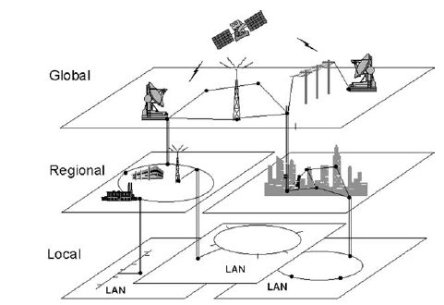

Figure 8 – Groups of communication networks in a smart sustainable city [14]

Such an approach, places communications and corresponding facilities and protocols at the core of the SSC ICT architecture and can multi-tier too.

Figure 9 depicts a corresponding SSC ICT architecture emphasizing on a physical perspective. On the other hand, figure 7 illustrates a corresponding SSC ICT architecture emphasizing on information flow. Both concern valid representations of the same architecture view, one closer to the language of infrastructure developer the second more in line with information system developer and they contain the following layers:

* *Sensing layer*: This consists of terminal node and capillary network. Terminals (sensor, transducer, actuator, camera, RFID reader, barcode symbols, GPS tracker, etc.) sense the physical world. They provide the superior "environment-detecting" ability and intelligence for monitoring and controlling the physical infrastructure within the city. The capillary network (including SCADA, sensor network, HART, WPAN, video surveillance, RFID, GPS related network, etc.) connects various terminals to network layer, providing ubiquitous and omnipotent information and data.
* *Network layer*: The network layer indicates various networks provided by telecommunication operators, as well as other metro networks provided by city stakeholders and/or enterprise private communication network. It is the "infobahn", the network layer data and support layer: The data and support layer makes the city "smarter", its main purpose is to ensure the support capabilities of various city-level applications and services. Data and support layer contains data center from industries, departments, enterprises, as well as the municipal dynamic data center and data warehouse, among others, established for the realization of data process and application support.
* *Application layer:* The application layer includes various applications that manage the SSC and deliver the SSC services.
* *Operation, Administration, Maintenance and Provisioning, and Security (OAM & P & security) framework:* This provides the operation, administration, maintenance and provisioning, and security function for the ICT systems of SSC.

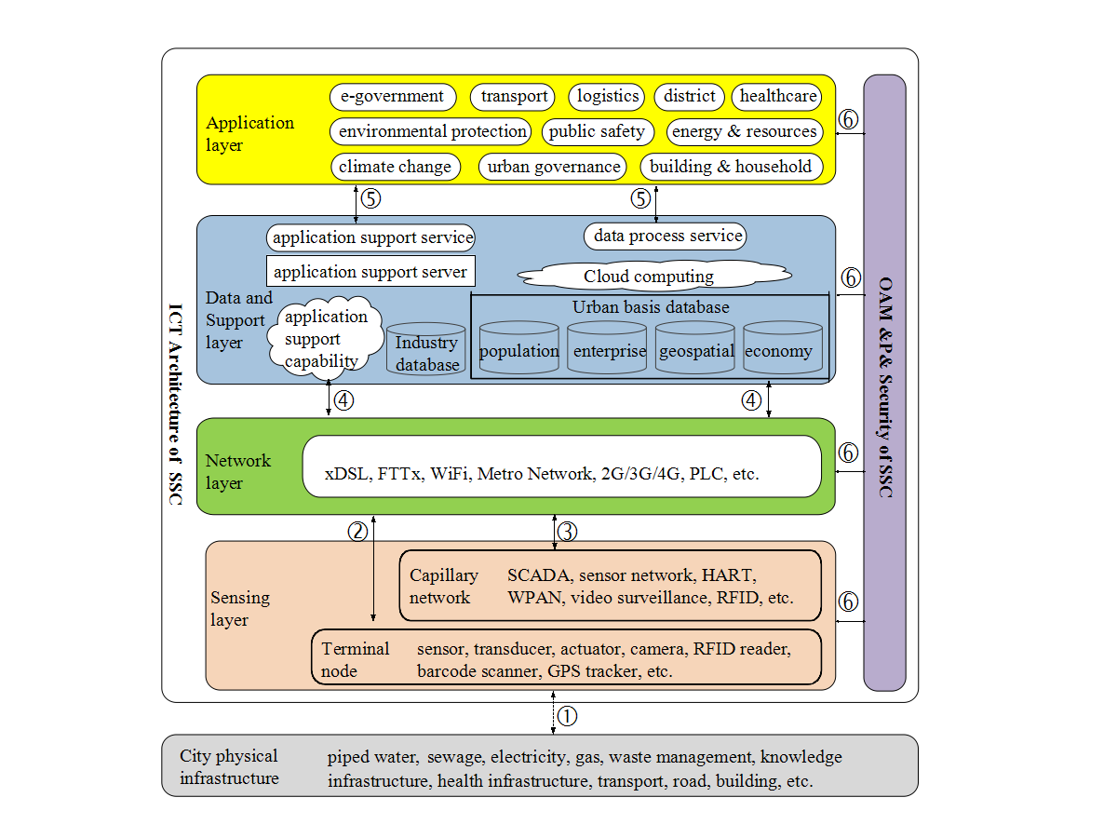

Figure 9 – A multi-tier SSC ICT architecture from communications view, emphasizing  
on a physical perspective

Figure 9 shows also, six interfaces between layers and OAM & P & security framework, marked with numbers in circles. These are places where communications and exchange of information between the layers, and OAM & P & security framework take place. They are the focal point of standards specifications and thus are called communication interface point. Overall functions at each of these reference points are listed below:

* Communication interface point 1: This exists between the city physical infrastructure and sensing layer. It enables the terminals sense the physical world, i.e., exchange of information and control signals between terminal nodes in sensing layer and the physical infrastructure.
* Communication interface point 2: This exists between the terminal nodes in sensing layer and the network layer. In this case terminal nodes, directly or through net gates, access to the network layer without through capillary network.
* Communication interface point 3: This exists between the capillary network in sensing layer and the network layer. In this case capillary networks collect the sensing data, and connects to the communication networks.
* Communication interface point 4: This exists between the network layer and the data and support layer. It enables communications between data centers and lower layers for collecting various information through the communication networks.
* Communication interface point 5: This point exists between the data and support layer and the application layer. It enables data centers and/or application support functionalities providing information to corresponding city applications and services, and also enables integrated applications exchanging data via data centers and/or application support functionalities.
* Communication interface point 6: This exists between the OAM&P and security framework and the four layers. It enables the corresponding modules to exchange data flow and control flow and provide operation, administration, maintenance, provisioning and security function.

Figure 10 introduce the following tiers:

* *Users layer:* It organizes SSC service end-users into groups from both the demand and the supply sides;
* *Presentations layer:* It contains the user interfaces (web, Apps, voice commands, etc.), which stand between end-users and SSC services;
* *Business layer:* It consists of the business processes, which lie behind each SSC service execution.
* *Communications layer:* It contains the above mentioned networks, over which the SSC services are performed and transactions and data flow are realized;
* *Data layer:* It contains the data and file repositories, where data are created or retrieved;
* *Sensing layer:* This layer consists of terminal node and capillary network. The terminals (sensor, transducer, actuator, camera, RFID tag, barcode symbols etc.) sense the natural environment where the SSC is located and the corresponding hard infrastructure and utilities (water, transport etc.). It provides the superior 'environment-detecting' ability and intelligence for monitoring and controlling the physical infrastructure within the city. The capillary network connects various terminals to communication layer, or directly to data layer and/or application layer providing ubiquitous and omnipotent information and data.

Figure 10 – A multi-tier SSC ICT architecture from communications view, emphasizing on an information flow perspective

There are two ways for the information flow in the above architectural view:

1. The information flow starts from the sensing layer to the application layer across the communication layer and the data layer. This is the most typical mode of information flow in SSC, as it involves the whole four layers of SSC.

2. The information flow starts at the sensing layer and terminates at the data layer directly without across the communication layer, or start at the sensing layer end at the application layer directly without across the communication layer and the data layer.

### 7.1.3 Modular SSC ICT architecture approach

Module definition for the SSC ICT architecture is an extremely complex process and it has to consider both the city type and the architecture view. According to the previously given analysis, soft urban infrastructure (people, data and applications) is flexible and can easily extend and interconnect. Difficulties rise from requirements, which deal with hard infrastructure and environment. Various attempts illustrate modular smart city approaches [8; 9; 10]. Moreover, an interesting modular architecture approach to smart city comes from [11] and can be utilized in the following analysis (Figure 11):

1) *Smart City Networking Infrastructure and Communications Protocol*: This module addresses the necessary infrastructure to deploy smart services and enhance living inside the city. Cities from scratch are based on innovations (both ICT-based and non ICT-based), which are embedded on city's hard infrastructure. For instance, a waste disposal, recycling and tele-heating factory can be installed and interconnected with buildings inside the city (Clever rubbish) [14]. Moreover, fiber-optic networks connect all local buildings with a central operating center, while smart buildings are accessible by their inhabitants via specific applications. In existing cities on the other hand, corresponding SSC cases integrate innovation with existing hard infrastructure with the IoT and basically with sensors that exchange data with specific applications. In such case, a corresponding modular analysis is depicted on. Moreover, protocol defines the codification for information interchange in SSC.

2) *Applications*: This module concerns all the smart applications, which are available inside the SSC. A well method for analyzing this module could be the classification of applications in the four SSC dimensions (Fig.1), including a separate group of mobility (i.e., intelligent transportation applications). It is analyzed in the following components:

a. Mobility: It concerns the applications that deal with transportation services (i.e., intelligent transportation, parking location and payments, traffic management, etc.).

b. Government: It represents applications regarding e-government services (i.e., information and document retrieval, certificate applications, government procedures, deliberation and consultation, etc.).

c. Economy: It contains applications in the business domain (i.e., e-business, business information systems, etc.).

d. Environment: This component utilizes applications for smart water and energy management, waste and emissions control, etc.

e. Living: application of this component address education, tourism, safety, health and care services.

3) *Business*: It addresses all business groups, which are available inside the SSC and utilize the above mentioned applications. Some particular business domains concern the industrial sector, finance, creative companies, rural production (i.e., agriculture, fisheries, etc.) and the service sector. This particular module addresses the following information management issues [11]:

a. User information for consumer behavior's detection.

b. Business intelligence for statistical and feasibility studies.

c. Industry information for market demand monitoring.

d. Business information for commercial and financial analysis.

e. Revenue Information for market cash flow and daily business activities' realization.

f. Circulation Information for emerged business cases' estimation.

4) *Management*: This module contains all rules and procedures for managing a smart sustainable city. The processes, people, resource, land and information are the primary elements and could be controlled centrally or individually with the appropriate set of standards. It is analyzed in the following components:

a. Information management: This includes information collection and dissemination across the SSC.

b. Process management: This addresses ICT management from a business transaction perspective in order to secure quality of service.

c. People management: This refers to human and workflow management in terms of a sequence of operations within the city, like a single organization (ISO1252 (2006)) and visualization (ISO/TR 16044 (2004)).

d. Land/spatial management: It represents urban and rural planning processes, as a means to secure sustainable land use.

e. Resource management: Focuses on resource utilization and constraints' avoidance, in order to capitalize the steadily flowing municipal resources and facilities (i.e., machinery, tools, etc.).

5) *Data*: This module extends the approach from Al-Hader et al. (2009). Data is crucial in SSC and can be either used or produced, while they can be stored centrally or in a distributed manner (locally). It is analyzed in the following components:

a. People data: It concerns individual information, which is produced by SSC inhabitants and are mostly preserved with privacy issues.

b. Process data: It is produced during SSC service execution and routine transactions between machines and/or people.

c. Documents: These are mainly used or produced by government applications or within the business sectors. Documents can be also the basis of SSC operations (i.e., quality assurance, disaster recovery plans, etc.) and can be organized in digital libraries.

d. Geospatial: This is the data being utilized by Geographical Information Systems (GIS).

e. Business data: This data is used or created in the business module and in the smart economy applications.

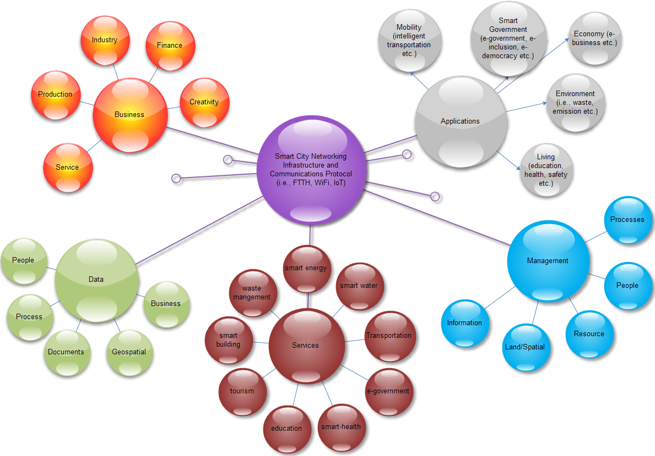

Figure 11 – Components analysis for a smart sustainable city

8 Guidelines for the SSC ICT architecture

These guidelines provide with specifications the SSC ICT architecture regarding the following aspects:

* Security and Privacy requirements: They are specified under the corresponding [ITU SSC‑0090] Technical report on Smart Sustainable City Cybersecurity, data protection and cyber resilience in smart sustainable cities
* Quality requirements: These are the minimum set of quality requirements have to be specified for each SSC ICT architecture's subsystem and for the overall architecture performance. Section 5.1.4 defined a set of principles for the SSC ICT architecture, some of which are totally quality-based (i.e., manageability, fault-tolerance, scalability, etc.)
* Guides for each subsystem: The above modular analysis returns the complex nexus of a SSC. However, most of the architecture components can be standardized and the assignment of standards to these components is presented in the following (Table 2):

| ID | Module | Description | Applicability to KPI | Standard |
| --- | --- | --- | --- | --- |
| **1.** | ***SSC Networking Infrastructure*** |  |  |  |
| 1.1 | Wide Area Network (WAN) | Wired network deployed across the city. | ICT | IEEE 1703-2012, described also in [b‑FG‑SSC infrastructure] |
| 1.2 | Fiber to the Home (FTTH) | Fiber-optic network, which is being deployed in the city and interconnects each building | ICT | IEEE 802.3ah  ITU G.983  ITU G.984 |
| 1.3 | Metro WiFi network | Wireless broadband network with city coverage | ICT | IEEE 802.11x |
| 1.4 | WiMax | Wireless broadband network, covering extended geographic areas. | ICT | IEEE 802.16 |
| 1.5 | Smart Building | ICT in building, which enables automation, control, safety and operation efficiency. | Physical infrastructure | Described in [b-FG-SSC infrastructure] and [b‑FG-SSC building] |
| 1.6 | Internet-of-Things | Sensors that transform usual objects to intelligent ones. | ICT | Ν/Α |
| 1.7 | Communications Protocol | Code and rules for interconnection and data exchange between sender and receiver. | ICT | *Depends on the communication nodes.* |
| 1.8 | Mobile communications | Mobile networks, provided by corresponding operators. | ICT | GSM  UMTS (3GSM)  IS-95 (CDMA one)  IS-2000 (CDMA 2000)  LTE |
| 1.9 | xDSL | Various DSL standards | ICT | Corresponding ITU specifications[1] like:  G.991.1, G.992.1, G.992.2, G.994.1, G.995.1, G.996.1, G.997.1, G.993  ETSI standards[2] |
| **2.** | ***Applications*** |  |  |  |
| 2.1 | Mobility – Intelligent Transportation | Systems utilizing ICT to use available data to improve the safety, management and efficiency of terrestrial transport, and to reduce environmental impact | ICT  Physical infrastructure  Environmental sustainability | Described in [b-FG-SSC infrastructure] |
| 2.2 | Mobility – Smart Parking | Parking management systems and self-automated parking services | Physical infrastructure | N/A |
| 2.3 | Government – eGovernment | G2G, G2B, G2C services, which enable government transformation to a more efficient, transparent and accountable. | Equity and social inclusion | Interoperability frameworks and standards, such as OASIS interoperability guidelines[3] and e-GIF[4] |
| 2.4 | Government – eInclusion | ICT applications, which support the close of the digital divide and enhance accessibility. | Equity and social inclusion | Digital Agenda for Europe: Action Area: 2.2 Interoperability and standards  "Improving ICT standard-setting"[5]  Design-oriented standards such as WCAG 2.0[6] |
| 2.5 | Government – eDemocracy | Applications for citizen engagement in policy and decision making, enable deliberation and enhance democracy. | Equity and social inclusion | N/A |
| 2.6 | Economy – eBusiness | ICT applications within business (i.e., e‑banking, business information systems like ERP and CRM, e-commerce, electronic payments, etc.) | Productivity | i.e., OASIS recommendations for e-business[7] |
| 2.7 | Environment – water | Smart Water Management (SWM) promotes the sustainable consumption of water resources through coordinated water management, by the integration of ICTs products, solution and systems. | Environmental sustainability | [b-FG-SSC water] |
| 2.8 | Environment – energy | Smart energy concepts (i.e., smart grids) aim to ensure: i) reliability, ii) self-healing, iii) interactivity, iv) compatibility, v) energy saving, vi) optimal use of energy from renewable sources, vii) safety, and viii) minimum carbon footprint | Environmental sustainability | Described in [b-FG-SSC infrastructure] |
| 2.9 | Environment – waste and emission | Solutions such as improvement of transport thanks to the ICT infrastructure and its applications, and an improvement in energy efficiency, can reduce pollution and waste management. | Environmental sustainability | Described in [b-FG-SSC infrastructure] |
| 2.10 | Living – education | Besides the known contribution of ICT to education, both classroom-based and distance-learning, the influence of the SCC will mean that the citizen will be placed in the center of educational scenarios. | Quality of life | Described in [b-FG-SSC infrastructure]  Sharable Content Object Reference Model (SCORM) for e-learning |
| 2.11 | Living – healthcare | Electronic Patient Records available to all medical services; public health professionals and clinicians to collaboratively access information in a secure way; tele-care and tele-medicine services. | Quality of life | Described in [b-FG-SSC infrastructure] |
| 2.12 | Living – safety/emergency | City safety system, Cloud-based large-scale data storage | Quality of life | Described in [b-FG-SSC infrastructure] |
| **3.** | ***Business*** |  |  |  |
| 3.1 | All types of business sectors | Methodologies and techniques, which enable companies to effectively adopt ICT for business. | Productivity | Enterprise Architecture and Business Process Re-engineering |
| 3.2 | All types of business sectors | Personnel ICT skills' enhance. | Productivity | 3tier ICT skills Pyramid[8]  Digital Agenda for Europe: Internet Use, Digital Skills and Online Content[9] |
| **4.** | ***Management*** |  |  |  |
| 4.1 | Process | Process mapping, standardization and management. | Productivity | Unified Modeling Language (UML)  ISO 9001:2008 quality management  ISO 1252 (2006)  (for operations' virtualization)  ISO/TR 16044 (2004) (virtual representation of actual work) |
| 4.2 | People | Human resource management techniques; community structuring and management schemas. | Quality of life,  Productivity | ISO/NP 30400  Terminology  ISO/CD 30405  Guidelines on recruitment  ISO/NP TR 30406  Management by sustainable employability of staff  ISO/AWI TS 30407  Cost-per-Hire  ISO/CD 30408  Human governance  ISO/NP 30409  Workforce planning |
| 4.3 | Resource | Local resource management methods (i.e., food, fleet, wood, etc.) | Environmental sustainability | N/A |
| 4.4 | Land | Urban and rural planning, land use and management methods. | Environmental sustainability ICT | Global Navigation Satellite System (GNSS)  reference stations |
| 4.5 | Information | Information and records management methods. | ICT | ISO 19005-3:2012  ISO 19005-2:2011  ISO 19005-1:2005  For Document and records management  BS ISO 15489:2001  Information and documentation. Records management. |
| **5.** | ***Data*** |  |  |  |
| 5.1 | Data Management | Issues about data security; integration; cloud; | ICT | Described in [b-FG-SSC infrastructure] |
| 5.2 | Government open data | Glossary and rules for data opening in government organizations | ICT  Equity and social inclusion | [10]Dublin Core[11] and ISO 11179 for data modeling  ISO 15000 ebXML for web services |
| **6.** | ***Services*** |  |  |  |
| 6.1 | Transportation | Parking management, logistics, trip optimization, intelligent transportation, accessibility and traffic management etc. | ICT,  Physical infrastructure | *Defined above in the application module* |
| 6.2 | e-government | administrative procedures, documents and open data, service applications (i.e., tax payments), e-deliberation and crowd sourcing, etc. | Equity and social inclusion | *Defined above in the application module* |
| 6.3 | Safety and Emergency | accident management (i.e., traffic accidents), crime prevention, public space monitoring, climate effects' changes, alerting and emergencies (i.e., in cases of kidnapping and natural disasters, etc.), etc. | Quality of life | *Defined above in the application module* |
| 6.4 | Health and care | information sharing (i.e., environmental pollution data to people with diseases), tele-medicine, tele-care, health record management, etc. | Quality of life | *Defined above in the application module* |
| 6.5 | Education | distance learning, digital content, digital libraries, ICT-based learning, ICT-literacy, etc. | Quality of life | *Defined above in the application module* |
| 6.6 | Tourism | city guides, location based services, marketplaces, content sharing, etc. | Quality of life | ISO19133:2005 for location based services  Other location based services' standards:  KML, the application programming interface for Google Maps and Google Earth  netCDF, science data encoding  Open GeoSMS  H.239[12] standard for content sharing |
| 6.7 | Smart building | building performance optimization, remote monitoring and control, etc. | Quality of life | *Defined above in the SSC Networking Infrastructure* |
| 6.8 | Waste management | monitoring, city waste management, emission control, recycling with the use of ICT, etc. | Environmental sustainability | *Defined above in the application module* |
| 6.9 | Smart energy | artificial lighting, smart grids, energy efficiency's management, etc. | Environmental sustainability | *Defined above in the application module* |
| 6.10 | Smart water | quality measurement, water management, remote billing, etc. | Environmental sustainability | *Defined above in the application module* |

9 Conclusions

These Technical Specifications collected a broad theoretical background regarding developing an SSC ICT architecture, which was strengthened with literature findings and experiences for various SSC cases in order to define a common SSC ICT architecture development process. This process returned a common SSC ICT meta-architecture, accompanied by a useful set of principles, functional requirements and guides for this architecture. However, it was concluded that no-unique physical SSC ICT architecture exists, but various alternatives are produced from the above process. Indicative architecture snapshots were depicted with regard of the software engineering and communications views respectively. Moreover, an analysis of the SSC ICT architecture in its subsystems and modules have been presented.

The content and supplementary information contained in these Technical Specifications allow the following general reflections:

* Multi-tier architecture secures SSC ICT good management. The proposed multi-tier meta-architecture covers hard and soft SSC facilities and delivers the required SSC services. The selected layers match completely to the SSC KPIs.
* Modular architecture secures flexibility and it is applicable to almost any SSC. The proposed modules focus on SSC synthesis and on ICT management. The selected modules with their components perform a perfect match to the SSC KPIs.

The illustrated architecture concerns a technical architecture, which can [14]:

a) Enhance SSC ICT operation.: Better-defined structure and modularity in the ICT environment leads to a much more effective ICT operation:

• Lower software development, support, and maintenance costs

• More application portability

• Improved interoperability and easier system and network management

• A better ability to address critical SSC organization-wide issues such as security and privacy

• Easier upgrade and exchange of system components

b) Secure an improved return on existing investment and reduced risk for future investment.:The structure of existing and planned systems is clearly defined, leading to:

• Reduced complexity in ICT infrastructure

• Maximum return on investment in existing ICT infrastructure

• The flexibility to make, buy, or outsource ICT solutions

• Reduced risk overall in new investment and the costs of ICT ownership

c) Enable faster, simpler, and cheaper procurement: There is a clear strategy for future procurement and migration, with the result that:

• Buying decisions are simpler because the information governing procurement is readily available in a coherent plan

• The procurement process is faster, maximizing procurement speed and flexibility without sacrificing architectural coherence

d) Establish flexibility for business growth and restructuring: It is much easier to ensure access to integrated information across the SSC:

• Maximum flexibility for SSC organization growth and restructuring

• Real savings when reengineering business processes following internal consolidations, mergers, and acquisitions

e) Shorten time-to-market: An ICT infrastructure much better equipped to support the rapid deployment of mission-critical SSC applications leads to:

• Faster time-to-market for new SSC services.

Appendix A

Table A.1 – Preferred architectures in various examined cases

|  |  |  |
| --- | --- | --- |
| Case | Findings | |
| Architecture | Organization |
| European Smart Cities | Urban Intelligence Measurement System | Project (various European Cities) |
| Two cities in Netherlands | SOA | State-Owned-Enterprise (SOE) run by the municipality |
| 52 cities | n-tier architecture (4 layers):  *Network, Content, Intelligence, e-services* | Public Organization (i.e., Gdansk (Poland), Masdar (UAE))  Public Private Partnership (PPP) (i.e., Amsterdam (Netherlands))  Private Companies (Malaga (Spain), New Songdo (Korea)) |
| Helsinki, Kyoto | n-tier architecture (3 layers): *information, interface, interaction* | State-Owned-Enterprise (SOE) run by the Municipality |
| Dubai | n-tier architecture (3 layers):  *Infrastructure, data, application* | Public Organization (Government) |
| Trikala, Greece | n-tier architecture (6 layers):  *data, infrastructure, interconnection, business, service and user* | State-Owned-Enterprise (SOE) run by the Municipality |
| Barcelona | n-tier architecture (4 layers):  *code, nodes, infrastructure and environment* | SOE run by the Municipality in cooperation with the local university |
| Blacksburg Electronic Village | n-tier architecture (3 layers): infrastructure, content, community | PPP between Bell Atlantic Telecoms, Virginia Tech, Municipality |
| Amsterdam | n-tier architecture | PPP between Municipality and Liander grid  Operator |
| Singapore | n-tier architecture (4 layers): ICT infrastructure, Cognitive infrastructure, Services, Customers | Public Organization |

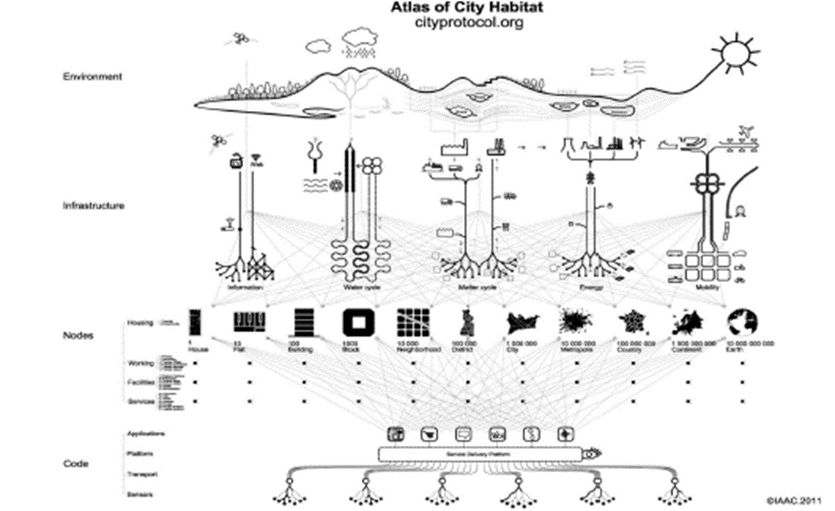

Figure A.1 – An indicative n-tier architecture (from Barcelona smart city)



Figure A.2 – An indicative SOA [1]

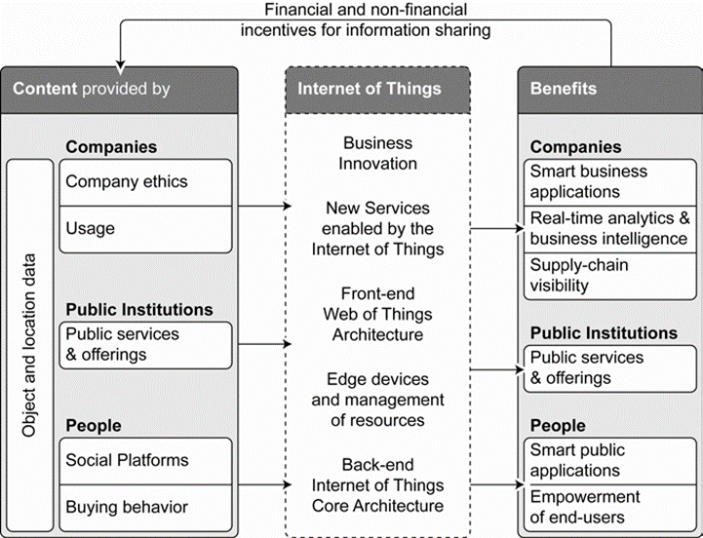

Figure A.3 – IoT architecture (content provided by city users and stakeholders is transformed by the IoT infrastructure and services to benefits to the same consumers)

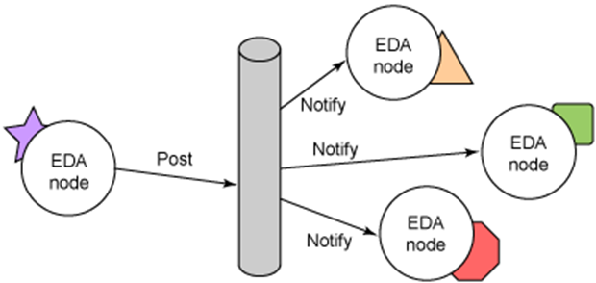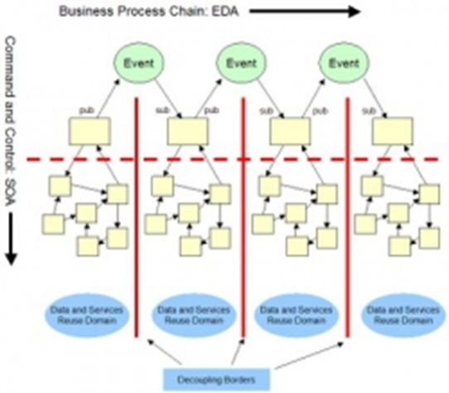

Figure A.4 – An indicative EDA (smart city as a system, where various events occur) [7]

Bibliography

[ITU-T TR SSC Def] FG-SSC deliverable, Technical Report on Smart sustainable cities: an analysis of definitions.

[ITU-T TR SSC KPIs Def] FG-SSC deliverable, Technical Report on Key performance indicators definitions for smart sustainable cities.

[ITU T TR SSC-0113] FG-SSC deliverable, Technical report on Setting the stage for stakeholders' engagement in smart sustainable cities.

[ITU-T TR SSC-0090] FG-SSC deliverable , Technical report on Cybersecurity, data protection and cyber resilience in smart sustainable cities.

[ITU-T TR SSC-0097] FG-SSC deliverable, Technical report on Overview of smart sustainable cities infrastructure.

[ITU-T TR SSC-0347] FG-SSC deliverable, Technical Specifications for Multi-service infrastructure for smart sustainable cities in new-development areas.

[ITU-T TR SSC overview] FG-SSC deliverable, Technical Report on Setting the framework for an ICT architecture of a smart sustainable city.

[ITU-T TR SSC building] FG-SSC deliverable, Technical Report on Intelligent sustainable buildings for smart sustainable cities.

[ITU-T TR SSC water] FG-SSC deliverable, Technical Report on Smart water management in cities.

[ITU-T TR SSC management] FG-SSC deliverable, Technical Report on Integrated management for smart sustainable cities.

[1] IBM Institute for Business Value (2009). How Smart is your city? Helping cities measure progress. Retrieved, February 6, 2015 from <http://www.ibm.com/smarterplanet/global/files/uk__en_uk__cities__ibm_sp_pov_smartcity.pdf>

[2] Giffinger, R., Fertner, C., Kramar, H., Meijers, E. and Pichler-Milanovic, N. (2008). *Smart Cities: Ranking of European medium-sized cities*. Retrieved, Feb. 6, 2015 from [http://www.smart-cities.eu/download/smart_ cities_final_report.pdf](http://www.smart-cities.eu/download/smart_%20cities_final_report.pdf)

[3] Pizzo, B. (2015). *Problematizing resilience: Implications for planning theory and practice*. Cities, 43, pp. 133-140.

[4] Khare, A., Beckman, T., and Crouse, N. (2011). *Cities addressing climate change: Introducing a tripartite model for sustainable partnership*. Sustainable Cities and Society, 1, 227-235.

[5] Dixon, T., Eames, M., Britnell, J., Watson, G.B., and Hunt, M. (2014). *Urban retrofitting: Identifying disruptive and sustaining technologies using performative and foresight techniques*. Technological Forecasting & Social Change, 89, pp. 131-144.

[6] Angelidou, M. (2014). *Smart city policies: A spatial approach*. Cities, 41, S3-S11.

[7] Anthopoulos, L., and Fitsilis, P. (2014). *Exploring Architectural and Organizational Features in Smart Cities*. In the Proceedings of the 16th International Conference on Advanced Communications Technology (ICACT2014), IEEE.

[8] Cruickshank, P. (2011) *SCRAN: The Network. Journal of Urban Technology*, 18(2), pp. 83‑97.

[9] Kuk, G., and Janssen, M. (2011). *The Business Models and Information Architectures of Smart Cities*. Journal of Urban Technology, 18(2), pp. 39-52.

[10] Kakarontzas, G., Anthopoulos, L., Chatzakou, D. and Vakali, A. (2014) "*A Conceptual Enterprise Architecture Framework for Smart Cities: A Survey Based Approach*". In the Proceedings of the ICE-B 2014 – International Conference on e-Business is part of the 11th International Joint Conference on e-Business and Telecommunications, Vienna, Austria; 28‑30 August, 2014, SCITEPRESS.

[11] Al-Hader, M., Rodzi, A., Sharif, A.R. and Ahmad, N. (2009). *Smart City Components Architecture*. In the Proceedings of International Conference on Computational Intelligence, Modelling and Simulation, IEEE.

[12] Piro, G., Cianci, I., Grieco, L.A., Boggia, G., and Camarda, P. (2014). *Information centric services in smart cities*. The Journal of Systems and Software, 88, pp. 169-188.

[13] Williamson, L. (2013). *Tomorrow's cities: Just how smart is Songdo*? [Online] Retrieved, March 20, 2015 from <http://www.bbc.com/news/technology-23757738>

[14] Perks, C., and Beveridge, T. (2003). *Guide to enterprise IT architecture*. Springer-Verlag New York, Inc.

[15] McGovern, J., Ambler, S.W., Stevens, M.E., Linn, J., Sharan, V., and Jo, E.K. (2003). *A Practical Guide to Enterprise Architecture*. Prentice Hall PTR.

[16] Anthopoulos, L. and Fitsilis, P. (2014). Smart Cities and their Roles in City Competition: a Classification. *International Journal of Electronic Government Research (IJEGR)*, 10 (1), pp. 67-81.

________________

1. <https://www.itu.int/ITU-T/worksem/asna/presentations/Session_6/asna_0604_s6_p4_palm.pdf>
2. <http://www.etsi.org/technologies-clusters/technologies/fixed-line-access/xdsl>
3. <https://www.oasis-open.org/policies-guidelines/interoperability-guidelines>
4. <http://xml.coverpages.org/egif-UK.html>
5. e-Inclusion activity <http://ec.europa.eu/einclusion>
6. <http://www.w3.org/TR/WCAG20/>
7. <https://www.oasis-open.org/news/pr/e-business-standards-developers-move-ahead-to-advance-collaboration-at-second-interoperabili>
8. Evans, N. (2002). Information Technology Jobs and Skill Standards. In Hawkins, Rudy and Wallace (Eds) *Technology Everywhere: A Campus Agenda for Educating and Managing Workers in the Digital Age*. John Wiley & Sons, Inc.
9. <http://ec.europa.eu/digital-agenda/en/internet-use-digital-skills-and-online-content>
10. <http://www.opendatafoundation.org/?lvl1=work&lvl2=standards>
11. <http://dublincore.org/>
12. <http://www.itu.int/rec/T-REC-H.239/en>