|  |  |  |  |  |
| --- | --- | --- | --- | --- |
|  | | **International Telecommunication Union** | | |
|  | |  | | |
| **ITU-T** | **FG-SSC** | |
| TELECOMMUNICATION STANDARDIZATION SECTOR OF ITU | | (10/2014) |
|  | ITU-T Focus Group on Smart Sustainable Cities | | | |
|  | **Smart water management in cities** | | | |
|  | Focus Group Technical Report | | | |



FOREWORD

The International Telecommunication Union (ITU) is the United Nations specialized agency in the field of tele­com­mu­ni­ca­tions, information and communication technologies (ICTs). The ITU Telecommunication Standardization Sector (ITU-T) is a permanent organ of ITU. ITU-T is responsible for studying technical, operating, and tariff questions and issuing Recommendations on them with a view to standardizing telecommunications on a worldwide basis.

The procedures for establishment of focus groups are defined in Recommendation ITU-T A.7. ITU-T Study Group 5 set up the ITU-T Focus Group on Smart Sustainable Cities (FG-SCC) at its meeting in February 2013. ITU-T Study Group 5 is the parent group of FG-SSC.

Deliverables of focus groups can take the form of technical reports, specifications, etc., and aim to provide material for consideration by the parent group in its standardization activities. Deliverables of focus groups are not ITU-T Recommendations.

|  |
| --- |
| **SERIES OF FG-SSC TECHNICAL REPORTS/SPECIFICATIONS**  Technical Report on "Smart sustainable cities: a guide for city leaders"  Technical Report on "Master plan for smart sustainable cities"  Technical Report on "An overview of smart sustainable cities and the role of information and communication technologies"  Technical Report on "Smart sustainable cities: an analysis of definitions"  Technical Report on "Smart water management in cities"  Technical Report on "Electromagnetic field (EMF) considerations in smart sustainable cities"  Technical Specifications on "Overview of key performance indicators in smart sustainable cities"  Technical Report on "Information and communication technologies for climate change adaptation in cities"  Technical Report on "Cybersecurity, data protection and cyber resilience in smart sustainable cities"  Technical Report on "Integrated management for smart sustainable cities"  Technical Report on "Key performance indicators definitions for smart sustainable cities"  Technical Specifications on "Key performance indicators related to the use of information and communication technology in smart sustainable cities"  Technical Specifications on "Key performance indicators related to the sustainability impacts of information and communication technology in smart sustainable cities"  Technical Report on "Standardization roadmap for smart sustainable cities"  Technical Report on "Setting the stage for stakeholders’ engagement in smart sustainable cities"  Technical Report on "Overview of smart sustainable cities infrastructure"  Technical Specifications on "Setting the framework for an ICT architecture of a smart sustainable city"  Technical Specifications on "Multi-service infrastructure for smart sustainable cities in new-development areas"  Technical Report on "Intelligent sustainable buildings for smart sustainable cities"  Technical Report on "Anonymization infrastructure and open data in smart sustainable cities"  Technical Report on "Standardization activities for smart sustainable cities" |

© ITU 2014

All rights reserved. No part of this publication may be reproduced, by any means whatsoever, without the prior written permission of ITU.

**Smart water management in cities**

Acknowledgements

This Technical Report was researched and written by Paolo Gemma (Huawei), Ziqin Sang (Fiberhome Technologies Group), Amanda Mc Intosh (Carlo-Schmid Programme) and Angelica V Ospina (University of Manchester) as a contribution to ITU-T Focus Group on Smart Sustainable Cities (FG-SSC) and ITU-T Focus Group on Smart Water Management (FG-SWM).

The authors would like to thank ISO/TMB Smart Cities AG for their valuable comments and contributions.

Additional information and materials relating to this report can be found at: [www.itu.int/itu-t/climatechange](http://www.itu.int/itu-t/climatechange). If you would like to provide any additional information, please contact Cristina Bueti at [t](http://www.bom.gov.au/water/about/wip/awris.shtml)[sbsg5@itu.int](mailto:sbsg5@itu.int).

Smart water management in cities

**Table of Contents**

Page

1 Introduction 2

2 Scope 4

3 Urban water issues 4

3.1 Rapid urbanization 5

3.2 Leadership and governance 6

3.3 Investment 7

3.4 Water utilities and infrastructure 7

3.5 Water availability and quality 8

3.6 Climate change 9

4 Smart water management in cities 11

4.1 SWM technologies 13

5 SWM integration: Strengthening urban water management 21

5.1 Intelligent solutions in urban water management 21

5.2 Remote monitoring solutions to urban wastewater management 25

5.3 Technologies for urban flood management 26

6 Action steps: SWM implementation 27

7 SWM opportunities 29

8 Gaps to be addressed 31

Conclusions 33

**List of Figures**

Page

Figure 1 – Interconnectedness of water and cities 2

Figure 2 – Influencing factors on urban water management challenges 5

Figure 3 – Projected megacities, 2015 6

Figure 4 – Projecting water stress 9

Figure 5 – Climate change effects on urban water resources 10

Figure 6 – Advantages of smart water management 12

Figure 7 – Schematic representation of smart water management technologies and tools 13

Figure 8 – Current implementation of smart water Management technologies and tools 13

Figure 9 – Smart metre technologies 16

Figure 10 – Example of SCADA software, Western Municipal Water District (WMWD), California 18

Figure 11 – Example of web-based technologies and city flooding: The Brisbane City web-based flood map 20

Figure 12 – The AWRIS system 22

Figure 13 – Screenshots of AQUADVANCED interfaces 23

Figure 14 – The BIT PipeScanner, 2nd generation 24

Figure 15 – WaterMOLE, 2nd generation 24

Figure 16 – Options investigated within Delft-FEWS real-time control of sewer system pilot project 26

Figure 18 – RainGain project location 27

Figure 19 – Steps towards the implementation of SWM 28

Figure 20 – Key actions involved in the implementation of SWM 28

Figure 21 – Smart water management tools 30

Smart water management in cities

Executive Summary

From their inception, information and communication technologies (ICTs) have played a pivotal role in the lives of cities. Historically, cities have been generating economic growth by developing institutions and assembling human resource to achieve prosperity, but unfortunately, this was often done at the expense of their water resource base. With rapid urbanization becoming an inevitable fact, cities are facing increasing challenges to secure financially sustainable water and sanitation services for its citizenry. If matched with appropriate and effective ICT solutions, in the form of smart water management (SWM), water issues within cities can be properly addressed and managed.

Smart water management (SWM) in cities seeks to alleviate challenges in the urban water management and water sector through the integration of ICT products, solutions and systems in areas of water management and sanitation, as well as stormwater management. Such technologies are adapted to continuously monitor water resources and diagnose problems in the urban water sector, allowing to prioritize and to manage maintenance issues more effectively, as well as to gather data needed to optimize all aspects of a city's water management system and feed information back to citizens, water operators, and technical services of cities.

Recognizing the impact that SWM can have at the intersection of water issues, growing cities, and increasing climate change impacts, the International Telecommunication Union (ITU) established Focus Groups on Smart Water Management (FG-SWM) and Smart Sustainable Cities (FG-SSC), with the vision that novel ICT-enabled tools can help empower regions, countries, and cities to overcome water-related challenges. Consequently, ITU has been at the forefront of emerging explorations on the potential of SWM in the alleviation of global challenges associated with this resource.

By promoting the coordinated development and management of urban water, SWM allows cities to strengthen institutional capacities, while striving to improve the sustainability of its natural resource base, particularly with respect to water and the environment. However, careful design and proper coordination among all relevant sectors – from the initial stages of project design, to implementation and assessment – is crucial to realize these opportunities.

This Technical Report aims to provide an overview of the key issues involved in SWM within urban settings, including the key water management problems and opportunities faced by cities. By highlighting the role and potential of ICTs, this Technical Report seeks to position SWM as a crucial area of action to achieve the goals set out by smart sustainable cities, and to respond to ongoing and emerging urban challenges, including those posed by climate change.

This Technical Report is structured around seven sections. The first section provides a general background of the analysis, highlighting the interconnectedness between water resources and cities, and situates the potential of ICTs and SWM. The second section provides a more in-depth understanding of urban water issues affecting urban settings, identifying the role of rapid urbanization, water availability and quality, water utilities and infrastructure, climate change impacts and investment needs. The third section explores smart water management in cities, providing an overview of key SWM technologies designed to improve performance, increase efficiency, lower cost and reduce potential environmental impacts, among others. The fourth section links theory to practice by providing selected examples of SWM solutions for urban water management, wastewater management and flood management. Building on this basis, the last three sections of this Technical Report suggest a set of concrete actions towards the implementation of SMW in cites (section five), the identification of the key opportunities associated with ICT-enabled solutions in the water sector (section six), and acknowledgement of the main gaps that need to be addressed to fully realize their potential in this field (section seven).

By offering analytical and technical insights into urban water issues and the role of ICT tools, this Technical Report seeks to stimulate further dialogue and discussion among the diverse stakeholders, practitioners and decision-makers interested in this field.

1 Introduction

The Water cycle (water resource, production, distribution, consumption, collection and treatment of waste water) play an integral part of the urban system, influencing each pillar of the urban society and its functionality, sustaining populations, generating energy, supporting tourism and recreational activities, ensuring environmental and human health, and fuelling local economic development. Such increasing convergence fosters urban growth, as more than half of the world's population currently reside in urban areas[1]. It is estimated that urban populations will increase from 3.6 billion in 2011, to 6.3 billion in 2050[2]. Urban areas will also have the task of absorbing rural populations, as their growth continues to decline.

As illustrated in Figure 1, the availability and distribution of water resources is intrinsically linked to the city's operations in areas as diverse as housing, health, economic development, tourism, recreation, transport, waste management and energy.

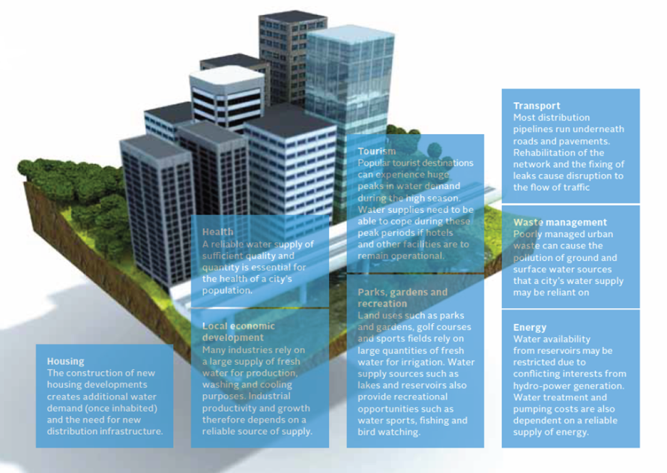

Source: Howe *et.al*. (2011).[3]

Figure 1 – Interconnectedness of water and cities

The increasing concentration of people, economic activities and assets in urban areas usually generates high amounts of waste and greenhouse gas pollution, heightening the city's susceptibility to the risks posed by disasters/hazards, as well as to the impacts of climate change. Thus, unbridled growth in urban areas poses socio-economic and environmental challenges to residents, businesses, industries, municipalities and governments alike. As per the focus of this Technical Report, it also poses significant challenges to urban planners in terms of effective and sustainable water management.

These challenges include the stress placed on water resources by fast-paced urbanization rates, which translates into a growing demand for clean water supplies and adequate sanitation, required to ensure human dignity. Rapid urban growth has also increased the competition for scarce water resources between sectors such as industry and agriculture.

The OECD report 'Water Security for Better Lives', suggests that achieving water security objectives means maintaining acceptable levels for four water risks: risk of shortage (including droughts), risk of inadequate quality, risk of excess (including floods), and risk of undermining the resilience of freshwater systems (e.g. by exceeding the coping capacity of the surface and groundwater bodies). This approach evidences an increasing awareness of the importance of tackling water-related challenges from an integrated, holistic perspective, considering both acceptable levels of risks, as well as their potential consequences (economic, environmental, social) on urban stakeholders.

The urban water service must, therefore, ensure proper management of water supply and distribution, water and wastewater treatment, and other municipal related services. Through franchising or licensing model franchises, the urban water industry is able to provide water and wastewater services for cities. The urban water utilities are constantly extending the water service chain, including (but not limited to) the following areas:

* **Raw water service**: Diversion of raw water is necessary to facilitate treatment and distribution to a city's population. In some cities, retail water price includes water diversion project costs.
* **Water supply services**: Provision of safe treated water to various sectors within the urban environment, including the residential, commercial, and industrial sectors.
* **Drainage services**: Provision of urban drainage through pipe networks is important to safeguard public health and prevent flooding. Some cities have separated their drainage network operation as a type of commercial service by an open bid for franchise of drainage service.
* **Wastewater treatment services**: Provision of wastewater treatment for commercial/marketed services is necessary to ensure environmental protection.
* **Reclaimed water service**: Usually offered by the vast majority of sewage treatment companies as a value-added business to industrial customers/users such as power plants.
* **Other water supply services**: The sea-water desalination market is in transition from an engineering, procurement, and construction (EPC) equipment provision to an integral investment and operational service.

With such a heavy reliance on water resources (Figure 1), any reductions on quantity or quality will have an adverse effect on the urban system. With the cities increasing their centralized production and consumption, and the rapidly changing land use patterns, the sustainable management of water resources constitutes a complex issue. Balancing economic development and water resource sustainability becomes even more problematic considering the current and expected impacts of climate change (e.g. sea level rise, water scarcity), added to the vulnerability associated with aging infrastructure.

Within this context, smart water systems can be characterized as systems with "a high degree of automation, rapid response times or the capability to capture information in real-time, the ability to transmit data between remote locations and the data processing facility, and for the data to be interpreted and presented to utilities and end users" (OECD, 2012, p. 4)[4]. While these systems combine both technical and non-technical innovations, information and communication technologies (ICTs) are increasingly providing novel operational possibilities to urban water managers.

Smart water management (SWM) approaches seek to promote a sustainable, well-coordinated development and management of water resources through the integration of ICT products, tools and solutions; thus providing the basis for a sustainable approach to water management and consumption.

The low cost of some ICT products, as well as their fast turnover rates when applied to urban environments, is fostering new and innovative approaches to ensure safe and adequate water provision for city dwellers. These technologies can be adapted to continuously monitor and diagnose problems, prioritize and manage maintenance issues, and use data to optimize all aspects of the urban water management network.

Harnessing the potential of ICTs in cities through the use of SWM can contribute to overcome water related socio-economic, cultural and environmental challenges, as well as to equip cities with technology to mitigate the impacts of climate change.

Building on this basis, this Technical Report explores the key issues involved in SWM within urban settings, including the key water management problems and opportunities faced by cities. By highlighting the role and potential of ICTs, this Technical Report seeks to position SWM as a crucial area of action to achieve the goals set out by smart sustainable cities, and to respond to ongoing and emerging urban challenges.

2 Scope

This Technical Report provides municipalities, decision-makers and interested stakeholders with an overview of the main technical aspects that need to be considered to effectively design and implement smart water management in cities. This Technical Report approaches smart water management systems from an overarching perspective. Therefore, it is expected that the smart water technologies described, as well as their integration into urban water management systems, can be relevant to inform the design of new systems (e.g. in the case of rapid urban growth and infrastructure extension in developing countries), as well as to update existing systems (e.g. linked to declining per capita demand for water and ageing infrastructure in developed countries).

While currently most water services (including drainage) rely on piped infrastructures, decentralized and non-piped water management techniques are starting to diffuse in both developed and developing cities. Given the scope of this Technical Report, the analysis focuses on the former. Further studies on the role of ICTs in decentralized water infrastructures could be the object of future work of ITU's Focus Group on Smart Water Management (FG-SWM).

Building on the efforts of Working Group 2 of the Focus Group on Smart Sustainable Cities (FG-SSC), this Technical Report offers both analytical and technical insights into urban water issues and the role of ICT, seeking to stimulate further dialogue and discussion among decision-makers, practitioners and experts working in this field.

In order to better understand the potential of ICT tools as part of SWM, the first section of this Technical Report explores the key challenges faced by cities in regards to water cycle, emphasizing those that are exacerbated by the impacts of climate change.

3 Urban water issues

Cities rely on multiple utility infrastructure systems that are characterized by their complexity, as well as by high investment and management costs. In the years ahead, it is expected that cities and other urban centres will encounter resource distribution challenges associated with an increase in population flow, energy issues due to the depletion of fossil fuel resources, increased investment overheads, spiralling maintenance and management costs due to aging infrastructure and improper land resource utilization, among others. Innovative and new sustainable systems are essential to minimize the impact of these emergent challenges.

Based on the context presented thus far, the provision of clean and reliable water constitutes a key area for the functioning of urban systems. Rapid urbanization, poverty and urban decay, weak political leadership and governance, insufficient and inadequate infrastructure, under investment and pricing issues, are among the key, and mutually re-enforcing factors that impinge upon a city's water management system. These factors are further exacerbated by the impacts of climate change and other environmental stressors, ultimately heightening water management challenges, and constraining the availability and the quality of urban water resources. The interconnected and dynamic nature of urban water management challenges is illustrated in Figure 2.

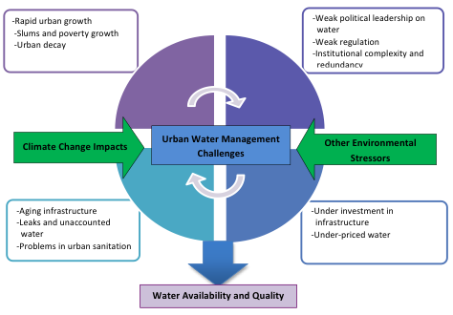

Source: Adapted from McIntosh (2014).[5]

Figure 2 – Influencing factors on urban water management challenges

This figure suggests that the impacts of climate change, among other stressors, exacerbate the complex set of challenges that affect urban water management systems (e.g. aging infrastructure, urban sanitation problems). At the same time, these challenges impinge upon the effectiveness of water management systems to prepare for, withstand, recover and adjust to these impacts. In order to understand better the linkages between these challenges and water management, the following section explores some of the key factors that influence urban water management.

## 3.1 Rapid urbanization

Cities around the world are continuously providing financial and specialized services for businesses, industry, and manufacturing sectors, among others. The emergence of new markets has contributed to a sharp population increase, fostering urbanization. The global urban population is estimated to be 3.5 billion of inhabitants, and is expected to surpass 5 billion by 2030[6]. This rapid growth engulfs outlying towns and blurs rural/urban boundaries creating peri-urban areas, areas immediately adjoining urban areas that are localized outside formal urban boundaries and urban jurisdictions, and in some regions, urban corridors, city chains and megacities.

Megacities and metacities – defined by the UN-Habitat as cities with more than 10 million inhabitants or 20 million inhabitants respectively – are growing rapidly, particularly in developing countries of Asia, Latin America and Africa[7]. It is estimated that by 2025 there will be 27 megacities, 21 of which will be located in developing countries. Projections suggest that by 2015, Bombay (22'6 million inhabitants), Dhaka (22'8), Sao Paulo (21'2), Delhi (20'9) and Mexico City (20'4) will be among the six biggest megacities, each surpassing 20 million inhabitants[8] (Figure 3).

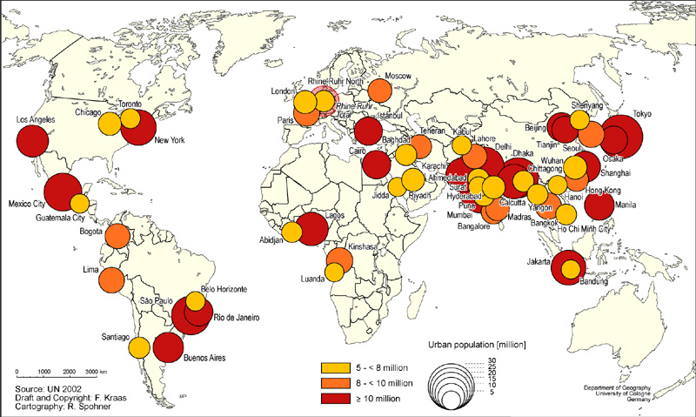

Source: Kraas and Nitschke (2008).**[9]**

Figure 3 – Projected megacities, 2015

These highly concentrated populations and the increasing size of cities have posed severe strains in local water resources, as cities are confronted by the need to meet an increasing demand for water resources. In the case of many cities, responding to this high demand has led to unsustainable water usage and over abstraction, and a depletion of groundwater and rivers that has serious consequences on water sources and on the environment. These challenges can have severe effects in megacities located in arid and semi-arid areas, particularly as climate change impacts further constrain their ability to provide access to a reliable and clean supply of water.

The inability to provide citizens with the necessary infrastructure has caused other problems, including the growth of the informal supply of drinking water, wastewater collection and disposal systems. These informal systems operate largely unregulated, posing major health risks to the population. Pressures to respond to this increasing demand have led cities to import water resources, contributing to increase urban carbon emissions.

## 3.2 Leadership and governance

Sustainable policies, strategies and practices are necessary to respond to the challenges affecting urban water resources. However, weak regulatory water and sanitation frameworks, along with overlapping functions within governmental agencies and institutions, have led to an unclear division of responsibilities and to uncoordinated efforts in urban water management. This has caused the fragmentation of strategies, as well as redundancies, jurisdictional conflicts, wastage of resources and conflicts in financing, resulting in inefficient and unsustainable approaches to urban water management in many cities around the globe. Heavy subsidies and fixed rates implemented by governments have encouraged ineffective usage and high consumption rates of water resources, ultimately placing further stress on this fragile resource.

Adding to these challenges, sectoral politicization has fostered short-term decision-making, while management goals and strategies are often limited to the term of the elected government. Insufficient capacity development and outdated management practices cause decisions to be made with inadequate information, or lead to poor implementation. Without capable staff and relevant information, the adoption of novel technology solutions needed to enhance a city's water management becomes unfeasible. Weak leadership and governance within the urban water structure has limited the sector's capacity to effectively address many of the existing and emerging challenges related to water resources.

Some of these challenges are explored in OECD's report 'Water Governance in OECD Countries: A Multi-level Approach'[10], including the co-ordination "gaps" that exist in water policy, multi-level governance challenges in decentralized public policy, and relevant policy responses. The OECD study suggests that the implementation of performance measurements, water information systems and databases, financial transfers, inter-municipal collaboration, citizen participation and innovative mechanisms (e.g. experimentation) are important tools for better co-ordination of water policy at the territorial level, and between levels of government.

## 3.3 Investment

Urban water management cannot be effective without the investment needed for a comprehensive, system-wide implementation. Increasing urbanization poses the need for new infrastructure to satisfy the requirements of the present as well as the future. The high cost and substantial investment requirements for the establishment and operation of such services has led to shifting responsibilities between governments and municipalities (e.g. jurisdictional financing conflicts), governments and industries/businesses (e.g. polluter pay effect), as well as between governments and the public (e.g. underpriced water due to insufficient tariffs) in order to generate the revenue and payment systems needed to finance urban water investments.

Consequently, the financing of water and sanitation services constitutes a major issue. The fact that aging infrastructure is crippling urban water distribution systems is a clear indicator that there is insufficient financing and investment within the urban water structure. To ensure a sustainable development of water infrastructure, appropriate investment levels are needed to support both short- and long-term decision-making, and to address the uncertainty and emerging risks associated with urban water challenges.

## 3.4 Water utilities and infrastructure

The rate of urbanization in some cities exceeds the capacities of governments (both local and national) to effectively plan and transition in an efficient and sustainable manner. Since the infrastructure design and capacity of water distribution and treatment plants are reliant on forecasted water demands and socio-economic data, unforeseen urban growth can lead to severe inequalities in service provision, thus constraining public access to water and sanitation.

Population growth in developing countries is often accompanied by increasing socio-economic challenges. For most cities in the developing world, a lack of revenue has translated into the lack of investment, limiting the city's ability to repair deteriorating infrastructure or improve aging facilities, while fostering the spread of informal infrastructure. Aging infrastructure is one of the most pressing concerns for the water utility industry. Statistics suggest that metallic water pipes failure rates range from 0.1 and 0.9 breaks per km and year[11]. According to the American Water Works Association, simply restoring existing water systems will cost over USD 1 trillion over the next 25 years[12]. Water lines, sewer mains, and treatment plants in cities, many built over a hundred years, are either leaking, collapsing, or overflowing, and it is estimated that 40% of clean water is lost yearly due to leaks with non-revenue water accounting for approximately USD 14 billion lost annually[13].

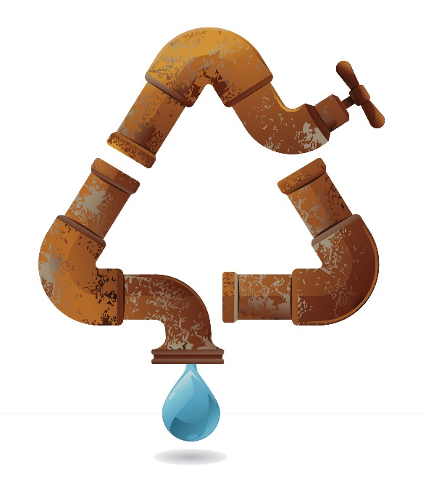

Water losses are also linked to illegal connections within the distribution network, as high amounts of non-revenue water means that a large portion of revenue is not always claimed from the customers. With the high cost of constructing, operating and maintaining water supply pumping, treatment and distribution infrastructure, and water utilities unable to recover these costs, a growing number of cities are facing serious challenges in the provision of safe and adequate water/sanitation.

While this section has focused on water utilities, it is important to recognize that urban water management encompasses a more diverse group of institutions and stakeholders, including property developers and households that invest in green roofs or buy water-efficient appliances. Further information on the role of these varied stakeholders in the implementation of SSC strategies can be found in other Technical Reports prepared by ITU FG-SSC (e.g. Smart Buildings for Smart Sustainable Cities, SSC Stakeholders)[14]

## 3.5 Water availability and quality

Urban water sources are very diverse. They include rivers, lakes, reservoirs, groundwater, desalination plants or a mixture of these sources. In many metropolitan areas, however, due to the growth of urbanization, the supply may extend far beyond the city's watershed. Such large cities rely heavily on a regional scale supply and distribution system. This is further complicated as freshwater is unevenly distributed over space and time, which places major planning and management challenges to the water sector. Approximately 700 million people in 43 countries are currently suffering from water stress and scarcity[15], with over 1 billion people without access to clean water[16], and over 2.6 million lacking adequate sanitation facilities[17].

In developing countries, poor water and sanitation facilities are the source of health problems for almost half of the population, and can be linked to 80% of diseases[18]. Urban pollution has also gradually led to the deterioration in water quality. Only 10% of the world's cities currently have water treatment facilities, and 90% of untreated wastewater in developing countries is discharged into rivers[19], further decreasing the availability of clean water resources for urban inhabitants. Therefore, providing a clean supply of water is considered to be both challenging and expensive.

Considering existing gaps in water demand and distribution, climate change impacts and poor water management magnify the vulnerability of countries that are experiencing water stress and weak water infrastructure. Water scarcity is not only a threat to human and economic development, but it may become a source of political instability in years to come. Illustrating the magnitude of water-related vulnerability at the global level, Figure 4 provides a baseline of water stress and projected changes by 2025. Climate change-related stressors on the urban water management are explained below.

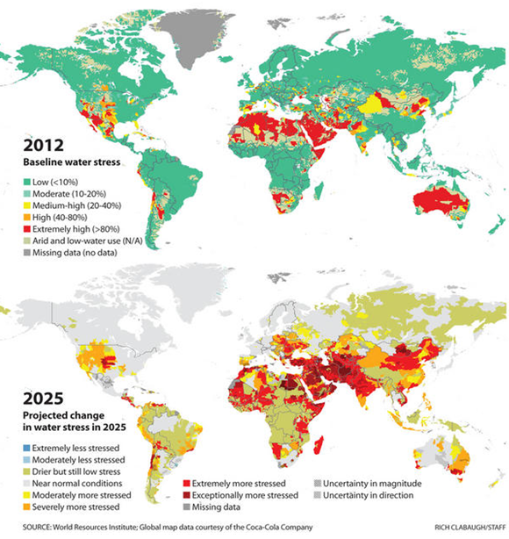

Source: World Resources Institute (2014).**[20]**

Figure 4 – Projecting water stress

## 3.6 Climate change

Data from the Intergovernmental Panel on Climate Change (IPCC)[21] climate change is projected to alter the frequency and magnitude of both floods and droughts. The impact is expected to vary from region to region. Some studies suggest that flood hazards will increase over more than half of the globe, in particular in central and eastern Siberia, parts of Southeast Asia including India, tropical Africa, and northern South America, but decreases are projected in parts of northern and Eastern Europe, Anatolia, central and East Asia, central North America, and southern South America (*limited evidence*, *high agreement*). These impacts are expected to impinge on water storage, decrease water quality and threaten urban water infrastructures, while disrupting service and increasing energy costs for operation and maintenance at both the local and the regional levels.

Since variation in precipitation regimes can cause severe droughts or lead to flooding, the increase in the frequency and intensity of droughts will negatively affect reservoir and groundwater storage. Towns and cities where the average level of rainfall is declining may experience precipitation in shorter, more intense bursts which can overwhelm urban drainage systems, leading to more street, basement, and sewer flooding. Sewerage systems that support storm water runoff, wastewater and sewage would be overwhelmed, endangering public health.

Cities, megacities and peri-urban areas are therefore highly vulnerable to climate change and its potential impact on its urban water systems. Cities in transboundary basins will be at higher risk, since inadequate management could intensify water stress. Figure 5 sums up the effects that various climate change manifestations are expected to have on urban water resources.

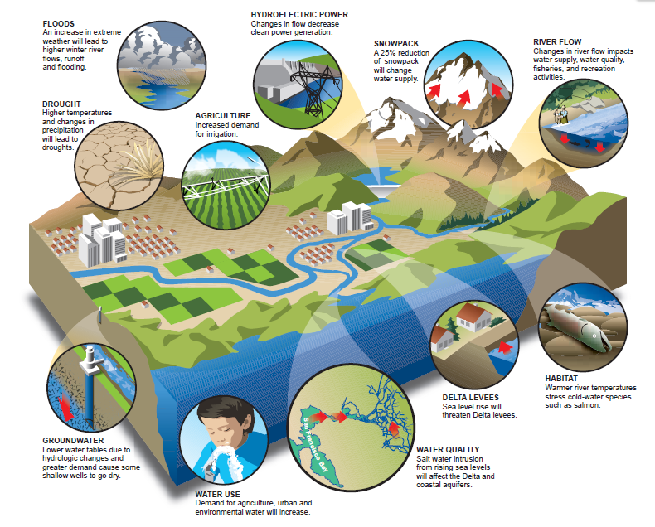

Source: Major et al. (2011).**[22]**

Figure 5 – Climate change effects on urban water resources

Sea level rise poses even a larger threat to coastal cities, which accounts for three-quarters of all large cities and half the world's population (UNEP and UN-Habitat, 2005). Salt water intrusion is expected to contaminate coastal surface water sources, and groundwater sources, decreasing thus their quality. An increase in sea level is also expected to lead to an increased probability of flooding of sewerage systems and wastewater pollution control plants (WPCPs), and to a reduced ability to discharge combined sewer overflows (CSOs) and WPCP effluent by gravity.

The analysis presented thus far suggests that climate change will exacerbate the city's vulnerability in terms of both the quantity and the quality of water resources. Based on this context, the following section will explore smart water management in cities, identifying the technologies that can be used to respond to the main challenges faced by cities in both the developed and developing countries.

4 Smart water management in cities

Water management is closely associated with water resource development and environmental protection, and it also entails proper management of the demand for public services and cost effectiveness. Consequently, urban water management must ensure access to water and sanitation infrastructure and services, manage rain, waste and storm water as well as runoff pollution, mitigate against floods, droughts and water borne diseases, while at the same time safeguarding the resource from degradation. As identified in the previous section, accelerated urbanization, especially in the developing world, coupled with increasing concerns for water security in the face of climate change and aging infrastructure, have challenged the effective implementation of these provisions. In today's integrated global economy, innovations in telecommunications have created a valuable opportunity to address these water challenges within cities, whilst improving urban water management.

Recognizing the challenges faced by the water sector, stakeholders from academia, corporations and the ICT sector have developed water intelligence tools that use ICTs to alleviate global water issues. The role played by smart water systems in optimizing the efficiency, effectiveness and flexibility of water and wastewater infrastructure assets and their management constitutes a topic of increasing attention, as evidenced in a recent OECD inventory of policies to promote and facilitate the diffusion of these technologies[23].

ICTs offer valuable opportunities to improve the productivity and efficiency within the water sector, with the aim of contributing to the sustainability of the resource. These technologies allow the continuous monitoring of water resources, providing real-time monitoring and measuring, making improvements in modelling and problem diagnosis, thus enabling proper maintenance and optimization of all aspects of the water network.

The increasing availability of more intelligent, ICT-enabled means to manage and protect the planet's water resources has led to the development of smart water management (SWM). The SWM approach promotes the sustainable consumption of water resources through co-ordinated water management, by integrating ICT products, solutions and systems, aimed at maximizing the socio-economic welfare of a society without compromising the environment. SWM can be applied to multiple sectors (e.g. industries, agriculture) and urban environments.

In cities, SWM strives to achieve three main goals through the utilization of ICTs, namely: (a) co-ordinated water resource management and distribution, (b) enhanced environmental protection, and (c) sustainable provision of public services and economic efforts.

Within urban environments, the implementation of SWM can make significant improvements in water distribution, helping to decrease losses due to non-revenue water, and helping to enhance waste- water and storm water management. Figure 6 illustrates the role of SWM water quality and reliability, ensuring proper management of green systems, decreasing water loss due to leakage, reducing operational costs, and improving customer control and choice. These improvements increase the efficiency of the water sector, while contributing to its economic sustainability since municipalities and water utilities are better able to recover costs from non-revenue water, including the detection of illegal connections.

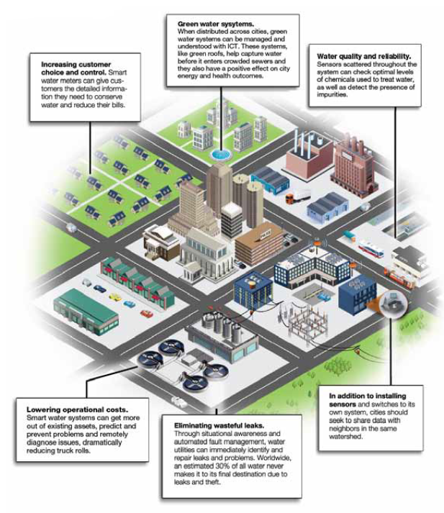

Source: Berst *et al*. (2013).[24]

Figure 6 – Advantages of smart water management

SWM tools can be categorized in the six main areas listed below. It should be noted that the examples provided are not limited to these areas, but may overlap several others, as seen in Figure 7.

1. Data acquisition and integration (e.g. sensor networks, smart pipes, smart metres).

2. Data dissemination (e.g. radio transmitters, wireless fidelity (WiFi), Internet).

3. Modelling and analytics (e.g. geographic information system (GIS), Mike Urban, Aquacycle, assessing and improving sustainability of urban water resources and systems (AISUWRS), and urban groundwater (UGROW).

4. Data processing and storage (e.g. software as a service (SaaS), cloud computing).

5. Management and control (e.g. supervisory control and data acquisition (SCADA), optimization tools).

6. Visualization and decision support (e.g. web-based communication and information systems tools).

7. Restitution of data and information to cities’ technical services and to the end users (e.g. Tools for sharing information on water and on services).

SCADA

MikeUrban

WIFI, Internet

Internet

Cloud

Sensors, Smart Pipes, Smart Meters

Figure 7 – Schematic representation of smart water management technologies and tools

As illustrated in Figure 7, SWM technologies often overlap a series of functionalities that are key for the effective operation of urban water systems. The following section will explore in more detail the role of each of these technologies, and their contribution to SWM.

## 4.1 SWM technologies

Smart water Management technologies are currently applied to many different areas of water management, as illustrated in Figure 8.

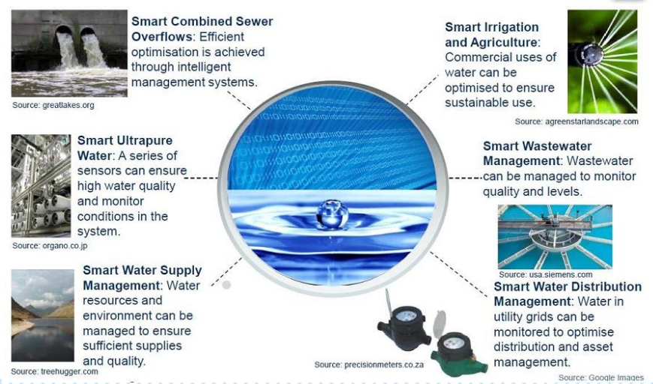

Source: Hauser (2012).[25]

Figure 8 – Current implementation of smart water Management technologies and tools

When applied to cities, the availability of reliable data to enhance operations can improve decision-making at multiple levels. Many innovative ICT tools have been developed in support of next-generation urban water infrastructure systems, helping to improve performance, increase efficiency, and reduce costs, decrease redundancy, and lower environmental impacts, among others. Some of these smart technologies are explained below:

a. Smart pipes and sensor networks

Smart pipes incorporate multifunctional sensors that can sense strain, temperature and pressure anomalies, as well as measure water flow and quality during service, to provide operators with continuous monitoring and inspection features, while assuring safer water supply distribution. Connecting smart pipes with a wireless processor and antenna enables data to be transferred directly to a command centre, providing water managers with the tools needed to detect and locate potential leaks in real time.

Smart pipes were initially developed for the transportation of oil, gas and hazardous liquids. Over the years, their applicability to water networks has slowly been realized. New research and development in prototypes for water distribution are needed to continue to advance public water supply systems[26].

Wireless sensor networks provide the technology for cities to more accurately monitor, and sometimes control, their water supply systems intricately using different parameters. Examples include sensors with the ability to analyse the acoustic signature of a pipe or to monitor soil moisture and detect leaks (e.g. if the ground is absorbing water, it could be an indication of a pipe leak; if the minimum daily noise is increasing it also means that a small leak was recently created). Many ICT companies are developing a wide range of sensors specifically designed for water networks. Some smart sensors can detect flow rates down to 0,3 m3/hr (5 liters/minute), enabling early-leak detection and thus reducing the risk of pipe break. The system reports pipe flow measurement data with pressure and acoustic measurement, combines this information to GIS data and sends automatic alerts to identify the location of possible leaks, thus allowing the prioritization of repair work.

Sensors can also be incorporated to optimize the water used in irrigation, measuring parameters such as air temperature, air humidity, soil temperature, soil moisture, leaf wetness, atmospheric pressure, solar radiation, trunk/stem/fruit diameter, wind speed/direction, and rainfall. Urban applications range from park irrigation to commercial irrigation systems, enabling better management and a more accurate allocation of water resources between sectors.

Sensors can also be incorporated to assess the water quality of surface water, as well as treated water sewage within cities. Currently, many monitoring tasks (e.g. sampling the chemical condition of water, sediments, or fish tissue for quality assessments) are still conducted manually, requiring human resources for sampling and further lab analysis. In addition to the cost of maintaining such monitoring programs, there are difficulties associated with the provision of effective warnings due to the lag time between data retrieval and data assessment.

To overcome these problems, more and more water quality monitoring programs are striving to deliver on-line (and sometimes real-time) water quality monitoring. Smart sensor networks for in situ monitoring are being utilized to improve water resource and wastewater management. Such sensors are the core of these systems, which perform the online measurement of the fundamental parameters of water quality including pH, conductivity, dissolved oxygen, turbidity, ammonia, phosphorus, nitrate, ; chemical oxygen demand (COD) and metal ions, etc.

Novel sensing technologies (e.g. micro-electro-mechanical-system technology, electrochemical technology, spectrophotometric technology) are applied to these sensors to achieve satisfactory measurement results with lower power consumption and lower cost requirements. These sensors are connected through smart sensor interfaces like IEEE 1451 standard, with reliable wired and/or wireless network technologies (e.g. WiFi, ZigBee, International Society of Automation (ISA100)), mobile network). Thus, the system is easily expandable to cover the broader water sector. Intelligence is integrated through the use of automatic control technologies and computer technologies, in order to ensure sample pre-treatment, sensor measurement, data collection, processing and analysis, and system communications.

Major tasks for smart sensor networks in water quality monitoring include the following:

* Identify and characterize changes in existing or emerging trends in surface water quality over time.
* Gather information to design or assess specific pollution prevention or remediation programmes, or to provide information in a timely manner to allow quick response to emergencies, such as spills and sewage leakages.
* Determine whether programme goals – such as compliance with pollution regulations or implementation of effective pollution control actions – are being met.

Integrating smart pipes and sensors within the urban system enables key functions such as the detection of events based on the monitoring of flow rate, pipe pressure, stagnant points, slow-flow sections, pipe leakage, backflow, and water quality to be monitored, which constitute data needed to optimize the operation of current networks.

b. Smart metering

Smart metres are electronic devices with advanced metering infrastructure (AMI) that supports on-line measuring of electric, heat, gas, and water consumption. These devices are rapidly evolving in response to market forces and governmental regulations. In the case of water consumption, smart metres typically consist of an embedded controller that interfaces with a metering sensor, a wireless transmitter, as well as communication extension and a 10-to-15-years-lifetime battery, as there is no mains power supply available for water meters. The metres are connected to a network of data logger which allows for the continuous monitoring of water consumption of a city, a building, a business or a home. The innovation of smart metres enables a two-way communication when required between the metre and a central system by transmitting data, which can be done through different channels (e.g. radiocommunication, power line, Internet, telephone). As smart water meters are battery powered, the main communication channel is based on radiocommunication between the smart meter and the network of RTUs, then on GSM/GPRS (or equivalent) up to the central system.

Smart metres typically collect consumption data, and then transmit this data to a gateway that interfaces with the local area network (LAN), home area network (HAN) and wide area network (WAN). The LAN consists of the metrology or measurement function of the metre, while the HAN is connected to the customers' network. Due to the display functions of HAN, it easily allows accessibility to consumption data through a user-friendly interface, allowing customers to compare and track their water consumption. As HAN functions are energy consuming those can be replaced by a web access to Home Data and collected via the LAN and the WAN. WAN is managed by the utilities and allows them to track, monitor and bill consumption.

The deployment of smart metres within an urban infrastructure enables remote accessibility of consumption data, which improves metre reading and billing, detection of leaks, illegal connections and tamper alerts, and can also enhance the identification of peak demand mainly for energy. Customer and provider relationships are improved through increased communication, utilities can improve their tariffs policies and consumers can be equipped with options like on-line alarms in case of leak or suspicious consumption, or the possibility to change payment methods (e.g. prepaid or postpaid).

Smart metering also allows water utilities to provide clear water consumption information which can help customers to track and control their water usage, and identify immediate savings on their bills, thus enabling better distribution network and consumption planning due to its real-time monitoring capabilities. Figure 9 illustrates an example of AMI infrastructure and SWM capabilities.

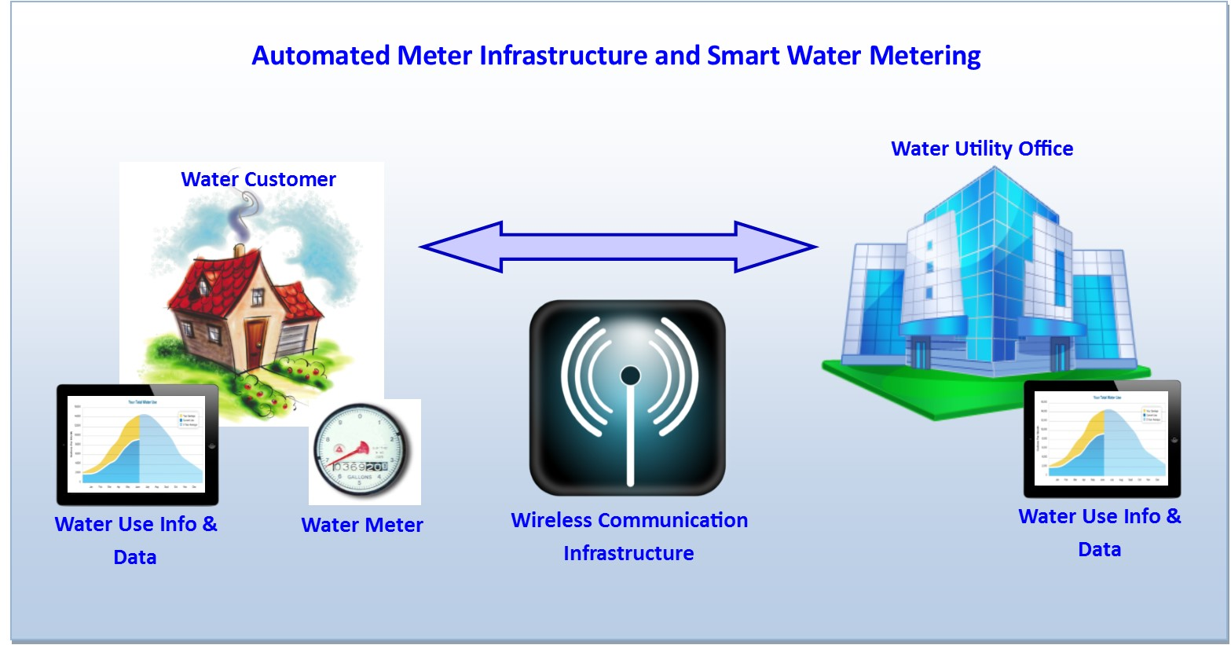

Source: Alliance for Water Efficiency (2014).**[27]**

Figure 9 – Smart metre technologies

c. Communication modems

Communication solutions include Bluetooth, Wireless M-Bus communication, global system for mobile communications/general packet radio service (GSM/GPRS), and Ethernet, among others. These solutions allow remote reading of sensors and metres by the direct transfer of real-time or time-stamped data to the central management system of the utility or water authority. The data is then made available online for customer information system (CIS), geographic information systems (GIS), cloud computing or supervision and data management tools, supporting improved decision-making within the system. Such communication devices incorporated with smart metres/sensors can also provide alerts to authorities (e.g. reverse flow, leak alert, fraud alarm, and battery levels, water quality alarms). Most of these types of communication solutions ensure spatial redundancy and enable a wide range of coverage between distant buildings, housing estates, and other districts. In the traditional collection systems, considerable amounts of time would have been wasted finding and measuring points, especially in remote locations.

d. Geographic information systems (GIS)

Geographic information systems (GISs) allow to capture, manage, analyse and display geographical information for underground assets description and decision-making. GIS has a wide range of applications in various sectors (e.g. natural resources, utilities, transportation, public safety and defence). Their integration can improve data management especially of large volume projects, since they provide high quality results' display (particularly in hydraulic simulation modelling), thus enabling additional analysis to inform decision-making.

GIS allows visualization and analysis of water resources and human activity data by linking geographic information with descriptive information. This is highly valuable to urban water management in assessing water quality and day-to-day operations on a local and regional scale. Other issues such as flooding can also be mitigated by the use of geographical information, by helping to identify critical areas that are at risk. This is necessary in the development of hazard maps, as well as in the planning of emergency responses. GIS utilization offers more robust analysis, increased efficiency and reduced costs.

By integrating information from resource satellites, GIS can cover large river basins which are occupied by some cities. Combined with local rainfall patterns, meteorological and hydrological data, as well as drainage systems, geographical information and interfaces improves urban storm water management by strengthening drainage management and enhancing rainwater reuse, thus helping to reduce the prevalence of urban flooding.

e. Cloud computing

Cloud computing uses an external computing power ability which is outside the boundary of a user's own infrastructure, to run programs or applications. Cloud environments typically enable the following functionalities: monitor and manage computing without human involvement, broad network access to allow computing services to be delivered, access over several networks and heterogeneous devices, technologic ability to scale up or down computational resources swiftly and as needed, ability to share across multiple applications, as well as to track applications/tenants for billing purposes.

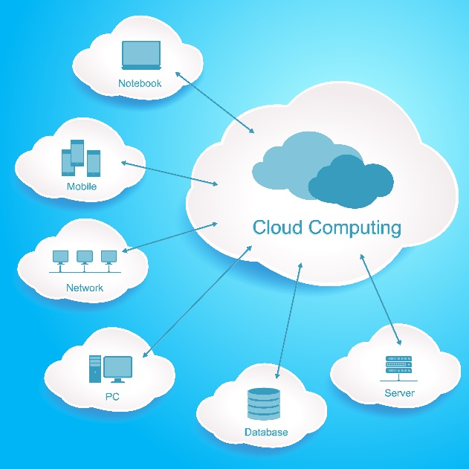

Cloud systems in urban settings also allow high efficiency and high utilization of pooled resources for a better balance of workload and computation through multiple applications, providing urban water managers with a wide range of possibilities in computer modelling and data storage. Urban flood management is another area where cloud computing is increasingly use.[28]

Beyond their technological interest, various issues like data privacy, security and ownership have to be clearly validated by the Cities prior to any massive deployment of Cloud computing solutions.

f. Supervisory control and data acquisition (SCADA)

When incorporated into water management systems, supervisory control and data acquisition (SCADA) are computer-controlled systems that contain a large variety of communication systems, allowing to monitor and control water treatment and distribution, as well as wastewater collection and treatment. The system allows for supervision through data acquisition and management, and has the ability to process and send commands within the system. The communication system may involve radio, direct wired connections or telemetry. An example of the structure of SCADA software is presented in Figure 10.

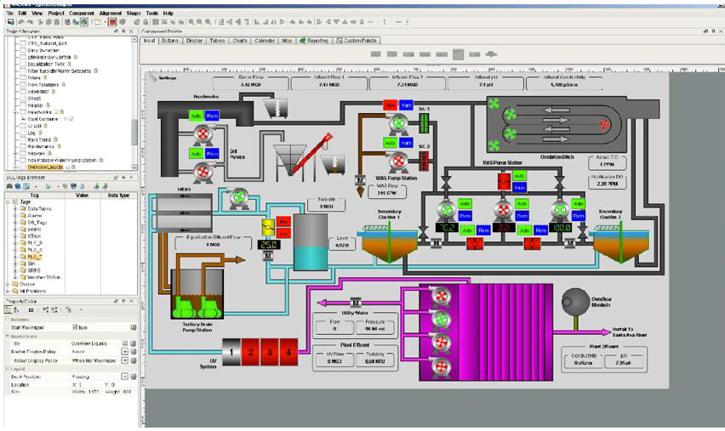

Source: Automation World, 2014.[29]

Figure 10 – Example of SCADA software, Western Municipal Water District (WMWD), California

Utilities have been using SCADA systems managing real-time alarms and efficiently operate plants and networks.

In some case, SCADA systems are going beyond their native functionalities by proposition optional modules on modelling or optimization. Even if these functions are described in the next chapter, a few examples of higher-level applications can be listed; such as determining times of peak water use, identifying potential system leaks, and setting billing rates, among others.

Globally speaking SCADA systems have contributed to reduce the operating costs of utilities, and have improved water distribution to households, businesses and industry. The monitoring and control functionalities of SCADA systems can help utilities to protect their infrastructure and prevent severe degradation. The implementation of SCADA has been associated to 30% savings on energy used to manage water systems, 20% reduction on water loss and 20% reduction in disruption[30]. Usage of SCADA as part of urban systems can also enhance disaster preparedness through storm water management, as well as support the remote operation and monitoring of major dams and weirs.

g. Models, optimization tools and decision support

Model-based water management has evolved over the years to improve the quality, quantity and operations costs of the global water supply through comprehensive modelling applications. These modelling software incorporate, to some extent, processes observed in the real world (e.g. through equations, algorithms and scenarios) and contain various data reporting and visualization tools for interpreting results from water distribution piping systems, water quality monitoring data, and wastewater management systems, among other relevant information for decision support. Multiple models have been used by urban water managers such as Mike Urban, Aquacycle, AISUWRS and UGROW, among others.



Optimization tools aim to find the best technical, environmental and financial solutions from models. Therefore, "optimization tools and principles have made it possible to develop prescriptive models for optimal management of large scale water resources systems, incorporating ubiquitous uncertainties in the prediction of natural processes and the economic impacts" (Datta and Harikrishna, 2004)[31]. The use of optimization tools can play an important role in effective decision-making towards the planning, design and operation of water resource systems.

Models, optimization tools and decision support tools for network management of urban water resources contribute to calculate and forecast consumption, reduce costs through the optimization of operations, plan and evaluate strategies, and also to conduct vulnerability studies to inform strategy design.

h. Web-based communication and information system tools

Information and knowledge management are increasingly recognized as important features for the effectiveness of the water sector[32]. A key problem faced within the sector is the existence of a large body of complex, unstructured and fragmented data. Web-based interfaces and online platforms provide a solution to enable the effective management, display, and retrieval of relevant information required by water managers/operators, urban planners, governments and the public.

Figure 11 provides an example of the role played by web-based technologies in city-based flood maps.

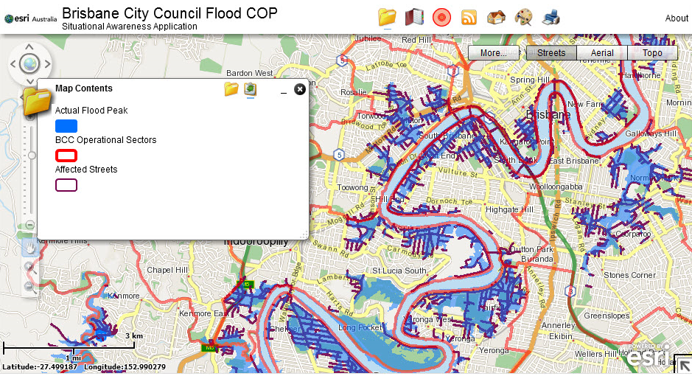

Source: Brisbane City Council (2014).[33]

Figure 11 – Example of web-based technologies and city flooding:   
The Brisbane City web-based flood map

Web-based servers offer access to integrated information from heterogeneous data sources, as well as innovative tools for the analysis and assessment of issues such as climate change, water scarcity, human health, sanitation and urbanization, all key factors to consider as part of urban water management. The integration of such web-based communication tools using open communication standards allows a range of stakeholders to connect to the system, and use available resources.

At the same time, communication and information systems can enable both the general public and administrators to access relevant information, fostering transparency and visibility of current water related activities by the specialized users (e.g. water managers, municipalities, governments), facilitating trust-building and public/stakeholder involvement. An intuitive and user‑friendly interface fosters data accessibility and dissemination, especially for the public.

Web-based communication and information system tools are used by governments and municipalities to deliver relevant water information to the public, as well as to provide early warnings (e.g. flood alerts). They also allow urban water managers to access relevant information such as rainfall data, storage and distribution, among others, thus helping to inform decision-making processes at multiple levels.

Data and systems security is a key point that has to be carefully addressed prior to any implementation of web-based technologies for Cities and Utilities, and in compliance with existing corporate standards and policies.

Another example of a related ICT tool for water infrastructure management is provided in Box 1.

Box 1 – Augmented Reality based Water Infrastructure Management

Augmented reality (AR) is a technology that extends and enhances human awareness, by superimposing digital information acquired using ICT in real world information that humans obtain via sight and hearing. Highly recognizable augmented reality markers are required for water infrastructure maintenance. Mobile devices can allow to recognizing them easily, despite conditions such as darkness, outdoor environments, dusty areas, or places that are difficult to access. This technology is applied in water infrastructure management and maintenance practices to obtain optimal information for an operation on site, linking real images by simply pointing the camera of a smart device towards an augmented reality marker. The appropriate information can be adjusted to specific needs and job descriptions. For example, an inspection worker should see checkpoints, while a worker conducting repairs should see maintenance procedures. Augmented reality technology enables more efficient and higher quality of maintenance operations by prompt access to necessary information including procedures and veterans’ know-how via images and recorded sounds which allows a worker intuitive understanding of what he or she should do. Indeed, daily communication for water infrastructure management and maintenance practice was typically implemented by oral or on whiteboard and papers. This makes it difficult to ensure accurate information and know-how sharing among workers and becomes a reason to decrease quality of maintenance.



Source: Fujitsu (2014)

5 SWM integration: Strengthening urban water management

Various smart water management initiatives are driving innovation and creating solutions at different scales worldwide. Within urban contexts, emerging initiatives involve smart grid integration, web-based communication, urban water management tools, models and systems, among others. The examples presented in this section are meant to provide a snapshot of some of the initiatives related to urban water management, urban wastewater management, and urban flood management issues, all of which are of vital importance to the effective functioning of SSC.

## 5.1 Intelligent solutions in urban water management

### Aquadapt

Aquadapt software integrates with existing management systems to help utilities make operating decisions that reduce energy consumption (i.e. water pumps) typically one of their highest costs after personnel. Aquadapt also contributes to improve water quality and greater consistency of operations. This software is used in water utilities in North America, the United Kingdom, Korea and Australia.

### Australian Water Resources Information System

The Australian Bureau of Metrology is currently building the Australian Water Resources Information System (AWRIS) as a tool to manage and display data from more than 200 organizations across the nation since it became responsible for delivering water information for Australia. The information system is intended to be a secure repository for water data and a means to deliver high quality water information to the public. Through data standardization, integration and organization, AWRIS will lead to improvements in the quality and efficiency of Australia's water management and policy decision-making. The system is illustrated in Figure 12.

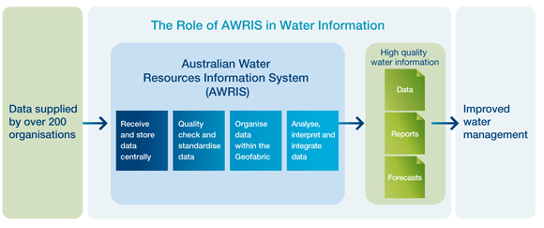

Source: Australian Government, Bureau of Meteorology, (2014).[34]

Figure 12 – The AWRIS system

Further information about this solution is available at: [http://www.bom.gov.au/water/about/wip/awris.shtml](http://www.raingain.eu/en/four-cities-gain-rain)

### AQUADVANCED an innovative IT solution

AQUADVANCED helps water operators to reduce operational costs, control water quality, and save water and energy. Its intuitive and modular interface gives operators a comprehensive view of the water network performance in real time, and enables them to efficiently manage their distribution networks. AQUADVANCED makes complex data actionable by gathering and analysing all the data coming from GIS, SCADA, sensors, data historian, workforce management, customer relation management in one single platform and turning it into a simple decision-making tool. More precisely, AQUADVANCED easily manages sectors by monitoring flows, pressure, water quality, and energy. It offers advanced event management (leaks detection, pressure level drops) in order to identify abnormal events and their causes, locate them accurately and monitor their resolution. The software analyses hydraulic behaviour in order to anticipate failure risks and simulate the impact of interventions. It also continuously monitors water quality throughout the water distribution network, as well as energy performance and provides optimal energy operating strategies.

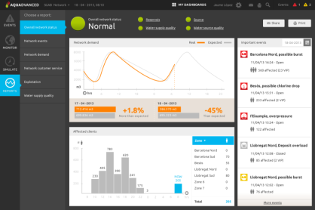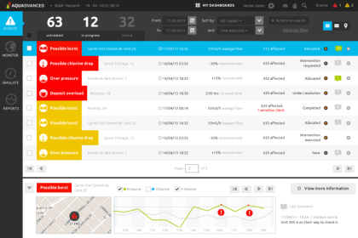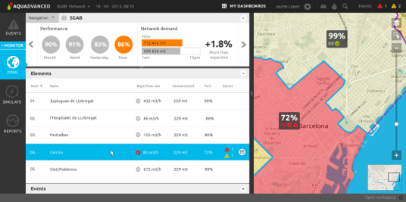

Figure 13 – Screenshots of AQUADVANCED interfaces

### EU UrbanWater project

UrbanWater is a collaborative ICT project co-funded under the 7th Framework Programme of the European Commission. The project is expected to be completed in 2015. It seeks to create an intelligent web-based urban water management system for effective urban water management. The platform will incorporate advanced metering solutions and real-time consumption data to equip water utilities with the information necessary for proper decision-making.

By integrating water availability estimations based on weather prediction and surface water reserves data, demand estimations based on household consumption data and consumption patterns and models, the water distribution network data, as well as automatic billing capabilities including adaptive pricing and customer engagement tools and using secure and cloud-based data management, both utilities and customers alike will be able to obtain the right information to effect change in consumption patterns in urban areas.

Further information about this initiative is available at: <http://urbanwater-ict.eu/the-solution-2/>

### Improvements in pipe scanning

Breivoll Inspection Technologies (BIT) is a Norwegian Small-Medium Enterprise (SME) and provider of condition water pipe assessment technology. BIT has developed pipe scanners and a pipeline analysis and reporting system (PARS) for the assessment of urban pipe systems. The pipe scanners are based on the acoustic resonance technology (ART) (Figure 14), and equipped with cameras to access the health of urban pipes. The PipeScanner analysis and reporting system (PARS) imports raw data from ART of the PipeScanner and performs the processing of data at the headquarters, through advanced algorithms and data filtering in a high-performance data centre. Information extensions are also available to export data to GIS databases.

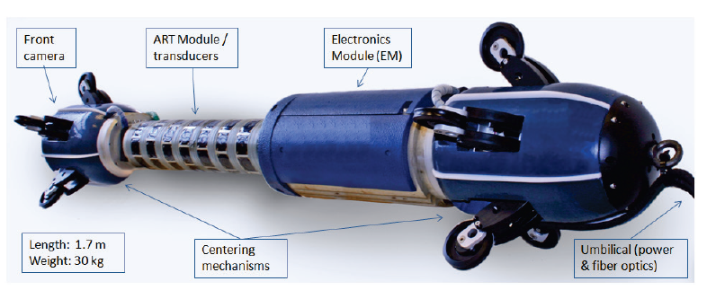

Source: Brenna *et al*. (2013).**[35]**

Figure 14 – The BIT PipeScanner, 2nd generation

Further improvements in this technology could enable cities to access reliable data on internal and external water pipe conditions, as well as data for modelling purposes. This technology can also facilitate linkages with other intelligent infrastructures, thus contributing to reducing costs and improving management. More information on these technologies is available at: [http://en.breivoll.no/](mailto:tsbsg5@itu.int)

### Wireless mobile sensors in underground pipes

iXLEM Labs in collaboration with Qatar University, Qatar National Research Fund, Acquedotto del Monferrato, Smat and Karamaa have created a solution to monitor and manage issues related to urban water distribution systems (Figure 15). Their solution comes in the form of "Watermole" which is a wireless mobile sensor that can be placed in pipes for monitoring. When the sensor intercepts a ground station, its position is identified and the acquired spectra are correlated to leakage positions (iXYLEM 2011). For more information visit: <http://www.ixem.polito.it/projects/qnrf_2009/index_e.htm>

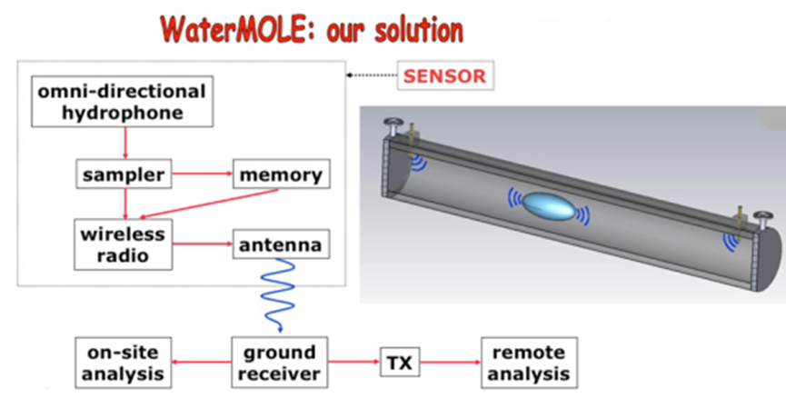

Source: Trinchero (2010).**[36]**

Figure 15 – WaterMOLE, 2nd generation

## 5.2 Remote monitoring solutions to urban wastewater management

### SolidAT and Holon Municipality, Israel

Located in the centre of Israel, Holon municipality's old sewage system was plagued with problems such as frequent blockages and overflows. By installing several of Solid Applied Technologies' (SolidAT) SmartScan 50 non-contact gauging devices equipped with sensors, the municipality was able to better control and manage its sewer systems. Additional improvements were achieved due to the high resistance of the devices to the methane environment, and to the municipality's ability to receive reliable information and monitor its sewer system using a web platform, and sending alerts via short message service (SMS) messages when the level reaches low/high limits.

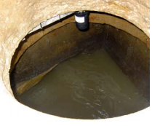

SolidAT offers a variety of level sensors and remote monitoring solutions for sewer level monitoring and water level monitoring. Further information is available at: <http://solidat.com/>

### Delft-FEWS and Hollandse Delta Regional Water Authority, Netherlands (pilot project)

In the Netherlands, extensive sewer networks are linked with SCADA. However, systems are not linked to Wastewater Treatment Plants (WWTPs) nor are they linked together, as each municipality is responsible for maintenance and operation within its boundaries. The system is vulnerable to storm events which sometime results in the contamination of surface waters. The pilot project was supported by grants from Agentschap NL, and investigated the possibility of optimizing the sewage flow through the entire system through the use of an automated centralized control of the system: by linking the SCADA systems of the regional water authority Hollandse Delta, and the WWTPs of five municipalities (Binnenmaas, Cromstrijen, Korendijk, Oud-Beijerland and Strijen) and using the dynamic modelling component of Delft-FEWS. Delft-FEWS is a real-time operation water management and forecasting software. Data was collected from each SCADA system and fed to Delft-FEWS, where a real time control (RTC) plug-in calculates the optimal pump settings. The settings calculated from Delft-FEWS were then sent back to the SCADA systems to control the sewer pumps (Figure 16)[37]. The project demonstrated how SCADA systems can be easily converted to centrally controlled operating systems. It is still working as an operational system, with plans to expand its functionality to other municipalities.

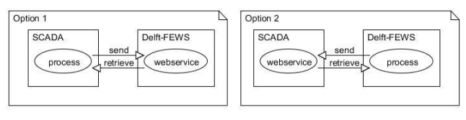

Source: Rooij and van Heeringen, (2012).**[38]**

Figure 16 – Options investigated within Delft-FEWS real-time   
control of sewer system pilot project

## 5.3 Technologies for urban flood management

### INFLUX

During rain and storm events technical services of cities have to ensure the safety of people and goods, protect the natural environment, comply with discharge regulations, and more generally make the best use of wastewater and stormwater assets capacities. Operators have to make use of all the capacities of the system: retention capacities of the network, optimal filling and water draining of storage basins, and maximal loading of the wastewater treatment plants. INFLUX is a predictive and dynamic management system that gives the operator an overall view of the operation of the entire sewage system based on validated metrological data, calculates trends and system behaviour for the coming 24 hours in dry weather and 6 hours in wet weather, and proposes the operator an optimal management strategy applied manually or automatically. The aim of the strategy is to store as much volume as possible in the water retention assets and the system itself, to increase the volume of wastewater to be treated in order to reduce outflows into the natural environments whilst limiting floods risks. This tools was installed in cities such as Bordeaux (CUB) or Paris (SIAAP) in France.

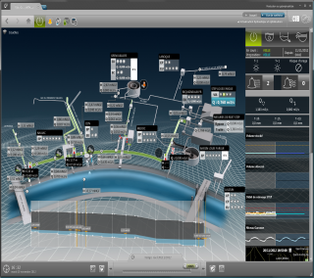

**Figure 17 – Screenshot of the INFUX interface**

### RainGain

The RainGain project is a transnational project aimed at improving urban flood prediction. Since radars have the advantage of being light, manageable, and more affordable to local water authorities, they were chosen as the medium of data collection. By collecting detailed rainfall data at an urban scale from weather radars, the project seeks to provide reliable information to city water managers to develop reliable urban water strategies, thus contributing to make cities more resilient to local rainfall-induced floods.

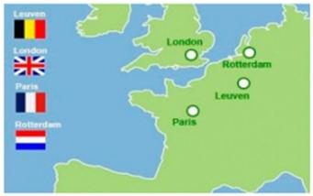

Source: DLFT Urban Water (2014).

Figure 18 – RainGain project location

The project investigates four different types of radar techniques in four pilot European cities (i.e. Leuven, London, Paris and Rotterdam) (Figure 18). The project involves the installation of new polarimetric X-band radars in Rotterdam and Paris, enhancing previously acquired X-band radar, as well as the acquisition of four additional rain gauges in Leuven, and upgraded C-band radar for testing and implementation of super resolution protocol in Greater London. The following areas will be investigated:

* Early warning systems based on fine-scale flood prediction, based on London's project experience.
* Real-time operational strategies of storage basins and pumping stations to maximize rainwater storage, based on the project's experience in Paris and Leuven's.
* Upgrading the capacity of urban water systems, based on Rotterdam's experience.

It is envisioned that, through the implementation of this initiative, city water managers will be better equipped to manage urban flooding by being able to make flood forecasts at the street level, in real time. For more information please visit: [http://www.raingain.eu/en/four-cities-gain-rain](http://en.breivoll.no/)

6 Action steps: SWM implementation

The series of key steps presented in this section aims at facilitating the design of strategies for the implementation of SWM systems. They encompass the methods and approaches that need to be considered as part of SWM's implementation, including concrete actions to realize each stage.

Following these action steps can contribute to the following:

* Target problems faced by urban water environment.
* Enhance efficiency and higher quality of services provided by SWM tools.
* Ensure proper robust policy development.
* Guarantee transparency.
* Promote further technological innovation.

The effective design and implementation of SWM involves the seven key steps presented in Figure 19.

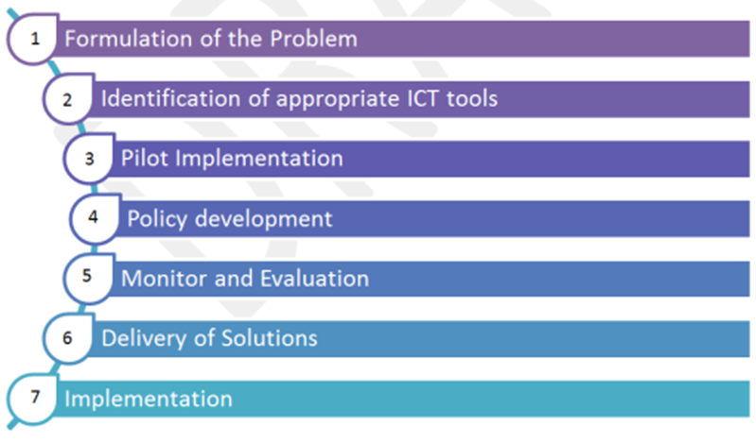

Figure 19 – Steps towards the implementation of SWM

Based on these main areas, Figure 20 summarizes the key actions that need to be conducted in order to realize each of them, and ultimately, implement SMW solutions.

Formulation and understanding of the problem

Setting of the context and goal

Gaining stakeholder perspectives

Assessment of current situation and definition of the target situation

Identification of appropriate ICT tools

Identify new and innovative SMW tools

Cost and benefit analysis of these tools

Stakeholder involvement

Pilot Implementation

From steps 1-2, head pilot study for e.g. 1 municipality

Monitor and adjustment

Outcomes

Policy development

Incorporation of business models and market projections

Refer to outcomes obtained from pilot

Stakeholder involvement

Monitoring and evaluation

Review steps 1-4

Lessons learned

Evaluation

Robust decision-making for the development of targeted solutions

Delivery of solutions

Network analysis and project preparation

Development of financing strategies and investment opportunities

Multi-criteria analysis and cost effectiveness

Equip/improve the necessary human capacities

Implementation

Setting logical timelines

Set monitor and review process

Information dissemination and stakeholder involvement

Implement delivery determined in step 6

Figure 20 – Key actions involved in the implementation of SWM

The actions conducted as part of these different stages are closely related, and in many cases, complement each other.

Having identified some of the key actions needed to successfully design and implement SWM, the following section explores the opportunities linked to these systems as part of water management systems.

7 SWM opportunities

The integration of smart water management technologies through realistic, measureable timelines and adequate implementation processes can deliver immediate visible and measureable results in urban water distribution and wastewater management. While challenges still exist, the analysis presented in this Technical Report suggests that the benefits are clear and significant. Through co-ordinated actions, holistic management, stakeholder involvement, adequate investment, and appropriate technology, SWM can improve both the reliance and sustainability of the water systems and networks. By protecting the safety and reliability of water supplies, increasing the resilience of water infrastructure, reducing flooding and overloads of wastewater systems, decreasing energy consumption, lowering operational costs while increasing customer choice and control, these systems can enable a sustainable water environment for cities to grow and thrive in.

Recent advances in technology and interconnectedness, once appropriately harnessed, can foster the conditions needed to promote sustainable water resource management in the face of rapid urbanization, water scarcity and climate change. This will enable cities to conduct the following tasks:

* Collect easily real-time data and measurements through sensor networks and low-cost innovative communications and protocols.
* Make better informed decisions through the use of advanced analytics which translate the raw data into actionable intelligence.
* Improve the efficiency, performance and optimization of infrastructure through real-time management systems.

The traditional independent system approach to urban water supply, wastewater disposal and storm water management will no longer be able to endure the increasing pressures faced by the water sector. However, the co-ordination of multiple sectors through SWM networks can contribute to ensure the sustainability of urban water management system. Through connectivity, SWM networks can allow water, wastewater and storm water information to be extracted and integrated into other data sources such as climate analysis and weather intelligence, thus facilitating a holistic management approach to overcome the pressures and challenges faced by the system. Figure 21 illustrates some of the SWM tools that play a role in water distribution control systems.

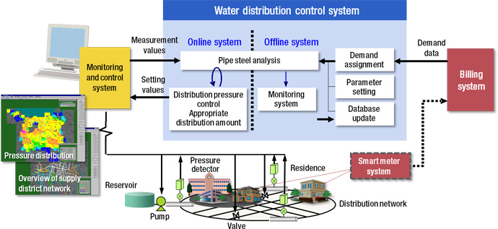

Source: Hitachi (2014).[39]

Figure 21 – Smart water management tools

SWM also generates economic, social, and environmental benefits through water resource sustainability, which, in turn, contributes to the comfort, security and well-being of urban residents. Some of the benefits associated to water and wastewater management include:

* **Economic savings**: SWM tools can greatly reduce non-revenue water by identifying leaks and illegal connection, regaining revenue necessary to maintain the infrastructure. SWM enables sustainable water use, thereby reducing the amount of water abstracted, treated and distributed which reduces operational costs.
* **Improved services**: Smart metering can improve the relationship between the water utilities and the customers by providing more transparent water consumption information. Improved monitoring and operations prevents supply interruptions and disruptions within the water distribution network, for example, in the event of sewerage and storm water overflows. Better management relieves pressure on water resources that may be scarce during periods of drought.
* **Improved wastewater management**:These benefits are associated to improvements in the performance and economic efficiency of the wastewater treatment, as well as enhanced monitoring that helps prevent infrastructure overload.
* **More efficient treatment**: Improved water quality monitoring throughout the systems utilizing sensors creates the possibility of source control of resource pollutants and the use of natural systems, thus reducing the potential treatment required for water supply systems, or the separation of specific pollutants in wastewater.
* **Environmental protection and enhancement**: Reduced demand and improved environmental monitoring helps to maintain and restore ecosystems that rely on a healthy aquatic environment.
* **Reduced carbon emissions**: Improved management results in less energy consumed for the abstraction, treatment and distribution process of water resources, thus helping to reduce a city's carbon footprint.
* **Flood control and storm water management**: Improved weather awareness and prediction through weather intelligence allows cities to plan more effectively their flood prevention strategies, as well as to manage urban drainage systems and storm waters accordingly.
* **Greater resilience**: Reliable data reduces inaccurate forecasts and predictions, as well as the uncertainty surrounding future demand and supply availability, thus improving decision-making for water investments and strategies. Improved operational control and monitoring can also help to prioritize infrastructure maintenance. At the same time, improved decision-making strengthens the capacity of centralized sewers and treatment facilities to cope with the pressures of urbanization.

8 Gaps to be addressed

It is imperative that urban water managers adopt appropriate water intelligence within their various management systems, and develop the capacity needed to realize the full potential of ICT tools in this field. Numerous experiences suggest that smart water management tools can be easily integrated. However, the current approach and lack of standardization within this sector may foster future problems of interoperability and reliability of SWM tools, possibly preventing future integration of system solutions. Added to this, improper policy development spearheads vendor and/or technology deadlocks.

These challenges could hinder the proper implementation of SWM tools in cities around the world. Some of the challenges mentioned throughout this analysis are discussed in further depth in the ITU and UNESCO's publication "Partnering for Solutions"[40], including the lack of technological standardization, proper ICT governance, policies, incentives/funding, business case and models (customer propositions/pricing/availability, value for water utility, etc.), co-operation and collaboration between stakeholders (water utilities, urban planners, policy makers, governments, municipalities, academia, ICT companies, public, etc.), focus placed on privacy/security/encryption, awareness and know-how, and limitations within the technology architecture (components/systems integration/communication/local vs global).

For the purposes of this Technical Report, the focus is placed on challenges related to standardization and policy perspectives. Other challenges will be addressed in future studies.

Lessons learned: Standardization and policy perspectives

Innovations in the ICT field are the result of a highly complex and continuously changing environment. To ensure the efficiency and the effectiveness of ICT products, tools and systems, standardization is essential. Standards contain the technical specification or other precise criteria designed to be used consistently as a rule, guideline or definition. Their adoption ensures a clear reference in terms of technical specifications, quality, performance and reliability[41]. The objective of standard development is to ensure that products and services are suitable for their purpose, enabling comparability and compatibility through a form of best practice summary, which evolved from the experience and expertise of all interested parties.

With regards to smart water management tools in cities, there are some trade-offs. Since this market is in its initial stages, standardization within this sector can either spur creativity and maximize the added value of technology for cities, or hinder further development within this sector. However, it must be stressed that timing is essential as it bridges research and innovations. Sensible standards introduced at the right moment can produce universal benefits[42]. In this regard, adequate standardization can serve as a risk management and technology roadmap guideline, enabling the strategic implementation of smart water management plans and projects.

Since smart water management solutions depend on ICTs, interoperability is also crucial. If the solutions are not interoperable, their effectiveness is highly restricted, especially in terms of enterprise networking. Interoperability of ICT products and their components refers to its ability to work with other systems or products without special effort on the part of the user. Standardization is an essential component for ensuring that ICT products, tools, and systems are produced and implemented in an efficient, equitable, and ecologically sustainable manner.

Reinstating its role as a standardization organization, ITU has developed key ICT standards in ubiquitous sensor networks (USNs), Internet of things (IoT), and machine-to-machine (M2M), in order to ensure that there is compatibility, interoperability, and certain levels of quality maintained, therefore contributing to the reduction of risks. However, the current pace of technological development demands further efforts, and pushes standardization and research to advance in parallel.

Recognizing the need for further standard development in this area, the ITU FG-SWM will be conducting a crucial gap analysis on smart water management tools, products and solutions. The analysis will provide the necessary guidance to produce sensible standards within this field, thereby steering the market in the right direction, and helping to make sure that the right tools can lead to the right solutions in cities.

As standardization provides a measure by which to judge the quality of an ICT product or tool, it is a key instrument for securing policy initiatives. In turn, proper policies will support the effective implementation of smart water management solutions in both developed and developing countries.

Though policies have been developed and deployed to target smart water initiatives, they have been met with mixed results, and in most cases, the focus has been placed on smart water metering alone. In some cases, these policies have fostered development and more research and innovation with regard to the smart water technology market. In other instances, they have contributed to stifle the development of this market.

Countries such as Canada, Israel and Singapore have been implementing policies at both the national and state levels on smart water systems, supporting green innovation and intelligent water technologies, which have led to the emergence of new smart water companies[43]. However, these policies have not specifically targeted smart water systems, but instead have been presented in the form of "Sustainability, Environment, and Water initiatives", "Water Technologies" and "Efficiency Initiatives"[44].

The key issues, however, have remained. What types of policies are required to accompany the development and stimulate the diffusion of ICT for water management? When should these policies be implemented? In addition to these issues, the baseline methodologies that need to be established for determining the trade-offs and synergistic benefits for ICT innovations within water management frameworks at the national and regional levels, have been overlooked, or otherwise focused on narrow sector-driven mandates.

Since the current smart water market is fairly new and fragmented, policies will need to be adaptable, while at the same time reflecting the country's intention of deployment and the type of technologies considered. Unfortunately, due the young nature of the smart water market, there have only been limited incentives and initiatives that pursue a more integrated research approach across sectoral domains. Herein lies a problem. Since policy developers need to co-ordinate efforts and have access to clear informational resources (many of which can only be provided through research and careful examination of the water sector within a given country), inadequate and narrow-minded frameworks are often designed.

In brief, properly timed and flexible policies are essential for the adoption of smart water management initiatives in urban areas. Therefore, governments should support new, generic, flexible smart water management incentives, especially those that support full system integration. This ensures that policy makes are better equipped with the knowledge necessary to design effective smart water polices.Coherent cross-sector policies developed through a multi stakeholder approach will ensure the success and sustainability of these tools.

Consequently, a coherent strategy must be the starting point before implementation of any city-wide SWM initiative. This facilitates the development of innovative partnerships to harness and utilize the necessary information effectively, thereby creating guidelines, strategies and best practices properly tailored through protocols and standards**.**

Standardization and policy development must be appropriately co-ordinated and taken forward based on robust research, including a careful examination of the water and wastewater sector, as well as the broad engagement of key stakeholders (e.g. different governmental sectors, non-governmental organizations (NGOs), academia, and the private sector) within a given city.

Conclusions

Although cities represent just 2% of the world's surface area, they hold more than half of the global population. Providing sustainable access to water will be among the greatest challenges in the coming half century. As the analysis presented in this Technical Report suggests, fast-paced urbanization places high competition on existing water resources, and is exacerbating pressures linked to rapid population growth and to the uncertainty posed by climate change impacts. Failing to meet the new challenges and demands associated to water resources could seriously undermine the ability of cities to achieve urban development, and to meet socio-economic and environmental goals. Therefore, it is crucial that traditional approaches are upgraded to enable smarter solutions, which are more effective in mitigating these challenges and in reducing costs through the optimization of existing and emerging infrastructures.

Smart water management (SWM) can play a key role in the transformation of cities of developed and developing countries into smart and sustainable cities (SSC), if adequate policies, stern governance, and broad stakeholder involvement are integrated into its planning and implementation. Through real-time monitoring, efficient operation, improved decision-making, and enhanced performance and service delivery, SWM can ensure that a city's growth is not achieved at the expense of its water resources. Further advantages such as increased revenue in utilities, reduced operational costs and increased public involvement place SWM as a viable, smart sustainable solution to address urban water challenges.

As emerging experiences suggest, initiatives on smart water systems have been more effective when implemented as part of broader strategic approaches to water management (i.e. water policy development). Therefore, efforts in this field must be co-ordinated and synergies built across the various sectors and stakeholders involved in water management. At the same time, experiences have demonstrated that public-private partnerships can be effective in fostering innovation. Further efforts should be made to strengthen the linkages between the utilities, industries and universities, in order to develop new research on smart water management, emerging challenges and opportunities, as well as novel water enterprises.

Acknowledging that both technical and non-technological innovations play a role in the effective operation of smart water systems, it is important that ICT developments are accompanied by innovations in the business models of water utilities, as well as by innovations in terms of water usage at the end of the pipe, so as to maximize the contribution of ICTs in this field.

Appropriate policies and measures are key to support the development and deployment of smart water systems (e.g. water pricing, education and information, competition for non-domestic consumers). Likewise, as smart water solutions continue to emerge and their integration to deepen in urban environments, the importance of common standards for hardware and software will continue to rise. These standards are key to encourage the international deployment of innovative technologies, and thus continue progress in the smart water management field.

A successful implementation of SWM requires that further emphasis be placed on the development of guidelines, best practices, standards and policies that are tailored to specific urban needs and priorities. These will ensure integrity, compatibility and interoperability among protocols, and promote accountability and security within the smart urban water management framework.

Through the work of ITU's Focus Group on Smart Water Management (FG-SWM) and Smart Sustainable Cities (FG-SSC), as well as its continued efforts on ICTs and climate change adaptation, ITU is contributing to the development of new standards and recommendations that will foster the adoption of smarter solutions in the water sector around the globe. Footnotes

1. UNDESA (2014), *World Urbanization Prospects: The 2014 Revision, Highlights*, United Nations, Department of Economic and Social Affairs (UNDESA), Population Division. <http://esa.un.org/unpd/wup/Highlights/WUP2014-Highlights.pdf>
2. UNDESA (2012), *World Population Prospects: The 2011 Revision, Highlights*, United Nations Department of Economic and Social Affairs (UNDESA) Population Division. <http://esa.un.org/unup/pdf/WUP2011_Highlights.pdf>
3. Howe, C. A., Butterworth, J., Smout, I.,K., Duffy, A.,M., and Vairavamoorthy, K. (2011), *Sustainable Water* *Management in the City of the Future: Findings from the SWITCH Project 2006-2011*, UNESCO-IHE, The Netherlands.

   <http://www.switchurbanwater.eu/outputs/pdfs/Switch_-_Final_Report.pdf>
4. OECD (2013), *Policies to Support Smart Water Systems: Lessons from Countries Experience*, Working Party of Biodiversity, Water and Ecosystems, OECD Environment Policy Committee, 30-31 May 2012, Paris.
5. McIntosh, A. C. (2014), *Urban Water Supply and Sanitation in Southeast Asia: A Guide to Good Practice*, Asian Development Bank (ADB), <http://www.pseau.org/outils/ouvrages/adb_urban_water_supply_and_sanitation_in_southeast_asia_a_guide_to_good_practice_2014.pdf>
6. EURAMET (2013), *Mega City Paper*, European Association of National Metrology Institutes (EURAMET), <http://www.emrponline.eu/call2013/docs/MegaCities.pdf> .
7. Engel, K., Jokiel, D., Kraljevic, A., Geiger, M., and Smith, K. (2011), *Big Cities, Big Water, Big Challenges: Water in* *an* *Urbanizing World*, WWF, <http://www.wwf.se/source.php/1390895/Big%20Cities_Big%20Water_Big%20Challenges_2011.pdf>
8. Kötter, T. (2004), *Risks and Opportunities of Urbanization in Megacities*, International Federation of Surveyors, August.
9. Kraas, F., and Nitschke, U., (2008), *Mega-urbanisation in Asia: Development Processes and Consequences of Urban* *Spatial Reorganization*, <http://www.megacities.uni-koeln.de/documentation/megacity/map/MC-2015-PGM.jpg>
10. OECD (2011), *Water Governance in OECD Countries: A Multi-level Approach*, OECD Studies on Water, OECD Publishing, <http://www.oecd-ilibrary.org/environment/water-governance-in-oecd-countries_9789264119284-en>
11. Brenna, L., Dyrkoren, P., Vangdal, A., Poulton, M., and Bruaset, S. (2013), *Report on System Development, Method* *Applicability, and Pipeline Condition Data for Modelling Purposes*. [www.trust-i.net](http://www.trust-i.net)
12. <http://www.awwa.org/>
13. Kingdom, B., Liemberger, R., and Marin, P. (2006), *The Challenge of Reducing Non-Revenue Water (NRW) in* *Developing countries*, Water Supply and Sanitation Sector Board Discussion Paper Series, Paper No. 8, December 2007. <http://siteresources.worldbank.org/INTWSS/Resources/WSS8fin4.pdf>
14. These reports are available at: <http://www.itu.int/en/ITU-T/focusgroups/ssc/>
15. <http://www.un.org/waterforlifedecade/scarcity.shtml>
16. <http://www.populationinstitute.org/external/files/Fact_Sheets/Water_and_population.pdf>
17. <http://www.who.int/water_sanitation_health/mdg1/en/>
18. <http://www.populationinstitute.org/external/files/Fact_Sheets/Water_and_population.pdf>
19. <http://www.un.org/waterforlifedecade/swm_cities_zaragoza_2010/pdf/01_water_quality_and_sanitation.pdf>
20. <http://www.wri.org/resources/maps/aqueduct-water-risk-atlas>
21. Jiménez Cisneros, B.E., T. Oki, N.W. Arnell, G. Benito, J.G. Cogley, P. Döll, T. Jiang, and S.S. Mwakalila, 2014: Freshwater resources. In: *Climate Change 2014: Impacts, Adaptation, and Vulnerability. Part A: Global and*

    *Sectoral Aspects. Contribution of Working Group II to the Fifth Assessment Report of the Intergovernmental*

    *Panel on Climate Change* [Field, C.B., V.R. Barros, D.J. Dokken, K.J. Mach, M.D. Mastrandrea, T.E. Bilir,

    M. Chatterjee, K.L. Ebi, Y.O. Estrada, R.C. Genova, B. Girma, E.S. Kissel, A.N. Levy, S. MacCracken,

    P.R. Mastrandrea, and L.L. White (eds.)]. Cambridge University Press, Cambridge, United Kingdom and New York, NY, USA, pp. 229-269. <http://www.ipcc.ch/pdf/assessment-report/ar5/wg2/WGIIAR5-Chap3_FINAL.pdf>
22. Major, D.C., Omojola, A., Dettinger, M., Hanson, R.T., and Sanchez-Rodriguez, R. (2011), *Climate Change, Water,* *and Wastewater in Cities. Climate Change and Cities: First Assessment Report of the Urban Climate Change Research* *Network*, Rosenzweig, C., Solecki, W. D., Hammer, S., Mehrotra, S., (Eds), Cambridge University Press, Cambridge, UK, pp. 113–143. <http://uccrn.org/wp-content/uploads/2011/06/ARC3-Chapter-5-Optimized.pdf>
23. OECD (2013), *Policies to Support Smart Water Systems: Lessons from Countries Experience*, Working Party of Biodiversity, Water and Ecosystems, OECD Environment Policy Committee, 30-31 May 2012, Paris.
24. Berst, J., Enbysk, L., and Williams, C. (2013), *Smart Cities Readiness Guide: The Planning Manual for Building* *Tomorrow's Cities Today*, Smart Cities Council, <http://www.corviale.com/wp-content/uploads/2013/12/guida-per-le-smart-city.pdf>
25. Hauser, A. (2012), *An Architectural Framework for Smart Water Networks*.
26. An example of this type of research was conducted by the Department of Mechanical Engineering, North-Western University, Illinois, USA, which developed a "Smart Pipe" prototype in 2009. Further information can be found at: <http://www.isws.illinois.edu/gws/sensor/smartpipe/>).
27. <http://www.allianceforwaterefficiency.org/smart-meter-introduction.aspx>
28. Examples include "CityCat" developed by Newcastle University. The system uses cloud computing to estimate spatial and temporal flood risk on a city scale. Further information is available at: <http://icfr2013.ex.ac.uk/papers/D3_Glenis.pdf>).
29. <http://www.automationworld.com/sites/default/files/styles/lightbox/public/field/image/120723scada_web.png?itok=IlXV7wPd>
30. Aoun, C. (2013), *The Smart City Cornerstone: Urban Efficiency.* <http://www.digital21.gov.hk/sc/relatedDoc/download/2013/079%20SchneiderElectric%20(Annex).pdf>
31. Datta, B., and Harikrishna, V. (2004), *Optimization Applications in Water Resources Systems Engineering*. <http://www.iitk.ac.in/directions/directsept04/bithin~new.pdf>
32. Dondeynaz, C., Mainardi, P., Carmona­Moreno, C., I and Leone, A. (2009), *A web based communication and* *information system tool for water management in developing countries*, 34th WEDC International Conference, Addis Ababa, Ethiopia. <http://wedc.lboro.ac.uk/resources/conference/34/Dondeynaz_C_-_292.pdf>
33. <http://www.sweetmaps.com/blog/wp-content/uploads/2011/01/BCC_esri_flood_map.jpg>
34. <http://www.bom.gov.au/water/about/publications/document/InfoSheet_3.pdf>
35. Brenna, L., Dyrkoren, P., Vangdal, A. C., Poulton, M., and Bruaset, S. (2013), *Report on System Development,* *Method Applicability and Pipeline Condition Data for Modeling Purposes D 46.2*, TRUST. <http://www.trust-i.net/downloads/index.php?iddesc=65>
36. Trinchero, D., Stefanelli, R., Cisoni, L., Kadri, A., Abu-Dayya, A., Khattab, T., and Hasna, M. (2010), *Wireless* *sensors as an efficient way to improve sustainability in water management by a significant reduction of water wasting*, ITU-T Workshop "ICTs: Building the green city of the future", Expo-2010, 14 May, 2010, Shanghai, China. <http://www.itu.int/ITU-T/worksem/ict-green/programme.html>
37. de Rooij, E., and van Heeringen, K. (2013), *How Delft-FEWS incorporates real-time sensor data with dynamic* *modelling to allow Real Time Control of sewer systems*, Environmental Software Systems. Fostering Information Sharing IFIP Advances in Information and Communication Technology, Vol. 413, pp. 54-61. <https://www.wageningenur.nl/upload_mm/9/a/9/c5a9bd1f-de4d-4cd8-984a-a9544dba9ea8_Rooij_etal.pdf>
38. *Ibid*.
39. <http://www.hitachi.com/products/smartcity/smart-infrastructure/water/solution.html>
40. http://www.itu.int/dms_pub/itu-t/oth/0b/11/T0B110000253301PDFE.pdf
41. Carayannis, E. G., and Nikolaidis, Y. (2010) *Enterprise Networks and Information and Communication* *Technologies (ICT) Standardization*, in Wang, L. and Koh S.C.L. (Eds): Enterprise Networks and Logistics for Agile Manufacturing, pp. 99-118, Springer.
42. *Ibid*.
43. OECD (2012), *Policies to Support Smart Water Systems. Lessons From Countries Experience*, Working Party on Biodiversity, Water and Ecosystems, OECD, Paris, France.
44. *Ibid*.

    **Bibliography**

    IEEE 1451 (2009), *Understanding the IEEE 1451 standard in 6lo WPAN Sensor Networks*.

    **Glossary**

    AISUWRS Assessing and Improving Sustainability of Urban and Water Resources and Systems

    AMI Advanced Metering Infrastructure

    AR Augmented Reality

    ART Acoustic Resonance Technology

    BOD Biochemical Oxygen Demand

    COD Chemical Oxygen Demand

    CSO Combined Sewer Overflow

    EM Electronic Module

    EPC Engineering, Procurement, and Construction

    GIS Geographic Information System

    GPRS General Packet Radio Service

    GSM Global System for Mobile Communications

    HAN Home Area Network

    ICT Information and Communication Technology

    IoT Internet of Things

    IPCC Intergovernmental Panel on Climate Change

    ISA International Society of Automation

    LAN Local Area Network

    M2M Machine-to-Machine

    NGO Non-Governmental Organization

    OECD The Organization for Economic Co-Operation and Development

    PARS Pipeline Analysis and Reporting System

    RTC Real Time Control

    SaaS Software as a Service

    SCADA Supervisory Control and Data Acquisition

    SCC Smart Sustainable City

    SMS Short Message Service

    SME Small-Medium Enterprise

    SWM Smart Water Management

    UGROW Urban Groundwater

    UNEP United Nations Environment Programme

    UN-Habitat United Nations Human Settlements Programme

    USN Ubiquitous Sensor Network

    WAN Wide Area Network

    WiFi Wireless Fidelity

    WPCP Wastewater Pollution Control Plant

    WWTP Wastewater Treatment Plant