 |  | International Telecommunication Union
 |  | ITU-T | FG-SSC
 |  | TELECOMMUNICATION  STANDARDIZATION SECTOR  OF ITU |  | (03/2015)
 | ITU-T Focus Group on Smart Sustainable Cities
 | Integrated management for smart sustainable cities
 | Focus Group Technical Report

FOREWORD
The International Telecommunication Union (ITU) is the United Nations specialized agency in the field of telecommunications, information and communication technologies (ICTs). The ITU Telecommunication Standardization Sector (ITU-T) is a permanent organ of ITU. ITU-T is responsible for studying technical, operating, and tariff questions and issuing Recommendations on them with a view to standardizing telecommunications on a worldwide basis.
The procedures for establishment of focus groups are defined in Recommendation ITU-T A.7. ITU-T Study Group 5 set up the ITU-T Focus Group on Smart Sustainable Cities (FG-SSC) at its meeting in February 2013. ITU-T Study Group 5 is the parent group of FG-SSC.
Deliverables of focus groups can take the form of technical reports, specifications, etc., and aim to provide material for consideration by the parent group in its standardization activities. Deliverables of focus groups are not ITU-T Recommendations.

SERIES OF FG-SSC TECHNICAL REPORTS

© ITU 2015
All rights reserved. No part of this publication may be reproduced, by any means whatsoever, without the prior written permission of ITU.

Integrated management for smart sustainable cities

About this Technical Report
This Technical Report has been developed as a contribution to the International Telecommunication Union's (ITU) Focus Group on Smart Sustainable Cities – Working Group 2.
Acknowledgements
This Technical Report was researched and written by Nengcheng Chen (Wuhan University, China), Ziqin Sang (Fiberhome Technologies Group, China), Wenying Du (Wuhan University, China) and Zeqiang Chen (Wuhan University, China). The authors also acknowledge the guidance and support from all the members of the FG-SSC Management Team, and especially Flavio Cucchietti (Telecom Italia, Italy, and FG-SSC Vice-Chairman) and Paolo Gemma (Huawei, China, and FG-SSC Working Group 2 Coordinator).
Additional information and material relating to this Technical Report can be found at: www.itu.int/itu-t/climatechange. If you would like to provide any additional information, please contact Cristina Bueti at tsbsg5@itu.int.

Integrated management for smart sustainable cities
Table of contents
Page
1 Introduction 1
1.1 Background 1
1.2 Service framework 2
1.3 Intended application 3
2 Resources, challenges and technologies of integrated management for smart sustainable cities 5
2.1 Resources of integrated management for smart sustainable cities 5
2.2 Challenges of integrated management for smart sustainable cities 6
2.3 Technologies of integrated management for smart sustainable cities 9
3 Integrated management for smart sustainable cities 12
3.1 Overview 12
3.2 Meta-models for resource integrating 14
3.3 Technical specifications for fusion process 17
3.4 Interface specifications for management service 19
4 Instances of the integrated management for smart sustainable cities 21
4.1 Daily management 21
4.2 Emergency response management 22
5 Conclusion 23
Bibliography 24
Annex – Abbreviation and acronyms 27

Integrated management for smart sustainable cities
Executive summary
This Technical Report has been developed within the Focus Group on Smart Sustainable Cities (FG-SSC) and provides a technical proposal for integrated management, which can be followed by any municipality interested in improving the management of its infrastructure, operations and citizen interactions, and in addressing critical urban challenges – such as security, criminality, pollution, traffic congestion, inadequate infrastructure, and response to natural hazards. Information and communication technologies (ICTs) proved to be instrumental to support urbanization and allow the transition towards smart sustainable cities. The rapid proliferation of ICT products and solutions in cities has led to the lack of uniformity in tools, such as information representation methods, software interface specifications, etc., posing additional challenges to urban management practices.
Integrated management for smart sustainable cities (IMSSC) seeks to alleviate challenges in the smart sustainable city management through the incorporation of sensor web, model web, service interfaces, ICT products, Internet of things (IoT) as well as the cloud computing technologies in areas of city operations and management. Integration of such technologies is adapted to continuously resolve the problems in smart sustainable city management by encoding, fusing and sharing the information resources of the cities in a unified way.
Recognizing the impact that IMSSC can have on the city management, the International Telecommunication Union (ITU) established the Focus Group on Smart Sustainable Cities (FG-SSC) with the vision that cities worldwide can be empowered to alleviate and overcome management challenges effectively and become smarter and more sustainable.
By promoting the coordinated development and management of smart sustainable cities, IMSSC allows cities to maximize socio-economic institutions as well as keep the city operate in an orderly way. However, in order to realize the orderly operation of all relevant sectors in the cities, a series of technical specifications are essential. Thus this Technical Report aims at emphasizing the management problems faced by cities and at providing IMSSC as a possible solution to mitigate such challenges, with the goal of generating further dialogue and discussion.
1 Introduction
1.1 Background
"A smart sustainable city is an innovative city that uses information and communication technologies (ICTs) and other means to improve quality of life, efficiency of urban operation and services, and competitiveness, while ensuring that it meets the needs of present and future generations with respect to economic, social and environmental aspects".
The above definition describes what a smart sustainable city should be. However, significant urban challenges – such as security, criminality, pollution, traffic congestion, inadequate infrastructure, response to natural hazards – still prevent this vision to become reality. Some examples of the challenges faced by cities are listed in Figure 1.
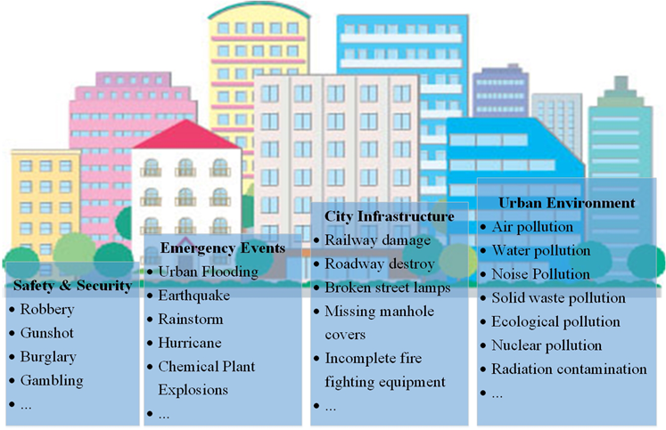
Figure 1 – Examples of challenges faced by cities
In order to successfully address these challenges, cities should take into consideration the deployment of the necessary tools to be able to monitor, map and report what is happening in real time. An effective reporting mechanism will ensure that such problems are tackled rapidly to avoid or reduce possible causalities and economic losses [b-Namb]. As part of a recent widespread urban digitalization process, several cities have deployed a variety of sensors, including cameras, rain gauge, and pressure transducer, etc., to be able to acquire first-hand information about all city's operations in a timely manner. Even if all this information is available in cities, it is unfortunately distributed in different departments or even regions. Nonetheless, an effective management mechanism is still lacking.
In response to this challenge, this Technical Report proposes an integrated management solution for smart sustainable cities. With IMSSC, the sensors, nodes, and models can function in an organized way. As a result, when emergency events occur, the data, models and other resources needed can be rapidly discovered and acquired. To achieve the goal of making a city smarter and more sustainable, the first step is to analyse real-time processes and understand event patterns through event modeling. Additional capabilities, in terms of processing units, application units, as well as models, might be needed. Secondly, there is a need for fusion processing guidance, so that different sources of observations can be combined together to compensate their own deficiencies and attain the goal more efficiently. Finally, services for information resource publishing and sharing as well as result fusing are also necessary to disseminate information across the concerned agencies. By adopting the integrated management system, each city can make a big step towards the implementation of the smart sustainable city vision.
1.2 Service framework
The users involved in IMSSC are not only municipal departments, but also enterprises and citizens. Municipalities are usually in charge of the daily operation and maintenance of IMSSC which is initiated by them. When emergency events occur, they need to synthesize all the information and make proper decisions to rescue lives and reduce economic losses. Citizens are the users and main beneficiaries of the integrated management for smart sustainable cities. They are able to report problems of daily management, emergencies, as well as receive notifications from the municipal authorities. Enterprises can be viewed from two perspectives: some enterprises can take part and assist the municipality to improve the capacities of the integrated management, others can just act as ordinary citizens to do the work of reporting or notice feedback. The service framework of IMSSC is represented in Figure 2.
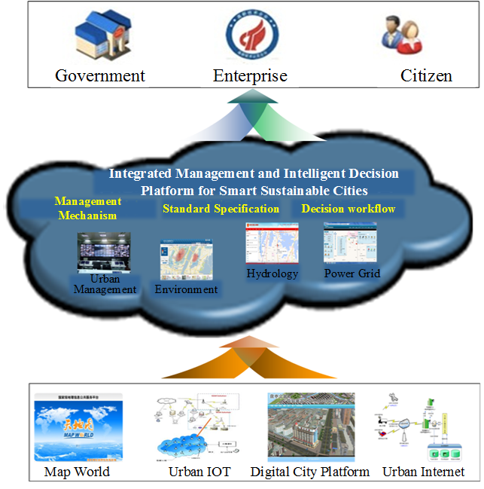
Figure 2 – Service framework of IMSSC
1.3 Intended application
The proposed integrated management solution of smart sustainable cities aims at tackling four main types of problems, namely inadequate safety and security protection, increasingly worsened urban environment, damaged city infrastructure, and natural or man-made emergency events. In this Technical Report, these four types of problems are represented as theoretical events through a uniform event information model. They are detected by sensors, recorded by observations, analysed and processed by models, and finally settled by a decision made according to nodes. The goal of IMSSC is achieved by the direct management of information resource carriers, events, sensors, observations, models, and nodes. The roles of the different information resources in IMSSC are presented in Figure 3:
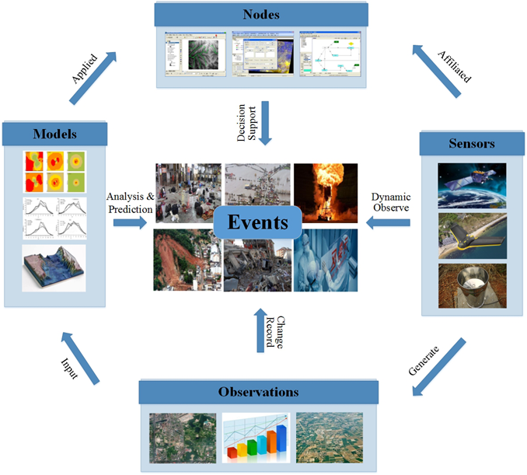
Figure 3 – Roles of the different information resources in IMSSC
These information resources represent the crucial infrastructure for real-time monitoring of city dynamic processes. However, these resources have not yet been efficiently used due to the lack of a unified management of the observation resources and information carriers, the rapid and smooth processing of information, as well as the real-time publishing and sharing services. As a consequence, the interconnection among the different city departments has not been established yet. This is a missed opportunity for every city administration as events like traffic congestion, urban flooding, and pipeline leakage that existed before perpetuate. The operational efficiency of cities is not always as satisfying as it could be, affecting negatively citizens' quality of life. Therefore, it is imperative to perform IMSSC to resolve all the challenges described above.
IMSSC is to model the information resources of cities uniformly, fuse the data from the information resources to acquire a higher level of information, and share the information to serve people in cities [b-Nama]. In this Technical Report, information resources are composed of nodes, sensors, data, models, and events, among which nodes include sensing nodes, processing nodes, and application nodes, and sensors are affiliated to sensing nodes. The fusion process aims to fuse the information resources with toponym and maps, respectively. Services mainly include data, model and event service. IMSSC is able to ensure the well-organized and efficient operation of people, things and streams in cities, so that disastrous events can be detected in advance and timely avoided before the occurrence, so that casualties and economic losses can be reduced as much as possible. At the same time, IMSSC is able to settle the widely-existing problems, such as traffic congestion, and environmental pollution, etc., improve the living quality of citizens, protect the environment, and implement the sustainable development of cities.
The objectives and challenges of IMSSC, as well as the technologies used to address the problems and to achieve the goals of smart sustainable city development are illustrated in section 2. The specific meta-models, fusion processing workflows, and services proposed for IMSSC are presented in section 3, while section 4 provides examples pertaining to the application of meta-models, fusion processing workflows, and services for IMSSC. Section 5 is a summary of this Technical Report.
2 Resources, challenges and technologies of IMSSC
2.1 Resources of IMSSC
IMSSC aims at offering a solution to all problems affecting current urban development, including inadequate safety and security protection, increasingly worsened urban environment, damaged city infrastructure, and natural or man-made emergency events, in a rapid and efficient way. IMSCC is also expected to improve citizen's quality of life, efficiency of urban operation and services, and competitiveness, while ensuring at the same time that the needs of present and future generations with respect to economic, social and environmental aspects are met.
These problems are the results of the interaction among people, urban infrastructure, and the corresponding environment in cities. Citizens are the main players of a city. Their activities determine and influence the existence and evolution of the urban infrastructure and environment. There is a saying that "people who live in cities create the urban landscape." It is human beings that constitute the versatility of a city, create a beautiful life and live it. Consequently, citizens are the direct object of IMSSC.
Urban infrastructure is a general term for all types of urban facilities on which various economic activities and other social activities occur for the survival and development of cities, and it is divided into the engineering infrastructure and social infrastructure. It is particularly important for production units, and is one of the necessary conditions to reach its economic, environmental and social benefits. Engineering infrastructure generally refers to energy systems, water supply and drainage systems, transportation systems, communication systems, environmental systems, disaster prevention systems and other engineering facilities. Social infrastructure refers to the administration, education, health care, business services, finance and insurance, social welfare and other facilities. The urban infrastructure provides citizens with what they need for their daily life. A good urban infrastructure enables improved quality of life and significant steps toward smart sustainable cities development. Therefore, urban infrastructure is also a direct object of IMSSC.
Urban environment here mainly refers to natural conditions of the city, including geology, geomorphology, hydrology, climate, flora and fauna, soil and other various factors. Irrational and excessive expansion of the city's development will lead to the deterioration of the environment. Urban environmental quality directly affects the operation of a city and the living conditions of urban inhabitants. To improve inhabitant dwelling, realize IMSSC, and achieve the harmonious development between human beings and nature, the environment must be the direct object of IMSSC.
The observing, reporting, analysing, forecasting and decision supporting of all these three direct objects are implemented by digital equipment and the associated information systems. In this Technical Report, the challenges listed in Figure 1 as well as the direct objects are abstracted for the convenience of information representing. The challenges are abstracted events and represented by event information models. The digital equipment is abstracted as four kinds of information resources, comprising of sensors, observations, models, and nodes. Among the information resources, sensors are composed of airborne, space borne, and ground-based sensor systems, such as satellite sensors, unmanned aerial vehicles (UAVs), vehicle-mounted mobile measurement systems, global positioning systems (GPSs), radio frequency identification (RFID), temperature and humidity monitors, rainfall sensors and other equipment. This equipment is deployed wherever events may occur and is applied in event monitoring. Observations refer to the data generated by sensors, ranging from numerical values to all kinds of images, and they carry the information which can reflect the event occurrence. There are several kinds of analysing, processing, and forecasting models, such as hydrological analysis models, transportation congestion processing models, and pollutant diffusion models, etc. All these models are useful in analysing, processing observations, or making predictions based on historical and present observations in cases when observations are obscure and cannot provide the intuitive situation changes. Nodes can be united sensing centers, integrated processing units or small size application divisions, and they are able to offer significant decision support for events. Therefore, information resources, including events, sensors, observations, models, as well as nodes are viewed as the indirect objects of IMSSC in this Technical Report. The direct and indirect objects of IMSSC are presented in Figure 4.
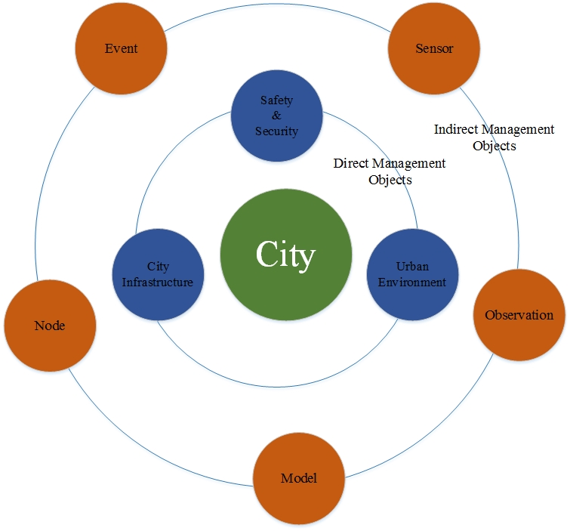
Figure 4 – Direct and indirect objects of IMSSC
2.2 Challenges of IMSSC
In cities nowadays, information resources, like sensors, observations and models, are featured as different sources, great varieties, and huge numbers. However, when responding to the emergency events, many problems still exist, including:
- the encoding formats of the information resources are various, difficult to be integrated;
- the fusion workflow between information resources is not unified, resulting in the non-uniform fusion results, inconsistent accuracy, and difficulty in fusion processing;
- the inconformity of the information resources and their fusion results service interfaces cause trouble in their publishing, sharing, discovering, and accessing [b-Toppeta].
All problems described above pose significant challenges to urban development and to IMSSC.
To be specific, the challenges faced by IMSSC can be illustrated from three perspectives:
1) Information resources come from various sources and heterogeneous systems. It is difficult to interconnect such systems for data sharing. Consequently, this leads to difficulties in multi-level collaborative decision-making. Taking sensors as examples, there are space borne platforms (hundreds of orbiting satellites), airborne platforms (thousands of UAVs, airships and balloons, etc.) and ground platforms (millions of ground sensors). However, there is no unified meta-model to represent and manage the huge amounts of heterogeneous sensors. Information resources with large numbers, different kinds and multiple representation ways are major obstacles in the development and integrated management for smart sustainable cities. The difficulty of information resource management in smart sustainable cities is demonstrated in Figure 5.
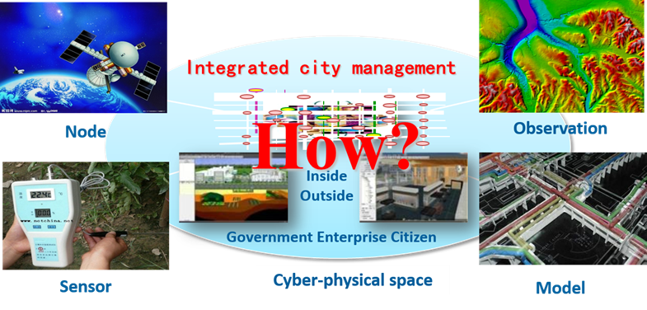
Figure 5 – Difficulty of information resource management in smart sustainable cities
2) Cooperation between the different information resources is lacking, and their fusion processing is difficult, leading to incomplete and inaccurate decisions. Just in terms of the observation data, only less than 10% of the present observation data can be processed timely and efficiently, and the capability of fusion processing on the space, aerial and ground observation data is insufficient. On one hand, when coping with significant environment and disaster events, the poor timeliness and great time lag of data fusion, processing and collaborative analysis always hinders the first-hand data and information from being delivered to the right place on time. On the other hand, the historical surveying and mapping information database cannot be effectively associated and fused with the current observations, forming the obstacles of information overlay and intuitional display. Thus, the status of events and the situation of the schedulable sources cannot be made clear, leading to incomprehensive and inaccurate decisions. The problem of information fusion processing in smart sustainable cities is elaborated in Figure 6.
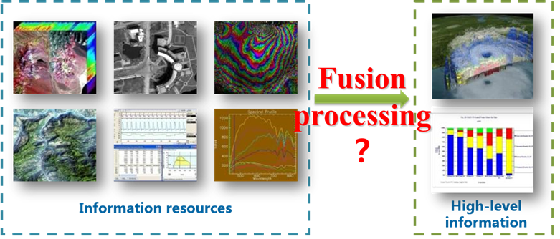
Figure 6 – Problem of information fusion processing in smart sustainable cities
3) The demand granularity of the information resources and fusion results are quite different, together with the distributed resources, inconsistent interfaces, and passive decision services. The information resource interfaces are different, as well as the different user requirements, and distributed service resources. When facing up with great environmental and disaster events, many problems appear, including which data are needed, which sensors can supply the data, which models are in need, and where the models can be found. The non-uniform service interfaces at present are not able to satisfy the complex task requirements, and the active service-focused mode is also absent, resulting in problems of passive and untimely decisions. The problem of refined decision-making in smart sustainable cities is shown in Figure 7.
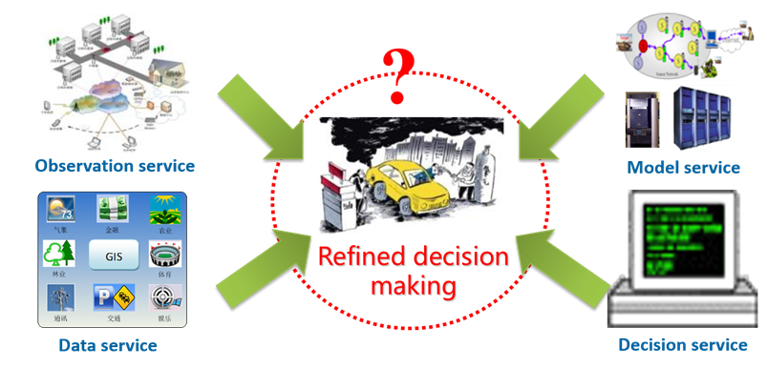
Figure 7 – The problem of refined decision-making in smart sustainable cities
Briefly, the scale of information resources in cities is increasing dramatically, together with the multiple demands from the environment and disaster monitoring. There is an urgent need for establishing an integrated information management infrastructure to implement resource integration, fusion processing, and management service for smart sustainable cities. Through the infrastructure, the heterogeneous observation resources can be combined via the Internet, to form the dynamic coupling mechanisms for collaborative observations, maximize the use of observation resources, provide the task-driven service mode based on the space and time information, and greatly improve the integrated management and service level. During the process, the sustainable monitoring of the environmental safety, the quick response during serious disaster events, and the transformation from the anytime, anybody, anywhere, anything (4A) service to the flexible right time, right body, right place, right thing (4R) service can be completed.
2.3 Technologies of IMSSC
Compared with the digital city management, from the technical level, the integrated management for smart sustainable cities is to realize the transformation from the online management based on the Internet to the real-time dynamic management on the basis of IoT, from the sensing management of every single sensor to the collaborative management of multiple sensors, from the island of the industrial model management to the model web management of the application decisions [b-Balazinska].
To be specific, IMSSC consists of the observation web, service web, and model web technologies.
The observation web technology [b-Simonis] aims at breaking through the barriers of the multiple and heterogeneous observing and sensing modes, and at implementing the automatic, real-time, and comprehensive sensing about the city management and operating status via the web, sensing, and intellectual technologies. The architecture of the observation web technology used in smart sustainable cities is presented in Figure 8.
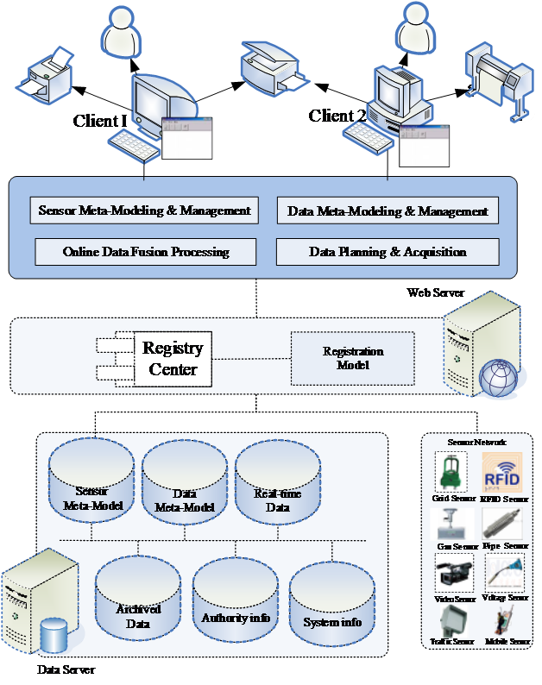
Figure 8 – Architecture of the observation web technology used in smart sustainable cities
The model web technology [b-Nativi] is to hurdle the bars in the meta-modeling as well as catalog registration technology, and to bridge the communication gaps between the heterogeneous sensors, models, as well as simulation and decision support systems. The model web technology could be used to solve the problems in the expression, understanding, sharing and cooperation of the heterogeneous city decision models. Users could realize the city integrated emergency decision by combining and optimizing these models on decision terminals. The framework of the model web technology used in smart sustainable cities is presented in Figure 9.
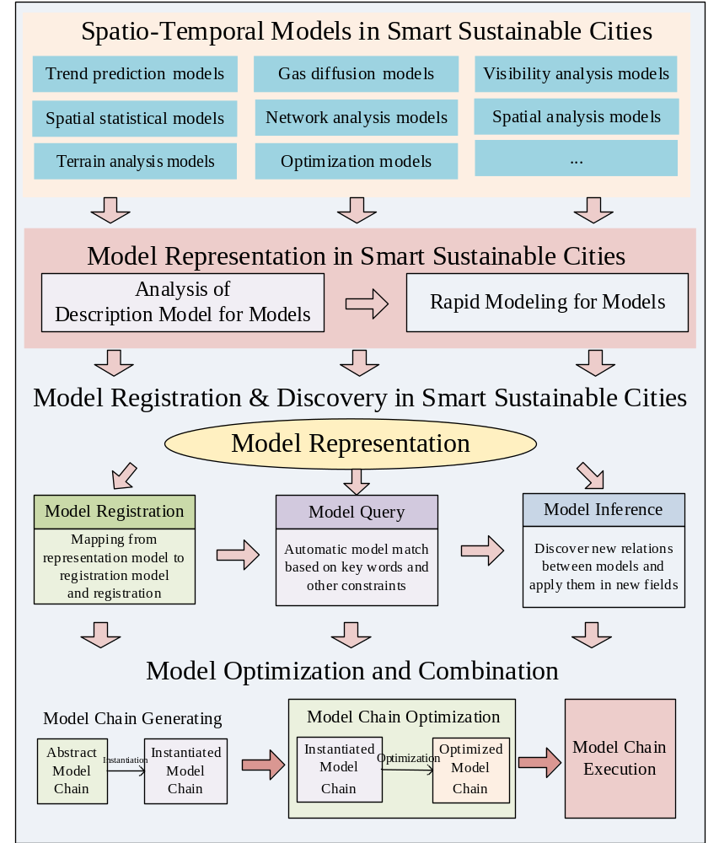
Figure 9 – Framework of the model web technology used in smart sustainable cities
The service web technology [b-ESTO] is to overcome the obstacles in the workflow and sensor web technologies, and to achieve the goal of network intelligent service which is in accordance with specific sensor actions and interface specifications. The framework of the model web technology used in smart sustainable cities is demonstrated in Figure 10.
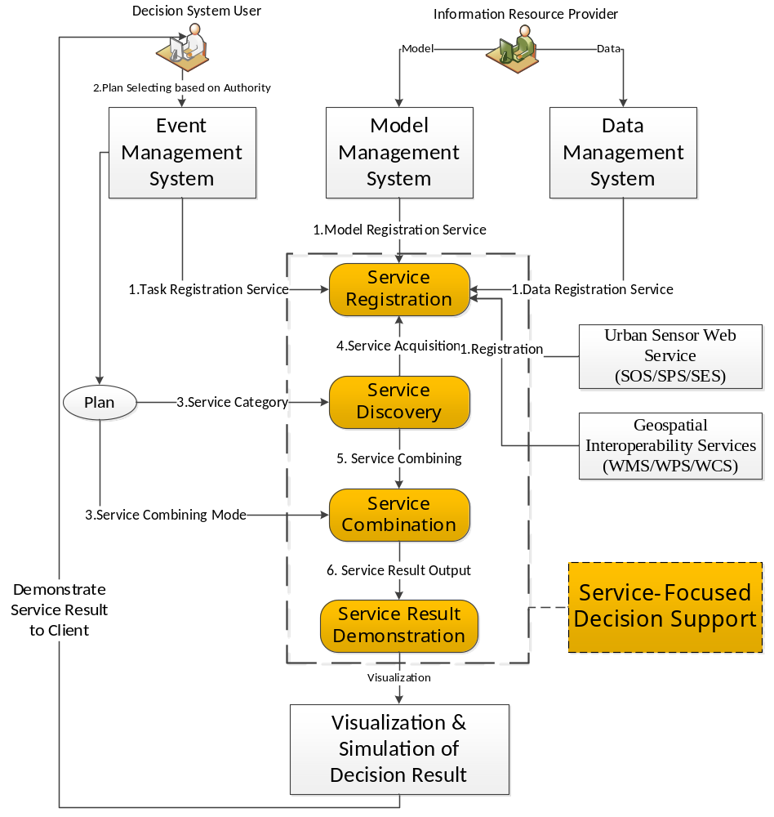
Figure 10 – Framework of the model web technology used in smart sustainable cities
3 Integrated management for smart sustainable cities
3.1 Overview
With the continuous development of smart sustainable city, the categories and forms of information resources are greatly expanded. A large number of heterogeneous information resources, like nodes, sensors, observations and events, are involved in IMSSC. The relationship of these information resources is complicated, sometimes complementary, reinforced or redundant. However, there is no technical proposal to manage them in an integrated way so that the redundant information can be eliminated, the weakness of one kind of information resources can be supplemented by another, and several information resources can be combined together to fulfil the tasks more effectively. A technical proposal for IMSSC is put forward in Figure 11. In this proposal, the sensors, observations, models and nodes are encoded and managed in a uniform way in advance, and when events occur, the service centre will invoke the sensors, observations, models as well as the nodes to perform the corresponding missions as predefined.
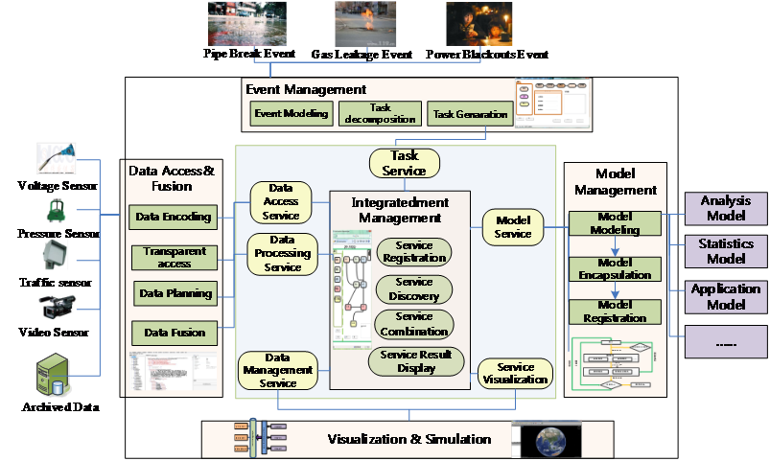
Figure 11 – Technical proposal for the integrated management of smart sustainable cities
To complete the smooth realization of IMSSC, a set of theoretical foundation is needed, including meta-models, fusion processing workflows, and sharing services. Meta-models are aimed to implement the modelling of these information resources, including nodes, sensors, observations and events, demonstrating their capabilities in different aspects and providing the basis for capability enhancement. Workflows of information resource fusion processing are used to guide the implementation of capability enhancement. Service interfaces are intended for unified and efficient sharing of information, offering decision support for municipal authorities during emergencies. In the infrastructure, the meta-models are the basis and premise for the fusion processing workflows and sharing services, including node metadata [b-Chenh]; observation process metadata [b-Cheng], [b-Chenf], [b-Hu], and [b-OGCc]; observation metadata [b-Di], [b-ISO 19156], [b-OGCd], and [b-OGCg]; event metadata [b-Fan], and [b-OGCe], and model metadata [b-Visconti]. The fusion processing workflows are means to enhance the capabilities of the information resources modelled by the meta-models and shared by the sharing services, consisting of the technical specifications for fusing resources with toponym [b-Smart], and maps separately [b-Chanier]. The sharing service interface specifications [b-Chenb] are ways to share and manage the modelling results of information resource and fusion processing results, composed of the data [b-Chenc], [b-Chend], [b-Chene], and [b-OGCa], as well as model, and event service interface specifications [b-OGCb], and [b-OGCf]. The organization of the theoretical foundation for the integrated management under the smart sustainable city environment is described in Figure 12:
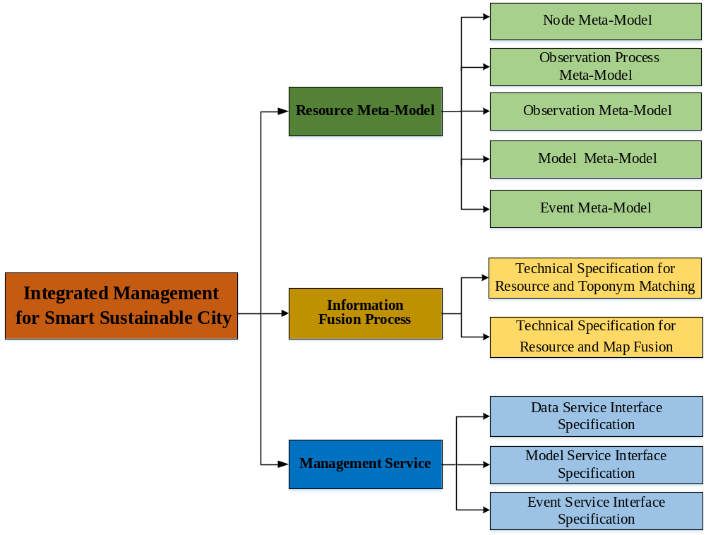
Figure 12 – Organization of the theories for integrated resource management
under the smart sustainable city environment
3.2 Meta-models for resource integrating
There are five meta-models for resource integrating, namely node meta-model, observation process meta-model, observation data meta-model, model meta-model and event meta-model. Only the aspects of the node meta-model are elaborated in detail: background, scope, and content.

3.2.1 Node meta-model

3.2.1.1 Background
In the present sensor web applications, especially the emergency response and decision support applications for land surface events on the earth, a series of problems exist, including the "more" and "less" sensor web resources, insufficient data processing capability, and the lack of service-focused model [b-Chena]. How to make people be able to access observation resources in a transparent, efficient and customized manner, and implement the online information fusion, data assimilation, dynamic management, as well as intelligent service for the resources is still a challenge. Thus, there is an urgent need for a unified management model to organize and allocate the sensor web resources [b-Liang]. The node meta-model is aimed at providing an open and unified sensor web node information model in order to realize the unified description for the inherent features of the nodes. Through the node meta-model, it becomes clear which nodes have the capability of completing data processing and serving needed for a certain task, as well as the working state, timeliness, and geolocation of which nodes are able to meet the task requirements. The node meta-model facilitates the efficient management and allocations for heterogeneous nodes.

3.2.1.2 Scope
The node meta-model defines the sharing metadata for node resources in the comprehensive smart city management. The metadata content is confined to the unified description for inherent properties, capabilities, and status and space-time information of the nodes. The structure, physical characteristics of the nodes themselves, as well as node observation data and the following processing and services are all excluded.
The meta-model can be applied in the integrated discovery and sharing, integrated management, planning, dispatching, as well as collaborative observing for all kinds of nodes. The specific application scope of the node meta-model is given in Figure 13.
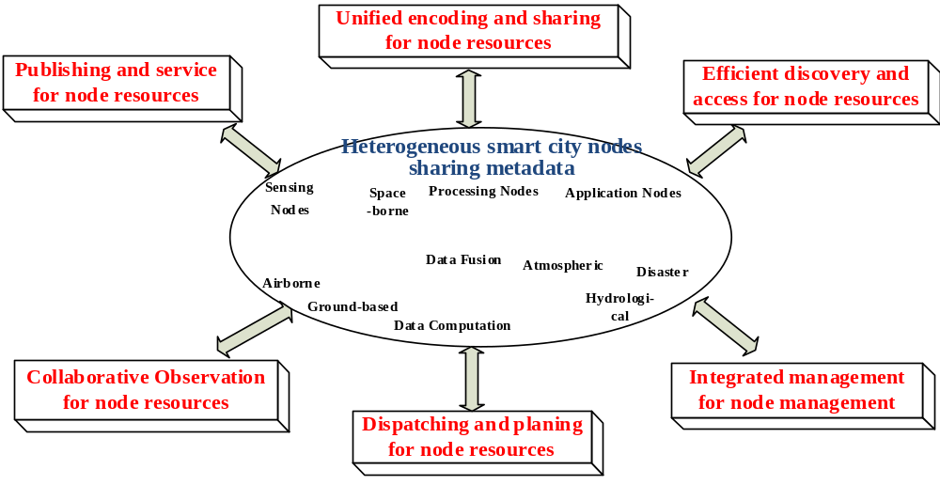
Figure 13 – Application scope for node meta-model

3.2.1.3 Content
Based on the node description components and different metadata requirements from all kinds of nodes, the node metadata is organized into the general information description framework, with five components, including the sensor tag, performance, state, service and accessibility, and a nine-tuple structure [b-ISO 19115-2]. The node meta-model is shown as follows:
Node metadata = {Identification, Characteristics, Capability, Quality, Space-time, Working, Service, Administration, Constraint}.
Among all the meta-model components, identification and characteristics information are tessellations for sensor tag component, capability and quality information for performance, service information for service, and administration and constraint for accessibility. The relationship between the five components and the nine-tuple structure is demonstrated in Figure 14 [b-Chenh].
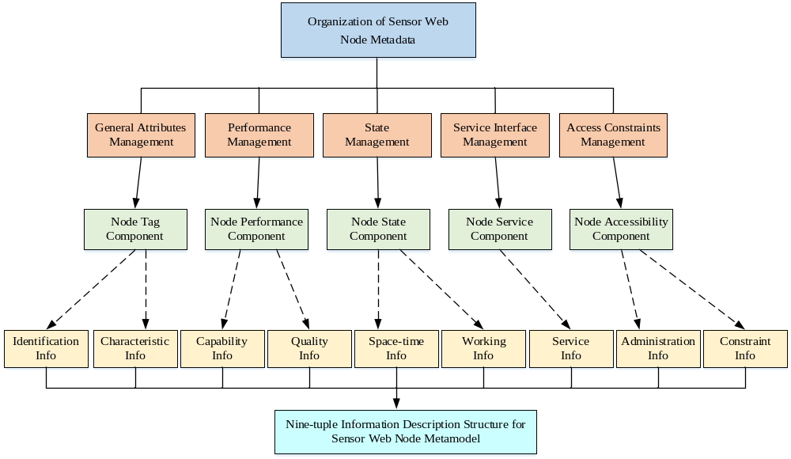
Figure 14 – Description structure for the nine-tuple smart sustainable city node information
1) Identification information: Such information includes keywords and the node name, identity (ID), type, level, and dynamic feature, which describe the general information of a node for uniquely identifying a node.
2) Characteristics information: Such information includes node function, suitable fields, core units, platform environment, communication fabric, and input and output features that describe the characteristic information of a node. The core units refer to sensor, processing algorithm, or service to different types of nodes.
3) Capability information: Such information includes function, communication, capability, and resource consumption capability features. Heterogeneous nodes have different function capabilities and need to have extended metadata according to a specific node type.
4) Quality information: Such information includes product quality and quality of service (QoS) features. Various nodes have different quality indicators and need to have extended product quality metadata according to a specific node type.
5) Space-time information: Such information includes time and space referencing framework, location, and valid time features that describe the real location and time of a node in dynamic observation systems.
6) Working information: Such information includes the use state, fault state, and resource consumption, which can determine whether a node is available at a task moment.
7) Service information: Such information includes the service name, type, address, parameters, provider, and mode features that describe the metadata contents of node service interfaces. The relation among the services of a service combination can be represented through the service connection feature.
8) Administration information: Such information includes contact, history, and document features that note the important information usable for node administration management.
9) Constraint information: Such information includes access level, legal constraint and security constraint features, which affect the accessibility of a node.
3.3 Technical specifications for fusion process
There are two technical specifications for fusion process, namely resource and toponym matching specification as well as resource and map fusion specification. Only the aspects of the resource and toponym matching specification are explained in detail: background, scope, and content.

3.3.1 Resource and toponym matching specification

3.3.1.1 Background
Toponym is important in the GIS databases, and it can assist users in the searching, interpreting and analyzing of the geographic data. Meanwhile, in the Internet of things and construction of smart cities, the scanning, imaging and radar type sensors, aerial and space images as well as ground-based observations, and disaster, accident calamity, public hygiene event as well as welfare event are all carriers of information resources. However, they lack the association with the actual place names, resulting in the difficulty of being applied in the smart sustainable city. The research of how to match up and fuse nodes, sensors, observations, and events with toponym database is able to label geographic locations, and is beneficial to the unified management, efficient discovery, time and space pattern mining, as well as visualization for all these observation resources. The technical specification for resource and toponym database matching in the integrated management for smart sustainable cities is designed to formulate a unified and efficient workflow to realize the fusion of resources and their toponym. Through the fusion, the actual place names can be assigned to the corresponding nodes, sensors, observations and events, which will assist in expressing and understanding the observation information.

3.3.1.2 Scope
The technical specification for resources and the toponym database matching in IMSSC provides a unified workflow for observation resources matching up with the toponym database, including matching the nodes, sensors, observations and event resources up with the toponym database. The technical specification is limited to matching nodes, sensors, observations and event resources up with the toponym database. However, the structure and characteristics information of the resources and toponym database themselves as well as the data processing method and service are not included.
The interface specification of fusion process can be used to provide technical guidance for matching the observation resources up with the toponym database, add and correct positions for observation resources, implement quality supervision as well as efficient management for resources and toponym and so on. The concrete application scope is depicted in Figure 15.
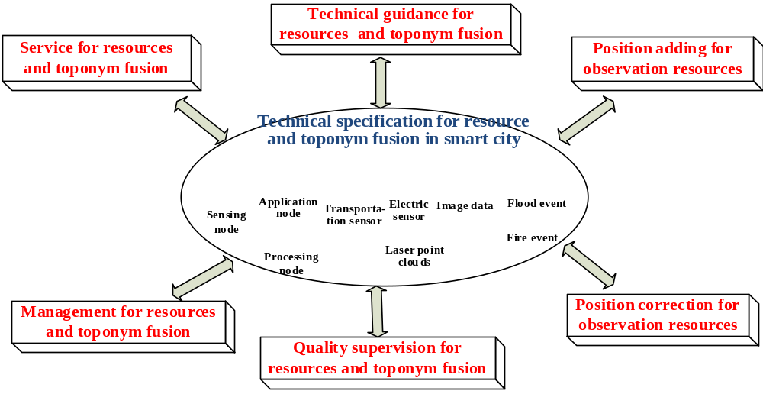
Figure 15 – Application scope of technical specification for resource and toponym database matching in the integrated management for smart sustainable cities

3.3.1.3 Content
The fusion of nodes and the toponym database, assigning the actual place name information to nodes, will make it convenient to overlay nodes on maps or images, and increase the efficiency of sensor accessing and dispatching. Fusing sensors with the toponym database will facilitate the graphical display of sensors on the map, and provide data support for sensor planning, arrangements, as well as intensive observations under emergencies. The observations fusing with the toponym database, mainly adding observed properties, will make the demonstration of the data's geographic positions more intuitive, and convenient to be invoked at any time. The fusion between events and toponym, adding graphic position labels for events, will contribute to map display, pattern of spatial distribution, and causality inferring for events. The technical workflow of matching resources up with the toponym database in IMSSC is shown in Figure 16 [b-Smart].
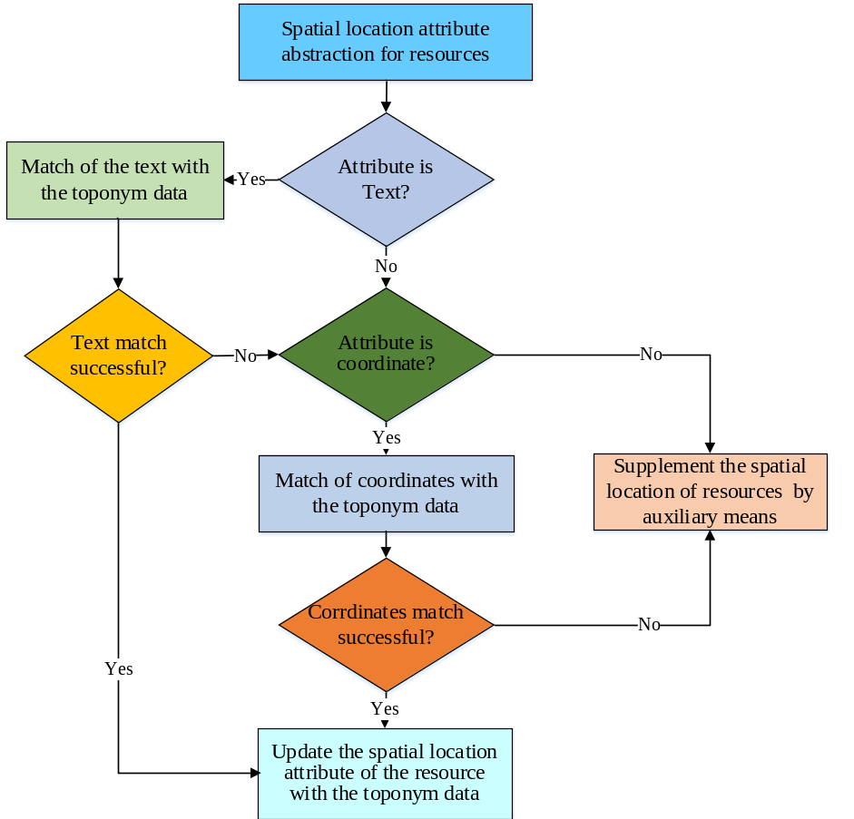
Figure 16 – Technical workflow of matching resources up with the toponym database in the integrated management for smart sustainable cities
3.4 Interface specifications for management service
There are three service technical interface specifications for management service, namely model service interface specification, data service interface specification, and event service interface specification. Only the aspects of the model service interface specification are described in detail: background, scope, and content.

3.4.1 Model service interface specification

3.4.1.1 Background
In IMSSC, all departmental applications, such as urban construction, water conservancy, electric power, environmental protection, transportation, and fire-fighting, need to be combined with concrete models. Nevertheless, research is limited to some application fields, and systems must be modified or even re-developed when new problems appear. It will take more time and money to restrict the models' application in IMSSC [b-Nativi]. The model service interface specification proposed in this Technical Report offers a general and unified service interface, and with the storage and invoke for the models separated from the users, the sharing, management as well as interoperability for heterogeneous models or model chains can be implemented.

3.4.1.2 Scope
Through the model service interface, model providers can perform the registration, insertion and publishing of the model metadata; model consumers are able to query model metadata information, find the model in need and finally discover, access and invoke the model according to the model ID returned.
The model service interface specification can be exploited for the publishing, sharing and reuse of the models. The concrete application scope of the model service interface specification is depicted in Figure 17.
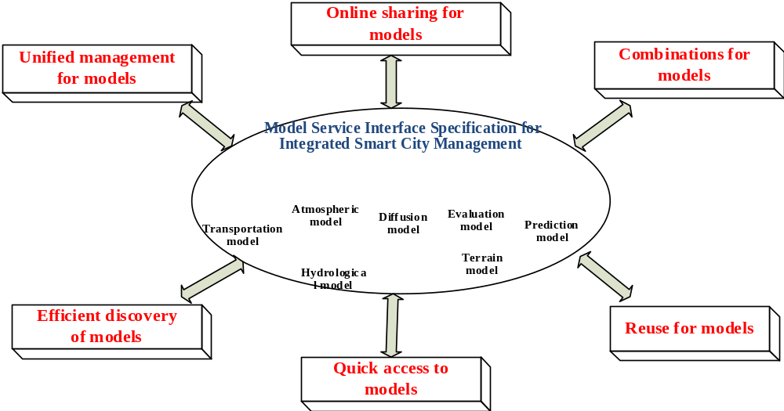
Figure 17 – Application scope of the model service interface specification under the environment of the integrated management for smart sustainable cities

3.4.1.3 Content
The model service under the smart city environment is an open interface, and it acts as an intermediate agent between the user and the model storage warehouse. A web service interface is defined in the service interface specification, in which queries about the model metadata, input and output, as well as representation for models are allowed. Moreover, the methods of registering new models, deleting existing models, as well as inquiring about new models are all defined in the model service interface specification [b-de Castro]. There are three kinds of operations in the interface specification, namely core, transactional, and enhanced operation. Core operations include the GetCapabilities, DescribeModel, and ExecuteModel operation. Transactional operations consist of the InsertModel, DeleteModel, and UpdateModel operation. Enhanced operations are composed of the GetFieldOfInterest and GetModelByFunction operation. Among all these operations, only the three core operations are mandatory, while the others are optional. The element structure for the model service interface specification is as explained in Table 1.
Table 1 – Elements of the integrated smart sustainable city management
model service interface specification
Interface  specification  name | Operation type | Operation name | Operation definition | Mandatory  or not
Model service interface specification of the integrated management for smart sustainable cities | Core operations | GetCapabilities | Provides access to metadata and detailed information about the models available by a model server. | Yes
 | Core operations | DescribeModel | Enables querying of metadata about the models and model chains available by a model server. | Yes
 | Core operations | ExecuteModel | Provides the execution of models. | Yes
 | Transactional operations | InsertModel | Allows registration of new models at the model server. | No
 | Transactional operations | DeleteModel | Allows the deletion of registered models and all their associated algorithms. | No
 | Transactional operations | UpdateModel | Allows the update of model parameters and functions. | No
 | Enhanced operations | GetFieldOfInterest | Provides access to models from a model service by passing only the field of interest of a user. | No
 | Enhanced operations | GetModelByFunction | Provides access to models from a model service by passing only the expected function of a user. | No
4 Instances of the integrated management for smart sustainable cities
4.1 Daily management
The daily management for smart sustainable cities can be implemented following the steps described herein. Firstly, the access of the monitoring data and processing models of different municipal departments can be achieved by encoding the information resources, like the nodes, sensors, observation data and models, according to the meta-model proposed in section 3.1. Secondly, by referring to the fusion processing technical specification in section 3.2, the integration of different information resources can be realized, together with a higher level of acquired information. Thirdly, the unified management service interface specification can be employed to issue and share nodes, sensors, models and other information resources. When needed, users can access and obtain the corresponding data or models quickly via the uniform service interfaces.
4.2 Emergency response management
The access and integration of all kinds of city monitoring data resources from different departments can be realized by conforming to the theories proposed in this Technical Report. Via the technologies of model representation, registration, combination, and optimization, and combination of the available data resources, the model-driven data access can be formed with the model selection. The parameters are optimized, and the dual-directional coupling between the data and the models is formed. By encapsulating the data and models into web services, and linking them with the decision information requirements from different users, and by combining concrete city decision task execution workflows, the active and focused service of a city decision information can be formed. Finally, the typical application of IMSSC will be established, as demonstrated in Figure 18.
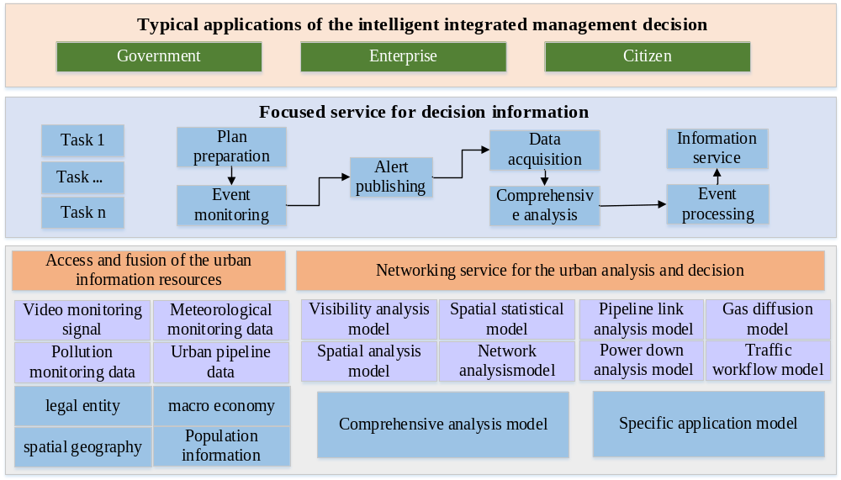
Figure 18 – Technical roadmap for the typical applications of integrated management intelligent decision in smart cities
Aimed at different application topics from multilevel inter-agency intelligent decisions, such as water leakage, power interruption, gas pipeline leakage and so on, the spatial-temporal intelligent analysis and decision model database should be built including general analysis model (visibility analysis model, spatial statistical model, spatial analysis model, and network analysis model), and specific application models (pipeline connection analysis model, gas diffusion model, power down analysis model, etc.).
Model information should be expressed in a unified way, so that the models can be conveniently managed and coupled, and the output of various models can be easily fused. In addition, the model registration centre for cities should be established based on the representation model so that the model registration and discovery can be realized consequently. Moreover, using the combination and optimization technology, the abstract and instantiated model chains can be created for decision support in different applications. Through the execution of the model chains, the decision result can be produced, providing support for multilevel intelligent decisions.
When faced with emergency events, the focus is mainly on the task generation, plan preparation, and event responding. The theories proposed in this Technical Report can be used to provide different data, models and services for different stages, respectively.
For example, when a pipeline explosion event occurs in the task generation stage, the network and spatial analysis model, as well as the pipeline network and topography data can be adopted to acquire the location, the severity level, and other important information of the event; then the task requirements can be extracted. In the plan preparation stage, by accessing the corresponding data from the departments transparently, and performing a comprehensive analysis on the resources, mainly basic geographic data, topography data, data diffusion model, overlay analysis model, and network analysis model, the development tendency of the event, the first responders and the emergency facility distribution and other information can be obtained, providing the basis for making the correct emergency response plan. In the event responding stage, using the road network and real-time traffic information, and combining the optimal path, buffer analysis and other models, provides valuable support for a fast response to the emergency. When a multilevel emergency occurs, different service-focused measures should be taken to meet the requirements of the different users, namely municipalities, enterprises and citizens. Municipalities need all the city departments to work collaboratively through the task creation, plan preparation, event monitoring, alert publishing, data acquaintance, comprehensive analysis, event handling, and information service, to realize the focused service of the decision information. The relative model and data analysis is performed in the task creation stage, together with the task requirements extracted. For example, the gas company is informed during the plan preparation stage to monitor the gas leakage event as well as the situation, locate the event source, feedback the information to the command centre, and issue the alert information to the environmental protection, fire-fighting, transportation, communication, surveying and mapping, health care, and public security departments. After that, it is necessary to assess the staff, facilities and equipment conditions of the different departments, and instruct each concerned department with the appropriate event handling methods to respond promptly. Finally, a communication should be issued to the citizens to inform them about the emergency measures put in place. Through the active focused service described above, decision support for smart pipeline in cities can be provided, proving the efficiency of IMSSC.
5 Conclusions
This Technical Report provides a proposal for integrated management for smart sustainable cities with the aim of better coordinating and managing city infrastructure and operations, as well as citizen interactions. The theoretical foundation of IMSSC is depicted, including the meta-models for resources integration (node meta-model, observation process meta-model, observation data meta-model, event meta-model, and model meta-model), fusion processing workflow (fusion of resources and toponym, and maps separately), and service interface specification (observation service, model service, and event service).
Taking into consideration the management challenges faced by cities worldwide, this Technical Report describes the advantages of adopting an integrated management system in order to make cities function more efficiently and citizens live more conveniently.
This Technical Report provides practical guidance to help urban planners make cities smarter and more sustainable. Adopting the proposed technical solutions, the overall efficiency of information resource collecting and sharing, as well as the effectiveness of information fusion processing will be considerably enhanced, facilitating IMSSC.
The next step is to put theory into practice, and to improve it according to the specific problems of every urban environment. To this end, it is essential to acknowledge the importance of turning the requirements presented here into international standards in order to multiply the benefits of this approach across all cities worldwide.

Bibliography

[b-Balazinska] Balazinska, M., Deshpande, A., J. Franklin M., B. Gibbons, P., Gray, J., Nath, S., Hansen, M., Liebhold, M., Szalay, A., and Tao, V., Data Management in the worldwide sensor web [J]. IEEE Pervasive Computing, 2010, 6(2): 30-40. [Online] Retrieved from: [22.05.2014]
[b-Chanier] Chanier, F, Checchin, P., Blanc, C., et al., Map fusion based on a multi-map SLAM framework [C]//Multisensor Fusion and Integration for Intelligent Systems, 2008. MFI 2008. IEEE International Conference on. IEEE, 2008: 533-538. [Online] Retrieved from: [18.12.2013]
[b-Chena] Chen, C., and Helal, S., Sifting Through the Jungle of Sensor Standards [J], IEEE Pervasive Computing, 2008, 7:84-88. [Online] Retrieved from: [16.05.2014]
[b-Chenb] Chen, N., Chen, Z., and Hu, C., A capability matching and ontology reasoning method for high precision OGC web service discovery [J], International Journal of Digital Earth, 2011, 4(6):449-470. [Online] Retrieved from: [23.02.2014]
[b-Chenc] Chen, N., Di, L., Yu, G., and Gong, J., Automatic on-demand data feed service for autochem based on reusable geo-processing workflow [J], IEEE Journal of Selected Topics in Applied Earth Observations and Remote Sensing, 2010a, 3(4): 418-426. [Online] Retrieved from: [19.04.2014]
[b-Chend] Chen, N., Di, L., Yu, G., Gong, J., and Wei, Y., Use of ebRIM-based CSW with sensor observation services for registry and discovery of remote-sensing observations [J], Computers & Geosciences, 2009a, 35: 360-372. [Online] Retrieved from: [27.02.2014]
[b-Chene] Chen, N., Di, L., Yu, G. and Min, M., A flexible geospatial sensor observation service for diverse sensor data based on Web service [J], ISPRS Journal of Photogrammetry and Remote Sensing, 2009b, 64(2): 234-242. [Online] Retrieved from: [12.05.2014]
[b-Chenf] Chen, N., and Hu, C., A sharable and interoperable meta-model for atmospheric satellite sensors and observations [J], IEEE Journal of Selected Topics in Applied Earth Observation And Remote Sensing, 2012, 5(5): 1519-1530. [Online] Retrieved from: [19.04.2014]
[b-Cheng] Chen, N., Hu, C., Chen, Y., Wang, C., and Gong, J., Using SensorML to construct a geoprocessing e-Science workflow model under a sensor web environment [J], Computers & Geoscience, 2011, 11(27): 1016-1025. [Online] Retrieved from: [27.03.2014]
[b-Chenh] Chen, N., Wang, K., Xiao, C., et al., A heterogeneous sensor web node meta-model for the management of a flood monitoring system [J], Environmental Modelling & Software, 2014, 54: 222-237. [Online] Retrieved from: [19.05.2014]
[b-de Castro] de Castro, V., Marcos, E., and Cáceres, P., A user service oriented method to model web information systems [M]//Web Information Systems-WISE 2004. Springer Berlin Heidelberg, 2004: 41-52. [Online] Retrieved from: [15.04.2014]
[b-Di] Di, L., Moe, K., and Yu, G., Metadata requirements analysis for the emerging Sensor Web [J], International Journal of Digital Earth, 2009, 2:3-17. [Online] Retrieved from: [19.03.2014]
[b-ESTO] Report from the Earth Science Technology Office (ESTO), Advanced Information Systems Technology (AIST) Sensor Web Technology Meeting [R]. In 2007 Proceedings of ESTO/AIST Sensor Web Principal Investigator Meeting, San Diego, CA, February 2007, 13-14. [Online] Retrieved from: [16.04.2014]
[b-Fan] Fan, M., Fan, H., Chen, N., Chen, Z., and Du, W., Active on-demand service method based on event-driven architecture for geospatial data retrieval [J], Computers & Geosciences, 2013, 56:1-11. [Online] Retrieved from: [17.03.2014]
[b-Hu] Hu, C., Chen, N., and Li, J., Geospatial Web-based Sensor Information Model for Integrating Satellite Observation: An Example in The Field of Flood Disaster Management [J], Photogrammetric Engineering & Remote Sensing, 2013, 79(10):915-927. [Online] Retrieved from: [21.04.2014]
[b-ISO 19115-2] ISO 19115-2:2009, Geographic information –Metadata –Part 2: Extensions for imagery and gridded data.
[b-ISO 19156] ISO 19156:2011, Geographic information – Observations and measurements.
[b-Liang] Liang, S., and Tao, C., A distributed geospatial infrastructure for Sensor Web [J], Computers & Geoscience, 2005, 31 (2), 221-231. [Online] Retrieved from: [12.04.2014]
[b-Nama] Nam, T., and Pardo, T. A., Conceptualizing smart city with dimensions of technology, people, and institutions[C]//Proceedings of the 12th Annual International Digital Government Research Conference: Digital Government Innovation in Challenging Times. ACM, 2011: 282-291. [Online] Retrieved from: [13.03.2014]
[b-Namb] Nam, T., and Pardo, T.A., Smart city as urban innovation: Focusing on management, policy, and context [C]//Proceedings of the 5th International Conference on Theory and Practice of Electronic Governance. ACM, 2011: 185-194. [Online] Retrieved from: [14.05.2014]
[b-Nativi] Nativi, S., Mazzetti, P., and Geller, G.N., Environmental model access and interoperability: The GEO Model Web initiative [J], Environmental Modelling & Software, 2013, 39: 214-228. [Online] Retrieved from: [18.05.2014]
[b-OGCa] OGC 06-009r6, OpenGIS Sensor observation service implementation specification [S] (Version 1.0). Wayland, MA, USA: Open Geospatial Consortium, 2007c. [Online] Retrieved from: [21.03.2014]
[b-OGCb] OGC 06-028r3, OpenGIS Sensor Alert Service Implementation Specification [S] (Version 0.9.0). Wayland, MA, USA: Open Geospatial Consortium, 2007b. [Online] Retrieved from: [26.02.2014]
[b-OGCc] OGC 07-000, OpenGIS Sensor Model Language (SensorML) Implementation Specification [S] (Version 1.0.0). Wayland, MA, USA: Open Geospatial Consortium, 2007a. [Online] Retrieved from: [09.04.2014]
[b-OGCd] OGC 08-094r1, OpenGIS SWE Common Data Model Encoding Standard [S] (Version 2.0.0). Wayland, MA, USA: Open Geospatial Consortium, 2011a. [Online] Retrieved from: [03.05.2014]
[b-OGCe] OGC 08-132, OpenGIS Event Pattern Markup Language (EML) [S] (Version 0.3.0). Wayland, MA, USA: Open Geospatial Consortium, 2008a. [Online] Retrieved from: [14.03.2014]
[b-OGCf] OGC 08-133, OpenGIS Sensor Event Service Interface Specification [S] (proposed) (Version 0.3.0). Wayland, MA, USA: Open Geospatial Consortium, 2008b. [Online] Retrieved from: [24.02.2014]
[b-OGCg] OGC 10-025r1, OpenGIS Observations and Measurements-XML Implementation [S] (Version 2.0). Wayland, MA, USA: Open Geospatial Consortium, 2011b. [Online] Retrieved from: [26.12.2013]
[b-Simonis] Simonis, I., OGC® Sensor Web Enablement Architecture [R], OGC White Paper, 2008. [Online] Retrieved from: [10.05.2014]
[b-Smart] Smart, P.D., Jones, C.B., and Twaroch, F.A., Multi-source toponym data integration and mediation for a meta-gazetteer service [M]//Geographic Information Science. Springer Berlin Heidelberg, 2010: 234-248. [Online] Retrieved from: [21.11.2013]
[b-Toppeta] Toppeta, D., The smart city vision: how innovation and ICT can build smart, "livable", sustainable cities [J]. The Innovation Knowledge Foundation, 2010. [Online] Retrieved from: [14.10.2013]
[b-Visconti] Visconti, M., and Cook, C.R. (2002), A meta-model framework for software process modeling. Product Focused Software Process Improvement, Springer Berlin Heidelberg, 532-545. [Online] Retrieved from: [15.03.2014]

Annex
Abbreviation and acronyms
This Technical Report uses the following abbreviations:
4A | Anytime, Anybody, Anywhere, Anything
4R | Right time, Right body, Right place, Right thing
EML | Event Pattern Markup Language
ESTO | Earth Science Technology Office
GIS | Geographic Information System
GPS | Global Positioning System
ID | Identification
ICT | Information and Communication Technology
IMSCC | Integrated Management for Smart Sustainable Cities
IoT | Internet of Things
ISO | International Organization for Standardization
ITU | International Telecommunication Union
OGC | Open Geospatial Consortium
QoS | Quality of Service
RFID | Radio Frequency Identification
SSC | Smart Sustainable City
SES | Sensor Event Service
SOS | Sensor Observation Service
SPS | Sensor Planning Service
UAV | Unmanned Aerial Vehicle
WCS | Web Coverage Service
WMS | Web Map Service
WPS | Web Processing Service

____________

