|  |  |  |  |  |
| --- | --- | --- | --- | --- |
|  | | **International Telecommunication Union** | | |
|  | |  | | |
| **ITU-T** | **FG-SSC** | |
| TELECOMMUNICATION STANDARDIZATION SECTOR OF ITU | | (10/2014) |
|  | ITU-T Focus Group on Smart Sustainable Cities | | | |
|  | **Electromagnetic field (EMF) considerations in smart sustainable cities** | | | |
|  | Focus Group Technical Report | | | |



FOREWORD

The International Telecommunication Union (ITU) is the United Nations specialized agency in the field of tele­com­mu­ni­ca­tions, information and communication technologies (ICTs). The ITU Telecommunication Standardization Sector (ITU-T) is a permanent organ of ITU. ITU-T is responsible for studying technical, operating, and tariff questions and issuing Recommendations on them with a view to standardizing telecommunications on a worldwide basis.

The procedures for establishment of focus groups are defined in Recommendation ITU-T A.7. ITU-T Study Group 5 set up the ITU-T Focus Group on Smart Sustainable Cities (FG-SSC) at its meeting in February 2013. ITU-T Study Group 5 is the parent group of FG-SSC.

Deliverables of focus groups can take the form of technical reports, specifications, etc., and aim to provide material for consideration by the parent group in its standardization activities. Deliverables of focus groups are not ITU-T Recommendations.

|  |  |
| --- | --- |
| **SERIES OF FG-SSC TECHNICAL REPORTS** | |
|  |  |
|  |  |
|  |  |
|  |  |
|  |  |
|  |  |

© ITU 2014

All rights reserved. No part of this publication may be reproduced, by any means whatsoever, without the prior written permission of ITU.

Overview

ITU-T Study Group 5 has established a new Focus Group on Smart Sustainable Cities (FG-SSC) to assess the standardization requirements of cities aiming to boost their social, economic and environmental sustainability through the integration of information and communication technologies (ICTs) in their infrastructures and operations.

Wireless networks provide vital infrastructure and connection of ICTs that underpin smart sustainable cities. The effective design and careful deployment of wireless networks and short range devices (SRDs) are vital to ensuring electromagnetic field (EMF) compliance and maximum efficiency for ICTs.

Key features of this Technical Report are:

a) It details the EMF considerations in smart sustainable cities.

b) It provides guidance on implementation, and promotes efficient deployment of wireless networks in smart sustainable cities.

c) It features a ‘Smart Sustainability City EMF Check-list’ designed to provide an easy to use reference for city officials and planners to ensure smart city policies operate most efficiently and comply with EMF exposure standards.

d) It references WHO materials, ICNIRP Guidelines, ITU-T Recommendations and IEC Standards. It is not intended to replicate the material in all references.

**Electromagnetic field (EMF) considerations in   
smart sustainable cities**

About this Technical Report

This Technical Report has been developed as a contribution to the International Telecommunication Union's (ITU) Focus Group on Smart Sustainable Cities (FG-SSC) – Working Group 2 ‘SSC infrastructure’.

Acknowledgements

This Technical Report was researched and principally authored by Mike Wood (Telstra) and Jack Rowley (GSMA) with oversight and contributions from Gilbert Buty and Christophe Grangeat (Alcatel-Lucent); Hector Carril (Secretaría de Comunicaciones de la Nación, Argentina); Pablo Bilbao (Argentine Federation of Municipalities - FAM); Josette Gallant and Hughes Nappert (Industry Canada); Brian Copsey (Copsey Communications); Davide Colombi and Christer Törnevik (Ericsson); Haim Mazar (Ministry of Communications, Israel); ITU-R Study Group Spectrum Management; Jafar Keshvari (Microsoft); Ken Joyner and Michael Milligan (Mobile Manufacturers Forum); Mitsuo Hattori (NTT and ITU-T Study Group 5 Working Party 2/5 Chairman); Joe Wiart (Orange Group); Fryderyk Lewicki (Orange Polska); Tariq Alamri (Communications and Information Technology Commission, Saudi Arabia); Flavio Cucchietti (Telecom Italia); Brendon Woods Consulting (Australia), Dr Phil Knipe (TRS), Angelica Ospina (University of Manchester) and Ziqin Sang (Wuhan Research Institute of Posts and Telecommunications).

The authors also acknowledge the guidance and support from all the members of the FG-SSC Management Team, and especially Paolo Gemma (Huawei and FG-SSC Working Group 2 Coordinator) and Cristina Bueti (ITU).

Additional information and materials relating to this Technical Report can be found at: [www.itu.int/itu-t/climatechange](http://www.itu.int/itu-t/climatechange). If you would like to provide any additional information, please contact Cristina Bueti at [tsbsg5@itu.int](mailto:tsbsg5@itu.int).

Electromagnetic field (EMF) considerations in smart sustainable cities

**Table of Contents**

Page

1 Introduction 2

1.1 Scope 2

1.2 Background 2

2 ICTs and EMF 4

2.1 How wireless networks support ICT services? 4

2.2 Examples of ICT Systems connected by wireless networks 5

2.3 Importance of wireless network connectivity 13

2.4 Wireless Technology Power and Operating Range 13

3 EMF and Health 15

3.1 World Health Organization and EMF 16

3.2 EMF and Health Summary – World Health Organization 16

3.3 IARC Classification for radio frequency fields 17

4 EMF Exposure Limits 18

4.1 Internationally Harmonized EMF limits 19

4.2 EMF safety training 21

4.3 Compliance assessment standards for wireless networks and devices 21

4.4 Compliance for wireless networks 22

4.5 Typical antenna compliance zones for workers 22

4.6 Compliance for Wireless Devices 25

4.7 EMF Compliance Framework 26

4.8 Compliance assessment 26

4.9 Requirements for low power systems 27

4.10 Compliance for shared sites 27

5 EMF Health and Safety Information 27

5.1 Compliance information 28

5.2 Health and Safety Information 28

5.3 Sources of information 28

6 Community Information, Consultation and Engagement 28

6.1 Guidance on public participation and consultation 29

6.2 Why consultation is important? 29

6.3 Risk communication guidance 29

7 Wireless ICT Network Infrastructure 30

7.1 Mobile network base stations and antennas 30

Page

7.2 Macro base stations and small cells 30

7.3 Sharing and Co-Location 32

7.4 Location of antennas and access restrictions 34

7.5 Signage 34

8 ICT Wireless Technologies 36

8.1 Mobile network technologies – 3G and 4G 36

8.2 WiMAX 37

8.3 Wi-Fi 38

8.4 Mobile back-haul and radio relays 38

8.5 Bluetooth 39

8.6 DECT 40

9 ICT Antenna siting approval requirements 40

9.1 Antenna permit procedures 40

9.2 Environmental Impact Assessment 43

9.3 Schools, hospitals and similar community facilities 44

9.4 Access to public buildings and land 44

9.5 Planning exclusion zones 45

9.6 Visual integration with the environment 45

9.7 Environmental Impact Assessment 46

10 Conclusions 47

Bibliography 49

Annex 1 Smart Sustainable City - EMF Check-list 53

Annex 2 Summary of ICNIRP guidelines 54

Annex 3 Summary of typical exposure levels 56

Annex 4 Abbreviations and Acronyms 57

Electromagnetic field (EMF) considerations in smart sustainable cities

Executive Summary

Wireless and wired networks provide the underlying connections that underpin smart sustainable cities (SSC). The design and deployment of wireless networks must ensure compliance with the required quality of service as well as with the standards and regulations on human exposure to radio frequency (RF) electromagnetic fields.

This Technical Report details the electromagnetic field (EMF)[1] considerations in smart sustainable cities to ensure that the networks and connected devices operate safely and efficiently. Efficient deployment of wireless infrastructure will reduce the transmitted RF power in providing services and improve the efficiency of ICTs.

The key audience of this Technical Report includes city officials, town planners, urban developers, infrastructure providers, network operators and the public.

This Technical Report comprises the following key sections:

– **ICTs and EMF** –Provides a summary of how wireless networks support ICTs in the community, providing services that include smart metering, remote health care and medical monitoring, smart cars, mobile education, and smart homes and buildings.

– **EMF and health** – Provides an overview of the extensive research into EMF and health, and the conclusions from the World Health Organization (WHO).

– **EMF exposure limits** – Provides a summary of the international EMF exposure limits developed by the International Commission on Non-Ionizing Radiation Protection (ICNIRP) along with information on the application of the limits to workers and the general public.

– **EMF health and safety information** – Provides an overview of the most relevant information available on the linkages between EMF exposure, health and safety that can be used to respond to the requirements of various audiences.

– **Community information consultation and engagement** – Provides guidance on community engagement, consultation and risk communications in order to increase public and policymaker awareness, and foster better-informed discussions and citizen engagement in this field.

– **Wireless ICT network infrastructure** – Provides an overview of the infrastructure elements that form a wireless network, and explains the role of these different elements.

– **ICT wireless technologies** – Provides a summary of the various wireless technologies including 3G and 4G mobile telecommunications, worldwide interoperability for microwave access (WiMax), wireless fidelity (Wi-Fi), Bluetooth, digital enhanced cordless telecommunication (DECT), and the backhaul systems that connect the radio sites to the core telecommunications network and the Internet.

– **ICT antenna siting approval requirements** – Provides guidance on good practice policy for planning rules for ICT infrastructure.

This Technical Report concludes by providing city officials and decision makers with a ‘check-list’ that includes the key EMF-related aspects that need to be considered during the design and implementation of SSC, in order to ensure that its operation complies with EMF standards, and operate efficiently and safely.

# 1 Introduction

Connected devices, distributed sensors and Internet technologies are enabling smart sustainable cities (SSC) to capture valuable data, deploy new services and enhance existing services. The use of these tools can contribute to improving the effectiveness of city management, generating new growth opportunities for local businesses, improving sustainability and raising the quality of citizens’ lives, among other benefits. Wireless technologies and services are playing a pivotal role in enabling smart sustainable cities around the world.

Wireless and wired networks provide the underlying connections that underpin smart sustainable cities. The design and deployment of wireless networks must ensure compliance with the required quality of service as well as with the standards and regulations on human exposure to radio frequency (RF) electromagnetic fields (EMFs). Efficient deployment of wireless infrastructure will reduce the transmitted RF power in providing services and support the maximum efficiency for ICTs.

## 1.1 Scope

This Technical Report details the EMF considerations in smart sustainable cities to ensure that the networks and connected devices operate safely and efficiently. The recommendations in this Technical Report are based on existing ITU and WHO technical and policy recommendations. Supplement 1 to Recommendation ITU-T K.91 includes a Guide on Electromagnetic Fields and Health that provides further information suitable for all stakeholders.

The target audiences of this Technical Report include:

• City officials

• Town planners

• Urban developers

• Infrastructure providers

• Network operators

• The public

This Technical Report provides guidance on the implementation of good policies for wireless networks and promotes the efficient deployment of smart sustainable cities strategies.

This Technical Report features a ‘Smart Sustainable City EMF Check-list’ designed to provide city officials and planners with a clear and easy-to-use reference, in order to ensure the efficient operation of smart city designs while complying with EMF safety standards (refer to Annex 1 for the check-list).

This Technical Report is not intended as a substitute for national EMF and wireless antenna siting requirements.

Guidance on terms and definitions in relation to smart sustainable cities can be found in related publications and Technical Reports from the ITU-T Focus Group on Smart Sustainable Cities. Abbreviations and acronyms are in Annex 4.

## 1.2 Background

Some countries around the world have witnessed the opposition of local stakeholders to the deployment of mobile network antenna sites, and similar smart sustainable city wireless infrastructure. This opposition may be linked to concerns about potential health risks caused by the exposure to EMF, as well as to concerns about aesthetics, impacts on property values, or issues such as privacy of information. With respect to EMF exposure, these fields are imperceptible and unknown for the general public. This unawareness and imperceptibility can generate public distrust and rejection, which in turn can result in social conflicts and lead to delays in the deployment of new wireless technologies. In this context, city officials and elected representatives need to develop transparent policies and mechanisms for the implementation of wireless facilities.

# 2 ICTs and EMF

Radio communications and wireless systems are a part of everyday life in today's society. All radio communications systems use EMF in the radio frequency (RF) part of the electromagnetic spectrum. Wireless networks provide vital infrastructure and the underlying connections supporting the information and communication technologies (ICTs) for smart sustainable cities (SSC).

## 2.1 How wireless networks support ICT services?

The connected devices in our homes, businesses and communities are linked together through dedicated wireless networks. Connected devices typically operate at very low power and over short distances.

For example, the connected devices in a home can use a large number of radio access technologies, such as Wi-Fi, Bluetooth or protocols based on 434 or 868 MHz unlicensed services using industrial, scientific, and medical (ISM) spectrum as well as mobile networks.

Connected devices in larger buildings such as hospitals, universities and schools typically use dedicated wireless systems with antennas distributed throughout the facility.

Other wireless systems in our communities include, among other RF sources, television (TV) broadcast, amplitude modulation (AM) and frequency modulation (FM) radio broadcasting, mobile phones and their base stations, wireless broadband, paging services, cordless phones, baby monitors, emergency services (for example, police, fire, ambulance) as well as rural and country communications, such as wireless local loop technologies and high frequency (HF) two-way radio. Some common RF transmitter sources and their typical operating powers are shown in Figure 1. More information is provided in Table 1 of section 2.4.

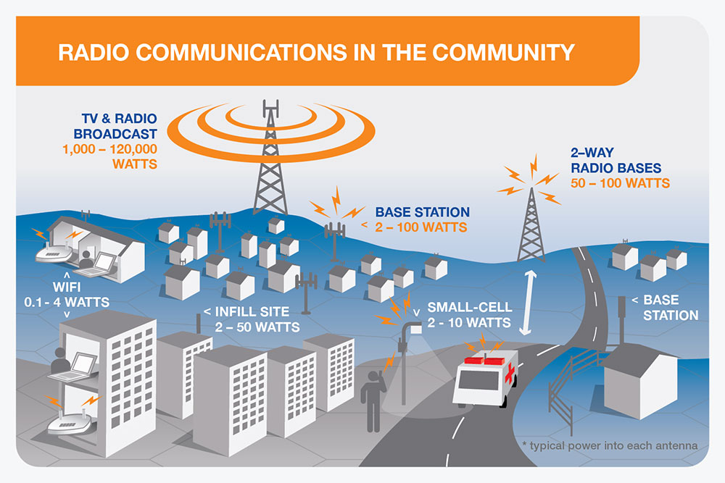

NOTE – Power in watts = transmitter power into the antenna.   
Source: Adapted from EMF Explained, available at <http://www.emfexplained.info/?ID=25186>

Figure 1 – Typical radio and wireless communications in the community

## 2.2 Examples of ICT systems connected by wireless networks

This section describes some of the SSC applications that can be supported by wireless networks.

### 2.2.1 Smart metering and power grids

Smart metering infrastructure of the power grid enables the continuous monitoring of electricity consumption across the grid, so that the loads and distribution can be optimized and save energy. To monitor consumption, the electricity meters are connected to a wireless device at the customer premises, which communicates back to the main network control centre. The electricity network sub- stations may also be connected to the main control centre through a wireless connection. Wireless connections can also be used for other services such as gas or water consumption meters.

Wireless technologies that are used for smart metering include cellular, ZigBee, Wireless M-Bus, WiMax and other mesh radio technologies. Some meters include more than one transmitter. For example, a 900 MHz band transmitter for connection to the monitoring network and a 2.4 GHz transmitter module for connection to wirelessly enabled equipment in the home. Figure 2 shows how data from smart meters can be transferred via a long-term evolution (LTE) wireless network to a server that is accessible by the end consumer over the Internet. This arrangement can provide information on power usage, billing and may facilitate remote access for home automation or to turn-off services such as air-conditioning that is not required. Analysis by Ericsson (2013) of the solution shown in Figure 2 found that there was a net positive effect on greenhouse gas (GHG) emissions at around 1% energy savings in the home (1% corresponds to a savings potential of about 80 kg of CO2e in Australia).

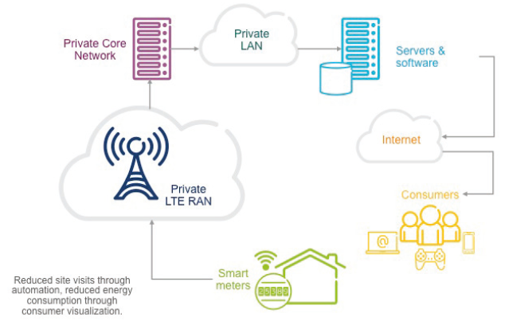

Source Ericsson (2013)

Figure 2 – Smart metering solution using LTE wireless network

### 2.2.2 Remote health care and medical monitoring

Health services and patient care use an extensive range of medical devices and monitoring probes. Within a hospital, dedicated wireless networks inside the buildings and facilities provide the connection for these devices.

Remote monitoring and connection for medical devices is possible in the wider community through the use of public mobile and wireless networks as well as domestic Wi-Fi networks. A newly formed partnership between ITU and WHO constitutes a relevant example of the use of mobile technology to improve non-communicable disease (NCDs) prevention and treatment. Mobile solutions used as part of this initiative are primarily short message service (SMS) or apps based, and will include a range of services such as mAwareness, mTraining, mBehavioural change, mSurveillance, mTreatment, mDisease management and mScreening, among others. This enables significant benefits through extended and remote medical care for broad sectors of the population.

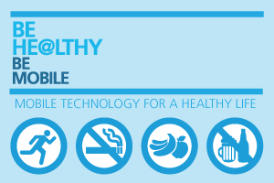

Source: <http://www.itu.int/en/ITU-D/ICT-Applications/eHEALTH/Pages/Be_Healthy.aspx>

Figure 3 – ITU-WHO mobile health for non-communicable disease (NCDs) initiative

### 2.2.3 Smart connected cars

Smart connected cars offer a range of sophisticated technology advances in navigation, security, driver and vehicle safety, servicing and maintenance. Smart cars utilize mobile networks for external connectivity, as well as Wi-Fi and Bluetooth for internal links. The effectiveness of connected cars in a smart city depends largely on the coverage and on the capacity of the supporting mobile networks. Smart navigation, based on global positioning system (GPS) location and central traffic information (such as Waze[2]), save time and greenhouse gas (GHG) emissions. Short-range devices such as transport and traffic telematics (TTT), road tolling, automatic meter reading (AMR), street lamp control and railway applications, are among the technologies that characterize the operation of SSC.

Within this context, Figure 4 illustrates the way in which smart connected cars are interlinked with a series of mobile-based functionalities (for example, temperature management, battery monitoring, technical maintenance, navigation), ultimately contributing to more efficient mobility.

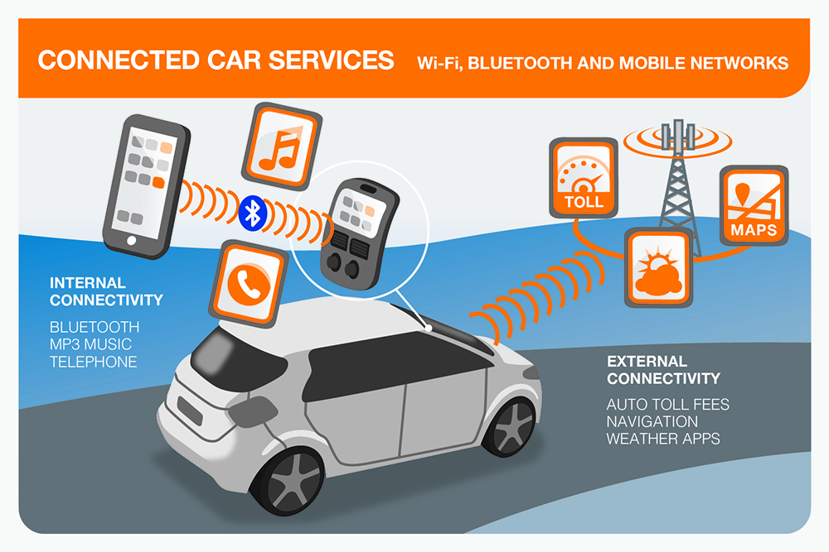

Source: Adapted from ITU (2014): <http://www.itu.int/en/fnc/2014/Documents/S5P3_St%c3%a9phane_Petti.ppt>

Figure 4 – A view of connected car services for a more comfortable and efficient mobility

### 2.2.4 Fleet management

Wireless tracking devices fitted to vehicles can strengthen the efficiency of fleet logistic operations, while reducing energy consumption and GHG emissions. These tracking devices can feed data to centralized fleet management software or to other vehicles in the fleet. In addition to location, they can also be used to remotely monitor loading capacities, enabling vehicle loading optimization. For example, the vehicle’s route can then be adjusted to make use of spare capacity. Further benefits can arise in SSC where wireless devices can be used in applications such as traffic volume monitoring, connected road signs and traffic light synchronization. Such wireless devices are part of the intelligent traffic control (ITC) system. The impact of GHG savings of smart transportation and logistics, and smart grids and smart meters, have been estimated for different regions around the world, as illustrated in Figure 5.

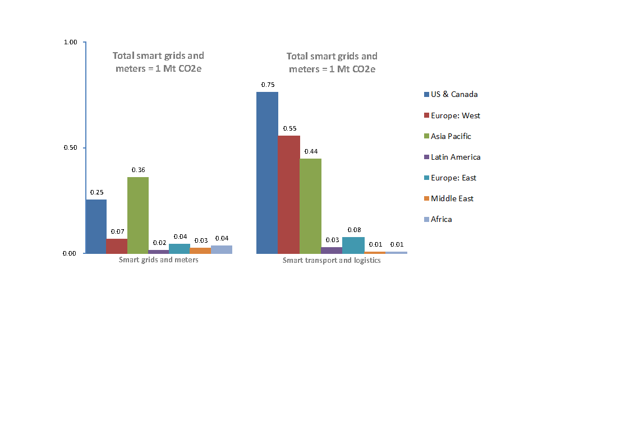

Source: GSMA, Mobile’s Green Manifesto (2012).

Figure 5 – Estimated GHG savings in smart transportation and logistics, and smart grids and smart meters, MtCO2e, 2011

### 2.2.5 Mobile networks connecting ICTs

Mobile networks are increasingly utilized as a core network to connect ICT systems and devices. As they continue to evolve and cater for increased data speeds, capacity, and coverage, these networks become an ideal solution for many ICT applications.

With careful planning, mobile networks can provide cities with very cost effective and efficient connectivity solutions for ICT systems. Increasing deployments of fourth generation (4G) and higher speed technologies, they are being used in the support of multiple ICT solutions, whilst providing mobile services to communities. Figure 6 shows how mobile networks connect both people and things and thereby support SSC applications, for example, smart energy, smart education, and smart health care.

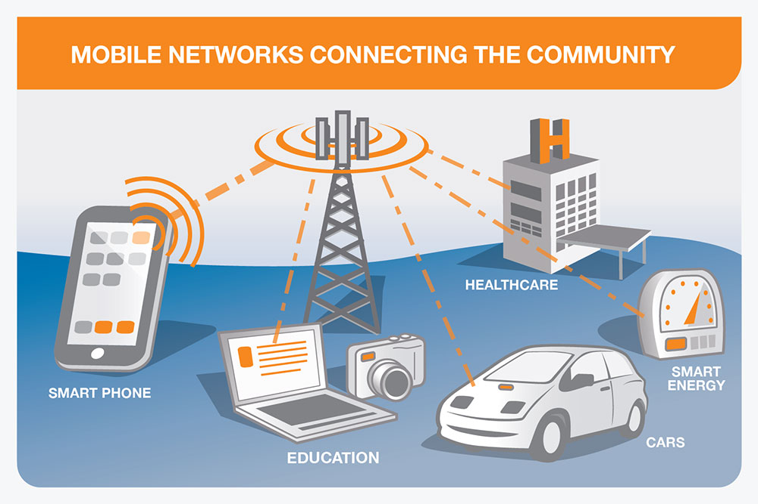

Source: Adapted from GSMA (2013).

Figure 6 – Examples of connected devices and applications through a mobile network

### 2.2.6 Mobile education (mEducation)

Mobile education (mEducation) provides students, teachers, and all stakeholders interested or involved in capacity building with the ability to learn anywhere, and anytime. mEducation makes educational content available over mobile networks to devices such as tablets, smart phones and feature phones. Traditional learning is being transformed by non-traditional mobile technology environments that are beginning to shape the future of education. mEducation represents a powerful shift in the way in which education is delivered and accessed, as well as in the way content is created, adapted and appropriated by the end user. Beyond the supply of new learning mechanisms, mEducation enhances teaching and assessment, and facilitates educational administration and management via mobile technologies that are increasingly available.

Figure 7 provides an example of how mobile devices can increase access to learning opportunities by allowing increased flexibility and diversity in the access to and use of educational programmes.

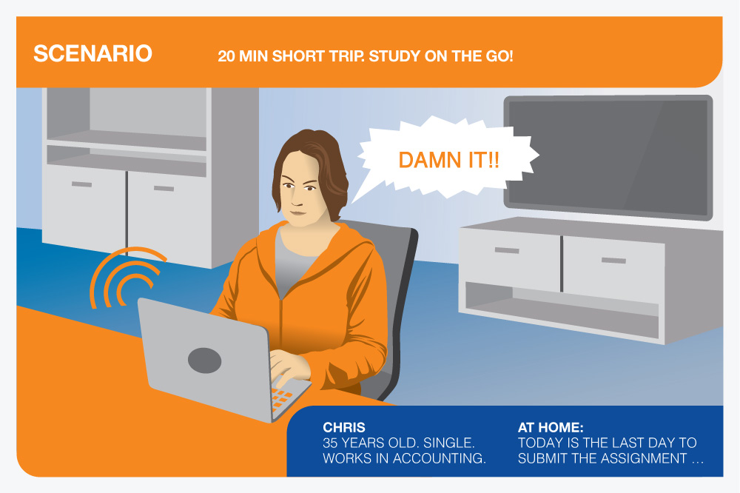

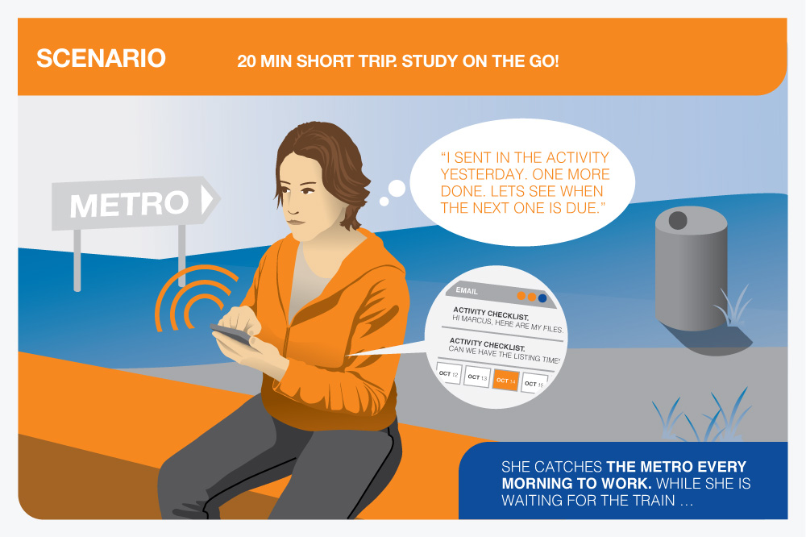

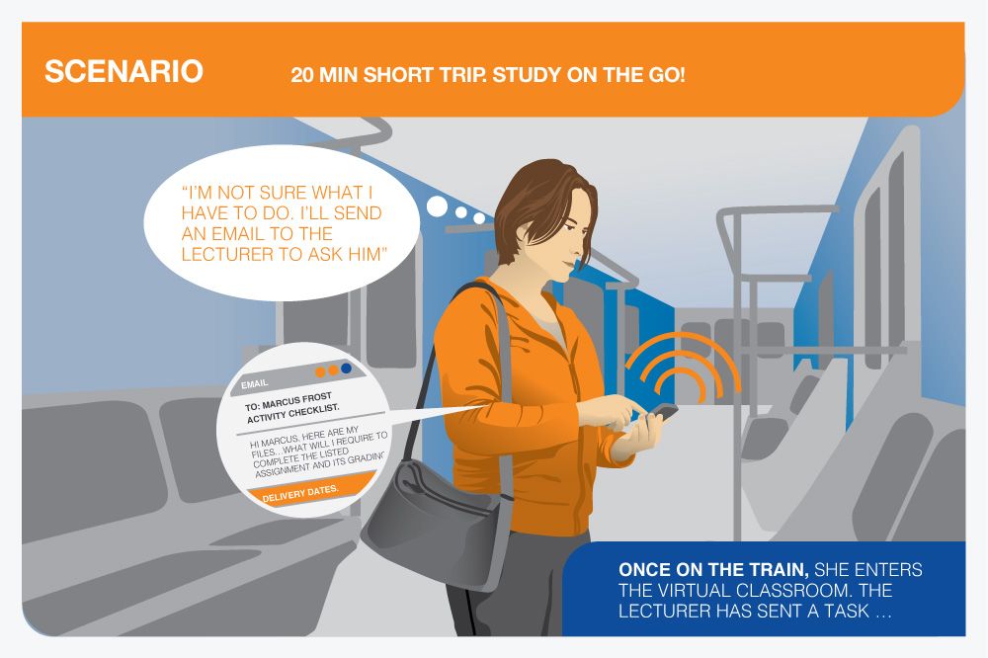



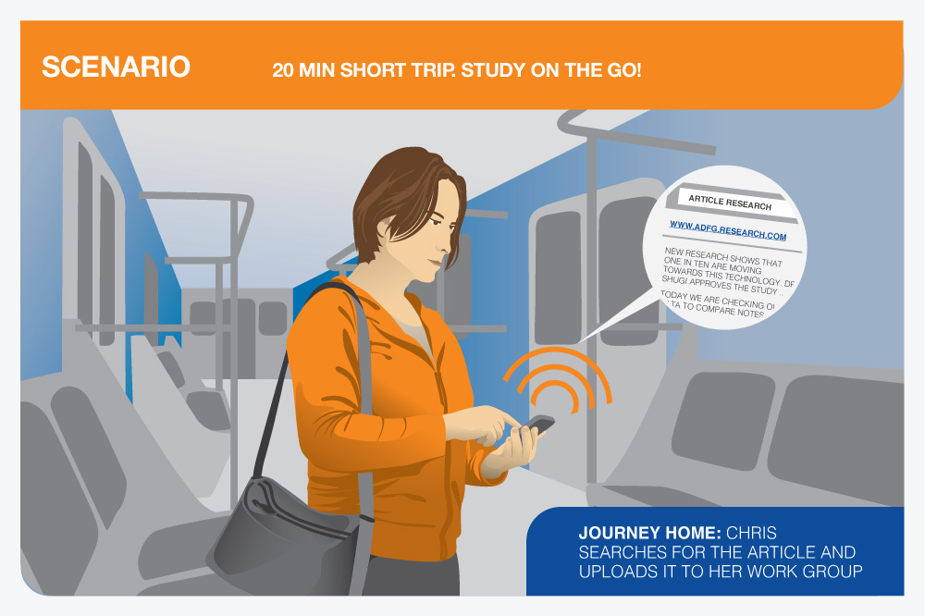



Source: Adapted from GSMA, Orange, Universitat Oberta de Catalunya.  
Case study: University goes portable with tablet technology (2012.)

Figure 7 – Storyboard example of mobile devices increasing access to learning

### 2.2.7 Smart buildings and smart houses

Mobile connectivity can enable emission reductions in buildings by increasing automation and control, for example, in building management systems, heating, ventilation and air conditioning (HVAC) and lighting. Mobile technology can enable users to control building technologies remotely, for example, by adjusting HVAC settings from a mobile device. Mobile machine-to-machine (M2M) devices can be embedded in HVAC, lighting and other appliances across a building, either as the main means of communication with access points or as a back-up facility to short-range M2M communication in the case of critical systems. A recent report by GSMA (2012) suggests that potential reductions in GHG emissions from smart buildings are estimated to be in the range of 30 MtCO2e by 2020.

Short range devices (SRDs) enable smart houses. Technologies such as Z-Wave provide indoor network of remote controls, smart smoke alarms and security sensors. Figure 8 illustrates an example of SRDs enabling an intelligent house by enabling automation and monitoring of temperature, appliances, electricity, and so on.

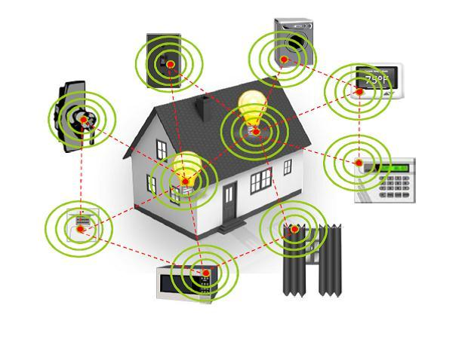

Source: ITU Workshop on Short Range Devices and Ultra Wide Band’, Geneva, 3 June 2014, available at http://www.itu.int/en/ITU-R/study-groups/workshops/RWP1B-SRD-UWB-14/Presentations/International,%20regional%20and%20national%20regulation%20of%20SRDs.pdf

Figure 8 – Short range devices enabling smart and intelligent house

## 2.3 Importance of wireless network connectivity

As the analysis and the examples presented thus far suggest wireless networks provide essential connection of devices in SSC. Without network connection, the devices cannot communicate and operate correctly. The design and location of the antenna sites in a wireless network underpins the entire operation of SSC. The base stations of mobile networks need to be located in close proximity to the devices in order to ensure connection and improved efficiency in their operation. The connected devices operate at low power and have a limited operating distance. The range of the devices usually constitutes the limiting design factor when choosing the physical locations to install base stations.

## 2.4 Wireless technology power and operating range

Table 1 provides a summary of the ICT wireless technologies, including typical peak transmitter powers, equivalent isotropic radiated power (EIRP) and operating distances. The information is relevant to city officials involved in the development of antenna siting policies or the approval of site applications. It illustrates the low powers used by wireless network technologies in comparison to broadcast services.

Table 1 – Summary of the ICT wireless technologies, transmitter powers and operating distances

|  |  |  |  |  |
| --- | --- | --- | --- | --- |
| Technology/Device | Transmitter power | EIRPmax | Operating range | Remarks |
| Short Range Devices | | | | |
| Bluetooth | 0.001 to 0.1 W | 0.1 W | up to 100 m | Typical antenna gain is 0 dBi |
| Smart meter | up to 0.1 W | 0.1 W | up to 100 m |
| Radio frequency identification (RF‑ID) | 0.001 – 1 W | 4 W | up to 500 m | Antenna gain up to 6 dBi |
| Wi-Fi access point | 0.1 – 1 W | 4 W | up to 500 m |
| DECT base station | 0.25 W | 0.25 W | up to 100 m | Typical antenna gain is 0 dBi |
| DECT phone | 0.25 W | 0.25 W | up to 100 m |
| Radiocommunication services | | | | |
| Mobile phone | Up to 0.25 W (time averaged) | 2 W | 1 – 30 km | Antenna gain is 0 dBi |
| WiMAX router | up to 1 W | 1 W | ~5 km | Typical antenna gain is 0 dBi |
| WiMAX network site | 3 W | 100 W | ~35 km | Typical antenna gain is 14 dBi |
| Mobile network base station (small cells) | 1 – 10 W | up to 100 W | 100 m – 1 km | Typical antenna gain is 5 – 10 dBi |
| Mobile network base station (macro site)* | 10 – 80 W | 2,600 W | 1 – 30 km | Additional gain of about 18 dBi and feeder loss of about 3 dB for base station antennas |
| Typical FM radio station transmitter | 1 – 20 kW | 197 kW (ERP=120 kW) | < 100 km | Additional gain of about 13 dBi and feeder losses 2 dB per antenna |
| VHF TV transmitter** | 1 – 30 kW | 328 kW (ERP=200 kW) | < 150 km |
| Typical UHF TV transmitter* | 1-40 kW | 1640 kW (ERP=1000 kW) | < 100 km | Additional gain about 16 dBi |
| UHF DVB-T transmitter | 1 – 5 kW | 246 kW (ERP=150 kW) | < 100 km |
| Typical AM radio station transmitter*** | 50 – 1,200 kW | 3,280 kW (ERP=2000 kW) | >300 km | Additional gain about 4 dBi |

Source: Recommendation ITU-T K.70, Appendix II; Recommendation ITU-R BS.1698-0, section 2.1.5.

* Per carrier.

** Nominal analogue TV transmitter power is peak power.

*** Nominal AM transmitter power is carrier power.

UHF = Ultra High Frequency; VHF = Very High Frequency  
 (see ITU Radio Regulations, Vol. 1, Article 2, 2008).

# 3 EMF and health

Exposure to electromagnetic fields (EMFs) in everyday life is not a recent occurrence. Humans have been exposed to natural EMF throughout their lifetime; however, human sources of EMFs have increased in the past century with the development of technology and radio communications.

The electromagnetic spectrum extends from static electric and magnetic fields, domestic electric power frequencies (50/60 Hz) through radio frequency, infrared, and visible light to gamma-rays (Figure 9).

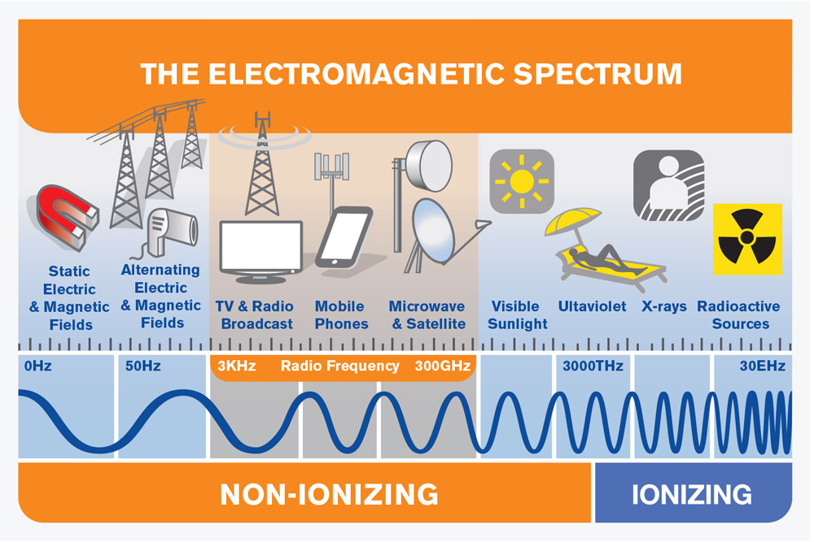

Source: ITU-T, Supplement 1 to Recommendation ITU-T K.91 - Guide on Electromagnetic Fields and Health, 2014.

Figure 9 – The electromagnetic spectrum and typical sources of electromagnetic fields

Radio signals are a form of electromagnetic energy (or electromagnetic radiation (EMR)). Radio signals are non-ionizing, which means that they cannot directly impart enough energy to a molecule to break or change chemical bonds. This is in contrast to ionizing radiation, such as X-rays, which can strip electrons from atoms and molecules, producing changes that can lead to tissue damage and possibly cancer.

It has been known for many years that exposure to sufficiently high levels of radio signals can heat biological tissue and potentially cause tissue damage if the human body cannot cope with the extra heat. Much of the public concern relates to the possibility of health hazards from long-term exposures at levels too low to produce measurable heating.

## 3.1 World Health Organization and EMF

Electromagnetic fields (EMFs) of all frequencies represent one of the most common and fastest growing environmental exposures. As part of its Charter to protect public health and in response to public concern, the World Health Organization (WHO)[3] established the International EMF Project in 1996. The purpose of the EMF Project is to assess the scientific evidence of possible health effects of EMF in the frequency range from 0 to 300 GHz.

Box 1. The World Health Organization (WHO)

The WHO is the directing and coordinating authority for health within the United Nations system. The WHO has responsibility for:

• Providing leadership on global health matters;

• Shaping the health research agenda;

• Setting norms and standards;

• Articulating evidence based policy options;

• Providing technical support to countries; and

• Monitoring and assessing health trends.

Further information about the EMF Project can be found at: <http://www.who.int/emf>

## 3.2 EMF and health summary – World Health Organization

Extensive research has been conducted into the potential health hazards of exposure to many parts of the frequency spectrum, including the RF-EMF used by mobile phones, base stations and other wireless systems and services.

The data emerging from this research has been analysed in more than 150 reports[4] by expert review groups mandated by national or international authorities (Box 2). Weighing the whole body of evidence, there is no evidence to convince experts that exposure below the guidelines set by the International Commission on Non-Ionizing Radiation Protection (ICNIRP)[5] carries any health risks, for adults, pregnant women or children.

WHO[6] states:

*‘Extensive research has been conducted into possible health effects of exposure to many parts of the frequency spectrum including mobile phones and base stations. All reviews conducted so far have indicated that exposures below the limits recommended in the ICNIRP (1998) EMF guidelines, covering the full frequency range from 0-300 GHz, do not produce any known adverse health effect. However, there are gaps in knowledge still needing to be filled before better health risk assessments can be made.’*

Box 2. Recent expert group conclusions on EMF & health

*“...no evidence has been found that exposure to radiofrequency electromagnetic fields has a negative influence on the development and functioning of children’s brains, not even if this exposure is frequent.”*

Health Council of the Netherlands (2011).

*“…it is the opinion of ICNIRP that the scientific literature published since the 1998 guidelines has provided no evidence of any adverse effects below the basic restrictions and does not necessitate an immediate revision of its guidance on limiting exposure to high frequency electromagnetic fields.”*

International Commission on Non-Ionizing Radiation Protection (ICNIRP, 2009).

*“...Recent research on exposure from transmitters has mainly focused on cancer and symptoms, using improved study designs. These new data do not indicate health risks for the general public related to exposure to radiofrequency electromagnetic fields from base stations for mobile telephony, radio and TV transmitters, or wireless local data networks at home or in schools.”*

SSMs Independent Expert Group on Electromagnetic Fields, (Sweden, 2013).

## 3.3 IARC classification for radio frequency fields

The International Agency for Research on Cancer (IARC) is the specialized cancer agency of the World Health Organization. The objective of the IARC is to promote international collaboration in cancer research. The Agency is inter-disciplinary, bringing together skills in epidemiology, laboratory sciences and biostatistics to identify the causes of cancer so that preventive measures may be adopted and the burden of disease and associated suffering reduced.

The IARC Monographs Programme is a core element of the Agency's portfolio of activities, with international expert working groups evaluating the evidence of the carcinogenicity of specific exposures.

In May 2011, 30 scientists from 14 countries met at the IARC[7] in order to assess RF-EMF. This assessment was published as Volume 102 of the IARC Monographs[8]. Based on mixed epidemiological evidence on humans regarding an association between exposure to RF-EMF from wireless phones and head cancers (glioma and acoustic neuroma), RF-EMF fields have been classified by the IARC as possibly carcinogenic to humans (Group 2B). The Group 2B category is used when a causal association is considered credible, but when chance, bias or confounding cannot be ruled out with reasonable confidence.

Following the IARC classification, the WHO[9] issued an updated Fact Sheet in June 2011, stating that: ‘*To date no adverse health effects have been established as being caused by mobile phone use’.* The WHO Fact Sheetnotes that:

*‘While an increased risk of brain tumors is not established, the increasing use of mobile phones and the lack of data for mobile phone use over time periods longer than 15 years warrant further research of mobile phone use and brain cancer risk. In particular, with the recent popularity of mobile phone use among younger people, and therefore a potentially longer lifetime of exposure, WHO has promoted further research on this group. Several studies investigating potential health effects in children and adolescents are underway.’*

The WHO[10] states that studies to date provide no indication that environmental exposure to RF fields, such as from base stations, increases the risk of cancer or any other disease.

Furthermore, WHO[11] Fact Sheet 304 states:

*‘Considering the very low exposure levels and research results collected to date, there is no convincing scientific evidence that the weak signals from RF Base stations and wireless networks cause adverse health effects.’*

Further information on the IARC classification for RF-EMF is available (Supplement 1 to Recommendation ITU-T K.91).

# 4 EMF exposure limits

Scientific research over many decades has enabled national and international health authorities to establish safety limits for exposure to electromagnetic fields. Exposure limits vary depending on the EMF frequency and incorporate conservative safety margins for added protection.

In the following sections, the basis for the international EMF exposure limits is summarized along with information on application of the limits to workers and the general public. The methods used for assessing compliance with EMF exposure standards are introduced and typical compliance zones for mobile communication network antenna are described.

## 4.1 Internationally harmonized EMF limits

The WHO encourages the adoption of exposure limits that provide similar levels of health protection for all people. The International Commission on Non-Ionizing Radiation Protection (ICNIRP) is a non-governmental organization which has official relations with the WHO. The ICNIRP guidelines form the basis of WHO[12] and ITU Recommendations to governments and have been widely adopted around the world.

ITU[13] recommends the exposure limits for EMF developed by ICNIRP where no national limits exist. National EMF exposure limits based on the ICNIRP guidelines provide a global reference, an internationally harmonized approach and a global consistency of exposure protection.

The ICNIRP EMF guidelines cover the frequency range 0-300 GHz which includes the frequency of all wireless ICT systems and devices.

The ICNIRP EMF guidelines are based on a threshold level of exposure above which health effects have been established. A reduction factor is then applied to establish a safe exposure level for workers (occupational exposure, factor of 10) and the general public (factor of 50). The rationale explaining the lower safety factor for the occupational exposure is provided in Annex 2.

The basis of the ICNIRP guidelines at radio frequencies are established effects that are related, in the radio frequency (RF) domain, to temperature rise (i.e., thermal effects). ICNIRP states that non-thermal effects have not been established and their relevance to human health is uncertain. Therefore, ICNIRP states that it is impossible to use reports of such effects as a basis for setting limits on human exposure to these fields.

The reduction factors for the general public and workers, as shown in Figure 10, are designed to account for any scientific uncertainties, variations in the population health and environmental conditions.

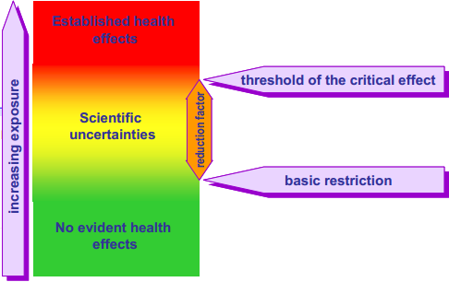

Source: ICNIRP presentation: EMF Safety Guidelines - The ICNIRP View presented at the ITU Workshop on Human Exposure to Electromagnetic Fields, Turin, 9 May 2013 available at <http://emfguide.itu.int/pdfs/ITU-EMF-Workshop-Turin2013-ICNIRP-Matthes.pdf>

Figure 10 – ICNIRP exposure limits and reduction factor

ICNIRP (1998, p.511, Tables 6 and 7; see Annex 2 of this Technical Report) define the exposure thresholds. The basic restriction expressed in watt/kg are the fundamental limits while the reference levels, expressed in V/m, A/m or W/m2, are derived from the basic restrictions and the relationship between exposure to an incident field and the power absorbed by a human body. Annex 2 of this Technical Report provides a summary of the ICNIRP guidelines. Figures 11 and 12 depict ICNIRP reference levels at different frequencies for the electric field (Figure 11) and power density (Figure 12). The limit values are shown for both occupational (solid-red) and general public (dashed-green) exposures (Mazar, forthcoming).

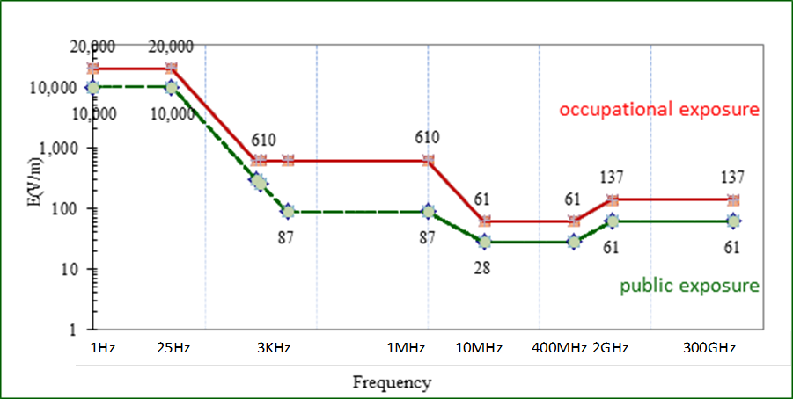

Source: Mazar, ‘International, Regional and National Regulation and Standardisation’ [forthcoming].

Figure 11 – ICNIRP electric field strength reference levels for   
public and occupational exposures

Source: Mazar, ‘International, Regional and National Regulation and Standardisation’ [forthcoming].

Figure 12 – ICNIRP power density reference levels above 10 MHz for public and occupational exposures

## 4.2 EMF safety training

Specialized EMF safety training is very important for workers that need to access areas where the EMF exposure levels exceed the general public limits, for example, on radio towers or on building rooftops with antennas. EMF safety training is also very important for workers that service or work ICT devices and equipment. These programmes can be tailored to suit the level of work and expertise required in each case.

EMF safety training typically covers the following topics:

• Understanding EMF safety limits.

• Identifying ICT equipment and antennas.

• Identifying areas that exceed public exposure limits around antenna installations.

• Working safely on antennas.

• Working safely on transmitters.

• Using EMF safety meters and personal monitors.

The IEEE recommended practice for RF safety programs provides guidance on topics that should be included in RF safety awareness training (IEEE C95.7, 2005).

## 4.3 Compliance assessment standards for wireless networks and devices

Compliance with public or worker (occupational) EMF exposure limits can be assessed through calculation or measurement. Detailed guidance on assessments is provided in technical standards produced by ITU and other international organizations such as the International Electrotechnical Commission (IEC) or the European Committee for Electrotechnical Standardization (CENELEC). Key standards are mentioned in the relevant sections that follow. In some cases, national requirements may be specified based on the international technical standards.

In general, calculation may be used for simpler installations where only one significant RF source is present, or where there are few objects in the nearby environment, for example, calculation of compliance boundaries for antennas on a mobile base station mast. Some sophisticated calculation tools allow for assessments for very complex installations, and can consider the effects of the surrounding environment. Furthermore calculations are the only tool in the case of installations that are in the planning stage or not operating yet. Measurements may be required for complex sites with multiple transmitters or many reflecting objects, for example, a rooftop with many antennas that have overlapping transmission patterns. For some types of low power antennas or devices with integral antennas, the manufacturer may provide the compliance information. This may include position requirements to ensure that the public or workers cannot access areas close to the antenna (Recommendation ITU-T K.61 (2008); IEC 62232 (2011)).

## 4.4 Compliance for wireless networks

In principle, RF-EMF levels decrease when a person moves further away from the source, (for example, a transmitting antenna). For each antenna, the RF exposure level can be calculated based on its emission characteristics, or measured using appropriate methods (Recommendation ITU-T K.61: 2008; IEC 62232, 2011). The distance at which the RF exposure level is always below the RF exposure limit is called the ‘compliance distance’. The compliance distance may be based on a field strength, power density or a specific absorption rate (SAR) evaluation (for example, for small cells, portable devices and tablets). In either case, the compliance distance incorporates a conservative safety margin.

It is also possible to determine a three dimensional (3D) compliance boundary around an antenna. The region inside the compliance boundary is often called the ‘exclusion zone’.

The advantage of defining a compliance boundary is that it specifies the compliance distance in all directions. Base station antennas are usually directional and therefore the RF level behind the antenna is much smaller than in front of it.

## 4.5 Typical antenna compliance zones for workers

The following typical types of antenna are commonly found at a base station or at antenna sites. A photo of the antenna(s) is given to illustrate each antenna as well as a diagram indicating the shape of the compliance boundary (shown in blue) for workers. Please note that while the locations described refer to areas directly in line with the antenna, the exclusion zone/compliance boundary in other directions (e.g. above, below, behind) may, though small (in the range of several centimetres), exist. In addition, the exclusion for the public will be somewhat larger.

|  |  |
| --- | --- |
| **Omnidirectional coverage** |  |
| These antennas radiate RF energy equally in all directions in the horizontal plane. The antenna input power is typically 10 – 80 watts, and the compliance boundary for a worker typically extends 0.1 – 1.5 meters from the antenna. |  |

|  |  |
| --- | --- |
| **Sector coverage** |  |
| These antennas restrict most of their radiated RF energy to a narrow angular sector in their forward direction (typically 60 to 120 degrees in the horizontal plane, typically 8 to 14 degrees in the vertical plane). The photograph shows two sector antennas, one mounted above the other. The antenna input power is typically 10 – 80 watts, and the compliance boundary for a worker extends typically 0.2 – 3 meters from the front face of the antenna.  In the diagram, the compliance zone is shown conservatively as covering the full height of the antenna; however, due to the vertical antenna pattern beam width the exclusion zone boundary may be narrower in the vertical direction.  Where antennas are mounted on the exterior wall of a building, there is typically no compliance zone within the building to the rear of the antenna. |  |

|  |  |
| --- | --- |
| **Complex or shared base stations** |  |
| Antennas are often grouped together on masts. The combination illustrated here is that of an omnidirectional antenna mounted above a cluster of three sector antennas. In the case that multiple antennas are present on a site, whenever an additional antenna is installed, the compliance boundary of each antenna should be evaluated again, taking into account the additional exposure of the newly installed antenna.  In the diagram, the compliance boundaries are shown independently for each antenna. For antennas that are close together or operate at high powers, the zones may overlap leading to large exclusion zones than for the individual antennas. |  |

|  |  |
| --- | --- |
| **Small cells** |  |
| Small cells are low-powered radio access nodes that operate in licensed or unlicensed spectrum that have a range of a few meters up to 1 to 2 kilometres. Small cells can be used to provide in-building or outdoor wireless service. They are often used to increase the network capacity and coverage in localized areas.  As these are low powered devices, compliance distances are very small and may be incorporated within the antenna cover. For some sites, installation recommendations may be provided to ensure compliance with limits. |  |

|  |  |
| --- | --- |
| **Radio relay (also known as fixed point-to-point radio link)** |  |
| Radio relays operate in frequency bands that typically range from 1.4 GHz up to 86 GHz and beyond. The most common antenna type is a parabolic dish antenna characterized by high directivity and low radiation outside the main beam direction. Radio relays generally operate in line of sight and are therefore installed so that the radio path is inaccessible by the general public.  The distance in front of the dish antenna to the EMF exposure compliance boundary can range from centimetres to metres depending on the transmitter power used, antenna dimensions and gain. It is recommended that the compliance distance be assessed either by measurement or calculation as part of the site safety assessment.  If the antenna is accessible, workers should never step in front of the dish up to the EMF exposure boundary to ensure compliance with the safety guidelines, and also because it will interrupt radio link. |  |

Source: Adapted from GSMA and MMF (2008).

Figure 13 – Examples of typical worker compliance zones for a range of antenna installations used for mobile networks

The shape of the compliance boundary in the diagrams above is very simplified and tends to overestimate the likely real exposure levels as it does not take account of the antenna radiation pattern. In practice, simplified or more complex diagrams may be used depending on regulatory or national practice approaches. It is important that the zones are clear to persons who may be using the diagrams.

## 4.6 Compliance for wireless devices

Low power wireless devices include mobile phones, tablets, wireless sensors and supporting infrastructure such as wireless access points. In general, these devices will be designed and tested for compliance by the manufacturer and no further action is required other than follow any installation or usage instructions provided by the manufacturer. The IEC has published technical standards to assess compliance of devices intended for use close to the ear (IEC 62209-1, 2005) and close to the body (IEC 62209-2, 2010). The device manufacturer should provide a copy of the compliance assessment and documentation on request. However, national requirements may differ.

## 4.7 EMF compliance framework

A global EMF compliance framework is important in order to ensure the protection of the public and the workers from the adverse effects of EMF.

At the request of the International Advisory Committee (IAC) to the WHO’s International EMF Project, the WHO has developed a Model Act and a Model Regulation that provide the legal framework to ensure this protection at the national level. An important aspect of this model legislation is that it uses international standards that limit EMF exposure of people (that is the ICNIRP exposure guidelines) and international standards for assessing the emissions of EMF from devices (IEC and IEEE device emission standards).

This Model Legislation follows the widely accepted practice among lawmakers of setting out an enabling Act that permits the responsible Minister or National Regulatory Agency to subsequently issue Regulations, Statutory Orders or Ordinances as appropriate, so as to deal with specific areas of concern. It comprises three main elements:

• A Model Act to enable an Authority to initiate regulations and statutes that limit the exposure of its population to electromagnetic fields in the frequency range from 0 Hz to 300 GHz.

• A Model Regulation which sets out in detail the scope, application, exposure limits and compliance procedures that are permitted under the Act, in order to limit people’s exposure to electromagnetic fields (EMF).

• An Explanatory Memorandum describing the approach to the Act and its Regulations.

The WHO model legislation for EMF is available from the EMF Project website[14].

The WHO advises that if a national authority wants to develop its own exposure limits, it should use or take into account the WHO Framework for Developing EMF Standards.

ITU supports the model legislation as an effective model to regulate EMF exposure, as the harmonized exposure level should be equal to all humans, disregarding race or borders.

## 4.8 Compliance assessment

When a wireless access point or base station is installed, there should be an assessment of compliance with exposure limits. In order to allow for accurate and efficient assessments, different approaches can be implemented depending on the characteristic of the antenna and/or on the installation type. In some specific cases, compliance with relevant exposure limits can be assessed without the need of conducting measurements, for example, where low power is transmitted, or where the position/orientation of the transmitters/antennas makes compliance zones inaccessible to the general public or where simpler calculation methods can be used (Recommendation ITU-T K.52).

Sophisticated calculation tools can be used where sufficient information is available on the transmitter and antenna characteristics, and the surrounding environment. Both broadband and frequency selective equipment can be used for the assessment (Recommendation ITU-T K.61). Measurements conducted with broadband equipment, however, might lead to overly conservative results. If the exposure level in areas accessible to the general public is found to be above the limits by means of broadband measurements, then compliance should be verified with frequency selective equipment. Otherwise, the mitigation techniques described in Recommendation ITU-T K.70 should be applied.

## 4.9 Requirements for low power systems

Some types of wireless network infrastructure operate at very low power, and consequently they have small compliance zones or compliance zones contained within the equipment cover. These may be deployed in many locations as part of SSC infrastructure in order to provide widespread wireless connectivity. With the aim of reducing the administrative burden on city officials and providing an environment that fosters wireless connectivity, SSCs should develop simplified procedures for small, low-power antenna installations. Generally, the important parameters are: (a) the transmitter power, (b) antenna gain, and (c) the position of the antenna. Some small cell installations will produce similar exposures in nearby areas to higher power macrocell sites because the small cells may be positioned at lower heights and closer to people (Cooper *et al.*, 2006).

ITU-T Study Group 5 is developing technical specifications for simplified assessments of low power systems. In terms of guidance, transmitters of less than two watts EIRP do not require an EMF evaluation (Recommendation ITU-T K.52, 2004).

In some countries, low power radio systems may be assessed for compliance as a class of radio transmitters with defined installation (for example, height above public areas) and RF compliance (for example, maximum transmit power) requirements. In such a case, it may be sufficient to provide approval for all equipment of the same type subject to the specified requirement without reviewing individual installations. An example would be installing small cell base stations on street light poles where the equipment operator would be responsible for the details for each particular installation.

## 4.10 Compliance for shared sites

There may be practical or radio coverage reasons for antennas sharing a site. Practical matters may include the availability of existing physical infrastructure, security and power. Radio coverage reasons may include height, proximity to an area where many users are located and avoiding obstructions from other objects and structures.

Where antennas are mounted near to one another, their transmission patterns may overlap to create a larger compliance zone than for the individual antennas. Operators of radio equipment at a shared site may need to exchange information about transmitter and antenna characteristics for RF compliance assessments to be completed.

Authorities and operators should discuss and agree on the framework for ensuring compliance of a shared site, both for the case of a new site that is to be shared, and the case of new equipment additions to an existing site.

# 5 EMF health and safety information

There are many sources available on EMF health and safety information. Understanding what information is available and being able to provide the most appropriate and suitable information to respond to the requirements of particular audiences is crucial.

ITU recommends EMF information from the WHO.

EMF information for consumers should be prepared in a format that is concise and easy to read. There are many sources of information available on the subject and quite often there is a tendency to provide too much information, which can lead to confusion and misunderstanding.

Information should be tailored to suit the specific requirements of the target audience. A layered or scaled approach is often very effective in communicating complex messages. The EMF Explained Series[15] has been developed by the ICT industry using a layered approach. Information on EMF Explained is sourced from national and international health agencies.

## 5.1 Compliance information

In many cases, ICT providers will only need to make available basic safety compliance details for the relevant product. This may consist of a compliance statement or compliance value. Where possible, this information includes a brief explanation of what the compliance value means, as well as a reference for further information.

Some governments require control measurements and publication of the results to show compliance with the RF-EMF. In areas of high social concern about EMF, one solution to these problems can be the control of the electromagnetic emissions by taking measurements and having a proper communication. Measurements turn emissions into something objective and, when presented to the public in an understandable format, help diminish the unawareness and helplessness of the public (Recommendation ITU-T K.83). Other approaches have also been used including operator declarations of compliance, measurements of random sample of sites and post-installation measurements of antennas (Recommendations ITU-T K.52; ITU-T K.61 and ITU-T K.70). Measurements and monitoring of environmental levels of radio signals from mobile and wireless networks consistently find levels that are small fractions of the ICNIRP public exposure limits. The WHO[16] reports that recent surveys have shown that the RF exposures from base stations range from 0.002% to 2% of the levels of international exposure guidelines, depending on a variety of factors such as the proximity to the antenna and the surrounding environment. This is lower or comparable to RF exposures from radio or television broadcast transmitters.

## 5.2 Health and safety information

Where health and safety information on EMF is required, the same principles apply in terms of using a format that is concise and easy to read. It is recommended to reference independent national and international health agencies like the WHO, which offers EMF fact sheets in a number of languages. In many cases, a brief summary on health may also be required and this should always reference or quote the information’s source.

## 5.3 Sources of information

Sources of EMF information include:

Table 2 – Selected sources for information on EMF topics

|  |  |
| --- | --- |
| Information | Source |
| EMF and health | WHO EMF Project - <http://www.who.int/peh-emf/en/>  ICNIRP EMF documents - <http://www.icnirp.org/PubEMF.htm> |
| ITU-T EMF information | ITU-T EMF - <http://www.itu.int/en/ITU-T/emf/Pages/default.aspx> |
| ICT industry information | EMF Explained - [www.emfexplained.info](http://www.emfexplained.info)  SAR Tick - [www.sar-tick.com](http://www.sar-tick.com) |

# 6 Community information, consultation and engagement

While many stakeholders recognize the personal benefits of using ICT tools and mobile services, local officials and the public may have concerns about possible risks emerging from the radio signals used by antenna sites and ICT devices. These concerns may lead to delays in acquiring new antenna sites, to negative media stories and to heightened pressure on policymakers to adopt further restrictions, amongst others. Research conducted for the European Commission suggests the existence of low levels of public awareness in regard to the need for antenna sites, the operation of wireless devices and mobile phones, as well as the regulation and control of radio signals (Eurobarometer, 2010). The following aspects should be considered in order to increase that awareness, and to foster better-informed discussions and citizen engagement in this field.

## 6.1 Guidance on public participation and consultation

Recognizing the importance of effective communication, in 2002 the EMF Project of WHO produced a booklet on risk communication that contains the following definition (WHO, 2002):

*‘RISK COMMUNICATION: An interactive process of exchange of information and opinion among individuals, groups and institutions. It involves multiple messages about the nature of risk and other messages, not strictly about risks, that express concerns, opinions, or reactions to risk messages, or to legal and institutional arrangements for risk management.’*

This definition suggests that risk communication is not only about presentation of scientific information about a given risk, but it also provides a forum for discussion on broader issues of ethical and social concern.

## 6.2 Why is consultation important?

Consultation and dialogue with communities is crucial in order to ensure that people who may have an interest or be affected by the deployment of new ICT technologies and systems are well informed. When a new development or technology appears in a town or local neighbourhood unexpectedly, local stakeholders can oppose it because they may feel offended or threatened by its appearance, or simply excluded from the process that led to its implementation.

If people feel that their personal well-being or that of their family is being negatively affected in some way, their opposition to the new development can turn to anger or frustration with those responsible.

In order to avoid such a situation, effective risk communication emphasizes the need to do the following:

• Build a working relationship with local stakeholders as a trustworthy and reliable party.

• Ensure transparent information management in order to address concerns, reduce public scepticism and make the issues more understandable to the broader public.

• Provide stakeholders with trusted sources of information, and/or foster a dialogue between the parties involved.

• Emphasize the community’s benefits associated with improved mobile communications.

• Find ways of providing people with a sense of involvement in the project, in order to reduce their perception of being powerless.

## 6.3 Risk communication guidance

Risk perception is driven by individualization, dissolution of beliefs, social institutions and practices (Burgess, 2004). The WHO risk communication handbook is intended to support decision-makers faced with public controversy, scientific uncertainty, and the need to operate existing facilities and/or applications for new facilities (WHO, 2002). The handbook’s goal is to improve the decision-making process by reducing misunderstandings and improving trust through better dialogue. When successfully implemented, community dialogue helps to establish a decision-making process that is open, consistent, fair and predictable. It can also help achieve the timely approval of new facilities, while protecting the health and safety of the community.

The mobile industry has also developed guidance on practical risk communication (GSMA and MMF, 2009).

# 7 Wireless ICT network infrastructure

Wireless networks form the backbone of the ICT infrastructure that supports SSC. This section looks at the infrastructure elements of a wireless network in order to improve the understanding of the role played by the differing elements.

Wireless networks utilize various wireless technologies to connect ICT devices to a common platform or core network. In many cases, the ICT devices are connected through a core network to the Internet enabling global access and widespread interconnection.

## 7.1 Mobile network base stations and antennas

Mobile networks rely on a network of base stations that send and receive data from the ICT devices. Base stations need to be located close to users in order to improve efficiency by providing a good quality connection. Mobile devices use adaptive power control, and where the connection is good they will operate on the lowest power level needed to maintain a quality connection. A base station generally consists of an equipment cabinet with transmitters and receivers that are connected to external antennas mounted on a supporting structure. Figure 14 illustrates the distribution of a wireless network infrastructure and antennas in an urban area.

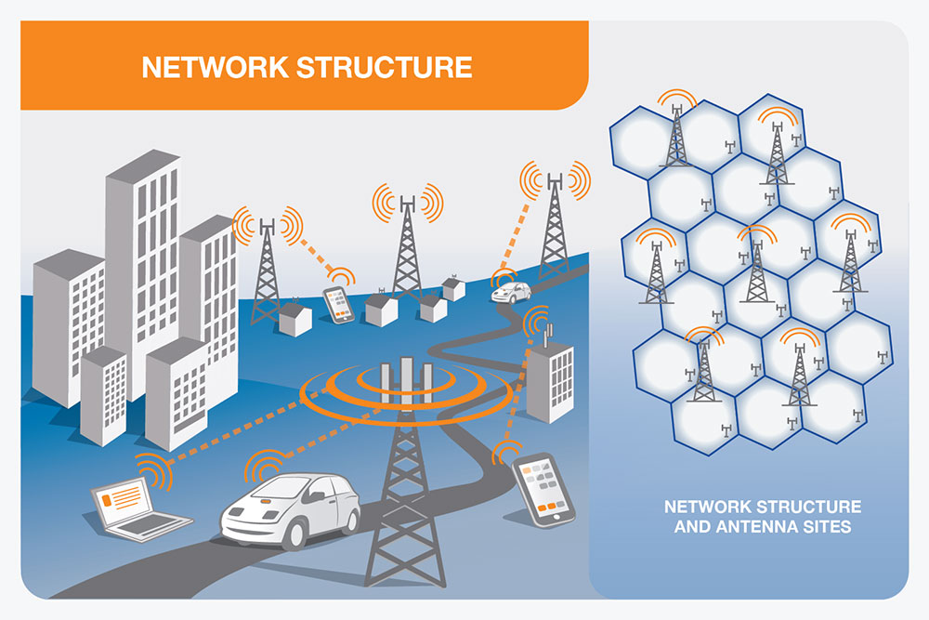

Source: Adapted from <http://www.gsma.com/publicpolicy/mobile-and-health/mobile-networks>

Figure 14 – Example wireless network structure and antenna   
sites distributed across a city

## 7.2 Macro base stations and small cells

Wireless base stations consist of various types of base stations depending primarily on the required coverage and service area. These types are represented in Figures 15 and 16, and explained below.

**Macro base station** – A macro base station utilizes antennas mounted on a tower, pole or building rooftop and typically covers a larger geographic area.

**Small cells** – Small cells are low power base stations or antenna systems installed close to mobile terminal users to improve capacity in a small geographic area. Depending on the transmitted power range, different terms can be used for small cells such as ‘medium range base stations’, ‘local area base stations’ or ‘home area base stations’ (see 3GPP TS 25.104 and TS 36.104). Small cells are sometimes also referred to as micro, picot or feta cells.

**In-building base station** – Small cell systems can be deployed inside buildings such as multi-storey office buildings, shopping centres, apartments, and underground railway systems by installing specially designed ‘in-building’ systems. These systems are sometimes referred to as distributed antenna systems (DAS) or small cell in-building coverage (IBC) and operate in a similar way to macro base stations but at much lower power levels.

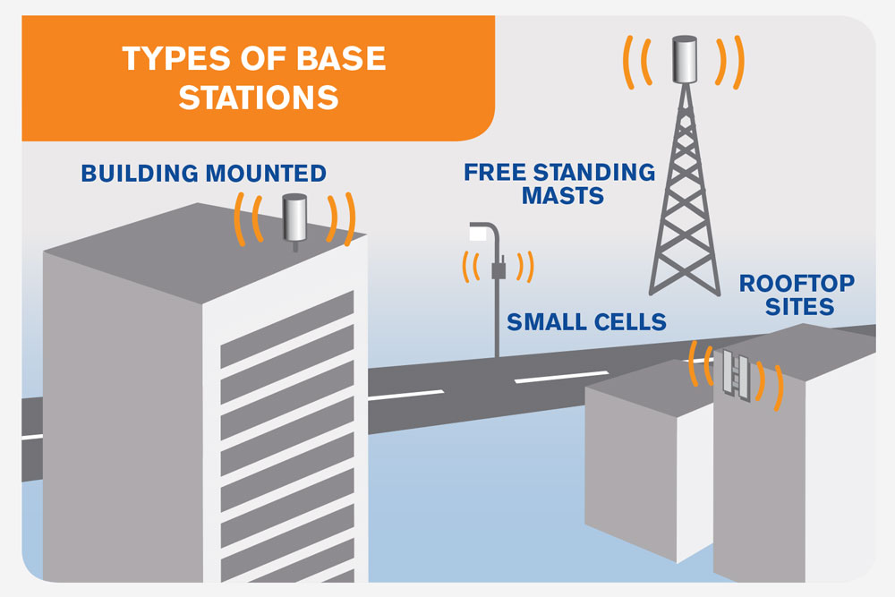

Source: Adapted from <http://www.gsma.com/publicpolicy/new-gsma-animation-and-infographic-highlight-the-importance-of-mobile-networks-in-the-connected-world>

Figure 15 – Small cell on street light and macro base station on building and tower

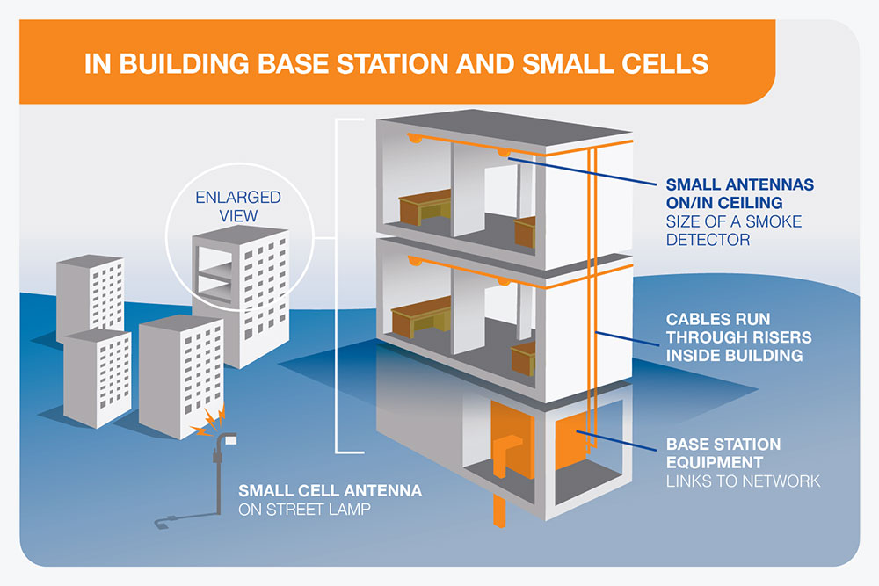

Source: Adapted from Mobile Carriers Forum fact sheet ‘The mobile phone network: In-Building coverage,’ available at <http://www.mcf.amta.org.au/pages/Fact.Sheets>

Figure 16 – In-building small cells or distributed antenna system to provide coverage throughout a building

A dedicated in-building system usually consists of:

• Base station equipment, often located in a facilities’ room or other service area;

• Cables which run from the base station through the building risers connecting the base station equipment to antennas; and

• Small antennas located on the ceilings or walls in strategic locations.

## 7.3 Sharing and co-location

There is an increasing trend for mobile network operators to adopt a variety of infrastructure models. This is being driven mainly by commercial and efficiency considerations, rather than by regulatory mandates. Sharing can also permit the co-location of SSC (for example, emergency communication networks) with the equipment of wireless network operators.

Infrastructure sharing may be passive or active:

1. Passive sharing includes site sharing, where operators use the same physical components but have different site masts, antennas, cabinets and backhaul. A common example is shared rooftop installations. Practical challenges include the availability of space and property rights. A second type of passive sharing is mast sharing, where the antennas of different operators are placed on the same mast or antenna frame, but the radio transmission equipment remains separate.

2. In active sharing, operators may share the radio access network (RAN) or the core network. The RAN sharing case may create operational and architectural challenges. For additional core sharing, operators also share the core functionality, demanding more efforts and alignments from operators. Again there may be issues of compatibility between the technology platforms used by the operators.

The different approaches to infrastructure sharing are illustrated in Figure 17.

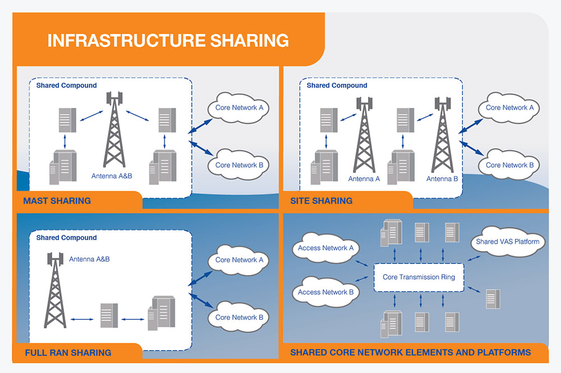

Source: Adapted from GSMA, Mobile Infrastructure Sharing, (2008).

Figure 17 – Main types of infrastructure sharing

Infrastructure sharing has the potential to (GSMA, 2008):

• Lead to faster and wider roll-out of coverage into new and currently underserved geographical areas.

• – Reduce the number of antenna sites.

• Reduce the energy and carbon footprint of mobile networks.

• Reduce the environmental impact of mobile infrastructure on landscape.

• Reduce costs for operators.

• Optimize the use of the RF spectrum and increase data speeds through active sharing of the frequencies.

In some cases, site sharing increases competition by giving operators access to key sites necessary to compete on quality of service and coverage, thus sharing improves roaming. Governments may also consider positive incentives to roll out into underserved areas.

In both passive and active sharing, it is necessary to consider the possible effects on RF exposure levels and compliance boundaries. As discussed in section 7.2, antennas that are close together or operating at higher powers may have overlapping compliance zones leading to a combined zone that is larger than the individual antenna zones. Antennas that are shared by more than one operator may have higher combined transmitter powers.

Nearby residents may think that a higher number of antennas in the surrounding areas will lead to higher exposure levels at the ground level in publicly accessible areas. Measurements undertaken in Germany demonstrated that neither distance to the antenna nor the number of visible antennas were accurate indicators of RF exposure. Instead, the orientation of the antenna’s main lobe constitutes the main factor influencing exposure (Bornkessel *et al.*, 2007).

## 7.4 Location of antennas and access restrictions

Wireless communication antennas should be positioned so that locations where the public exposure limits may be exceeded are not reasonably accessible to the general public. This can be achieved by selecting the location of the antenna or by the use of barriers to restrict access.

Low power antenna installations and wireless access points have no or limited positioning requirements. In addition, simple guidance may be provided by the operator or equipment manufacturer.

Higher power antennas are generally mounted above head height (sometimes on a short antenna mounting pole) or on the outer surface of buildings where it is not possible for the public to access areas in front of the antennas. Such antennas have directive antenna patterns that substantially decrease the exposure to directions above the horizon and to the ground near the antenna tower. When locating antennas, an assessment of the size of the EMF compliance zone should be conducted to determine whether the compliance zones could reach adjacent buildings. This could require a change in antenna position or reduction in transmitter power in order to ensure compliance with the EMF limits (Recommendation ITU-T K.70, 2007).

A number of options are available when considering the use of physical barriers to restrict access, namely:

• Rooftop access controls: This may include a locked ladder or rooftop door with permission required and information available for persons requiring access to the rooftop.

• Physical barriers: Non-metallic screens, fences or chains can be used to indicate areas that should not be entered by members of the public.

In some cases, painted lines may also be used to indicate compliance boundaries. However, their effectiveness depends on the awareness that exists among the persons that may access the area.

The building owner is often provided with information on how to arrange access for persons, such as maintenance personnel, who may need to work in areas close to or in front of the antennas.

## 7.5 Signage

In general, signage requirements should be appropriate for the technical parameters of the wireless equipment/antenna and the accessibility of the site.

Low power installations where the compliance zone is within the equipment will generally not require signage.

For other installations, signs should be placed near the compliance zone boundaries. The IEEE Recommended Practice for Radio Frequency Safety Programs, 3 kHz to 300 GHz, provides guidance on the installation of signs (C95.7-2005). Depending on the region, RF-EMF safety signs may require multiple languages to ensure understanding. Some examples of signs and where they may be used are provided in Table 3.

Table 3 – Guidance on use of RF warnings signs

(Adapted from (C95.7-2005) and (C95.2-1999))

|  |  |  |  |
| --- | --- | --- | --- |
| Sign | Guidance on use | Example - Australia | Example - USA |
| Notice | Used to alert persons to the potential of exposures exceeding the reference levels for the public.  Note: In some countries, these signs are called Notices or Caution Signs |  |  |
| Caution | Used to alert persons to the possibility of exposures exceeding the reference levels for workers.  Note: In some countries, these signs are called Caution Signs or Warning Signs |  |  |
| Warning | Used to advise persons of potential exposures that may exceed the reference levels for workers by a factor of 10 (the safety factor in the (ICNIRP, 1998) guidelines.  Note: Not used in all countries. | Not used in Australia |  |
| Danger | Normally only used for situations in which immediate and serious injury will occur such as in the case of RF burns and/or RF electrical shocks. |  |  |

Other signage, such as advertising, should not generally be attached to wireless network antennas unless it is part of the integration of the antennas with the visual environment (see section 9.6). Other general requirements for signage can be found in the European Directives 2013/35/EU and 92/58/EEC.

# 8 ICT wireless technologies

Wireless technologies used by ICT systems include cellular and mobile technologies, Wi-Fi, WiMax, Bluetooth, DECT, ZigBee and Wireless M-Bus.

This section provides a summary of some of the wireless technologies used by the ICT systems.

## 8.1 Mobile network technologies – 3G and 4G

4G LTE (Long-term evolution) is the latest major enhancement to mobile radio communications networks. LTE is a standard that is part of the evolution of 3G, which incorporates significantly increased data rates (for the same transmitted power) and better performance to enhance the mobile broadband experience. It should be noted that this improved level of service can be achieved without increasing the output power of the transmitters. The functioning of 3G and 4G technology is illustrated in Figure 18.

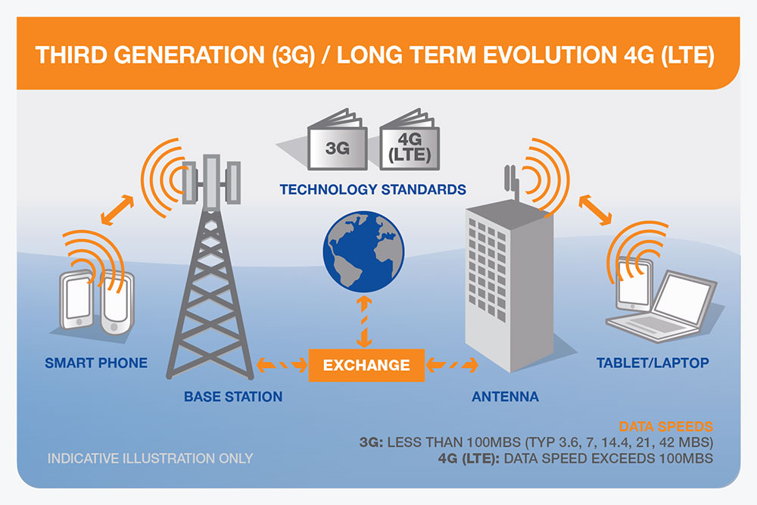

Source: Adapted from EMF Explained, available at <http://www.emfexplained.info/?Page=25196>

Figure 18 – 3G and 4G technology

## 8.2 WiMAX

The worldwide interoperability for microwave access (WiMAX) is a telecommunications technology aimed at providing wireless data over long distances in a variety of ways. Products are based on the Institute of Electrical and Electronics Engineers (IEEE) 802.16 standards. WiMAX provides an alternative Internet wireless access technology to broadband cables and digital subscriber lines (DSL). WiMAX networks enable a variety of options for broadband connections, essentially constituting a larger version of a Wi-Fi network (Figure 19).

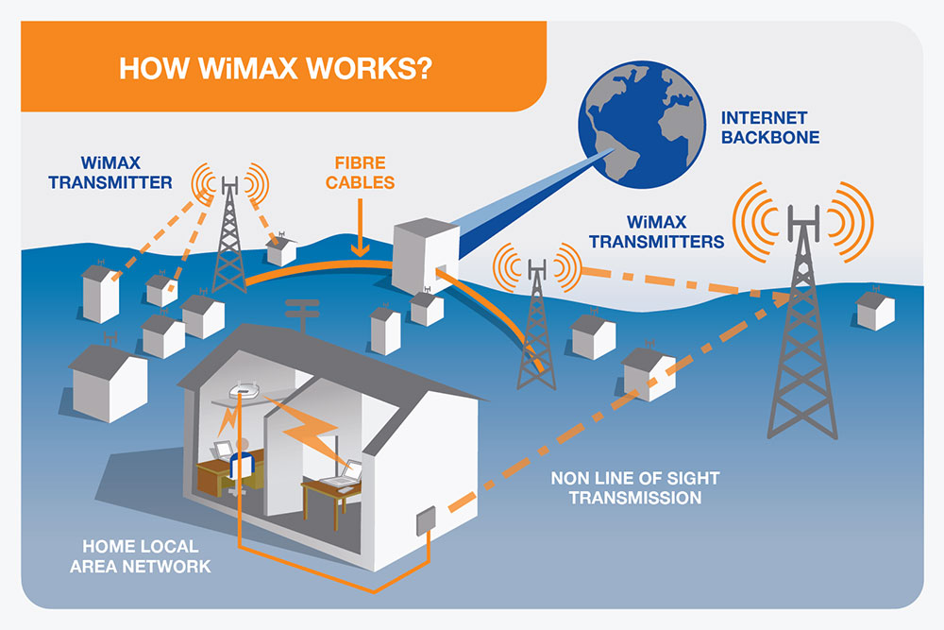

Source: Adapted from EMF Explained, available at <http://www.emfexplained.info/?ID=25133>

Figure 19 – Illustration of a WiMAX network

## 8.3 Wi-Fi

Wi-Fi is the term used to describe high speed wireless network connections over short distances between mobile computing devices such as laptops and the Internet (Figure 20). These are sometimes termed wireless local area networks (WLANs) and refer to products that are based on the Institute of Electrical and Electronics Engineers (IEEE) 802.11 standards.

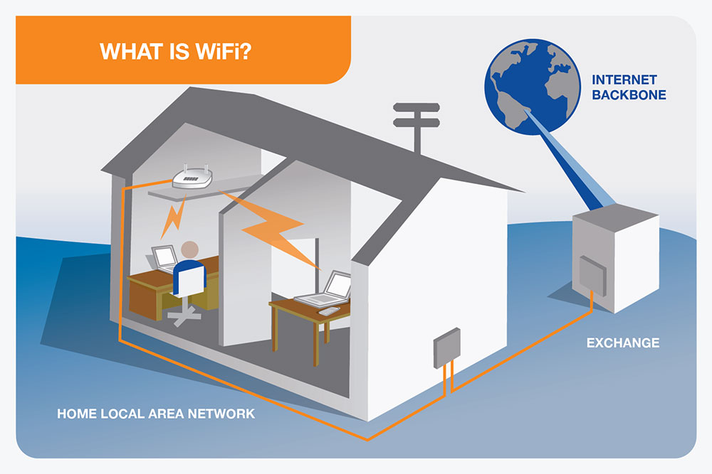

Source: Adapted from EMF Explained, available at <http://www.emfexplained.info/?Page=24788>

Figure 20 – Illustration of a Wi-Fi modem connected to laptops in a home

## 8.4 Mobile backhaul and radio relays

A critical aspect to selecting new sites for ICT base stations is the availability of a connection back to the core or main network. This is often referred to as ‘backhaul’ or ‘transmission’. As the demand for data intensive mobile services such as video increases, the capacity of the backhaul data connection will also need to grow. The capacity needed per base station site will differ substantially, depending on target data rates and population density. Ericsson (2014) forecasts that in 2019, high capacity base stations are expected (in the more advanced mobile broadband networks) to require backhaul in the 1 Gbit/s range, whereas low capacity base stations are expected to require back-haul in the 100 Mbit/s range.

Microwave and optical fibre are major transmission media technologies and are the best suited to meeting these capacity requirements. Optical fibre transmission will increase its share of the mobile backhaul market and it is projected to connect more than 40% of base stations by 2019. Today, microwave dominates the market for transmission technologies for mobile backhaul worldwide, connecting 60% of all base stations.

Some distributed and short-range wireless technologies (for example, Wi-Fi, Bluetooth, Wireless M-Bus and Zig-bee) may be able to operate with lower speed backhaul, such as x-type digital subscriber line (xDSL) (or even slower means), in the case of applications that do not require high data rates.

An existing building in a community is more likely to have a network connection at the building or in a very close proximity, compared to establishing a new site. In this last case, the backhaul would need to be designed and constructed as a separate project and in many cases may prove not to be feasible, for example, on the top of a mountain or a hill.

## 8.5 Bluetooth

Bluetooth wireless technology is a short-range radio technology that uses radio frequency fields to transmit signals over short distances between telephones, computers and other devices. The technology offers simplified communication and synchronization between devices without the need for cables. An illustration of these connections is provided in Figure 21.

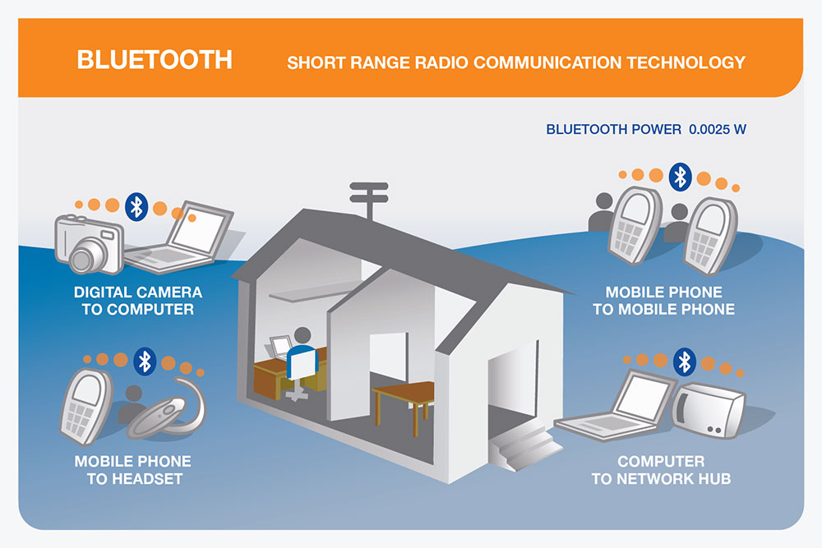

Source: Adapted from EMF Explained, available at <http://www.emfexplained.info/?Page=25530>

Figure 21 – Illustration of Bluetooth connections

## 8.6 DECT

DECT stands for digital enhanced cordless telecommunication. DECT is a common standard for digital cordless telephones and consists of a radio technology suited for voice, data and networking applications in residential, corporate and public environments (Figure 22). Many cordless phones used in residential homes use DECT technology.

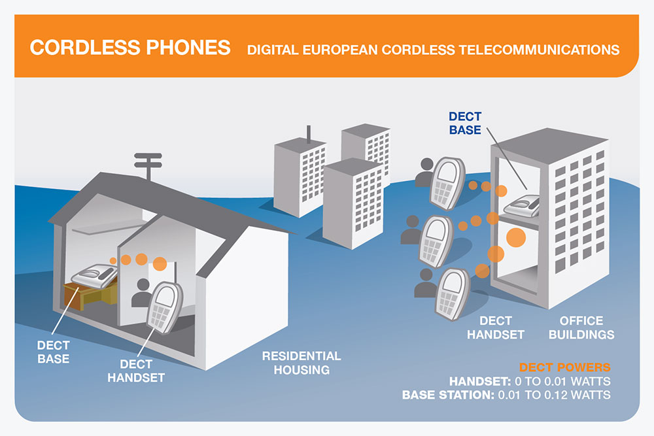

Source: Adapted from EMF Explained, available at <http://www.emfexplained.info/?Page=25533>

Figure 22 – DECT cordless phone systems in homes and office buildings

# 9 ICT antenna siting approval requirements

Public wireless communications and ICT systems are critical national infrastructure for today’s society and their role is particularly evident in the event of emergencies and disasters. Consistent planning rules for ICT infrastructure are critical for the efficient deployment and operation of ICT systems. Fragmented planning authority rules may delay network deployments and may lead to ICT systems not functioning properly and/or providing intermittent service, which in some cases (for example, medical cases) may be life threatening.

## 9.1 Antenna permit procedures

Standardized antenna permit procedures will reduce the administrative burden on both authorities and operators of wireless infrastructure. It is helpful if the procedures are harmonized nationally, considering that wireless infrastructure is deployed at the local level to provide national and international connectivity.

RF exposure limits and compliance procedures should be adopted nationally based on international human exposure recommendations and technical compliance standards. National policy for wireless infrastructure should contain a statement to the effect that compliance with RF-EMF exposure limits is sufficient to address concerns about possible health hazards.

SSC should avoid policies such as restrictive RF exposure limits or planning exclusion zones that increase public concern and that can negatively impact deployment.

Siting rules should also take into account the physical characteristics of the wireless network equipment. Generally, the requirements needed to obtain approvals increase according to the size of the proposed base station. Under these rules, small installations such as small cells or other small antenna installations on existing physical infrastructure may require no local authority approvals, while macro base stations may be subject to the full planning process.

The radiocommunication companies must avoid the installation of base stations without having fulfilled the requirements set by the relevant authorities (at the national, provincial and municipal levels).

At the same time, procedures should be developed in consultation with the operators of wireless infrastructure.

The following sections provide further guidance on these matters based on international good practices.

### 9.1.1 Small cells

The wireless infrastructure for SSC will increasingly rely on small cell installations for wireless services. This may take the form of Internet access via Wi-Fi or mobile communication systems. Small cell systems can provide higher data rates or coverage in areas that are difficult to reach by macro cell solutions, for example, shopping centres, train stations and sporting stadiums.

Recommendation ITU-T K.100 has developed criteria for the EMF compliance assessment of base stations including small cells. It is expected that small cells transmitting below a specified power will be deemed to comply with RF exposure limits without the need for further assessment.

### 9.1.2 Information requirements

The information requirements should focus on providing the information needed to strengthen decision-making processes. Examples of topics that may be included are:

a) a proposed location of the wireless infrastructure;

b) a written description of the proposed work;

c) a statement of compliance with RF-EMF exposure limits;

d) a confirmation of the agreement reached, in principle, with the landlord of the proposed location;

e) a statement identifying if the site is designed to use simplified procedures based on low-power, small-size, modification to existing site, or other factors as defined in national rules; and

f) a statement that the authority may obtain further information on the proposed wireless infrastructure, including contact details of the information provider.

In particular locations, such as heritage areas, additional design information may be required to evaluate the application.

### 9.1.3 Notification and consultation requirements

There may be differing levels of stakeholder interest in wireless antenna siting proposals due to the characteristics of the wireless infrastructure or the proximity to community facilities. Notification, consultation and dialogue requirements should be standardized for effective communication with the stakeholders.

– **Notification** for the majority of sites may be limited to the landowner, the local authority, affected public utilities and others as required by national regulations. It is helpful if the notification can be standardized nationally both within and between network operators as this is less confusing to potential landlords and local authorities. Notification by poster or letter might be an appropriate means in some locations. Notification constitutes a form of basic information provision, a one-way communication approach.

– **Consultation** might be sensible for locations with the potential for public opposition, such as community facilities, locations with high amenity value or for sites with potentially high perceived impact. This could mean a longer period of notification, allowing time to resolve any issues with landowners and neighbours through more careful design, location choice and potential flexibility in the implementation. Consultation by letter, telephone or through meetings could be appropriate in locations where some opposition is expected either regarding planning and environmental issues or due to community concerns. Consultation constitutes a two-way information exchange between the operator and the key stakeholders.

– **Dialogue** might be necessary for environmentally sensitive areas or locations with complex concerns such as schools or hospitals or locations where protests have previously taken place. Prior discussions can be undertaken with landowners, neighbours, local authorities and other stakeholders in order to develop agreements in advance of full deployment. This will require a longer lead time in order to reduce or remove potential delays to deployment. Dialogue should be considered for sites where a high level of community concern is anticipated or where they could potentially escalate. This is a planned communication process aimed at building trust and avoiding large-scale public events and media campaigns. Dialogue constitutes a multiple exchange of information between governments, operators and a broad set of interested stakeholders.

### 9.1.4 Modifications to existing sites

Planning regulations should encourage the use of existing base station facilities for network upgrades, modifications and deployment of additional ICT systems where feasible by providing for faster decision-making and simplified procedures. Modifications to existing sites need to ensure that the site remains compliant with EMF exposure limits.

Simplified procedures for physical modifications should also be considered. In the USA, section 6409(a) of the Middle Class Tax Relief and Job Creation Act of 2012 provides that the State or local government “may not deny, and shall approve” any application for collocation, removal, or modification of equipment on wireless tower or base station that does not substantially change the physical dimensions of a tower or base station. The Federal Communications Commission (FCC) has previously defined “substantial increase in size” in the Nationwide Collocation Agreement, 47 C.F.R. Part 1, Appendix B, as follows:

• Increase in tower height by more than 10% or height of additional antenna array plus 20 feet (approximately 6 m), whichever is greater;

• More than four new equipment cabinets or one new shelter;

• Protrusion of more than 20 feet (approximately 6 m) or width of tower, whichever is greater;

• Excavation outside existing leased or owned property and current easements.

As another example, New Zealand provides for simplified procedures where a replacement pole does not have a diameter greater than 50% of the original structure and height increase the lesser of three metres or 10% (Ministry of the Environment, 2009). Other jurisdictions have similar provisions for modifications to existing sites. An overview of base station planning requirements in Europe may be found on the GSMA website[17].

### 9.1.5 Decision periods

The procedures for antenna permits should specify the timelines in place for decisions to be made. These should generally be similar to those for other similar types of physical infrastructure.

Some countries have adopted specific decision periods for wireless network antenna site proposals. In a ruling known as the ‘shot-clock’ rule, the USA FCC specifies that decisions must be made within 90 days for co-location requests at an existing site and within 150 days for new sites. In case of delays, the antenna operator can seek legal review. For some developments in England and Wales (for example, ground based masts below 15 m and some rooftop developments), the authority must make a decision within 56 days. If no decision is made, the operator can proceed on the basis that the lack of response is a consent.

In no case should operators install antennas without meeting prior specific approval procedures of the corresponding national, regional or municipal authority, as this will increase public concerns in regards to antenna installations.

### 9.1.6 Independent appeals process

In some cases, members of the community or the antenna operator may not be satisfied with the authority’s decision. A clear process should be defined for appeals to an independent authority as well as the grounds to appeal. It is important for all parties that the decision-making process is fair, transparent and free from political influence. In some countries, judicial review of local authority decisions is possible. In other countries, there are separate environment courts or the appeal may be made to a relevant ministry.

In Australia, New Zealand, the UK, and the USA courts have generally concluded that compliance with national RF-EMF limits is sufficient to address health concerns (Dolan *et al*., 2009).

## 9.2 Environmental impact assessment

This Technical Report limits the discussion of the environmental impact assessment to matters related to the siting of the wireless network infrastructure. This section is based largely on the New Zealand Ministry of the Environment’s ‘National Environmental Standards for Telecommunication Facilities: Users’ Guide’ (Ministry of the Environment, 2009). This is a binding regulation and replaces certain rules in district plans and by-laws that affect the activities of telecommunications operators. Every local authority and consent authority in New Zealand must observe national environmental standards and must enforce the observance of national environmental standards to the extent their powers enable them to do so.

Environmental impact assessment for telecommunication facilities may include:

• assessment of compliance with national RF-EMF exposure limits in areas that are reasonably accessible to the public;

• consideration of protection of vegetation, and historic, amenity and coastal areas;

• procedures for change of antennas and modifications to existing utility structures;

• restrictions on the size and location of telecommunication cabinets;

• compliance with noise limits for telecommunication cabinets, air conditioning equipment and diesel generators;

• consideration of visual effects of proposed wireless network equipment.

Wireless network equipment generally presents a low environmental impact, and therefore requirements in this area should be proportionate and reasonable.

## 9.3 Schools, hospitals and similar community facilities

It is recognized that there may be community concerns or specific requirements for siting of wireless infrastructure near specific facilities.

In regard to schools, hospitals, elderly care and similar facilities, Recommendation ITU-T K.91( 2012) states that with respect to human exposure there are currently no technical requirements for any special consideration for locating base stations close to areas such as hospitals and schools. This is due to the fact that existing exposure guidelines incorporate safety margins in the exposure limits which are applicable to all locations. It also notes that good reception will result in lower transmitting power for customer devices and, therefore, in lower exposure to the end user.

In the case of hospitals, there may be electromagnetic compatibility (EMC) questions related to hospital equipment and wireless network infrastructure. ISO/TR 21730 (2007) provides guidance on the use of mobile wireless communication and computing technology in health care facilities including recommendations for electromagnetic compatibility with medical devices.

This guidance states the following:

*‘RF emissions from in-building system network antennas (WAN microcells or repeaters, LAN access points) are most appropriately managed by locating them in a place where separation distance mitigates medical device EMI effects, such as the roof of corridors and rooms.*

*RF emissions from base station sites physically located on healthcare facility roof-top or building structures should conform to existing national radio regulations to limit emissions directly into the supporting building structure.’* (p. 14)

Most studies of interference have used mobile phones and other wireless equipment close to pacemakers or other medical devices (Calcagnini *et al*., 2011; Iskra *et al*., 2007; Morrissey, 2004; Tang *et al*., 2009; van der Togt *et al*., 2008). They have generally reported no interference at separations greater than 1 to 2 m between the phone and the medical device. The separation is in the order of 15-20 cm for mobile phones and pacemakers. As indoor wireless networks typically operate on similar powers to mobile phones, provided the antenna installation is ceiling or wall mounted, interference is unlikely to occur.

Provided that the potential EMC issues are addressed, there is no reason to restrict the siting of the antennas. In addition, measurements reported for femtocells indicate that mobile devices will operate at lower power levels thereby reducing the risk of interference and resulting in lower exposure from mobile devices (Boursianis *et al*., 2012; Zarikoff *et al*., 2013).

## 9.4 Access to public buildings and land

With the rapid growth and expansion of ICT systems, wireless networks need to maintain coverage and service in order to meet community and service demand.

The use of existing public buildings, infrastructure and land to locate wireless network base stations can provide an ideal solution to finding new suitable locations particularly in well-established communities and residential areas where the ICT systems are required. This approach could also help to protect open spaces. The Broadband Deployment on Federal Property Working Group[18] was established in June 2012 by the United States President in order to develop and implement a strategy to facilitate the timely and efficient deployment of broadband facilities on Federal lands, buildings, and rights of way, federally assisted highways, and tribal lands. Countries like Mexico have launched similar initiatives.

## 9.5 Planning exclusion zones

In the context of wireless communications, infrastructure deployment planning-based exclusion zones (also known as ‘Buffer Zones’ or ‘Cordon Sanitaires’) are geographic areas generally imposed by some local governments and their agencies around community facilities where a base station cannot be established. These areas are generally distance-based and are applied without regard for the nature, or operation of radio base stations, or existing sources of RF-EMF exposure in the environment.

Typically, exclusion zones are imposed by some government policymakers in residential areas around community facilities such as primary and secondary schools, pre-schools or medical facilities including hospitals. However, there is no science-based rationale for their introduction, the specified facilities or the zone size (NRPB, 2004).

As the availability of mobile networks can contribute to save lives (for example, in the case of accidents, disasters, etc.), exclusion zones should be minimized (Chapman *et al*., 1998; Wu *et al*., 2012). A policy of planning-based exclusion zones has the potential to impact significantly upon the siting and deployment of wireless communications infrastructure. In turn, this impacts the delivery of quality wireless services (including mobile broadband) to consumers that increasingly rely upon these services. Operators usually have to increase the transmit power in nearby base stations to fulfil the service requirements.

A case study, based on the city of Melbourne, Australia, explored the effects of implementing a hypothetical 500 m exclusion zone policy around community facilities (schools, pre-schools and medical facilities) to a large urban area (Evans Planning, 2012). The study found that across the full metropolitan area, 54.1% of all existing radio base stations would be impacted. For an inner urban suburb, an exclusion zone of 500 m around all community facilities would cover 87.5% of the total geographic area of the suburb, affecting virtually all of the existing antenna sites.

Overall, the existence of multiple negative consequences suggests that distance-based planning exclusion zones are not an effective response to community concerns related to wireless infrastructure siting. SSC should not apply unscientific planning exclusion zones affecting wireless network infrastructure.

Some countries, such as Israel, prohibit or restrict the siting of base stations in nature reserves in order to preserve the aesthetics of the natural environment and avoid disruption due to construction activities. In the United Kingdom, a joint accord between National Parks England and the Mobile Operators Association was signed in July 2014. The accord aims to help communities living in national parks to benefit from consistent high quality connectivity and protect the special qualities of the National Parks by minimizing any adverse environmental impacts.

There are no indications that specific siting requirements are needed for wireless network equipment sited near petrol stations.

## 9.6 Visual integration with the environment

Similar to all forms of development, wireless network equipment may have a visual effect. This visual effect can be attributed to two unavoidable characteristics of wireless network equipment:

a) They are structures which generally protrude from other structures; and

b) They need to be located at suitable heights in order to operate effectively.

These characteristics mean that wireless network equipment may be, and often is, highly visible in both urban and rural landscapes. The visual effect of wireless network equipment may be addressed by:

a) Undertaking a detailed assessment of the landscape in which the wireless network equipment is to be located; and

b) Designing the facility to respond appropriately to this landscape setting.

In this way, the wireless network equipment can be designed in a manner that is compatible with the particular landscape setting. The higher the level of compatibility of the wireless network equipment design with the landscape, the less significant or intrusive the visual effect will be. Understanding the contextual setting is paramount to developing a design response that is both appropriate and compatible.

Whilst reducing the visual effect is a very important objective, other factors may have a substantial bearing on the final outcome. It should be recognized that not all wireless network equipment will be able to achieve the best visual outcome. Some of the issues which often need to be considered in parallel with visual integration include:

• availability and suitability of land;

• any reasonable requirements of the landlord;

• radio frequency performance;

• impact on other facilities located at the same site;

• noise – usually from air conditioners and/or diesel generators;

• access for maintenance purposes;

• installation time frames and availability of materials;

• construction issues – structural and loading feasibility;

• cost;

• compliance with relevant and applicable national RF exposure standards; and

• co-location and site sharing opportunities.

Key principles for design and siting with improved visual integration include:

• colour relative to surroundings;

• texture relative to existing materials;

• form in regard to height, shape and position;

• bulk and scale relative to the local environment;

• design in harmony with the surroundings;

• ability to integrate with existing wireless network equipment;

• local landmarks, cultural or historical centres, viewpoints; and

• use of surrounding vegetation for screening ground level equipment shelters.

It should be noted that in some cases efforts to reduce the visual effect of the wireless network equipment have been criticized as a form of concealment of potential health risks. Therefore, dialogue and openness should be ensured from the early stages of the process in order to address these concerns.

## 9.7 Environmental impact assessment

This Technical Report limits the discussion of the environmental impact assessment to matters related to the siting of wireless network infrastructure. This section is based largely on the New Zealand Ministry of the Environment’s ‘National Environmental Standards for Telecommunication Facilities: Users’ Guide’ (Ministry of the Environment, 2009). This is a binding regulation and replaces certain rules in district plans and bylaws that affect the activities of telecommunications operators. Every local authority and consent authority in New Zealand must observe national environmental standards and must enforce the observance of national environmental standards to the extent their powers enable them to do so.

Environmental impact assessment for telecommunication facilities may include:

• assessment of compliance with national RF-EMF exposure limits in areas that are reasonably accessible to the public;

• consideration for the protection of vegetation, and historic, amenity and coastal areas;

• procedures for change of antennas and modifications to existing utility structures;

• restrictions on the size and location of telecommunication cabinets;

• compliance with noise limits for telecommunication cabinets, air conditioning equipment and diesel generators;

• consideration of visual effects of proposed wireless network equipment.

Wireless network equipment generally presents a low environmental impact, and therefore requirements in this area should be proportionate and reasonable.

# 10 Conclusions

Wireless and wired networks provide the underlying connections that underpin smart sustainable cities. Efficient deployment of wireless infrastructure will reduce the transmitted RF power in providing services and support greater efficiency for ICTs.

The design and deployment of wireless networks must also ensure compliance with the required quality of service as well as with standards and regulations on human exposure to radio frequency (RF) electromagnetic fields.

Wireless and wired access technologies are used to support SSC applications such as smart meters, remote health care, and smart transportation and education. Availability of connectivity is essential to the operation of these services which in turn deliver environmental benefits, improved quality of life and reductions in operating costs.

A range of different wireless technologies are used to support the ICT applications of SSC. The choice of a particular technology is influenced by factors such as range and data rate requirements. Short range wireless technologies include Bluetooth; medium range includes Wi-Fi; and longer range includes mobile technologies such as 2G, 3G and LTE. Each technology will have its own specific requirements in relation to the siting of wireless network infrastructure. However, in all cases shorter operating distances allow for lower powers for both the wireless network and the SSC application.

In some cases, the public may be concerned about possible health risks from exposures to the radio signals. It is important that SSC policies for EMF exposures follow the science-based recommendations of WHO and ITU. International EMF exposure guidelines have been developed by ICNIRP to protect all persons from all established health risks. It is recommended that national governments base their EMF exposure limits on the ICNIRP exposure guidelines and that SSC adopt the same requirements. Operators and manufacturers of wireless technologies should ensure compliance with these limit values. ITU and IEC have developed technical standards that can be used for compliance assessments through calculations or measurements. The compliance assessment policies should follow the ITU-T Recommendations.

SSC should adopt standardized antenna permit procedures as this will reduce the administrative burden on both authorities and operators of wireless infrastructure. These permitting procedures should be harmonized nationally to the largest extent possible and specify decision periods, information requirements and include simplified procedures for matters such as installation of small cells and modifications to existing sites. SSC can also promote an efficient deployment by providing access to government building and lands. SSC should avoid policies, such as restrictive RF exposure limits or planning exclusion zones, that increase public concern and that can negatively impact deployment. In regard to community facilities, Recommendation ITU K.91 (2012) states that with respect to human exposure there are currently no technical requirements for any special consideration when locating base stations close to areas such as hospitals and schools.

Siting rules should take into account the physical characteristics of the wireless network equipment. In general, the requirements needed to obtain approvals increase according to the size of the proposed radio base station. Physical installations of wireless equipment should consider the surrounding environment and aim for visual integration. Whilst reducing the visual effect is a very important objective, other factors may have a substantial bearing on the final outcome. Higher data rate applications may require backhaul data connections by optical fibres, whereas in other cases radio links may be sufficient. In all cases, power and access for maintenance are critical considerations in wireless equipment siting. The position of antennas should also take into account the orientation and size of EMF compliance zones. Appropriate signage can be used to inform persons accessing areas near to antennas of safe working procedures.

SSC officials, ICT industry and other stakeholders should base communications on reliable sources such as the ITU and WHO publications. Good risk communication practice and community engagement can reduce public concerns about EMF. Specific groups, such as workers that service or work with wireless ICT devices and equipment, may require EMF safety training.

Having acknowledged the importance of good practices in the deployment of wireless ICT technologies and services for the efficient operation of SSC the ‘Smart Sustainability City EMF Check-list’ (Annex 1) has been developed as a guide for policy and decision-makers. It is recommended that city officials and planners apply the ‘Smart Sustainability City EMF Check-list’ to ensure that SSC wireless ICT operates efficiently, and in compliance with EMF exposure standards.

Bibliography

3 GPP TS 25.104

3 GP TS 36 104

Bornkessel, C., Schubert, M., Wuschek, M., and Schmidt, P. (2007), *Determination of the General Public Exposure around GSM and UMTS Base Stations,* Radiation Protection Dosimetry, Vol. 124, No. 1, 1 March, pp. 40-47.

Boursianis, A., Vanias, P., and Samaras, T. (2012), *Measurements for Assessing the Exposure from 3G Femtocells, Radiation Protection Dosimetry*, Vol. 150, No. 2, June, pp. 158-167.

Burgess A. (2004), *Cellular Phones, Public Fears and a Culture of Precaution*, Cambridge:Cambridge University Press.

Calcagnini *et al*., *Electromagnetic Compatibility of WLAN Adapters with Life-Supporting Medical* *Devices* (2011), Health Physics, 100 (5): May, 497-501,

Chapman, S., and Schofield, W.N. (1998), *Lifesavers and Samaritans: Emergency Use of Cellular (Mobile) Phones in Australia, Accident Analysis & Prevention*, Vol. 30, No. 6, November, pp. 815-819.

Cooper, T.G., Mann, S.M., Khalid, M., and Blackwell, R.P. (2006), *Public Exposure to* *Radio Waves near GSM Microcell and Picocell Base Stations*, Journal of Radiological Protection, Vol. 26, No. 2, June, pp. 199-211.

Council Directive 92/58/EEC of 24 June 1992 on the minimum requirements for the provision of safety and/or health signs at work (ninth individual Directive within the meaning of Article 16 (1) of Directive 89/391/EEC).

Directive 2013/35/EU of the European Parliament and of the Council of 26 June 2013 on the minimum health and safety requirements regarding the exposure of workers to the risks arising from physical agents (electromagnetic fields) (20th individual Directive within the meaning of Article 16(1) of Directive 89/391/EEC) and repealing Directive 2004/40/EC.

Dolan, M., and Rowley, J. (2009), *The Precautionary Principle in the Context of* *Mobile Phone and Base Station Radiofrequency Exposures*, Environmental Health Perspectives, Vol. 117, No. 9, September, pp. 1329-1332.

EMF Explained. Available at <http://www.emfexplained.info/>.

Ericsson: Smart Metering in Australia, 2013. Available at <http://www.ericsson.com/res/thecompany/docs/corporate-responsibility/2012/smart-metering.pdf> .

Ericsson: Mobility Report, June 2014. Available at <http://www.ericsson.com>/.

Eurobarometer 2010 Special Eurobarometer 347: Electromagnetic Fields, Conducted by TNS Opinion & Social at the request of the Directorate General for Health and Consumer Affairs. Survey coordinated by Directorate General Communication.

EVANS PLANNING, MANIDIS ROBERTS, PICONET CONSULTING: Impact of exclusion zone policies on siting base stations: Australian case study analysis, GSMA, August 2012.

GSMA, Mobile Infrastructure Sharing, 2008. Available at <http://www.gsma.com/publicpolicy/public-policy-resources/mobiles-green-manifesto>

GSMA: Mobile’s Green Manifesto, 2012.

GSMA and MMF: RF safety at base station sites, 2008, available at <http://www.gsma.com/publicpolicy/gsma-joint-brochure-rf-safety-at-base-station-sites> .

GSMA and MMF: Risk Communication Guide for Mobile Phones and Base Stations, 2009, available at <http://www.gsma.com/publicpolicy/mobile-and-health/risk-communications>.

GSMA, Orange, Universitat Oberta de Catalunya, Case study: University goes portable with tablet technology, (2012).

Health Council of the Netherlands: GSM Base Stations, The Hague, Publication no. 2000/16E, 2000.

Health Council of the Netherlands: Influence of radiofrequency telecommunication signals on children’s brains. The Hague: Health Council of the Netherlands, 2011; publication no. 2011/20E.

ICNIRP 1998, Guidelines for Limiting Exposure to Time-Varying Electric, Magnetic, and Electromagnetic Fields (up to 300 GHz)’, ICNIRP guidelines, Health Physics, Vol.74, pp. 494-522.

ICNIRP Statement on the ‘Guidelines for limiting exposure to time-varying electric, magnetic, and electromagnetic fields (up to 300 GHz)’, ICNIRP, Health Physics, 97(3):257-258, September 2009.

IEC 62209-1 ed1.0 (2005), *Human exposure to radio frequency fields from hand-held and body-mounted wireless communication devices - Human models, instrumentation, and procedures - Part 1: Procedure to determine the specific absorption rate (SAR) for hand-held devices used in close proximity to the ear (frequency range of 300 MHz to 3 GHz)*.

IEC 62209-2 ed1.0 (2010), *Human exposure to radio frequency fields from hand-held and body-mounted wireless communication devices - Human models, instrumentation, and procedures - Part 2: Procedure to determine the specific absorption rate (SAR) for wireless communication devices used in close proximity to the human body (frequency range of 30 MHz to 6 GHz)*.

IEC 62232 ed1.0 (2011), *Determination of RF field strength and SAR in the vicinity of radiocommunication base stations for the purpose of evaluating human exposure*.

IEEE C95.2-1999, IEEE Standard for Radio-Frequency Energy and Current-Flow Symbols.

IEEE C95.7-2005, IEEE Recommended Practice for Radio Frequency Safety Programs, 3 kHz to 300 GHz.

ISO/TR 21730:2007, *Health informatics -- Use of mobile wireless communication and computing technology in healthcare facilities -- Recommendations for electromagnetic compatibility (management of unintentional electromagnetic interference) with medical devices*.

ITU Workshop on Short Range Devices and Ultra Wide Band’ Geneva, 3 June 2014. Accessed at http://www.itu.int/en/ITU-R/study-groups/workshops/RWP1B-SRD-UWB-14/Presentations/International, regional and national regulation of SRDs.pdf.

ITU-D, 2014, Report on Question 23/1, Strategies and Policies Concerning Human Exposure to Electromagnetic Fields. <http://www.itu.int/dms_pub/itu-d/opb/stg/D-STG-SG01.23-2014-PDF-E.pdf>

ITU-T Supplement 1 to Recommendation ITU-T K.91 (2014), Guide on electromagnetic fields and health.

Iskra *et al*. (2007), *Potential GPRS 900/180-MHz and WCDMA 1900-MHz Interference to Medical* *Devices*, IEEE Transactions on Biomedical Engineering, 54(10):1 October, 858-1866.

Joyner, K.H., Van Wyk, M.J., and Rowley, J.T. (2014), *National Surveys of* *Radiofrequency Field Strengths from Radio Base Stations in Africa*, Radiation Protection Dosimetry, Vol. 158, No. 3, February, pp. 251-262, accessed at <http://rpd.oxfordjournals.org/content/158/3/251>.

Mazar, H., *Radio Spectrum Management: Policies, Regulations, Standards and Techniques*, West Sussex: John Wiley & Sons, forthcoming.

Ministry for the Environment (2009), *National Environmental Standards for Telecommunication* *Facilities: Users’ Guide*, Wellington.

Mobile Carriers Forum (2001), *Guidelines for Better Visual Outcomes Low-impact Mobile Facilities*.

Mobile Carriers Forum (August 2007), Mobile Network Base Station Deployment Technical Paper.

Morrissey, *Mobile Phones in the Hospital: Improved Mobile Communication and Mitigation of EMI Concerns Can Lead to an Overall Benefit to Healthcare* (2004), Health Physics, 87(1): July, 82-88.

NRPB (2004), *Mobile Phones and Health 2004*: Report by the Board of NRPB, Vol. 15, No. 5 available from <http://www.hpa.org.uk>/.

Recommendation ITU-R BS.1698-0 (2005), *Evaluating fields from terrestrial broadcasting transmitting systems operating in any frequency band for assessing exposure to* *non-ionizing radiation*. <http://www.itu.int/rec/R-REC-BS.1698/en>

Recommendation ITU-T K.52 (2004), *Guidance on complying with limits for human exposure to electromagnetic fields*.

Recommendation ITU-T K.61 (2008), *Guidance on measurement and numerical prediction of electromagnetic fields for compliance with human exposure limits for telecommunication* *installations*.

Recommendation ITU-T K.70 (2007), *Mitigation techniques to limit human exposure to EMFs in the vicinity of radiocommunication stations*.

Recommendation ITU-T K.83 (2011), *Monitoring of electromagnetic field levels*.

Recommendation ITU-T K.91 (2012), *Guidance for assessment, evaluation and monitoring of human exposure to radio frequency electromagnetic fields*.

Recommendation ITU-T K.100 (2014), *Measurement of radio frequency electromagnetic fields to determine compliance with human exposure limits when a base station is put into service*.

Rowley, J.T., and Joyner, K.H. (2012), *Comparative International Analysis of Radiofrequency* *Exposure Surveys of Mobile Communication Radio Base Stations*, Journal of Exposure Science and Environmental Epidemiology, Vol. 22, No. 3, May/June, pp. 304-315, accessed at <http://www.ncbi.nlm.nih.gov/pmc/articles/PMC3347802>/.

Swedish Radiation Safety Authority (Strålsäkerhetsmyndigheten, SSM). Eighth report from SSM’s Scientific Council on Electromagnetic Fields. March 2013.

Tang *et al*. (2009), *Electromagnetic Interference Immunity Testing of Medical Equipment to Second- and Third-Generation Mobile Phones*, IEEE Transactions on Electromagnetic Compatibility, 51(3, Part 2): August, 659-664.

Valberg, P.A., Van Deventer, T.E., and Repacholi, M.H. (2007), *Base Stations and Wireless* *Networks – Radiofrequency (RF) Exposures and Health Consequences*, Environmental Health Perspectives, Vol. 115, No. 3, March, pp. 416–424.

Van Der Togt *et al*. (2008), *Electromagnetic Interference From Radio Frequency Identification Inducing Potentially Hazardous Incidents in Critical Care Medical Equipment*, JAMA, 299(24): 25 June, 2884‑2890.

World Health Organization (2002), *Establishing a Dialogue on Risks from Electromagnetic Fields* available at <http://www.who.int/peh-emf/publications/risk_hand/en/>.

World Health Organization, *Electromagnetic fields and public health: Base stations and wireless* *technologies*, Backgrounder, May 2006 available at <http://www.who.int/peh-emf/publications/facts/fs304/en>/.

Wu, O., Briggs, A., Kemp, T., Gray, A., Macintyre, K., Rowley, J., and Willett, K. (2012), *Mobile Phone Use for Contacting Emergency Services in Life-Threatening Circumstances*, The Journal of Emergency Medicine, Vol. 52, No. 3,March, pp. 291‑298.e3.

Zarikoff, B., Malone, D. (2013), *A Comparison of RF Exposure in Macro- and Femtocells*, Health Physics, Vol. 105, No. 1, July, pp. 39-48.

Annex 1  
  
Smart sustainable city - EMF check-list

The ‘Smart Sustainable City EMF Check-list’ is designed to provide an easy to use reference for city officials and planners in order to ensure that smart city ICT designs using wireless systems operate efficiently and in compliance with EMF exposure standards.

The following check-list[19] identifies the key elements for EMF compliance and wireless network deployment efficiency.

|  |  |  |
| --- | --- | --- |
| No. | Smart sustainable city - EMF check-list | Check |
| 1 | **EMF compliance framework**  Ensure that an EMF compliance framework is established to protect the general public and workers from the adverse effects of EMF. | □ |
| 2 | **ICT devices meet ICNIRP RF-EMF exposure guidelines**  Ensure that devices are assessed for compliance with the public exposure guidelines. | □ |
| 3 | **Wireless networks meet ICNIRP RF-EMF exposure guidelines**  Ensure that the network sites are assessed for compliance to the ICNIRP guidelines, and that access controls and safety procedures are in place for working at antenna sites. | □ |
| 4 | **Document RF-EMF compliance**  Ensure that the EMF compliance for ICT devices and networks is documented. | □ |
| 5 | **Base station antennas are selected to suit the ICT network requirements**  Ensure that the appropriate base station antennas are used to improve ICT efficiency, provide services and integrate with the environment. | □ |
| 6 | **Wireless network antennas are located in close proximity to the ICT devices**  Ensure that network and base station antennas are located where the ICT devices are being used. | □ |
| 7 | **Planning legislation incorporates ICT networks and antenna requirements**  Ensure more efficient deployment of ICT systems through a consistent approach to planning approval. | □ |
| 8 | **EMF ICT compliance information is available**  Ensure that EMF compliance information is available to the public and other interested stakeholders. | □ |
| 9 | **General EMF information is available to the community**  Ensure that the references for EMF information are the WHO and ITU resources. | □ |
| 10 | **Existence of wireless network information programme**  Ensure availability of information about the operation of wireless networks based on credible sources and using appropriate communication channels addressing compliance, health concerns and siting. | □ |

Annex 2  
  
Summary of ICNIRP guidelines

In 1998, the International Commission on Non-Ionizing Radiation Protection (ICNIRP)[20] published their guidelines on limiting exposure to EMF, to protect against all known adverse health effects. This publication resulted from a thorough review of the scientific literature and assessed all health risks to both the general public and workers. The exposure limits have incorporated large safety factors to allow for uncertainties in the sensitivities of people to EMF and in the scientific studies.

Basic restrictions

In the frequency range from 10 MHz to 10 GHz, that includes the frequencies used for mobile and wireless communications, the RF exposure limits (basic restrictions) are expressed as SAR values, see Table 4. The specific absorption rate (SAR) is the rate at which RF energy is absorbed in body tissues and is expressed in units of W/kg.

Table 4 – ICNIRP basic restrictions applicable to wireless services 10 MHz to 10 GHz

|  |  |  |  |  |
| --- | --- | --- | --- | --- |
| Type of exposure | Frequency | Whole body average SAR (W/kg) | Localised SAR (head and trunk) (W/kg) | Localised SAR  (limbs) (W/kg) |
| Occupational worker | 10 MHz -10 GHz | 0.4 | 10 | 20 |
| General public | 10 MHz -10 GHz | 0.08 | 2 | 4 |
|  |  |  |  |

For frequencies from 10 GHz to 300 GHz, the ICNIRP basic restrictions are given in terms of power density, see Table 5.

Table 5 – ICNIRP basic restrictions applicable to wireless services between 10 GHz and 300 GHz

|  |  |
| --- | --- |
| Type of exposure | Equivalent plane wave  power density (W/m2) |
| Occupational exposure | 50 |
| General public | 10 |

Reference levels

The ‘basic restrictions’ are the actual limits based on the mechanism by which the RF fields affect tissues. For practical assessments, ICNIRP also provides the equivalent frequency dependent "reference levels", expressed as electric field (V/m), magnetic field (A/m) and power density (W/m2), so that RF measurement equipment can be used to determine compliance, see Table 6. While the reference levels can be used to show compliance with SAR limits, exceeding the reference levels does not necessarily mean the SAR limit has been exceeded. In this case, further tests would need to be conducted to determine whether the basic restriction (SAR) has been exceeded.

Table 6 – ICNIRP basic restrictions applicable to wireless services above 10 MHz

|  |  |  |  |  |
| --- | --- | --- | --- | --- |
| Type of exposure | Frequency | E-field strength (V/m) | H-field strength  (A/m) | Equivalent plane wave power density Seq  (W/m2) |
| Occupational/worker | 10-400 MHz | 61 | 0.16 | - |
| 400-2000 MHz | 3f1/2 | 0.008f1/2 | f/40 |
| 2-300 GHz | 137 | 0.36 | 50 |
| General public | 10-400 MHz | 28 | 0.073 | - |
| 400-2000 MHz | 1.375f1/2 | 0.0037f1/2 | f/200 |
|  | 2-300 GHz | 61 | 0.16 | 10 |

NOTE – Where f is as indicated in the frequency column.

WHO has promoted the adoption of ICNIRP guidelines by national authorities because ICNIRP is a formally recognized non-governmental organization of WHO that works closely with WHO on all areas of non-ionizing radiation protection. In addition, ICNIRP uses the WHO's health risk assessments for developing their guidelines. ITU also encourages Member States to adopt the ICNIRP guidelines.

Exposure limits for RF workers are higher than for the general public because workers are adults who are normally exposed under controlled conditions, are trained to be aware of any potential risks and to take the appropriate precautions. The public comprises people with widely different ages, from babies to the elderly, who should not be expected to take any precautions to avoid RF exposures. Thus the public exposure limits incorporate very large safety factors; they are 50 times below the RF exposure level at which the first health effects are seen. By contrast, the occupational exposure limits are 10 times lower.

Annex 3  
  
Summary of typical exposure levels

Typical exposures from mobile communication systems and other similar uses of radio signals are summarized in Table 7 based on the results of a WHO workshop (Valberg *et al*., 2007).

Table 7 – Typical maximum exposures for a range of wireless services

|  |  |  |
| --- | --- | --- |
| Service | ICNIRP reference level | Typical maximum exposure |
| Average urban, base stations | 41 to 61 V/m | 0.1–0.3 V/m |
| Average urban, TV and radio | 28 V/m | 0.4–0.7 V/m |
| Wi-Fi access point (20 cm) | 61 V/m | 3.9 V/m |
| DECT cordless phone (20 cm) | 58 to 61 V/m | 11.5 V/m |
| Baby monitors (20 cm) | 28 to 61 V/m | 8.5 V/m |

Wireless technologies are based on international regulations and technical standards. There is little variation in the level of exposure between countries as shown in analyses of base station measurement surveys conducted internationally (Rowley *et al*., 2012) and in developing regions such as Africa (Joyner *et al*., 2014). The global average reported from 173,000 measurement points from 23 countries conducted from the year 2000 onwards was 0.073 μW/cm2 (730 μW/m2), approximately 5,500 times (in power-density and 74 in field-strength) below the most restrictive ICNIRP reference level for the public relevant to these mobile communication services of 400 μW/cm2 (4W/m2) at 800 MHz.

The ICNIRP reference levels are only likely to be approached in areas close to the transmitting antennas as shown in Figure 23.



Source: From Figure 5, p. 20, of the Health Council of the Netherlands, 2000.

Figure 23 – Exposure levels near a GSM base station antenna with a radiating power of 20 W transmitting at 900 MHz

Annex 4  
  
Abbreviations and acronyms

3D Three Dimensional

3G 3rd Generation mobile technology

4G 4th Generation mobile technology

AM Amplitude Modulation

AMR Automatic Meter Reading

CENELEC European Committee for Electrotechnical Standardization

DAS Distributed Antenna Systems

DECT Digital Enhanced Cordless Telecommunication

DVB-T Digital Video Broadcasting - Terrestrial

DSL Digital Subscriber Line

EIRP Equivalent Isotropic Radiated Power

EMC ElectroMagnetic Compatibility

EMF ElectroMagnetic Field

EMR ElectroMagnetic Radiation

ERP Effective Radiated Power

FCC Federal Communications Commission

FM Frequency Modulation

Gbit/s Giga bits per second

GHG Greenhouse Gas

GPS Global Positioning System

GSMA Global System for Mobile Communications Association

GSM Global System for Mobile communications

HF High Frequency

HVAC Heating, Ventilation, and Air Conditioning

IAC International Advisory Committee

IARC International Agency for Research on Cancer

IBC In-Building Coverage

ICNIRP International Commission on Non-Ionizing Radiation Protection

ICT Information and Communication Technology

IEC International Electrotechnical Commission

ISM Industrial, Scientific, and Medical

ITC Intelligent Traffic Control

ITU International Telecommunication Union

LAN Local Area Network

LTE Long-Term Evolution

M2M Machine-to-Machine

Mbit/s Megabits per second

NCD Non-Communicable Diseases

RAN Radio Access Network

RF Radio Frequency

RF-ID Radio Frequency Identification

SAR Specific Absorption Rate

SMS Short Message Service

SRD Short Range Devices

TTT Transport and Traffic Telematics

TV Television

UHF Ultra High Frequency

VHF Very High Frequency

WAN Wide Area Network

WHO World Health Organization

WiMAX Worldwide Interoperability for Microwave Access

Wi-Fi Wireless Fidelity

WLAN Wireless Local Area Network

xDSL x-type Digital Subscriber Line

____________

1. An electromagnetic field consists of waves of electric and magnetic energy moving together through space. Often the term ‘electromagnetic field’ or EMF is used to indicate the presence of electromagnetic radiation. Radio signals are one type of EMF.
2. <https://www.waze.com/>
3. <http://www.who.int> /
4. <http://www.gsma.com/publicpolicy/mobile-and-health/science-overview/reports-and-statements-index>
5. <http://www.icnirp.org/cms/upload/publications/ICNIRPemfgdl.pdf>
6. <http://www.who.int/peh-emf/research/en/>. Accessed 5 September 2014.
7. <http://www.iarc.fr/en/media-centre/pr/2011/index.php>
8. <http://monographs.iarc.fr/ENG/Monographs/vol102> /
9. <http://www.who.int/mediacentre/factsheets/fs193/en> /
10. <http://www.who.int/features/qa/30/en> /
11. <http://www.who.int/peh-emf/publications/facts/fs304/en> /
12. WHO, Framework for developing health-based electromagnetic field standards, 2006.
13. Recommendation ITU-T K.52.
14. <http://www.who.int/peh-emf/standards/en/>
15. <http://www.emfexplained.info>/
16. <http://www.who.int/peh-emf/publications/facts/fs304/en/>
17. <http://www.gsma.com/publicpolicy/mobile-and-health/base-station-planning-permission-in-europe>
18. <http://www.whitehouse.gov/the-press-office/2012/06/14/executive-order-accelerating-broadband-infrastructure-deployment>
19. This check-list does not replace national regulatory or other legal requirements.
20. <http://www.icnirp.org/cms/upload/publications/ICNIRPemfgdl.pdf>