|  |  |  |
| --- | --- | --- |
| INTERNATIONAL TELECOMMUNICATION UNION | | **Focus Group on MACHINE-TO-MACHINE SERVICE LAYER** |
| **TELECOMMUNICATION STANDARDIZATION SECTOR**  STUDY PERIOD 2013-2016 | |  |
| **English only**  **Original: English** |
|  |  | Santander, Spain, 21-24 January 2013 |
| **MEETING ANNOUNCEMENT** | | |
| **Source:** | TSB | |
| **Title:** | Fourth meeting of FG M2M, Santander, Spain, 21-24 January 2013 | |

1 The fifth meeting of ITU-T Focus Group on Machine-to-Machine Service Layer (FG M2M) is scheduled to take place from 21-24 January 2013 inclusive at Palacio de la Magdalena in Santander, Spain, at the kind invitation of University of Cantabria.

2 The results from the last meeting of FG M2M are available at <http://ifa.itu.int/t/fg/m2m/docs/1212-SanJose/out/>. Please note that a TIES or Guest account is required to access these documents. If you do not have a TIES account, a Guest account can be obtained at <http://www.itu.int/ITU-T/edh/faqs-guest.html>.

3 Participation in FG M2M is open to ITU-T Member States, Sector Members and Associates. It is also open to any individual from a country which is a member of ITU and who is willing to contribute to the work. This includes individuals who are also members or representatives of interested standards development organizations.

4 The items for discussion at the meeting will be made available on the Focus Group web page:  
<http://www.itu.int/en/ITU-T/focusgroups/m2m/>. Information related to the meeting and contributions received will be made available on the Focus Group web page.

The meeting will **open at 0930 hours on 21 January 2013 at Palacio de la Magdalena**. Participant registration will begin at 0830 hours. No registration fee is required for participating in this meeting.

The discussions will be held in English only.

The documents will be made publicly available for this meeting. In preparing documents please use the basic template for the FG documents available from the Focus Group web page.

Participants shall submit input documents to FG M2M in electronic format to TSB as follows:

* Contact TSB at [tsbfgm2m@itu.int](mailto:tsbfgm2m@itu.int) to receive a number (nnn) for each document
* Prepare documents with a file name as follows: *m2m-i-nnn* (with the appropriate file extension)
* Using an FTP client, upload the document to the document drop folder in the FG Distraction FTP area, namely:
  + **Host name:** ifa.itu.int
  + **Path:** /t/fg/m2m/docs/incoming
* Alternatively, send your input document to [tsbfgm2m@itu.int](mailto:tsbfgm2m@itu.int)
* Note: contents of the document drop box can be read with a web browser at: <http://ifa.itu.int/t/fg/m2m/docs/incoming/>.

Documents will be processed by TSB and moved to the relevant read only folder: <http://ifa.itu.int/t/fg/m2m/docs/1301-Santander/in/>.

Meeting documents can also be quickly and easily viewed and downloaded by clicking on the “Meeting Documents” link on the FG M2M website.

In agreement with the Focus Group management, the deadline for document submission for this meeting is **14 January 2013**. Please note that this is a paperless meeting.

5 Wireless LAN facilities are available for use by delegates at the venue. Detailed information is available on site.

6 For practical information, please refer to the **Annex 1** of this document.

7 **Remote Participation:** You can participate remotely at the FG M2M meeting. As a remote delegate you will be able to hear discussions, see documents and presentations and interact with the remote meeting host. If you wish to participate as a remote delegate, you need to register in advance at <http://www.itu.int/reg/tsg/3000482>. Remote participation instructions will be made available to registered participants.

8 To enable TSB to make the necessary arrangements concerning the organization of the Focus Group meeting, please register via the on-line form at <http://www.itu.int/reg/tsg/3000482> as soon as possible, but **not later than 14 January 2013**. **Please note that pre-registration of participants to the meeting is carried out exclusively *online.*** To easily provide you with any updates concerning the meeting planning, please fill in your valid e-mail address on your registration form.

9 We would remind you that citizens of some countries are required to obtain a visa in order to enter and spend any time in Spain. The visa must be requested and obtained from the office (embassy or consulate) representing Spain in your country or, if there is no such office in your country, from the one that is closest to the country of departure. Please be aware that visa approval might take time so kindly make your visa request as soon as possible.

**ANNEX 1**

**Practical information**

# Santander

## Location and Access

Santander is located by the North shoreline of Spain. It is well connected with the most important Spanish cities (namely Madrid and Barcelona) and it is very close to Bilbao (120 km). There are several ways to reach Santander; in the following we provide a brief outlook of them.

### By plane

To reach Santander by plane, there is the option to arrive directly at its airport, but Bilbao airport (with more European connections) can also be used, since it is easy to reach Santander from Bilbao by road. In this sense, University of Cantabria has an agreement with a private taxi service (cheaper than a taxi), with a fare of 125 euros per way (either Santander-Bilbao or Bilbao-Santander).

#### Santander International Airport (SDR)

Santander Airport (SDR) is located 7 km away from the downtown and has regular flights to Madrid and Barcelona operated by the IBERIA airline company.

* To Madrid: 8 flights per day; From Madrid: 8 flights per day.
* To Barcelona: 2 flights per day; From Barcelona: 2 flights per day.

There are also flights to and from Madrid operated by the low Cost Ryanair airline company per day.

* To Madrid: 2 flights per day; From Madrid: 1 flight per day.
* To Barcelona: 1 flight per day; From Barcelona: 1 flight per day.

In addition, there are a number of international connections, most of them operated by Ryanair.

The following two tables provide the current international and domestic flights in Santander airport:

Table 1. International flights

| **Airport** | **City** | **Country** | **Airline Company** |
| --- | --- | --- | --- |
| BRUSSELS CHARLEROI | BRUSSELS | BELGIUM | [RYANAIR](http://www.ryanair.com) |
| DUBLIN | DUBLIN | IRELAND | [RYANAIR](http://www.ryanair.com) |
| FRANKFURT HAJN | FRANKFURT | GERMANY | [RYANAIR](http://www.ryanair.com) |
| LONDON /STANSTED | LONDON | UK | [RYANAIR](http://www.ryanair.com) |
| MILAN / BERGAMO | MILAN | ITALY | [RYANAIR](http://www.ryanair.com) |
| ROME /CIAMPINO | ROME | ITALY | [RYANAIR](http://www.ryanair.com) |
| PARIS/BEAUVAIS | PARIS | FRANCE | [RYANAIR](http://www.ryanair.com) |
| PISA | PISA | ITALY | [RYANAIR](http://www.ryanair.com) |

Table 2. Domestic flights

| **Airport** | **City** | **Country** | **Airline Company** |
| --- | --- | --- | --- |
| BARCELONA | BARCELONA | SPAIN | [RYANAIR](http://www.ryanair.com), VUELING |
| GRAN CANARIA | GRAN CANARIA | SPAIN | [RYANAIR](http://www.ryanair.com) |
| IBIZA | IBIZA | SPAIN | [RYANAIR](http://www.ryanair.com) |
| LANZAROTE | LANZAROTE | SPAIN | [RYANAIR](http://www.ryanair.com) |
| MADRID-BARAJAS | MADRID | SPAIN | [RYANAIR](http://www.ryanair.com) |
| MALAGA | MALAGA | SPAIN | [RYANAIR](http://www.ryanair.com) |
| MENORCA | MENORCA | SPAIN | [RYANAIR](http://www.ryanair.com) |
| PALMA DE MALLORCA | PALMA DE MALLORCA | SPAIN | [RYANAIR](http://www.ryanair.com) |
| REUS | REUS | SPAIN | [RYANAIR](http://www.ryanair.com) |
| SEVILLA | SEVILLA | SPAIN | [RYANAIR](http://www.ryanair.com) |
| TENERIFE NORTE | TENERIFE | SPAIN | [RYANAIR](http://www.ryanair.com) |
| VALENCIA | VALENCIA | SPAIN | [RYANAIR](http://www.ryanair.com) |

#### Bilbao International Airport (BIO)

As said before, another interesting alternative is to use Bilbao airport (with several European connections), and then travel to Santander by car, bus, etc.

**International flights**

Bilbao international airport, located in Loiu, only 120 km from Santander has regular flights with the main European capitals:

Table 3. International flights

| **Airport** | **City** | **Country** |
| --- | --- | --- |
| AMSTERDAM/SCHIPHOL (AMS) | AMSTERDAM | [VUELING AIRLINES](http://www.aena-aeropuertos.es/csee/Satellite/Aeropuerto-Bilbao/en/CompAereas_FP/1105694857573/1047658432597/VUELING-AIRLINES.html) |
| [BARCELONA-EL PRAT (BCN)](http://www.aena-aeropuertos.es/csee/Satellite/Aeropuerto-Barcelona/en/Page/1045569607459/) | BARCELONA | [VUELING AIRLINES](http://www.aena-aeropuertos.es/csee/Satellite/Aeropuerto-Bilbao/en/CompAereas_FP/1105694857573/1047658432597/VUELING-AIRLINES.html)  [IBERIA](http://www.aena-aeropuertos.es/csee/Satellite/Aeropuerto-Bilbao/en/CompAereas_FP/1105694858062/1047658432597/IBERIA.html)  [TRANSPORTES AEREOS DE CABO VER](http://www.aena-aeropuertos.es/csee/Satellite/Aeropuerto-Bilbao/en/CompAereas_FP/1237554303466/1047658432597/TRANSPORTES-AEREOS-DE-CABO-VER.html)  [RYANAIR](http://www.aena-aeropuertos.es/csee/Satellite/Aeropuerto-Bilbao/en/CompAereas_FP/1237554303569/1047658432597/RYANAIR.html) |
| BERLIN /TEGEL (TXL) | BERLIN | [VUELING AIRLINES](http://www.aena-aeropuertos.es/csee/Satellite/Aeropuerto-Bilbao/en/CompAereas_FP/1105694857573/1047658432597/VUELING-AIRLINES.html) |
| BRUSESLS (BRU) | BRUSSELS | [BRUSSELS AIRLINES N.V./S.A.](http://www.aena-aeropuertos.es/csee/Satellite/Aeropuerto-Bilbao/en/CompAereas_FP/1105694857981/1047658432597/BRUSSELS-AIRLINES-NVSA.html) |
| DUBLIN (DUB) | DUBLIN | [AER LINGUS](http://www.aena-aeropuertos.es/csee/Satellite/Aeropuerto-Bilbao/en/CompAereas_FP/1105694857837/1047658432597/AER-LINGUS.html) |
| DUBROVNIK (DBV) | DUBROVNIK | [AIR NOSTRUM L.A. MEDITERRANEO](http://www.aena-aeropuertos.es/csee/Satellite/Aeropuerto-Bilbao/en/CompAereas_FP/1178186740971/1047658432597/AIR-NOSTRUM-LA-MEDITERRANEO.html) |
| DUSSELDORF (DUS) | DUSSELDORF | [LUFTHANSA](http://www.aena-aeropuertos.es/csee/Satellite/Aeropuerto-Bilbao/en/CompAereas_FP/1105694858091/1047658432597/LUFTHANSA.html) |
| DUSSELDORF /WEEZE (NRN) | DUSSELDORF | [RYANAIR](http://www.aena-aeropuertos.es/csee/Satellite/Aeropuerto-Bilbao/en/CompAereas_FP/1237554303569/1047658432597/RYANAIR.html) |
| FRANKFURT (FRA) | FRANKFURT | [LUFTHANSA](http://www.aena-aeropuertos.es/csee/Satellite/Aeropuerto-Bilbao/en/CompAereas_FP/1105694858091/1047658432597/LUFTHANSA.html) |
| GINEBRA (GVA) | GENEVA | [EASYJET SWITZERLAND, S.A.](http://www.aena-aeropuertos.es/csee/Satellite/Aeropuerto-Bilbao/en/CompAereas_FP/1237552407587/1047658432597/EASYJET-SWITZERLAND-SA.html) |
| LISBOA (LIS) | LISBON | [TAP PORTUGAL](http://www.aena-aeropuertos.es/csee/Satellite/Aeropuerto-Bilbao/en/CompAereas_FP/1105694858154/1047658432597/TAP-PORTUGAL.html) |
| LONDRES / HEATHROW (LHR) | LONDON | [VUELING AIRLINES](http://www.aena-aeropuertos.es/csee/Satellite/Aeropuerto-Bilbao/en/CompAereas_FP/1105694857573/1047658432597/VUELING-AIRLINES.html) |
| LONDRES /STANSTED (STN) | LONDON | [EASYJET AIRLINE CO. LTD.](http://www.aena-aeropuertos.es/csee/Satellite/Aeropuerto-Bilbao/en/CompAereas_FP/1105694858009/1047658432597/EASYJET--AIRLINE-CO-LTD.html) |
| MADEIRA (FNC) | FUNCHAL | [AIR NOSTRUM L.A. MEDITERRANEO](http://www.aena-aeropuertos.es/csee/Satellite/Aeropuerto-Bilbao/en/CompAereas_FP/1178186740971/1047658432597/AIR-NOSTRUM-LA-MEDITERRANEO.html) |
| [MADRID-BARAJAS (MAD)](http://www.aena-aeropuertos.es/csee/Satellite/Aeropuerto-Madrid-Barajas/en/Page/1049727006353/) | MADRID | [EASYJET AIRLINE CO. LTD.](http://www.aena-aeropuertos.es/csee/Satellite/Aeropuerto-Bilbao/en/CompAereas_FP/1105694858009/1047658432597/EASYJET--AIRLINE-CO-LTD.html)  [IBERIA](http://www.aena-aeropuertos.es/csee/Satellite/Aeropuerto-Bilbao/en/CompAereas_FP/1105694858062/1047658432597/IBERIA.html)  [RYANAIR](http://www.aena-aeropuertos.es/csee/Satellite/Aeropuerto-Bilbao/en/CompAereas_FP/1237554303569/1047658432597/RYANAIR.html) |
| MANCHESTER (MAN) | MANCHESTER | [EASYJET AIRLINE CO. LTD.](http://www.aena-aeropuertos.es/csee/Satellite/Aeropuerto-Bilbao/en/CompAereas_FP/1105694858009/1047658432597/EASYJET--AIRLINE-CO-LTD.html) |

### By ship

A few metres from the Jardines de Pereda and the Promenade with the same name, in the business centre of the capital, we can find the Santander shipping terminal, which offers two journey services per week to Great Britain on the “Val de Loire” Ferry.

* Plymouth – Santander: Britany Ferrys

There is also the possibility of embarking at Roscoff and Saint Malo (Brittany) and at Cherbourg and Caën (Normandy).

### By train

Two companies, RENFE and FEVE, offer a very complete service. Both stations are located at the Plaza de las Estaciones, in the downtown, where all bus routes which connect the capital with the rest of the peninsula and Europe are based.

# Venue

The meeting will be held at **Palacio de la Magdalena.** Its address is:

Real Sitio de la Magdalena s/n,

39005-Santander; SPAIN.

Figure bellow shows the plain map of the Magdalena area, highlighting the location of the Magdalena Palace:

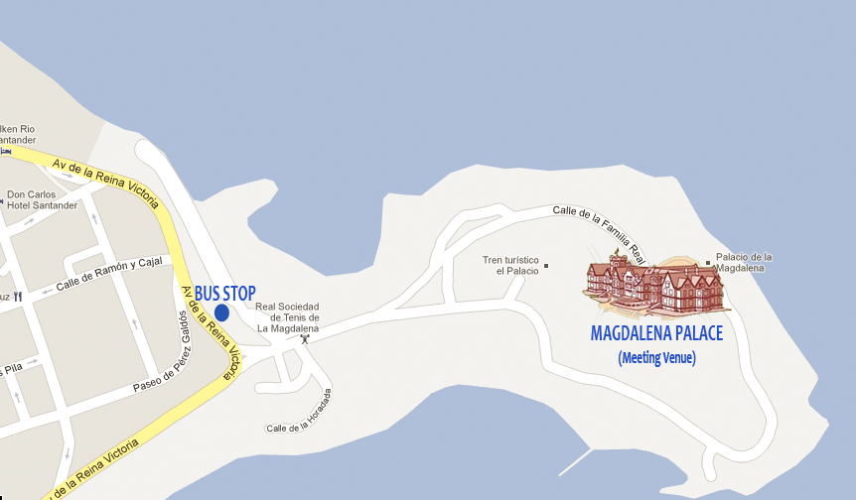

Figure 1. Magdalena Area Map

You can reach the building either on foot (it is approximately 20 minutes walking from hotels at Sardinero area) or by taxi. If you take the bus, most of the bus lines leave you in a bus stop located close to the main entrance of the Magdalena area, but you need to walk 10 minutes to reach the Palace.

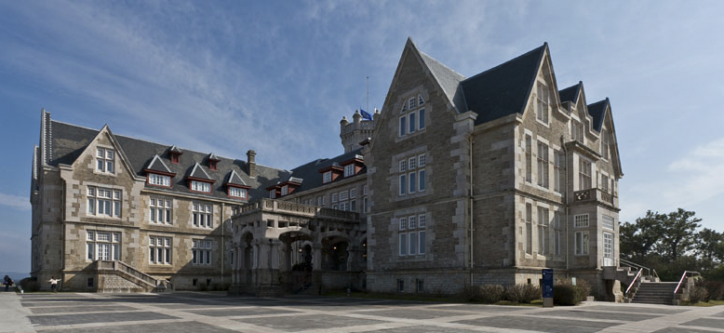

Figure 2. Magdalena Palace Premises

# Hotels

The following website provides a map with all hotels listed in the following, as well as the meeting venue: <http://goo.gl/maps/U6z8x>

### Hotel Chiqui (***)

**Address:** Avda.García Lago Avenue, 9. Santander. Tel.: +34-942-282700

**Web page**: [http://www.hotelchiqui.com](http://www.hotelchiqui.com/)

Located within the Sardinero area, just in front the beach, it offers its visitor with an astonishing view over Sardinero beach, Magdalena peninsula and Cabo - cape - Mayor cliff. It has 161 sea viewing rooms and suites, all of them with bathroom, satellite TV, phone and safe box.

**Price (****Breakfast and VAT included):**

Double room (single use) or Single room: 69,90 €

Double room: 69,90 €

### Hotel Real (*****)

**Address:** Avda. Pérez Galdós, Nº 28, Santander. Tel.: +34-942-272550

**Web page**: <http://www.hotelreal.es>

Built in 1917, this magnificent palatial building is situated on a hill that dominates the bay of Santander and is surrounded by its own park. It is in the city’s most select and quietest residential area, between the centre and El Sardinero. It is just a few minutes from the beaches and the casino, as well as being near to the Magdalena Palace and the festival, congress and exhibition halls.

Hotel Real’s high position means that it has wonderful views of the city, as well as of the Bay of Biscay right up to the horizon, including the bay and across El Puntal bay.

**Price (Breakfast and %VAT included), wifi, gymnasium and free parking:**

Double room (single use) or Single room, sea view: 105 €

Double room, sea view: 130 €

### Hotel Santemar (****)

**Address:** c/ Joaquín Costa, 28, Santander. Tel.: +34-942-272900

**Web page**: <http://www.hotelsantemar.com/>

Located in the Bay of Santander, next to the Casino and 50 metres from the Beaches of Sardinero, the Santemar Hotel combines tradition and modern, experience and efficiency. The Santemar hotel offers 350 rooms, equipped with everything you may need: satellite TV, video channel, direct-dial telephone and safe-deposit box.

**Price (Breakfast and VAT included):**

Double room (single use) or Single room 65,96 €

Double room 88,56 €

### Hotel Silken Rio (****)

**Address**: Avda. Reina Victoria 153-155 - Santander. Tel.: +34-942-274300

**Web Page**: <http://www.hoteles-silken.com/>

Located in one of the most privileged areas of the city, facing the Sardinero beach and just a few meters away from the Concha and Camello beaches. This veteran establishment provides its gets all the services they may require. All this, plus highly customized service, makes this one of the best and more comfortable hotels in Santander.

**Price (Breakfast and VAT included):**

Double room (single use) or Single room: 65,97 €

Double room: 80,57€

### Gran Hotel Victoria (****)

**Address**: C/ Maria Luisa Pelayo, 38 - Santander. Tel.: +34-942-291100

**Web Page**: <http://www.granhotelvictoria.com>

The Hotel is situated between the “GranCasino” and the “Palacio de la Magdalena”, in front of the Sardinero beach. Fully renovated in 2004. All rooms have terraces, the majority with views of the sea. Free WIFI internet connection. Magnificent traditional cuisine, seasonal cooking, seafood. Fully equipped meeting rooms. Private garden.

**Price (Breakfast and VAT included):**

Double room (single use) or Single room: 76 €

Double room: 97 €

### Bahia Hotel (****)

**Address**: Avenida Alfonso XIII, nº 6 39002 Santander. Tel.: +34-942-205000

**Web Page**: http://www.gruposardinero.com

The Bahía Hotel is located right in the retail, administrative and financial heart of the city. Its rooms have all the comforts our guest could possibly require to make their stay more pleasurable.

**Price (10% VAT included):**

Double room (single use) or Single room: 67 €

Double room: 77 €

Double room (sea view): 97 €

Breakfast: 17 €

### Silken Coliseum Hotel (****)

**Address**: Plaza de los Remedios, 1 39001 Santander. Tel.: +34-942-318081

**Web Page**: http://www.hoteles-silken.com

In the heart of the city centre, the Silken Coliseum Hotel is the perfect setting for business lunches, meetings or conventions. In addition to the normal services, the Silken Coliseum hotel has an executive floor, non-smoking rooms, a business center…

**Price (Breakfast and VAT included):**

Double room (single use) or Single room: 65.97 €

Double room: 80,84 €

### Hotel Hoyuela (****)

**Address**: Avda. de los Hoteles, 7. 39005 Santander. Tel.: +34-942-282628

**Web Page**: http://www.hotelhoyuela.es

This hotel is located right by the beach, and only 440 yards from Magdalena Palace. It is within walking distance of the center of Santander and the University.

Apart from its remarkably good location, the Hotel Hoyuela offers elegant and beautiful design, plenty of great facilities and services, and a good restaurant. The rooms are nicely decorated

**Price (Breakfast and VAT included):**

Double room (single use) or Single room: 65.97 €

Double room: 87 €

### Gran Hotel Sardinero (****)

**Address**: Plaza de Italia 1. 39005 Santander. Tel.: +34-942 271100

**Web Page**: <http://www.hotelsardinero.es>

This seafront hotel is set 20 metres from Sardinero Beach. It offers elegant rooms, in many cases with views of the Cantabrian Sea, 20 metres from Sardinero Gran Casino. Rooms at Gran Hotel Sardinero feature classic cream décor.

Gran Sardinero Hotel is set 400 metres from the Magdalena Palace and 500 metres from both the Congress and Sports Palaces. Buses and taxis to the centre of Santander, 3 km, pass just outside the hotel.

**Price (10% VAT included):**

Double room (single use): 80 € o Single room: 70 €

Double room: 80 €

Double room sea view: 100 €

Breakfast: 15 €

# Santander map

In the map below all hotels as well as the meeting venue are highlighted on Santander map.

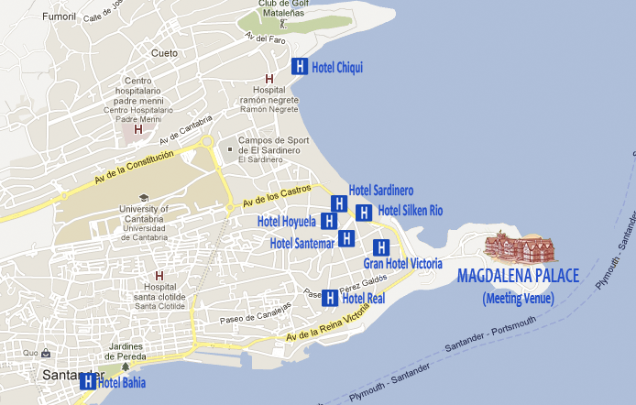

Figure 3. Meeting Venue and hotels

## Contact person

Mrs. Guillermina López

(Assistant of Prof. Luis Muñoz)

Universidad de Cantabria

Tel: +34 942 201 387

E-mail: [guillermina.lopez@unican.es](mailto:guillermina.lopez@unican.es)