|  |  |
| --- | --- |
|  |  |

|  |
| --- |
| **Workshop on Disaster Relief Systems, Network Resiliency and Recovery (20th May 2013); AND  Meeting of the ITU Focus Group on Disaster Relief System, Network Resilience**  **and Recovery (20-24 May 2013)**  ***(Diamond Cliff Resort & Spa)***  **Phuket, Thailand** |

**Participants’ Information**

***Venue***

The Diamond Cliff Resort & Spa

284 Phrabaramee Rd.

Patong Beach,

Phuket 83150, Thailand

Tel 66 76 341 324

Fax 66 76 380 056, 66 76 340 507

<http://diamondcliff.com>

Contact: Ms. Pilantha Warasri

Email : pilantha@diamondcliff.com

Phuket, the biggest island in Thailand, is located in the Andaman Sea, southern Thailand. Patong Beach is one of the most popular tourist areas in Phuket. Most of Phuket nightlife and its cheap shopping is located in Patong, and the area has become increasingly developed. Other popular beaches are located south of Patong. There are several coral islands to the south of Phuket, the [Similan Islands](http://en.wikipedia.org/wiki/Similan_Islands) lie to the north west, and [Phi Phi Islands](http://en.wikipedia.org/wiki/Phi_Phi_Islands) to the south east.

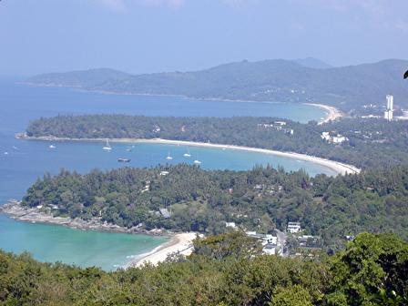

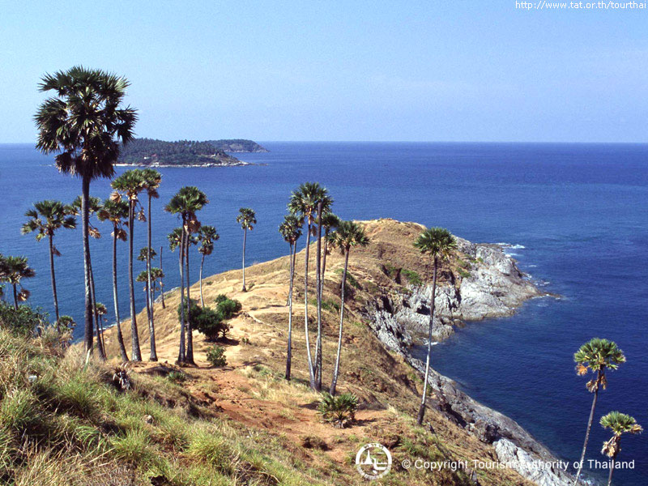

***Registration***

A registration desk for participants will be located in front of the meeting room, Patong Room, Diamond Cliff Resort & Spa. Registration commences 8:30 on 20 May 2013.

***Hotel***

The meeting venue, Diamond Cliff Resort & Spa, is recommended for all participants. The special rate at THB 3,000 (nett) will be applied for the participants who indicate the event name when making a reservation.

The rate is inclusive of breakfast and WiFi.

Participants are kindly requested to send the hotel booking form to the hotel with a copy to NBTC for finalizing necessary arrangements by the Host.

(Remarks : Exchange rate as of 18 March 2013, USD1= THB30.)

***Travelling to Phuket***

The following are recommended airlines from Bangkok to Phuket:

**1. Thai Airways International Airline (**[**www.thaiairways.com**](http://www.thaiairways.com)**)**

**2. Air Asia (**[**www.airasia.com**](http://www.airasia.com)**)**

**3. Nok Air (**[**www.nokair.com**](http://www.nokair.com)**)**

**4. Bangkok Airways (**[**www.bangkokair.com**](http://www.bangkokair.com)**)**

***Transfer from Phuket International Airport***

Transportation from Phuket International Airport to the Hotel will be provided by the host. Alternatively, participants wishing to arrange the travel on their own are recommended to contact the Information Desk at the Airport for assistance.

Followings are recommended types of transportation from Phuket International Airport to the hotel;

⮚ Mini bus, THB1500 one way (maximum 10 persons)

⮚ Private taxi, THB950 one way (maximum 3 persons)

***Climate***

Phuket has a tropical climate with a dry season from November to April and a rainy season from May to October. Average temperatures are consistent year-round. Average highs range from 29°C (84°F) to 33°C (91°F); average lows range from 23°C (73°F) to 26°C (79°F).

***Visa and Immigration Requirements:***

As visa requirements change from time to time, please check with your nearest Embassy/Consulate for your visa requirements before departure. Advance submission of applications is recommended (at least 15 working days). For more details, please kindly visit <http://www.mfa.go.th/web/2637php>.

***Time Zone:***

GMT+7 hours

***Banks & Currency:***

The unit of Thai currency is Thai Baht (THB). The exchange rates as in March 2013 , 1USD = THB 30.

***Electricity:***

The standard supply is 220 volts, 50 Hz. Outlets for 220 volts are available at the hotels..

***Emergencies***

Police 191  
Fire 195  
Medical Emergencies 1554

Tourist Police 1155

***Correspondence:***

International Affairs Bureau

National Broadcasting and Telecommunications Commission

87 Phaholyothin Road

Phayathai, Bangkok 10400

Thailand

Tel: 66 2 272 7054

Fax: 66 2 278 1736

Email: chonlada.b@nbtc.go.th, [inter_org@nbtc.go.th](mailto:inter_org@nbtc.go.th),

Contact Person: Ms. Chonlada Boonna-In

**\*\*\*\*\*\*\*\*\*\*\*\*\*\*\*\*\*\*\*\*\*\*\*\*\*\*\*\*\***