ITU-T FG Cloud #7
General Meeting Information

Meetings and Dates:
ITU-T FG Cloud Computing #7 Meeting 26-30 September 2011
- 26th Sep. : ITU-T FG Cloud and ISO/IEC JTC 1/SC 38/SGCC Joint Meeting
- 27th ~ 30th Sep. : ITU-T FG Cloud #7

Location:
Seoul, Republic of Korea

Meeting Venue:
Ramada Seoul
112-5, Samsung-Dong, Gangnam-gu, Seoul, Korea
Tel: +82-2-6202-2000
Fax: +82-2-6202-2001
Website: http://www.ramadaseoul.co.kr/ (Korean)
http://www.ramadaseoul.co.kr/eng/ (English)
http://www.ramadaseoul.co.kr/cha/ (Chinese)

Room Rate:
Superior Room : 130,000 KRW per night
(Daily buffet breakfast, tax, and surcharge not included)

Cut-off Date: 30 July 2011
Please make your reservations before the cut off date to ensure the reduced group rate. Rates may be significantly higher after the cut-off date.

Reservations:
Please fill out the ROOM RESERVATION FORM in Appendix A and send the completed form via fax or email to the hotel.

To ensure that your confirmation is sent promptly, please type your information into the form. (The available room is limited. First request, first served.) Handwritten faxes can be difficult to read.

If you have not received a faxed or emailed confirmation within 48 hours of sending the form, please call Reservation at +82-2-6202-2000 or email reservation@ramadaseoul.co.kr ASAP.

Cancellation:
Any cancellation within 5 days or less before the meeting or NO SHOW, one night room rate will be charged from your credit card.

Please Note:
Please contact the Ramada Seoul Hotel directly to make any changes.

Internet:

Hotel is uncomplimentary to guests with access to internet in guest rooms.
Meeting room will be equipped with wireless LAN access to internet.

Airport Transportation

Ramada Seoul is in the heart of Gangnam business area, Samsung-dong, within a short walk of COEX and the Korea City Air Terminal.

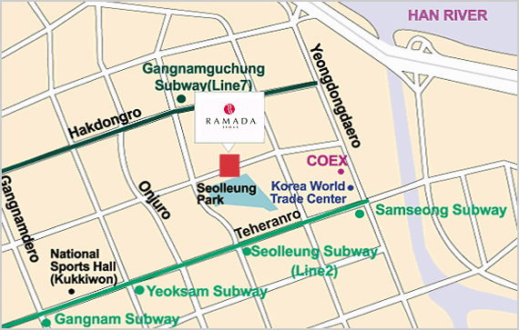

About one hour driving distance from Inchon International Airport, Ramada Seoul is 40 minutes away from Gimpo Airport, 20 minutes from downtown, and 10 minutes from Seolleung and Gangnam-gu Office subway stations by car. City Air Terminal is only five minutes away by taxi, and Ramada Seoul shuttle service is also available.

< Bus >

Regular Bus 12-3, 21, 78-1, 62-1, 83

Premium Bus 772, 64-1

Local Bus 4428

< Airport Limousine Bus >

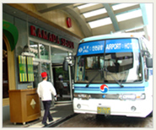

Line 6704 (every 15 minutes , KAL Limousine Bus 3B Route)

(Kangnam Area 3B Route)

Incheon Airport(Exit 4B) → Hyatt Regency Incheon → Palace → Ritz Carlton → Novotel Ambassador → Ramada Seoul →Coex Intercontinental → Grand Intercontinental → Renaissance → Imperial Palace

- Departure Point : Ramada Seoul → Arrival Point :Incheon Airport
- Travel Time : 80 min
- Ticket Purchase : Front desk

< Subway>

7-minute walk from Seolleung Station, Subway Line 2

10-minute walk from Gangnam-gu Office Station, Subway Line 7

Visa Requirements:
If you require an invitation letter for obtaining your Korea visa, please fill-in the INVITATION LETTER REQUEST FORM in Appendix B and email it with the subject of “ITU-T FG Meeting : Invitation letter request” to the host (Mr. Myung-ho Yoo; yoomh70@kcsa.or.kr) by 20th July. The invitation letter will be dispatched within two week after receiving the email request.

Information of Seoul:

You could find more information about Seoul on the website:
- 36 Hours in Seoul : http://travel.nytimes.com/2010/11/14/travel/14seoul-hours.html
- Interactive Seoul Map: http://gis.seoul.go.kr/SeoulGis/EnglishMap.html
- Metro Map : http://www.seoulsubway.co.kr/station/eng/linemap.action
- Visit Seoul - Seoul information : http://www.visitseoul.net/
- Insadong : http://en.wikipedia.org/wiki/Insadong

Currency & Exchange

The Korean currency unit is the WON (indicated ￦). Bank notes are ￦10,000, ￦5,000, ￦1,000 bills and coin denominations are ￦500, ￦100, ￦50, ￦10. One US dollar is about ￦1,100 as of June, 2011. Money can be exchanged at Incheon International Airport, banks, and hotels. http://www.keb.co.kr/IBS/english/fx/rate/average/index.jsp


Weather
The Weather in September is usually hot. The average temperature is 15~24°C (59~75.2°F). For more detailed climate information, please contact the Korea Meteorological Administration:
http://www.kma.go.kr

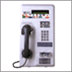
Telephone Calls
To make an international call, first dial the international dialling code (001, 002 or 008), then the country code, area code, and the local telephone number. You may also rent a cellular phone at the Incheon International Airport.

Electricity
The standard supply is 220 volts with AC/60 cycles. Outlets for 220 volts are available at the hotels.

The two following outlets are compatible with those available in Korea.

a)It is popularly known as the europlug which is described in CEE 7/16
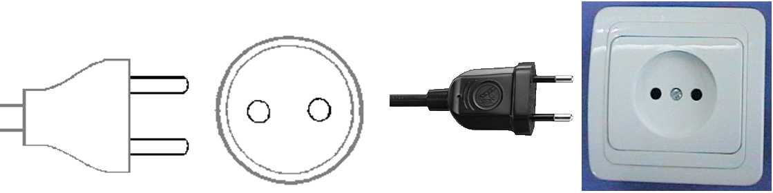
b) This plug is similar to the above except that it is round and has the addition of two grounding clips on the side of the plug
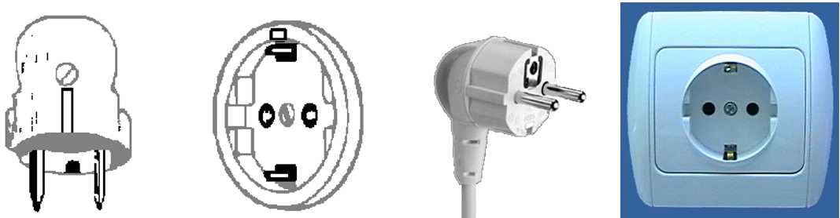

Emergencies
Police 112
Fire Department 119
Medical Emergencies 1339

Business Hours
Government offices are open from Monday to Friday between the hours of 09:00 and 18:00.
Most private businesses open at anywhere from 08:30 to 10:00 and close in the evening. Banks are a major exception. Their business hours are from 09:30 to 16:30 on weekdays. They are closed Saturdays and Sundays.
Foreign diplomatic missions in Seoul generally maintain strict business hours including lunch. They are usually open from 09:00 to 17:00 on weekdays and are closed on Saturdays and Sundays.
Major departments stores are usually open from 10:30 to 20:00, including Sundays, but smaller shops tend to be open earlier and close later every day of the week

Automated Teller Machines (ATM) for Foreign Travellers
Travellers who carry internationally recognized credit cards can get a cash advance in Korean won at Automated Teller Machines (ATMs) installed at airports, major hotels, department stores, subway stations and tourist attractions.

Tax
Value-added tax (VAT) is levied on most goods and services at a standard rate of 10% and is included in the retail price. In tourist hotels, this 10% tax applies to meals and other services and is added into the bill.

Mail
Domestic postal rates are ￦190 for a letter of up to 25g, ￦1,490 for registered letter of no more than 25g, and ￦1,500 or ￦2,000 for a package of up to 2kg. A postcard costs ￦160.
■ Korea post: www.koreapost.go.kr

Newspaper, TV and Radio
There are three English-language dailies, the Korea Times and the Korea Herald, and the International Herald Tribune Joongang Daily. They are available at most news stands and in most hotel gift shops.
Korea has fine TV networks, all broadcasting in Korean (KBS1, KBS2, MBC, SBS, and EBS). Along with the national broadcasting networks, there are also many cable TV channels specializing in a wide field of programming including news, movies, entertainment, sports, etc. Of note is Arirang TV, a special English channel produced in Korea. The channel features programming in politics, the economy, community, and culture, providing insight and understanding about things Korean through popular TV serial dramas with English subtitles. Some 90 hotels in Korea offer Arirang TV on cable or satellite.

Local time
GMT + 9 hours

Computer Networking
Each meeting room will be equipped with wireless access (Wireless LAN, supporting IEEE802.11b, 2.4GHz band) to the Internet. Those who wish to use the wireless access must be equipped with the necessary hardware and correctly configured PC.

Contact of the Host (including VISA):
Mr. Myung-ho Yoo
KCSA(Korea Cloud Service Association)
Tel: +82 70 87302344
Fax: +82 2 21798188
Email: yoomh70@kcsa.or.kr


Appendix A
HTL Acc. 9014597
Name  (Surname & First name) | Mr / Ms
Address
Tel. | (Please Include Country & Area Code) | Fax. | (Please Include Country & Area Code)
E-mail |  | Website
Special Requests
2. Hotel Booking Details
Check in Date |  | Type for Room
Check out Date |  | Number of Rooms
Number of Nights |  | Number Of Persons

(if applicable) I will be sharing with _________________________________________________(Name of Person).

ROOM TYPES AND RATES : These rates are available between 20th.Sep,2011 ~ 2nd.Oct,2011
Superior Room (Room Only) KW 130,000 
Superior Room (Including breakfast for one person) KW 145,000  *Breakfast pre-reservation
Superior Room (Including breakfast for two person) KW 160,000  *Breakfast pre-reservation
Executive Room (Including club benefits for One person) KW 160,000 
Executive Room (Including club benefits for Two persons) KW 186,000 
*Breakfast price to be KW 17,000 with no pre-reservation.

Prices do not include 10% Service Charge and 10% VAT.

Executive Room Club Benefits:
a) Complimentary Breakfast at the Café Stasio on lobby floor from 06:30 ~ 09:30.
b) Free high speed Internet is free in the guest room.
c) 2 hours free use of meeting room on the club lounge on 14th.
d) Various periodicals and newspapers.
e) Free use of Sauna and gym.
f) Compliment coffee, tea and soft drink at the Ramada club lounge on 14th from 11:00 ~ 20:00

3. Payment Guarantee
Please charge to my □ VISA □ Master □ AMEX □ Other_____________
Card number □□□□ □□□□ □□□□ □□□□ Expiry date(mm/yy) □□/□□
Cardholder’s name(as it appears on the credit card) _________________________

• Reservation requests are filled on a first-come, first-served basis.

4. Cancellation Policy:
Cancellations MUST be sent to the hotel in writing. Cancellations can be made up until 1 day prior to arrival without penalty.
Cancellations made less than 1 day prior to arrival date will be subject to 1 night’s accommodation charge.
I have read and understood the cancellation policies and wish to confirm my hotel reservation as above.
Date: Name: | Signature

Please return form to: Fax +82 2 6202 2008 OR e-mail) reservation@ramadaseoul.co.kr
Tel +82 2 6202 2000
Address : 112-5 Samsung-dong, Kangnam-gu, Seoul, Korea 135-010

Appendix B

Information other accommodations

Park Hyatt Seoul
- Park King Room : 370,000 KRW per night
- +82-2-2016-1234
- www.parkhyattseoul.co.kr
- 995-14 Daechi 3 - dong Gangnam-gu Seoul, Korea 135-502

Ritz-Carlton Seoul Hotel
- Superior Deluxe Room : 350,000 KRW per night
- +82-2-3451-8114
- resv@ritzcarltonseoul.com
- www.ritzcarltonseoul.com
- 602 Yeoksam-dong, Gangnam-gu, Seoul, Korea 135-080

Intercontinental Seoul Hotel
- Deluxe Room : 330,000 KRW per night
- +82-2-559-7777
- ic-reservations@parnas.co.kr
- www.seoul.intercontinental.com
- Coex Intercontinental : 159 Samsung-dong, Gangnam-gu, Seoul, Korea 135-975
- Grand Intercontinental : 159-8 Samsung-dong, Gangnam-gu, Seoul, Korea 135-732

Imperial Palace Seoul Hotel
- Business Double Room : 320,000 KRW per night
- +82-2-3440-8000
- www.imperialpalace.co.kr
- 248-7 Nonhyeon-dong, Gangnam-gu, Seoul, Korea 135-010

Renaissance Seoul Hotel
- Deluxe Double Room: 312,000 KRW per night
- +82-2-555-0501, +82-2-553-8118
- www.renaissance-seoul.com
- www.marriott.com
- 676 Yeoksam-dong, Gangnam-gu, Seoul, Korea 135-915

Novotel Ambassador Gangnam Seoul Hotel
- Standard Double Room : 297,000 KRW per night
- +82-2-531-6521
- novogres@ambatel.com
- novotel.ambatel.com
- 603 Yeoksam-dong, Gangnam-gu, Seoul, Korea 135-907

Ibis Ambassador Seoul Hotel
- Double Room : 165,000 KRW per night
- +82-2-3454-1101
- ibis-seoul@ambatel.com
- ibis.ambatel.com
- 893-1 Daechi-dong, Gangnam-gu, Seoul, Korea 135-840

Seoul Stars Hotel
- Standard Double Room : 100,000 KRW per night
- +82-2-550-9700
- admin@seoulstarshotel.com
- www.seoulstarshotel.com
- 236-8 Nonhyeon-dong, Gangnam-gu, Seoul, Korea 135-831

Dynasty Hotel
- Double Room : 85,000 KRW per night
- +82-2-540-3041
- info@dynasty.co.kr
- www.hoteldynasty.co.kr
- 202-7 Nonhyeon-dong, Gangnam-gu, Seoul, Korea 135-545

There are not enough rooms for you. Please make a reservation, ASAP.
Thank you.

Appendix C

ITU-T FG Cloud Computing #7 Meeting
Seoul, Korea

INVITATION LETTER REQUEST FORM

If needed, please return this form, no later than 20 July 2011 for the processing of formal invitation letter.

Family Name
Given Name
Date of Birth(yyyy/mm/dd)
Gender
Company(Individual Member)
Nationality
Passport Number
Mailing Address
(With postal code)
Expected entry date
Expected departure date
Tel.
Fax.
E-mail

If there is no special request for original invitation letter, it will be provided by default a scanned copy of the invitation letter. Also, invitation letter can be delivered with grouping of your company.

