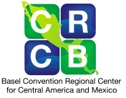
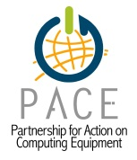
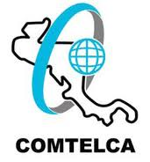
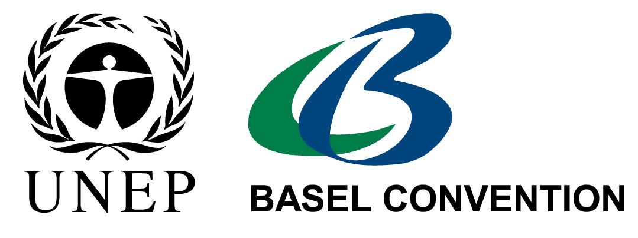
CENTRAL AMERICAN AND CARIBBEAN AGENDA FOR ENVIRONMENTALLY SOUND MANAGEMENT OF WASTE ELECTRICAL AND
ELECTRONIC EQUIPMENT (WEEE)

Transforming the management of WEEE into an opportunity

March 21, 2013, San Salvador, El Salvador

The Central American Workshop for the Environmentally Sound Management of Waste Electrical and Electronic Equipment (WEEE), whose organization was conducted by the Secretariat of the Basel, Rotterdam and Stockholm Conventions (BRS), administered by the United Nations Environment Programme (UNEP); in partnership with the Basel Convention Regional Centre for Central America and Mexico (BCRC-CAM); the International Telecommunications Union (ITU); the Central American Commission for Environment and Development (CCAD); the Ministry of Environment and Natural resources of El Salvador (MARN); the Regional Technical Commission on Telecommunications (COMTELCA); the General Superintendence of Electricity and Telecommunications of El Salvador (SIGET); and the Partnership for Action on Computer Equipment (PACE), took place from the 19th to 21st of March, 2013, in San Salvador, El Salvador.

The Forum was attended by institutions, companies and organizations working in the environmentally sound management of WEEE, in order to ensure the protection of the environment as well as the health of the population. Ministries of Environment and Health, Telecommunications Regulatory Authorities, private sector, Academia and non-governmental organizations participated.

The participants of the Central American Workshop for Environmentally Sound Management of WEEE expressed that:

- They reaffirm the commitments made for the implementation of the Basel, Rotterdam and Stockholm Conventions (BRS);
- They recognize the importance of Resolution 79 on electrical and electronic waste approved in the World Assembly for Standardization of Telecommunication (Dubai, 2012), which calls upon ITU to develop activities related to capacity building and implementation of recommendations, methodologies and other publications on the environmentally sound management of WEEE.

- They welcome the decision of the Council of Ministers of the CCAD in its meeting in Roatan, Honduras, in June 2012, declaring WEEE as a priority.

- They thank the Organization of American States (OAS) for having selected the "Formulation of the WEEE Strategy for Central America" proposal, submitted by the Basel Convention Regional Centre for Central America and Mexico (BCRC-CAM) and CCAD, as recipient of the project "Sustainable Communities in Central America and the Caribbean" to receive funding from the Department of State of the United States of America, this being a catalytic support for this very important task.

- They recognize the commitment made at the World Summit on the information society (WSIS) (Geneva 2003, Tunisia 2005) and its follow-up, which establishes as a priority the Environmentally Sound Management (ESM) of WEEE at the global level.

- They invite the Global Environment Facility (GEF) and other cooperation organizations, to collaborate in the formulation and implementation of the WEEE strategies for Central America and the Caribbean.

- They recognize the contribution of the "INTERPOL Program on Crimes Against the Environment" to control the illicit movement of WEEE between Europe and Africa and sincerely invite this organization to consider establishing a similar program in Central America and the Caribbean.

- They highlight the importance of strengthening the coordination of activities for the management of WEEE between environmental and health authorities, with the telecommunications regulatory authorities and the private sector.

- They are aware that the ESM of the WEEE requires articulated efforts between public sector, private sector, NGOs, academia and citizenship, to transform the management of WEEE into an opportunity for sustainable development.

- They recognize the importance of the definition of roles and the commitment of manufacturers and importers and distributors, to make effective the extended producer responsibility, throughout the life-cycle of electrical and electronic equipment.

- They recognize the importance of reuse and recovery of materials, which increases the economic value of all computers that have been collected.

- They make an appeal to the ITU to implement projects aimed at reducing the gap in WEEE regulations in developing countries, particularly in Central America and the Caribbean.

- They call the ITU and UNEP in conjunction with Basel Convention Regional Centres and other relevant international and regional organizations (for example: Solving the E-waste Initiative and Partnership for Action on Computing Equipment (PACE)), to create initiatives such as online learning programs and on strengthening of competencies, on themes related to ESM of waste electrical and electronic. These initiatives would support governments in the preparation of inventories and country profiles, as well as in the development and implementation of policies, laws, regulations, rules, strategies, programs, plans and projects related to WEEE, including ICT, in an environmentally sound manner.

- They call environmental, health, and telecommunications and energy authorities in the region, to design and implement in a participatory way and with a regional harmonious focus, policies, laws, regulations, rules, strategies, programs, plans and projects on environmentally responsible management of WEEE, with ITU and UNEP support and from other agencies, taking into account the capacities existing in each country.

- They recognize the importance that this process be carried out in coordination with producers, importers, distributors, wholesalers, operators and telecommunications service providers and WEEE management companies, supported by models which are environmentally, social and economically sustainable, making a special effort to incorporate the informal sector.

- They invite ITU and UNEP, in conjunction with the Basel Convention Regional Centres and other international and regional organizations concerned, to continue to develop workshops in Latin America and the Caribbean, aimed at raising awareness about the increase in risks to the environment and health, due to the increase and poor management of WEEE, and at the same time to promote the development of capabilities focused on ESM.

- They are committed to sharing the experiences and knowledge of their institutions and organizations, and to actively contribute in the process of formulation and implementation of the regional strategies for Central America and the Caribbean for ESM of WEEE, actively participating in national and regional workshops organized for the formulation of the same.

- They recognize the need to support awareness-raising programmes on the importance of the ESM of WEEE, as well as to develop and implement schemes that facilitate the deduction from public assets of used and disused, electrical and electronic equipment so as to enable their repair/rehabilitation and use of materials/recovery.

- They highlight the importance of promoting joint work with companies certified and qualified in the environmentally sound management of WEEE throughout Latin America and the Caribbean.

- They recognize the importance of environmentally responsible management incorporates social, economic, environmental and health aspects.

