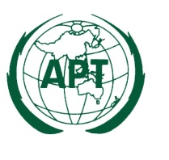 | APT-ITU Seminar on the outcomes of  WTSA-12 and WCIT-12  7 – 8 March 2013, Bangkok, Thailand |  | Document:  SEM-OUTCOMES/  INP-01

APT Secretariat

APT Common Proposals to the WTSA-12 and outcomes

