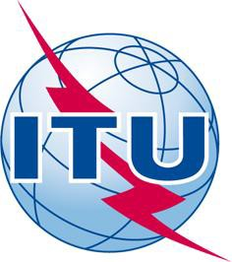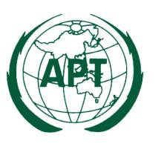APT-ITU Seminar on the outcomes of
WTSA-12 and WCIT-12
7 – 8 March 2013, Bangkok, Thailand

PROVISIONAL AGENDA

1. Opening

2. APT Common Proposals to the WTSA-12 and key discussions and outcome of WTSA-
12 on the proposals

3. Other Key discussions and outcome of the WTSA-12

4. Interactive discussion on WTSA-12

5. APT Common Proposals to the WCIT-12 and key discussions and outcome of WCIT-12 on the proposals

6. Other Key issues and outcome of the WCIT-12

7. Interactive Discussion: The revised ITR and expected impact to the international telecommunications

8. Interactive Discussion: Any follow-up issues from WTSA-12 and WCIT-12

9. Any other issue

10. Closing

Agenda - APT-ITU Seminar on the outcomes of WTSA-12 and WCIT-12 (Draft 3) 14 January 2013

