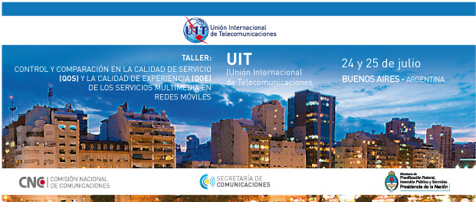

NEWS BULLETIN

- VENUE

Hotel Panamericano
Carlos Pellegrini 551 – 1009 – Buenos Aires
Tel. + (54) (11) 4348-5000
www.hotelespanamericano.com

- LOCAL CONTACT

Mr Luciano Intelesano
Chief of Public Relations, Ceremonial & Protocol
International & Institutional Affairs Department
National Communications Commission (CNC)
Perú 103 – Piso 8 - Ciudad de Buenos Aires – República Argentina
Tel: + (54) (11) 4347-9557 - Fax: + (54) (11) 4347-9546
E-mail: lintelesano@cnc.gov.ar

- ACCOMMODATION & HOTEL RESERVATIONS

It is important to make your reservation as soon as possible since the event will take place during the winter break.

The Argentine Administration has negotiated special rates in downtown hotels shown in the table below. Participants are requested to complete the attached form and send it to the selected hotel via e-mail.

All reservations require a credit card number. You will get a confirmation message once you reservation has been accepted by the hotel. In case of failure to attend the meeting, the reservation must be cancelled well in advance.
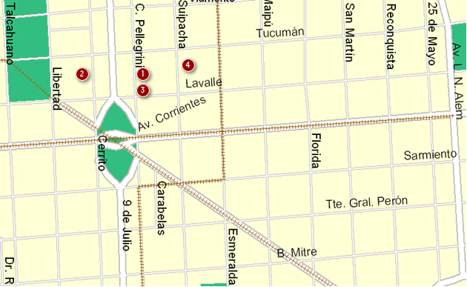

HOTEL | STAR RATING | ROOM | DAILY  RATE | OBSERVATIONS
(1) Panamericano (Venue)  Carlos Pellegrini 511  Tel: +54. 11-4348-5000  Fax: +54-11-4348-5250/51  Check-In: 3:00 PM  Check-Out: 12:00 PM  reservas@panamericano.us  www.panamericano.us | * * * * * | Standard Single or Double | USD 164 | Including taxes & breakfast buffet
(2) NH Tango  Cerrito 550  Tel: +54. 11-4124-6700  Fax: +54. 11-4124-6750  Check-In: 3:00 PM  Check-Out: 12:00 PM  reservas.mercosur@nh-hotels.com  www.nh-hoteles.es | * * * *  Superior | Standard Single or Double | USD 131 | Including taxes & breakfast buffet
(3) Colón  Carlos Pellegrini 507  Tel: +54. 11-4320-3511  Fax: +54. 11-4320-3507  Check-In: 3:00 PM  Check-Out: 12:00 PM  reservas@execolon.com.ar  www.exehotelcolon.com | * * * * | Standard Single or Double | USD 85 | Including taxes & breakfast buffet
(4) Argentina Tango Hotel  Suipacha 545  Tel./Fax +54. 11-4322-3434  Check-In: 2:00 PM  Check-Out: 12:00 PM  reservas@atangohotel.com  www.atangohotel.com | * * * | Standard Single or Double | USD 53 | Including taxes & breakfast buffet

- INVITATION

Reception Cocktail: Thursday, 24 July 7 pm at the Amazonas Lounge, Venue Hotel.
Suggested attire: Formal

- FLIGHTS AND TRANSPORTATION

Ezeiza International Airport: located 40 minutes away from the city of Buenos Aires; used for international air traffic.

Jorge Newbery Airport (Aeroparque): used mainly for domestic air traffic though it also manages many international flights; it is only 15 minutes away from the Buenos Aires downtown area.

Delegates have several transfer options from the airport to their hotel in the city of Buenos Aires:

Car service and private taxis: There are many taxi and private car companies located at the exit of the arrivals area in both airports.
Estimated cost for transfer from Ezeiza Airport to the city of Buenos Aires: $ 330 (USD 42)
Estimated cost for transfer from J.Newbery Airport to the city of Buenos Aires: $ 100 (USD 12)

Minibuses: this is a less expensive option; they leave from the airport every 30 minutes with a shuttle service to the main downtown hotels. www.tiendaleon.com.ar
Estimated cost for transfer from Ezeiza Airport to the city of Buenos Aires transfer: $ $ 110 (USD 14)
Estimated cost for transfer from J.Newbery Airport to the city of Buenos Aires: $ 45 (USD 6)

For more information, please visit the following web page: Aeropuertos Argentina 2000 - www.aa2000.com.ar

5. GENERAL INFORMATION

City of Buenos Aires

With its European architecture, vast parks and sculptural monuments, it is the capital of the Argentine Republic. There are several tourist attractions such as museums, exhibition halls, art galleries, cinemas and theatres. It is the country’s financial, economic and stock market hub. The intense business activity is reflected on the various top-brand shops, department stores and shopping malls.
Nightlife is extremely varied and continues until dawn. Discos, restaurants, bars and many other attractions to suit every taste spread all over the city creating countless options for tourists.
The obelisk is a national historic landmark that stands as the city’s icon.

Entry formalities
Most of the delegates do not require a visa to enter Argentina. You can check all visa requirements at www.mrecic.gov.ar “temas consulares” (consular issues). However, make sure to consult with your embassy or consulate to avoid misunderstandings.
Those who require a visa to enter Argentina should contact Mr Luciano Intelesano at lintelesano@cnc.gov.ar to request a personalized letter of invitation addressed to the petitioner via e-mail. This letter will then be delivered to the petitioning country’s Argentine Embassy in order to get the visa.
Argentina does not require any vaccination certificates, except for the case of vaccination against cholera and yellow fever for passengers coming from countries in which these deceases are endemic.

Language

Spanish is the official language; English is widely spoken.

Electricity

AC power voltage in Argentina is 220 V, 50 Hz. 110 V adaptors are usually available at hotels.

Weather

Buenos Aires has a benign climate (warm and humid) throughout the year. Therefore, extreme temperatures are rare. Nevertheless, it is winter in July.
The usual temperatures for this time of year range between 5 and 15ºC (41–59ºF) with an average temperature of 10ºC (50º F).
For more information, please check the National Weather Service at http://www.smn.gov.ar/

Currency

The peso ($) is Argentina’s official currency. Although dollars are usually accepted, foreign exchange can be obtained in banks and authorized foreign exchange offices. The most widely accepted credit cards are American Express, VISA, Diners and Mastercard.
.

Exchange rates may fluctuate. As of 19 May 2014 the dollar/peso rate was:
USD 1 = $ 8.00.

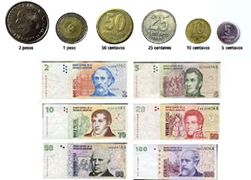

Shopping. Tax refunds
At the airport, tourists can get a 21% refund of the amount paid for Value Added Tax (VAT), if they have bought national products for amounts over $ 70 (per purchase slip) at the shops that have joined the “Global Refund” system.
For further information, please visit:
http://www.aa2000.com.ar/ip_dsv_internayregiona_partidas.aspx#P_9 “Tax-Refund”

Business hours
Banks and Foreign Exchange Offices: Monday to Friday, from 10 am to 3 pm.
Business offices: Monday to Friday, usually from 9 am to 12 noon and from 2 pm to 7 pm.
Shops: Monday to Friday from 9 am to 8 pm. Saturdays from 9 am to 1 pm
Cafés, bars and pizza restaurants: almost open round the clock, with a break between 2 and 6 in the morning.
Restaurants: lunch is served as from 12.30 noon and dinner as from 8.30 pm on. Many places offer fast food options at all times.

Tip
It is customary practice to leave a 10% tip in cafés and restaurants, as well as to tip porters, bell boys and ushers in theaters.

Useful information

For more information on the city of Buenos Aires, please visit the following web page: www.bue.gov.ar

