PRACTICAL INFORMATION

Meeting Venue
The meeting will be held on the Level 3 of Suntec Singapore Convention & Exhibition Centre.
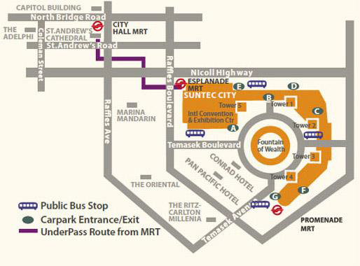
The contact details of the venue is as follows:
Suntec Singapore
Convention & Exhibition Centre
1 Raffles Boulevard
Singapore 039593

Transportation and site information
Transportation:

The venue is approximately 20km from Singapore Changi Airport and it takes about 20 minutes by car from Singapore Changi Airport to the venue.

Public Taxi

Public Taxi is readily available at all terminals at Singapore Changi Airport.

All taxis are metered. Fares must be charged according to the taxi meter, plus applicable surcharges. More information can be found here: http://www.taxisingapore.com/taxi-fare/

Public Train (Mass Rapid Transit, MRT)
  - The train station is accessible by foot from Terminal 2 or Terminal 3.
  - To get to the city, transfer to the westbound train at Tanah Merah station. The last train that connects to the last westbound train at Tanah Merah station leaves Changi Airport station at 11.18pm. All the trains and gantries at the stations are luggage-friendly.
  - Suntec Singapore Convention & Exhibition Centre is accessible via Promenade station, Esplanade station or City Hall station.

Passports and Visas
Generally, foreigners who do not require visas for entry and are visiting Singapore as tourists may be given up to 30-day social passes upon their arrival in Singapore. All foreign visitors entering Singapore must have a valid passport. Visitors from countries whose citizens require a visa should at the earliest time and well in advance of travel apply for a visa at a Singapore Embassy or consulate. Please visit the following website to check if you require a visa for entry into Singapore: http://www.ica.gov.sg/page.aspx?pageid=96&secod=94
For an introduction letter, please see Annex C.

Climate – during January
Monthly Average values of the temperature and precipitation in Singapore are given in the table below:
 | June
Average Max Temperature | 30C / 86F
Average Minimum Temperature | 24C / 75F
Average Precipitation | 200mm

http://www.nea.gov.sg/weather-climate

Hotels
Hotels close to the venue:
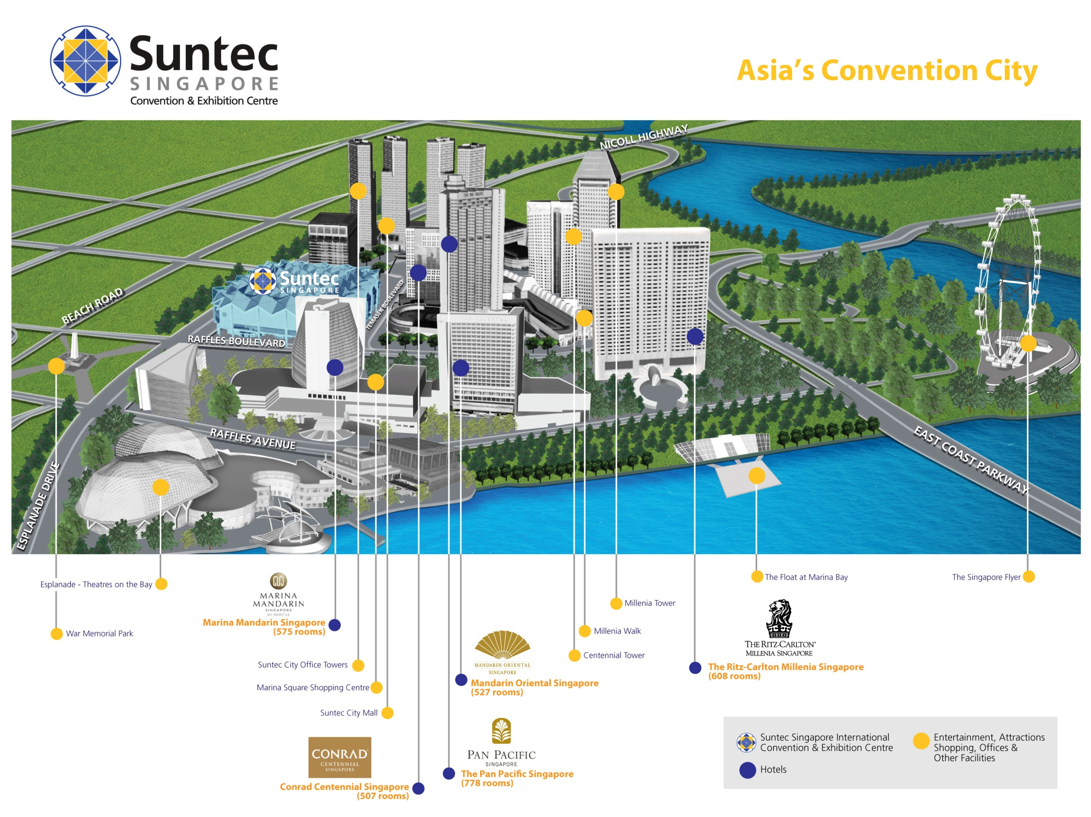
- Conrad Centennial Singapore
  - 2 Temasek Boulevard, Singapore 038982
Website: www.conradhotels.com
- Marina Mandarin Singapore
  - 6 Raffles Boulevard, Marina Square, Singapore 039594
Website: www.meritushotels.com
- Mandarin Oriental Singapore
  - 5 Raffles Avenue, Marina Square, Singapore 039797
Website: www.mandarinoriental.com

- Pan Pacific Singapore
  - 7 Raffles Boulevard, Marina Square, Singapore 039595
Website: www.panpacific.com
- Ritz-Carlton Millenia Singapore
  - 7 Raffles Avenue, Singapore 039799
Website: www.ritzcarlton.com

Internet access and wireless coverage
All meeting rooms will have a wireless network with access to the Internet. Every guest room offers a high-speed Internet access for free. The access to Internet will be granted using the LAN technologies listed below:
- Wireless via WiFi: 802.11bgn and 802.11ac – Both accessible on 2.4GHz and 5GHz

Technical assistance
In case you have any technical problem at the venue (e.g. connecting to internet, finding meeting rooms etc.) please contact for help:
- Ms Mary Ho (mary.ho@suntecsingapore.com); or
- Mr Edwin Low (edwin_kf_low@ida.gov.sg).

Electricity
Singapore’s voltage is 220-240 volts AC, 50 cycles per second. Most hotels can provide visitors with a transformer, which can convert the voltage to 110-120 volts 60 cycles per second. The power plugs used in Singapore are of the three-pin, square shaped type.

Useful information
Currency exchange

The currency in Singapore is the Singapore Dollar. Apart from banks and hotels, money can be changed wherever the sign “Licensed Money Changer” is displayed. Most shopping complexes have a licensed money changer. Visitors are discouraged from changing money with unlicensed money changers

Exchange rate:

Online exchange rates are shown at: http://www.xe.com/
Exchange rate as of 3 November 2015:
US Dollar: 1$ | 1.3992 SGD
Euro: 1€ | 1.5315 SGD

Additional information
Tipping: Tipping is not very common in Singapore. It is prohibited at the airport and discouraged at hotels and restaurants, as most have already added a 10% service charge to the bill. Taxi drivers do not get tipped.
Time Zone: GMT+8:00.
Emergency Number: In case of emergency please dial 999.

About Singapore:

Located in Southeast Asia, Singapore has a land area of about 710 square kilometres, making her one of the smallest countries in the world and the smallest in the region. Although small in size, Singapore commands an enormous presence in the world today with its free trade economy and highly efficient workforce. Also, her strategic location in the region has enabled her to become a central sea port along major shipping routes.

At present, Singapore’s population stands at about 5.5 million people, with English as the main language of instruction, and a mother tongue for each major ethnicity. One of the distinctly Singaporean things one will notice is a ubiquitous collage of cultures. Coming together as a society and living in harmony, there are four major races – namely the Chinese (majority), Malay, Indian and Eurasian. Each community offers a different perspective of life in Singapore in terms of culture, religion, food and language.

Being a multi-racial society, Singapore is as diverse as it is cohesive. With so much to see and do, this is perhaps best experienced through your encounters with the locals. And if you’re feeling nostalgic and looking to discover old world charm, you can explore and experience the island’s key historical landmarks or memorials. You can also embark on a heritage trail and enjoy the sights and sounds at various cultural precincts, notably Chinatown, Little India and Kampong Glam.

For more information about what you can do in Singapore, please visit www.yoursingapore.com.

Contact persons
Infocomm Development Authority of Singapore (IDA)
10 Pasir Panjang Road
#10-01
Singapore (117438)

Mr Edwin Low
Email: Edwin_kf_low@ida.gov.sg

Or

Ms Eunice Lim
Email: Eunice_lim@ida.gov.sg

ANNEX A
INVITATION LETTER REQUEST FORM
All foreign visitors entering Singapore must have a valid passport. Visitors from countries whose citizens require a visa should at the earliest time and well in advance of travel apply for a visa at a Singapore Embassy or consulate. You may need a letter of invitation from the Singapore host, which you will need to present to the Embassy/Consulate in your area in order to obtain your visa. The visa must be requested as soon as possible and at least four (4) weeks before the start date of the meeting and obtained from the office (embassy or consulate) representing Singapore in your country or, if there is no such office in your country, from the one that is closest to the country of departure. In order to obtain the invitation letter, please:
- Fill out the form below
- Provide the electronic copy of your passport (the name, date of birth, nationality, passport number, valid date of passport, etc. must be seen clearly)
- Send as email attachments to edwin_kf_low@ida.gov.sg or Eunice_lim@ida.gov.sg. Please mark as reference in the subject “Invitation letter request for ITU-T Forum on Internet of Things in Smart Sustainable Cities: A New Age of Smarter Living”:
(It is recommended to scan your passport page and email it to us so that it is discernible and can be used).
Company
Applicant Information |  |  |  | Mr Miss Ms Mrs
 |  |  |  | Date of birth :
 |  |  |  | Place of Issue:
 | Date of Issue: |  |  | Date of Expiry:
 | Marital Status:
 | If the country in which you'll obtain your visa is different from your nationality, please indicate it here:
Address | Telephone Number:  Fax Number:  E-mail:
Note
Date of arrival in Singapore |  |  | Date of departure from Singapore
(Please do not forget to attach a copy of your passport photograph page before sending.)
In order to receive an invitation letter, your information should be provided to the host before 21 December 2015.

