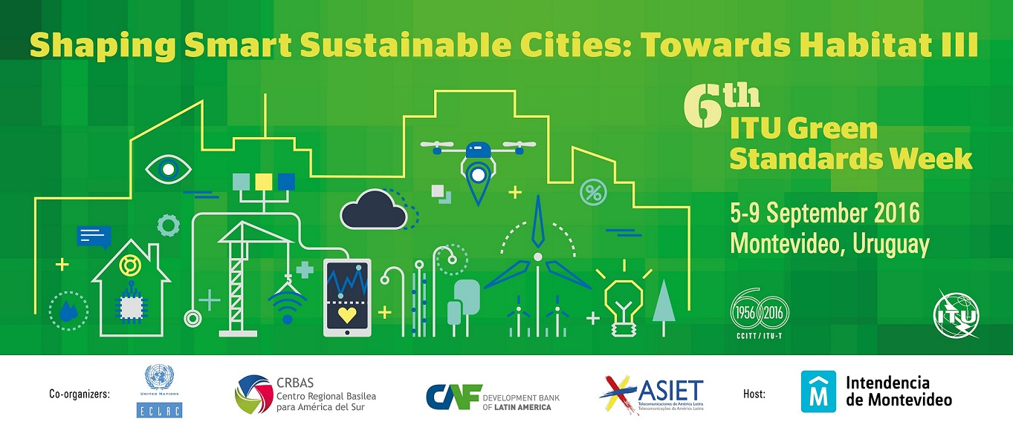

**Montevideo Declaration**

**9 September 2016**

*Adopted by the participants of the 6th Green Standards Week held from 5‑9 September 2016 in Montevideo, Uruguay.*

***Introduction***

*The 6th Green Standards Week 2016 was organized by International Telecommunication Union (ITU) together with the Municipality of Montevideo (IM), the Inter-American Association of Telecommunication Enterprises (ASIET), the Economic Commission for Latin American and the Caribbean (ECLAC), the Basel Convention Regional Centre for the South American Region (CRBAS) and the Development Bank of Latin America (CAF) on the theme “Shaping Smart Sustainable Cities: Towards Habitat III", in Montevideo, Uruguay.*

*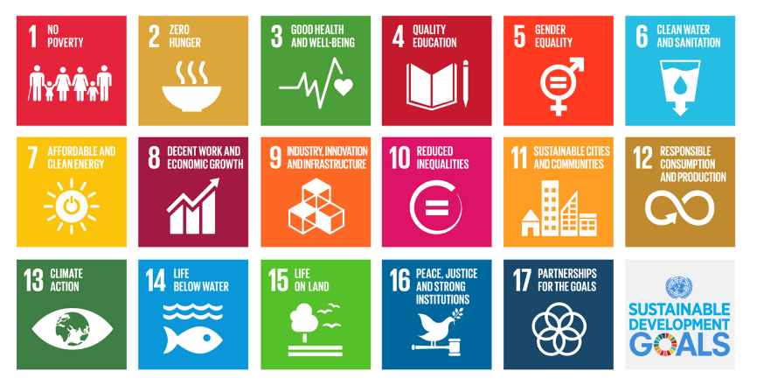In line with the Sustainable Development Goals, this year’s Green Standards Week targeted inclusivity, accessibility, improved quality of life, labor mobility, increased production and resiliency, while retaining information and communication technologies (ICTs) at the epicenter of urban functioning. The intensive discussions held and close cooperation established between the urban stakeholders during the Green Standards Week will better equip them to implement smart sustainable city activities, introduce intuitive policies and prioritize technology-driven infrastructure upgrades in keeping with the sustainable development goals.*

*The Habitat III Conference in October 2016, will highlight the formidable role that urbanization can play in development, tackling global challenges such as poverty and protecting every individuals’ right to a city. This landmark Conference can be leveraged to promote a unique model of urban development premised on ICTs and smart cities integrating all facets of sustainable development and establishing a circular economy. The Habitat III Conference will conclude with the New Urban Agenda, a result of the collaborative efforts of various United Nations agencies, civil society, NGOs, governmental entities, private sector among others.*

*To support the on-going research on smart sustainable cities, the International Telecommunication Union (ITU) and the United Nations Economic Commission for Europe along with other 16 United Nations agencies have created the United for Smart Sustainable Cities (U4SSC) Initiative to advocate for public policies that can facilitate the integration of ICTs for smart sustainable city transitions.*

*With the aim of advancing the global smart city movement for the New Urban Agenda, this year’s Green Standards Week helps provide a sound resource base, catalogue best practices for smart city expeditions and foster the development of international standards to facilitate smart sustainable city transitions.*

***Declaration***

*Therefore, we, the participants of the Green Standards Week 2016 declare our willingness and affirm our commitment to:*

1. **Unlock the potential of ICTs for sustainable urbanization** to develop a competitive and sustainable edge in urban areas in order to improve the living situation of all urban residents and improve access, inclusiveness, transparency and reliability of the infrastructure through the use of open data. ICTs can play an important enabling role in the avoiding of high-emissions infrastructures by supporting the construction of intelligent sustainable buildings and smart transportation systems. Within the urban space, ICTs will also increase access to high quality public goods and services (education, housing, good governance, security, health and access to labor market, etc) to enhance social inclusion.
2. **Create a critical knowledge-base** to establish a semantically interoperable, secure and integrated platform for managing private and public data sets within the Internet of Things (IoT) domain of smart sustainable cities. This platform would sustain the management of large volumes of data from varied sources over a secure IoT ecosystem which focusses on protecting the privacy of users.
3. **Spearhead the smart and sustainable vision** by placing ICTs at the core of reinventing the multi-dimensional urban system which will help accelerate the implementation of more economically vibrant, inclusive, resilient, sustainable, liveable model for cities and their surrounding territories. This vision will generate a global network of self-sustaining and self-reliant townships based on the concept of knowledge economy and digital economy.
4. **Set the stage for a circular economy in smart sustainable cities** to improve resource efficiency and introduce high-quality recycling methods to drastically reduce the generation of waste, including e-waste, and reduce reliance on virgin resources with the urban environment. International standards and sustainable design practices in favor of circular economy can create a virtuous production and reuse cycle which phases out linear consumption patterns and overcomes problems related to availability of resources.
5. **Develop tangible solutions for e-waste management** by implementing credible international standards (e.g. ITU-T Recommendations) which highlight important guidelines for the collection, storage, transport and treatment of end of life devices. International standards advocate for adequate safety measures to be applied for e-waste recycling and prevent illegal dumping of e-waste in developing countries, thereby protecting the environment and the health and safety of populations, as well as conserving valuable resources. The development of local recycling of materials for final disposal.
6. **Contribute to the development of the New Urban Development** bypromoting the implementation of new ICTs to improve urban management techniques and introduce measures to boost accountability and transparency for the delivery of urban services and access to digital information as desired in the New Urban Agenda. The concept of smart sustainable cities with their extensive ICT infrastructure will be boosted in order to create livable green urban spaces with extensive regenerative capacity and reduce unforeseen disruptions in provision of basic services. Based on the premise of smart sustainable cities, the provision of affordable housing, protection of cultural diversity, enhancement of social interactions, facilitation of political participation, safeguarding biodiversity, and protection of other species in the urban realm and fostering safety and social cohesion will be prioritized.
7. **Catalyze the implementation of international standards and key performance indicators for smart city transitions** by unanimously committing to transform urban areas into safe, economically efficient, dynamic, climate change resistant, ecologically resilient, inclusive and sustainable cities by upgrading existing urban infrastructures using ICTs and empowering women and other excluded groups in the decision-making process and improving access to the job market. Implementing international standards with the aim of driving smart city transformations will bring all smart city stakeholders on a level playing field and will promote equitable access to public goods, natural resources and create a fair and enabling business environment across the globe.
8. **Redefine smart sustainable cities as an ecosystem for innovation** to explore the many benefits to be derived by cities, their surrounding areas and communities from the growing range of digital applications and services in smart sustainable city establishments. The essence of smart city transitions is the need to upgrade the core urban infrastructures to improve the capacity of the city to efficiently plan and manage resources, enhance mobility, foster inclusion and improve environmental conditions.
9. 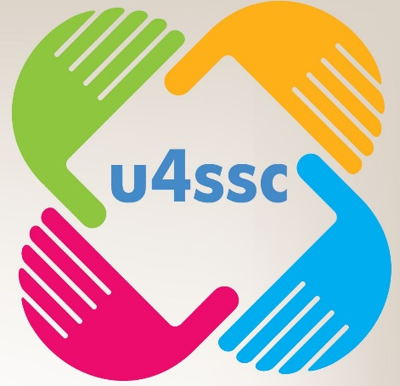**Reaffirm the central role of the United for Smart Sustainable Cities (U4SSC) Initiative** by participating in this initiative and supporting the capacity building activities carried out by the U4SSC to make ICTs accessible and affordable to all citizens in cities. Through the U4SSC, it will be possible to introduce ICT-based transformative action for sustainable urban development and introducing efficient, transparent, and equitable regulatory and legislative frameworks, inclusive planning systems, effective financial management with increased transparency and accountability to all inhabitants and urban stakeholders which will hasten the transition to smart sustainable cities.
10. **Make ICT accessibility a reality** using public procurement policies to improve access to digital innovations for seniors and persons with disabilities to improve their quality of life, promote independent living and achieve equitable communications.
11. **Encourage the use of participatory open data platforms using ICTs** to facilitate knowledge transfer among national, sub-national, and local governments and other stakeholders to enhance effective urban planning and management using effective e-governance techniques.
12. **To promote the right to the city understood as its equitable use** within the principles of sustainability and social justice and with the aim of bringing management closer to the people.
13. **To invite national and local governments, international agencies, non-governmental organizations (NGOs)**, civil society, municipalities, the academia and private sector entities to collaborate and contribute to making smart sustainable cities the core of future urban development strategies.
14. **To invite to participate in priority activities** aimed at the promotion of smart sustainable cities and ICTs as key components of the New Urban Agenda.

Finally, the organizers and participants of this 6th Green Standards Week would like to convey our most sincere appreciation to the Municipality of Montevideo for fostering the multiple interests of the smart sustainable city stakeholders and for hosting the 6th Green Standards Week in this wonderful city.

___________________________