Workshop on Smart Sustainable Cities
Samarkand, Uzbekistan, 1-2 June 2017

PRACTICAL INFORMATION

Event Venue
Registan Plaza Hotel ****
53, Shokhrukh str. Samarkand
140100, Uzbekistan
Tel: +(998) 66 2332475
Fax: +(998) 66 2334976
http://registan-plaza.com/#!/page_home

Registration
Registration will be conducted exclusively online at: https://www.itu.int/online/edrs/REGISTRATION/edrs.registration.form?_eventid=3000977 . To enable us to make the necessary arrangements concerning the organization of the workshop on Smart Sustainable cities, we should be grateful if you would register as soon as possible, but not later than 15 May 2017.

On-site registration will begin on Thursday, 1 June 2017 at 10:00 am at the Forum venue, Registan Plaza Hotel, in the 2nd floor Conference room.

Working languages
The Meeting will be held in English and Russian with simultaneous interpretation.

Accommodation
Hotel Registan Plaza ****
53, Shokhrukh str. Samarkand
140100, Uzbekistan
Tel: +(998) 66 2332475
Fax: +(998) 66 2334976
http://registan-plaza.com/#!/page_home

Accommodation of fellowship holders is envisaged at this hotel.
Located 3 km from Samarkand International Airport, in the city center of Samarkand, this is also the venue of the Forum itself.
The Hotel Registan Plaza in Samarkand is conveniently located in the city centre, in immediate proximity to both the business district and the historical sights of the Old Town. The design and structure of the hotel, as well as its interior, meet the up-to-date standards of the hotel industry. You and your guests are offered high-quality European services with underlying Oriental hospitality.
In the Hotel President, the following facilities are at your disposal: four lifts cater to seven floors; 165 spacious, beautifully furnished and comfortable rooms providing satellite TV, internal and IDD telephones, mini-bars, air-conditioning and well-equipped bathrooms.
The hotel accepts payments in cash in the national currency (sum) and credit cards (VISA, NBU). An exchange office is open every day.
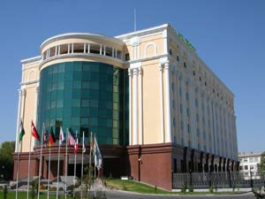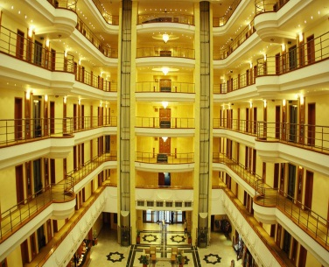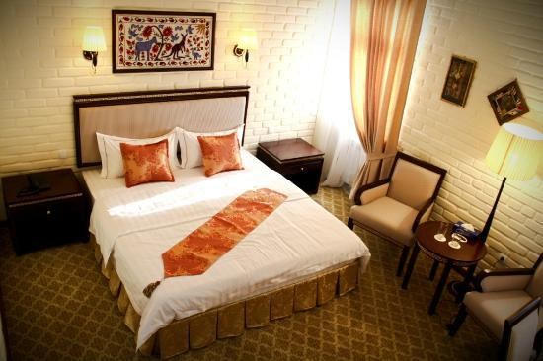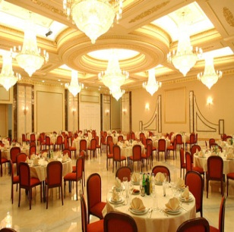

Room Type | Special Rates
Standard Room | USD 130.00/135.00
Double Room | USD 160.00
Deluxe | USD 160.00
Single or double occupancy includes the following:
- All local taxes
- A rich Open Buffet Breakfast
- Free Usage of Life Style Health Center (indoor & outdoor swimming pools, sauna, gym)
- Free Unlimited Wireless Internet service in all Guest Rooms and in public areas.
If participants need a hotel reservation, they are kindly asked to complete the HOTEL AND TRANSFER RESERVATION FORM (Annex 1) and send it to the national coordinator, Ms Umida Musayeva (Senior Specialist of the International Department of the Ministry for Development of Information Technologies and Communications of the Republic of Uzbekistan), by e-mail (u.musaeva@mitc.uz) by 15 May 2017 at the latest. (For inquries, tel: +998 71 238-41-41, mobile: +998 90 371-83-88.)

Transportation
Transportation will be available for delegates from the Samarkand International airport to the hotel. If you need transfers from the airport to the hotel upon your arrival and from the hotel to the airport upon your departure, please provide the relevant information in Annex 1.
Airport
There are currently twelve airports in Uzbekistan that are operated by Uzbekistan Airways National Air Company. Five of the international airports are Tashkent, Samarkand, Bukhara, Urgench and Termez.

Samarkand International Airport meets international standards and the ICAO requirements and receives all the types of aircraft. Following a complete overhaul, the international terminal provides a maximum level of convenience and services for passengers. Flights to Kiev, Moscow, St. Petersburg, Kaliningrad, Simferopol, Kazan, Yekaterinburg, and Tashkent are performed. Located 10 minutes (5 km) from the city center, ground transportation options are: Taxi, Route-taxi, bus.

Train (Tashkent – Samarkand)
For those participants arriving at Tashkent International Airport can use Tashkent – Samarkand high-speed rail line (Afrosiyob). Trains depart from Tashkent to Samarkand at 07:00 or 08:00 and arrive in Samarkand at 09:08 or 10:08 every day.

Entry Requirements and Visa Information for Uzbekistan
Those participants requiring an entry visa for Uzbekistan are requested to contact their local Embassy/Consulate of the Republic of Uzbekistan for information well in advance and to fill in a form at: http://evisa.mfa.uz/registration.aspx.
Visas are issued to foreign citizens in the diplomatic and consular missions of the Republic of Uzbekistan abroad on the basis of the Visa Support Letter (permission from the Ministry of Foreign Affairs of Uzbekistan).
At Tashkent International Airport and Samarkand International Airport, Consular Bureau visas can only be issued to those foreign citizens arriving from countries that do not have diplomatic or consular missions of the Republic of Uzbekistan. In this case, visa support from the host administration is required.
Should participants need visa support, they are kindly asked to complete the Visa Support application form from http://evisa.mfa.uz/evisa_en/?action=vvod of the Ministry of Foreign Affairs of Uzbekistan, a signed copy of the application form and a copy of the passport and send everything together to the national coordinator, Ms Umida Musayeva (Senior Specialist of the International Department of the Ministry for Development of Information Technologies and Communications of the Republic of Uzbekistan), by e-mail (u.musaeva@mitc.uz) by 15 May 2017 at the latest. (For inquries, tel: +998 71 238-41-41, mobile: +998 90 371-83-88.)
There is a bilateral non-visa agreement for citizens of Kyrgyzstan (up to 60 days), Armenia, Azerbaijan, Belarus, Georgia, Kazakhstan, Moldova, Russia and Ukraine.
There is a simplified visa procedure for citizens of Austria, Belgium, Czech Republic, France, Germany, Italy, Japan, Latvia, Malaysia, Thailand, Spain, Switzerland and the United Kingdom. Visitors from these countries can get a multiple entry tourist visa for up to 1 month or a business visa for up to 1 year (Malaysia: up to 6 months). Moreover, a tourist voucher or invitation from a physical or juridical person in Uzbekistan is not required to be submitted to the Ministry of Foreign Affairs of the Republic of Uzbekistan. Visas shall be issued within 2 working days, excluding the day of the document’s acceptance.
There is a bilateral non-visa agreement for up to 90 days for holders of diplomatic passports of the Republic of Korea (up to 60 days), Brazil, Hungary, Latvia, Romania, Slovakia and Turkey. Citizens of these countries possessing a diplomatic passport and accredited as staff members of the diplomatic representations and consular missions located on the territory of Parties as well as members of theirs families can enter and stay without a visa for the whole period of their professional activity.
There is also a bilateral non-visa agreement for up to 90 days for citizens of Romania and Slovakia holding service passports.
Uzbekistan and Japan issue visas without consular fees on a mutual basis.

General Information
The Republic of Uzbekistan is situated between the Amudarya and Syrdarya rivers and occupies 447,400 square meters. The territory spans 1,425 km from west to east and 930 km from north to south. The territory borders on Kazakhstan in the north, on Kyrgyzstan and Tajikistan in the east and southeast, on Turkmenistan in the west, and on Afghanistan in the south.
Uzbekistan is the oldest land in Central Asia, with a history spanning 25 centuries and with a specific historical and cultural community different from that of other regions. Lately, tourism interests in Uzbekistan have noticeably increased and accordingly, the range of travel facilities and services of local tour operators are increasing year after year to attract more travelers to explore this wonderful place.
Throughout Uzbekistan there are many cities where hundreds of architectural monuments of different epochs are located. Among them are Samarkand, Bukhara, Khiva, Shakhrizabs, Termez and Kokand. These cities were the centers of science and art.
The Great Silk Road, one of the most significant achievements in world history, also passed through these cities.
Insurance
Insurance is not necessary for travel to Uzbekistan.
Vaccination requirements and medical facilities
There is no need for vaccination. A Medical Service will be available on-site, with immediate transportation and admission to a hospital for emergencies. During the Meetings, first aid will be provided.
Climate
The climate of Uzbekistan is sharply continental, characterized by high summer temperatures and cool winter temperatures. The average temperature in January falls below -6° C, while the average temperature in June may rise above +30° or +32° C. The average annual atmospheric precipitation on the plains is 120-200 mm, and 1000 mm in mountainous areas. Due to low precipitation, agriculture greatly relies on irrigation.

Time Zone
Uzbekistan is 5 hours ahead of Greenwich Mean Time (GMT+5).
Currency
The national currency of the Republic of Uzbekistan is the Uzbek Sum. All payments must be made in the national currency. Currency exchange offices are available in every city in Uzbekistan. Currency can also be exchanged at bureau de change in hotels and at banks.
Banks are open from 09:00 until 19:00 from Monday to Saturday.

Changed on 25.04.2017.

№ | Currency |  | CB | Buy | Cell
1 | US dollar | 1 UZS | 3714 | 3752 | 3678,63 | USD
2 | EURO | 1 UZS | 3881 | 3921 | 3901.63 | EUR

Telecommunications
Among the Fixed Line Operators there are three companies namely: JS “Uzbektelecom”, JV “Est Telecom” and JV “Buzton”. Mobile operators are Uzdunrobita (trademark “UМS”), Unitel (trademark “Beeline”), Ucell, Rubicon Wireless Comm. (CDMA 800), and UzbekTelecom-Mobile (CDMA 450).
Meeting participants can get Internet access in the respective hotels and at the venue of the meeting. High-quality and cheap telephone services are possible through IP-telephony cards. The Tashkent calling code is +998 71. A local call from a regular phone will cost you around 5,20 Sum per minute. For international calls from Tashkent you should dial 00 + country code and city) or follow the instructions on the telephone card.

Safety:
Security will be guaranteed.

Electricity
The standard supply is 220 volt, 50 Hz, C.A. Outlets for 220 volts are available at hotels.

ANNEX 1

ITU Workshop Smart Sustainable Cities’,
Samarkand, Uzbekistan, 1–2 June 2017

HOTEL AND TRANSFER RESERVATION FORM

This form should be sent to the national coordinator in Republic of Uzbekistan, to ensure booking of hotel and transfer to and from the airport by e-mail: musaeva@mitc.uz,
Family name _______________________________________

First name _________________________________________

Address __________________________________________________________________

_______________________________________________________________________________

Tel ________________________________

Fax ________________________________

E-mail ______________________________

Registan Plaza Hotel ___________single / double room(s) (please clarify)
from________________________ May 2017 to________________________June 2017

Date ____________________ Signature ___________________________

TRANSFER INFORMATION

Transportation will be provided from Samarkand International Airport to the hotel and back

Date of Arrival |  |  | Time of Arrival |  | FLIGHT NO.
Date of Departure |  |  | Time of Departure |  | FLIGHT NO.

__________________

