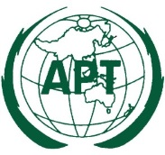 | ASIA-PACIFIC TELECOMMUNITY
 | The 26th APT Standardization Program Forum (ASTAP-26) |  | Document  ASTAP-26/OUT-18
 | 9 – 12 September 2015, Bangkok, Thailand |  | 12 September 2015

Chairman, Coordination Committee
REPORT OF THE 3rd APT/ITU C&I Event

- Introduction
The 3rd APT/ITU Conformance and Interoperability (C&I) Event was held on 7th and 8th September 2015 at the Centara Grand at Central World in Bangkok. This event was jointly organized by APT and ITU. 114 participants registered to this event and 9 exhibitors provided testing/showcasing in this event. In the workshop which was held on 8th September, 16 presentations were introduced from APT member country, invited speaker, exhibitors and ITU.
- Objectives of the event
The objective of the APT/ITU Conformance and Interoperability Event is to foster understanding and promote activities on C&I in the APT region. The event will also directly contribute to capability building and finding a solution for interoperability issues of APT member countries.
- The date of the event
- Conformance and Interoperability Testing: 7th AM September 2015
- Showcasing: 7th PM September – 9th September 2015
- Workshop: 8th September 2015
- Testing and Showcasing
The following testing and showcasing were provided by the exhibitors.
- Key component for Broadband Access Network (NTT electronics, Japan)
NTT Electronics (NEL) is the world's leading provider of key devices for telecom equipment in the fields of long-haul, metro-core and access networks, such as optical passive components, LSIs and transceivers. NEL showcasing provided information and sample display for Optical PLC Splitters which is based on G.671, EPON OLT/ONU MAC LSI and 10G/1G Burst-mode TIA which is based on G.9801 respectively.
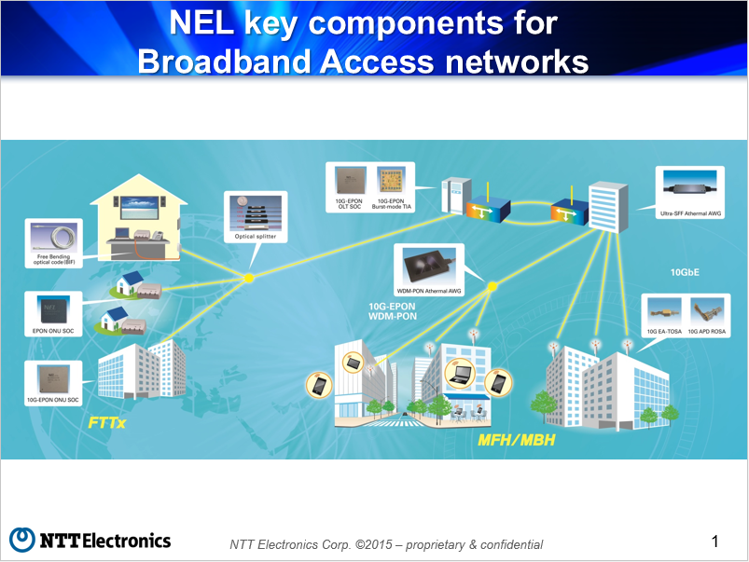
- Smart City (Fujikura Ltd, Japan)
Theme for the exhibition is "smart city". Fujikura showcased the following goods.
- Wireless Broadband Leaky Coaxial Cable (WBLCX).
- Fixed Wireless Access (FWA) for WI-FI.
- Optical Fiber Perimeter Intrusion Detection System (PIDS).
- Quick Charger for Electric Vehicle.
- High Voltage Shore Connection System (HVSC System).
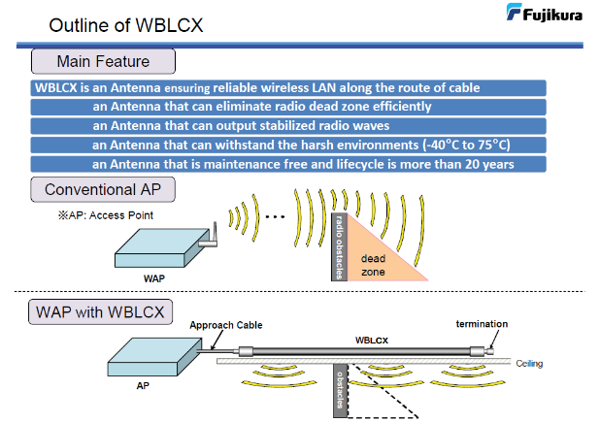
- Optical Sensor and OSP products (Furukawa Electric, Japan)
Furukawa Electric exhibited Optical sensor, Optical cable (Loose tube cable and Drop), Fusion Splicer S178A and Conduit. These products are accommodated to common optical fiber network using ITU-T.G. fiber specifications. Today, we are facing strange weather, we have never seen due to global warming. And we are threatened by various disasters caused by heavy rain. For example, Mudslide, Flood of river, Road submergence, and others. Therefore, it's important to see whether the disasters are likely to occur or not. Furukawa’s Optical sensor system is effective to prevent disaster. These sensors have Simple and Robust structure. So, they have High Reliability and Low Failure Rate. It means the systems are suitable even for harsh environment and cost effective solution. And Furukawa Electric has various optical products and applications. These products are contributing to various industries.
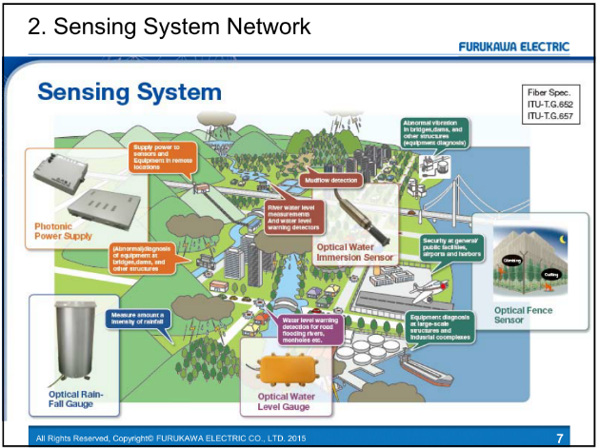
- IPTV (Oki Electric, Japan)
OKI exhibited IPTV solutions based on ITU-T standards (H.721, H.265, et.al). The state of the art, 4K linear TV, was shown on 4K TV. 4K has around 4,000 horizontal pixels. Clear and realistic video contents were delivered over IP network. VoD was also exhibited. Audience could select and watch any contents in the content portal page. Attractive Hokkaido contents was created by Hokkaido Television Broadcasting (HTB). 4K STB was provided by Sumitomo Electric and 2K STB was by Mitsubishi Electric. IPTV server system was provided by OKI.
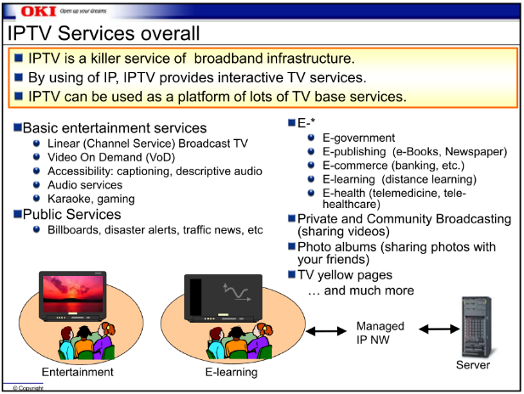
- SDN/NFV (NEC Corporation, Japan)
NEC Corporation exhibited vCPE (virtualized Customer Premises Equipment) by SDN/NFV technology that will simplify the home equipment installation process and the carrier's broadband network access and connectivity. CPE is the physical equipment installed in a customer's home, possibly including the residential gateway (RGW), cable TV decoder, phone terminal, etc. The principle of virtualised CPE is that certain IP functions are shifted away from the residential gateways towards the carrier's own network. The residential gateway is therefore simplified and reduced to the essential components needed in the customer premises, i.e access, modem and L2 switching. By minimising dependence on hardware CPE, vCPE by SDN/NVF technology will speed up the deployment of new services in the home, reduce time to market for new services and enhance the customer's connectivity experience.
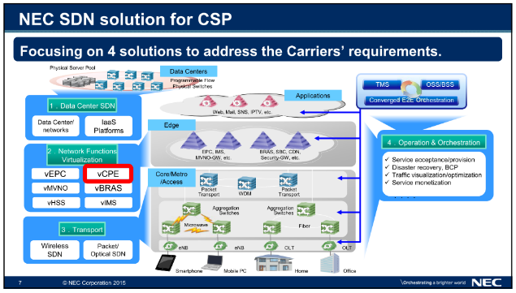
- NGN E2E service (HATS Japan, ITRC Iran)
HATS and ITRC reported the result of NGN End-to-End service interoperability testing supported by APT and ITU. This interoperability event referred to test specifications which are developed on the ITU-T Q.3900 Recommendation series. There are maily two service test items, VoIP test at the UNI of NGN based on ITU-T Q.3948 and Mutimedia communication test at UNI of NGN based on ITU-T Q.3939. 6 campanies (NTT, NEC Engineering, neix, SONY, OKI, ITRC) tried to connect each equipments according to test specificaiton. Specifically, ITRC(IRAN Telecommunication Research Center) connected remotly from Iran to Japan via internet VPN. ITRC member reported challenges for remote interoperability testing on this workshop.
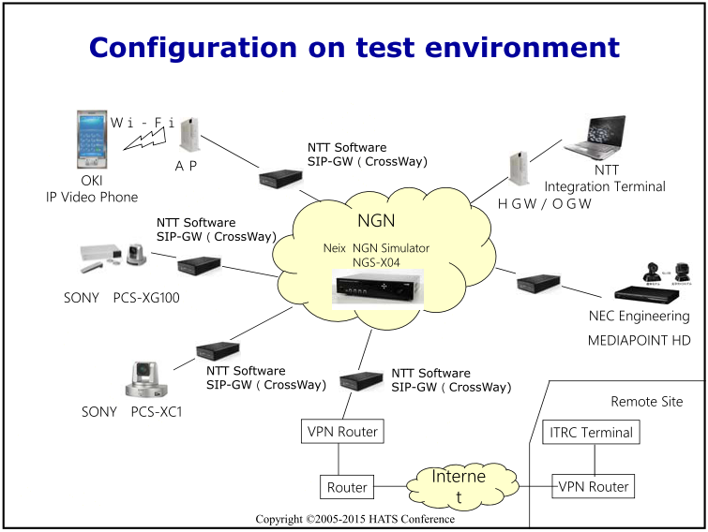
- Automated Mobile Accessibility Inspection Solution (SCE Inc, Rep. of Korea)
SCE Inc. exhibited automated inspection solution called forApp that inspects mobile accessibility conformance to standards, guidelines and best practices. SCE’s forApp service is a user interface analysis service for mobile applications. forApp supports user interface improvement by analyzing each user interface unit of a mobile application. forApp provides automated analysis reports of accessibility issues to help mobile application developers and operators improve their applications. forApp is able to complete this analysis without requiring original source codes or other information about the applications. SCE’s forApp service consists of three key services: an automated application inspection service, an online expert consulting program, and an accessibility statistics database.
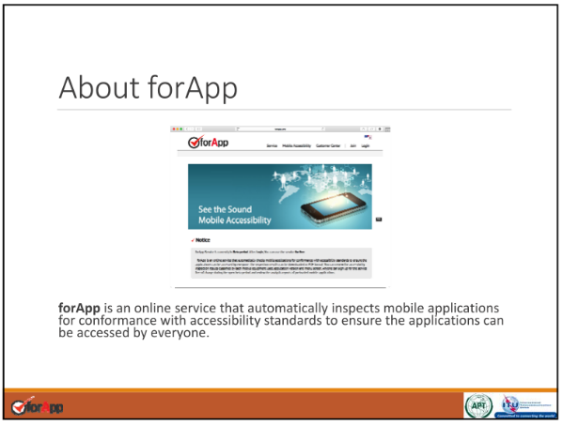
- BAN portable health clinic (NICT, Japan)
The portable health clinic (PHC) was introduced to reduce easily curable diseases and prototyped as a portable-clinic box equipped with major diagnostic tools integrating a simple equation to categorize patients into four groups depending on the level of action or attention required. Body area network (BAN) technologies, such as IEEE802.15.6, are intended not only for hospital/care facility use but also for outdoor uses. The BAN-enabled portable health clinic (BAN-PHC) allows a coordinator to wirelessly and securely gather all measured data from medical devices and sensors. Automatic data retrieval removes human error and reduces time spent on manual data copying. Once data are collected in the coordinator, they are sent to a backend local server for categorization and further remote diagnosis. The health checkup using BAN-PHC was conducted in FY2012-2013 in Bangladesh and the results demonstrated the benefits of the checkup and tele-consultation program as an effective healthcare service in developing countries. Currently we have received many requests to use the BAN-PHC system not only in Asia but also in Africa and are planning to provide the evaluation systems to appropriate organizations in those countries.
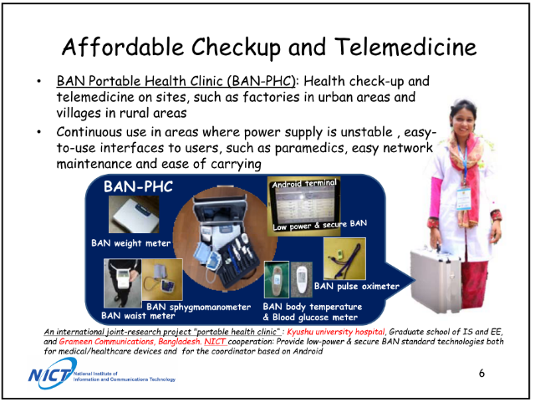
- Seamless network (NICT, Japan)
Seamless network concept exhibited by NICT, supported by Chulalongkorn University, Hitachi Ltd. and Electronic Navigation Research Institute, shows overview of on-going projects of seamless access network technologies related on the ASTAP EG-SACS (Expert group on seamless access communication system.) A radio over fiber (RoF) technology, to realize seamless convergence between radio and optical networks, is applicable not only for the signal transport technology with low latency feature nut also distributed radar system in the millimeter-wave band for foreign object debris detection. The field trial demonstration of the millimeter-wave radar system at Thailand is also shown by the movies.

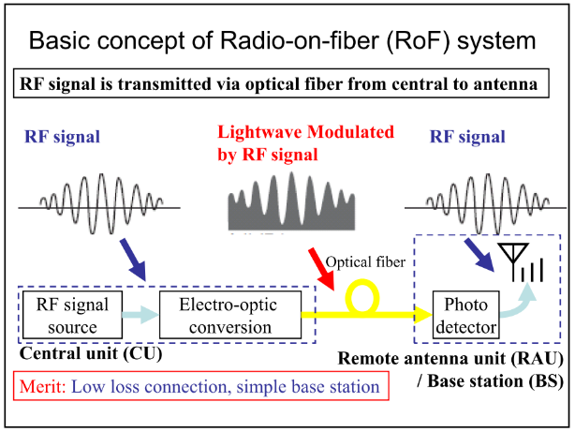

- Presentations in the workshop
All presentation files can be found in the URL below.
http://www.aptsec.org/2015-CI3-DOCS-INP
- C&I3/INP-03 Testing activities for Conformity Assessment of Telecommunications in Vietnam (Mr. Nguyen Van Khoa, Vietnam Telecommunications Authority)
This presentation introduces following main topics:
  - An overview of the conformity assessment in Vietnam in general and focus in telecom industry;
  - Conformance testing activities;
  - Role of Authority of Telecommunications in Conformity Assessment, Conformance Testing and its recent development in testing activities;
  - Challenges and our action plan regarding to Conformity Assessment.
- C&I-3/INP-04 Proposed Innovative Optical Cable Solution for closing the urban-rural digital divide (Global Pan Inc.)
This presentation introduces following main topics.
  - Broadband backhaul is mandatory form cities to rural areas. Comparing wired and wireless solution, optical cable solution is 1000 times faster and lower CAPEX than microwave solution. Estimated cost of cable plus construction is 4500-5500US$/km with shallow direct burial using a handy pick. Minimum CAPEX/OPEX available with Optical Solution if direct-surface installation is allowed with later burying, submerging and suspending.
  - ITU-T SG15 develops a new Optical cable Standard for direct surface installation. It was agreed to develop new cable standards in Jun 2015.
  - Innovative optical cable with a steel pipe allowing direct-surface installation. It is thin, lightweight, robust, easy-handling. The metal pipe protecting fibers against crush, rodent, moisture/water, high/low temp.
  - Thin and lightweight cable is cost-effective and easy cable laying by do it yourself. It is possible to lay by helicopter.
  - Pilot tests are being conducted and planned in Japan, Bhtan, Nepal, India (MP state). Multiple countries express interests in conducting pilot tests.
- C&I-3/INP-05 Important Keys for Optical Access Network (NTT Corp.)
This presentation introduces following main topics.
  - FTTH is already matured in Japan. More than 26 million subscribers with stable and high quality network. NTT constructs infrastructure based on ITU standards to avoid vendor lock-in, to realize stable and high quality system and to promote competition between vendors.
  - FTTH quality depends quality of engineer largely and it should be improved from the beginning because it is almost impossible to re-build whole FTTH network after growth.
  - NTT group has experience to provide training and consulting to other carriers.
- C&I-3/INP-06 Components of Broadband Access Network (NTT Electronics)
This presentation introduces following main topics.
  - NEL provides codec LSI, video codec system, LSI for broadband core/access network and optical communication products.
  - Optical splitters has features, 1. Completely passive, wide wavelength range of 1260 to 1660 nm, wide temperature range, Compact package, suitable for cassette, Good performance/High reliability（based on ITU-T Recommendation G.671 and L.37）. NEL has shipped 8 million of splitters within 10 years all over the world. There is no failure in the field so far.
  - WDM-PON AAWG (NG-PON2) has the features, 1. Wide operation temperature range, 2. It can be used in both of C-band and L-band with cyclic design, 3. Water immersion and corrosion resistance tested.
  - NEL provides MAC SoCs and Burst-mode TIA are developed for next generation 10G-EPON as key components.
- C&I-3/INP-07 Report of Smart City showcasing (Fujikura Ltd.)
This presentation introduces following main topics.
  - Wireless Broadband Leaky Coaxial Cable (WBLCX) is an antenna which has the features, 1. It is ensuring reliable wireless LAN along the route of cable, 2. It can eliminate radio dead zone efficiently, 3. It can withstand the harsh environments, 4. It is maintenance free and lifecycle is more than 20 years.
  - WBLCX enables 1. WAP can be installed anywhere, 2. Reduce the number of WAPs, 3. Eliminate signal shadows. It is suitable for using in hotel, hospital, underground carpark, shopping mall and factory warehouse. It is used for Japanese Shinkansen.
  - Fujikura provides Optical Fiber Perimeter Intrusion Detection System (PIDS) for security of airport, seaport, military area, chemical plant, solar/nuclear power plant and high speed train area.
  - Fujikura provides solutions for FWA, Quick Charger for EV and High-Voltage Shore Connection System (HVSC System).
- C&I-3/INP-08 Introduction of Optical Fiber Sensors (Furukawa Electric)
This presentation introduces following main topics.
  - Optical fiber sensors has strong features for lighting resistant, external noise resistant, high reliability of low failure rate, cost effective and monitoring to extensive area.
  - Furukawa Electric provides solutions for optical water level gauge, optical water immersion sensor, optical rain-fall gauge, photonic power supply using optical fiber and optical fence sensor.
  - Furukawa electric also provides optical fiber, optical cable and fusion splicer S178A.
- C&I-3/INP-09 Report of IPTV Testing and showcasing (Oki Electric)
This presentation introduces following main topics.
  - UHDTV (Ultra HDTV) enables 4 times higher resolution by 4K and 16 times resolution by 8K. 8K realizes outstanding clear and realistic image/video services. ITU-T H265 is suitable for 4K/8K video coding method.
  - IPTV testing in the 3rd C&I event checked the different points between ITU-T H.721 (2010) and H.721 (2015) such as video codec (H.265), audio codec (ALS, DTS-HD), Resolution (up to 4K) and VoD protocols (DASH).
  - IPTV showcasing demonstrated; 1. Linear TV that supports ITU-T H.264, H.265 and H.721 (2015), 2. 4K UHDTV contents and 3. Contents encoded both 4K/H.265 and 2K/H264 format.
  - IPTV showcasing displayed; 1. IPTV Head-end by Oki Electric, 2. IPTV STB by Mitsubishi Electric and 3. IPTV STB by Sumitomo Electric.
- C&I-3/INP-10 Telecom Carrier SDN solutions: vCPE (NEC Corp.)
This presentation introduces following main topics.
  - NEC is focusing 4 solutions 1. Data center SDN, 2. Network Function Virtualization, 3. Transport SDN, 4. Operation & Orchestration to address the Carriers’ requirements.
  - NEC’s NFV solution has following key benefits. 1. Capex reduction, 2. Opex reduction, 3. Flexible and faster new revenue creation, 4. Resiliency for traffic surge and disaster. It has openness, interoperability, scalability, operation efficiency, carrier-grade and business opportunities.
  - NEC provides virtualized CPE solution. This solution enables home LAN extension and per device policy management.
- C&I-3/INP-11 Report of NGN End-to-End Service interoperability testing on APT/ITU C&I event 2015 organized by HATS (HATS Japan, ITRC Iran)
This presentation introduces following main topics.
  - NGN E2E service interoperability testing organized by HATS on 14th July in Japan. 5 Japanese companies and Iran Telecommunication research center joined this event.
  - This testing event aimed to assure the interoperability of the NGN equipment which complied with ITU-T Recommendations and TTC standards.
  - Testing for VoIP and Multimedia service were performed. NGN-SIP communication was successfully done for VoIP and Multimedia service but video communication caused error and frozen video picture because of the packet loss.
  - Iran Telecommunication research center remotely joined from Iran and they confirmed interoperability between Japanese and Iran SIP terminal was successfully performed.
- C&I-3/INP-12 Report of Automated Mobile Accessibility Checkers solution (SCE Inc.)
This presentation introduces following main topics.
  - Discrimination acts are requested by laws and regulations in many countries and mobile accessibility supports people with disabilities to access to websites.
  - Focus and alternative text are the key components of mobile accessibility in order to maintain compatibility with the system-provided accessibility tools.
  - forApp is the online service developed by SCE Inc.. It automatically inspects mobile applications for conformance with accessibility standards and makes an inspection report.
  - 6 common issues on focus and alternative text can be identified by forApp services.
- C&I-3/INP-13 Affordable BAN Portable Health Clinic and its Enhancement (NICT)
This presentation introduces following main topics.
  - NCD (Non Communicable Diseases) has increased in low and middle income countries and it causes catastrophic increasing of medical expenditures. BAN-PHC (BAN Portable Health Clinic) is a portable and affordable solution to provide health check-up and telemedicine on sites without power supply.
  - Bring it to the site and use measurement devices for automatic categorization (B-Logic). The collected data is diagnosed in the remote medial help center and it provides medical certificate or prescription if triage is high.
  - 7792 examinees were checked their health and 3080 were diagnosed affected and emergent by telemedicine in 2013.
  - China and Japan works on common medical BAN standards of IEEE802.15.4n, 4j and 6.
  - BAN-PHC has been enhanced to use 400MHz for sneak wireless and long-haul communications. It also uses BAN Beam switch-over and non-invasive sensors.
- C&I-3/INP-14 Report of Seamless Network Showcasing (NICT)
This presentation introduces following main topics.
  - Radio on fiber (RoF) is a technology to transmit RF signal via optical fiber from central unit to remote antenna unit. Its merits are low loss connection and simple base station.
  - It can be used for application to 5G mobile fronthaul/backhaul and high-speed transmission at millimeter-wave/terahertz wave.
  - RoF expands digital coherent optical transmission to high-speed wireless bases station in the mobile fronthaul network.
  - Seamless optical/radio link with RoF is used for resilient network and enhance total capacity of MIMO.
  - Milimeter wave over 60GHz transmission is used for highly-precise optical clock signal generator, high-capacity MMW-RoF backhaul for railways system and radar system for high-precision imaging in the airport.
- C&I-3/INP-15 ITU C&I Programme Pillars 1 and 2 (ITU)
This presentation introduces following main topics.
  - ITU-T takes the lead role of pillar 1 and 2 of C&I Programme which is defined in Resolution 177 (ITU PP-14).
  - Main outcomes of the pillar 1 Conformity Assessment are Product Conformity Database, Whitelist of mobile phones, Pilot projects of conformity assessment, Guideline of Testing laboratories recognition procedure and establishment of Conformity Assessment Steering Committee (ITU-T CACS)
  - ITU-T organizes Pillar 2 Interoperability event such as HATS interoperability event on NGN supported by ITU and APT, E-health testing and showcasing event, APT/ITU C&I event and ITU test event.
- C&I-3/INP-16 ITU C&I Programme Pillars 3 and 4 (ITU)
This presentation introduces following main topics.
  - ITU-D takes the lead role of pillar 3 Capability building and 4 Establishing C&I programmes in developing countries of C&I Programme.
  - ITU Forums was held in each region and study for test centres and capacity building in the regions.
  - ITU is implementing proposals on human capacity building and assists developing countries in the establishment of test facilities and in cooperation with international institutions such as UNIDO, ILAC, IAF.
  - ITU provides training on C&I in regions such as type approval testing for mobile terminals, homologation procedures and market surveillance as activities of pillar 3 Capability building
  - ITU provides guidelines such as establishing conformity and interoperability regimes – basic guidelines as activities of pillar 4 Establishing C&I programmes.
  - ITU provides direct assistance through the regional offices for regulatory framework, institutions roles and typical procedure, mutual recognition agreements, funding and roadmap/feasibility study.
- C&I-3/INP-17 Activities of ITU-T SG11 on C&I (Vice-Chairman, ITU-T SG11)
This presentation introduces following main topics.
  - ITU-T SG11 has responsibility on signalling requirement and protocols and test specifications. WP4 of SG11 is the leading WP of test specifications, conformance and interoperability testing.
  - Major outcomes of ITU-T SG11 on C&I are establishing the conformity assessment steering committee (ITU-T CASC), a living list of ITU-T Recommendations, reference table of ITU-T Recommendations and corresponding test specification and Pilot projects.
  - Most telecom operators have implemented the IMS and efforts to assure interoperability are needed to adapt TE to IMS because of the different implementation of SIP-IMS protocols. ITU-T Q.3940 and series ITU-T Q.3941.1-Q.3941.4 were recently approved for this purpose.
- C&I-3/INP-18 C&I Activities in ITU-T SG16 (Chairman, ITU-T SG16)
This presentation introduces following main topics.
  - Q25/SG16 “IoT application and service” is going to join new SG20 “IoT and applications, smart cities”.
  - SG16 has held 8 testing events, 2 application challenges and 14 showcasing since July 2010. Those event was held in Singapore, Pune, Rio de Janeiro, Dubai, Bangkok, Sapporo and Tshkent etc.
  - SG16 believes that Showcasing is also very important to show the users about the performance of new technologies, and ensure that the technologies are already put in market.
  - SG16 is planning to continue enhancing the C&I testing events, including the first IPTV Conformance Testing in Geneva (Oct. 2015) and Rio Paralympic Games.

- Workshop Wrap-up
The future plan of the APT C&I event were discussed in the wrap-up session in the C&I workshop. The moderator suggested to deliver the questionnaire to ask the opinion and evaluation of the APT members and take them into consideration for the next action of APT on C&I. EG ITU-T in the ASTAP will discuss the results of the questionnaire and make a report to WG PSC in the ASTAP-26.
- Discussion for the future event
Conformance and interoperability is one of the high interested issues in the global telecom market especially in the developing countries. To assure the end to end interoperability of the service and ICT products is a strong demand of the telecom operators and service providers. In the recent years, emerging technologies and services are innovated such as cloud computing, IoT, bigdata and convergence of the vertical industries has been progressing. Many forums and SDOs are challenging to harmonize various technologies and products. Standardization efforts are needed to achieve interoperability among these diverse services, networks and devices.
In the 3rd APT/ITU C&I event, NGN E2E service testing and IPTV testing were successfully performed. 9 exhibitors displayed their technologies, solutions and products in the showcasing. 16 presentations were introduced in the workshop and useful information and innovative idea were shared among APT member countries.
ASTAP EG ITU reviewed the report of the third C&I event which was held on 7th & 8th in September 2015 back to back with the ASTAP-26. EG ITU also briefly reviewed the summary of the questionnaire and recognized that most of the member of ASTAP who provided the answer to the questionnaire supported to continue the C&I event. The meeting discussed the future plan of the event and agreed that EG ITU would create C&I coordination committee to discuss the detailed plan of the next action on APT C&I at the ASTAP-27 in March 2016. EG ITU meeting did not get any consensus on the date and the contents of the next event but the chair of EG ITU abstracted some ideas from the answer of the questionnaire as follows;
- Support APT member countries based on ITU’s C&I Pillar 3 Capability building and Pillar 4 Establishing C&I test center. It is proposed that APT provides C&I training supported by ITU regional office.
- Attract more exhibitors and audience from APT member countries and out of APT member countries and increase participation from private sectors especially telecom operators. The following ideas were proposed
  - Enhance the collaboration with ITU such as collocated event with ITU meeting
  - Joint with other APT’s events such as APT Policy and Regulatory Forum (PRF)
  - Create a new APT forum independent of ASTAP to organize C&I event.
- Closing
The chair of the coordination committee expressed his appreciations to all participants and exhibitors of C&I event. He would like to say gratitude to member of coordination committee and APT secretariat for their support as well.

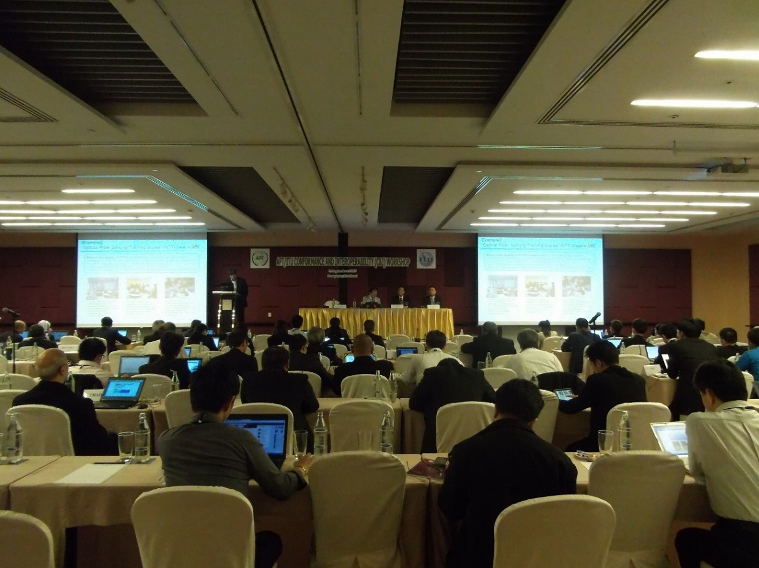
Workshop

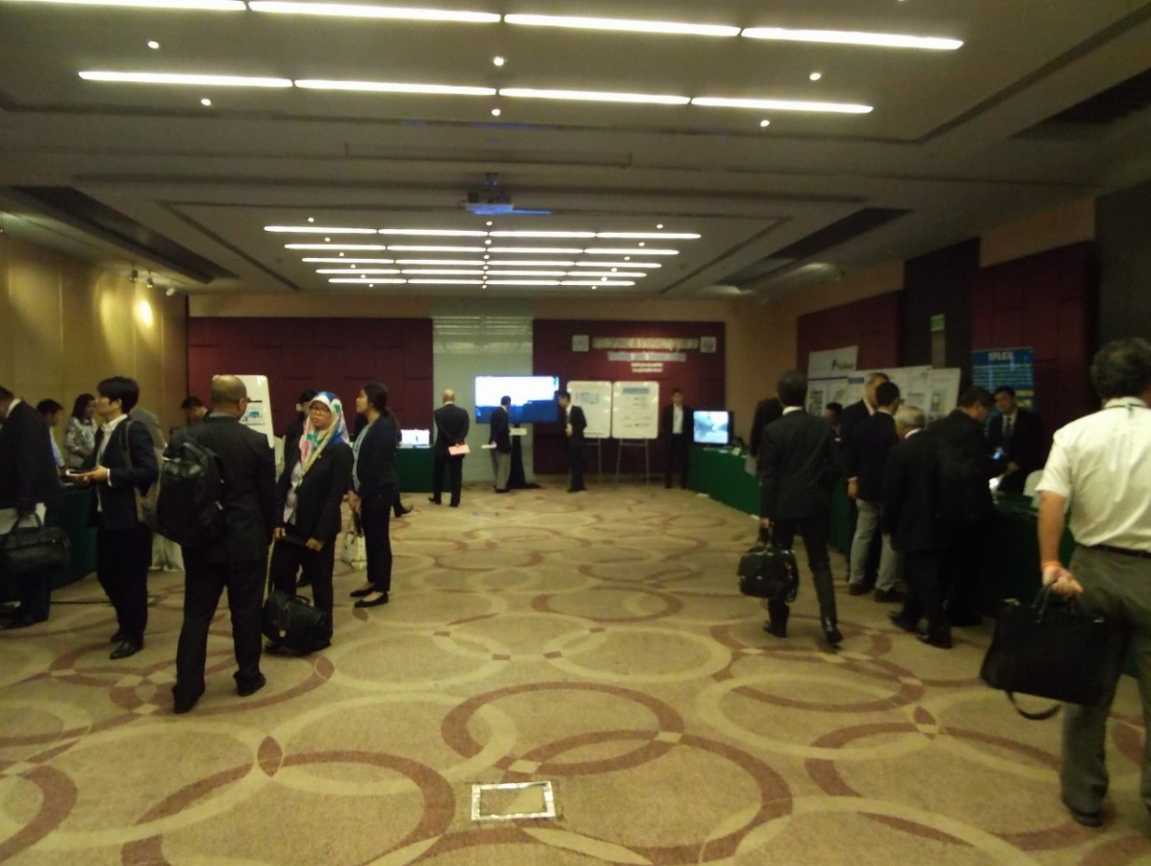
Showcasing

Annex
SUMMARY OF THE RESPONSES FOR THE QUESTIONAIRE
TO EVALUATE THE C&I EVENT 2015

