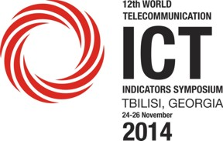 | 12th ITU World Telecommunication/ICT Indicators Symposium (WTIS)  24-26 November 2014  Tbilisi, Georgia | 

PARTICIPANT INFORMATION FORM

Delegates are kindly requested to fill in the fields clearly to facilitate logistical arrangements.

DELEGATE DETAILS:

First Name:……………………………………………………………… Surname: …………………………………....................................
Title: ……………………………………………………………………………………………………………………………….................................
Organisation: …………………………………………………………………………………………………………………………………………………..
Address of Organisation: ………………………………………………………………………………………………………….......................
Telephone : ……………………………………………..........................Fax: ……………………………………………………………………..
E-mail address: ……………………………………………………………………………………………………………………………………………….

FLIGHT INFORMATION:

Arrival Date and Time: …………………………………………………… Flight Number: …………………………………………………….
Departure Date and Time: ……………………………………………… Flight Number: ……………………………………...............
Please include all flight details in order to facilitate pick-up service at Tbilisi airport.

ACCOMMODATION:

Name of Hotel in Tbilisi: ……………………………………………………………………..............................................................
Check-in date: .................................................................. Check-out date: ..................................................

ANY OTHER RELEVANT DETAILS:

___________________________________________________________________________________
PLEASE SEND COMPLETED FORM TO:
Natia Shovnadze
transport@gncc.ge
Tel: +995 32 239 93 22- Mobile: +995 593 55 25 05

