 | 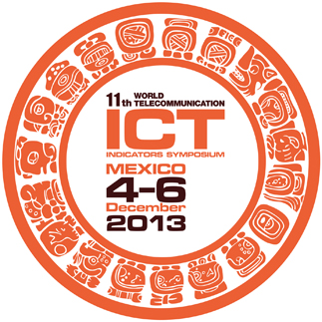 | 

PARTICIPANT INFORMATION FORM
11th World Telecommunication/ICT Indicators Symposium (WTIS)
Mexico City, Mexico, 4 – 6 December 2013

Delegates are kindly requested to fill in the fields clearly to facilitate logistical arrangements.

DELEGATE DETAILS:

First Name:……………………………………………………………… Surname: …………………………………..................................

Title: ………………………………………………………………………………………………………………………………...............................

Organisation: …………………………………………………………………………………………………………………………………………………

Address of Organisation: …………………………………………………………………………………………………………......................

Telephone : ……………………………………………..............................Fax: ………………………………………………………………..

E-mail address: ………………………………………………………………………………………………………………………………………………

FLIGHT INFORMATION:

Arrival Date and Time: …………………………………………………… Flight Number: ……………………………………….
Departure Date and Time: ……………………………………………… Flight Number: ……………………………………...

Please include all flight details in order to facilitate pick-up service at Mexico City International Airport, Mexico.

ACCOMMODATION:

Name of Hotel in Mexico City: ……………………………………………………………………..............................................
Type of room: .................................................................................................................................................................
Occupancy: □ Single room □ Double room
Check-in date: .................................................................. Check-out date: ................................................

ANY OTHER RELEVANT DETAILS:

_________________________________________________________________________________

PLEASE SEND COMPLETED FORM TO:

Rebecca Cedeno
rebeca.cedeno@ift.org.mx
+52 55 501 52236

