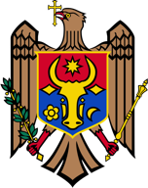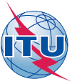
Ministry of Information Technology and Communications

of the Republic of Moldova
WORKSHOP ON THE NATIONAL DIGITAL INNOVATION FRAMEWORK
DATE: 12th May 2017 / VENUE: CODRU Hotel
Time | Activity
08:00hrs – 8:30hrs | - Arrival and Registration of Participants
08:30hrs – 08:45hrs | - Opening Remarks: Ministry of Information Technology and Communications of the Republic of Moldova
08:45hrs – 09:00hrs | - Introduction to the Session by ITU
9:00hrs – 10:25hrs | - Goal Setting
10:25hrs – 10:35hrs | Tea/Coffee Break
10:35hrs – 11:25hrs | - Gap Identification
11:25hrs – 12:15hrs | - Building the Framework
12:15hrs – 12:30hrs | - Digital Transformation Outcome Document
12:30hrs – 13:30hrs | Lunch & Networking
13:30hrs – 15:00hrs | - Project Buildings
15:00hrs – 15:15hrs | Tea/Coffee Break
15:15hrs – 16:00hrs | - Ways forward/presentations
16:00hrs – 16:15hrs | - Closing

