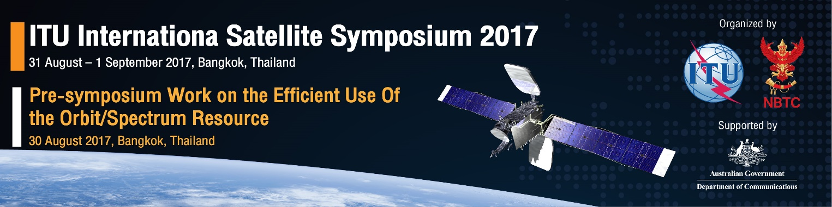
Registration Form

Personal Information
Title | ☐ Mr. ☐ Ms. ☐ Mrs. ☐ Dr. ☐ Prof. ☐ Other:
First Name
Family Name
Organization
Position (Job Title)
Contact Information
Address
City/Town
Postcode
Country
Phone No.
Mobile No.
Email

I will attend | ☐ Pre-symposium Workshop on the efficient use of the orbit/spectrum  30 August 2017  ☐ International Satellite Symposium 2017  31 August – 1 September 2017

Please return the completed registration form to:
Mr Wisit Atipayakoon, Email: wisit.atipayakoon@itu.int
Or fax to, +66 2575 3507

