CV of Mr. XIE, Yi
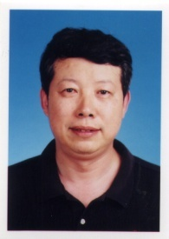
Mr. XIE, YI
Vice President
China Academy of Information and Communication Technology (CAICT)
Tel: +86 10 62301646
Fax: +86 10 62304364
E-mail：xieyi@caict.ac.cn

EDUCATION BACKGROUND
1987-1990 Beijing University of Posts and Telecommunications
Doctor Degree of Engineering, Microwave & Electromagnetic Field
1982-1985 National Institute of Metrology, China
Master Degree of Engineering, Metrology
1978-1982 Changchun University of Science and Technology
Bachelor Degree of Engineering, Optical Physics

WORK EXPERIENCE
2002-NOW Vice President, China Academy of Information and Communication Technology
1990-2002 Engineer & Director, Telecommunication Metrology Center of MII
1985-1990 Engineer of National Institute of Metrology
1982-1982 Technician of Huazhong Precise Instrument Factory, Hubei Provence, China

