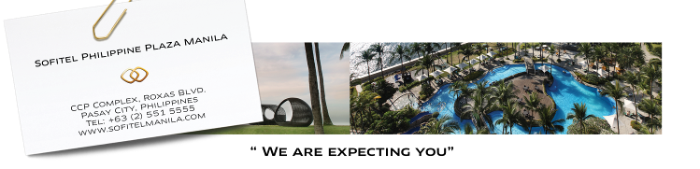

Department of Science and Technology
National ICT Planning Division
(Regional Development Forum)
June 5-7, 2016
ROOM RESERVATIONS REQUEST FORM
To help us offer you the best possible service, kindly complete the form and email to H6308-SL10@sofitel.com prior to Friday, 6th of May 2016. Should you have further concerns, please do not hesitate to contact Madelene Sy, Sales Manager at +63-917-3092119 or +63-2-8326950

- Personal details:
First Name
Last Name
Position
Name of Organization
Date of birth (DD/MM/YY)
E-mail Address
Contact Number
Passport No./ Expiry Date
(Please present upon check-in)
Country/Mailing Address/ Postal Code

Personal details of Guest sharing in the room:
First Name
Last Name
Date of birth (DD/MM/YY)
E-mail Address

- Please specify the room type:
 | Room Type | Dates of Stay | Room Rate  (Per Room Per Night)
 | Superior Room – Single |  | Php 6,200.00 nett
 | Superior Room – Double |  | Php 7,000.00 nett
 | Luxury Room – Single |  | Php 7,200.00 nett
 | Luxury Room - Double |  | Php 8,000.00 nett
 | Club Room – Single |  | Php 13,204.00 nett
 | Club Room – Double |  | Php 14,186.00 nett

- Room rate inclusive of Buffet Breakfast at the Spiral
- Room rate inclusive of 10% service charge, 12% VAT and 0.825 local city
Tax mandated by the government
- All rooms can accommodate a maximum of two (2) adults and one (1) child
Below 12 years old.
- Special room rates are valid until May 6, 2016. After this date, published rates shall apply and rooms are subject to availability.

- Room preference subject to availability at check in:

 | Smoking Room |  | Two Separate Single Beds
 | Non Smoking Room |  | King Size Bed

- Guarantee Details to be used to secure the reservation:
Credit Card Type
Credit Card No. (16Digits)
Expiry Date
Cardholder’s Name
Cardholder’s Signature

Cancellation should be received on or before May 16, 2016.

All confirmed reservations as of May 16, 2016 will be charged
100% of the total room rate and booking is no longer cancellable.
In case of non-arrival full stay rate will be charged likewise.

- Flight Details: (Optional)

 | Flight Number | Time
Arrival Date :
Departure Date:

- We can arrange your Airport Transfers: (Optional)

 | Airport Pick-Up |  | Airport Drop-Off
 | MB S-Class (white) PHP3,900 |  | MB S-Class (white) PHP3,900
 | MB E-Class (black) PHP3,200 |  | MB E-Class (black) PHP3,200
 | Toyota Grandia PHP 2,600 |  | Toyota Grandia PHP 2,600
 | Toyota Altis PHP 1,500 |  | Toyota Altis PHP 1,500

- Check-in/Check-out (Local Time):
The Hotel’s check in time is 2:00pm and check out time is 12:00 noon.
Additional charges may apply to early check-in and late check-out and
are subject to availability. Check-out from 6:00pm will incur a full
night charge at the room rate quoted.

- Deposit:
Front Desk shall require upon check-in a deposit equivalent to total
room charge and additional refundable deposit of Php 3,000.00 per
day to cover incidental charges.

