Saman Perera – Senior General Manager Information Systems – Mobitel (Pvt) Ltd
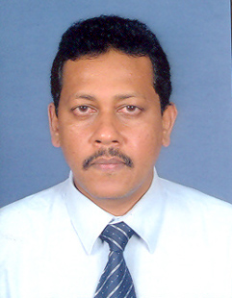
Saman Perera currently serving as Senior General Manager Information Systems for Mobitel and responsible for overall Information Systems strategy and infrastructure for the organization. Prior to Joining Mobitel, he was with Lanka Bell (a fixed wireless telecommunication service provider) as Senior Manager Information Technology and was responsible for overall management of Information Technology Division.
Saman brings in over 24 years of experience in all areas of Information Technology out of those 21 years he has worked for Mobile/wireless telecommunication providers.
He has served as a council member of the Computer Society of Sri Lanka and has made contributions to the industry as a speaker at the National Information Technology Conference in several occasions. He has served as a visiting lecturer for the Masters in Information Systems Management postgraduate program conducted by Faculty of Graduate Studies, University of Colombo. Also serving as an eternal examiner (thesis evaluation) for MBA in IT conducted by Computer Science and Engineering department, University of Moratuwa.
He holds MBA in Management of Technology from University of Moratuwa, Master of Science in Computer Science from University of Colombo and Bachelor of Science from University of Colombo.

