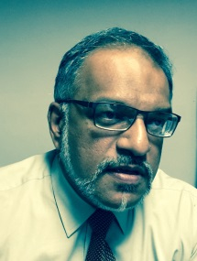**Mr. M I Deen, General Manager**

Enterprise Solutions, Sri Lanka Telecom

Over 20 years experience embracing Customer Services, IT, Data Communications and Internet, IPTV, and Cloud Computing in his tenure at Sri Lanka Telecom, in various roles in Engineering, System Architecture and Development, Project Management, Operations Management, leading to his present position as General Manager Enterprise Solutions. Further he is the Program Manager of the SLT Cloud Project to introduce a Service Provider class cloud in Sri Lanka. He holds degrees of BSc (Eng) Hons in Electronics, Computer and Systems Engineering, MSc in Digital Communication Systems, from Loughborough University, UK, and MBA from Postgraduate Institute of Management, University of Sri Jayawardhanapura. He is a Chartered Engineer and Chartered IT Professional, and has membership of the bodies IET (UK), IESL (Sri Lanka), BCS (UK) and MCS (Sri Lanka).