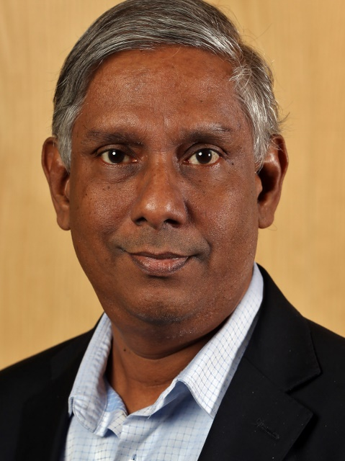

Prof. Gihan V. Dias

Prof. Dias graduated from the University of Moratuwa in 1985 and was awarded a doctorate in Electrical Engineering and Computer Science from the UC Davis in 1992.

In addition to being a Professor in Computer Science and Engineering at the University of Moratuwa, Sri Lanka he serves as the Domain Registrar of the LK Domain Registry and the President of the Federation of Information Technology Industry Sri Lanka – Software Chapter.

His a member of the Asia-Pacific Top-Level Domain Association (APTLD) board, a Trustee of the Internet Society and President of its Sri Lanka Chapter.

He has been active in several areas of computing, including computer networking, language technologies, security, distributed event processing, Internet identity and personal cloud.

He has assisted many public and private organisations to build, secure, and make best use of their computer systems. He was inducted to the Internet Hall of Fame in 2013.

