ASIA-PACIFIC REGIONAL FORUM ON IMT TOWARDS 2020 AND BEYOND

Introduction
The ITU Asia-Pacific Regional Forum on “IMT towards 2020 and beyond – Technology & Spectrum” is being organized by ITU and is kindly hosted by Ministry of Information and Communication of Viet Nam with support from various sponsoring entities; on 11th of February 2014 in
New World Saigon Hotel
76 Le Lai Street, District 1,
Ho Chi Minh City, Viet Nam
Tel: +84 8 3822 8888
Fax: +84 8 3823 0710
Email: saigon@newworldhotels.com
Hotel Accommodation
The following hotels near the meeting venue are recommended for participants to stay during the meeting.

Name of Hotel | Room Rate/  Room Type |  | Star Rating / Distance | Facilities Information (Complementary) | Address
 | Single | Double / Twin
New World Saigon Hotel | 2,756,000 VND  (130 USD)  (Room RoH)  Inclusive of all taxes | 2,968,000  VND  (140 USD)  (Room RoH)  Inclusive of all taxes | 5-star  Meeting Venue Hotel  20 minutes from Tan Son Nhat Airport | - Daily buffet breakfast  - Wireless Internet in room  - Internet TV  - Daily seasonal fruit plate  - 2 bottles of water daily | See Meeting Venue information above.
Golden Central Hotel Saigon | 1,653,000 VND  (78 USD)  (Signature Deluxe)  Inclusive of all taxes | 1,653,000 VND  (78 USD)  (Signature Deluxe)  Inclusive of all taxes | 4-star  10 min walk from Venue  20 minutes from Tan Son Nhat Airport | - Daily buffet breakfast  - 2 bottles of water daily  - Wireless Internet in room | 140 Ly Tu Trong Str, Dist. 1,  Ho Chi Minh City, Viet Nam  Tel: +84 8 38270666  Fax: +84 8 38270566  Website: http://goldenhotelsaigon.vn/en/
Reservation of the accommodation can be done by completing the Hotel Accommodation Reservation Form and sending to local secretariat (see contact information below).

Map of Hotels
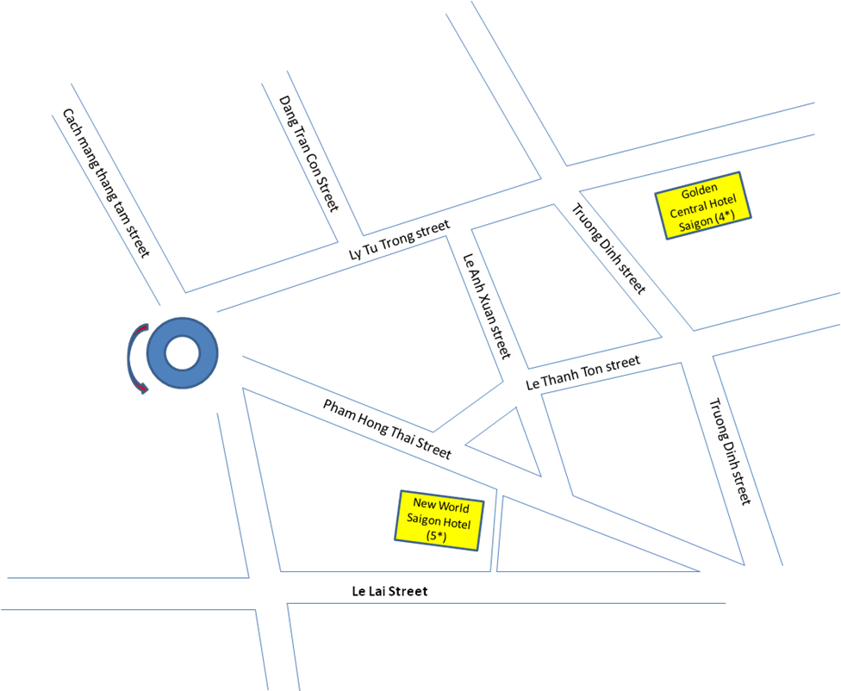

- Due to peak season of Ho Chi Minh City during the meeting period, you are kindly requested to send your Registration Form for finalizing the hotel reservation and other necessary arrangements to the contact persons indicated below by 8 January 2014 at the latest.
- Local Secretariat may not be able to guarantee hotel reservation and prices after the due date.
- Confirmation notices will be sent to participants for the Hotel booking reservation.
- Hotel Reservation Cancellation policy:
- No charge for Cancellation/Amendment made before 2 February 2014
- Cancellation/Amendment after 2 February 2014 will be charged at one night’s room and Tax
- Cancellation on Arrival date or No-show will be charged at all reserved nights and Tax.
Transportation and access
Tan Son Nhat International Airport (SGN), is the largest airport in Viet Nam. It is located 6 km north of the center (District 1) of Ho Chi Minh City. For further information, you can check at: http://www.vietnamairlines.com.vn/wps/portal/en/site/flight_info/time_table.
Airport taxis are available from Tan Son Nhat International Airport to the New World Saigon Hotel and the other Hotels with a fare of around VND 120,000 (about US$6). Delegates need to arrange their own transportation from airport to their respective hotels.
Visa and immigration information
Visas are exempted for the citizens of the countries which have signed a bilateral visa exemption agreement with Viet Nam. For information on entry visas to Viet Nam, participants are kindly requested to check the following web page of the Ministry of Foreign Affairs:
http://lanhsuvietnam.gov.vn/Lists/BaiViet/B%C3%A0i%20vi%E1%BA%BFt/DispForm.aspx?List=dc7c7d75%2D6a32%2D4215%2Dafeb%2D47d4bee70eee&ID=306
Tourist visas may be valid for 15 to 30 days. Tourist visa can only be obtained in Vietnamese Embassies and Consulates abroad.
A business visa will usually require a Visa Approval Letter (Visa Reference Number) which will be sent directly from Vietnamese Immigration Department to the relevant Vietnamese consulate or embassy. It takes at least 3 weeks to process the internal Visa Approval Letter (Visa Reference Number).
Please kindly be informed that during the major Vietnamese Tet Holiday which runs
from 29 January to 8 February, 2014 all Government offices will be closed (including the Immigration Department and Vietnamese Embassies in other countries). Therefore, delegates are urged to process their visa requests at their earliest convenience. During the Tet Holiday period Local Secretariat will not be able to attend to any enquiries or any requests for assistance relating to visa support.
Other information
Climate
The average temperature in Ho Chi Minh City during February varies from 26⁰C to 30⁰C degrees Celsius.
Currency
The legal tender of Viet Nam is Dong (VND). For money changing, banks and money changes are conveniently located over the city and at the airport, as well as at the hotels.
Exchange rate (as of 30th October 2013):
1 US Dollar (USD) 21,200 VND
1 € (EUR) 29,200 VND
Major Banks are open from 08.00 a.m. to 04.00 p.m., Monday to Friday. All main credit cards are welcome.
Food
A wide range of choices in the food/diet from Asian style to Western style is available in hotel restaurant and food-courts nearby the meeting venue. The local cuisine is excellent for different tastes.

Electricity
The mains voltage in Viet Nam is 220 Volts, 50 Hz. The power plugs used are of the 2-pin flat or circular.
Time Zone
GMT + 7 hours
Contact information
Local Secretariat:

To:  Ms Nguyen Thu Huyen  Authority of Radio Frequency Management  Ministry of Information and Communications  Socialist Republic of Viet Nam  Tel: +84 4 35564919 ext 502  Fax: +84 4 35564916  E-mail: huyennt@rfd.gov.vn | Copy to:  Ms Doan Thanh Huong  Mobile: +84 916 060708  Email: wp5dmeeting@gmail.com

