 | ITU ASP CoE Training on  IPv6 Infrastructure Security  22-26 June 2015, Thailand | 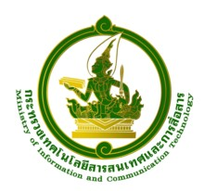
Supported by


Useful Information for Participants
1. Training workshop venue

TOT Academy, TOT Public Company Limited, Nonthaburi 11000, Thailand
Tel: +66 25801076
Fax +66 25918087
E-mail: sudaporv@tot.co.th, thalimne@tot.co.th
At the TOT Academy, internet services are available at the training venue and the hotel. Also, Wi-Fi card can be purchased for in room use during your stay.

2. Transportation

All participants are requested to make their own arrangements for airport transfer. More detailed information about the airport can be found on the following website.
http://www.suvarnabhumiairport.com/
After passing the immigration, an airport limousine can be hired from the counter by showing the TOT Academy map.
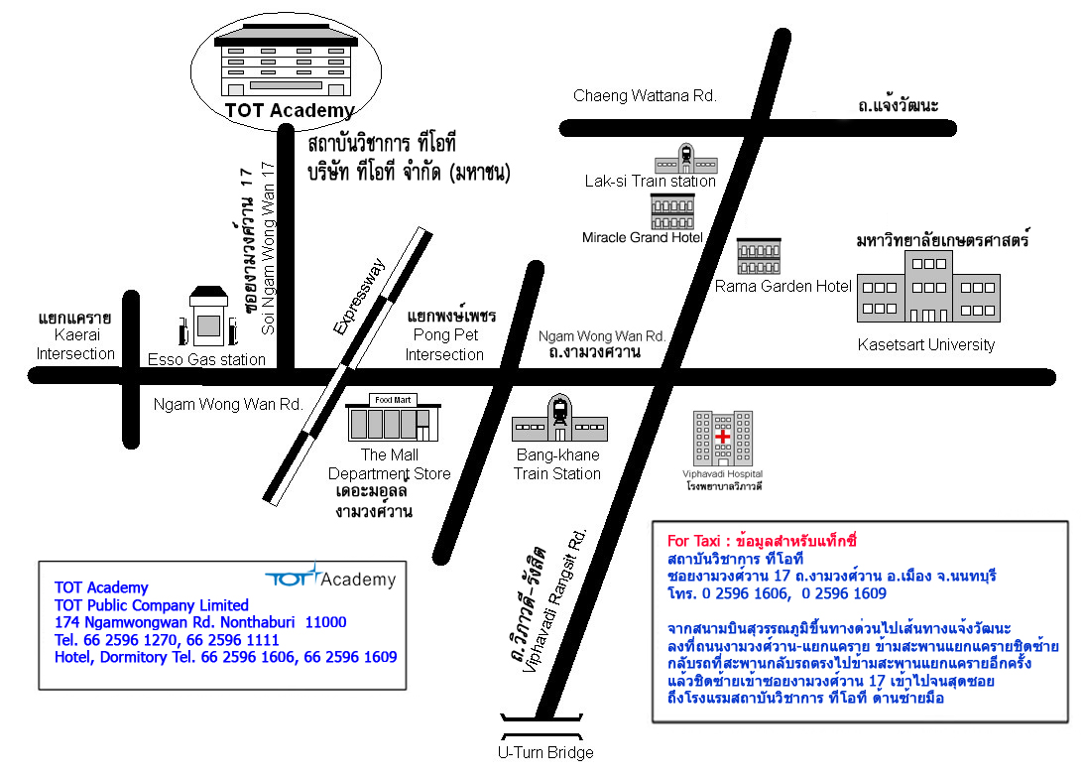

3. Passport and Visa

All participants entering Thailand must possess valid passports or accepted travel documents and need to check visa requirements before entering the country. Please check the visa with the nearest Thai Embassy. For more information please visit the website http://www.mfa.go.th.

4. Contact point
For any further information you may require or if you need a personal invitation letter or official document for your visa application, please contact:
Mrs. Sudaporn Vimolseth
Tel: +66 2580 1076, Fax: +66 2591 8087
Email: sudaporv@tot.co.th
Ms. Tharinee Limpibunterng
Tel: +66 2596 1009 Fax: +66 2591 8087
Email: thalimne@tot.co.th

5. Practical Information

Weather
In June, the temperature is between 28 -35ºC.
Language
English is spoken in most hotels, shops and restaurants as well as in major tourist destinations.
Time
The time in Bangkok is 7.00 ahead of Greenwich Mean Time (+7.00 GMT).
Electricity
The electric current is 220 volt AC throughout the country.
Power Plug
For Thailand, the picture/diagram shows the type of main power plug used in Thailand so participants can bring the right adaptor for their electrical appliances. This plug and receptacle are technically known as NEMA 5-15 (North American 15 A/125 V grounded).
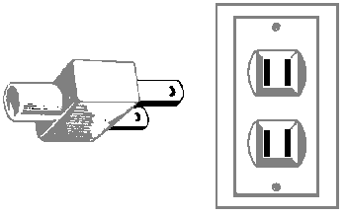
Currency
The currency exchange is 1$ USD is approximately 30 baht.
Business Hours
Government and business offices are open from 8.30 to 16:30 hrs, Monday to Friday. Bank opens Monday to Friday from 9.00-15.30 hrs while the department stores open daily from 10.00-20.00 hrs.

Local Travel during your stay
Participants staying at TOT Academy Hotel do not need to travel as training venue is co-located. For participants who would like to go out at night for their dinner or shopping, Taxis can be called from the hotel or you can walk out to the main road and call the taxi. There are two shopping Mall, Supermarket and Food Court near the training venue.

Have a nice trip to Bangkok

