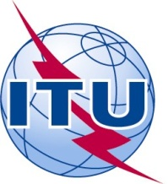 | ITU-GSMA Regional Training Workshop on ICTs for Disasters Management for Arab States  Khartoum - Sudan, 28-29 August 2017 | 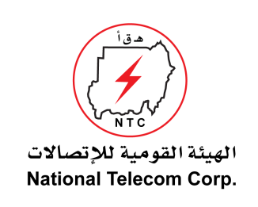

HOTEL RESERVATION FORM
(to be submitted before 15 August 2017)
(USE CAPITAL LETTERS)
1. Mr. / Mrs.
(Family name) (First name)
2. Country :

3.Address :

4. Tel.:__________________ Fax: __________________ E-mail :

5. Specify name of hotel ______
Hotel Fax No.______
Booking of a single room
Booking of a double room
from to
for nights

6. Arrival Date :
Day: _____________ Time : _________________ Flight No. : ________________
7.Departure date :
Day : ____________ Time : _________________ Flight No. : _______________

Date : Signature :

To be returned before 15/08/2017, to:  cc: | the hotel choosen  Eng. Abdulrahman El Daw  International Relations Coordinator,  NTC - Sudan  Tel: +249 187 171248  Fax: +249 183 484486  E-mail:abdulrahman@ntc.gov.sd

