FIRST-ITU Regional Symposium for Arab and African Regions and Cyber Drill fourth edition for Africa Region

Jointly organized By ITU, FIRST And TCRA

Tanzania Information Pack
for Participants

DAR ES SALAAM, TANZANIA

13th – 17th November 2017
(5 days)

Welcome Note

The Tanzania Communications Regulatory Authority (TCRA) wishes to extend a warm welcome to all participants of the Cyber Drill event.

TCRA hosts within its structure the Tanzania Computer Emergency Response Team (TZ-CERT), a team with the responsibility of coordinating response to cyber security incidents at the national level and cooperate with regional and International entities involved with the management of cyber security incidents.

The organizers of the event for November 13th – 17th 2017 are the International Telecommunications Union (ITU) and Forum for Incident Response and Security Teams-FIRST. The event will be hosted by TCRA.

This information pack will help you understand how to enter Tanzania and what to prepare before coming to Tanzania, where to stay, what to do during your free time and how to handle any emergency needs. We hope that this information will make your stay in Tanzania a pleasant one.

We look forward to seeing you at the event.

General Information
Tanzania is located south of the equator and on the coast of the Indian Ocean and is the largest country in Eastern Africa with a land area of 881,289 sq. km in the mainland and 2,460 sq. km in Zanzibar and a population of 50.1million (2016). It shares its borders with Burundi, Kenya, Malawi, Mozambique, Rwanda, Uganda, Zambia and the Indian Ocean with a coastline of 1,424 km in length. It is three hours ahead of GMT.

Tanzania is blessed with many and varied tourist attractions among which one of the seven natural wonders of Africa which holds the stature of a UNESCO World Heritage Site; the Ngorongoro Crater which lies 110km west of Arusha city. The Crater attracts over 500,000 visitors each year as it has the biggest population of animals on Earth. Other tourist attractions in Tanzania mainland include the Serengeti National Park the home of the wildebeest, Mount Kilimanjaro the highest mountain in Africa and a number of Game Reserves spread across the country.

In the Isles, we have the popular luxury destination of Zanzibar as well as the islands of Pemba and Mafia. These three islands are fondly known as the 'The Spice Islands' and offer a wide range of interesting and colorful experiences not to mention a variety of spices and essential oils.

Tanzania is also well known as the home of the rare and beautiful gemstone called Tanzanite which can be bought from reputable jewellery retailers in Arusha City and Dar es Salaam. We also have various souvenirs available in village and town markets and curio shops such as the famous 'Tinga Tinga' paintings, the colourful khanga, kitenge and batik fabrics as well as ebony carvings popularly known as 'makonde' because most of the carvers are of the Makonde tribe from Southern Tanzania

The official language is Kiswahili but English for international correspondence. In addition, there are more than 120 tribal languages spoken in the country. However, one can rarely feel lost regardless of where one is in this vast country because Kiswahili is also the national language.

Entry Requirements
Foreigners seeking to enter to Tanzania should be in the possession of valid passports and must also present an onward or return ticket together with proof that he/she has sufficient funds to support himself or herself while in Tanzania. All foreigners from Non-Commonwealth Countries are required to have a valid visa unless their countries have a visa abolition agreement with Tanzania. Citizens of Commonwealth countries are not required to obtain visa, unless they are citizens of the United Kingdom, Canada, Nigeria, India, Pakistan or The Republic of South Africa, Australia and New Zealand. Those that do require a visa can usually obtain at Tanzanian Embassies and High Commissions abroad.

More information on Visa requirements can be found on this link:
http://www.foreign.go.tz/index.php/en/services/category/services-for-foreigners
participants from countries that require visas can contact TCRA for information beforehand on the following email address: connie@tcra.go.tz

Currency
The Tanzanian shilling (Tsh.) is divided into 100 cents. Notes are in denomination of 500, 1000, 2,000, 5,000 and 10,000 shillings. Coins are in order of 5, 10, 20, 50, 100, 200 and 500 shillings. Money can be changed in banks, Bureau de Change and other accredited points such as hotels. Credit cards (Access, Master Card, Visa, American Express, Euro Card and Diners) are accepted by major hotels around the country. Travelers’ cheques in US dollars and Pound Sterling are recommended, although Euros are also accepted. Banking hours in major towns are from Monday to Friday (08.30 - 16.00 hrs), Saturday from 08.30 hrs - 13.30 hrs and are closed on Sundays. These may vary in smaller towns. ATM Machines are available in branches of major banks and accept most VISA cards and MasterCards.

Rates for currencies can be found on the Bank of Tanzania’ website:
http://bot.go.tz/FinancialMarkets/ExchangeRates/ShowExchangeRates.asp

Transport Services
Tanzania is easily accessible by air, rail, sea and road. The major International airports include Julius Nyerere International Airport (JNIA); Zanzibar International Airport (ZIA); Kilimanjaro International Airport (KIA); and Songwe International Airport.

Major world airlines like Emirates, KLM Royal Dutch Airlines, Kenya Airways, Ethiopian Airlines, Swiss Air, Egypt Air, Air Malawi, Air Mozambique, Air Uganda, South African Airways, Etihad airways, Turkish Airlines, airsychelles, flydubai, oman air, RwandaAir and Qatar Airways fly in and out of Tanzania.

Air Tanzania, Precision Air and Fastjet as well as other domestic commercial operators fly to various destinations within and out of the country.

Tanzania is well served by two rail networks - the Tanzania Railways Limited (TRL) which runs passenger and goods services along the Central Line between Dar Es Salaam and terminal stations on both Lake Victoria (Mwanza) and Lake Tanganyika (Kigoma). The second rail network is the Tanzania Zambia Railway Authority (TAZARA).

This railway runs southwest from Dar es Salaam for a distance of 1,800 km through the world's largest and famous Selous Game Reserve and the mineral rich Southern Highlands. It then cuts across the border with Zambia and continues to New Kapiri Mposhi where it is well connected to the Democratic Republic of Congo, Zambia itself, Zimbabwe and South African Railway networks.

Tanzania has four major ports: Dar es Salaam, Tanga, Mtwara and Zanzibar. These ports are well equipped and form a very important gateway link to the world and to the land-locked countries of Uganda, Rwanda, Burundi, the Democratic Republic of Congo, Zambia and Malawi. Several private ferry boat operators serve the Dar es Salaam - Zanzibar route using a range of crafts from sailing dhows to tourist-class twin-hull boats. Participants wishing to travel to Zanzibar may visit www.azammarine.com for more information about Azam fast ferries to Zanzibar.

Accommodation
The following hotels are available for participants which are very close to venue of the event-Bank of Tanzania Conference Centre. Participants will be responsible for hotel accommodation costs and all incidental costs to be paid directly to service providers.

Hotels around the venue
S/N | Hotel | Room Type | Rates per night (USD)  approximate
1. | Dar es Salaam Serena Hotel  Tel: +255 22 2212500  Fax: +255 22 2113981  E-mail: dshreservations@serena.co.tz  Website: http://www.serenahotels.com | Standard  Superior  Executive | 217.50  237.50  246.50
2. | Hyatt Regency Hotel  Mobile: +255 764 70 1234  Fax: +255 22 212 0777  E-mail: daressalaam.kilimanjaro@hyatt.com  Website: https://daressalaamkilimanjaro.regency.hyatt.com | Standard city view  Standard sea view  Club city view  Regency Suite  Executive suite  Presidential suite  Royal Suite | 265.00  300.00  365.00  515.00  885.00  3150.00  4150.00
3. | Holiday Inn Dar es Salaam  Tel: +255 222139250  Fax: +255 222139260  E-mail: reservations@holidayinn.co.tz  Website: http://www.holidayinn.co.tz/ | Standard single  Standard Double  Executive Single  Suite | 99  109  139  169
4. | Southern sun Hotel  Tel: +255 22 213 7575  E-mail: ssdar.reservations@tsogosun.com  Website: https://www.tsogosun.com/southern-sun-dar-es-salaam | Single Standard  Executive room and suites (for Special order or VIP) | 196.50
5. | New Africa Hotel  Mobile: +255 677 023 236, +255 22 2117131/32, +255 658 222 220  Tel: +255 22 2117050/51,  E-mail: gm@newafricahotel.com  Website: http://www.newafricahotel.com/ | Standard Single  Executive Suite | 120  250
 |  |  | Single | Double
6. | Ramada Encore Dar es Salaam hotel  Tel: +255-22-2343434  Email: reservations@ramadaencoredar.com  Website: https://www.wyndhamhotels.com/ramada/dar-es-salaam-tanzania/ramada-encore-dar-es-salaam/overview# | Standard Room  Executive Room  Junior Suites Rooms  Suite Room | 160  185  200  280 | 175  200  215  280
7. | Golden Tulip Dar es Salaam City Center Hotel  Telephone:  +255222129351  Email: info@goldentulipdarcitycenter.com  Website: http://www.goldentulipdarcitycenter.com/ | Superior Room  Deluxe Room  Junior Suit  Family Suit | 96  112  134  163
8. | Best Western Plus Colosseum Hotel  Tel: +255 22 2110629  Fax: +255 22 2110615  Email: info@bestwesternpluscolosseum.com  Website: http://www.bestwesternpluscolosseumhotel.com/home | Deluxe Standard  Deluxe Standard Twin | Single | Double
8. |  | Deluxe Standard  Deluxe Standard Twin | 100 | 120
8. |  | Deluxe Standard  Deluxe Standard Twin | 120
9. | Protea Hotel Dar es Salaam Courtyard  Tel:+255222130130  Email: info@phcourtyard.com  Website: http://proteahotels.com | Superior  Deluxe | Single | Double
9. |  | Superior  Deluxe | 110 | 140
9. |  | Superior  Deluxe | 145 | 175

Weather Details
Tanzania brags of a tropical weather throughout the year and is semi-temperate as you move further inland. The hottest month is January with temperatures that go as high as 32C in Dar es Salaam and the coldest is July with temperatures as low as -4C in some areas of the Southern highlands. September is the driest month and April the wettest. More details are available on: http://www.meteo.go.tz/

Time Zone
GMT +3

Communications
The country telephone code is +255 and there are area codes for landline. Fax facilities are available at most hotels. E-communication is also available. Broadband Internet connection is available in all the hotels.

Telecom providers in Tanzania are TTCL, Vodacom, Tigo, Airtel, Halotel, Smart and Zantel. SIM cards can be purchased from the airport as well as from official mobile operator’s outlets across the country.

Major Cities
The business city, Dar es Salaam has a population of about 5.5 million. Other interesting towns include Arusha, Mwanza, Mbeya, Kilimanjaro and Dodoma the capital city.

Language
The official language is Kiswahili but English is widely used especially for international correspondence. In addition, there are more than 120 tribal languages spoken in the country. However, one can rarely feel lost regardless of where one is in this vast country because Kiswahili is also the national language.

Culture
Tanzania has a range of fascinating cultures of which the most famous is the proud Maasai, a pastoral population. There are more than 120 tribes in Tanzania which differ in their culture, customs and language. When you visit Tanzania you can learn about different medicinal plants, tribal rituals and traditional farming methods.

Religion
The main religions are Christianity and Islam. However, you can also find Hindus and as well as traditional religions.

Water and Electricity
It is wise to stick to bottled water for drinking purposes.

The electrical supply is 220V~240V AC, 50Hz. The plugs used in most hotels are three-pin (British Standard), although two-pin plugs are also used.

Traditional Foods
The local people generally eat Nyama choma: Barbecued meat. Ugali: Maize meal porridge, a staple usually served with stews or meat. Mandazi: A fried dough ball that resembles a savoury doughnut. Kachumbari: Spicy tomato relish served with meat. Wali wa nazi: Rice cooked with coconut milk. Hotels and restaurants offer a range of foods including Chinese, Indian and Creole. European style food is available and seafood is a speciality in many places.

Internal Transport
There is no railway service in Dar es Salaam but there are the taxi and bus services. Those wishing to hire a car will need a valid international driver's license. Taxis are available at reasonable rates. One can go just about anywhere at Dar es Salaam by making use of the bus services or taxis that operate throughout the town.

Safety of Participants
Tanzanians are warm - hearted and generous people and are eager to help visitors get the most out of their stay. Hotels are safe and have watchmen. Tanzania is a politically stable, multi-democratic country. However, as in all countries, a little common sense goes a long way and reasonable precautions should still be taken, such as locking valuables in the hotel safe and not walking alone at night.

What to Buy
Locally made products are widely sold at reasonable prices. You can offer to buy yourself or your friend items like; Batiks and Tingatinga paintings, Ebony carvings such as cutlery, bracelets, furniture and sculptures. Others include Maasai belts, rings and necklaces made of colourful beads, Khanga for women’s wrap around and Jewels to include Tanzania’s special Mineral – Tanzanite

Business Hours
Generally, from 08:00hrs to 17:00hrs each Monday to Friday and a half-day on Saturdays.

Healthcare Information
An international vaccination certificate against yellow fever is required if visitors are from an infected area.
More details on health requirements: http://www.taa.go.tz/index.php/traveller-guides/health-requirements

Tanzania Tourist Attractions
Tanzania is one of the unique destinations on the African continent that has yet to be discovered by many. It is a land of many wonders harboring an un-paralleled diversity of fauna and flora. Kilimanjaro, the highest permanently snow-capped free standing mountain in Africa, the exotic Islands of Zanzibar, the finest game sanctuaries of Serengeti, Tarangire, Lake Manyara, Ngorongoro Crater, Ruaha, Selous and the Marine Park of Mafia Island are only but a few of the living examples.
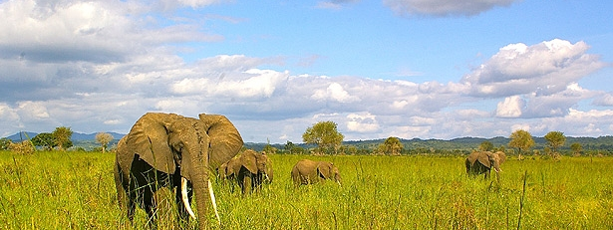
Photo credit: MNRT
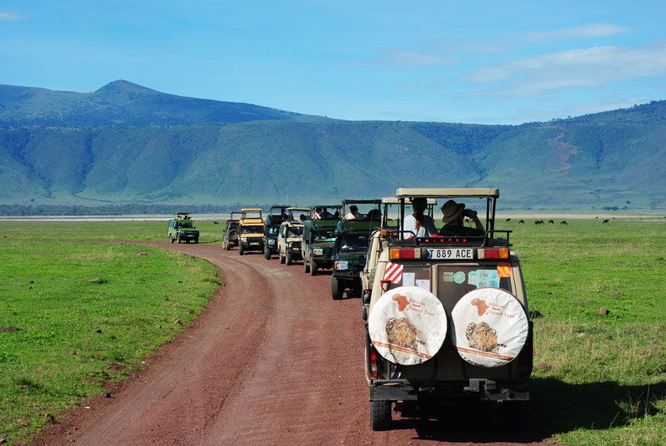
Ngorongoro crater: Photo credit Google

The scenery, topography and very friendly people make Tanzania one of the best places to visit and promise the best wildlife photographic safaris on the continent. Tanzania indeed has it all Tanzania has 16 National Parks, 1 conservation area, 17 game reserves, and several marine parks, a breathtaking coast and Lake Zone and gently undulating highlands that are a hiker’s paradise
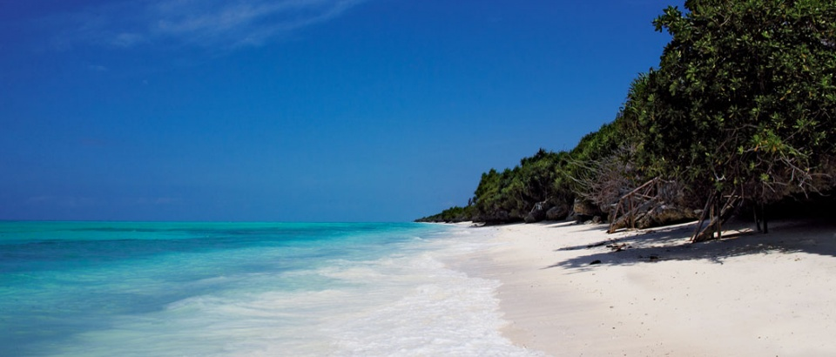
Beaches in Zanzibar, Photo credit: The Tanzania specialists

Contact Details
Tanzania Communications Regulatory Authority (TCRA)
Mawasiliano Towers
20 Sam Nujoma Road
P.O Box 474
14414 Dar ss Salaam
Tel: +255222199760 – 8, +255 22 2412011 - 2 | Fax: +255 22 2412009 / +255 22 2412010
Email: connie@tcra.go.tz , dg@tcra.go.tz

