Recommendation ITU-R SM.2140-0
(08/2021)
Performance evaluation of mobile direction finders in operational environment

SM Series
Spectrum management

Foreword
The role of the Radiocommunication Sector is to ensure the rational, equitable, efficient and economical use of the radio-frequency spectrum by all radiocommunication services, including satellite services, and carry out studies without limit of frequency range on the basis of which Recommendations are adopted.
The regulatory and policy functions of the Radiocommunication Sector are performed by World and Regional Radiocommunication Conferences and Radiocommunication Assemblies supported by Study Groups.

Policy on Intellectual Property Right (IPR)
ITU-R policy on IPR is described in the Common Patent Policy for ITU-T/ITU-R/ISO/IEC referenced in Resolution ITU-R 1. Forms to be used for the submission of patent statements and licensing declarations by patent holders are available from http://www.itu.int/ITU-R/go/patents/en where the Guidelines for Implementation of the Common Patent Policy for ITU-T/ITU-R/ISO/IEC and the ITU-R patent information database can also be found.

Series of ITU-R Recommendations
(Also available online at http://www.itu.int/publ/R-REC/en)
Series | Title
BO | Satellite delivery
BR | Recording for production, archival and play-out; film for television
BS | Broadcasting service (sound)
BT | Broadcasting service (television)
F | Fixed service
M | Mobile, radiodetermination, amateur and related satellite services
P | Radiowave propagation
RA | Radio astronomy
RS | Remote sensing systems
S | Fixed-satellite service
SA | Space applications and meteorology
SF | Frequency sharing and coordination between fixed-satellite and fixed service systems
SM | Spectrum management
SNG | Satellite news gathering
TF | Time signals and frequency standards emissions
V | Vocabulary and related subjects

Note: This ITU-R Recommendation was approved in English under the procedure detailed in Resolution ITU-R 1.

Electronic Publication
Geneva, 2021

© ITU 2021
All rights reserved. No part of this publication may be reproduced, by any means whatsoever, without written permission of ITU.

RECOMMENDATION ITU-R SM.2140-0
Performance evaluation of mobile direction finders in operational environment
(2021)
Scope
This Recommendation provides guidance on standard methods of evaluating the overall performance of mobile direction finding units, in actual operational conditions, preferably in typical environments where the system will be used by the procuring administration. It may serve as part of an evaluation test within the scope of a tender or as an acceptance test for monitoring services after the procurement.
Keywords
Direction finder (DF) performance evaluation, on-site measurement, realistic environment, mobile/transportable equipment, homing, Line of Bearing
Acronyms/Abbreviations
CDF Cumulative distribution function
CW Continuous wave or continuous waveform
DF Direction finder
GNSS Global navigation satellite system
LoB Line of bearing
LoS Line of sight
OATS Open-air test site
PDF Probability density function
RF Radio frequency
RMS Root mean square
SNR Signal to noise ratio
Tx Transmitter
Related ITU-R Recommendations, Reports and Handbook
ITU Spectrum Monitoring Handbook (Edition 2011)
Recommendation ITU-R SM.854
Recommendation ITU-R SM.1723
Recommendation ITU-R SM.2060
Recommendation ITU-R SM.2061
Recommendation ITU-R SM.2096
Recommendation ITU-R SM.2097
Report ITU-R SM.2125
Report ITU-R SM.2354
NOTE – In every case the latest edition of the Recommendation/Report in force should be used.

The ITU Radiocommunication Assembly,
considering
a) that in order to give an accurate measure of the performance of a direction finding system, tests must be done under actual operational conditions, similar to those in which the system will actually be used, and such measurements serve to determine the “system accuracy”;
b) that the direction finder (DF) accuracy may be tested in a real environment, on an open-air test site (OATS) or on a laboratory platform;
c) that mobile DF overall performance testing in real environment is not addressed in detail in other ITU documents;
d) that the use of mobile DF systems is increasing;
e) that different types of DF antenna technology and DF methods are used by manufacturers and this results to different levels of performance under different operating environments;
f) that under urban conditions, bearing analysis relies on probabilistic methods, due to the effects of multipath propagation and other local effects. Statistical processing with continuously obtained bearings at mobile monitoring stations simplifies localization of radio emission sources using the homing procedure;
g) that performance data in specifications of DF equipment usually reflects ideal test conditions and does not include the influences of obstructions, reflections and disturbing RF signals at the final installation site;
h) that test procedures for mobile DF systems under ideal (OATS) conditions will be similar to those of fixed DF systems,
recommends
1 that test procedures as described in Report ITU-R SM.2125 may be used to evaluate the DF accuracy of a radio direction-finding system in its realistic RF environment;
2 that test procedures as defined in Recommendation ITU-R SM.2096 may be used to test and report the DF sensitivity of mobile DF systems;
3 that test procedures as defined in Recommendation ITU-R SM.2061 may be used to test and report the immunity of a mobile system to multipath environments;
4 that test procedures in Annex 1 may be used to test the performance of mobile DF systems in real operating environments and report the results for the benefit of the user administration and additionally may serve as part of an evaluation test within the scope of a tender or as an acceptance test for monitoring services after the procurement.

Annex 1
Test procedures for evaluating the performance of Mobile DF units
in operational environments
TABLE OF CONTENTS
Pages
1 Introduction 3
2 General considerations 4
2.1 Measurement set-up 6
3 Test procedures 7
3.1 Evaluation of Homing mode (recommended method) 7
3.1.1 General considerations 7
3.1.2 Homing in predefined route 7
3.1.3 Homing in real conditions – target localization 10
3.2 Evaluation of Standoff mode (alternative method) 16
3.2.1 Measurement Set-up 16
3.2.2 Measurement procedure 18
3.2.3 Test data analysis 19
4 Report of results 23

1 Introduction
Mobile Direction Finders (DF) are probably the most effective tools for the location of sources of harmful interference and for finding unauthorized transmitters. At the same time, they are often one of the most costly tools of a radio monitoring service.
The main DF engineering features are:
– accuracy;
– sensitivity;
– immunity to distorted wave fronts;
– insensitiveness to depolarisation;
– effects of co-channel interference;
– resistance to receiver desensitization;
– minimum signal duration time.
Most of the aforementioned features can be tested at an OATS using restricted frequencies where no reflections from nearby obstacles, ambient noise, and other radio signals may interfere with the measurement (Recommendations ITU-R SM.2060 and ITU-R SM.2061) or can be measured using a simulator (Report ITU-R SM.2354). The methods in Report ITU-R SM.2125-1 and Recommendation ITU-R SM.2096 can be used to determine instrument accuracy and “system sensitivity”.
In clean environments (laboratory, anechoic chamber, OATS), most direction finding systems have excellent performance, and that does not allow discrimination among direction finding systems. An administration might procure a system that performs well in laboratory tests, only to find that it does not work when actually deployed. Hence, the “system accuracy” is not always a measure of how a DF system will perform in actual operational conditions. However, “system accuracy” is usually included in data sheets and can be used as reference to compare with “operational accuracy” results for site acceptance tests, and to compare with “DF immunity” tests against multi-path for controlled multi-path conditions.
Tests in a real environment are mainly used to determine “operational system performance” or the “overall performance” in actual operational conditions, preferably in typical locations where the system will be used by the procuring administration. It may serve as part of an evaluation test within the scope of a tender or as a method to facilitate the administration to select the most suitable tool of its inventory to cover particular needs.
This Recommendation proposes general test procedures that can be used to evaluate the DF performance of a non-fixed, on a moving vehicle, automatic radio direction-finding system referred with the general term of “mobile DF”, in its realistic RF environment.
The tests described in this Recommendation are intended to evaluate the overall DF performance in the RF environment in which any particular “mobile DF” system is planned to be operational. The real environment includes influences from the surrounding buildings, obstructions, reflections from nearby and moving objects, low SNR (either low signal level or high noise floor), co-channel and adjacent channel transmissions and, in some cases, the presence of strong RF signals. Hence, in these most commonly applied conditions, the administrations can select which test method should be used according to the actual needs and the characteristic of the “mobile DF” itself.
It should be noted that the DF performance results measured with the methods described in this Recommendation are unique to any specific “mobile DF” system and cannot simply be transferred to other “mobile DF” system, even of the same type, in different RF environments.
While the procedures can be used by an administration to compare the performance of mobile DF systems from different manufacturers tested at the same locations with the same types of signal parameters i.e. frequency, strength and modulation, the procedures cannot be used to compare the performance of DF systems tested by different administrations in different locations.

2 General considerations
The specifications of accuracy, sensitivity, immunity to distorted wave fronts, insensitiveness to depolarization, co/adjacent-channel interference and resistance to receiver desensitization are assumed as individually tested and evaluated in a clean environment and their values are included in the technical manual that accompanies the “mobile DF”.
An operational “mobile DF” is expected to meet different conditions and requirements in different places of operation. In that perspective:
a) Different typical geo-environments can be assumed i.e.:
• Open space: no buildings, some low height vegetation;
• Rural: very low building density, low building heights;
• Residential: medium building density with some open spaces, medium building heights;
• Urban: high building density, high ratio building height/street width;
• Hilly terrain.
b) Different typical types of signals can be investigated:
• Unmodulated carrier;
• Narrow band – Wide band modulation;
• Analogue – Digital modulation.
c) Different types of RF conditions can be assumed:
• Co-channel interference;
• Adjacent channel interference;
• High Noise floor;
• High power transmissions.
d) Different frequency bands can be selected for testing.
Any AoA DF unit, irrespectively of the technique used, the number and size of antennas or the number of elements per antenna and their installation on a tower or a vehicle, permanently or temporarily, is designed to produce a single output, the Line of Bearing (LoB). The antenna system receives the signal under investigation and the DF unit, utilizing the appropriate AoA bearing technique, calculates the most probable (with some degree of uncertainty) direction from which the signal is arriving.
In practice a “mobile DF” system is used in two different modes:
a) Homing mode: the vehicle follows a path according to the DF data collected, in order to geolocate the transmitter. The Homing analysis relies on probabilistic methods, due to the effects of multipath propagation and other local effects. Statistical processing with continuously obtained bearings at moving monitoring stations simplifies that procedure. Consequently, the software that is used is an integral part of the moving “mobile DF” unit.
b) Standoff mode: involves obtaining several discrete LoB measurements from fixed locations, which are located in suitable distances from the subject emitter. Successive measurements may be made, at different locations, with as few as one “mobile DF” station and be combined using standard triangulation methods for geolocation purposes.
Based on the requirements of the procuring administration, the performance of a “mobile DF” unit should be evaluated in both or either of the aforementioned modes and in a selection of typical environments of interest.
Consequently, two alternative evaluation procedures are proposed in order for the procuring administration to gain a more complete and comprehensive understanding of the “mobile DF’s” capabilities and performance under the RF conditions and in the environments of interest:
a) Evaluation of Homing mode
b) Evaluation of Standoff LoB mode.

2.1 Measurement set-up
Test equipment should be prepared for the field evaluation/testing. The set of equipment includes test transmitters to generate CW and modulated signals over the frequency range of interest and with power appropriate to generate the desired received SNR or field strength.,
The polarization of the test transmitting antenna should match the polarization of the “mobile DF” system under evaluation. All main polarization angles supported by the DF antenna should be tested with single polarization transmitting antennas. The polarization used should be mentioned in the test report.
Before the beginning of any measurement the “mobile DF” system should be calibrated / set-up according to manufacturer’s instructions. As a second step the operation of the unit should be briefly tested/established by moving a test transmitter (at central frequency of DF antenna) around the DF unit and establish that the LoB follows the moving transmitter, hence ensuring that the system is operational.
The selected frequencies should be well distributed within the frequency ranges of interest (given by the manufacturer’s specifications). The number of signals (in combinations of frequency and modulation) selected can be produced by test transmitters or targets of opportunity covering the services that interest the procuring administration and are typical of the test environment.”
The selection of test frequencies may use the methodology found in Recommendation ITU-R SM.2060 (The number of test frequencies may be limited by license restrictions or other factors).
All the necessary measures to ensure accuracy of direction and location data should be taken. If an on-board compass does not provide sufficiently accurate heading information, then for ensuring the GNSS based direction accuracy of the DF system, the mobile unit should be driven in straight line with constant speed (around 20 km/h) for 10 s, before it parks, without final parking manoeuvres, at the measuring location. External to the DF antenna references can be used to ensure/validate the accuracy of direction and location data (i.e. landmarks, digital maps, satellite images, odometer, compass, GNSS based surveying equipment etc.).
All test settings (signal type, DF bandwidth, test point angle, distance, etc.) should be noted in the test report.
Finally, all test equipment (including transmitter, transmitting antennas etc.) should be calibrated periodically to ensure valid data.
The following procedures may serve as a method for the administration to evaluate the performance of any “mobile DF” unit in environments of interest. They are not indented for publishing a ranking of “mobile DF” systems, instead the aim is to assess, using quantitative and qualitative measures, how the “mobile DF” unit will act in different typical environments, frequency bands and modulations of interest to the particular administration that wants to use the most suitable equipment for a specific set of needs.

3 Test procedures

3.1 Evaluation of Homing mode (recommended method)

3.1.1 General considerations
A “mobile DF” unit is the tool to investigate and solve cases of interference and of unauthorized transmissions, which are usually connected to matter of urgency. The capability of a “mobile DF” unit to locate the source under investigation by following the instantaneous or average LoB towards it, as it moves, is its great advantage over a fixed DF station.
However, the operating conditions of a (moving) “mobile DF” unit are much harsher than those for a fixed DF station:
– constantly changing propagation environment (from LoS to heavy Rayleigh);
– different RF environment from location to location (high noise floor, signals with very high field strength);
– available SNR has different values depending on the distance from the target and the local RF conditions;
– existence of transmissions at the same frequency or at adjacent channels without fulfilment of any protection ratio.
The “mobile DF” under test will have to locate a certain number of targets, in a certain type of geo and RF environment. The procuring administration can set the targets, either by installing some transmitters for the test or by using targets of opportunity. Each target is set to a different combination of frequency and modulation (with and without co-channel or adjacent channel interference).
The combination of the measurement details will be selected by the procuring administration in order to best serve its needs. In the case of evaluating various systems, the same measurement details should be used for every individual “mobile DF” system.

3.1.2 Homing in predefined route
This is a test of the “mobile DF’s” Homing performance in controlled conditions. The procuring administration, following the procedures below, will be able to evaluate quantitatively the homing performance of a “mobile DF” unit selecting various parameters and controlled environments.
Step 1
A predefined route forming a closed area should be set. Different types of scenarios can be selected (i.e. open, low height building, heavy urban, etc.). The target is within the closed area determined by the predefined route. Figure 1 illustrates an example of a route around a low height building area.
FIGURE 1
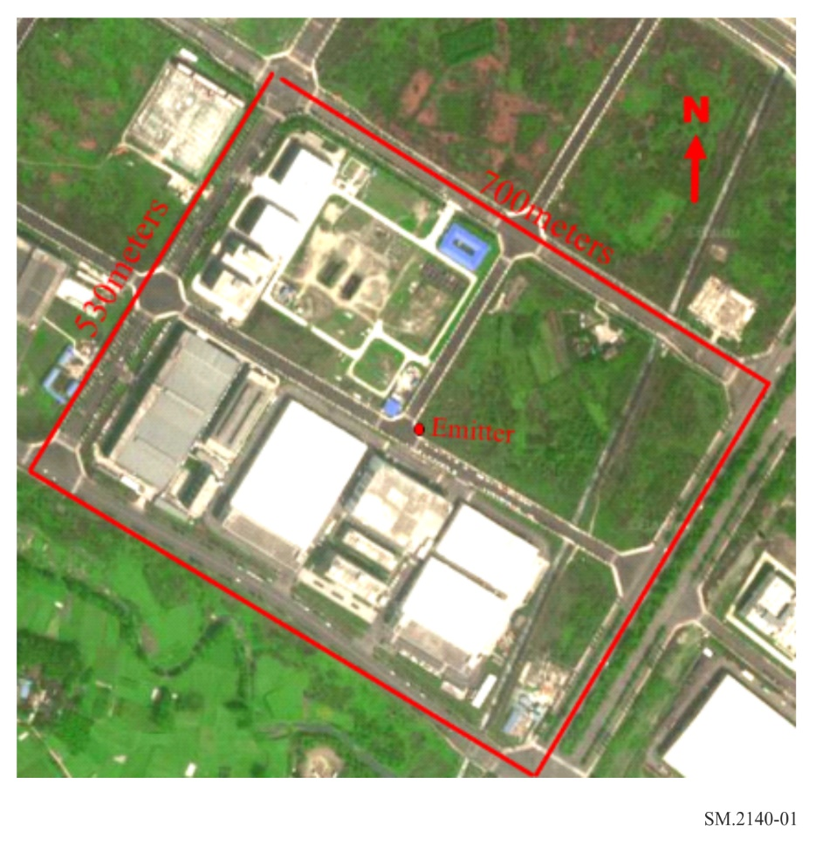
Step 2
The “mobile DF” unit under test moves around the predefined route. It should be ensured that the unit can receive signal with enough signal-to-noise ratio (20 dB) on most of the route. During the process, the positioning software runs automatically (without any manual intervention). The “mobile DF” needs to move at least once around the predefined route, but in order to eliminate random factors and make the test more repetitive, it is strongly recommended to move three or more times around the route. Figure 2 shows a typical software positioning process.
Step 3
When the travel is completed, the positioning software outputs the location of the transmitter. The positioning error should then be recorded.
FIGURE 2
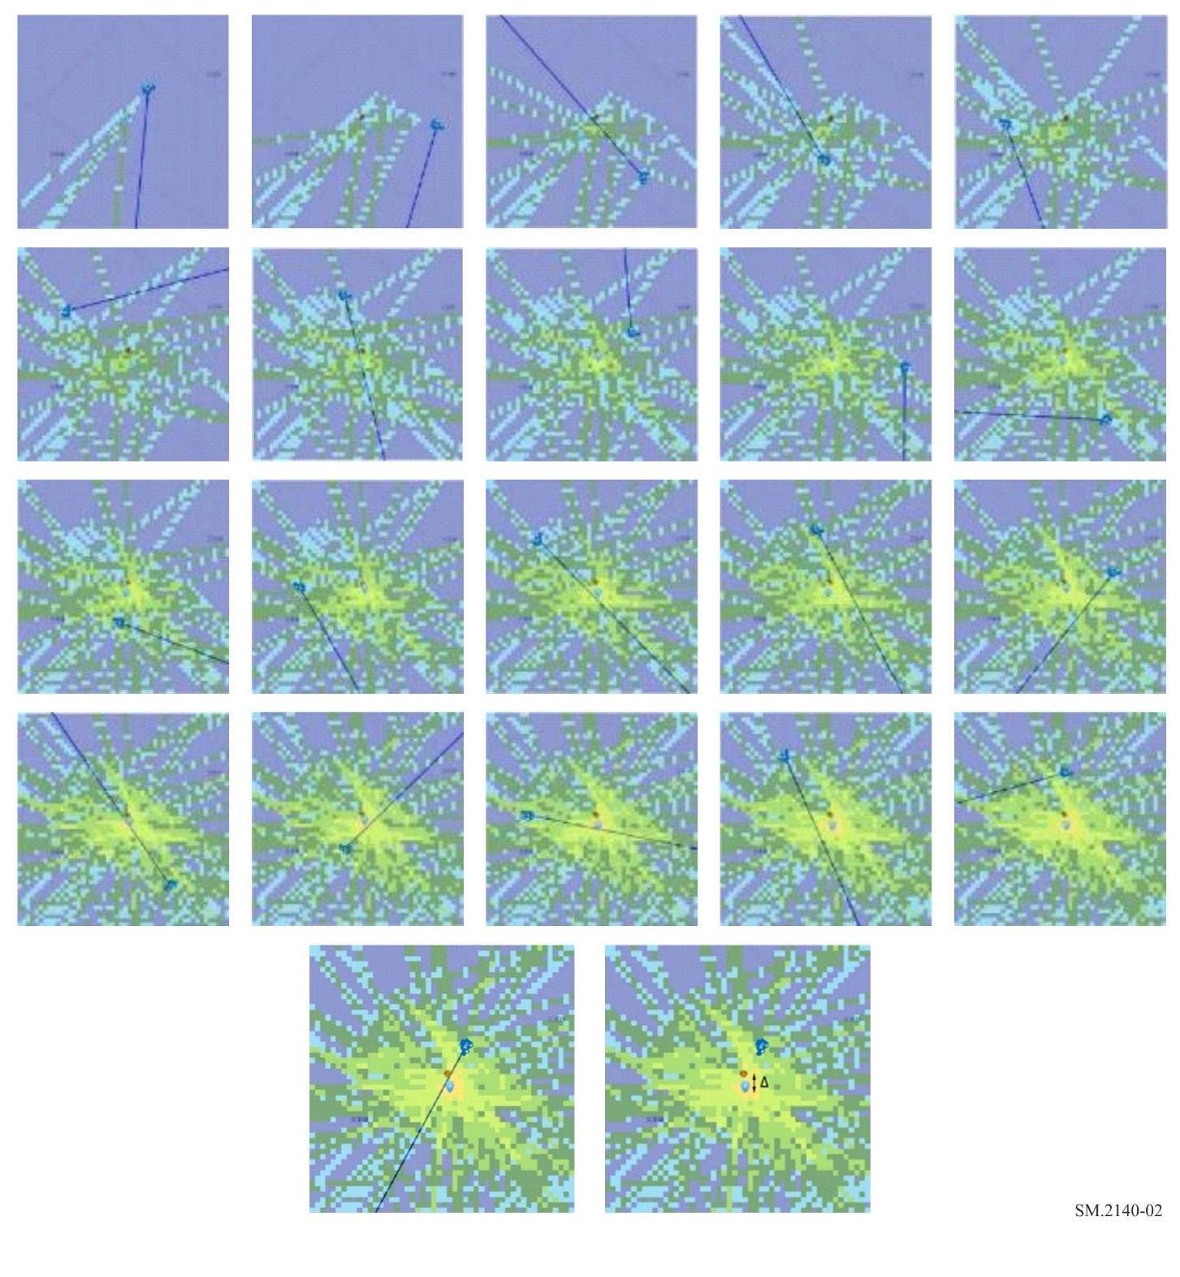
Step 4
Select different combinations of working conditions and conduct multiple tests (optional, selected from the main working condition combinations of the purchaser).
Different combination of parameters can be selected:
– frequency band
– modulation
– weather conditions
– number of laps around the target
– speed of driving.
The results of the “Homing in predefined route” test can be presented as in the following Table.
TABLE 1
Results of “Homing in predefined route”
Terrain scenario | Frequency | Modulation | Weather | Laps | Speed  (km/h) | Positioning error  (metre)
Terrain scenario: Open, low height building, heavy urban, etc.
Frequency: Centre frequency and bandwidth
Modulation: Modulation of signal
Weather: The weather and temperature at the time of the test (e.g. sunny 31℃).
Laps: Number of laps around the target.
Speed: Speed of driving.
Position error: The distance between the best position given by the software and the real position.

Test data processing
The mean value of positioning error (in metres), standard deviation and RMS of positioning error can be calculated.
$\hat{x}= \frac{\sum{x_{i}}}{n}$ (1a)
$\hat{σ}=\sqrt{\frac{\sum{{(x_{i}-\hat{x})}^{2}}}{n-1}}$ (1b)
$RMS=\sqrt{\frac{\sum{{x_{i}}^{2}}}{n}}$ (1c)
where:
$\hat{x}$ mean value
$\hat{σ}$ standard deviation value
$RMS$ root mean square value
$x_{i}$ i^{th} sample data of positioning error
n number of samples.
Evaluation rules for reference
– the lower the mean value and RMS of positioning error are, the better the performance is;
– the smaller the standard deviation of positioning error is, the better the consistency of “mobile DF” is under different test conditions.
Most importantly the purchasing administration should judge whether the measured positioning deviation is acceptable. Generally, the positioning deviation should be small enough to facilitate the handheld device search or visual search, such as within 200 to 300 metres.

3.1.3 Homing in real conditions – target localization
This is effectively a test of the “mobile DF’s” Homing performance in real operational conditions.
The “mobile DF” under test will be asked to locate a certain number of targets, in a certain type of geo and RF environment and defined combinations of frequency and modulation.
The administration can set up the following scenarios:
A) Three-point triangulation: Three locations having LoS to the target could be selected. The “mobile DF” unit will be parked consequently in these three locations and perform Standoff LoB measurements. The results of these three measurements will be used for triangulation in order to identify the polygon area where the target is possibly installed. The signal level of the target at these measuring locations should be high enough above the noise floor in order to have a LoB measurement of good quality.
FIGURE 3
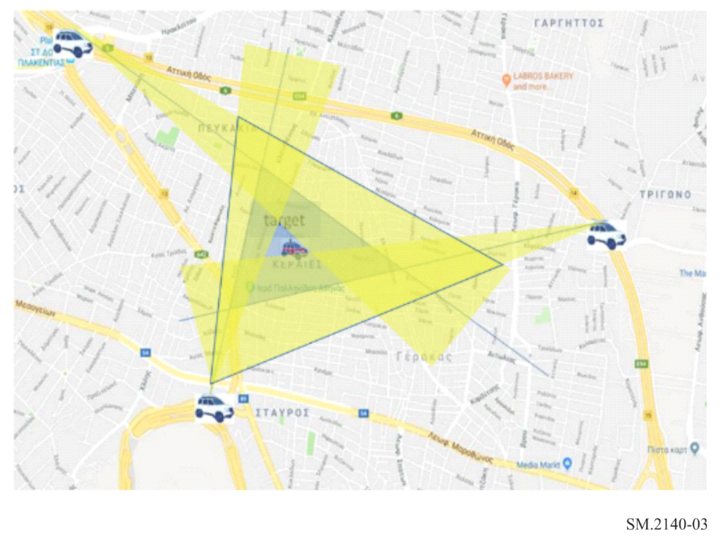
The resulting triangle per target should be presented on a map and included in the final report. The area of the polygon, in (m²), provided it includes the target, can be another measure of “mobile DF” performance (see Fig. 3).
B) Blind Homing: The administration provides on map the polygons that contain the target locations and set the starting point in one corner of the Area of Investigation (see Fig. 4).
FIGURE 4
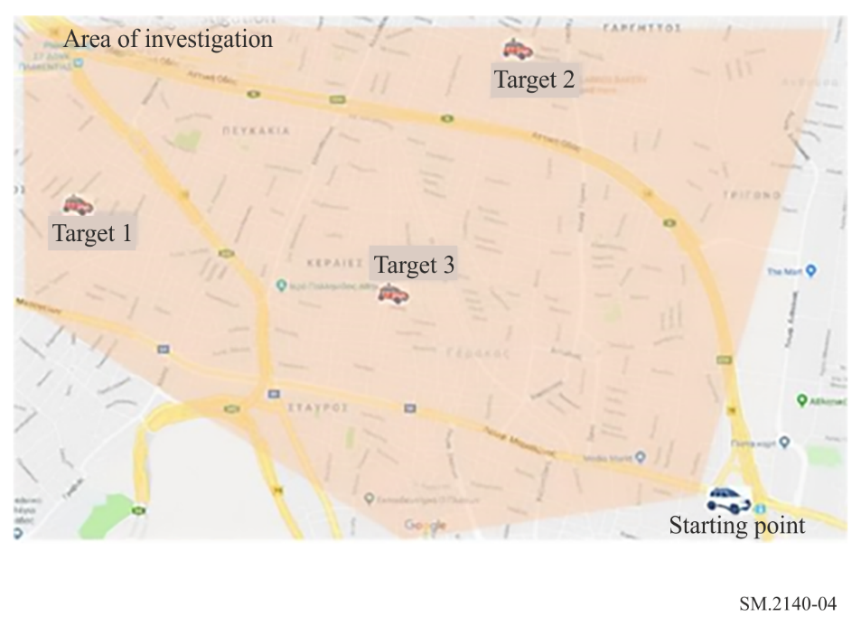
The “mobile DF” units can then start the Homing procedure. As described before, a “mobile DF” unit continuously obtains bearings as it moves in order to locate the target. Bearing analysis relies on probabilistic methods, due to the effects of multipath propagation and other local effects, and by using the appropriate software the Homing procedure is simplified and the “mobile DF” is driven towards the area where most probably the target is located.
The bearing analysis software is usually proprietary of the DF’s manufacturer and is an integral part of the unit like the antenna, the receiver and the direction finding methodology. The driver of the “mobile DF” unit should only follow the general directions given by that software (respecting road traffic signs) and not using the experience of any technical personnel being on board. In all cases, the traffic code has to be followed, and the vehicle to be driven in a speed between 20 to 40 km/h.
The transmitted power is set high enough in order to have SNR = 20 dB at the starting point of each homing procedure.
The directions of the bearing analysis software and the root followed by the vehicle should be recorded for post processing and evaluation.
The geolocation software will give on the screen the estimation of the direction towards which the “mobile DF” should be driven and finally an estimation of the target location with images similar to the ones shown in Fig. 5 or Fig. 6.
FIGURE 5
Use of display of heatmap of uncertainty to indicate most probable location of target during a homing operation
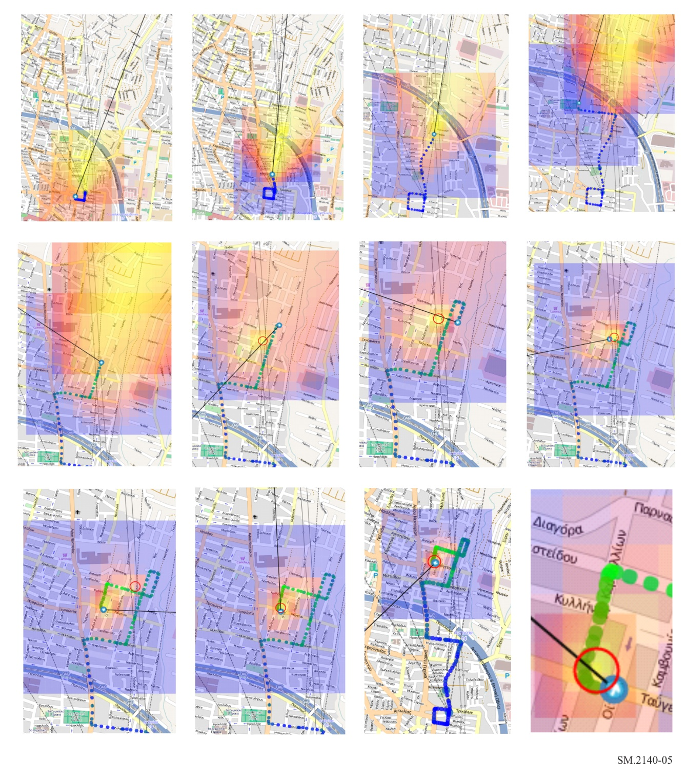
FIGURE 6
Use of display of ellipse of uncertainty to indicate most probable location of target during a homing operation
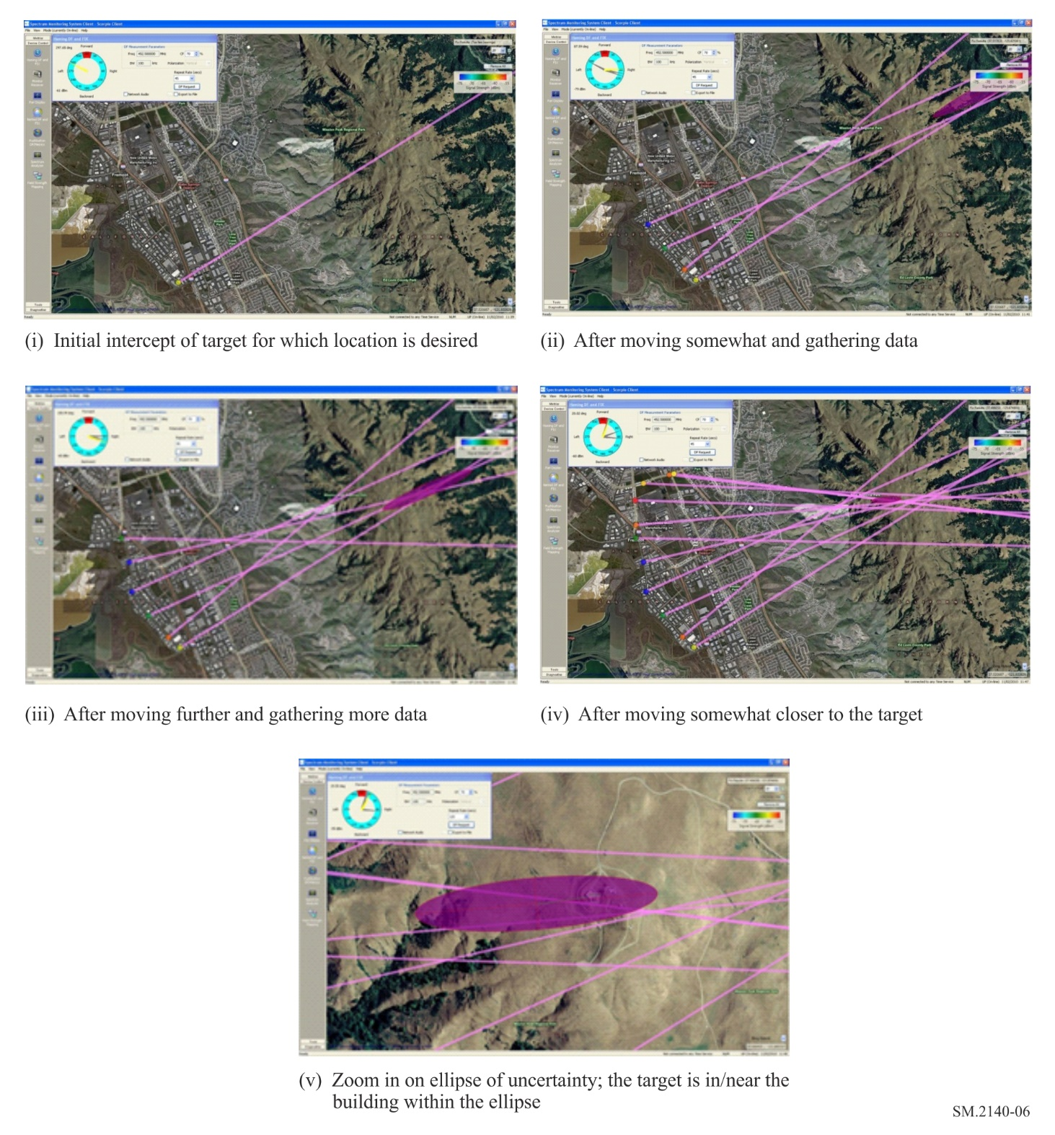
A transmitter is considered as located when the users of the DF system conclude to which building the transmitter is hosted or have located the vehicle carrying the transmitting antenna. This usually happens when the suggested location is in the hottest colour of the pallet used and being surrounded completely by colder colours (when the software is using a colour hit map to represent the possible direction of the target and the estimation of its location) and/or is within the ellipse of uncertainty (when the software is using an error ellipse to represent the estimation of the target location).
At the end of each run the distance driven by the “mobile DF” is recorded.
The results of the “Homing” test can be presented as in Table 2. In Fig. 7 the performance of two different “mobile DF” units in a heavy urban environment can be seen (red and green routes). In blue the calculated shorter route between the starting point and the target.
FIGURE 7
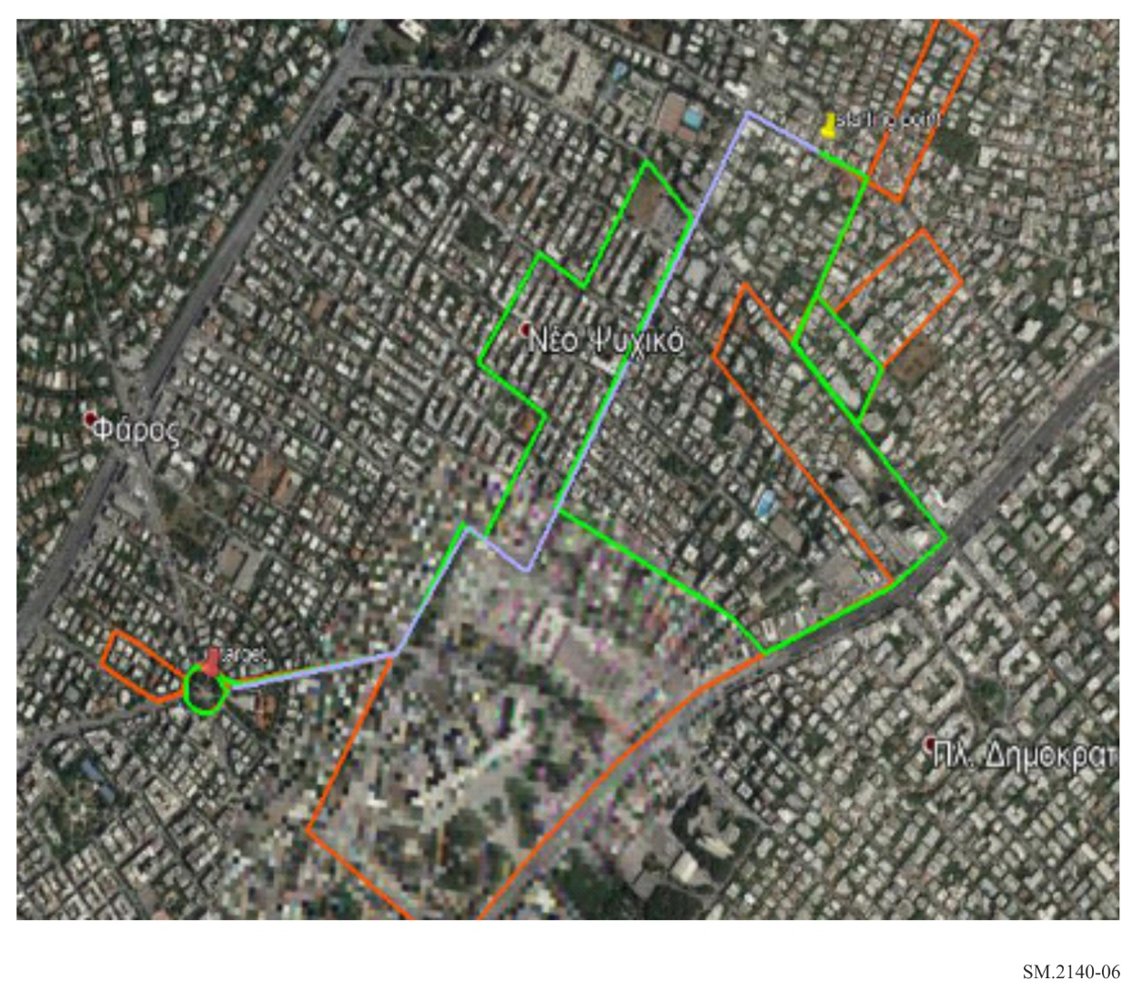

TABLE 2
Results of “Blind Homing”
Location | Frequency (MHz) | Modulation | Type of environment | Info about target’s location | Shortest distance (m) |  | Distance covered (m) |  | Result
 |  |  |  |  | Eq 1 | Eq 2 | Eq 1 | Eq 2 | Eq 1 | Eq 2
Location: name of place where the homing was performed (e.g. Athens).
Type of environment: depend on the density of obstacles (i.e. Urban, rural, residential, etc.).
Frequency: the frequency of the signal transmitted by the target.
Modulation: the modulation type of the transmitted signal (i.e. cw, fm, etc.).
Info about targets location: known or unknown.
Shortest distance to target on the map: the shortest on the map distance following existing roads from the homing starting point to the target.
Distance covered: the real distance the “mobile DF” drove from homing starting point until the final localization of the target, following existing roads and traffic rules.
Result: target found or not.

3.2 Evaluation of Standoff mode (alternative method)
The aim of the Standoff Mode test is to characterise the typical response of a “mobile DF” unit in different types of real environments as this feature of “mobile DF” is described in ITU documentation. In many cases a “mobile DF” will be asked to investigate a possible cause of interference in a region which is not covered by a fixed monitoring network. An initial set of at least three standoff LoB measurements, in properly selected locations (a suitable distance from the subject emitter) can assist in the interference geolocation process (see Fig. 3).
The technical parameters of the “mobile DF” unit under test should have been determined according to Report ITU-R SM.2125. The tests described in the following paragraphs are also based on the principles of Report ITU-R SM.2125 about testing in real environment.

3.2.1 Measurement set-up
Three typical test areas are proposed:
(1) The first test environment should be free of obstacles between the “mobile DF” and the Tx (hence there are only a few distant sources of reflections far away from the Tx). The unobstructed direct path between the transmitter and the DF receiver antenna is predominant (Fig. 8a). The performance in this environment can be used as a reference and represents a typical environment where there are no obstructions between the transmitter and the “mobile DF”.
(2) The second test environment should have an unobstructed direct path between the transmitter and the “mobile DF” and also some reflections, mainly from obstacles behind the unit, as shown in Fig. 8b.
(3) The third test environment should have reflection sources surrounding the “mobile DF” unit while there is also an unobstructed direct path between the transmitter and the “mobile DF”. The reflections coming from obstacles between the transmitter and the “mobile DF” are predominant (Fig. 8c).
FIGURE 8a | FIGURE 8b | FIGURE 8c
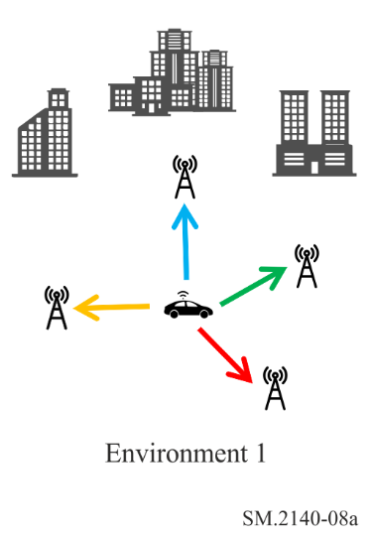 | 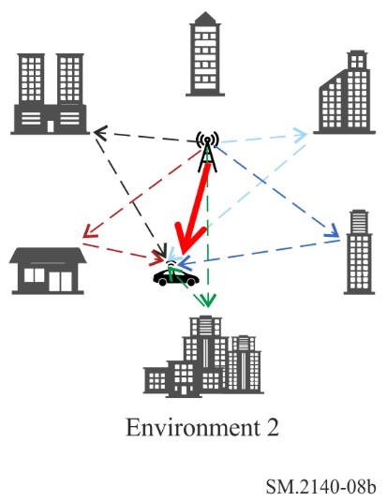 | 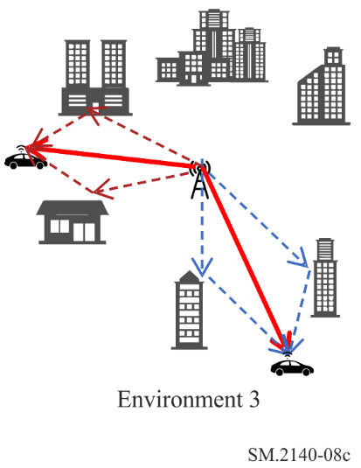
The DF equipment under test should be placed in a vehicle with a global positioning system and with appropriate power source, which will drive to the three types of environment. Each test location should be inside the calculated coverage area of the test transmitter. In general, the “mobile DF” unit will be called to conduct LoB measurements in at least eight (8) different locations around the target, per frequency band of interest, per typical environment. The azimuth distribution of test positions is of no importance if the specifics of each environment are fulfilled.
For the first test environment the requirement is to have a predominant unobstructed direct path between the Tx and the “mobile DF” without any nearby obstacles in order to avoid the existence of any strong multipath reception.
The second test environment is required to have an unobstructed direct path between the transmitter and the “mobile DF” unit, plus reflections created only by obstacles and reflection sources surrounding both the transmitter and the DF. The test locations should preferably be at different distances from the transmitter, if applicable. The test location with the longest distance should be at the limit of coverage to maintain a 20 dB SNR over the minimum specified field strength. For the short distance test location, it is only sufficient to be in the far field.
For the third environment, the main requirement is the existence of an unobstructed direct line between the transmitter and the “mobile DF” unit and reflection creating obstacles placed between the transmitter and the “mobile DF”. The reflections, in this case, can be considered as dominant. The test locations should preferably be at different distances from the transmitter, if applicable. The test location with the longest distance can be at the limit of coverage to maintain a 20 dB SNR or the minimum agreed field strength. For the short distance test location, it is only sufficient to be in the far field.
The test could be performed with unmodulated (CW) or modulated signals using the test transmitter or “targets of opportunity”, including analogue and digital signals with modulation types typical of the signals to be received by the installed DF system, and typical of the operational environment.
If the test is being performed with unmodulated carriers, the DF bandwidth should be set to a value in line with Recommendation ITU-R SM.2060. If the test is performed using a signal with analogue or digital modulation, the DF bandwidth should be adjusted according to the signal bandwidth.
It should be up to the evaluating administration to select the frequency bands and modulation of the test signals covering its particular needs.
All test settings (signal level in μV/m, SNR, signal type, location type, DF bandwidth, test point angle, distance, antenna types, etc.) should be noted in the performance evaluation report.

3.2.2 Measurement procedure
a) Open field environment
a1) The initial test aims to evaluate the performance of a DF unit placed on a certain type of vehicle.
In case the mobile unit installation (permanently fixed on a vehicle) is tested according to Recommendation ITU-R SM.2097 (factory operational tests) for the required set of frequencies/modulations, and the relevant data sheets are available, this measurement can be omitted.
If the DF units is portable, hence can be temporarily installed on different type of vehicles or if the permanent installation was not tested according to Recommendation ITU-R SM.2097 the procedure described in this section can be used.
a2) The “mobile DF” parks in the centre of the open field area and the Tx drives around it. Instantaneous LoB and position coordinates are recorded. The measurements are repeated for each set of parameters (frequency, modulation).
b) Other environments
In this procedure, the transmitter is placed in a fixed location at the centre of the test area. A “target of opportunity”, if available, could also be used.
The “mobile DF” should be driven in different locations around the transmitter and in varying distances from it, ensuring the accuracy of direction and location data as described above, to record continuous readings of LoB. The coordinates of each individual LoB measurement location should be carefully recorded.
In each test location the received signal should be (by properly adjusting the transmitting part) 20 dB above noise (SNR = 20)
For each area the LoB is measured and recorded for a defined period of time (i.e. 10 min). The instantaneous LoB values and position coordinates are inserted in the Table of results (see Table 1) and the deviation from the actual direction to the target (ΔDF = LoB-A) is calculated.
Table 1 is an example of a result table; one table is used for each combination of environment/test position/modulation/frequency.
TABLE 3
Sample test data table
Index | Coordinates | Calculated  True azimuth  towards target  (degrees) | LoB  (degrees) | Calculated  ΔDF = LoB-A  (degrees) | Calculated  ΔDF = |LoB-A|  (degrees)
1 | C₁ | TAz₁ | LoB ₁ | ΔDF₁
2 | C₂ | TAz₂ | LoB ₂ | ΔDF₂
3 | C₃ | TAz₃ | LoB ₃ | ΔDF₃
… | … | … | … | …
x | C_{x} | TAz_{x} | LoB _{x} | ΔDF_{x}

– True azimuth (A) is calculated, knowing the exact location of the transmitter on the map and the exact “mobile DF’s” coordinates.
– LoB is measured by the mobile DF.
– ΔDF = LoB-A

3.2.3 Test data analysis
The presented procedure may serve as a starting point for the administration to evaluate the performance of the DF mobile unit.
The evaluation of the calculated data (ΔDF), from the data collected (LoB), can be analysed in two steps in order to give a quantitative measure of the “mobile DF’s” standoff mode performance in real environments.
Step 1
Each manufacturer gives in the specification sheet a value for the accuracy of its Mobile DF. The accuracy is usually given in RMS for the whole band of operation or in different frequency sub-bands and irrespectively of signal modulation. The value corresponds to testing in a free-of-reflections environment (usually in OATS) and there is no information about the size of the measurement data set, its mean value and standard deviation. Often, the accuracy is characterised as typical without any further detail.
For any set of measurements statistical outliers (“wild data”) of individual DF measurements can be discarded using the interquartile rule equation (3):
${ΔDF}_{discarted}=\begin{matrix}ΔDF>(Q_{75}+1.5ΙQR) \\ ΔDF<(Q_{25}-1.5ΙQR)\end{matrix}$ (3)
where:
Q₇₅ : is the lowest value of ΔDF that is greater or equal to the 75% of the measured values
IQR = Q₇₅-Q₂₅
Q₂₅ : is the lowest value of ΔDF that is greater equal to the 25% of the measured values.
The expected ${ΔDF}_{rms}$ will be different from one environment to another. For the first area, it should be as minimum as possible (approximately equal to what is specified by the manufacturer). For the second environment, is expected to be higher than the one of the first one as it is a measure of on-site multipath immunity. For the third area, the ${ΔDF}_{rms}$ is expected to be even higher due to predominance of reflections arriving at the DF.
ΔDF_{rms} in every individual environment, is calculated per frequency sub-band defined by the manufacturer and considering all measurements of all types of modulations, frequencies and locations (after excluding outliers per set of measurements) according to equation (2):
${ΔDF}_{{rms}_{{{env}_{z}}_{{band}_{j}}}}=\sqrt{\frac{1}{N}\sum_{i=1}^{N}{{{ΔDF}_{i_{{env}_{z}}}}^{2}}}$ degrees (2)
where:
env_{z} : environment type : z = 1,2, or 3
Bandj : individual frequency sub-band of testing as described in spec sheet
j : count of frequency sub-bands in spec sheet (1 to J)
N : count of measurement (No. of azimuths* L * M * No. of modulations)
No. of azimuths : typically 8 (positions)
L : number of LoB collected at each azimuth per frequency per modulation
M : number of individual frequencies within each one of the J sub-bands
No. of modulations : CW plus individual types of modulations.
At the end of the evaluating procedure, there will be a set of J values of ${ΔDF}_{{rms}_{{{env}_{1}}_{{band}_{j}}}}$, per environment, which equal the number of DF accuracy values (per sub-band) given by the manufacturer. Hence, by assuming that environment 1 and OATS are similar, there is a direct indication about the performance of the “mobile DF” comparing the computed RMS values to the respective values from the spec sheet.
Step 2
Each “mobile DF” – under evaluation – can be considered as been tested by the manufacturer for any systematic errors in the estimation of the Line of Bearing. ΔDF can be considered as random errors and may be handled by the theory of statistics. These uncertainties may arise from instrumental imprecision, and/or, from the inherent statistical nature of the phenomena (i.e. environmental effects) being observed. Statistically, both are treated in the same manner as uncertainties arising from the finite sampling of an infinite population of events. The measurement process, as presented, is a sampling process of a distribution too large to be measured to its entirety.
The user will attempt to determine the performance of a “mobile DF” unit in certain types of environments by taking a random sample of finite size and using the sample parameters as an estimate of the true values.
The measurement of a fixed quantity, therefore, involves taking a sample from an abstract, theoretical distribution determined by the imprecision of the instrument. In almost all cases of instrumental errors, it can be argued that the distribution is Gaussian (Normal). Assuming no systematic error, the mean of the Gaussian should then be equal to the true value of the quantity being measured and the standard deviation proportional to the precision of the instrument.
The experimental mean and the experimental standard deviation can be calculated.
$\hat{x}= \frac{\sum{x_{i}}}{n}$ (4a)
$\hat{σ}=\sqrt{\frac{\sum{{(x_{i}-\hat{x})}^{2}}}{n-1}}$ (4b)
where:
$\hat{x}$ experimental mean
$\hat{σ}$ experimental standard deviation
$x_{i}$ ith sample data of DF
n number of data collected.
The ΔDF value has a positive sign when the estimated direction to the target (LoB) is on the right side of the actual direction (A), while it has a negative sign when the estimated direction to the target (LoB) is on the left side of the actual direction (A).
The distribution of the data collected (after excluding “wild data” following equation (3)) can be drawn in the form of a histogram (see Fig. 9)
A perfect circular array, with identical elements, symmetrically placed, that collects LoB values towards targets randomly distributed around its perimeter, should not be biased towards one or the other direction and the ΔDF values measured in an open field, should be equally distributed to the right and to the left of ΔDF equal to zero degrees.
Theoretically, an infinite data set of ΔDF values, collected from a perfect operating DF unit, in an open field, should have a zero experimental mean ( $\hat{x}=0$ ).
In practise, provided that the Open field scenario (environment 1 in Fig. 8a) is free of reflections, and the DF antenna is properly placed on the vehicle, the ΔDF values will have an experimental mean value tending to zero.
The ΔDF data set, after excluding statistical outliners using equation (3), can be approximated with a Normal Distribution with mean μ=$\hat{x}$ and standard deviation σ = $\hat{σ}$, as it can be seen in the graph of Fig. 9.
The data in Fig. 9 obtained from the evaluation of a “mobile DF” unit in an Open field at 20 MHz steps in frequency in the 150 to 1 300 MHz range, in 15 degrees intervals around the target. The initial data set consisted of 1 416 LoB values. After excluding the “wild data” using equation (3) the data set consisted of 1 285 LoB values. Using this data set the histogram is built. The experimental mean is $\hat{x}=-0.27$ degrees and the experimental median $\overline{x}$ = −0.4 degrees. The experimental standard deviation is $\hat{σ}$ = 1.73 degrees. The rms value is ΔDF_{rms} = 1.775.
If the experimental mean value is greater than half of the standard deviation, the operation of the DF antenna is biased significantly towards one direction which means that it is either malfunctioning, misplaced on the vehicle or that there is a significant and probably unnecessary bias in the measurement setup or scenario. In either case the reason for the bias should be investigated and the problem should be fixed before proceeding with further measurements.
When the circular Array of the DF antenna is not malfunctioning and is properly mounted on the vehicle, the “mobile DF” will not have results biased to any particular direction. In this case the user is only interested on the magnitude of the angular deviation towards the target, that is only for the values |ΔDF| = |LoB-A|.
FIGURE 9
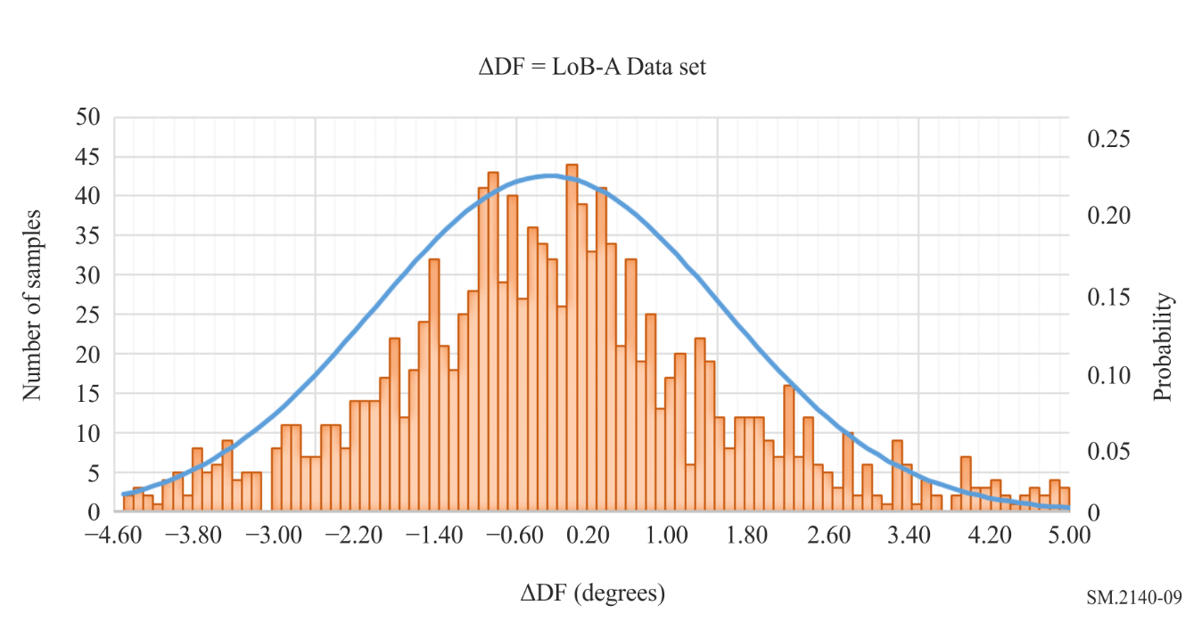
The relevant histogram of the |LoB-A| data set (after excluding the ΔDF = LoB-A “wild data” following equation (2)) and using Sturges method (equation (5)), will give a more visually comprehensive presentation of the “mobile DF’s” performance.
FIGURE 10
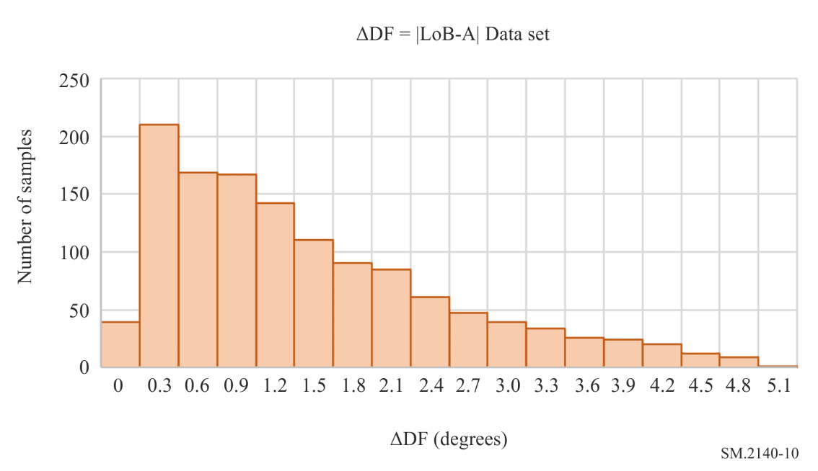
The data in Fig. 10 represents the histogram of the magnitude of the Data set in Fig. 9. The experimental mean is $\hat{x}=1.35$ degrees and the experimental median $\overline{x}$ = 1.0 degrees. The experimental standard deviation is $\hat{σ}$ = 1.106 degrees. The rms value remains unchanged: ΔDF_{rms} = 1.775.
The data collected in environments type 2 and type 3 can be analysed in a similar way.
After excluding the outliers using equation (3), the histogram of the magnitude of ΔDF, using Sturges method (equation (5)) can be created.
$Number of bins=1+3.322 Log\left(k\right)$ (5)
where k is the size of the data set.
The experimental mean, median and standard deviation values in each combination of environment/frequency/modulation/SNR/weather (see Table 4), can be used to describe in a quantitative method the performance of the “mobile DF” in that combination of operational parameters.
TABLE 4
Data set analysis table
 | Operational conditions |  |  |  |  | Results
DF unit | Environment | Frequency | Modulation | Max SNR | Weather | $$\hat{x}$$ | $$\overline{x}$$ | $$\hat{σ}$$ | rms

The best performance would be the one with the lowest mean ΔDF and the lowest standard deviation (the spread of the random error is narrow).
By plotting, on the same X-Y axis, the histograms of different |ΔDF| data sets – corresponding to the performance of a “mobile DF” in different environments and for variations of operational parameters (frequency, modulation, SNR etc) the user can have a more comprehensive visualisation of the overall performance of a “mobile DF” in real operational conditions.
Following the completion of the standoff mode test procedure, the procuring administration would have the confidence that the system is operational and could have an indication of how well the vehicle set up is expected to perform in real environments.
The administrations can further evaluate the collected Data Sets using more advanced statistical analysis tools and methods in order to identify more complex relationships between performance and different variables (the environment, frequency bands, etc.) and the strength of impact of these variables on it.

4 Report of results
The final evaluation report should include:
1 All the test settings of each measurement as described in the appropriate section. i.e.:
– type of environment
– weather conditions
– location of target
– location of measurement
– frequency / modulation / SNR.
2 The results of each type of measurement:
I. Homing Mode evaluation
a) Homing in predefined route
• Table 1 – Results of “Homing in predefined route”
• RMS of positioning error
• Screen shots from the positioning software
• Satellite Images of the test area
b) Target localization
b1) Three-point triangulation:
• Triangulation polygon created of individual estimations of AoA on a map
• The area of the polygon, in (m²), provided it includes the target (see Fig. 3).
b2) Blind Homing:
• Screen shots from the positioning software or video of the blind homing process
• Route covered by “mobile DF” on map
• Table 2 – Results of “Blind Homing”.
II. Standoff mode evaluation
• Table 3 – Sample test data table, per set of operational parameters
• Statistical Evaluation of open field performance
• Satellite images of test areas
• Table 4 – Data set analysis table
• Histogram of ΔDF and |ΔDF| values per set of operational parameters.

Report ITU-R SM.2125.
ITU Spectrum Monitoring Handbook (see § 4.7.2.1.1).
ITU Spectrum Monitoring Handbook (see § 4.7.2.2).
ITU Spectrum Monitoring Handbook (see §§ 3.6.2.2.5 and 3.6.2.2.6).
Recommendation ITU-R SM.2097.
Report ITU-R SM.2125-1.
Recommendation ITU-R SM.1723-2.
Angle of Arrival.
ITU Spectrum Monitoring Handbook (see § 4.7.3.3).
Line of Bearing.
When there are not many options of using targets of opportunity in order to evaluate the performance of the “mobile DF” unit over different types of modulation, the equipment could include test transmitters and modulation generators to generate signals in some combination of key modulation types (both analogue and digital) and a range of emission bandwidths (e.g. a narrow, medium and wide bandwidth in the range 10 kHz to 20 MHz).
NOTE: It would be recommended to test to an agreed SNR equivalent to the minimum signal strength advertised by the manufacturer at which specified accuracy is achieved.
By mutual agreement between administrations and manufacturers, testing of certain types of modulated signals may be specified.
An important consideration in frequency selection is the availability of frequencies for licensing for test purposes. Not only should frequencies which may be in use in nearby areas be avoided (if they can be received at the test site), but frequency licenses are mandatory in many countries, even for temporary use. Especially in urban areas there may be restrictions on what frequencies and frequency bands may be used for testing the DF system.
SNR = 20 dB (usually it lower when a mobile DF tries to find a source of interference or of unauthorised transmission).
ITU Spectrum Monitoring Handbook (see § 4.7.3.3).
ITU Spectrum Monitoring Handbook (see § 4.7.3.1).
Statistics and the treatment of experimental data. W. R. Leo (Adapted from Chapter 4, Techniques for Nuclear and Particle Physics Experiments, by W. R. Leo, Springer-Verlag 1992).

