Recommendation ITU-R SM.2139-0
(08/2021)
Test procedure for determining
the accuracy of TDOA systems

SM Series
Spectrum management

Foreword
The role of the Radiocommunication Sector is to ensure the rational, equitable, efficient and economical use of the radio-frequency spectrum by all radiocommunication services, including satellite services, and carry out studies without limit of frequency range on the basis of which Recommendations are adopted.
The regulatory and policy functions of the Radiocommunication Sector are performed by World and Regional Radiocommunication Conferences and Radiocommunication Assemblies supported by Study Groups.

Policy on Intellectual Property Right (IPR)
ITU-R policy on IPR is described in the Common Patent Policy for ITU-T/ITU-R/ISO/IEC referenced in Resolution ITU-R 1. Forms to be used for the submission of patent statements and licensing declarations by patent holders are available from http://www.itu.int/ITU-R/go/patents/en where the Guidelines for Implementation of the Common Patent Policy for ITU-T/ITU-R/ISO/IEC and the ITU-R patent information database can also be found.

Series of ITU-R Recommendations
(Also available online at http://www.itu.int/publ/R-REC/en)
Series | Title
BO | Satellite delivery
BR | Recording for production, archival and play-out; film for television
BS | Broadcasting service (sound)
BT | Broadcasting service (television)
F | Fixed service
M | Mobile, radiodetermination, amateur and related satellite services
P | Radiowave propagation
RA | Radio astronomy
RS | Remote sensing systems
S | Fixed-satellite service
SA | Space applications and meteorology
SF | Frequency sharing and coordination between fixed-satellite and fixed service systems
SM | Spectrum management
SNG | Satellite news gathering
TF | Time signals and frequency standards emissions
V | Vocabulary and related subjects

Note: This ITU-R Recommendation was approved in English under the procedure detailed in Resolution ITU-R 1.

Electronic Publication
Geneva, 2021

© ITU 2021
All rights reserved. No part of this publication may be reproduced, by any means whatsoever, without written permission of ITU.

RECOMMENDATION ITU-R SM.2139-0
Test procedure for determining the accuracy of TDOA systems
(2021)
Scope
The accuracy of Time-difference-of-arrival (TDOA) systems is an important consideration to regulatory authorities and others who have to locate emitters with TDOA-based emitter location systems. To facilitate comparison between TDOA systems, this Recommendation provides guidance on methods of determining the accuracy of TDOA systems, reporting of the results, and selecting the test scenario.
Keywords
Accuracy of TDOA systems, measurement, test site, test scenario, time-difference-of-arrival, TDOA
Acronyms
CEP Circular error probability
EEP Elliptical error probability
GDOP Geometric dilution of precision
RMS Root mean square
RTK Real-time kinematic
SNR Signal to noise ratio
TDOA Time-difference-of-arrival
VDOP Vertical dilution of precision
Related ITU Recommendations, Reports
Recommendation ITU-R SM.2060
Recommendation ITU-R SM.2097
Report ITU-R SM.2211
Report ITU-R SM.2356
NOTE – In every case the latest edition of the Recommendation/Report in force should be used.
The ITU Radiocommunication Assembly,
considering
a) that ITU-R has included the time-difference-of-arrival (TDOA) emitter location method in the ITU Handbook on Spectrum Monitoring (Edition 2011);
b) that Report ITU-R SM.2211-1 – Comparison of time-difference-of-arrival and angle-of-arrival methods of signal geolocation, gives a description of the strengths and weaknesses of TDOA systems;
c) that the test procedures applied have an impact on measured and reported accuracy of TDOA-based emitter location systems;
d) that the test scenario has an impact on measured and reported accuracy of a TDOA-based emitter location systems;
e) that the accuracy of TDOA systems may influence the perceived suitability of a TDOA emitter location system to fulfil certain monitoring tasks;
f) that test procedures to validate accuracy of TDOA systems specifications should be independent of system design;
g) that a well-defined set of test procedures for determining the accuracy of TDOA systems, wherever adopted, will facilitate an objective assessment of different systems;
h) that an objective comparison of different systems requires a test in the same scenario,
recommends
1 that the test procedure in Annex 1 should be used to determine and report the accuracy of TDOA systems;
2 that the test scenario in Annex 2 should be used to set up the test site;
3 that for each accuracy performance specification, the test procedure and test scenario, should be indicated;
4 that administrations consider undertaking performance tests in addition to those described in Annex 1 in an operational environment to assess the impact of signal impairments, adverse propagation effects, and sensor geometry (including elevation) on the overall accuracy or performance of TDOA systems to determine the suitability of the system to meet their requirements.

Annex 1
General test procedure for determining the accuracy of TDOA systems

1 Introduction
This Recommendation proposes a test procedure that can be used to evaluate the accuracy of TDOA systems. The goal is to define a method that can be used to conduct testing, so administrations have a basis for comparison of TDOA-based emitter location systems from different manufacturers and based on their requirements.
It should be noted that accuracy is not the only parameter to characterize the overall performance of a TDOA system and its suitability to meet the requirements of an administration. Important aspects such as the ability to locate pulsed signals and the time delay between emission and geolocation may also be important but are outside the scope of this Recommendation.
The accuracy of TDOA systems is defined as the root mean square (RMS) value of the difference between the true emitter location and the location reported by the measurement system.
The procedure could be conducted in a scenario that is under ideal/controlled conditions according to Annex 2 or the requirements of the administration and can be used for TDOA system accuracy and performance comparisons.
Further discussion of TDOA can be found in the ITU Handbook on Spectrum Monitoring (Edition 2011), Chapter 4.7, and in Report ITU-R SM.2211-2 – Comparison of time-difference-of-arrival and angle-of-arrival methods of signal geolocation.

2 Principle of measurement
Considering that TDOA accuracy is significantly impacted by test signal and the relative test method, Annex 1 specifies the modulation type and bandwidth of test signal, test frequency selection, settings of system under test, and measurement procedure. In Annex 2, the measurements will be conducted under controlled scenario, with the goal of test repeatability and consistency of the results at any similar test site, so co-channel interference and external uncontrollable conditions such as multipath propagation and terrain variations will not be included to reduce the complexity and duration of the test procedure. The measurement should take place in an environment far from strong radiation and with no secondary radiation. Prior to the final site selection, the electromagnetic environment shall be evaluated to ensure sufficiently low levels of external signal and noise energy exist for the test.
However, a variety of real-world effects can impede the accuracy of TDOA systems. These real-world effects can be divided into two categories, systematic or deterministic effects, and random or non-deterministic effects. Examples of sources of error which can introduce a systematic bias to location results include the impact of sensor geometry (GDOP) and elevation variation (VDOP) which arise largely from terrain in the coverage area. Errors resulting from VDOP are a function of the difference in elevation among the sensors, the emitter, and the associated separation distances. For example, when the separation distance is small, elevation differences can introduce significant error if not accounted for by the TDOA system through the use of terrain or case-specific elevation data. On the other hand, propagation effects and other signal impairments can give rise to either random or systematic errors, depending on the circumstances. Errors from all these sources will impact system performance in a real operational environment. Measurements in a flat unobstructed area typically provide better measured accuracy and performance results for a TDOA system than measurements including the above-listed sources of error. To determine the suitability of a TDOA system for use in a real operating environment, it is suggested the measurements described in this Recommendation be repeated with TDOA receivers deployed in a realistic setting where the full impact of both systematic and random effects can be evaluated. While such a test can determine the usefulness of the TDOA system, it cannot practically be used to compare the performance of multiple systems.

3 Measurement set up

3.1 Test site
The test site is recommended in Annex 2. It also could be chosen according to the requirements of the administration based on deployment scenarios of interest.
The measurement setup described in this section as well as the measurement procedure of § 4 are valid in general and can be used with different test sites.

3.2 Test equipment selection
The test equipment should include a signal transmitting system with positioning equipment. The transmitting system consists of a signal generator capable of generating analogue and digital modulations, power amplifier, and a set of transmitting antennas for the test frequency bands. It is recommended to use omnidirectional antennas to connect the transmitting system for testing. Fixed power levels should be used and logged with the test data. The polarization of the test transmitter antenna should match the polarization of the TDOA antennas. The polarization used should be noted in the test report.
If required, the positioning equipment can make use a real-time kinematic (RTK) positioning device to provide higher position accuracy. If other positioning equipment is used, the accuracy of the equipment should be marked and recorded in the test report. All test equipment shall be calibrated to ensure traceability to a national standards laboratory.

3.3 Test frequency selection
The test frequencies should be selected uniformly in the operating frequency range of the system. Below 100 MHz, a minimum frequency interval of 10 MHz should be used; between 100 MHz and 1 000 MHz, a minimum frequency interval of 50 MHz should be used; if the operating frequency is above 1 000 MHz, a minimum frequency interval of 100 MHz should be used. The number of frequency points can also be determined by mutual agreement between the administration and the manufacturers based on the system requirements or use case.
Some frequencies should be avoided because of possible interference from some authorized or uncontrollable signals in the general area. These should have been identified in the site survey. Frequencies with impairments caused by external effects should be excluded from the test. If there is an interference signal on the test frequency which is 6 dB higher than the noise floor, the test frequency should be changed to a new one within 5 MHz of the original frequency.

3.4 Test signal modulation settings
Both analogue and digital modulation formats should be used for the test signal. The modulation scheme should be varied within the limits of the test equipment capabilities to produce bandwidths based on the needs of the administration and the agreement by the manufacturer. For each modulation type, the output power should be noted in addition to the received amplitude at each TDOA receiver. The modulation format, and parameters (i.e. symbol rate) should be noted in the test report.

3.5 Settings of system under test
This Recommendation lists a typical test configuration with three TDOA receivers. If the system, as defined by the administration, employs four or more receivers, it can also refer to this Recommendation to set up test after adjustment of the receiver geometry, and this situation should be mentioned in the test report. However, if systems are being compared, the number of sensors should be identical.
The antenna of the TDOA system must be adjusted to a suitable height, preferably consistent from one receiver location to another. Before the test, the TDOA system should have a warm-up period in accordance with manufacturer’s recommendation to achieve the specified performance.
The TDOA system should be configured to measure at each test frequency with an acquisition bandwidth not larger than the modulation bandwidth of the transmitted frequency and a fixed acquisition time (i.e. number of IQ samples/IQ sampling rate) based on the manufacturer’s recommended settings.

4 Measurement procedure

4.1 Test position selection
Multiple test positions should be selected to measure the geolocation accuracy of the TDOA system. In addition to centre position of the test site, other testing positions are required as follows:
– The number of additional test positions shall be no less than three.
– Test positions should be selected inside the region composed by the TDOA receivers. Test locations along the radial lines between sensors should not be used.
– The distance between test positions must be greater than the nominal geolocation accuracy of the system under test.
– If possible, two test positions outside the region bounded by the TDOA receivers should be selected to determine the ability of the system to process poor GDOP conditions. The distance from the boundary of the TDOA receivers should be no less than the nominal geolocation accuracy of the system under test. These test positions and results should be recorded separately in the test report.

4.2 Test procedure
1 Locate the transmitting system at test position 1 and adjust the antenna to the same height as the TDOA receiver antenna.
2 Run the positioning device to measure the position of the transmitting system and record the latitude and longitude (αj, βj) (j = 1, 2…m).
3 Set the modulation mode of the transmitting system and select the test frequency f_{i}(i = 1, 2…n).
4 Adjust the transmitting system to achieve 20 dB SNR for each TDOA receivers at least to support the test.
5 Set the operating frequency of the TDOA system as the current test frequency f_{i}, then set the optimum receiving mode of the system under the corresponding signal modulation mode and record the parameters of receiver.
6 Run the TDOA system taking at least 10 (ten) measurements, record the latitude and longitude of each measured location and the average results (x_{i}, y_{i}), and enter them into Table 1 and pin the results on a location diagram.
7 Change the test frequency, modulation parameters and location of the signal transmitting system repeating the above until completion of all frequencies, modulations and positions.

4.3 Test data processing and presentation of the results
The distance between measured positions (x_{i}, y_{i}) and actual position (α_{j}, β_{j}) of the transmitting system is the geolocation error ΔL_{ij}. The formula of calculation is shown as:
$${∆L}_{ij}=R×\arccos\left(sin\left(\frac{β_{j}×π}{180}\right)×{sin\left(\frac{y_{j}×π}{180}\right)}+\cos\left(\frac{β_{j}×π}{180}\right)×\cos\left(\frac{y_{i}×π}{180}\right)×\cos\left(\frac{\left(x_{i }-α_{j}\right)×π}{180}\right)\right)$$
where:
R: Earthʼs long elliptical radius.
After geolocation error of all positions in the whole operation frequency band of the system under test has been measured, the accuracy of the TDOA system under the corresponding signal modulation mode and bandwidth can be obtained as follows:
${∆L}_{rms}= \sqrt{\frac{\sum_{i=1}^{n}{\sum_{j=1}^{m}{{\left(∆L_{ij}\right)}^{2}}}}{mn}}$
where:
m: number of testing positions
n: number of frequency points.
The test report of TDOA accuracy should be including the test data table and the location diagram at least. Based on the actual testing, the rough time required to compute the result, output power of the test equipment and received amplitude at each of the TDOA sensors also shall be recorded if that is possible. Additionally, if the TDOA system provides the quality of the correlation (i.e. percentage or fraction value) – this should be included in the test report.
TABLE 1
Sample test data table
Basic information
Date:
Weather conditions:
Test Environment:
# of Sensors:
Company:
Product:

Test location 1 |  |  | Latitude |  |  | xx.xxxx |  |  | Longitude |  |  | xx.xxxx
Meas  #1 | Signal generator settings |  |  |  |  | TDOA system settings |  |  | TDOA measurement results
Meas ID # | Frequency  (MHz) | Bandwidth  (kHz) |  | Modulation | Amplitude  (dBm) | # of Samples | Bandwidth  (kHz) | Attenuation  (dB) | Latitude | Longitude | Quality  (0>1) |  | Error  (metres) | Time of meas
1
2
3
4
5
6
7
8
9
10
AVERAGE

Note that ΔL is geolocation error for average location determined. It is calculated as the distance between the true position and the average location displayed by the TDOA system. Alternatively, it can be reported as delta x (measurement deviation in the latitude direction in metres and with positive values eastwards), and delta y (measurement deviation in longitude direction in metres and with positive values northwards).

Annex 2
Test scenario for determining the accuracy of TDOA systems

1 General requirement of test site
The test scenario should be free of reflective surfaces, obstacles and transmitters, which should be far from strong radiation and with no secondary radiation. The ideal test site could be the Open Air Test Site (OATS) as defined in Recommendation ITU-R SM.2060.
The test site also can be selected according to the administration’s requirements. The aspects on planning of a TDOA networks given in Report ITU-R SM.2356 should be considered when planning the setup of the TDOA system under test.

2 Test site set up
The recommended scenario is shown in Fig. 1 and should be a planar region bounded by a circle. The test site also can be chosen according to the requirements of the administration and according to deployment scenarios of interest. There must be sufficient separation distance between the TDOA receivers to guarantee proper operation, especially on narrowband test signals. Based on this, the radius of test site should be no less than 500 metres. If this cannot be achieved, the radius of the test site will be determined by mutual agreement between the administration and the manufacturer. These cases should be noted in the test results.
FIGURE 1
General test site structure
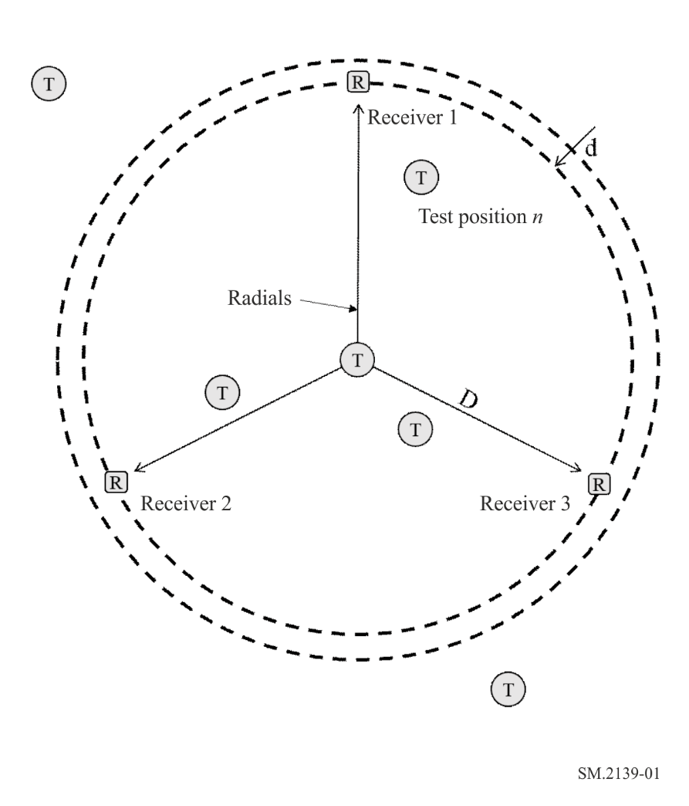
Receiver – TDOA Receiver location
“T” – Possible test position locations
Layout the testing system as shown in Fig. 1:
– The distance from each receiver to the site centre of the testing system is D, which is no less than 500 m unless agreed to by the manufacturer.
– Each TDOA receiver must be evenly distributed in the test site, and the distance between the receivers should be consistent with normal working conditions of TDOA systems.
– The distance from each receiver to the test site edge is d, and d is not less than 50 m.
– The minimum distance from a test location to any receiver should be in accordance with the manufacturer’s recommendation. In general, the wider the test signal modulation bandwidth, the close the test transmitter can be to the receiver. Narrow test signal modulation bandwidth will require further separation distance from the receivers.

Annex 3
Examples of TDOA system test results
For test data created by measurements performed in a realistic operational environment which may be impacted by the interference signal, statistical outliers (“wild data”) can be excluded but should be noted in the test report.
Providing visualizations of the TDOA accuracy test will assist authorities in interpreting the results, and better understand the sources of error for different test locations and signal bandwidths. It is recommended the following elements be included on the visual display of TDOA test results:
– map of the test area with the scale shown or distance between two of the sensors clearly marked;
– precise location of the test emitter;
– the test sequence number (reference to the table of test conditions such as centre frequency, signal bandwidth, output power level);
– location of each of the TDOA estimates of the test emitter (such as an “X” or crosshair);
– location of the average of the TDOA estimates, and the measured distance to the test location;
– EEP or CEP (optionally);
– TDOA convergence or heat map (optionally).
To better understand test results, measurements should also be displayed on a commercially available Geographical Information System (GIS), or on the map display provided by the system under test. For each test location, the results should be overlaid with the transmitter location to create a picture of the nature of the errors. Additional information from the system under test (if available) should be displayed and included with the test report. Such information could include:
– Elliptical Error Probability (EEP) or Circular Error Probability (CEP) data with associated percentage (usually 50% or 95%) to include major and minor axes, as well as rotation relative to North;
– TDOA Hyperbola;
– colour map depicting convergence of the geolocation algorithm;
– sensor locations;
– number of TDOA Sensors.
This information will help authorities understand the sources of error associated with each measurement, such as signal bandwidth, signal-to-noise ratio, and geometry (GDOP). Four examples are shown below.
FIGURE 2
Example geolocation test results – good GDOP
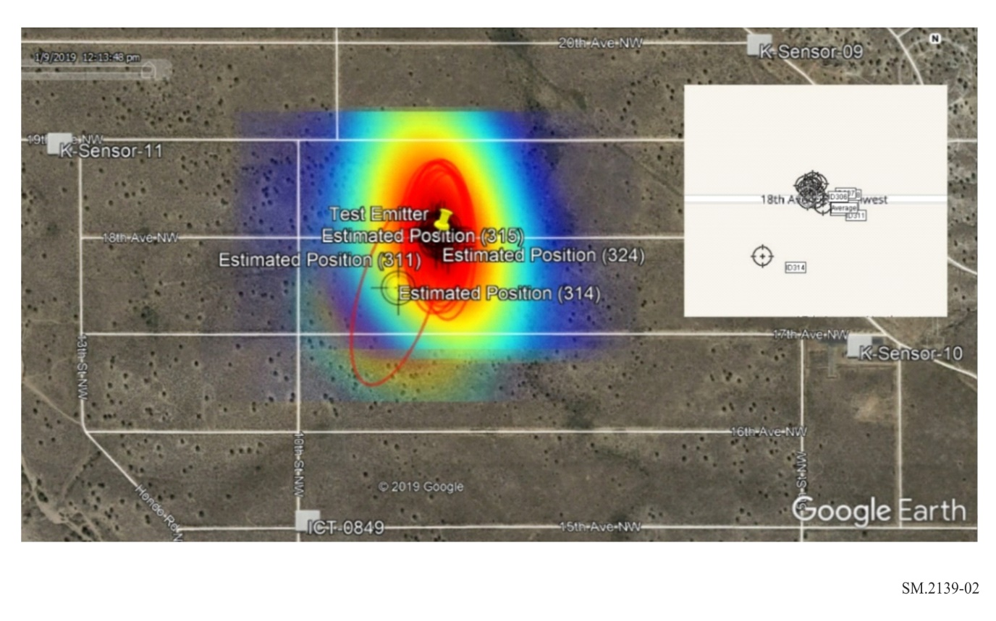
In Fig. 2, a set of 12 TDOA measurements are shown, using four TDOA Sensors, with the test emitter (represented by the yellow pin) in a location favourable for accurate TDOA measurements (good GDOP). The estimated locations, EEP’s, and colour map of the measurement results are shown. The visualization provides the user a quick assessment of the accuracy and consistency of the results relative to the test emitter. The inset shows the location results as they appear in the TDOA system map display. This measurement set includes an outlier (number 314) which needs additional analysis to determine if interference or some other external factor caused the unusually large error.
The procedure requires determination of the error between the test emitter location and the average of the TDOA measurements. This can also be depicted visually; an example is shown in Fig. 3. The image also shows a random distribution of error around the test emitter, and, in this case, the average produces an accurate estimation of emitter location – better than most of the individual measurements. The outlier is not shown on this image to better visualize the distribution of error.
FIGURE 3
Distribution of TDOA errors – good GDOP
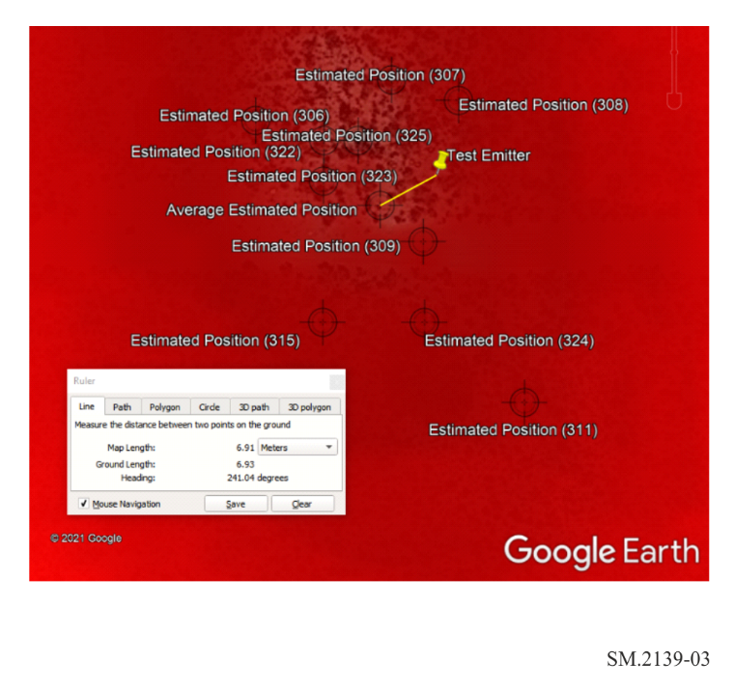
In Fig. 4, the test emitter was located outside the sensor boundary resulting in poor GDOP and producing larger measurement errors. As can be seen, the measurements are spread along an axis representing the line of bearing from the sensor field to the emitter. The EEPs are elongated due to uncertainty introduced by geometry.
FIGURE 4
Example geolocation test results – poor GDOP
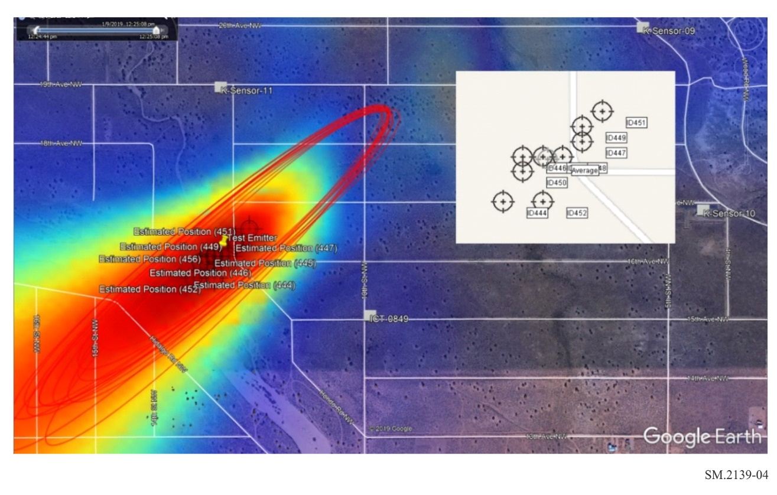
The worst-case error in this data set was over 120 metres. However, averaging the random errors result in an accuracy of about 20 metres as can be seen in Fig. 5.
FIGURE 5
Average TDOA error – poor GDOP
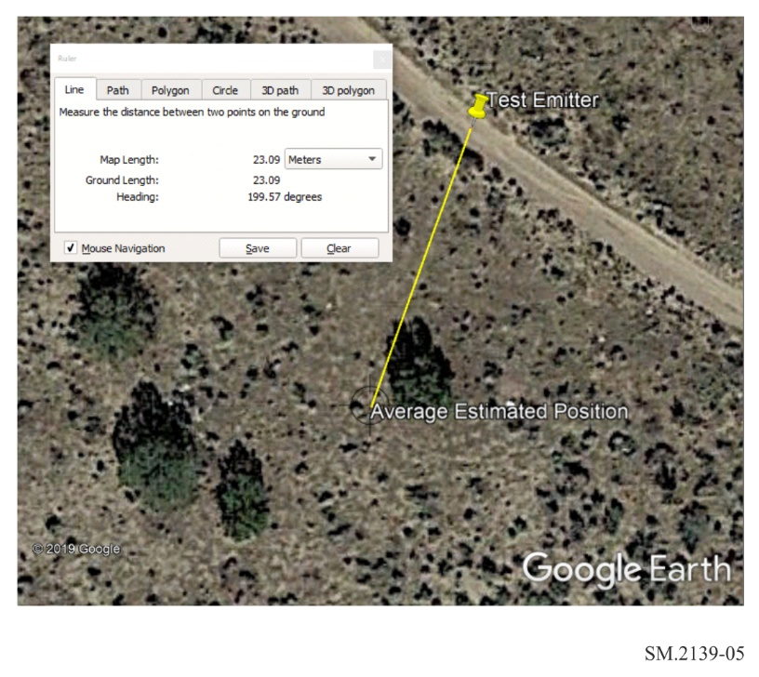
The measurement examples shown above used four TDOA sensors and were conducted on signals with a relatively wide modulation bandwidth (about 1.25 MHz). Performing the test with three sensors, the minimum required for emitter location, and signals of different bandwidth may reveal limitations associated with given hardware or algorithms. Such limitations should be considered by administrations to discriminate between TDOA systems.
NOTE – The designations employed and the presentation of material in Figs 2 to 5 do not imply the expression of any opinion whatsoever on the part of ITU and of the Secretariat of the ITU concerning the legal status of the country, territory, city or area or its authorities, or concerning the delimitation of its frontiers or boundaries.

