Recommendation ITU-R SM.1603-2
(08/2014)
Spectrum redeployment as a method
of national spectrum management

SM Series
Spectrum management

Foreword
The role of the Radiocommunication Sector is to ensure the rational, equitable, efficient and economical use of the radio-frequency spectrum by all radiocommunication services, including satellite services, and carry out studies without limit of frequency range on the basis of which Recommendations are adopted.
The regulatory and policy functions of the Radiocommunication Sector are performed by World and Regional Radiocommunication Conferences and Radiocommunication Assemblies supported by Study Groups.

Policy on Intellectual Property Right (IPR)
ITU-R policy on IPR is described in the Common Patent Policy for ITU-T/ITU-R/ISO/IEC referenced in Annex 1 of Resolution ITU-R 1. Forms to be used for the submission of patent statements and licensing declarations by patent holders are available from http://www.itu.int/ITU-R/go/patents/en where the Guidelines for Implementation of the Common Patent Policy for ITU-T/ITU-R/ISO/IEC and the ITU-R patent information database can also be found.

Series of ITU-R Recommendations
(Also available online at http://www.itu.int/publ/R-REC/en)
Series | Title
BO | Satellite delivery
BR | Recording for production, archival and play-out; film for television
BS | Broadcasting service (sound)
BT | Broadcasting service (television)
F | Fixed service
M | Mobile, radiodetermination, amateur and related satellite services
P | Radiowave propagation
RA | Radio astronomy
RS | Remote sensing systems
S | Fixed-satellite service
SA | Space applications and meteorology
SF | Frequency sharing and coordination between fixed-satellite and fixed service systems
SM | Spectrum management
SNG | Satellite news gathering
TF | Time signals and frequency standards emissions
V | Vocabulary and related subjects

Note: This ITU-R Recommendation was approved in English under the procedure detailed in Resolution ITU-R 1.

Electronic Publication
Geneva, 2014

© ITU 2014
All rights reserved. No part of this publication may be reproduced, by any means whatsoever, without written permission of ITU.

RECOMMENDATION ITU-R SM.1603-2**
Spectrum redeployment* as a method of national spectrum management
(Question ITU-R 216/1)
(2003-2012-2014)
Scope
This Recommendation gives guidelines for spectrum redeployment issues.
Keywords
Guidelines, national spectrum management, spectrum redeployment, spectrum refarming
Related ITU Recommendations, Reports
Reports ITU-R SM.2012, ITU-R SM.2015 and ITU-R SM.2153.
NOTE – In every case the latest edition of the Recommendation/Report in force should be used.
The ITU Radiocommunication Assembly,
considering
a) that all administrations need to make spectrum available for new radio applications and for increased use of existing applications;
b) that as the use of the spectrum increases it may become progressively more difficult for administrations to find suitable spectrum for radio applications;
c) that making spectrum available for some new applications may require redeployment to other frequency bands or redeployment to new technologies (i.e. to decreased bandwidth or analogue to digital);
d) that redeploying licence-exempt bands will be complicated by lack of records of users;
e) the experiences of administrations in spectrum redeployment techniques would provide information on the practice;
f) that frequency management and thus redeployment of spectrum is a national responsibility and there is a need for guidelines by collating the experiences of administrations in spectrum redeployment techniques,
recommends
1 that the following definition for spectrum redeployment be recognized as:
“Spectrum redeployment (spectrum refarming) is a combination of administrative, financial and technical measures aimed at removing users or equipment of the existing frequency assignments either completely or partially from a particular frequency band. The frequency band may then be allocated to the same or different service(s). These measures may be implemented in short, medium or long time-scales.”;
2 that Annex 1 should be used as a guide for national consideration of redeployment issues.

Annex 1
Redeployment issues
TABLE OF CONTENTS
Page
Policy on Intellectual Property Right (IPR) ii
Annex 1 Redeployment issues 2
1 Introduction 4
2 The requirement for spectrum redeployment 4
3 Spectrum redeployment 5
3.1 Time-scales 5
3.2 Voluntary and regulatory spectrum redeployment 6
3.3 Cost of implementation 8
3.4 Regional coordination for redeployment 9
3.5 Global/regional harmonization for redeployment 9
4 Relationship between spectrum redeployment and spectrum pricing 9
4.1 Spectrum pricing 10
4.2 Compensation 10
5 Conclusions 12
Attachment 1 to Annex 1 An example of the spectrum redeployment process based on the French experience 12
1 Interests driving the decision to redeploy spectrum 13
2 The cost of redeployment 13
3 Calculation of the redeployment cost using the residual book value 13
3.1 Evaluation of the cost incurred by the user on leaving the frequency band 14
3.2 The residual book value, Vcr 14
3.3 Renewal costs 14
3.4 Calculation of the redeployment cost 14
4 Calculation of the redeployment cost using residual economic value 15
4.1 Analysis of the value of networks 15
5 The redeployment fund and redeployment procedures 16
5.1 The redeployment fund 16
5.2 The redeployment procedures 16
Attachment 2 to Annex 1 Examples of the spectrum redeployment process based on the UAE experience 17
1 The change in channel plan for private mobile radio 17
2 The use of 8.33 kHz channelling for VHF aeronautical mobile 18
3 The digital switchover planning in the VHF and UHF bands 18
Attachment 3 to Annex 1 19
An example of the spectrum redeployment process at the regional level 19
Attachment 4 to Annex 1 An example of spectrum redeployment process based on the Benin experience 20
1 Issues and objectives of the redeployment 20
2 Methodology 20
3 Results of the redeployment 21
4 Conclusion 21
Attachment 5 to Annex 1 An example of the spectrum redeployment process based on the Ukrainian experience 22
1 Prerequisites and objectives of the redeployment 22
2 Redeployment planning 23
3 Redeployment implementation 24
4 Conclusion 24
Attachment 6 to Annex 1 An example of the spectrum redeployment (refarming) process based on the United States of America experience 25

1 Introduction
The radio spectrum is a finite, but reusable resource that can benefit each administration by providing a medium to assist communications and economic development. In order to maximize the benefits to an administration the radio spectrum needs to be efficiently and effectively managed. Part of efficient and effective spectrum management is planning the development of radio services in advance of their requirement; this may include extending the coverage of existing services, enhancing the performance of existing services and introducing new services. This type of spectrum planning is considered to be associated with the development of a national spectrum strategy and the strategy is normally expected to cover a period of five to ten years. Report ITU-R SM.2015 – Methods for determining national long-term strategies for spectrum utilization, provides details on the planning process, evaluation of scenarios and appropriate procedures for transition from present spectrum utilization to long-term objectives.
To improve existing services or introduce new services, it may be necessary to move existing users of the radio spectrum to more modern technologies or new frequency bands. This movement of existing spectrum users, or as it is otherwise known, spectrum redeployment, needs to be planned. Spectrum redeployment should be included in the administration’s national spectrum strategy together with the mechanism identified to assist implementation of redeployment. It should be considered equally with all other options, i.e. sharing, removing restrictions, and not as a last resort.
Spectrum redeployment is not necessarily a simple task and an administration may face a number of difficulties that can complicate, delay and even disrupt the process. The administration is encouraged to use spectrum monitoring data to supplement other data when considering redeployment. The level of difficulty experienced and options of implementations available may subsequently influence an administration’s approach to spectrum redeployment. The following text examines the process of spectrum redeployment and the various factors that are associated with its use.

2 The requirement for spectrum redeployment
All administrations have plans to introduce new radio services and for some this may include the need to move existing users of the radio spectrum to new technologies or new frequency bands. This requirement to move existing users of the spectrum can arise for a number of reasons, for example:
a) a spectrum allocation may have been in operation for a considerable period of time and currently no longer matches the demands of users, or the capabilities of modern systems;
b) an allocation within a specific range of frequencies is required for a new radio service and these frequencies are occupied by services with whom the new service cannot share;
c) a decision by a WRC to allocate a currently-occupied frequency band to a different service on a regional or global basis.
If, as in the case of b) above, the spectrum allocation is not being used efficiently, there may be a requirement to re-engineer the band to improve spectral efficiency and this can include the following options:
– increasing the level of spectrum sharing;
– reducing the channel bandwidth to increase the number of channels;
– changing to more efficient modulation techniques that permit greater sharing;
– reducing the frequency reuse distance.
Any of the above options may provide the requirement for starting a spectrum redeployment process in order to change existing users’ current equipment and/or their frequency assignment, even though any change in frequency may be limited to the same frequency band. In some cases, the spectrum sharing criteria between services on a co-primary basis is detailed but the national requirements may be to assign these frequencies to one of the radio service and may require the redeployment of other radio services from the same band.
If an administration can move existing users to unused spectrum, then the spectrum redeployment process may not be difficult. However, resistance amongst radio users to changes in the type of equipment used, or to changes in frequency allocation, limits an administration’s flexibility to make spectrum available for new users and services. In addition, in some countries, increasing spectrum congestion can make the identification and use of alternative frequency bands time-consuming and difficult. Delays in the introduction of new services are undesirable, as they can make a proposed solution obsolete before it is implemented and, in the case of a proposed change affecting one or more frequency bands, a delay with one service1 may impact on several other bands and services.
These delays, as studies have shown, are capable of causing a significant loss to a country’s economy. If a solution is not achieved, this may lead in the long term to impairment in spectrum use and a reduction in radiocommunications development. Hence, it is important that once an administration has decided to use spectrum redeployment, any unnecessary delays in the process are avoided.
The extent to which an administration will need to use spectrum redeployment will depend on the size of the demand for spectrum and the level of spectrum congestion within the administration. For those administrations where the level of demand for spectrum has given rise to spectrum congestion and there is little usable spectrum available, the need for an effective spectrum redeployment policy is self-evident. However, there are benefits in identifying a suitable spectrum redeployment mechanism. Benefits can apply even to countries where spectrum congestion is not a problem, as the necessity to make spectrum available to take advantage of new services is an issue that faces all administrations, e.g. providing spectrum to take advantage of the global growth in mobile services.

3 Spectrum redeployment
Spectrum redeployment is a national spectrum management tool and therefore, in theory, any frequency band and any system could be subjected to some form of spectrum redeployment. In practice, spectrum redeployment is more limited as it can only be applied in cases where an administration can change the use of the frequency band and this may be limited by international agreements and sharing criteria.
The administration should derive benefits in terms of technical, economic and social aspects from the process of redeployment of spectrum.
For example, the new use of a released band can make more efficient use of the spectrum and can provide services to improve quality of life and generate new business opportunities that can increase employment.
The issues associated with applying spectrum redeployment in bands where use is exempt from licences are more complex than for licensed use, as there is no record of users of the service. The ramifications of these issues are described in § 3.2.2.

3.1 Time-scales
The approach an administration takes to spectrum redeployment depends on the time-scale in which the spectrum needs to be made available. For some services a change in spectrum use may be associated with a new international allocation. In this case, the period for planning the introduction for the particular service may take place over a 10 to 20 year time-scale and be subject to a long-term plan with quite detailed market predictions of the possible technology developments to justify the allocation process.
For services where the change in spectrum use is based on a change in the end user service, for example mobile data, the demand for spectrum access can arise more quickly due to the rapid change of market requirements and the availability of the technology. These services may require a more flexible system for the national designation of spectrum for a particular service and typically would be characterized by a shorter planning cycle (i.e. less than five years) where the spectrum would need to be made available over a much shorter time period.
A reasonable amount of advance notice of the proposed change should be given to enable existing or new users time to plan and implement any consequent changes. The spectrum manager should schedule the period of advance notice into plans for the process.
In all cases, redeployment decisions should be taken at an early stage to allow the maximum time for the migration of existing services and systems. An early decision on spectrum redeployment is desirable, although not always possible, as it provides a clear basis on which existing and new users can develop their implementation plans and for larger systems may include establishing the necessary financial backing. To avoid leaving spectrum unused for any lengthy period, it is also desirable to have a flexible transition period that only clears existing users from the spectrum when it is required by the new services. However, this approach may require a compromise on technical decisions on the structure of the assignments in the frequency band and may not produce the most efficient use of the spectrum.

3.2 Voluntary and regulatory spectrum redeployment
Spectrum redeployment may be used in a number of different ways but there are only two basic types: voluntary spectrum redeployment and regulatory spectrum redeployment.

3.2.1 Voluntary spectrum redeployment
This method of spectrum redeployment represents the case when an administration decides to implement spectrum redeployment and to use methods to encourage an existing spectrum user to voluntarily decide to return the frequencies used to the spectrum manager for re-assignment. This process tends to occur when an existing user recognizes the benefits they are gaining from using the spectrum are less than the costs of continuing to use it. This method may not be suitable if the spectrum needs to be recovered quickly, as it is likely to take time. Typically voluntary spectrum redeployment occurs when there may be more than one increase in licence fees or for an increase in licence fees to coincide with the existing equipment needing to be serviced or replaced, or a new technology appearing that provides a better service than the existing equipment, e.g. for taxi drivers, the greater range provided by cellular telephones compared to mobile radio.
The stimulus for an administration deciding to implement voluntary spectrum redeployment may arise for many reasons, including the monitoring of statistics on the use of a frequency band, e.g. if the number of users in a frequency band are decreasing nationally, or possibly regionally, or if there is a rapid turnover of users in the band. Such changes in the number of users may indicate that the existing service is either no longer desirable or there are problems of operation with that particular service. Noting that spectrum users may vacate a frequency band for a large number of reasons and that in some frequency bands there may be only a limited number of users (either due to a large operating bandwidth or individual users having access to multiple frequency assignments in the band), the decision by a single user to leave a band may create an opportunity for the administration to consider future usage. If a frequency band became vacant, without any action by the administration, good spectrum management practice should mean the automatic reconsideration of the frequency band’s usage.
When this spectrum redeployment method is to be used as part of an identified administrative policy then it may need to be linked to a charging mechanism, e.g. licence fees. To provide the greatest flexibility the charging mechanism also needs to be flexible. Hence this spectrum redeployment method may be suitable for charging mechanisms like spectrum pricing, where the cost of the licence can be linked to a wide variety of factors, e.g. coverage area, extent of sharing, bandwidth, hours of operation.

3.2.2 Regulatory spectrum redeployment
Regulatory spectrum redeployment is the approach most associated with an administrative policy to redeploy spectrum. This method basically consists of the administration either terminating the licence or refusing to renew the licence. Early notification/publicity of the administration’s plans for the frequency band is essential to ensure that those affected will have the maximum time to plan alternative arrangements.

3.2.2.1 Spectrum redeployment at the expiration of the current licence
This approach currently appears to be the most common way of achieving spectrum redeployment. The difficulty faced by the administration in applying the policy will depend on the length of the licence term and the speed with which the administration wishes to recover the frequency band. If the period of the licence is short (e.g. one or two years) or the administration knows sufficiently far in advance that it requires this spectrum, then recovering the spectrum may not be a problem. However, if the administration wants to recover the spectrum quickly, it may face claims for compensation depending on the terms and conditions of the licence, if:
– the existing licence period is long (e.g. 10-15 years); or
– the licensee has purchased radio equipment based on an understanding that, even though the licence period is short, the licence will be renewed automatically.

3.2.2.2 Spectrum redeployment at the end of the equipment’s lifetime or before the expiration of the licence
This approach requires that the administration announce its intentions to redeploy the spectrum sufficiently far in advance of the date on which they propose to reclaim the frequency band. To minimize difficulties, the administration could wait until the end of the equipment’s lifetime. However, the lifetime of equipment differs from service to service and for some systems, such as military equipment, updating technologies are used which further prolong the lifetime of equipment. For cases where the operational lifetime of the equipment is unacceptable, compared to the period the administration has set to recover the spectrum, it may be necessary for the administration to agree with the users a fixed lifetime for the equipment or impose a cut-off date; potentially giving rise to claims for compensation.

3.2.2.3 Redeployment of spectrum in licence-exempt bands
By definition there are no records of users and their application of services used in licence-exempt bands. It would be impossible to contact all users to notify them of redeployment bands, and this prevents the band from being emptied of incumbent users.
Considerations for new assignments or allocations of licence-exempt bands should take account of the legacy from assigning licence-exempt services if the bands are later to be the subject of redeployment plans.
Most users of licence-exempt devices for short-range radiocommunication devices (SRD) (refer to Report ITU-R SM.2153) are reluctant to pay any costs caused by spectrum policy change. However, it is difficult to establish the spectrum policy plan in the licence-exempt bands because of life time of the products, which is between 3 and 10 years on the average depending on the product type.
In the case of redeployment of licence-exempt bands, the administrations may review the potential infringement of people’s property rights because most licence-exempt users are unspecified. In order to judge the property infringement for existing users, it needs to consider the relationship between the government authority and the property loss.

 | Government | User | Maker
Role | – Permit licence-exempt bands | – Pay cost | – Type approval
Responsibility limits | – Support | – Guideline | – Type approval is a procedure of the public benefit protection from interference.

For the protection of unspecified users’ property rights in the licence-exempt bands, the items to be considered for spectrum redeployment policy are as follows:
– public relation (advertising nationwide newspapers for six months, etc.);
– compensation guideline for applying the product life cycle;
– replacement of parts (simple engineering technique, which may unintentionally increase the lifetime of the product);
– extension of grace period.

3.3 Cost of implementation
Redeployment can impact on the budgets of administrations and existing users of the spectrum. The administration can lose revenue from licence fees if the period allowed to move existing users out of a particular frequency band is too long. It is the existing users who initially incur the cost of implementing spectrum redeployment, as they will need to purchase new equipment in addition to the new licence fee. The level of costs incurred by users will depend on the amount of equipment used, how much time they have had to amortize its costs and how much of their existing equipment they can reuse. Taking three typical examples can provide an indication of the range of costs, and while the costs may be associated with regulatory redeployment they could equally apply to voluntary redeployment:

3.3.1 Migration to frequency bands within the tuning range of the equipment used
This option assumes that all the equipment associated with spectrum redeployment process can be re-tuned. In this case, the costs may be limited to those associated with the re-tuning and testing of the equipment. If the costs of operating in the new frequency band were lower (e.g. a lower licence fee), the cost of re-tuning would be offset by the reduced operating costs. This approach is reasonably simple and therefore suitable for short-term implementation.

3.3.2 Migration into other frequency bands outside the tuning range of the equipment used
This option is potentially more technically and economically difficult to implement. For some services it may be impossible to move to other bands, e.g. science services using physically specific frequencies. For other services it may require a general change of the radio infrastructure, which could be costly. However, it should not be assumed that the costs are always high. If redeployment is part of a move to a new technology that is already available (e.g. a taxi company moving from two-way radio to a cellular phone) the cost to the end user may be low, providing they have had time to amortize the cost of their original equipment. In addition, the increased flexibility and performance could over a short period of time outweigh the costs. Depending on the extent of the operator’s infrastructure, migration to a higher frequency band may require a long transition period, due to the consequences of shorter propagation paths, e.g. re-designed infrastructure, acquisition of new transmission sites and equipment; this does not necessarily fit with the general desire for rapid changes in the telecommunication environment.
It should be noted that the consequences of migration to a lower frequency band can also lead to a longer transition period, because a greater propagation range may require international coordination.

3.3.3 Migration to achieve greater spectral efficiency
This option would almost certainly require the purchase of some new equipment (e.g. a move from equipment with a 12.5 kHz bandwidth to a 6.25 kHz bandwidth). However, it is unlikely that this option would require any change in the transmission/reception infrastructure (i.e. antennas and masts) and so again the costs would be limited. If the costs of operating in the new frequency band are lower (e.g. a lower licence fee), then the costs of new equipment would be offset by the reduced operating costs.
Administrations may consider the existing market situation in terms of number of users and number of equipment using a particular equipment specification set, availability of the new equipment from different manufacturers and then decide on the realistic time-scales with costs impact while mandating the reduction in channel bandwidth. In digital radios, enhanced data rate support requires higher channel bandwidths and even channel aggregation as compared to the legacy analogue 12.5 kHz channels. These digital radios offer higher spectral efficiency per communication path even though using higher bandwidth. The digital radios offer many more data and multimedia services than the voice-only service offered by the analogue radios.

3.4 Regional coordination for redeployment
Redeployment in certain frequency bands may require regional coordination. The implementation of GE06 Agreement involved digital switchover from analogue terrestrial broadcasting. To use the digital dividend for the mobile service, the analogue switch-off needed regional coordination because of the higher transmission powers of analogue terrestrial broadcasting.

3.5 Global/regional harmonization for redeployment
Redeployment in certain frequency bands may require regional harmonization to achieve economies of scale. This has been experienced by recent examples of redeployments undertaken for IMT in different bands. Significant costs are involved in deploying IMT networks. Availability of equipment, propagation, bandwidth and harmonization across major markets are the key factors considered by service providers and therefore must be considered for spectrum redeployment.

4 Relationship between spectrum redeployment and spectrum pricing
From the above text, it can be seen that the effects of redeployment on existing spectrum users may vary from minimal, e.g. slight frequency adjustment in same band, to major, e.g. new transmission infrastructure. Incumbents that are subjected to the burden of major system changes may, in some cases, seek some form of compensation, based on certain administrative policies. Hence it is useful for the administration to have a range of spectrum management tools or mechanisms to encourage existing users to change frequency bands, particularly if the administration requires spectrum redeployment to be implemented quickly. Two mechanisms for encouraging spectrum users to vacate a frequency band are spectrum pricing and some form of compensation.

4.1 Spectrum pricing
As previously noted, spectrum pricing can be used to encourage spectrum users to voluntarily vacate a frequency band. The use of spectrum pricing to promote a more rapid migration in cases of spectrum redeployment, can take three to five years to be successful, and in many cases this time-frame could be acceptable to the administration. Spectrum pricing has the benefit that it is fully flexible and can be applied to a variety of situations, as it enables a pricing structure to be created that provides spectrum users with the financial inducement to change equipment or frequency bands. In addition, spectrum pricing can also be applied progressively to promote spectrum redeployment on an area-by-area basis. This aspect of spectrum pricing is particularly helpful for tackling local areas of spectrum congestion or cases where a new service or new operating condition (e.g. reduced bandwidth, reduced power) would be introduced.
However, spectrum pricing may have the undesirable consequence of increasing illegal spectrum use, i.e. users that are not prepared to pay for a licence and require that more resources have to be provided on spectrum monitoring and spectrum enforcement activities.

4.2 Compensation
The radio spectrum is an asset that belongs to the country and not to individual groups of spectrum users. Payment of compensation should not be de facto policy, but if it is to be provided it is advised that administrations have the appropriate policies for compensation and competition restrictions that comply with national legislation and international bodies like the World Trade Organization (WTO).
Determining whether some form of compensation is justified, the correct level of any compensation and how it should be provided can be a difficult task depending on:
− the spectrum rights provided by the administration when they issued the licence;
− the spectrum rights retained by the administration;
− the time-scales for completion of spectrum redeployment;
− the proposed method of compensation.
It should be noted that compensation does not only have to be given in the form of a direct financial payment; for example it could take the form of licensing assistance (trial licences) or equipment subsidies.
The following subsections consider the potential sources of any compensation (see Report ITU-R SM.2012 for discussions on the issue of spectrum rights).

4.2.1 The new entrant compensates existing spectrum users
This approach has been used in some countries, e.g. Bulgaria, Finland, France, Israel, Italy, Jordan, the United Kingdom and the United States of America, where it was considered necessary to speed up the process of spectrum redeployment. Basically, it consists of the new entrant(s) compensating the existing spectrum users for early vacation of the frequency band.
The advantages of this approach are that the administration does not have to fund any compensation and, if properly managed, it can speed up the release of spectrum only when the new entrant requires it. However, there are several potential disadvantages; the new entrants may have to pay less or more than the market value for the spectrum or equipment/infrastructure unless a fund has been established through an auction mechanism or there is some form of spectrum trading, i.e. the user of the spectrum sells on the rights to use the spectrum. Furthermore, without a clear mechanism for trading or handling payments the process could raise issues of transparency. To avoid these concerns an administration may have to maintain strict oversight of the process, which may require considerable effort.
There are different ways this approach can be implemented:
− the spectrum may be suitable for some form of spectrum trading;
− a fund could be established against which each existing user either makes a claim or is given a set level of compensation;
− existing spectrum users are directly compensated by the new entrants.
An administration may provide legislation that allows payment of the expenses of relocating the incumbents’ operations from one or more frequencies to another frequency or frequencies, including the costs of any modification, replacement, or re-issuance of equipment, facilities, operating manuals, or national regulations incurred, e.g. pre-auction notices.
Where spectrum is to be auctioned the administration should make known, before the auction, the marginal costs anticipated to be associated with such relocation or with modifications necessary to accommodate prospective licensees. The administration’s procedures may include a process for resolving any differences that arise between the incumbent and new licensees regarding estimates of relocation or modification costs.

4.2.2 Redeployment funds
Some countries have introduced the concept of a redeployment fund to compensate spectrum users for having to hand back spectrum. This approach provides a number of possibilities for implementing redeployment in a shorter time-scale than waiting for the expiry of a licence. Redeployment funds raise a number of issues that need careful consideration, not least the concern that the very existence of such a fund raises the idea that any user of the radio spectrum should receive compensation if required to change some aspect of their operation. Hence it is necessary to clearly identify the conditions under which any compensation may be paid and to establish a transparent mechanism that can be used to determine the level of compensation.
A redeployment fund can be funded from a number of different sources, for example:
– The new entrants could pay into the fund collectively.
– All licence holders could pay via part of the licence fee.
– Spectrum pricing fees could be transferred to the redeployment fund.
– Fees from auctioning of licences or frequency bands could be transferred to the redeployment fund.
While a redeployment fund can provide a convenient means to speed up the spectrum redeployment process, it is not a universal panacea. Redeployment funds may not be sufficiently strong to pay for redeployment in other than limited cases. The fund will need to be managed and there may be concerns over transparency, which is likely to increase the effort and costs. In addition, the existence of the fund, its size, the frequency with which compensation is paid and the levels of any payments, could lead to an assumption by spectrum users that payment of compensation is guaranteed, distorting the market value of the spectrum and generating the type of negotiations that actually prolong the redeployment process rather than shorten it. In addition, in some countries, the concept that individuals or companies that do not use the radio spectrum, or the frequency band concerned, should compensate others may raise political or judicial issues.

4.2.3 Compensation for loss by redeployment of licence-exempt band
Since the frequency redeployed in the licence-exempt band is changing from dedicated form to sharing one to increase spectrum efficiency, government support by frequency redeployment needs to be considered.
Object of the compensation is applied to radio station with licence of government such as permission, report, approval of use.
It is difficult to confer property right to licence-exempt devices because they are legally used without licence and any right acquisition activities from the administration. Even though property right of the licence-exempt devices is recognized, it is difficult to compensate its loss, because it is not regarded as invasion of property right under the law.
It is necessary to protect user by, for example, through a government service centre for replacement of an existing device, remodelling, money support, etc.

5 Conclusions
Spectrum redeployment is a spectrum management tool, which can be used to satisfy new market demands, increase spectrum efficiency or to respond to changes in international frequency allocations. In many cases, spectrum redeployment is a natural process as existing users change their radio operations based on new technologies and changing operational requirements. The main problems relating to spectrum redeployment occur when insufficient time is available for introducing a change in spectrum use, and it is necessary to use a supporting mechanism to speed up the redeployment process. However, the use of such supporting mechanisms can lead to objections from new or existing users about the consequent expenditure and inconvenience; it may require as much, if not more, management effort than the redeployment process.
While spectrum planning and the monitoring of spectrum requirements will not solve all redeployment problems, building these processes into the development of a national spectrum strategy may be a simpler way to limit problems associated with implementing spectrum redeployment.
Technical issues such as frequency usage plans and equipment characteristics are important considerations for administrations and users that need to be available for efficient and successful spectrum redeployment within the appropriate time-frames.
Reference the reports by the Electronic Communications Committee (ECC) within the European Conference of Postal and Telecommunications Administrations (CEPT) and the Permanent Consultative Committee III (PCC III): Radiocommunications of the Inter-American Telecommunication Commission (CITEL) could provide further information on the issues from a regional perspective and also include lessons from the experiences of other countries.
Attachments 1 to 6 provide examples of administrations’ experiences.

Attachment 1
to Annex 1

An example of the spectrum redeployment process
based on the French experience
This Attachment is based on the French experience. However, the general principles identified may well apply to other countries.
Redeployment is a spectrum management tool which makes it possible to observe the timetable laid down for the availability of frequencies to newcomers.

1 Interests driving the decision to redeploy spectrum
The community as a whole must derive sufficient benefit from a redeployment of radio-frequency bands to merit the granting of authorization. This benefit is reflected, in economic terms, through a maximization of the community surplus. In other words, one must reach an equilibrium point such that no other use of the spectrum can improve the community surplus, according to the Pareto optimality criterion.
In seeking this equilibrium point, it is useful to compare the preferences (utilities) of the various players involved. Their utility functions are expressed in terms of private value and social value for the community. Private value corresponds to the profits they can derive from the use of the frequency bands, whereas the social value corresponds to the importance of the service to society at large. The calculation of private value is fairly simple, whereas quantifying the social value is relatively complex. It is possible to call on the notion of “opportunity” in trying to evaluate the social value of the service. In other words, by calculating what the absence of the service would cost the community.
As regards the process of spectrum redeployment, it is necessary to compare the utilities in terms of private value and social value of the agent being asked to relinquish the frequency bands and of the incoming agent.
Let U_{outgoer} and U_{incomer} denote the respective utilities (comprising the private and social values) of the operator leaving the spectrum and the operator who replaces him. Let C_{removal} denote the spectrum redeployment cost for the outgoer:
if U_{incomer} > U_{outgoer} + C_{removal} then the removal is socially and economically optimal;
if U_{incomer} < U_{outgoer} then the removal is not socially and economically optimal; and
if U_{outgoer} < U_{incomer} < U_{outgoer} + C_{removal} then a choice has to be made.

2 The cost of redeployment
It is assumed that, as the result of spectrum redeployment, the user of a frequency band is obliged to relinquish the band and to pursue his activity in a different frequency band or to use a non-radio solution where this is possible. For this user, the obligation to leave the frequency band may induce an additional cost that he would not have incurred in the absence of this obligation. In what follows, this additional cost will be known as the “redeployment cost”. The removal cost C_{removal} discussed earlier forms part of the redeployment cost.
In the telecommunication sector in particular, the resale value of the equipment involved in the move is in most cases unknown. Investments made in these networks are often so-called “sunk costs” for the users. This means that if the activity ceases the users cannot recoup their investments. Calculation of the residual value makes it possible to determine the theoretical value of this equipment when it cannot be resold. It is useful to distinguish the residual book value and the residual economic value. For this reason, two methods are envisaged and presented below for the calculation of the redeployment cost:
− calculation using residual book value;
− calculation using residual economic value.

3 Calculation of the redeployment cost using the residual book value
The book value method is applied in particular when the outgoer keeps normal accounts. Moreover, in the case of commercial activity, this method takes into account the tax advantages that the outgoer has enjoyed relating to the depreciation of his equipment.

3.1 Evaluation of the cost incurred by the user on leaving the frequency band

3.1.1 Move to another part of the spectrum or exit from the spectrum
It must first be determined whether the outgoing user is obliged to use radio frequencies if he is to pursue his activity. If this is the case (as, for example, for an operator of mobile services), the outgoing user is moved to another frequency band and the cost, Cd, of this move to another part of the spectrum is evaluated. If this is not the case (as for example, for an organism owning fixed radio links), the two following hypotheses must be envisaged:
− the user is moved to a different frequency band and the cost Cd is evaluated;
− the user gives up the use of frequencies in favour of an alternative wire-based system and an evaluation is made of the cost, Cs, corresponding to the exit from the radio spectrum.
The choice between these two hypotheses, taking only the economic criterion, leads to adopting the least costly of the two.
Let Ci be the cost incurred by the user on leaving the frequency band. Ci is equal either to Cd if the user is obliged to occupy a different frequency band, or to the smaller of Cd and Cs if the user has the possibility of adopting a wire-based solution.

3.2 The residual book value, Vcr
This method makes allowance for the age of the outgoing user’s equipment, taking the residual book value Vcr of this equipment. The usual definition of the residual book value of an item of equipment is obtained as follows:
Vcr = purchase price of the equipment ready for use minus depreciation
Vcr represents the value of the fraction of equipment remaining to be depreciated. If at this stage in the depreciation, its owner can no longer use the equipment, the latter, according to accounting theory, would incur a loss equal to Vcr.

3.3 Renewal costs
Because of technological evolution and the ageing of equipment, the occupier of a frequency band is called upon to renew his equipment even in the absence of any change of band. Let Cr be this cost of renewal of equipment, with identical properties and the same frequency band. Cr in this case represents the cost this occupant would incur even in the absence of any spectrum redeployment.

3.4 Calculation of the redeployment cost
Take the user of a frequency band whose present equipment has a residual book value Vcr and who has to evacuate this band by reason of redeployment. Leaving the band means that he has to spend a sum equal to Ci (see § 3.1) in order to be able to pursue his activities. The fact of evacuating the band will probably mean that it is impossible for him to use his present equipment, hence causing a loss equal to Vcr (see § 3.2). If he were to stay in the band, he would have to spend a sum equal to Cr (see § 3.3). We therefore have the following relationship:
Redeployment cost = additional cost for the user obliged to leave the frequency band
= Ci + Vcr – Cr
Remarks:
− if the calculation results in a negative redeployment cost, this means that the user has an interest in leaving of his own accord the frequency band he currently occupies;
− calculating the redeployment cost of a frequency band requires, in each case, an expert appraisal to establish the actual costs of the existing network and the new network.
The results of the calculation are highly sensitive to the level of depreciation and the architecture of the existing network.

4 Calculation of the redeployment cost using residual economic value
The economic approach makes it possible, among other things, to leave aside the following two aspects:
− the fact that the actual service life of the equipment may be different from the life used for accounting purposes2 (determined on the basis of depreciation periods);
− the possibility that the outgoing user does not apply a depreciation regime.

4.1 Analysis of the value of networks
Once the incomer has recognized his interest in using radio waves to provide his service and when it is established that the value to the incomer is greater than the value to the outgoer plus the cost of moving (in other words U_{incomer} > U_{outgoer} + C_{removal}), the outgoer has five options:
Option 1: The outgoer ceases activity: the outgoer provides a service whose value to society is small, whose technology is obsolete or which no longer has any justification; all these are cases in which it is preferable that the outgoer cease his activity.
Option 2: Sharing frequency bands for a single service: the existing operator uses frequencies but in an inefficient manner or is unable to justify the quantity at his disposal; in this case, he could, without technical handicap, agree to another operator being installed to provide the same service.
Option 3: Sharing frequency bands between different services: the incomer may exploit the host frequency band without the existing operator having to move and the latter can also continue exploiting the spectrum without interference from the incomer. This is the solution of sharing frequency bands for the provision of different uses.
Option 4: The outgoer moves his activity to another host frequency band: the incomer has the exclusive use of the whole frequency band and the existing operator must move his activity to another frequency band.
Option 5: The outgoer moves his activity to a totally different platform: the incomer wishes to benefit from the exclusive use of the whole frequency band and the existing operator must move his activity. On examination, it turns out that the development cost of the activity of the outgoer on other frequency bands is higher than the development cost of the same activity on a wire-based support (cable, optical fibre, etc.). It is preferable, for an unchanged service, that the outgoer evacuate the frequency bands and move to an alternative platform.
Each of these cases can be tackled by an economic study of the different investment options.
Referring to the work carried out in France on the unbundling of the local loop and the calculation of network costs, the spectrum redeployment cost is examined by comparing different options (again referred to in terms of “configurations”). Take the case of the operator who has to evacuate his frequency band (totally or partially) and move to a different frequency band or a different platform (or simply adjust his use of the frequency band in order to accommodate another operator). The removal of the operator (called the outgoer) must not be to his detriment. The move must involve an incentive for the outgoer. Otherwise, he will not evacuate the frequency band or will try to delay his departure. Equally, the move by the operator must not give rise to the constitution of profits. As a result, an equilibrium point has to be found through the calculation of “fair” compensation. This is done through a comparison between the situation of the outgoer who has to bear the costs of the move and the situation of this same operator if he had not had to move and if he had only incurred the costs of renewing his equipment.

5 The redeployment fund and redeployment procedures

5.1 The redeployment fund
The fund is managed by the body responsible for managing the spectrum (Agence nationale des fréquences (ANFR)) with a specific budget that is kept strictly separate from the ANFR’s general budget. It can be financed in several ways, including contributions from public entities for the requirements of redeployment. So far, the only contributions have come from the Ministry of Finance.
The Ministry of Finance supplies the initial share of the fund, on an annual basis of 3 million euros, increased by an additional amount determined each year on a case-by-case basis in the light of the cases dealt with. From 1997 to 2001, the contributions emanating from the Ministry of Finance have amounted to 65 million euros because of the moves required to accommodate GSM 1800, IMT-2000 and SRD applications (including Bluetooth). At a later stage, contributions will also come from private persons. Users may be called on to pay their contributions into the fund at the time they obtain the new frequency band. For example, GSM operators will contribute in 2002 for additional frequencies in the 1.8 GHz band and IMT-2000 operators will pay the contribution just after the granting of the authorizations, i.e. in September 2001.
The ministries and the independent authorities (or the entities delegated for the purpose) benefiting from the redeployment fund sign a redeployment convention with the ANFR.
The Board of the ANFR, on which all the ministries and authorities concerned are represented, approves these conventions. The cumulative total of conventions signed as of 30 June 2002 is 59 million euros. The entities that have already benefited from the redeployment fund are mainly the operator France Telecom and the Defence Ministry. Other beneficiaries are notably Electricité de France (EDF) and Société nationale des chemins de fer (SNCF).

5.2 The redeployment procedures
The procedures are launched by the part of the administration responsible for assigning frequencies before the re-attribution of the frequency band. In France, the bodies in charge of assigning frequencies are known as “affectataires”.
At their request, the tasks delegated by the State to the ANFR are as follows:
– to prepare the evaluation of the various cost elements and redeployment principles;
– to propose a schedule for the redeployment operation;
– to organize the supervision of the procedure;
– to manage the redeployment fund.
To carry out these tasks, the ANFR relies on a number of commissions within which consensus is sought and found.
The Commission pour la planification des fréquences (CPF) receives, examines and coordinates the demands for frequencies emanating from “affectataires”.
It has the following tasks:
− to draw up and keep up to date the national Table of Frequency Allocations and to harmonize, as necessary, the use of frequency bands;
− to examine all issues relating to the use and allocation of frequencies having national or international implications;
− to issue directives to the Commission d’assignation des fréquences (CAF), which is accountable to it and for which it acts as the appeals body.
Other commissions are involved in synthesis and prospective in order to:
− contribute to prospective analyses of the radio-frequency spectrum with a view to optimizing its use by public and private users;
− make proposals regarding the rules for electromagnetic compatibility, spectrum engineering and the standards needed to ensure proper use of radio systems;
− bring together representatives of the departments concerned, as well as those of operators of networks open to the public and the industries concerned.
Usually, all decisions are taken by consensus. However, when this is not possible, the decision is taken by the ANFR Board, which is the highest decision-making body on matters related to the frequency spectrum. An appeals procedure can then be launched with the Prime Minister’s office at the request of a member of the ANFR Board.
To date, all redeployment cases have been handled using the usual procedure, with consensus obtained in the commissions concerned and with full transparency guaranteed.

Attachment 2
to Annex 1

Examples of the spectrum redeployment process based on the UAE experience
This Attachment is based on the UAE experience of spectrum redeployment which may be of use for some of the developing countries.

1 The change in channel plan for private mobile radio
The Telecommunications Regulatory Authority (TRA) of the UAE follows a transparent mechanism for the development of the spectrum regulatory framework whereby all regulations undergo a public consultation procedure. The private mobile radio regulations cover the channel plans for the VHF and the UHF bands where the TRA proposed to reduce the channel size from 12.5 kHz to 6.25 kHz for doubling the number of channels available for assignment. Majority of the respondents informed that very few vendors are manufacturing equipment supporting 6.25 kHz. The digital mobile radio works on 12.5 kHz and delivers spectrum efficiency of 6.25 kHz per communication channel by making use of two-slot time division multiple access (TDMA) to provide a doubling of capacity compared to analogue systems by accommodating two simultaneous and independent calls within the same 12.5 kHz channel. There are two FDMA-based systems offering 6.25 kHz but the challenge is that one standard is proprietary and for the other only one vendor is manufacturing the equipment. Therefore, the decision has to be made in such cases based on the following principles:
– Consumer benefit by access to low cost equipment available from variety of manufacturers.
– Not to create market disruption by stopping a certain category of equipment on channel size.
– Use of spectrum pricing as a tool for incentivizing use of 6.25 kHz.
– Adopt channel plan which caters for both 6.25 kHz and 12.5 kHz channels.

2 The use of 8.33 kHz channelling for VHF aeronautical mobile
The UAE TRA initiated consultations with the stakeholders to implement 8.33 kHz channelling in the VHF aeronautical mobile band. Although the majority of the UAE aircraft are fitted with equipment which supports this channelling, very few old aircraft do not have compliant radios. This example is quoted as the challenge in this band cannot be addressed by a single country and has to be taken at a regional level. ICAO EUR Region enforced mandatory carriage of 8.33 kHz radios above FL245 in 1999 to alleviate the congestion in the VHF. The European Commission decided to regulate on the implementation of VHF 8.33 kHz to the European airspace above FL195. Several studies were conducted and the implementation was done in phases and the details are available on the EUROCONTROL website. The issue will now be dealt at the ICAO MID region level through consensus of all participating countries.

3 The digital switchover planning in the VHF and UHF bands
The UAE TRA initiated its digital broadcast switch-over plan after the conclusion of the GE06 Agreement. This planning involved the following:
– Evaluation of existing penetration of terrestrial analogue TV;
– Requirements of existing analogue TV broadcasters;
– Business modelling for switch over of existing operators to digital broadcast;
– Planning of national frequency layers for the operators with reservation of digital dividend spectrum for mobile service;
– Decision to use VHF TV band III for introducing digital audio broadcasting (DAB);
– Use of SFN as the choice based on planning;
– Decision to adopt more spectrum efficient system (DVB-T2);
– Selection of most viable business model based on number of possible frequency layers;
– Decision to give spectrum rights to broadcasters;
– Dialog with broadcasters to use existing infrastructure to deploy digital transmission;
– Encourage site sharing to operate multiple MUX from the same site to reduce transmission costs;
– Regional harmonization of system and switch-over dates as both will contribute towards economies of scale;
– Regional harmonization for an earlier analogue switch-off date to make the digital dividend band available for mobile at an earlier date.

Attachment 3
to Annex 1

An example of the spectrum redeployment process at the regional level
This Attachment is based on the experience of redeployment at the regional level for the aeronautical mobile.
Communications for air-traffic control use the aeronautical mobile (R) between 117.975-137 MHz. The number of available VHF assignments was increased by optimizing frequency reuse (improved coordination and possibly confining VHF assignments to smaller areas), using more spectrum (118 to 132 MHz increased to 117.975-137 MHz), and splitting the radio spectrum into narrower bandwidths. This example shows the challenges associated with redeployment on a regional basis.
In 1947, VHF assignments for aeronautical mobile (R) in 118-132 MHz used 200 kHz spacing, providing just 70 channels. In 1958, the spacing was reduced to 100 kHz, doubling the number of channels to 140. In 1959 the upper limit of the aviation band was expanded to 136 MHz, giving another 40 channels, bringing the total to 180. In 1964, the channel spacing was halved again to 50 kHz, resulting in 360 channels being available. The channel spacing was further cut to 25 kHz in 1972, doubling the available channels to 720. Seven years later, in 1979, the upper limit of the aviation band was once again expanded to 137 MHz, bringing the total number of channels to 760.
In 1995, the proposal was made to reduce the channel spacing to 8.33 kHz, resulting in 2 280 channels. With each iteration of the improvements in number of channels by reducing the channel size, a much higher number of radios required replacement and the time-scales for the implementation also increased.
Following consultations with the stakeholders concerned, the European Commission, in January 2006, decided to address the scope of the mandate in two phases. The first phase, aimed at the deployment of 8.33 kHz channel spacing in the airspace above flight level 195 (FL195), was completed with the adoption and publication of Commission Regulation (EC) No. 1265/2007, with below FL195 (Second Phase) to be managed through a later amendment. Eurocontrol has published a Close-Out report (http://www.eurocontrol.int/vhf833/public/standard_page/above_fl195.html) detailing to what extent the original planning and assumptions have been satisfied by the actual execution of the above FL195 phase. The report discusses the lessons learned, with equal emphasis given to successes and failures.

Attachment 4
to Annex 1

An example of spectrum redeployment process based on the Benin experience
The redeployment of the spectrum is a complex task which can become harder when implemented in a developing country because of the immaturity of the national framework for spectrum management and especially the lack of a national strategy shared by all stakeholders (government, regulatory authority, operators ...).
However, these reasons should not be taken as an obstacle for developing countries as a redeployment may represent a real opportunity for effective and efficient use of the spectrum. Indeed, due to the lack of a national strategy for spectrum management, various technologies from various regions have often been deployed in inadequate frequency bands, so a spectrum redeployment usually put things in order and allow the introduction of appropriate technologies and services.
This Attachment is based on the Benin experience of spectrum redeployment of the 790-890 MHz frequency band, which may be useful for some of the developing countries.

1 Issues and objectives of the redeployment
The Benin telecommunications sector is driven by three main actors offering various services:
– a public operator offering fixed telephony (wired and wireless) and internet access services;
– five private operators offering mobile telephony and internet services;
– five internet access providers through wireless access networks.
The 790-890 MHz frequency band was previously occupied by the public operator for its CDMA 2000 network as fixed internet wireless access system. Due to the decision of the Government of the Republic of Benin to grant licences for new generations networks, it has been necessary to carry out a redeployment of this band.
The main objective of this redeployment was to make the 790-890 MHz frequency band available for the promotion of broadband, and by doing so, to enable the efficient use of the band.

2 Methodology
The regulatory authority of Benin is the structure responsible for the management and control of the radio spectrum. As such, it could lead the redeployment process, from design to implementation, but in order to be impartial and due to the short time given, it was decided to hire a consulting company to carry out the redeployment.
The selection of the company was made according to criteria such as expertise in radio engineering, planning and deployment of CDMA and UMTS networks and knowledge of associated costs.
A committee was appointed to monitor the redeployment process, with members from the regulatory authority, the Ministry of ICT, and operators involved. The study mission lasted five months and required regular meetings with all the operators involved. At the end of the mission, the following deliverables were developed:
– a document detailing three options for the outgoing operator with the frequency plan, the benefits and the technical constraints of each option;
– the schedule of implementation of each option;
– the cost of the redeployment regarding each option with the detailed elements associated costs;
– a detailed communication plan to address the subscribers of the outgoing operator.

3 Results of the redeployment
– First digital dividend made available and improvement of the spectral efficiency
This redeployment has achieved the main goal consisting on making available the 790-890 MHz frequency band for the promotion of broadband in Benin.
Figure 1 shows the evolution of the occupation of the spectrum before and after the redeployment.
Figure 1
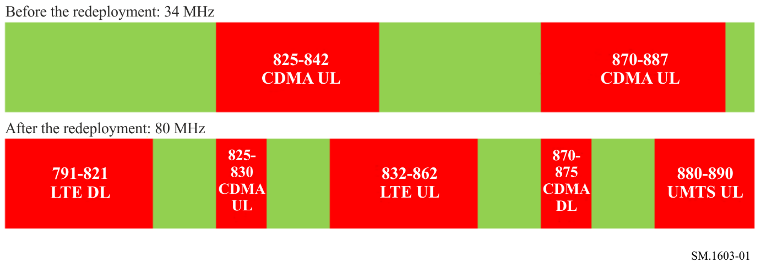
– Economic and social benefits
The redeployment of the 790-890 MHz frequency band offer both economic and social advantages. Indeed, the CDMA network operated by the public operator has 93 012 voice subscribers and 48 890 data subscribers (Population of Benin: 9 500 000 inhabitants in 2012) with limited coverage and services.
It is therefore obvious that the introduction of mobile broadband in the band will lead to important economic benefits (new licences, operatorsʼ contribution, payment of fees, etc.), as well as social benefits (universal service, job creation, access to mobile broadband for everyone, etc.).

4 Conclusion
This redeployment was a very good thing for Benin because it has helped achieving an important aim, which is making available the first digital dividend for the deployment of third generation networks, in line with international trends. This has led to better use of spectrum resources.
Moreover, this redeployment allowed to experience the main difficulties of a redeployment and find appropriate solutions. Special attention should be given to the following points during an operation of redeployment in a developing country:
– The involvement of all stakeholders in the redeployment:
This is an elementary precaution that will guarantee success. Indeed, it is essential all stakeholders be actively involved in the redeployment to ensure that their needs and constraints are taken into account.
– Service continuity:
Redeployment should not in any case lead to services disruption for subscribers; service continuity must then be ensured. To do so, it should be necessary to make a clear and detailed communication plan to subscribers, as well as a detailed schedule of changing customer equipment when necessary.
– Financial assessments:
Validation of financial assessments was one of the most difficult tasks of the study because of the lack of documentation to determine the depreciation of the equipment and the residual value of the equipment. The outgoing operator was not able to provide purchase invoices, so the evaluations were based on estimations collected from suppliers.
– Redeployment funding:
As there is usually no redeployment funding in developing countries, it is crucial to determine early source of funds to finance the implementation of the redeployment and to ensure that these funds will be available when required, so that the effective implementation of the redevelopment will not be delayed.

Attachment 5
to Annex 1

An example of the spectrum redeployment process based on
the Ukrainian experience
This Attachment contains the description of the spectrum redeployment process in Ukraine aimed for introduction of the CDMA-450 (IMT-MC-450 EV-DO) technology in the 450 MHz band, started at the end of 2006 and finished in 2011.

1 Prerequisites and objectives of the redeployment
The prerequisites of the redeployment process were: decreasing the number of NMT-450 users due to operation of GSM-900 on one hand and ever-growing demand for mobile data transmission services on the another hand.
Before starting the redeployment process, the 450-470 MHz frequency band was occupied by the public operator of the NMT-450 network (453-457.5/463-467.5 MHz) and operators of analogue trunk and radio telephony communications, telemetry of alarm systems (450-453/460-463 MHz, with a frequency step 25 kHz), as shown in Fig. 2.
Figure 2
Frequency use in the band 450-470 MHz before redeployment
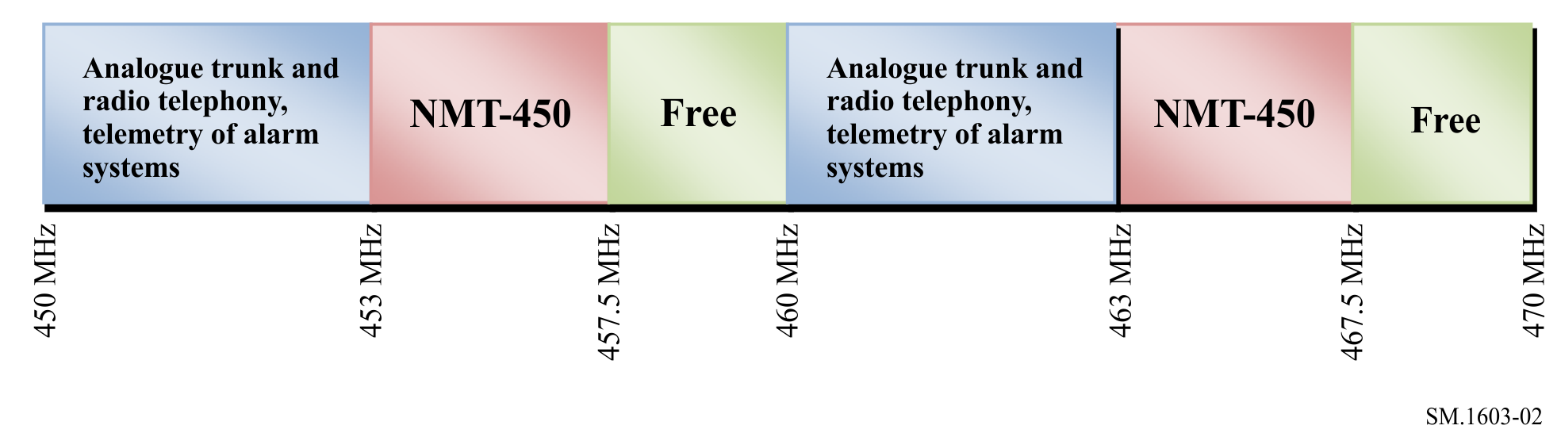
The operator of NMT-450 network appealed to the Ukrainian regulator, the National Commission on Communication Regulation of Ukraine, for changing its licence for outdated standard NMT-450 into the new one for CDMA-450 standard in the same frequency range.
The request was satisfied in accordance with the Law of Ukraine on Telecommunications allowing operator to do so without auction.
In order to create a competitive environment in the band, the Regulator adopted the Decision
No. 450 of 17 November 2006 on considering of frequency plan for development of digital cellular communication technology CDMA-450. The main objective of the Decision was to make the band 450-470 MHz available for CDMA-450. Thus this Decision launched the redeployment process in the occupied frequency band 450-453/460-463 MHz.

2 Redeployment planning
In order to make the band 450-470 MHz available for CDMA-450, the Regulator together with the Ukrainian State Centre of Radio Frequencies (UCRF) studied the occupancy of the bands
450-453/460-463 MHz in Ukraine. Totally 147 users operated in 27 regions of Ukraine in this band.
Based on the results of the analysis, the proposals on arranging redeployment process were prepared as follows:
– to inform operators that prolongation of issued licences for analogue trunk and radio telephony in the bands 450.6-453/460.6-463 MHz is not planned;
– to leave the frequency band 450.0-450.6/460.0-460.6 MHz for analogue trunk communications and rearrange it for the usage of frequency step of 12.5 kHz instead of 25 kHz;
– to shift analogue trunk and radio telephony frequencies from the band 450.6-453/460.6-463 MHz to the bands 450.0-450.6/460.0-460.6 MHz and 413-420/423-430 MHz;
– to stop licensing the band 450.6-453/460.6-463 MHz from 01.11.2007;
– to set the end of transition period for 1 November 2011.
The redeployment process was planned in such a way as to ensure the following:
– minimal negative impact to existing operators in the band;
– minimal financial expenses;
– providing as much as possible alternative frequencies in the band 450-450.6/ 460-460.6 MHz;
– possible financial compensation to operators.
During the planning of redeployment process several rounds of public consultations were done with operators, using the frequency band 450.6-453/460.6-463 MHz in order to agree on redeployment proposals and terms.

3 Redeployment implementation
In the frequency band 450.0-450.6/460.0-460.6 MHz, the Regulator and UCRF succeeded to assign frequencies for 89% of operators. From 1 November 2007, the process of licences and permissions reissuing started. The duration of the transition period was set for one year.
For the rest of operators, proposals for shifting to the frequency band 413-420/423-430 MHz were prepared. From 1 July 2008, the process of licences and permissions reissuing started. The duration of the transition period was set for two years.
As the usage of the band 450-470 MHz changed, the UCRF made efforts for concluding new coordination agreements with the neighbouring countries.
In order to compensate partly financial expenses occurred because of shifting operators to another frequency band, the Regulator adopted Decision No. 988 of 30 October 2007 providing operators 40% reduction for the works of the UCRF on EMC calculation, frequency assigning and radio frequency monitoring. This norm was valid till 31 December 2007.
The use of the band 450-470 MHz after redeployment is shown in Fig. 3.
Figure 3
Frequency use in the band 450-470 MHz after redeployment
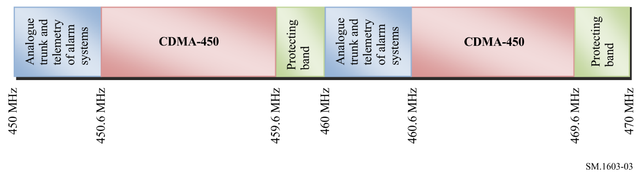

4 Conclusion
The frequency redeployment process in the band 450-470 MHz in Ukraine succeeded because of cooperation of the Regulator and operators. Several rounds of public consultations were done.
During the frequency redeployment planning and implementation, a combination of the following methods was used:
– voluntary and regulatory spectrum redeployment;
– redeployment at the expiration of the current licence;
– migration to frequency bands within the tuning range of equipment used as much as possible;
– compensations.

Attachment 6
to Annex 1

An example of the spectrum redeployment (refarming) process based
on the United States of America experience
“Refarming” is the informal name of a notice and comment rule-making proceeding, PR Docket No. 92-235, opened in 1992 to develop an overall strategy for using the spectrum in the private land mobile radio (PLMR) allocations more efficiently to meet future communications requirements.
In June 1995, the Commission adopted a new narrowband channel plan in the PLMR bands below 800 MHz. In February 1997, the Commission adopted a Second Report and Order which did away with 20 discrete radio services and replaced them with two frequency pools: the Public Safety Pool and the Industrial/Business Pool. In May 2001, the Commission adopted the Sixth Memorandum Opinion and Order which resolved all outstanding issues and terminated the proceeding.
The rules adopted in the refarming proceeding are applicable to the Private Land Mobile bands below 800 MHz. Specifically, the technical rules adopted affect the licensing and use of radios in the following bands:
figure 4
150-174 MHz
VHF high band; available nationwide, channels are generally spaced every 7.5 kHz,
authorized bandwidth is 20 kHz, 11.25 kHz or 6 kHz
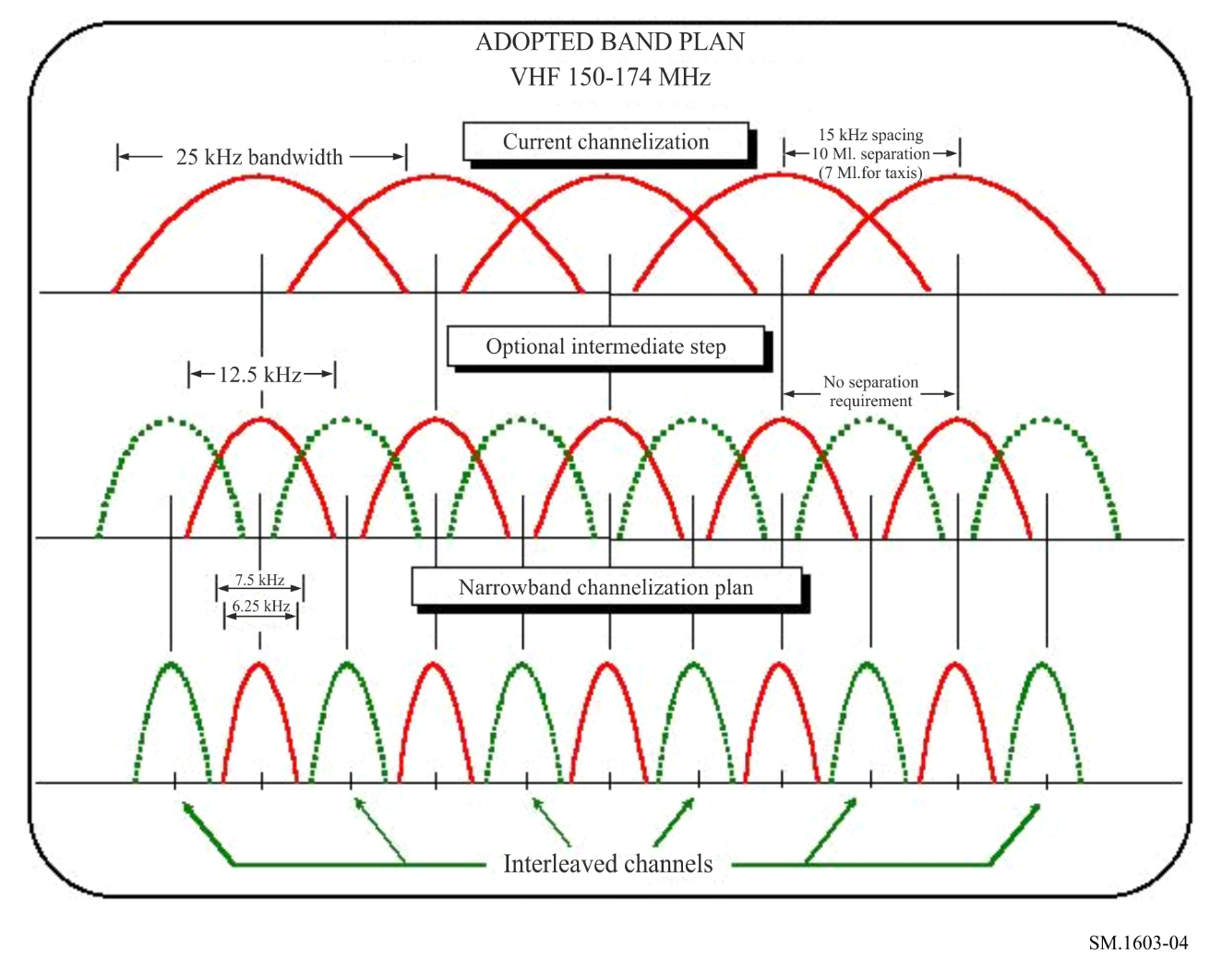
figure 5
421-430 MHz
Available only in Detroit, Buffalo, and Cleveland, channels spaced every 6.25 kHz,
authorized bandwidth is 20 kHz, 11.25 kHz or 6 kHz
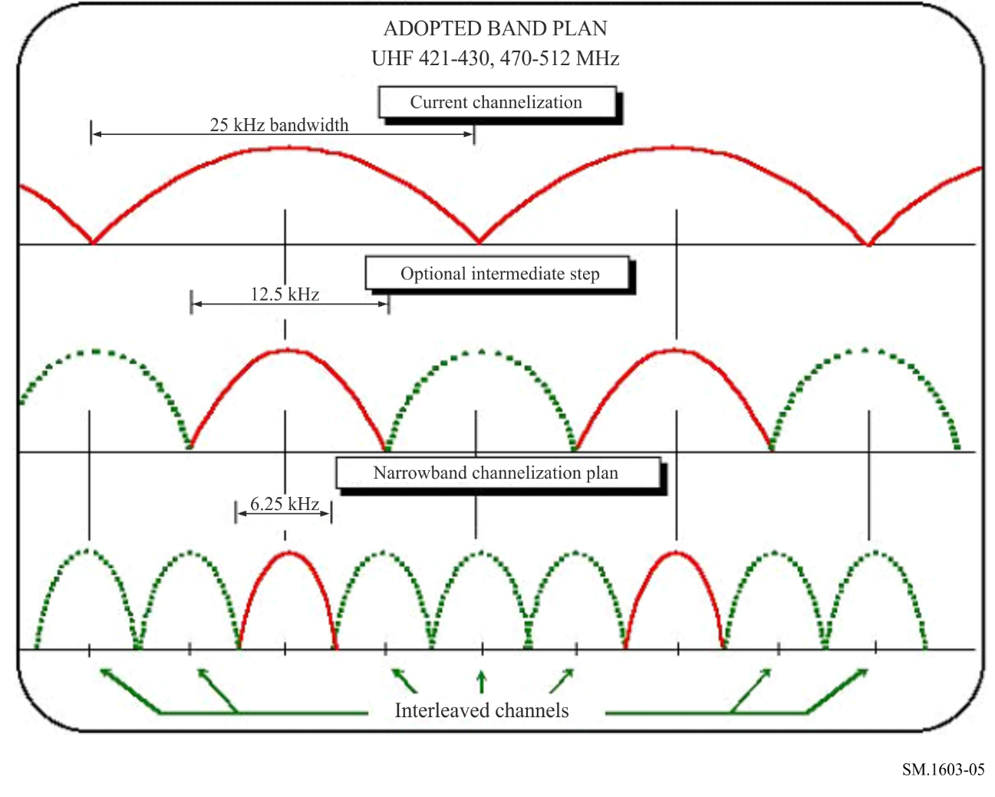
figure 6
450-470 MHz
Available nationwide, channels are generally spaced every 6.25 kHz,
authorized bandwidth is 20 kHz, 11.25 kHz or 6 kHz
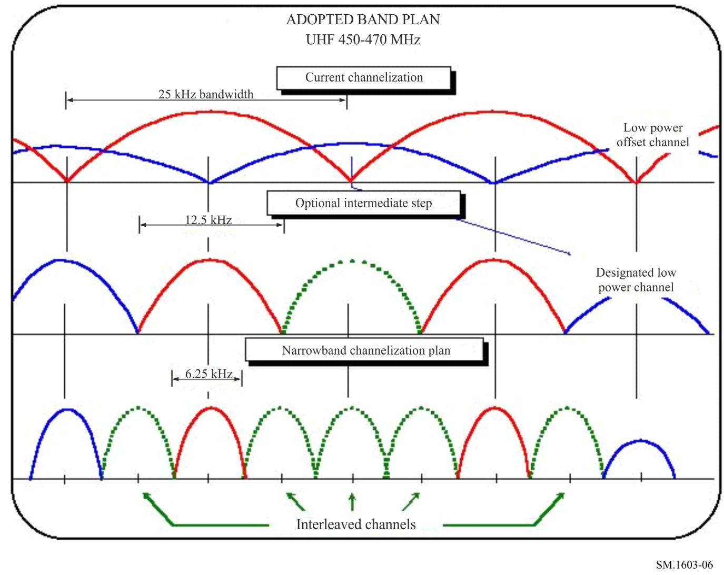
figure 7
470-512 MHz
Shared with UHF-TV; available only in 11 cities, channels are spaced every 6.25 kHz,
authorized bandwidth is 20 kHz, 11.25 kHz or 6 kHz
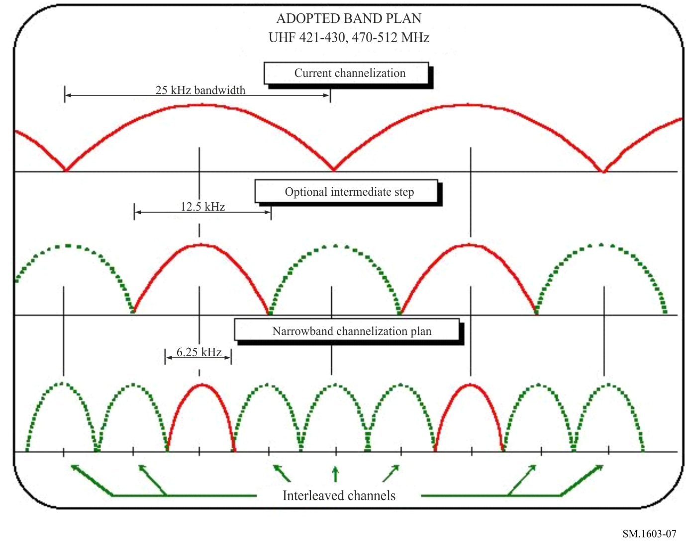
figure 8
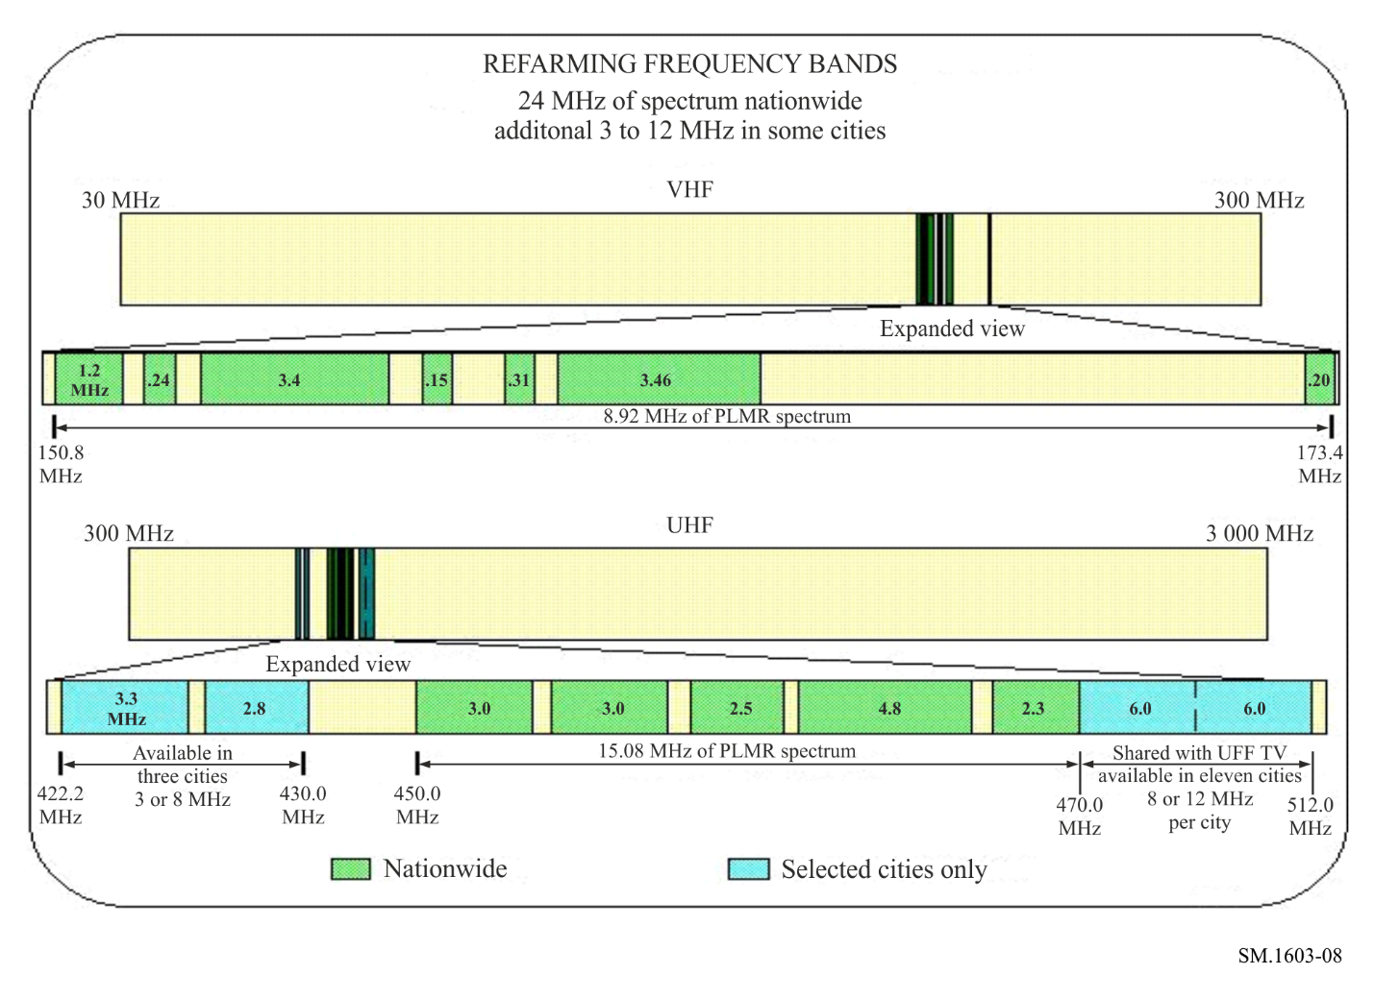

Information on the public safety radio systems operating in the 150-512 MHz radio bands and transition can be accessed at Narrowbanding Overview
______________

** Radiocommunication Study Group 1 made editorial amendments to this Recommendation in the years 2022 and 2023 in accordance with Resolution ITU-R 1.
* Also referred to as “refarming”.
1 Whether delays occur will depend on the difficulty an administration has in getting users to agree to the change. Assessment of the difficulty experienced by administrations should be based on their ability to make all users, both public and private, large and small release spectrum when it is required.
2 Depreciation for bookkeeping purposes is different from economic depreciation. Equipment that has been completely depreciated can often go on being used for several years before being replaced. In concrete terms, economic depreciation is the sum of a depreciation term (the loss of nominal value of the equipment in the course of a year) and the term representing the remuneration of fixed capital at discount rate k (or cost of capital). Only the remuneration of that portion of capital that is financed by borrowing (debt) is included in the financial charges recorded in the accounts. As a result, the depreciation for bookkeeping purposes corresponding to the cost of constant use (investment divided by the life of the equipment used in the accounts) and decreasing financial charges, presents a difference in coverage compared with economic depreciation. For the latter, the remuneration is applied to the total capital value of the investment in question, given that part of the financing is in fact obtained internally. It therefore covers both the equivalent of the financial charges and the remuneration of the investment out of own resources (remuneration of shareholders, etc.).

