Recommendation ITU-R SA.2142-0
(12/2021)
Methodologies for calculating coordination areas around Earth exploration-satellite
and space research earth stations to avoid harmful interference from IMT-2020 systems in the frequency bands
25.5-27 GHz and 37-38 GHz

SA Series
Space applications and meteorology

Foreword
The role of the Radiocommunication Sector is to ensure the rational, equitable, efficient and economical use of the radio-frequency spectrum by all radiocommunication services, including satellite services, and carry out studies without limit of frequency range on the basis of which Recommendations are adopted.
The regulatory and policy functions of the Radiocommunication Sector are performed by World and Regional Radiocommunication Conferences and Radiocommunication Assemblies supported by Study Groups.

Policy on Intellectual Property Right (IPR)
ITU-R policy on IPR is described in the Common Patent Policy for ITU-T/ITU-R/ISO/IEC referenced in Resolution ITU-R 1. Forms to be used for the submission of patent statements and licensing declarations by patent holders are available from http://www.itu.int/ITU-R/go/patents/en where the Guidelines for Implementation of the Common Patent Policy for ITU-T/ITU-R/ISO/IEC and the ITU-R patent information database can also be found.

Series of ITU-R Recommendations
(Also available online at http://www.itu.int/publ/R-REC/en)
Series | Title
BO | Satellite delivery
BR | Recording for production, archival and play-out; film for television
BS | Broadcasting service (sound)
BT | Broadcasting service (television)
F | Fixed service
M | Mobile, radiodetermination, amateur and related satellite services
P | Radiowave propagation
RA | Radio astronomy
RS | Remote sensing systems
S | Fixed-satellite service
SA | Space applications and meteorology
SF | Frequency sharing and coordination between fixed-satellite and fixed service systems
SM | Spectrum management
SNG | Satellite news gathering
TF | Time signals and frequency standards emissions
V | Vocabulary and related subjects

Note: This ITU-R Recommendation was approved in English under the procedure detailed in Resolution ITU-R 1.

Electronic Publication
Geneva, 2021

© ITU 2021
All rights reserved. No part of this publication may be reproduced, by any means whatsoever, without written permission of ITU.

RECOMMENDATION ITU-R SA.2142-0
Methodologies for calculating coordination areas around Earth exploration-satellite and space research earth stations to avoid
harmful interference from IMT-2020 systems in the
frequency bands 25.5-27 GHz and 37-38 GHz
(2021)
Scope
This Recommendation contains methodologies for calculating coordination areas around Earth exploration-satellite service (EESS) and space research service (SRS) earth stations (ES) in order to avoid harmful interference from IMT-2020 systems that may be deployed in the frequency bands 25.5-27 GHz and 37-38 GHz. Due to the differences in the protection criteria and in the earth station operations of EESS and SRS systems, different methodologies are provided for SRS, geostationary EESS and non-geostationary EESS.
Keywords
IMT-2020, EESS earth stations, SRS earth stations, mobile service, sharing/compatibility issues
List of abbreviations
BS base station
EESS Earth exploration-satellite service
ES earth station
GSO geostationary orbit
HEO highly elliptical orbit
IMT international mobile telecommunications
LEO low-Earth orbit
non-GSO non-geostationary orbit
SRS space research service
TRP total radiated power
TVG time-variable gain
UE user equipment
Related Recommendations and Reports
Recommendation ITU-R M.2101 – Modelling and simulation of IMT networks and systems for use in sharing and compatibility studies
Recommendation ITU-R P.452 – Prediction procedure for the evaluation of interference between stations on the surface of the Earth at frequencies above about 0.1 GHz
Recommendation ITU-R SA.609 – Protection criteria for radiocommunication links for manned and unmanned near-Earth research satellites
Recommendation ITU-R SA.1027 – Sharing criteria for space-to-Earth data transmission systems in the Earth exploration-satellite and meteorological-satellite services using satellites in low-Earth orbit
Recommendation ITU-R SA.1161 – Sharing and coordination criteria for data dissemination and direct data readout systems in the Earth exploration-satellite and meteorological-satellite services using satellites in geostationary orbit
Recommendation ITU-R SA.1396 – Protection criteria for the space research service in the 37-38 GHz and 40-40.5 GHz bands
Report ITU-R M.2292 − Characteristics of terrestrial IMT-Advanced systems for frequency sharing/interference analyses
The ITU Radiocommunication Assembly,
considering
a) that a methodology is needed to calculate the coordination areas around SRS earth stations for compatibility with IMT-2020 systems deployed in the frequency bands 25.5-27 GHz and 37-38 GHz;
b) that a methodology is needed to calculate the coordination areas around EESS earth stations for compatibility with IMT-2020 systems deployed in the frequency band 25.5-27 GHz;
c) that the resulting coordination areas will differ for all earth stations cases that will be analysed, due to the specificity of the terrain surrounding each of these earth stations,
recognizing
a) that Resolution 242 (WRC-19) invites the ITU Radiocommunication Sector to develop an ITU-R Recommendation on methodologies for calculating coordination zones around EESS/SRS earth stations in order to avoid harmful interference from IMT systems in the frequency band 25.5-27 GHz;
b) that Resolution 243 (WRC-19) invites the ITU Radiocommunication Sector to develop an ITU-R Recommendation on methodologies for calculating coordination zones around SRS earth stations in order to avoid harmful interference from IMT systems in the frequency band 37-38 GHz;
c) that RR No. 5.536A applies in the frequency band 25.5-27 GHz,
noting
a) that Recommendation ITU-R M.2101 provides the methodology for modelling and simulation of IMT networks and systems for use in sharing and compatibility studies whereas the methodologies developed in this Recommendation are specifically designed to determine coordination areas around EESS/SRS earth stations and as such might not be applicable in other scenarios;
b) that the methodologies developed in this Recommendation are derived from the time-variant gain (TVG) method found in Appendix 7 of the Radio Regulations;
c) that the subsequently derived coordination areas indicate the region beyond which the level of permissible interference will not be exceeded, and coordination is therefore not required;
d) that a more detailed analysis, utilizing local conditions and the relevant ITU-R Recommendations listed above, may show that compatible operation of IMT-2020 systems located within the coordination area around an EESS/SRS earth station is possible,
recommends
1 that the methodology described in Annex 1 should be used to calculate the coordination area around SRS earth stations operating in the frequency bands 25.5-27 GHz and 37-38 GHz;
2 that the methodology described in Annex 2 should be used to calculate the coordination area around non-GSO EESS earth stations operating in the frequency band 25.5-27 GHz;
3 that the methodology described in Annex 3 should be used to calculate the coordination area around GSO EESS earth stations operating in the frequency band 25.5-27 GHz,
recommends further
1 that administrations should consider detailed examination of specific locations inside the coordination area to determine the compatibility of IMT and EESS/SRS operations;
2 that methodologies, such as the one described in Annex 4, can be used to address the protection of EESS earth stations from IMT stations deployed inside the coordination area determined in accordance with recommends 2 and 3.

TABLE OF CONTENTS
Page
Policy on Intellectual Property Right (IPR) ii
Annex 1 – Methodology for calculating the coordination area around SRS earth stations 5
1 Introduction 5
2 TVG standard methodology 5
3 Determination of the IMT-2020 base station total power 6
4 Determination of the distribution of the IMT-2020 base station antenna gain towards the horizon 6
5 Determination of the SRS antenna gain G_{r} towards the horizon 11
6 Determination of the SRS protection threshold and reference bandwidth 13
7 Determination of the required propagation loss and associated percentage of time 13
8 Determination of the coordination contour 13
Annex 2 – Methodology for calculating the coordination area around non-GSO EESS earth stations in the band 25.5-27 GHz 15
1 Introduction 15
2 TVG modified methodology 15
3 Determination of the IMT-2020 base station total power 16
4 Determination of the distribution of the IMT-2020 BS antenna gain towards the horizon 16
5 Determination of the EESS antenna gain G_{r} towards the horizon 16
6 Determination of the convolution G_{tot} of both antenna gains towards the horizon 19
7 Determination of the EESS protection threshold and reference bandwidth 19
8 Determination of the required propagation loss and associated percentage of time 19
9 Determination of the coordination area contour 20
Annex 3 – Methodology for calculating the coordination area around GSO EESS earth stations in the band 25.25-27.5 GHz 21
1 Introduction 21
2 TVG standard methodology 21
3 Determination of the IMT-2020 base station total power 21
4 Determination of the distribution of the IMT-2020 BS antenna gain towards the horizon 21
5 Determination of the EESS antenna gain G_{r} towards the horizon 21
6 Determination of the EESS protection threshold and reference bandwidth 21
7 Determination of the required propagation loss and associated percentage of time 22
8 Determination of the coordination area contour 22
Annex 4 – Methodology to ensure the protection of EESS earth stations from IMT stations deployed inside the coordination area 23
1 Introduction 23
2 Propagation losses 23
3 Aggregate effect from several IMT-2020 base station in the EESS earth station 24
4 Earth station tracking a GSO satellite 24
4.1 General rules 24
4.2 Minimum attenuation towards the EESS earth station 25
5 Earth station tracking a non-GSO satellite 27
5.1 General rules 27
5.2 Practical case 27

Annex 1
Methodology for calculating the coordination area around
SRS earth stations

1 Introduction
Although it is recognized that the SRS earth station is most of the time tracking a non-GSO spacecraft, and hence, its gain towards the horizon varies with time, the trajectory of SRS spacecraft varies considerably from one mission to the other. All types of missions can be envisaged for SRS (near Earth), ranging from Low Earth Orbits (LEO) to missions around one of the Lagrange points, and including Geo-Synchronous Earth Orbits (GSO), Highly Elliptical Orbits (HEO) or lunar missions. Similarly, SRS (deep space) missions generally target planets in the ecliptic plane, but can stay for an extended period in near earth orbits, or depart from the ecliptic plane when chasing comets, asteroids or other bodies.
To ensure that the methodology defined here will cover all types of SRS missions, the SRS earth station antenna is assumed to be pointing towards the azimuth of the IMT-2020 station, at its minimum elevation angle.
The area which is determined through this methodology can be relatively large given the sensitivity of SRS earth stations, and the impossibility to consider a specific trajectory or orbit for the spacecraft. Hence, such zones should be considered as coordination areas where IMT-2020 can still be deployed, after agreement is obtained with the SRS operator.
The methodology used is the Time Variable Gain (TVG) methodology given in RR Appendix 7. This methodology would give results similar to a Monte Carlo analysis but is much faster and more efficient. In order to validate it, a comparison with results given by a Monte Carlo analysis has been performed for some of the points of the contour, using Recommendation ITU-R M.2101, showing that when a base station (BS) was deployed just outside of the contour, the SRS protection criterion was met, and when a BS was deployed just inside the contour, the SRS protection criterion was exceeded. Given that the user equipment will operate either indoor or in heavy clutter, the methodology focusses on the IMT-2020 base station. Since studies have shown that there is little aggregate effect from several base stations and user equipment near the earth station, the methodology only considers a single IMT-2020 base station. When considering the aggregation of multiple BS, distances are not expected to increase as long as BS antenna panels are not concurrently pointing towards the ES in azimuth. However, aggregation will have to be considered when BSs are being planned to be installed inside the coordination area.

2 TVG standard methodology
The required minimum propagation loss is then given by equation (1).
$L_{req}\left(p_{v}\right)= P_{t}+G_{t}\left(p_{n}\right)+ G_{r} - I\left(p\right)-L_{c}$ (1)
where:
𝑃_{𝑡} : total transmitting power level (dBW) in the reference bandwidth of a transmitting IMT-2020 base station
I(𝑝) : protection threshold (dBW) in the reference bandwidth to be exceeded for no more than 𝑝% of the time at the input of the antenna of the receiving SRS earth station that may be subject to interference
𝐺_{t}(𝑝_{𝑛}) : gain towards the horizon of the transmitting antenna (dBi) that is exceeded for 𝑝_{𝑛}% of the time on the azimuth under consideration
𝐺_{𝑟} : gain towards the physical horizon for a given azimuth (dBi) of the victim SRS earth station antenna
$L_{req}$(𝑝_{𝑣}) : minimum required propagation loss (dB) for 𝑝_{𝑣}% of the time; this loss must be exceeded by the propagation path loss for all possible 𝑝_{𝑣}% values retrieved from the considered gain complementary cumulative distribution function. 𝑝_{𝑣} is the time percentage that approximates the convolution between the variable horizon gain and the propagation mode path loss and is given by equation (2)
Lc : clutter loss (dB) applicable to the SRS earth station specific environment, if any. The clutter loss applicable to the IMT base station should be addressed during detailed coordination, when the environment where the base station is located is known:
(2)
The limitation to 50% comes from the propagation model used, Recommendation ITU-R P.452, which is limited to percentages of time up to 50%.

3 Determination of the IMT-2020 base station total power
The IMT-2020 base station total power, P_{t} in dBW, is given by equation (3).
$P_{t}=P_{e}+10\log\left(N\right)-L_{O}- 30 +10log\left(\frac{B_{ref}}{B_{IMT}}\right)$ (3)
where:
P_{e} (dBm) : power per antenna element
N : number of antenna elements
L_{O} (dB) : ohmic losses
B_{ref} : reference bandwidth of the SRS protection criterion (MHz for 26 GHz, Hz for 37-38 GHz)
B_{IMT} : reference bandwidth of the IMT base station (MHz for 26 GHz, Hz for 37-38 GHz).
As an example, an urban or suburban 8 × 8 elements antenna at 26 GHz with an input power of 10 dB(m/200 MHz) per element and a 3 dB ohmic loss would have a total power of −28 dB(W/MHz).

4 Determination of the distribution of the IMT-2020 base station antenna gain towards the horizon
The base station antenna panel is assumed pointing towards the SRS earth station in azimuth. The distribution of antenna gain towards the horizon is determined from the distribution of electric azimuth angles φ_{escan} and electrical tilt angles θ_{etilt}, as well as the mechanical tilt θ_{mtilt}. Those distributions themselves are given by the distributions of azimuths and distances of the user equipment as seen from the base station, using the BS and user equipment (UE) antenna heights.
In this Recommendation, the mechanical tilt makes reference to the horizontal plane. As the antenna panel is always oriented towards the ground this value is negative. The electrical tilt is defined with reference to the angle perpendicular to the antenna panel where a negative value refers to an electrical down-tilt. The following distribution of the IMT-2020 BS antenna gain towards the horizon has been derived for an urban/suburban base station at 6 m height with a −10° antenna mechanical tilt, and a user equipment at 1.5 m height. In this case, the azimuth beam pointing φ_{escan} can be simplified to a normal distributed in azimuth 𝒩(𝜇, 𝜎²) with zero mean 𝜇 = 0° and 𝜎 = 30°, capped at −60° and +60°. The φ_{escan} distribution is shown in Fig. 1.
FIGURE 1
IMT-2020 BS (Urban/Suburban) – Azimuth beam pointing distribution
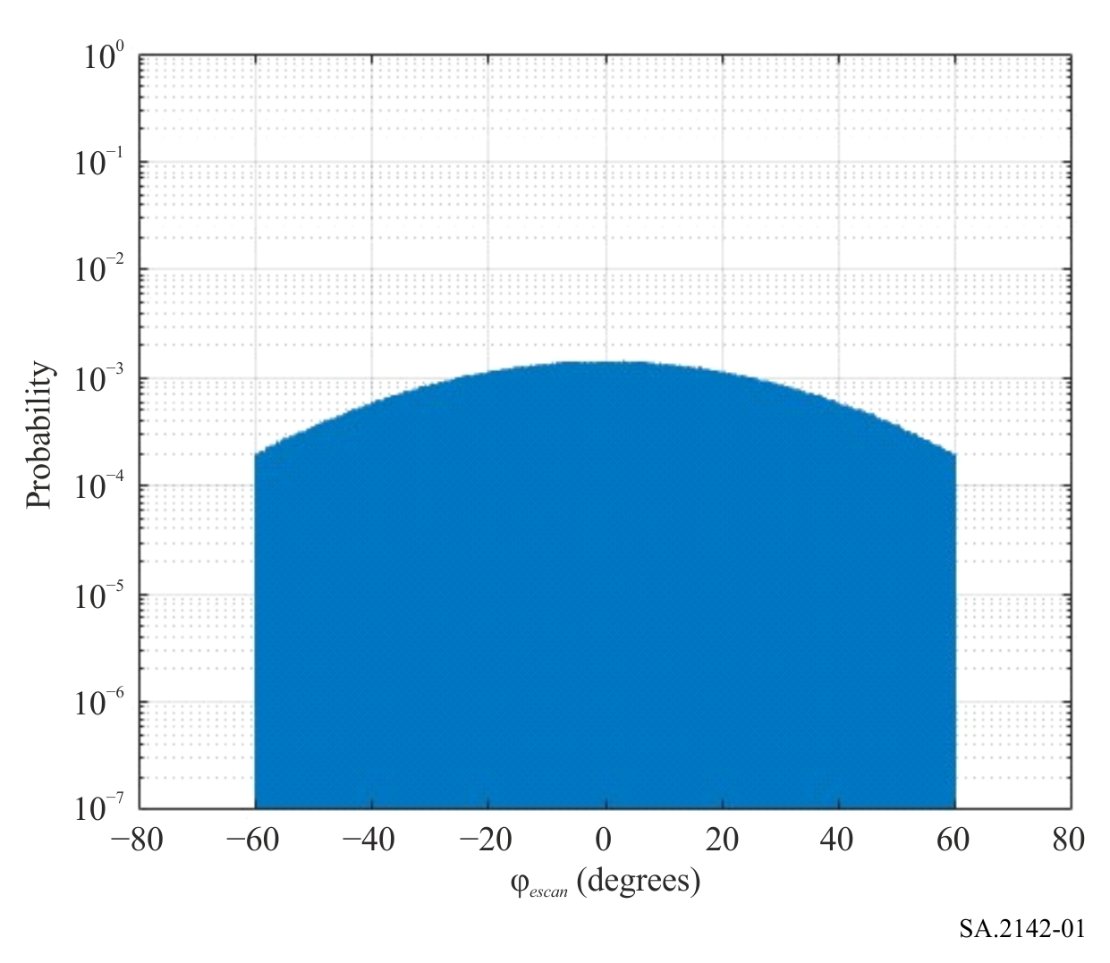
The elevation tilt θ_{tilt TOT} = θ_{etilt} + θ_{mtilt} (see Fig. 2) distribution has to be retrieved from the distribution of the distance between BS and UE, such as the Rayleigh distribution (𝜎 = 32 m).
FIGURE 2
IMT-2020 BS (Urban/Suburban) – Definition of total tilt
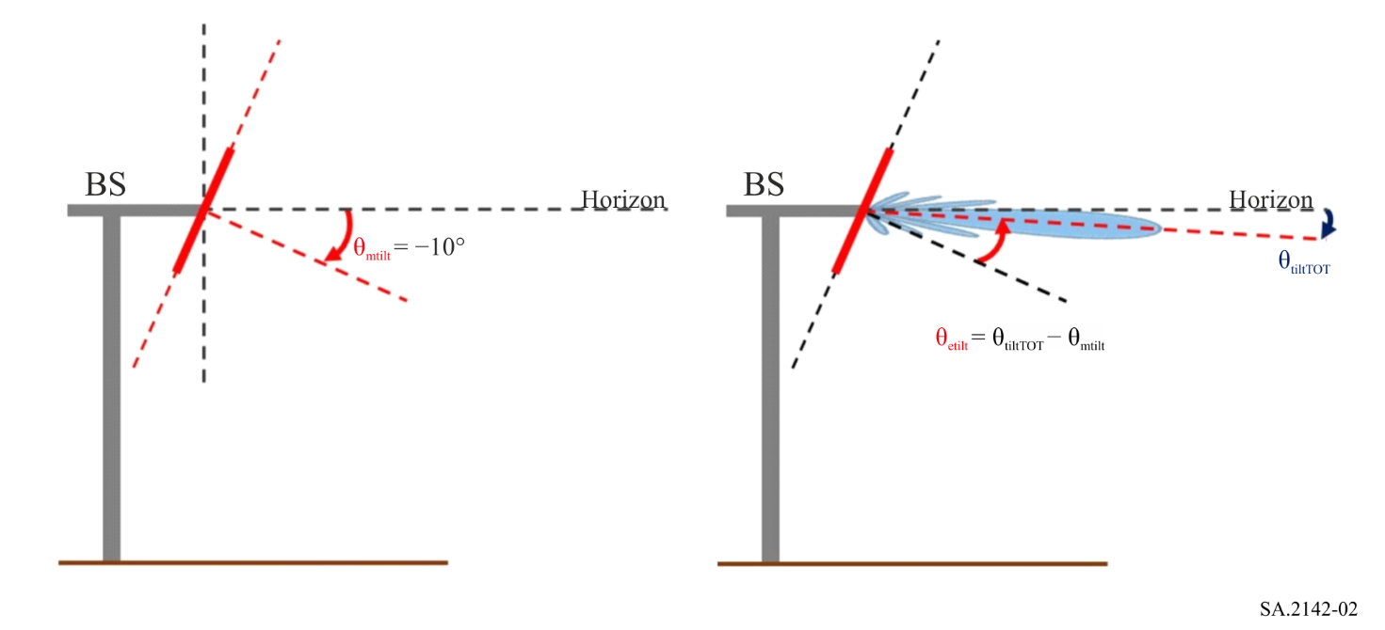
The UE distance and θ_{tilt TOT} PDFs are shown in Figs 3 and 4, respectively.
FIGURE 3
IMT-2020 BS (Urban/Suburban) – UE distance from BS PDF
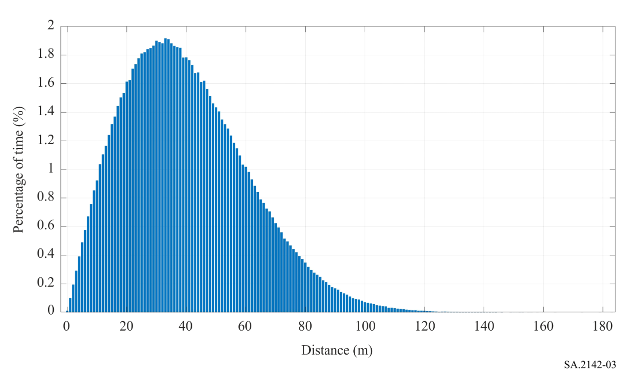
FIGURE 4
IMT-2020 BS (Urban/Suburban) – Total elevation tilt PDF
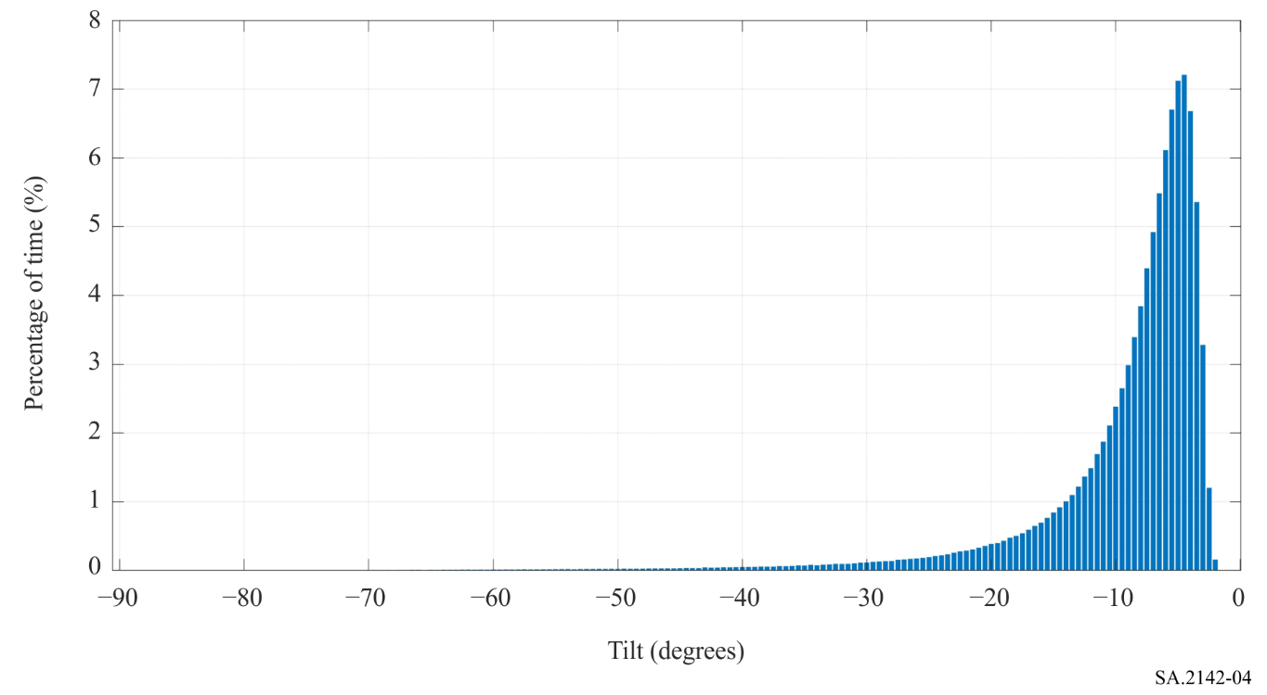
From these distributions, it is possible to determine the antenna gain distribution towards the victim earth station, using the antenna pattern from Recommendation ITU-R M.2101. The pattern for an 8 × 8 antenna with a 65-degree element aperture with an antenna gain of 5 dBi and a front to back lobe ratio of 30 dB is given in Fig. 5. The Recommendation ITU-R M.2101 antenna radiation pattern has been capped at −30 dBi (which is the minimum value of the single element radiation pattern of the array).
FIGURE 5
IMT-2020 BS (Urban/Suburban) – BS antenna pattern at 0 degree electrical tilt
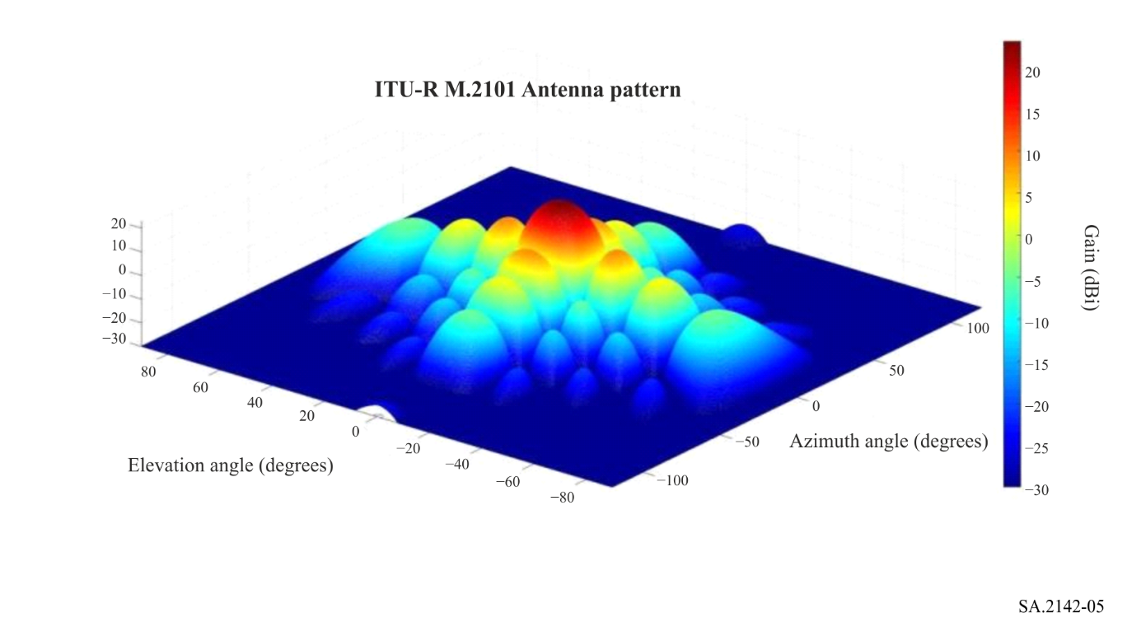
The distribution has been computed assuming a flat terrain, i.e. horizon 0 degree. This is a worst-case assumption given that higher horizon angles would provide lower antenna gain values (the antenna is pointing towards ground). It is given in Fig. 6 for 26 GHz, and in Fig. 7 for 37 GHz. The gain on the X-axis is G_{t}, and the percentage on the Y-axis is p_{n}, as described in equation (1).
FIGURE 6
Gain toward the horizon CCDF (IMT-2020 BS Urban/Suburban, 24.25-27.5 GHz)
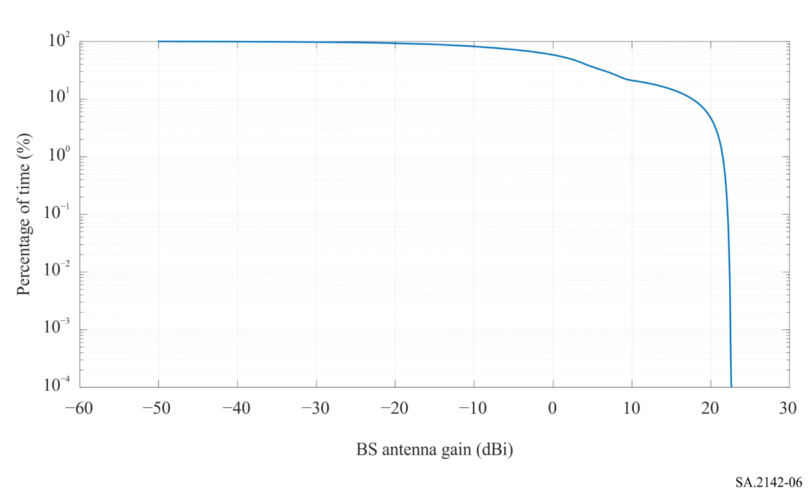

FIGURE 7
Gain toward the horizon CCDF (IMT-2020 BS Urban/Suburban, 37.00-43.50 GHz)
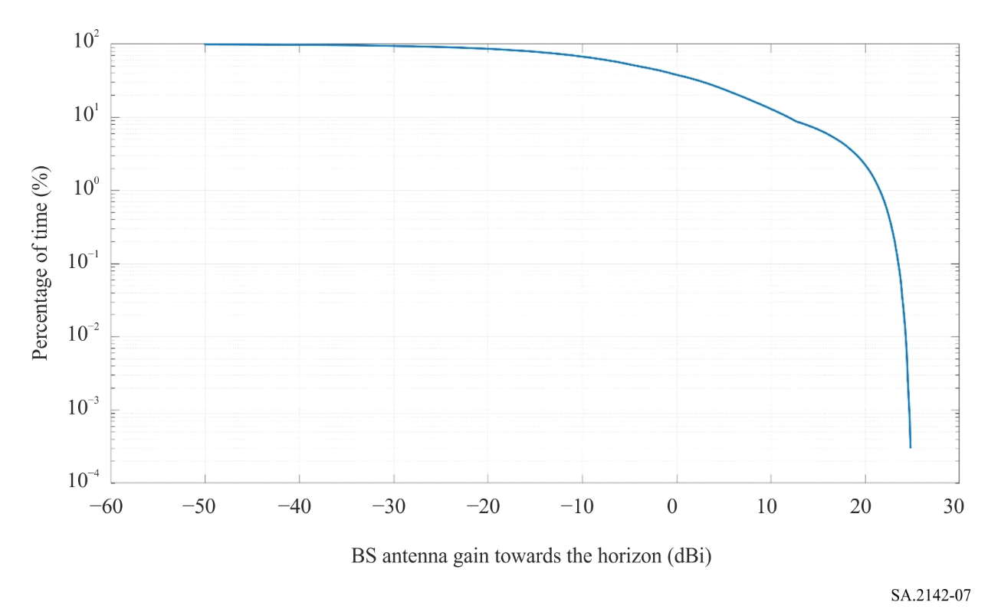
IMT-2020 BS antenna gain distributions towards the horizon, provided above, represent example, using antenna pattern from Recommendation ITU-R M.2101 and assuming that beam is always electronically steered towards UE within the coverage area. IMT-2020 BS antenna gain distributions could be derived using alternative antenna gain patterns for IMT-2020 BS, including actual measured antenna patterns, if available. Cases, when IMT-2020 BS implement switched-beam array technology where the BS beams are fixed and UEs are assigned to different beams as they move within the coverage area of the BS or if UEs location is fixed, should also be accounted for when calculating statistics for IMT-2020 BS gain towards the victim earth station.

5 Determination of the SRS antenna gain G_{r} towards the horizon
The SRS antenna gain towards the horizon is determined using the minimum pointing elevation angle for the azimuth considered and the relevant antenna pattern.
– The minimum elevation angle for SRS (near-Earth) in the bands 25.5-27 GHz and 37-38 GHz is 5 degrees; if the horizon elevation is higher than 4 degrees then the minimum elevation is assumed to be 1 degree above the horizon.
– The minimum elevation angle for SRS (deep space) in the band 37-38 GHz is 10 degrees; if the horizon elevation is higher than 9 degrees then the minimum elevation is assumed to be 1 degree above the horizon.
As an example, Fig. 8 gives the horizon profile for the SRS earth station in Robledo (Spain). The elevation angle around 75 degrees azimuth and above 250 degrees is higher than 4 degrees, hence the minimum elevation angle is 1 degree above this horizon for SRS (near-Earth). Elsewhere, the relevant value would be 5 degrees.
FIGURE 8
Horizon profile around Robledo
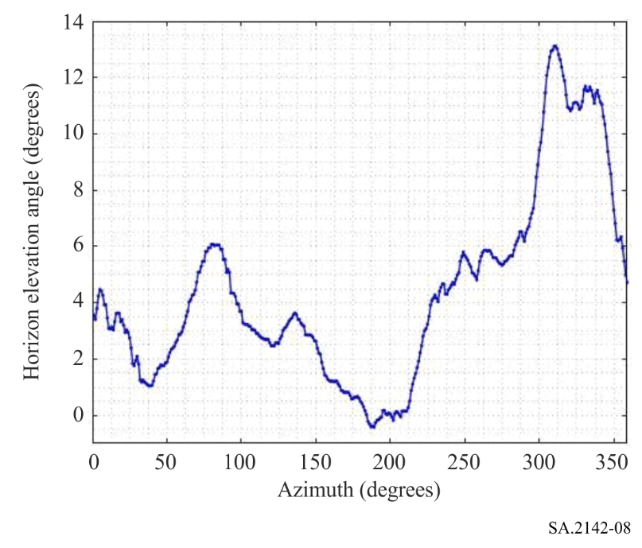
It should be noted that Recommendation ITU-R P.452 computes the elevation angle for all the points of the terrain model between the transmitter and the receiver, and then determines the maximum elevation value as seen from the transmitter side and from the receiver side. In this case, the value extracted from Recommendation ITU-R P.452 for the receiver side for all the azimuths would directly permit to generate the horizon profile depicted in Fig. 8.
The SRS antenna pattern depends on each antenna and frequency band of interest. Recommendation ITU-R SA.509 can be used in the 25.5-27 GHz band, and Recommendation ITU-R SA.1811 can be considered for the band 37-38 GHz. Alternatively, the antenna patterns contained in RR Appendices 7 or 8 could also be considered.
Figure 9 provides an example of SRS antenna gain G_{r} as function of the azimuth around the SRS earth station in Robledo (Spain).
FIGURE 9
SRS earth station antenna gain towards the horizon around Robledo
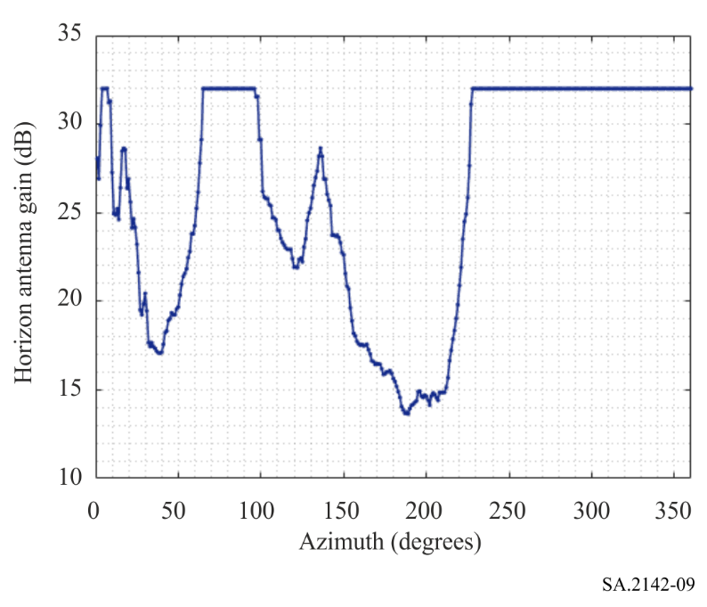

6 Determination of the SRS protection threshold and reference bandwidth
– The SRS protection threshold I is given in Recommendation ITU-R SA.609 for SRS (Near-Earth) below 30 GHz, as −156 dBW in a reference bandwidth B_{ref} of 1 MHz. The associated percentage of time p is either 0.1% for unmanned missions or 0.001% for manned missions. Since most of SRS earth stations can support both manned and unmanned missions, the value of 0.001% should be used.
– The SRS protection threshold I is given in Recommendation ITU-R SA.1396 for SRS in the band 37-38 GHz as −217 dBW in a reference bandwidth B_{ref} of 1 Hz. The associated percentage of time p is either 0.1% for unmanned missions or 0.001% for manned missions. Since most of SRS earth stations can support both manned and unmanned missions, the value of 0.001% should be used.
Those criteria do not include any apportionment that could be envisaged on a case-by-case basis.

7 Determination of the required propagation loss and associated percentage of time
For each azimuth around the SRS earth station, and each percentage of time p_{n} determined in § 2, the required propagation loss L_{req} and associated percentage of time 𝑝_{𝑣} should be determined using equations (1) and (2) respectively.

8 Determination of the coordination contour
For each of the azimuth around the SRS earth station, each of the distances from the SRS earth station location, and each of the percentages of time 𝑝_{𝑣} determined in § 7, the propagation loss should be determined using an appropriate propagation model such as the one contained in Recommendation ITU-R P.452 or Recommendation ITU-R P.2001, considering the terrain elevation and local clutter surrounding the earth station. In case Recommendation ITU-R P.2001 is used, the associated percentage of time p_{v} obtained through equation (2) should not be capped to 50%.
The terrain elevation model can be the 1-arcsec resolution terrain profile data of the Shuttle Radar Topography Mission (SRTM), however more detailed terrain models, including built area models, may be used. The terrain profiles can be sampled with an azimuth step of 1 degree around the earth station of interest and a distance step of 25 m. The losses can then be computed around the station with an azimuth step of 1 degree and a distance step of 100 m.
For each azimuth and percentage of time 𝑝_{𝑣}, the coordination distance required is then the maximum distance at which the propagation loss calculated is just below the required propagation loss L_{req}(𝑝_{𝑣}). The coordination distance to be retained for the azimuth angle considered is the maximum distance obtained for all values of 𝑝_{𝑣}.
Figure 10 provides as an example the coordination contour obtained around the SRS station in Cebreros (Spain) for an 8 × 8 urban/suburban base station at 26 GHz. The white circles are at 10 km relative distance.
FIGURE 10
View of coordination contour and protection level violations around Cebreros
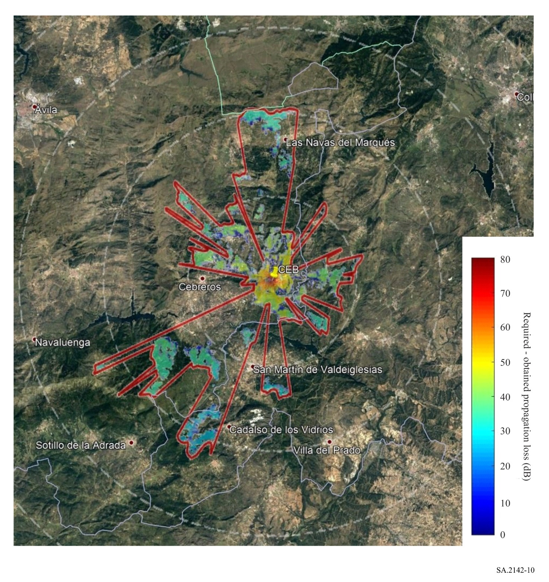

Annex 2
Methodology for calculating the coordination area around
non-GSO EESS earth stations in the band 25.5-27 GHz

1 Introduction
Most of non-GSO EESS satellites using this frequency band will be LEO satellites on polar orbits. Other types of orbits are as well usable with different inclinations, however it is not expected that this would change the results obtained when using this methodology with a particular satellite on a 400 km sun synchronous orbit, as proposed in § 5.
The methodology used is based on the time variable gain (TVG) methodology given in RR Appendix 7. However, since both the transmitter and receiver antenna gains are varying, a convolution has to be made between the distributions of those gains and hence, the methodology has to be slightly revised. Here again, the methodology has been validated through additional Monte Carlo simulation for some of the contour points.
Given that the user equipment will operate either indoor or in heavy clutter, the methodology focuses on the IMT-2020 base station. In order to derive coordination areas which size may be larger than the final distances obtained through detailed calculation during coordination, the base station panel considered is assumed to be physically pointing in the same azimuth as the victim EESS earth station.

2 TVG modified methodology
A modified version of the TVG methodology given in RR Appendix 7 has been used to approximate the convolution of the distributions of the transmitter antenna gain (base station tracking the UE), the receiver antenna gain (the EESS earth station tracking an EESS satellite on a typical polar orbit), and the propagation model. Equation (1) can be rewritten as follows:
𝐿_{𝑟𝑒q}(𝑝_{𝑣}) = 𝑃_{𝑡} + 𝐺_{𝑡}(𝑝_{𝑡}) + 𝐺_{r}(𝑝_{𝑟}) − 𝐼(𝑝) – Lc = 𝑃_{𝑡} + 𝐺_{𝑡𝑜𝑡}(𝑝_{𝑛}) − 𝐼(𝑝) – Lc (4)
where:
𝑃_{𝑡} : total transmitting power level (dBW) in the reference bandwidth of a transmitting IMT-2020 base station
I(𝑝) : protection threshold (dBW) in the reference bandwidth to be exceeded for no more than 𝑝% of the time at the input of the antenna of the receiving EESS earth station that may be subject to interference
G_{t}(𝑝_{t}) : gain towards the horizon of the transmitting antenna (dBi) that is exceeded for 𝑝_{t}% of the time on the azimuth under consideration
G_{r}(p_{r}) : gain towards the physical horizon for a given azimuth (dBi) of the victim EESS earth station antenna that is exceeded for 𝑝_{r}% of the time on the azimuth under consideration
𝐺_{tot}(𝑝𝑛) = 𝐺_{𝑡}(𝑝_{𝑡}) + 𝐺_{𝑟}(𝑝_{𝑟}) : is given by the convolution between the transmitting gain distribution 𝐺_{𝑡}(𝑝_{𝑡}) and the victim earth station distribution 𝐺_{𝑟}(𝑝_{𝑟})
Lc : clutter loss (dB) applicable to the EESS earth station specific environment, if any. The clutter loss applicable to the IMT base station should be addressed during detailed coordination, when the environment where the base station is located is known (see the example in Annex 4)
𝐿_{𝑟𝑒q}(𝑝_{𝑣}) : minimum required propagation loss (dB) for 𝑝_{𝑣}% of the time; this loss must be exceeded by the propagation path loss for all possible 𝑝_{𝑣}% values retrieved from the considered gain complementary cumulative distribution function. 𝑝_{𝑣} is the time percentage that approximates the convolution between the variable horizon gain and the propagation mode path loss and is given by equation (2).

3 Determination of the IMT-2020 base station total power
Same as Annex 1 – § 3.

4 Determination of the distribution of the IMT-2020 BS antenna gain towards the horizon
Same as Annex 1 – § 4.

5 Determination of the EESS antenna gain G_{r} towards the horizon
To determine the EESS earth station antenna gain towards the horizon for each azimuth, it is necessary to run a simulation whereby an EESS satellite orbit is propagated over a given period.
EESS satellites are generally using sun-synchronous orbits, with altitudes between 400 and 1 400 km, a typical value being 800 km. For the worst case 400 km altitude, the orbit inclination would be 97°. Figure 11 provides a view of such orbit.
FIGURE 11
EESS satellite orbit
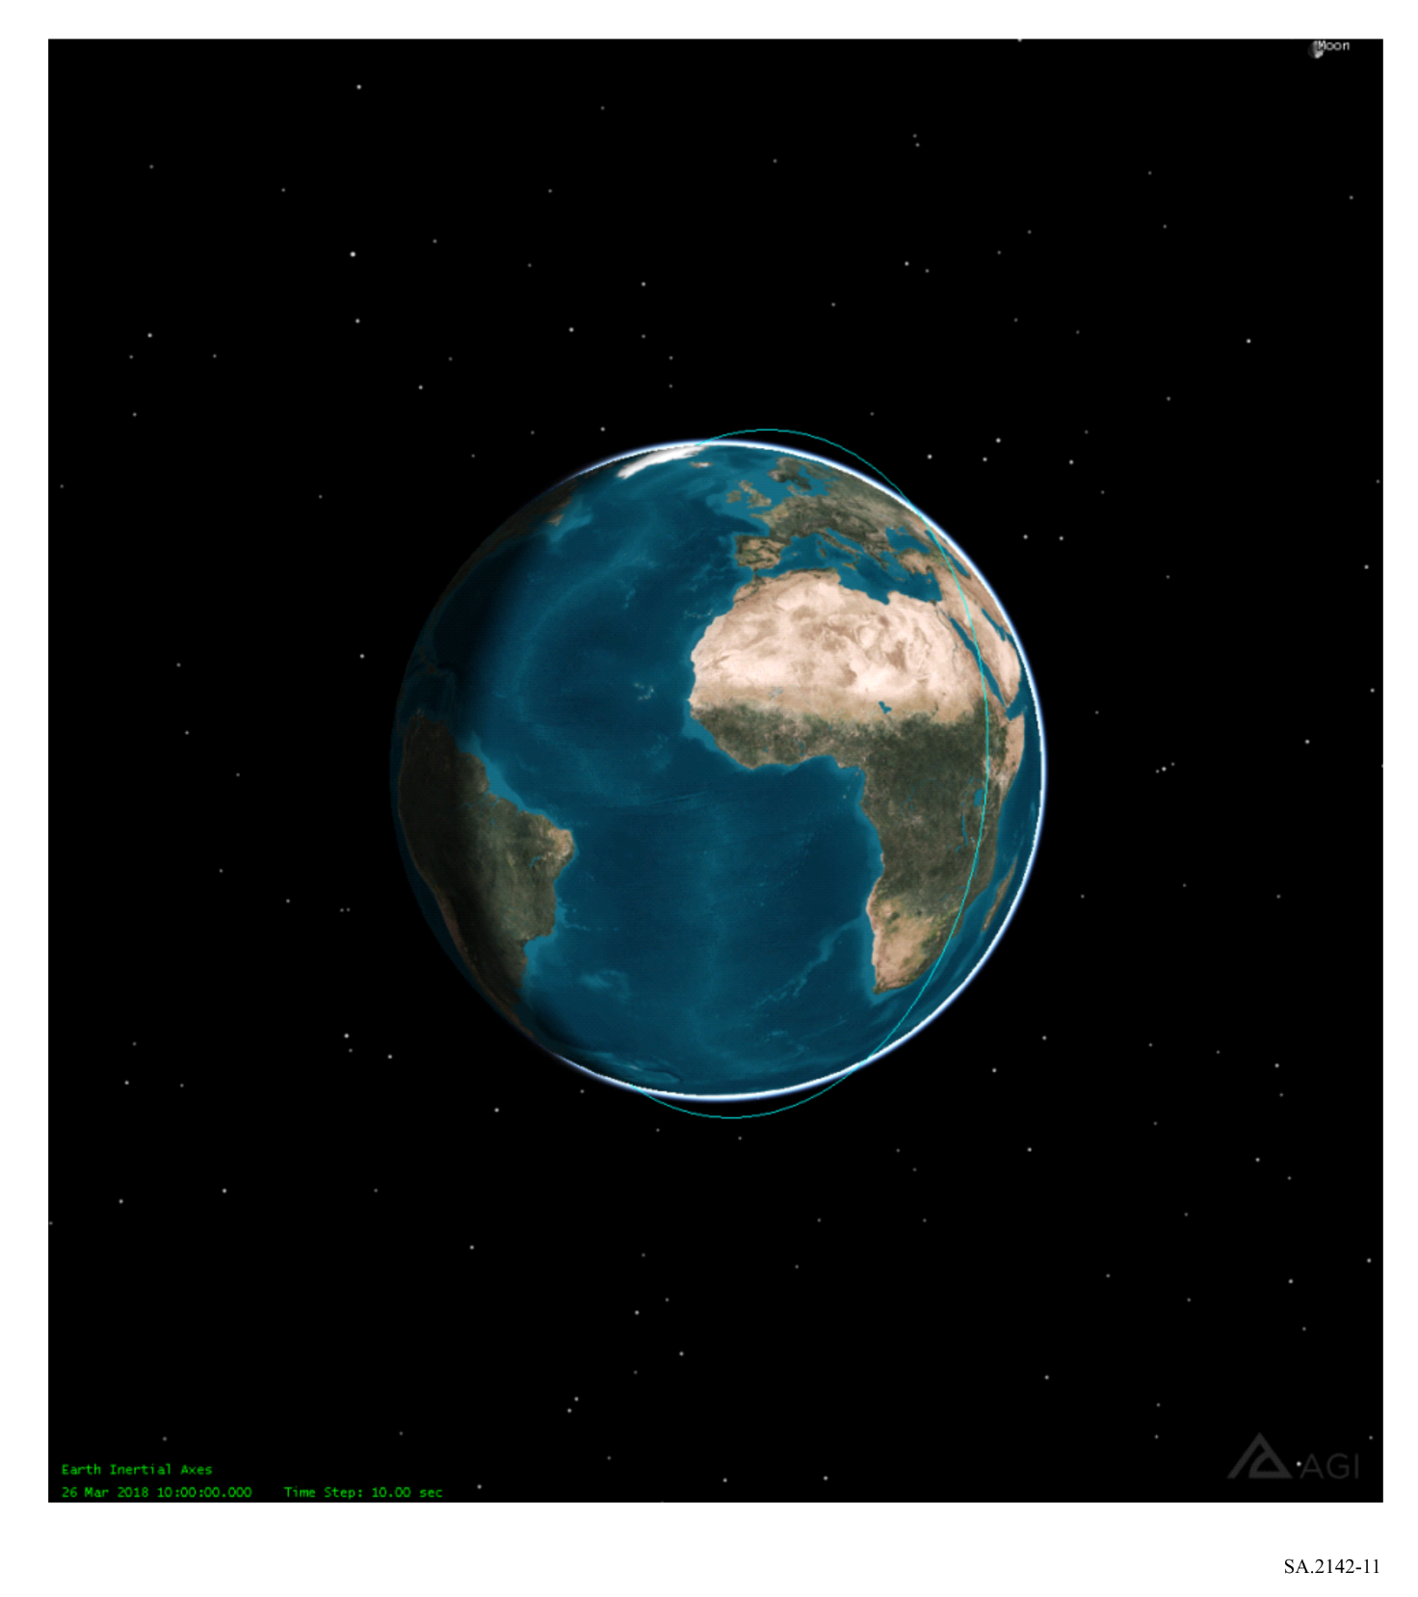
It is then necessary to determine the visibilities of such satellite from the EESS earth station considered. The satellite is visible as soon as its elevation angle as seen from the earth station is over 5 degrees. Figure 12 provides as an example a view of the portions of orbits that are visible from Kiruna (Sweden) over 5 degrees elevation over an 11-days period.
FIGURE 12
Visibility of the EESS satellite from a given earth station
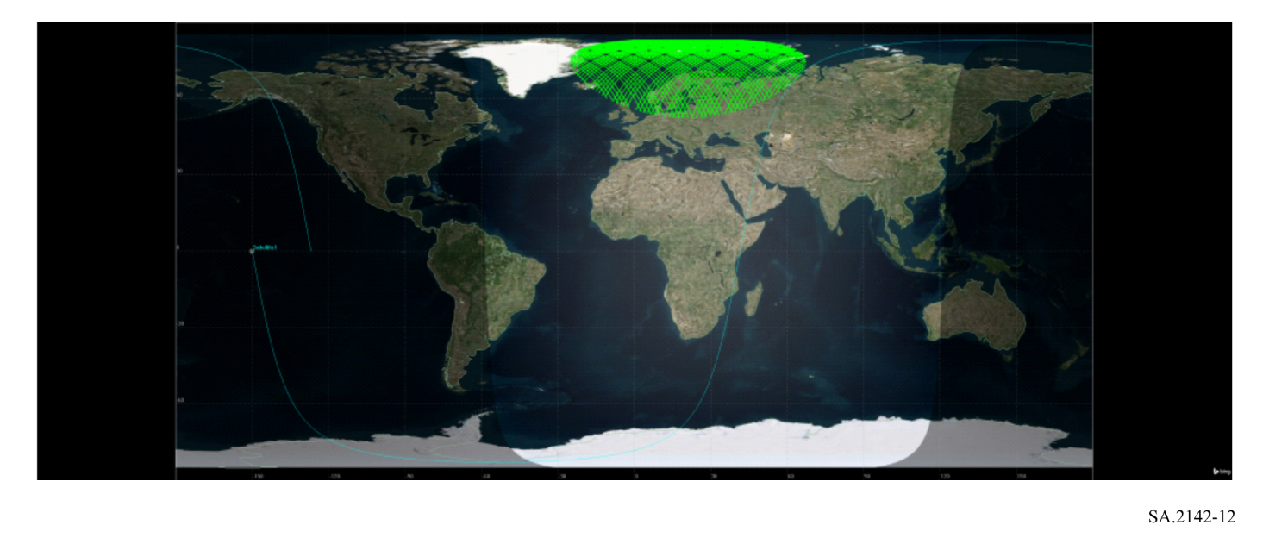
For each of the time steps where the satellite is in visibility, and each azimuth around the earth station, it is then necessary to determine the offset angle between the vector earth station-satellite, and the horizon direction for the azimuth considered. This offset angle can then be used to determine the antenna gain towards the horizon, using antenna patterns such as RR Appendix 7 or Appendix 8. The cumulative distribution function (cdf) of the antenna gain can then be extracted for each azimuth, as shown in Fig. 13 for Kiruna, and an antenna following RR Appendix 8 with a 70.7 dBi maximum antenna gain.
FIGURE 13
EESS antenna gain towards the horizon for Kiruna and a non-GSO satellite on a polar orbit at 400 km altitude
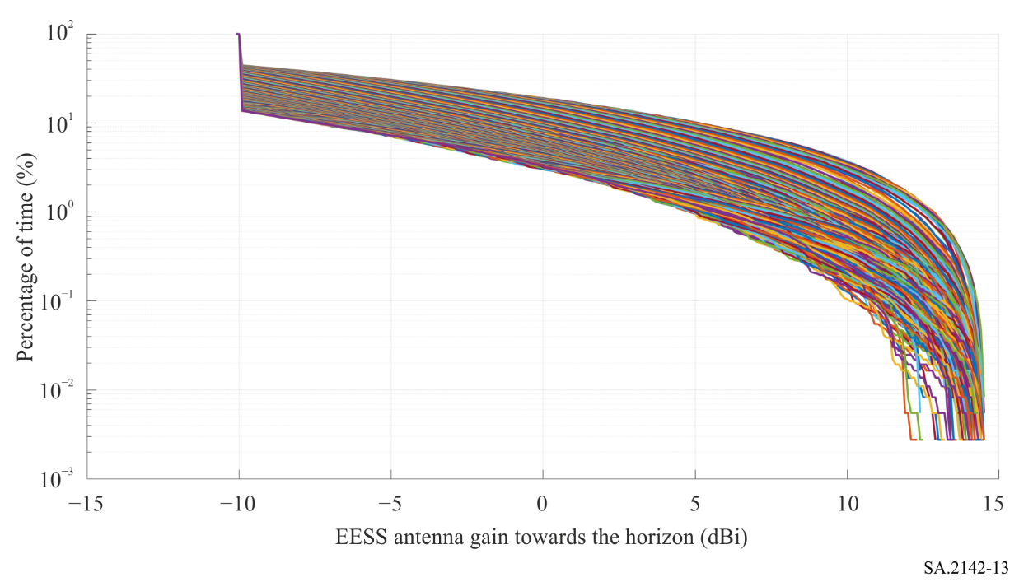
This cdf provides on the X-axis the value of G_{r} and on the Y-axis the value of p_{r} used in equation (4), for each azimuth.

6 Determination of the convolution G_{tot} of both antenna gains towards the horizon
When both distributions of base station gain towards the horizon and EESS gain towards the horizon are available, the next step is to convolve them. This can be done directly for each azimuth, or using this alternative approach:
– Generate N random base station antenna gain values G_{t} following the distribution (G_{t}, p_{t}) obtained in § 4;
– Generate N random EESS earth station antenna gain values G_{r} following the distribution (G_{r}, p_{r}) obtained in § 5;
– Sum the two random numbers obtained G_{tot} = G_{t} + G_{r};
– Generate the cdf of G_{tot}.
This has been done as an example for the EESS earth station in Kiruna, for all azimuth around the earth station, in Fig. 14.
FIGURE 14
Composite gain G_{tot} for Kiruna and a non-GSO satellite on a polar orbit at 400 km altitude
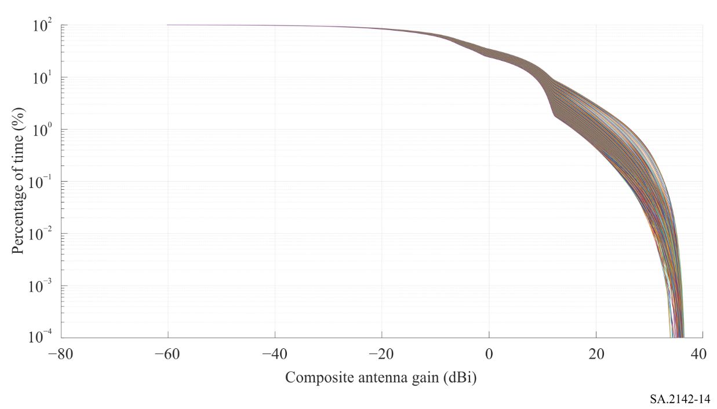

7 Determination of the EESS protection threshold and reference bandwidth
The EESS sharing threshold I is given in Recommendation ITU-R SA.1027. This Recommendation proposes two criteria, one long-term and one short-term. Monte Carlo analyses have shown that when the short-term criterion was met, the long-term was also met. In addition, applying this methodology with the long-term criterion and a percentage of time of 20% would largely overestimate the coordination distances required to ensure protection to EESS earth stations.
The sharing criterion to be used is therefore the short-term criterion, given as −116 dBW in a reference bandwidth B_{ref} of 10 MHz. The associated percentage of time p is 0.005%.

8 Determination of the required propagation loss and associated percentage of time
Same as Annex 1 – § 7.

9 Determination of the coordination area contour
For each of the azimuth around the EESS earth station, each of the distances from the EESS earth station location, and each of the percentages of time 𝑝_{𝑣} determined in § 8, the propagation loss should be determined using an appropriate propagation model such as the one contained in Recommendation ITU-R P.452 or Recommendation ITU-R P.2001, considering the terrain elevation and local clutter surrounding the earth station. In case Recommendation ITU-R P.2001 is used, the associated percentage of time p_{v} obtained through equation (2) should not be capped to 50%.
The terrain elevation model can be the 1-arcsec resolution terrain profile data of the Shuttle Radar Topography Mission (SRTM), however more detailed terrain models, including built area models, may be used. The terrain profiles can be sampled with an azimuth step of 1 degree around the earth station of interest and a distance step of 25 m. The losses can then be computed around the station with an azimuth step of 1 degree and a distance step of 100 m.
For each azimuth and percentage of time 𝑝_{𝑣}, the coordination distance required is then the maximum distance at which the propagation loss calculated is just below the required propagation loss L_{req}(𝑝_{𝑣}). The coordination distance to be retained for the azimuth angle considered is the maximum distance obtained for all values of 𝑝_{𝑣}.
Figure 15 provides as an example the coordination area contour obtained around the station in Kiruna (Sweden) for an 8 × 8 urban/suburban base station at 26 GHz.
FIGURE 15
View of coordination area contour around Kiruna
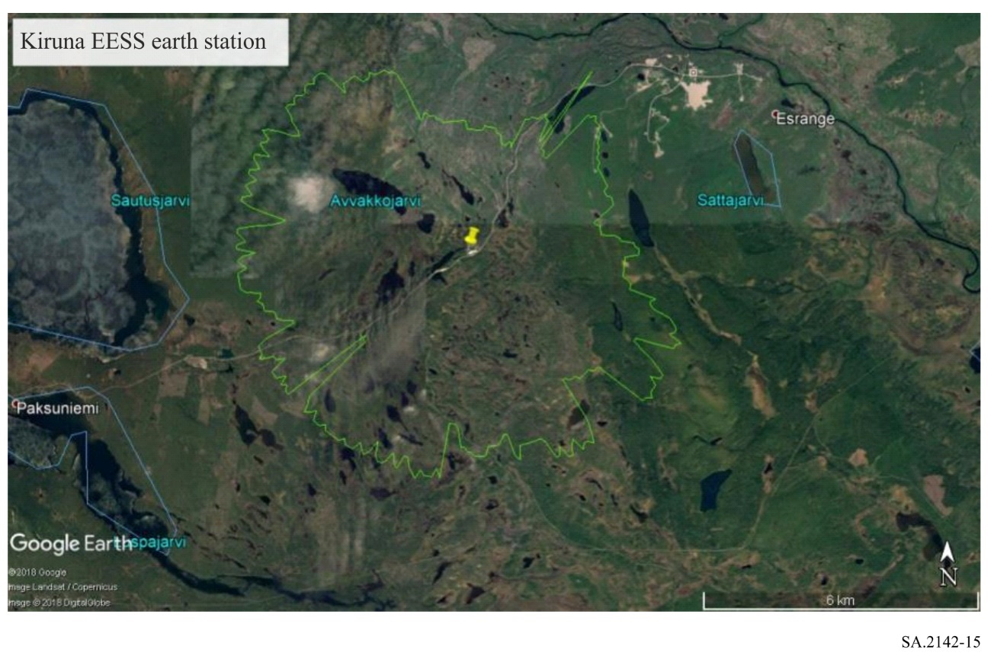

Annex 3
Methodology for calculating the coordination area around
GSO EESS earth stations in the band 25.25-27.5 GHz

1 Introduction
This methodology would apply to EESS satellites performing observations from the GSO orbit, such as meteorological satellites, in the band 25.5-27 GHz.
In this case, the EESS earth station is tracking a given GSO satellite and hence its antenna is not moving. The TVG methodology given in RR Appendix 7 can therefore be applied as such. This methodology would give results similar to a Monte Carlo analysis but is much faster and more efficient. Here again, the methodology has been validated through additional Monte Carlo simulation for some of the contour points.
Given that the user equipment will operate either indoor or in heavy clutter, the methodology focuses on the IMT-2020 base station. In order to derive coordination areas which size may be larger than the final distances obtained through detailed calculation during coordination, the base station panel considered is assumed to be physically pointing in the same azimuth as the victim EESS earth station.

2 TVG standard methodology
See Annex 1 – § 2.

3 Determination of the IMT-2020 base station total power
See Annex 1 – § 3.

4 Determination of the distribution of the IMT-2020 BS antenna gain towards the horizon
See Annex 1 – § 4.

5 Determination of the EESS antenna gain G_{r} towards the horizon
In this case, the GSO satellite is fixed at a given longitude on the GSO arc, at round 36 000 km altitude. It is therefore easy to determine only once the vector going from the EESS earth station towards the EESS satellite. The offset angle between this vector and the horizon direction for each azimuth can also be determined only once, whereas for a non-GSO satellite it had to be determined for each time step.
This offset angle allows to determine the antenna gain of the EESS earth station towards the horizon for the azimuth considered. Normally, it should be at its maximum value in the azimuth corresponding to the azimuth where the GSO satellite is.

6 Determination of the EESS protection threshold and reference bandwidth
The short-term EESS sharing threshold I is given in Recommendation ITU-R SA.1161, as −133 dBW in a reference bandwidth B_{ref} of 10 MHz. The associated percentage of time p is 0.1%.

7 Determination of the required propagation loss and associated percentage of time
See Annex 1 – § 7.

8 Determination of the coordination area contour
For each of the azimuth around the EESS earth station, each of the distances from the EESS earth station location, and each of the percentages of time 𝑝_{𝑣} determined in § 7, the propagation loss should be determined using an appropriate propagation model such as the one contained in Recommendation ITU-R P.452 or Recommendation ITU-R P.2001, considering the terrain elevation and local clutter surrounding the earth station. In case Recommendation ITU-R P.2001 is used, the associated percentage of time p_{v} obtained through equation (2) should not be capped to 50%.
The terrain elevation model can be the 1-arcsec resolution terrain profile data of the SRTM, however more detailed terrain models, including built area models, may be used. The terrain profiles can be sampled with an azimuth step of 1 degree around the earth station of interest and a distance step of 25 m. The losses can then be computed around the station with an azimuth step of 1 degree and a distance step of 100 m.
For each azimuth and percentage of time 𝑝_{𝑣}, the coordination distance required is then the maximum distance at which the propagation loss calculated is just below the required propagation loss L_{req}(𝑝_{𝑣}). The coordination distance to be retained for the azimuth angle considered is the maximum distance obtained for all values of 𝑝_{𝑣}.
Figure 16 provides as an example the coordination area contour obtained around the EESS earth station in Leuk (Switzerland) for an 8 × 8 urban/suburban base station at 26 GHz.
FIGURE 16
View of the coordination area contour around Leuk
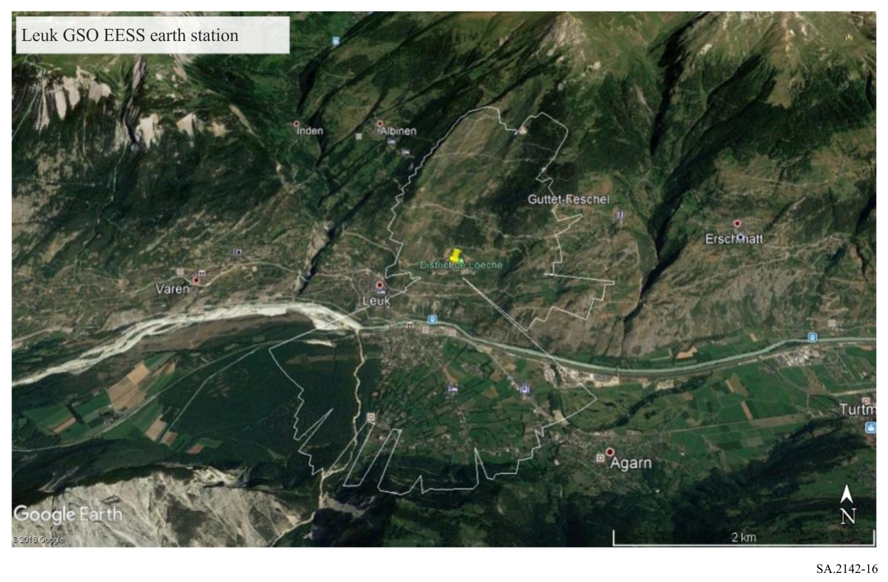

Annex 4
Methodology to ensure the protection of EESS earth stations
from IMT stations deployed inside the coordination area

1 Introduction
The purpose of the annex is to describe a methodology to ensure the protection of EESS earth stations (GSO or/and non-GSO) from IMT-2020 when the IMT base station is within the coordination area. Outside this coordination area, no calculation is necessary and the deployment of IMT-2020 could be made without particular constraint. However, in the coordination area, IMT-2020 could be deployed but some precautions have to be taken.
Studies have shown that, in the case of EESS protection (GSO or non-GSO), the generic TVG (made without terrain profile), provides distances which can most of the time be approximated to distances as follows:
– For GSO earth station, calculated with the maximum gain of BS towards horizon and a percentage of 50% in the model described by Recommendation ITU-R P.452.
– For non-GSO earth station, calculated with the maximum composite gain (G_{tot} – sum of EESS and BS gain towards the horizon) and a percentage of 50% in the model described by Recommendation ITU-R P.452.
The distance found by the TVG is also dependent of the emitted power. The studies show that the approximation mentioned above is totally relevant for the e.i.r.p. as 48 dBm/200 MHz for an 8 × 8 antenna (25 dBm/200 MHz of power considering 3 dB of ohmic losses and 23 dBi of maximum gain) and could be extended for higher e.i.r.p.
Some other studies, on EESS earth station, have shown that meeting short-term criteria (−133 dB(W/10 MHz) for 0.1% (GSO case) and −116 dB(W/10 MHz) for 0.005% (non-GSO) also implies meeting the long-term criteria. So, for EESS earth station, the studies could only focus on this criterion.
For the case of an EESS earth station, the coordination distance is, most of the time, limited to line of sight (LoS). In other words, the distance is often close to or below the radio horizon. Under this condition, the calculated losses provided by Recommendation ITU-R P.452 (50% and LoS conditions) are based on free space losses and diffraction.

2 Propagation losses
Under LoS condition, as described by Recommendation ITU-R P.452, the ducting and troposcatter effects do not play a role and the minimum losses are given by free space and diffraction. Free space loss increased with distance and diffractions are linked to the presence of physical obstacles on the propagation path, as well as diffraction by round Earth. The diffraction losses depend on the number and the height of the obstacles, the IMT-2020 base station antenna height and the earth station antenna height.
In an urban environment, with 6 m height hotspot IMT base station, the diffraction by buildings, i.e. clutter contribution, could be very important. As an example, the curves provided by Recommendation ITU-R P.2108 provide diffraction losses between 13 and 45 dB in the first 500 m. For this distance, the average value is close to 19 dB. This value is arbitrary and will be used as example in calculation. The use of real terrain profile with building height is however more accurate. Figure 17 provides an example of the building height that could be used in simulation.
Figure 17
Example of building height in the centre of the city of Toulouse
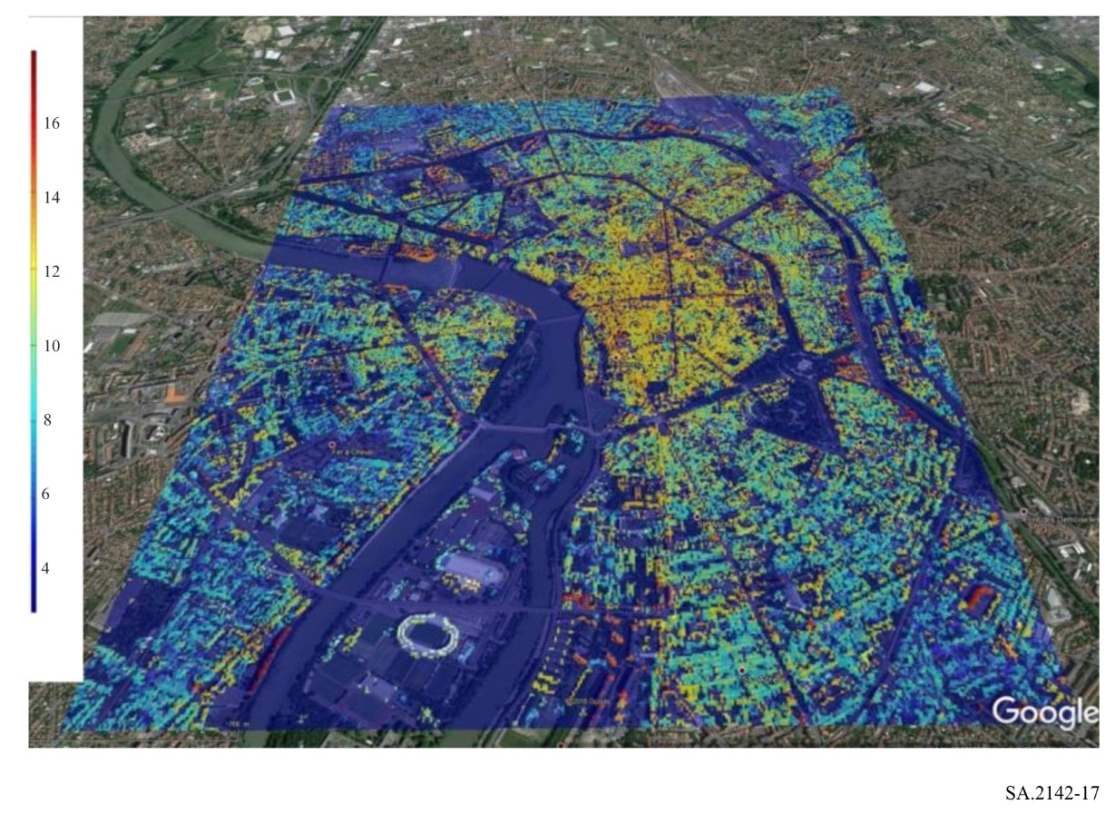

3 Aggregate effect from several IMT-2020 base station in the EESS earth station
The aggregated effect of several base stations could take place, only if several emissions generate the same magnitude of power in the EESS receiver. To obtain this condition in a LoS situation, considering the previous assumption of calculation (max gain, 50%), the BSs need to have the maximum gain towards the earth station with almost the same losses on each propagation paths. Considering an urban environment with different propagation path and several levels of diffractions losses, this situation may not be fully negligible. Hence an increased in margin on the EESS protection criteria to account for this aggregation could be used.

4 Earth station tracking a GSO satellite

4.1 General rules
As mentioned in § 1 of this Annex, the separation distance in the coordination area between an earth station pointing towards a GSO satellite and an IMT-2020 base station could be defined considering:
1 The maximum gain of the earth station towards the horizon (G_{rmax}).
2 The maximum gain of the BS towards the horizon (G_{tmax}).
3 The IMT-2020 power (or TRP with 3 dB of ohmic losses) converted in the EESS protection criteria reference bandwidth (10 MHz) (P_{t}).
4 The short term criterion of the EESS earth station: −133 dB(W/10 MHz) (C_{r}).
5 A margin for aggregation (s).
6 A percentage of time of 50% in Recommendation ITU-R P.452 (Note: For simplification, Recommendation ITU-R P.525 (free space) and Recommendation ITU-R P.526 (diffraction) could be used).
7 A relevant terrain profile between the earth station and the BS. This terrain profile has to be as precise as possible by including building/clutter losses.
In a real deployment, the separation distance could be difficult to use. In this situation, in order to define the position of the BS in regards of the EESS earth station, it is better to define the necessary losses based on the assumptions above. The required propagation loss could be calculated as follows:
$L_{req}= P_{t}+G_{tmax} + G_{rmax} - C_{r}+A$ (5)

4.2 Minimum attenuation towards the EESS earth station
The study explores the possibility to use the discrimination angle between the mechanical azimuth of BS and the azimuth where the EESS earth station is as a factor of compatibility improvement. Figure 18 provides the cumulative distribution of the BS antenna gain (hotspot at 6 m) towards the horizon for different BS panel physical azimuth angles. The Figure was built considering the distribution of electrical tilt (see Annex 1 § 4) and a mechanical tilt of −10°. Due to the UE distribution in horizontal steering angle (between −60 and 60°) and distance, the Figure shows that a maximum gain between 22.5 to 20 dBi could be found towards the horizon for steering angle values between 0 to 50 degrees. After this value, the maximum gain towards horizon decreases considerably and become less than 5 dBi when the BS is perpendicular to the receiver.
These results show that the position of BS with regard to the EESS earth station could considerably improve the compatibility between both services. Table 1 provides the necessary losses considering the distribution of gain presented in Fig. 18 and equation (5). The maximum TRP of the BS is taken as 25 dBm/200 MHz. Considering the reference bandwidth of EESS protection criteria (see Annex 1 § 3), the emitted power represents −18 dB(W/10 MHz). For higher TRP, the minimum attenuation would increase correspondingly. For antenna with lower or higher number of elements, the minimum attenuation would need to be recalculated.
The EESS earth station could point towards different positions on the geostationary arc, but the calculation shows that the gain towards horizon (G_{r}) could only vary from −6 to −10 dBi, at least in most European countries below a given latitude. In order to ensure the protection of the earth station, a value of −6 dBi is chosen.
Table 1 shows that, if an average clutter loss value of 19 dB is used, the separation distance between IMT-2020 and EESS earth station could become less than 1 km if the BS points in direction of the earth station and less than 100 m if the BS is perpendicular to the earth station.
FIGURE 18
cdf of the IMT-2020 BS gain towards the horizon for different azimuths
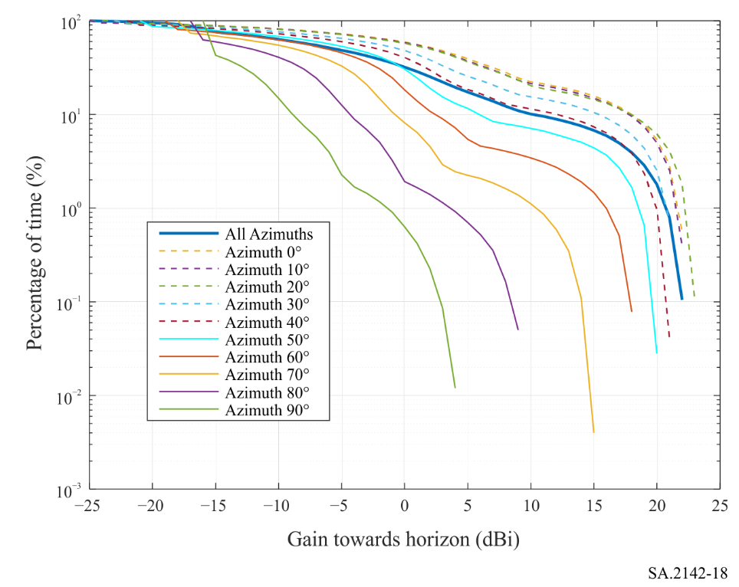
TABLE 1
Evaluation of necessary losses
Type | Azimuth  (degree) | P_{t}  (dB(W/10 MHz)) | G_{t}  (dBi) | G_{r}  (dBi) | C_{r}  (dB(W/10 MHz)) | Aggr. effect  (dB) | L_{b} ⁽¹⁾  (dB) | Distance using free space loss  (km) | Distance using free space + Clutter losses  (km) ⁽²⁾
Hotspot | 0 | −18 | 22.5 | −6 | −133 | 6 | 137.5 | 6.6 | 0.8
 | 10
 | 20
 | 30
 | 40 | −18 | 21 | −6 | −133 | 6 | 136 | 5.8 | 0.65
 | 50 | −18 | 20 | −6 | −133 | 6 | 135 | 5.2 | 0.58
 | 60 | −18 | 18 | −6 | −133 | 6 | 133 | 4.1 | 0.47
 | 70 | −18 | 15 | −6 | −133 | 6 | 130 | 3 | 0.33
 | 80 | −18 | 9 | −6 | −133 | 6 | 124 | 1.5 | 0.17
 | 90 | −18 | 4 | −6 | −133 | 6 | 119 | 0.8 | < 0.1
⁽¹⁾ When different technical and operational characteristics are employed for IMT base stations, the attenuation levels need to be calculated accordingly.
⁽²⁾ The distances are evaluated considering an average clutter loss of 19 dB (average value of distribution provided by Recommendation ITU-R P.2108 for a distance of 500 m).

5 Earth station tracking a non-GSO satellite

5.1 General rules
As shown in § 1 of this Annex, the separation distance in the coordination area between an earth station pointing towards a non-GSO satellite and an IMT-2020 base station could be defined considering:
‒ The maximum composite gain (associated gain of BS and earth station) towards horizon (G_{cmax}).
‒ The IMT-2020 power (or TRP with 3 dB of ohmic losses) converted in the EESS protection criteria reference bandwidth (10 MHz) (P_{t}).
‒ The short term criteria of the non-GSO EESS earth station: −116 dB(W/10 MHz) (C_{r}).
‒ A fixed value of aggregation (A).
‒ A percentage of time of 50% in Recommendation ITU-R P.452 that could be often simplified by the associated use of Recommendation ITU-R P.525 (free space) and Recommendation ITU-R P.526 (diffraction).
‒ A relevant terrain profile between the earth station and the BS. This terrain profile has to be as precise as possible including building/clutter losses. Example is given in Fig. 1.
In real deployment, the separation distance could be difficult to use. In this situation, in order to define the position of the BS in regards of the EESS earth station, the best way to proceed is to define the necessary losses based on the assumptions above. The losses could be calculated as follow:
$L= P_{t}+G_{cmax} - C_{r}+A$ (6)

5.2 Practical case
Similarly to the previous section, the study focuses on the possibility to use the discrimination angle between mechanical axes of BS and EESS earth station as a factor of compatibility improvement. Figure 19 provides the cumulative distribution of the composite gain (association of the BS gain and EESS gain) towards the horizon for different azimuth angles. Due to the angle limitation of BS electrical tilt from −60 to 60 degrees, the maximum composite gain is between 35 and 37.5 dBi for discrimination angle between 0 to 50 degrees and decreases for angle above.
Table 2 provides the necessary losses considering the distribution of gain presented in Fig. 19 and equation from § 5.1. In this example, the maximum power of the BS is taken as 25 dBm/200 MHz. Considering the reference bandwidth of EESS protection criteria (see § 3), the emitted power represent −18 dB(W/10 MHz).
The EESS earth station tracks a non-geostationary satellite at 800 km of altitude in polar orbit. The minimum elevation angle is taken as 5 degrees. For this elevation, the maximum antenna gain towards horizon, using RR Appendix 8, is closed to 15 dBi.
Table 2 shows that, if an average value of clutter loss of 19 dB is used, the separation distance between IMT-2020 and the EESS earth station could become less than 1.3 km if the BS points in direction of the earth station and less than 140 m if the BS is perpendicular to the earth station.
Figure 20 provides the map of losses in a city where the EESS earth station could be deployed in France. This Figure shows that the maximum distance in the city, where no building is present, is close to 3 km to obtain 142 dB of losses. When buildings are present in the path, the distance can decrease to a few hundred metres. However, care has to be taken far away (around 5 km) from the station on height elevation position (hills, mountains, etc.) as shown in the Northeast and Southwest directions of the station. Figure 20 shows that the diffraction losses due to the presence of buildings on the propagation path would ensure the EESS earth station protection without imposing undue constraint to IMT-2020.
FIGURE 19
cdf of the composite gain towards the horizon for different azimuths
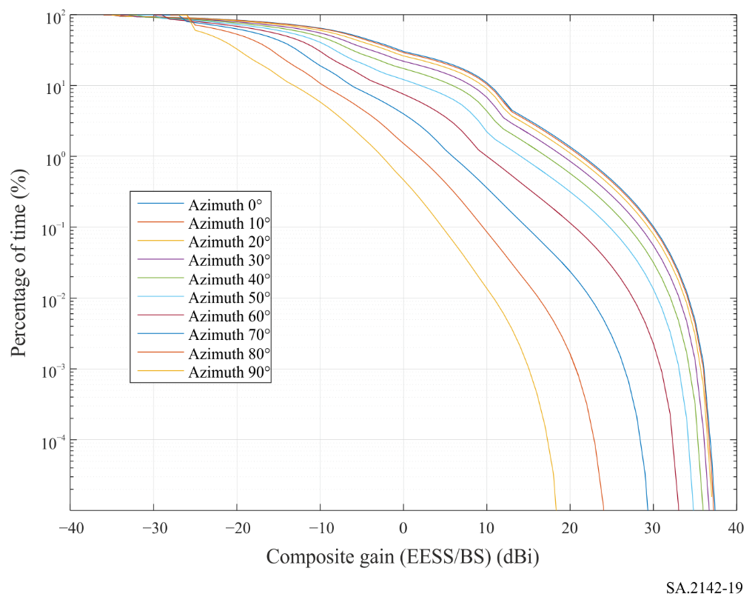
TABLE 2
Evaluation of necessary losses
Type | Azimuth  (degree) | P_{t}  (dB(W/10 MHz)) | G_{c}  (dBi) | C_{r}  (dB(W/10 MHz)) | Aggr. effect  (dB) | L_{b} ⁽¹⁾  (dB) | Distance use free space loss  (km) | Distance using free space + Clutter losses  (km) ⁽²⁾
Hotspot | 0 | −18 | 38 | −116 | 6 | 142 | 11.6 | 1.3
 | 10
 | 20
 | 30
 | 40 | −18 | 36 | −116 | 6 | 140 | 9.2 | 1.03
 | 50 | −18 | 35 | −116 | 6 | 139 | 8.3 | 0.92
 | 60 | −18 | 33 | −116 | 6 | 137 | 6.6 | 0.73
 | 70 | −18 | 30 | −116 | 6 | 134 | 4.6 | 0.52
 | 80 | −18 | 24 | −116 | 6 | 128 | 2.3 | 0.26
 | 90 | −18 | 19 | −116 | 6 | 123 | 1.3 | 0.14
⁽¹⁾ When different technical and operational characteristics are employed for IMT base stations, the attenuation levels need to be calculated accordingly.
⁽²⁾ The distances are evaluated considering an average clutter loss of 19 dB (average value of distribution provided by Recommendation ITU-R P.2108 for a distance of 500 m).

FIGURE 20
Loss map of the city of Toulouse using Recommendation ITU-T P.452 (50%) and
real terrain profile associated with building model
